STUDENT NAME: GABRIELA TERTIUC
STUDENT NUMBER: 2125134
MODULE CODE: BMSW4004
MODULE: PROBLEM SOLVING AND DECISION MAKING
MODULE LEADER: BALENDRAN KANDASAMY

Table of Contents
Introduction 3
The workplace Problem 3
Analysis Information 4
Root causes Analysis 4
Applying Situational Analysis Models 4
Range of Alternative Solutions 5
Evaluation of Alternative solution 6
Implementing the solution 7
Communication plan with stakeholders 8
Monitoring and review techniques 10
Conclusion 10
References 11
Appendix 13

Introduction
Problem solving refers to a process that acts as finding a solution to the problem for that problem solving helps to find a solution to the various complex issues. Problem solving is crucial for the organisation and stakeholders because it helps to empower better control of the working place environment. The skills can add more value that provides to stakeholders and the skills help to understand the needs for the changes and identify the improvement and that uses in certain environments (Tregoe, 2022).
PRET A Manger is popularly known as Pret and the shop is a franchise chain-oriented shop the shop was founded in 1983. It has more than 434 shops in the UK and among them, London has more than 273 shops. The restaurant is a casual restaurant and they offer Veggie Press that mainly focuses on vegan and vegetarian options. The shop donates unsold fresh food to the local charity and they also provide funds to homeless shelters (PRET, 2022).

The workplace Problem
A problem is considered a general task or a situation that can lead to difficulties and that could not be effectively dealt with and controlled through complexity and transparency. A problem can be diminished through collecting information and effectively talking with the stakeholders so that they can gain insight into the problem and its causes.
A complex problem refers to a problem that has beyond the scope within a single organisation and that helps to understand responses to the causes of the problem and also addresses the actual issues.
Less maintenance of Hygiene
Pret is a popular restaurant in the Uk and the restaurant has to maintain effective food hygiene, but it is the individual responsibility and the restaurant has promoted effective practices and can allow food safety standards. It is estimated that 2.4 million food poisoning cases happen throughout the UK and the number is increasing in recent times. For that, the Uk has developed the Food standard Scheme and Agency on the food standard and which encourages food handling and parodies guidances for restaurants (Deer, 2022).
Low morale
Pret should develop the morale among the staff of the restaurant because it can determine the less amount of job satisfaction and that impacts the services and products that are delivered by staff. This low morale can be caused by the lack of training facilities, unskilled colleagues, poor management, stress and pay issues etc. The morale among the staff can be increased through active participation in the collaborative team working facility (Leonard, 2020).
Poor hiring and training
Restaurants face shortages of labour for that they hire unskilled labour for that which provides pressure on the performances of the employees for that it impacts productivity levels of the employees (Baddiley, 2018).
Working pressure
The staff also faces the working pressure in the pick time and it also causes the hard part and that return stuff have to deliver working experiences and that can be prone to substances in the different issues. For that staff has to maintain an effective job culture that decreases the challenges they face during the time of working performances (Vinter, 2022).

Analysis Information

Root causes Analysis
Root causes analysis provides a structure of the process of the team and that will help to identify various factors and causes for that it helps to identify the cause of the failure that will help to develop an effective action that can sustain corrections.
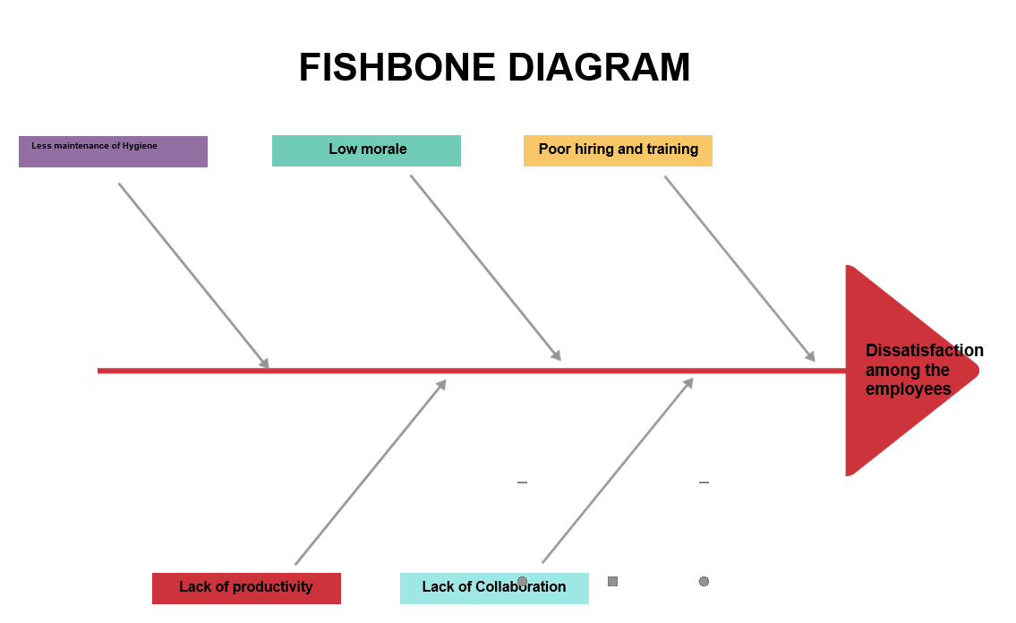
Figure 1: Fishbone Diagram
(Source: Self-created)

Applying Situational Analysis Models
SWOT
Strength- Strength is the factor that distinguishes an organisation from its competitors. The provides traits and develops a strong brand image and creates effective loyal customers and effective technological experiences help to develop effective advantages with the organisation that is compared to rivals.
Weakness- Weakness is the internal factor within the business. For that weakness, it improves the identified areas and it also determines the measure of the rectification and that control in the weak points and that will develop the effective measure for the improvement of the strong attribute and that influences future courses of action.
Opportunity- Opportunity delivers the external factor that will help to deliver benefits for the organisation. Opportunity promotes the effective opportunity for that success in the achievement of the career and promotes job satisfaction and proactively exploits the marketing goals for the employees. The process can promote future growth and effective uses in the marketing process for the organisation (Leonard, 2020).
Threats- These are the external factors this negatively impacts the business and employment. Threats can occur due to the problem of the supply chain, stringent government and financial downfalls and it is controlled outside of the organisation (DLT Labs, 2022).

Range of Alternative Solutions
Solution 1:
Effective leadership
There should be effective leadership experiences among the employees for that the employees can gain the experiences for the working perspectives and the leader can promote motivation and effective working quality among the working forces so that employees can improve their skills and that help to increase the productivity and working opportunity among the employees. The leadership can improve the morale among the working force the leadership should have an effective vision that is associated with high satisfaction levels and helps to improve the morals among the employees (Sharkey, 2022).
Solution 2:
Training and opportunity for the working forces
The organisation should develop the opportunity for the training of the skills development among the working forces and will depend on the several issues and it helps to expand the knowledge and the employees have to attain the training session and it helps to identify the various weakness on the working place skills and allow them to improve the strength skills and they will get knowledge on the skills on the similar skills. That initiative will develop a stronger understanding of responsibility from the working perspective (Frost, 2019).
Solution 3:
Collaboration with the team members
Organisations should implement effective collaboration in the working environment as it helps to achieve goals and produces services and goods on the aspects of the goods. For better collaboration with the team, it will encourage team members and they will work for encouragement among the team members and promote the benefit of the company (Indeed, 2022).

Evaluation of Alternative solution
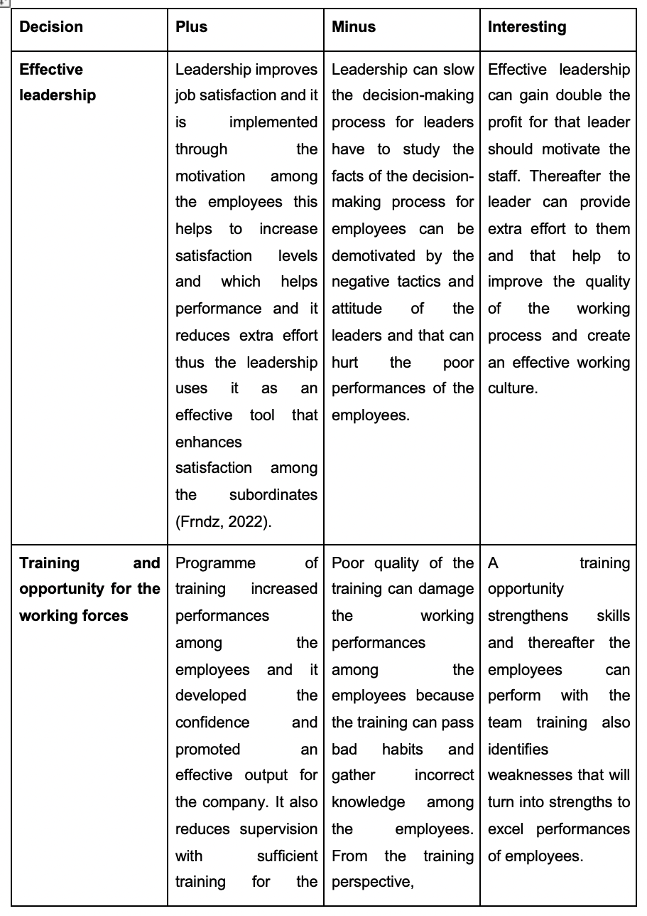

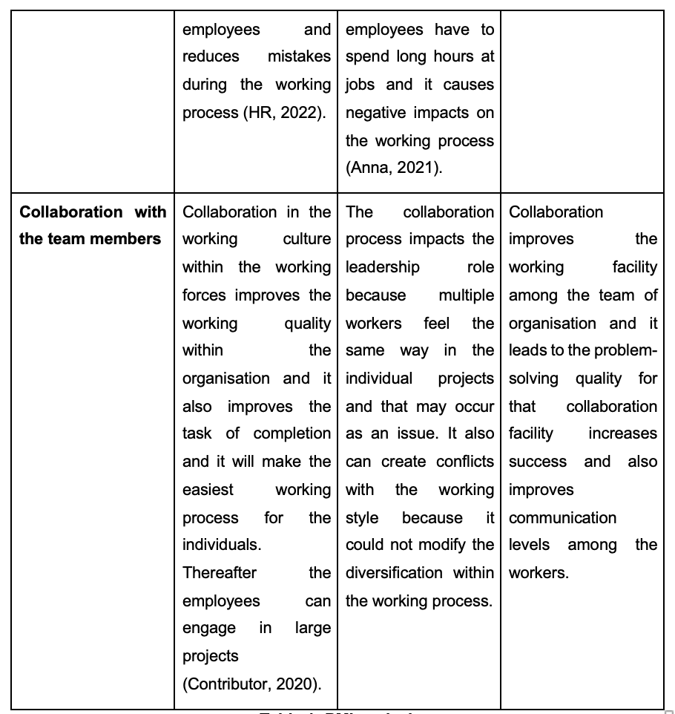

Table 1: PMI analysis
(Source- Self-developed)

Implementing the solution
Working loads management
Firstly, employees have to make a schedule that is based on the guideline and it impacts the working process of the employees without any interruption. The leaders can identify the mistakes of the employees. Through this process, employees can identify mistakes and share their experiences with the other employees for the working force \ and can promote effective management of the working process.
Delegate task
The employees will prefer the management duties for the employees who can engage in responsible projects and improve the experiment through the various skills. Thus the employees can set an expectation through the delegating task which ensures confidence based on their ability in the portion of the projects (Herrity, 2022).

Communication plan with stakeholders
Stakeholders are dedicated as the group, individuals and party and it grows interested in the organisation and out promotes outcomes that are based on the action. According to the report of the restaurant association, owners, consumers, employees, suppliers, investors and managers are recommended as the stakeholders because they all show particular interest in certain aspects.
Power and Interest Matrix
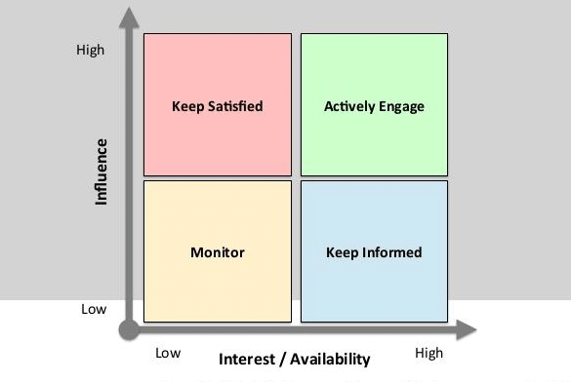
Figure 2: Power and Interest Matrix
(Source: Francis, 2019)
The power grid of the stakeholders represents the ability that affects the success of the business and they can influence the outcomes from the business perspective.
Low-interest, low power: Consumers and suppliers have little interest in business but it poses limited power on the influences of success.
High interest, low power: The sponsor and investor have a strong interest in the business but they have less effect on success.
Low Interest, high power: Contractors and partners are interested in projects but they have less amount of sufficient of power and they play an effective role in business.
High-interest, High -power: Owners and managers play a significant role in the business that provides success (Lucid, 2021).
Stakeholder engagement Plan

Stakeholder | Power/interest | Key interests and issues | Communication vehicle | Frequency | Comments
Customers | Low | Services are the key to their interest for them and they provide feedback after consuming services. | Interview | Daily | Customers demand effective quality and services.
Sponsor | High | The monitoring of social media helps to identify trends and patterns. | Online process | Weekly | It generates media coverage to gain profit in business.
Partners | Low | It is interested in the financial resources for the growth of the business. | Surveys | Monthly | It enhances workforce performance.
Manager | High | They make decisions on the business running and they take risks for the profit of the business. | Newsletter | Weekly | Priority to cultivate relationships in the working places.
Table2: Stakeholder engagement Plan
(Source: Self-developed)

Monitoring and review techniques
Monitoring and control help to keep projects on track and it plays a major part in completing projects at the right time. The data is gathered from the project manager to modify the effective plan for the projects and it also promotes effective opportunity and implements changes to resolve issues in the management to detect crises. For effectiveness, projects should be worked in small init and divided tasks among the various people and it will evaluate and manage the various issues. Thus it reflects the trace of the required projects.

Conclusion
The study concludes that the report focuses on job-related dissatisfaction with Pret and discusses the various factors that are reliable with the different problems. These issues are affecting the productivity and collaboration among the employees due to the management issue with the organisation. This report illustrates the work-oriented problem that is providing an effective solution and that impacts the effective performances among the employees within the working environments (PMP, 2019).

References
Anna (2021) Anna, 4 advantages & disadvantages of employee training | Easy LMS. Available at: https://www.easy-lms.com/knowledge-center/employee-training-center/our-top-advantages-and-disadvantages-of-employee-training/item12790 (Accessed: January 3, 2023).
Baddiley , S. (2018) Low morale in restaurants, LinkedIn. Available at: https://www.linkedin.com/pulse/20141003234550-107854722-low-morale-in-restaurants (Accessed: January 3, 2023).
Contributor, C. (2020) Advantages & disadvantages of collaboration in the Workplace, Small Business - Chron.com. Chron.com. Available at: https://smallbusiness.chron.com/advantages-disadvantages-collaboration-workplace-20965.html (Accessed: January 3, 2023).
Deer, M. (2022) Food hygiene requirements in restaurants, CPD Online College. Available at: https://cpdonline.co.uk/knowledge-base/food-hygiene/food-hygiene-requirements-in-restaurants/ (Accessed: January 3, 2023).
DLT Labs (2022) The importance of SWOT analysis, Medium. DLT Labs. Available at: https://medium.com/dlt-labs-publication/the-importance-of-swot-analysis-2ae85762f4b8 (Accessed: January 3, 2023).
Francis, A. (2019) Stakeholder analysis - stakeholder power and interest mapping, MBA Knowledge Base. Available at: https://www.mbaknol.com/strategic-management/stakeholder-analysis-stakeholder-power-and-interest-mapping/ (Accessed: January 3, 2023).
Frndz (2022) Advantages and disadvantages of leadership, Advantages and Disadvantages of Leadership | Frndzzz.com. Available at: http://frndzzz.com/leadership/advantages-and-disadvantages-of-leadership (Accessed: January 3, 2023).
Frost, S. (2019) The importance of Training & Development in the Workplace, Small Business - Chron.com. Chron.com. Available at: https://smallbusiness.chron.com/importance-training-development-workplace-10321.html (Accessed: January 3, 2023).
Herrity, J. (2022) 14 strategies for effectively managing people at work. Available at: https://www.indeed.com/career-advice/career-development/managing-people (Accessed: January 3, 2023).
HR (2022) Advantages of training programme, Whatishumanresource.com - Advantages Of Training Programme. Available at: https://www.whatishumanresource.com/advantages-of-training-programme (Accessed: January 3, 2023).
Indeed (2022) 11 ways to collaborate with your team (with benefits). Available at: https://in.indeed.com/career-advice/career-development/ways-to-collaborate-with-your-team (Accessed: January 3, 2023).
Leonard, K. (2020) Council post: Five reasons restaurants fail, and how to avoid them, Forbes. Forbes Magazine. Available at: https://www.forbes.com/sites/forbescoachescouncil/2020/05/27/five-reasons-restaurants-fail-and-how-to-avoid-them/?sh=2e155f9f198d (Accessed: January 3, 2023).
Lucid (2021) How to do a stakeholder analysis: Lucidchart Blog, How to Do a Stakeholder Analysis | Lucidchart Blog. Available at: https://www.lucidchart.com/blog/how-to-do-a-stakeholder-analysis (Accessed: January 3, 2023).
PMP (2019) Project Monitoring and control techniques, PMP - Project Management Professional Training. Available at: https://www.projectmanagementqualification.com/blog/2019/10/21/project-monitoring-control/ (Accessed: January 3, 2023).
PRET (2022) The Pret Coffee subscription, Freshly prepared food, organic coffee | Pret A Manger. Available at: https://www.pret.com/en-US (Accessed: January 3, 2023).
Sharkey, M. (2022) What is leadership and why is it so important?, Workplace from Meta. Available at: https://en-gb.workplace.com/blog/why-is-leadership-important (Accessed: January 3, 2023).
Tregoe, K. (2022) What is problem solving and why is it important: Consulting and training solutions: Kepner Tregoe, Kepner Tregoe | Leaders in problem solving. Available at: https://kepner-tregoe.com/blogs/what-is-problem-solving-and-why-is-it-important/ (Accessed: January 3, 2023).
Vinter, R. (2022) Staff shortages see UK restaurants struggle to cope with Christmas season, The Guardian. Guardian News and Media. Available at: https://www.theguardian.com/food/2022/dec/04/staff-shortages-see-uk-restaurants-struggle-to-cope-with-christmas-season (Accessed: January 3, 2023).

Appendix

