

Radonda Vaught Homicide Case — Medication Error Case

Name : Limbachiya Jaiminkumar Amrutbhai
Student Id : 2527056
Subject code : LCHS7002
Subject name : Health Care System Organisation and Leadership
Instructor : Dr. Fahad khan
Institution : University of Wales trinity saint david
Course : Msc public health and social care in practice
Date : 27/03/2026

Radonda Vaught Homicide Case — Medication Error Case

1.Introduction
One of the most serious health problems faced by patients worldwide is patient safety, whereby unnecessary harm may be incurred due to the healthcare systems, regardless of the income level. The World Health Organisation (WHO, 2023) identifies unsafe care as one of the primary causes of morbidity and mortality in the world and medication errors as one of the primary causes that cause harm to patients, though they are highly avoidable. The errors may occur during prescription, dispensing, or administering drugs and often result in system errors, not by the actions of a single person (WHO, 2017).
When it comes to this arrangement, the case of RaDonda Vaught is among the most debated cases of a fatal medication error in the recent past. In 2017, a patient in Vanderbilt University Medical Centre succumbed to death due to a nurse error when the midazolam was replaced by vecuronium. The responsibility of the professional in healthcare systems was questionable regarding the subsequent criminal prosecution, which was also the catalyst for organisational accountability and the culture of patient safety (AHRQ, 2022).
A major role of leadership is in the facilitation of safe and effective healthcare provision. The health and social care leadership concept is to guide people and groups to reach a shared goal that can result in patient safety and quality care (Northouse, 2022). Researchers have found that leadership behaviours possess strong effects on the culture of safety, involvement and reporting of incidents of employees in healthcare organisations (Althobaiti, 2026). The ability of leadership to reduce medication errors is also possible and capable of facilitating communication according to protocols and continuous quality improvement (Subrata, 2026).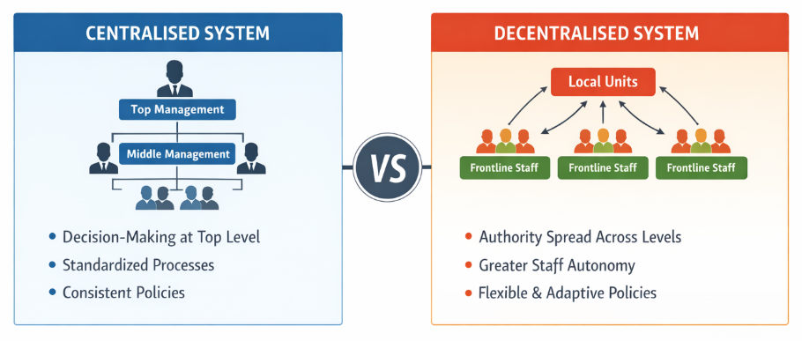
Figure 1 Figure 1: Centralised vs Decentralised Healthcare Governance Model
(Source: Created inspired by Sikalgar et al. 2025)
The healthcare organisations are either centrally or decentrally governed. A centralised system is a decision-making process where the decision-making power is centralised at the higher levels of management so that uniformity and standardisation are achieved. Quite the contrary, in decentralised systems, the power is distributed among the different organisational levels, and the employees working at the frontline become more independent and sensitive to the clinical situation (Sikalgar et al., 2025). These organisational strategies affect accountability, decision-making activities and patient safety outcomes (see Figure 1). The report critically examines the case of RaDonda Vaught's medication error in the context of systems thinking, governance, organisational structure and leadership theory perspectives. It examines how leadership activities and organisational structures contributed to the incidence of the incident and further the implications to patient safety, accountability and the improvement of the healthcare system.

2. Main part

A)Identifying the Problem and Setting the System Context
RaDonda Vaugh is an example of a deadly medication error, in which Instead of midazolam, Vaught accidentally administrated Vacuronium and she died as a result (AHRQ, 2022; Anders, 2025). A complex of the malfunctioning of the system, human factor, and the absence of guidelines has provoked the mistake (Alabdullah & Karwowski, 2025). Vaught did not find Versed in the Automated Dispensing Cabinet, so she picked the first drug, unaware that it would cause her a cardiac arrest (AHRQ, 2022; Alenzi et al., 2024). It was caused by bad supervision, no barcode checks, and poor communication. This incident led to the criminal conviction of Vaught, which proves how catastrophic the role of human error in healthcare can be (AHRQ, 2022; Althobaiti, 2026).
Global and National context
Medication errors are a global issue, and the World Health Organization reports that they are among the leading causes of harm and mortality and cause an approximate 5% proportion of adverse patient outcomes worldwide (Anders, 2025; Alenzi et al., 2024). The number of mistakes that occur annually in the U.S. is thousands, and over 7,000 cases are reported each year (Alabdullah & Karwowski, 2025). The failure of the small systems, the absence of interdepartmental communication, and insufficient safety measures, along with system overrides, may cause fatal mistakes (AHRQ, 2022; Alandajani et al., 2022), which is reflected in the case of RaDonda Vaught. Effective leadership would prevent such incidents, effective communication, and a strong safety culture (Althobaiti, 2026).
Data and Statistics
Medical errors are a topical issue of patient safety on a global level, as 200 - 500 thousand drugs cause harm annually in the U.S. (Anders, 2025). Approximately 200,000 harms are drug-related, and up to 5% of them result in death in the U.K. and up to 5% worldwide (Alabdullah & Karwowski, 2025; Althobaiti, 2026). Other system failures in the RaDonda Vaught case entailed the use of a half-finished EMR and ADC system and facilitated delays and miscommunication in the dispensing of medications (AHRQ, 2022; Alabdullah & Karwowski, 2025). The reason that resulted in the development of conditions that facilitated the occurrence of the fatal mistake was the ADC override, the staff being distracted, and the lack of barcode scanning in the PET scan space (Alandajani et al., 2022; Alenzi et al., 2024).

Rich Picture

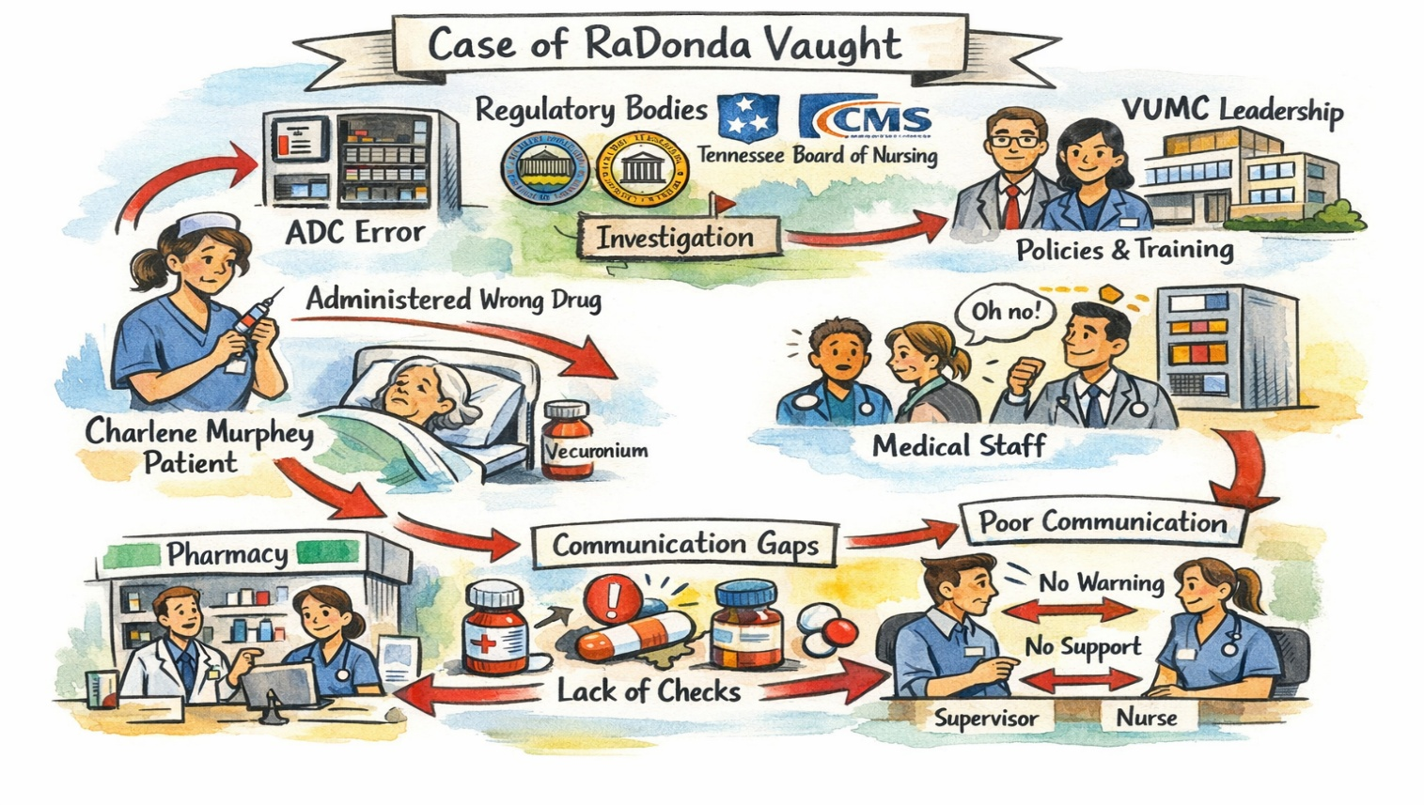
(Self generate)
Figure 2 a rich picture of a case of RaDonda Vaught incident analysis

In the case of RaDonda Vaughn, the important elements in the Rich Picture of the system context are the following (Hughes, 2008; Coelho et al., 2024):
Stakeholders Involved: The nurse who administered the drug: RaDonda Vaught (Coelho et al., 2024).
Charlene Murphey: Patient with incorrect prescription (Collado-Gonzalez et al., 2024).
VUMC Leadership: The policies, training, and general safety rules of the hospital (Dirik, Theiakouli & Efstathiou, 2026).
Automated Dispensing Cabinet (ADC) System: The malfunctioning technology of the error (Coelho et al., 2024).
Medical Personnel and Leaders: Physicians, other nurses, and staff who interacted with the patient and responded to the event (De Brun et al., 2020).
Regulatory Bodies: Tennessee Board of Nursing, Centers of Medicare and Medicaid Services, and other agencies of the state or federal government, which are involved in investigations (Hughes, 2008).
Communication Gaps:
The issue of medication preparation involved Vaught being distracted during the process and, consequently, failing to check the medication (Coelho et al., 2024; Collado-Gonzalez et al., 2024). The lack of communication between a pharmacy, supervisory staff, and a nurse led to the absence of opportunities for control and error prevention (De Brun et al., 2020).
Systemic Failures:
The integration issues between the EMR system and the ADC, which caused the time delays in accessing medications and consequently resulted in Vaught receiving the incorrect medication (Hughes, 2008; Coelho et al., 2024). Absence of barcode scanning in the PET scan region, which could have increased the error before its administration (Coelho et al., 2024). The lack of instructions on how to report medication errors was evidenced by the fact that the hospital took too long to recognize the incident (Barkhordari-Sharifabad & Mirjalili, 2019).
Organizational Structure:
Centralized decision-making at VUMC, i.e., the fact that the decisions concerning technology, not to mention the medication protocols, were being filtered at the higher levels, may have contributed to the slowness in reacting to the issues at the frontline level (De Brun et al., 2020; Dirik, Theiakouli, and Efstathiou, 2026). The absence of responsibility and omissions in the patient care cycle, which can be attributed to the unclear job responsibilities of Vaught, as she was the Help-All nurse (Collado-Gonzalez et al., 2024).
System Weaknesses and Causes of the Root
The systemic and human factors are the root causes of the medication error in the case in point (Coelho et al., 2024). One of the cases of human error is the distraction of Vaught during medication preparation (Collado-Gonzalez et al., 2024). However, some structural issues with VUMC resulted in the error being a fatality (Dirik, Theiakouli & Efstathiou, 2026).
The integration failures that occurred between the EMR system and the ADC led to the development of unnecessary delays in access to medications; the feature of override that is supposed to be employed in emergency situations was misused in the case in point (Hughes, 2008; Coelho et al., 2024). The fact that the hospital had not installed a barcode scanning system in the PET scan area was only helpful in increasing the error, since the absence of the safety feature would have automatically created a red flag on the difference between the ordered medication and the one administered (Hughes, 2008).
Such confusing job descriptions of a few of the jobs, including the Help-All nurse position, also caused a misunderstanding in accountability, and Vaught had the responsibilities that were not in her scope of practice without sufficient supervision (Collado-Gonzalez et al., 2024). Failure to report the incident, which was not timely, as prescribed by the hospital protocol, also contributes to the further delay of the problem recognition and its resolution, meaning that the systemic issues are not addressed (Barkhordari-Sharifabad & Mirjalili, 2019).
Governance Context
This situation is a multi-level politics since it involves the local hospital administration and the state and federal regulatory bodies (Hughes, 2008). At the local level, the management at VUMC was expected to ensure that medication processes and safety management were effective enough to prevent these kinds of errors (Dirik, Theiakouli, and Efstathiou, 2026). Another fact, however, is that the new EMR system was not introduced into the ADC in an appropriate way, and that the required preventive measures, such as barcode scanning, have not been put in place, demonstrates that there was a governance and oversight problem (Coelho et al., 2024). The Tennessee Board of Nursing had originally determined that it would not take any disciplinary action against Vaught; however, it later changed its mind without providing any explanation at the state level (Hughes, 2008). The failure of the state to respond promptly and make the issues of the system its priority in the first place was a factor in the perpetuation of systemic problems at VUMC (Barkhordari-Sharifabad & Mirjalili, 2019). Centers for Medicare and Medicaid Services started to examine VUMC at the federal level through an anonymous report (Hughes, 2008). However, the gap in time when the notification about the incident becomes possible, and the lack of corrective actions on the spot, show the susceptibility of regulatory control and responsibility (De Brun et al., 2020).
B) Decentralization or centralization in the Case Study
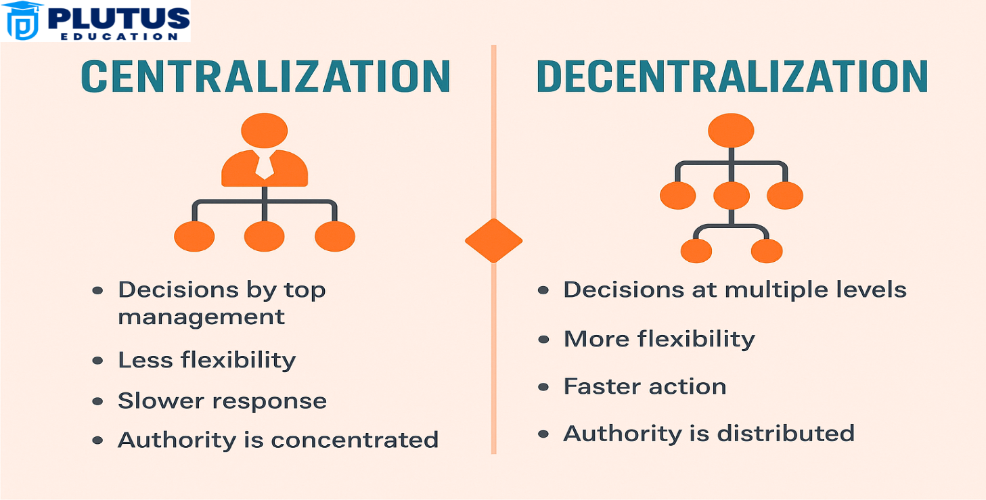
Figure 3 comparison of Centralization vs Decentralization
Source:(Monga 2024)
Centralized System
In the case of Vanderbilt University Medical Center (VUMC), the top administrators had control over the decision-making system used, the policies, protocols, and technology implementations (Wagner et al., 2019; Dirik, Theiakouli, and Efstathiou, 2026). At VUMC, the technology division and the management reserved the right to medication dispensing and ADC system overrides, designed to counter the emergency situation or acute problem (Hughes, 2008; Kim, Kim, and Suh, 2022; Liston, O'Connor, and Ward, 2023). Though it was effective, uniform, and efficient in all the departments, as it was centralized, it allowed the use of vecuronium instead of Versed due to the override option (Hughes, 2008; Kwiecien-Jagus et al., 2025).

The centralization strategy served to attain hospital-wide uniformity and save time on searching for the medication (Wagner et al., 2019; Dirik, Theiakouli, and Efstathiou, 2026). However, it also introduced rigidity, particularly in emergency or unanticipated situations, that limited the flexibility of the frontline personnel and speed of decision making (Kim, Kim, and Suh, 2022; Oliveira et al., 2024). The system that was supposed to accelerate the care process, the override system, failed to pass the safety checks, and Vaughn was left dissatisfied with the inadequate means related to ensuring that the appropriate drug and an adequate dosage were used (Hughes, 2008; Kwiecien-Jagus et al., 2025). Hence, centralization helped in efficiency and standardization, yet at the same time, it was what created the systemic vulnerabilities that led to the medication error (Dirik, Theiakouli & Efstathiou, 2026).
Decentralized System
The concept of healthcare decentralization involves the delegation of the decision-making process to those staff members who work at the front line so that nurses and respective departments can make decisions on the spot without the support of the top management (Wagner et al., 2019; Dirik, Theiakouli & Efstathiou, 2026). Decentralization in the case of Vaught would have allowed nurses to verify the medications, directly communicate with the pharmacy personnel, and correct the error instantly, which would have resulted in the death (Kim, Kim, and Suh, 2022; Oliveira et al., 2024). The decentralization can result in the inconsistency of the various departments and inconsistent practice and can cause stress or burnout to the staff members when the roles and support system are not clearly defined, thus compromising the quality of safety and care (Liston, O'Connor, and Ward, 2023; Dirik et al., 2026).
C) Leadership Theories and Their Implications on the Case of RaDonda Vaught
Patient safety, staff performance, and organizational culture are significant to healthcare leadership (Dirik, Theiakouli, & Efstathiou, 2026; Wagner et al., 2019). The RaDonda Vaught case at Vanderbilt University Medical Center was linked to a leadership approach that affected the center's response to primary challenges and employees' responses during hard times. The theories of behavioural leadership and the Tannenbaum and Schmidt leadership continuum would be more suitable in this case, as they provide effective frameworks for analysing the consequences of leadership. The Y, Z, and Theory X perspectives offer an image of the assumptions managers make about employees' behaviour. Theory X assumes that employees must be closely supervised and regulated, which aligns with VUMC's strict procedures and hierarchical decision-making. This method of control is embodied in the reliance on rigorous medication procedures and the centralisation of the Automated Dispensing Cabinet (ADC) system. However, research shows that an overabundance of restrictive systems can increase the risk of workarounds, and no more than 70% of nurses report bypassing safety measures due to inefficiencies in workflow (Oliveira et al., 2024). Rather, Theory Y provides trust, autonomy, and intrinsic motivation, which would have facilitated Vaught and her colleagues' questioning of unhealthy behaviors, such as using overrides daily. Another aspect emphasised by Theory Z is collective responsibility, long-term personnel development, and a sound organisational culture. The absence of such a culture at VUMC contributed to a breakdown in communication and to the lack of accountability among the teams.
Behavioural leadership theory has its roots in leadership behaviours, particularly people-oriented and task-oriented leadership. In the case of Vaughn, the leadership style was highly task-oriented, emphasizing procedural conformity rather than support and communication with its employees. Task-based leadership can improve standardisation, but people-based leadership has been shown to reduce negative patient events by 23-30 % through improved communication and cooperation (Wagner et al., 2019). The lack of supportive leadership behaviours at VUMC also limited staff's ability to report issues related to systemic defects, such as the absence of barcode scanning in the PET scan area. A more moderate manner of behaviour would have enhanced psychological safety, allowing risks to be detected at an early stage. The Tannenbaum Schmidt leadership continuum provides a continuum between dictatorial and democratic leadership patterns, where there is a focus on the level of control in contrast to the employee involvement by the leaders. At VUMC, the developed leadership practices were situated on the authoritarian end, and staff were barely involved in decision-making. This reduced the likelihood that frontline nurses would influence safety practices, though they were at the front line in experiencing system inefficiencies. It is also suggested that organisations with a more participative leadership style document near-miss incidents more than 50 times, which is critical for preventing significant errors (Liston, O'Connor & Ward, 2023). In the case of VUMC, the leadership might have shifted to the participative side of the continuum, which would have enabled Vaught to be more empowered to question the override process and seek clarity during a PET scan.
The issue of Vaught making the mistakes public instantly reveals individual accountability. However, the general organisational response indicates that leaders face constraints in enforcing a culture of fairness and learning. According to the study, 80% critical medical mistakes are attributed to the failure of the systems, rather than to personal negligence, and this is why leadership is necessary to eliminate the risks of the systems, and not to blame anyone (Kwiecien-Jagus, Medrzycka-Dabrowska, & Kopec, 2025). Open communication, shared responsibility, and adaptive decision-making could not be strong supports for this leadership style. Overall, a hybrid of Theory X, Y, and Z, the Behavioural theory of leadership, and the Tannenbaum and Schmidt continuum indicates that leadership directly influences patient safety outcomes, staff behaviour, and organisational learning. The participative, supportive, and trust-based leadership trend would also have reduced unsafe workarounds, improved communication, and strengthened the safety culture at VUMC.

D) Critical Analysis
In comparison between the centralised and decentralised models, both have their strengths and weaknesses in the healthcare organisations (Wagner et al., 2019; Dirik, Theiakouli, & Efstathiou, 2026). In the RaDonda Vaught case at Vanderbilt University Medical Center, centralisation was helpful to standardisation by reducing clinical variation by up to 30% and increasing consistency of the routine. However, it minimized frontline responsiveness in risky situations that require immediate decisions (Kim, Kim, and Suh, 2022). Inefficiency was observed in workarounds, such as neglecting the ADC system. The latter leads to the enhancement of access to medications in the short run. However, over 60% of medicine errors are linked to these practices (Kwiecien-Jagus et al., 2025), which justifies the fact that the inflexible systems promote the development of the unconsciously encouraged unsafe behaviours. In contrast, decentralization proves to be more bendable and receptive since it empowers frontline staff with the power to make instant clinical decisions (Dirik, Theiakouli, and Efstathiou, 2026). With the proper training and well-developed authority, nurses would have been better placed to question the medication procedure and prevent the administration of medication on suspicion. According to the studies, organisations with a higher staff autonomy have up to 40 fewer adverse events, mostly due to the existence of superior situational monitoring and immediate intervention (Kim, Kim & Suh, 2022). Moreover, decentralised systems promote the culture of accountability and transparency, which would motivate employees to speak out and contribute to the problem-solving processes in the group (Liston, O'Connor & Ward, 2023).

The chance to resolve the disagreements in real-time and collaborate with multidisciplinary teams could have very slim chances of mistakes in this scenario (Oliveira et al., 2024). There are, however, challenges associated with decentralisation. Otherwise, it may lead to inconsistency in practices and role ambiguity in interdepartmental relations and therefore put patients at risk (Wagner et al., 2019). Studies have shown uncoordinated decentralisation may cause up to 25% variance in the making of clinical decisions, particularly in instances where the care is complex.

In the Vaught case, the lack of a balanced solution between centralised control and decentralised autonomy led to the delay of recognition and subsequent action in making errors. It is even provided that the majority of the serious medical errors are not caused by the individual behaviour but some failures of the system, which justifies the need for leadership models that are able to integrate the rigidity and flexibility (Dirik, Theiakouli, and Efstathiou, 2026). Moreover, a responsive leadership approach with decentralised decision-making within a formal structure would have resulted in the recognition of the mistake at earlier stages and prevented it. However, decentralisation might involve some inconsistencies; the fact that it makes the staff more responsive, communicative, and engaged is one of the most important factors of successful patient safety practices.

Learnings and Enhancements
Interaction between Leadership and Governance
The case of RaDonda Vaught is highly expressive in illustrating the imperative quality of the interaction between the leadership and governance in the contribution towards the healthcare outcomes (Moraca et al., 2025; Northouse, 2022). In another situation, in the Vanderbilt University Medical Center (VUMC), the absence of assistance from the leadership to the frontline staff and the incapability of the governance structure directly resulted in the additional development of a medication error into a fatality (Moraca et al., 2025; Lappalainen, Harkanen & Kvist, 2019). Even though Vaught was the author of the issue, the organizational causes, including the ineffective introduction of the Automated Dispensing Cabinet (ADC) system, were largely overlooked (Mutair et al., 2021; Jang, Lee, and Son, 2021). The culture of reporting mistakes, investigating them, and resolving them systemically should also be promoted by the leadership so that the frontline personnel can be spared from being scapegoats (Northouse, 2022; Sikalgar et al., 2025). The delay in the resolution of the mistake was caused by VUMC governance, in which the key decisions are made centrally (Moraca et al., 2025; Moriwaki et al., 2025). The concentrated systems concentrate power in the hands of senior people, and it could slow down the response time when there is a need to respond urgently (Northouse, 2022; Mutair et al., 2021). In this case, the failure to report the incident to the hospital in line with the current practices was the result of the delay of leadership that increased the systemic weaknesses (Moraca et al., 2025; Lappalainen, Harkanen & Kvist, 2019). It is a symptom of the unwillingness to act and the desire to resolve the issue that the ADC system improvement came after the incident that occurred in the hospital (Jang, Lee, and Son, 2021; Sikalgar et al., 2025).
Evidence-Based Solutions
Evidence-based solutions would have prevented the death because of the medication error (Mutair et al., 2021; Northouse, 2022). The limitation of ADC reduces the scope of human error, and the efficiency of the medication control system with internal regulations and employee education facilitates safety (Moraca et al., 2025; Sikalgar et al., 2025). All medication locations are scanned to prevent errors in patient, drug, and dosage prescription according to the WHO standards (Jang, Lee, and Son, 2021; Moraca et al., 2025). Rather than facing the blame culture, leadership training provokes accountability, transparency, and error management (Northouse, 2022; Lappalainen et al., 2019). They help to make the employees' decision-making and response in the situations of crisis under pressure more efficient through regular workshops, simulations, and constant training (Moriwaki et al., 2025).
Lessons to Other Healthcare Organizations
The Vaught case identifies the most valuable lessons that assist in enhancing safety and leadership (Northouse, 2022; Jang, Lee, and Son, 2021). The leaders must take active steps in coming up with systems that restrict risks and protect patients (Moraca et al., 2025; Lappalainen et al., 2019). The positive safety culture allows staff to share mistakes through non-punitive systems that are aimed at comprehensive system enhancement (Mutair et al., 2021; Sikalgar et al., 2025). The type of technology that the hospitals must invest in is ADC systems, barcode scanners, and real-time alerts, and must be backed by the regular staff education about medication safety and crisis management (Moraca et al., 2025; Jang et al., 2021). Inclusive governance, decentralization, and transparency facilitate the promotion of patient safety (Northouse, 2022).
Continuous Improvement
Healthcare organizations must take care of patient safety by means of constant improvement (Moriwaki et al., 2025; Lappalainen, Harkanen & Kvist, 2019). The data-driven medication errors and near-miss audits allow the organization to be capable of learning what the root causes of the issue are and take certain interventions (Mutair et al., 2021; Moraca et al., 2025). It will be ensured that the safety measures will adjust to the new challenges as the development of a learning health system with real-time information supporting the changes in practice will take place (Northouse, 2022; Sikalgar et al., 2025). The outcomes could also be enhanced by the multidisciplinary teams that could be involved in the collaboration, communication, and shared responsibility between the leadership, employees, and regulators (Jang, Lee, and Son, 2021; Moraca et al., 2025). These strategies will be added to the leadership and governance practice to ensure that in the future, healthcare organizations become involved in the protection and care of patients, serving the staff, and continually improving the safety culture aiming to prevent the same tragedy as the Vaught case is the case with the addition of such strategies (Northouse, 2022; Mutair et al., 2021).
3) Recommendations
To remove the possibility of such cases as the RaDonda Vaughn one and improve patient safety, healthcare facilities ought to strive to improve the areas of leadership, technology, communication, and workforce health (Northouse, 2022; Sikalgar et al., 2025). According to the case, leadership assistance, structural protection, and reporting error measures, which have significant gaps, and through which, given an opportunity to fix, can reduce the likelihood of error in the medication errors significantly, are deficient (Moraca et al., 2025; Mutair et al., 2021).
3.1) Roles of Leadership that Support the Safety Culture
Effective leadership is the only way to attain a proactive safety culture in healthcare (Lappalainen, Harkanen, & Kvist, 2019; Northouse, 2022). Leaders also foster open communication, staff empowerment, and psychological safety, and therefore employees can report errors without fear of being penalized (Moraca et al., 2025; Jang, Lee, & Son, 2021). The delay in handling the error was likely caused by poor leadership, and this further complicated the outcomes of the patient and Vaught in the case of RaDonda Vaught (Mutair et al., 2021; Sikalgar et al., 2025). Leaders can also foster lifelong learning, collaboration, and open communication, and get employees to ask questions regarding the safety of patients and systemic issues rather than accusing one person in particular (Northouse, 2022; Lappalainen, Harkanen & Kvist, 2019). Special training can develop these leadership competencies in hospital administrators and clinical leaders and help them develop strategies to prevent errors and make their contribution to organizational behavior (Moraca et al., 2025; Mutair et al., 2021). Good leadership helps in the realization of strong healthcare systems that are supportive of patient safety, accountability of the staff, and professional development.
3.2) Install Automated Barcode Medication Systems
The use of automated barcode medication administration systems is one of the weak points that have been identified (Mutair et al., 2021; Moriwaki et al., 2025). In this kind of system, the mistake in the wrong medication to the wrong patient is verified by scanning the medication and a wristband that is issued to a patient (Moraca et al., 2025; Jang, Lee, and Son, 2021). In the story of Vaught, there is a possibility that, as barcode scanning was not provided in the region of the PET scan, the error was not spotted on time (Lappalainen, Harkanen & Kvist, 2019; Sikalgar et al., 2025). Barcode scanning may also be an additional precaution to prevent such errors in the future by being implemented in all high-risk environments, including imaging rooms and ICUs (Northouse, 2022; Moraca et al., 2025). This required the staff to be regularly trained and informed about how to use this technology and protection mechanisms, which are needed to guarantee that these tools are effective (Mutair et al., 2021; Jang, Lee, and Son, 2021).
3.3) Implement Daily Safety Huddles
Daily safety huddles are structured meetings that allow the staff and the management to discover risks ahead of time (Moraca et al., 2025; Northouse, 2022). Such brief meetings help the teams discuss the anticipations of threats, safety concerns of the patient, and anticipated challenges of the day (Mutair et al., 2021; Sikalgar et al., 2025). The Vaught case might have been addressed with better communication to highlight the problems with the ADC system earlier, since the error that was life-threatening would have been avoided (Lappalainen, Harkanen, and Kvist, 2019; Moriwaki et al., 2025). The safety huddles are also known to provide a non-punitive environment to report near-misses, as well as encourage continuous improvement (Moraca et al., 2025; Northouse, 2022). Huddles enhance teamwork, awareness of the situation, and vigilance that directly leads to patient safety (Jang, Lee, and Son, 2021; Mutair et al., 2021).
3.4) Minimize Reporting Systems and Accountability
The healthcare organizations are expected to establish reporting systems that are neither punitive, transparent, nor accessible (Mutair et al., 2021; Moraca et al., 2025). One of the methods of making sure that mistakes are detected and mitigated promptly is to encourage the personnel to report the mistakes and near-misses without fear of criminal or professional punishment (Northouse, 2022; Lappalainen, Harkanen & Kvist, 2019). The Vaught case demonstrates the effects of systemic failures that are not reported in time (Sikalgar et al., 2025; Jang, Lee, and Son, 2021). It is recommended that organizations increase accountability but emphasize longer-term solutions and not individual responsibility, which must encourage changes in patient care (Moraca et al., 2025; Mutair et al., 2021).
4) Conclusion
The case of RaDonda Vaught demonstrates that leading and system design have critical gaps allowing an avoidable medication error to become a life-threatening choice (Sikalgar et al., 2025; Subrata, 2026). The culture of support and transparency was not established at Vanderbilt University Medical Center (VUMC), and this was confirmed by the fact that Vaught was criminally accountable without the right organizational support (Wong, Cummings & Ducharme, 2013; Subrata, 2026). The lack of proactive leadership to prevent the systemic issues concerning the incorrect dispensing protocols and the Automated Dispensing Cabinets (ADC) implementation were also other factors that contributed to the severity of the mistake and the risk of the error (WHO, 2017; Sun, Zhou, and Wang, 2025). Systems thinking implies that the case demonstrates the essential defects in the healthcare work that involve the inability to use protective equipment, a lack of efficient communication systems, and no effective error detection systems (WHO, 2023; Sikalgar et al., 2025). Systems thinking is centered on the resolution of systemic problems and not on blaming people, but rather on making healthcare environments safer (Sun, Zhou, and Wang, 2025). The prevention of human error could have been reached with the help of such protective measures as barcode scanning and integrated medication systems that would have prevented the error and mitigated the consequences of human error (WHO, 2017; Wong, Cummings, and Ducharme, 2013). VUMC was governed in a decentralized manner, and this limited the autonomy of the frontline staff, decreased the response time, and reduced flexibility in patient care (Sikalgar et al., 2025; Subrata, 2026). A decentralized approach, and compliance with the just culture would have resulted in a more responsible and supportive approach (Wong, Cummings, and Ducharme, 2013; Sun, Zhou, and Wang, 2025). By correcting systemic failures, creating ongoing learning, and investing in leadership, healthcare organizations can maximize patient safety, reduce the risk of the occurrence of similar incidents, and ensure a long-term improvement in care delivery (WHO, 2023; Sikalgar et al., 2025).

Reference list
AHRQ, 2022. Vaught says some system practices contributed to fatal mistake. PSNet. Available at: https://psnet.ahrq.gov/issue/vaught-says-some-system-practices-contributed-fatal-mistake(Accessed on: 3 March 2026).
Alandajani, A, Khalid, B, Ng, YG & Banakhar, M 2022, ‘Knowledge and Attitudes Regarding Medication Errors among Nurses: A Cross-Sectional Study in Major Jeddah Hospitals’, Nursing Reports, vol. 12, MDPI AG, no. 4, pp. 1023–1039, viewed 15 March 2026, https://www.mdpi.com/2039-4403/12/4/98.
Althobaiti, FM 2026, ‘The effects of leadership on patient safety culture in health care: a systematic review’, BMC Nursing, vol. 25, Springer Science and Business Media LLC, no. 1, viewed 15 March 2026, https://link.springer.com/article/10.1186/s12912-025-04263-7.
Anders, RL 2025, ‘Global Perspectives on Patient Safety: The Central Role of Nursing Management’, Healthcare, vol. 13, MDPI AG, no. 24, p. 3240, viewed 15 March 2026, https://www.mdpi.com/2227-9032/13/24/3240.
‌ Alabdullah, H & Karwowski, W 2025, ‘Unraveling Patient Safety Culture Trends in U.S. Hospital Settings: A Yearly Retrospective Analysis’, Applied Sciences, vol. 15, MDPI AG, no. 10, p. 5365, viewed 15 March 2026, https://www.mdpi.com/2076-3417/15/10/5365.
‌ Alenzi, K, Alsheikh, M, Alsuhaibani, D, Alatawi, Y & Alshammari, T 2024, ‘Medication Errors in Psychiatric Hospitals: A Nationwide Real-World Evidence Study in Saudi Arabia’, Pharmaceuticals, vol. 17, MDPI AG, no. 11, p. 1514, viewed 15 March 2026, https://www.mdpi.com/1424-8247/17/11/1514.
Barkhordari-Sharifabad, M & Mirjalili, N-S 2019, ‘Ethical leadership, nursing error and error reporting from the nurses’ perspective’, Nursing Ethics, vol. 27, SAGE Publications, no. 2, pp. 609–620, viewed 15 March 2026, https://pubmed.ncbi.nlm.nih.gov/31331231/.
Collado-González, B, Fernández-López, I, Urtubia-Herrera, V, Palmar-Santos, AM, García-Perea, E & Navarta-Sánchez, MV 2024, ‘Paediatric Emergency Nurses’ Perception of Medication Errors: A Qualitative Study’, Nursing Reports, vol. 14, MDPI AG, no. 4, pp. 3069–3083, viewed 15 March 2026, https://www.mdpi.com/2039-4403/14/4/223.
‌ Coelho, F, Furtado, L, Mendonça, N, Soares, H, Duarte, H, Costeira, C, Santos, C & Sousa, JP 2024, ‘Predisposing Factors to Medication Errors by Nurses and Prevention Strategies: A Scoping Review of Recent Literature’, Nursing Reports, vol. 14, MDPI AG, no. 3, pp. 1553–1569, viewed 15 March 2026, https://www.mdpi.com/2039-4403/14/3/117.
‌ De Brún, A, Anjara, S, Cunningham, U, Khurshid, Z, Macdonald, S, O’Donovan, R, Rogers, L & McAuliffe, E 2020, ‘The Collective Leadership for Safety Culture (Co-Lead) Team Intervention to Promote Teamwork and Patient Safety’, International Journal of Environmental Research and Public Health, vol. 17, MDPI AG, no. 22, p. 8673, viewed 15 March 2026, https://www.mdpi.com/1660-4601/17/22/8673.
Dirik, HF, Theiakouli, C & Efstathiou, N 2026, ‘The Influence of Nursing Leadership Styles on Medication Safety: A Mixed‐Methods Systematic Review’, International Nursing Review, vol. 73, Wiley, no. 1, viewed 15 March 2026, https://pubmed.ncbi.nlm.nih.gov/41729137/.
‌ Hughes, RG 2008, Tools and Strategies for Quality Improvement and Patient Safety, Nih.gov, Agency for Healthcare Research and Quality (US), viewed 15 March 2026, https://www.ncbi.nlm.nih.gov/books/NBK2682/.
‌ Kim, S, Kim, H & Suh, HS 2022, ‘Priorities in the Prevention Strategies for Medication Error Using the Analytical Hierarchy Process Method’, Healthcare, vol. 10, MDPI AG, no. 3, p. 512, viewed 15 March 2026, https://www.mdpi.com/2227-9032/10/3/512.
‌ Kwiecień-Jaguś, K, Mędrzycka-Dąbrowska, W & Kopeć, M 2025, ‘Steps to Adapt the Medication Administration Error Survey in Highly Specialised Units—Polish Perspectives’, Nursing Reports, vol. 15, MDPI AG, no. 5, p. 173, viewed 15 March 2026, https://www.mdpi.com/2039-4403/15/5/173.
‌ Liston, E, O’Connor, E & Ward, ME 2023, ‘Exploring Safety Culture in the ICU of a Large Acute Teaching Hospital through Triangulating Different Data Sources’, Healthcare, vol. 11, MDPI AG, no. 23, p. 3095, viewed 15 March 2026, https://www.mdpi.com/2227-9032/11/23/3095.
‌ Oliveira, I, Costeira, C, Pereira Sousa, J & Santos, C 2024, ‘Patient Safety Culture in the Context of Critical Care: An Observational Study’, Nursing Reports, vol. 14, MDPI AG, no. 3, pp. 1792–1806, viewed 15 March 2026, https://www.mdpi.com/2039-4403/14/3/133.
‌ Wagner, C, Kristensen, S, Sousa, P & Dimitra Panteli 2019, Patient safety culture as a quality strategy, Nih.gov, European Observatory on Health Systems and Policies, viewed 15 March 2026, https://www.ncbi.nlm.nih.gov/books/NBK549280/.
Jang, S-J, Lee, H & Son, Y-J 2021, ‘Perceptions of Patient Safety Culture and Medication Error Reporting among Early- and Mid-Career Female Nurses in South Korea’, International Journal of Environmental Research and Public Health, vol. 18, MDPI AG, no. 9, p. 4853, viewed 15 March 2026, https://www.mdpi.com/1660-4601/18/9/4853.
Lappalainen, M, Härkänen, M & Kvist, T 2019, ‘The relationship between nurse manager’s transformational leadership style and medication safety’, Scandinavian Journal of Caring Sciences, vol. 34, Wiley, no. 2, pp. 357–369, viewed 15 March 2026, https://pubmed.ncbi.nlm.nih.gov/31390080/.
Moraca, E, Zaghini, F, Fiorini, J & Sili, A 2025, ‘Errors in Clinical Practice and Organizational Constraints: The Role of Leadership in Improving Patients’ Safety’, Safety, vol. 11, MDPI AG, no. 2, p. 57, viewed 15 March 2026, https://www.mdpi.com/2313-576X/11/2/57.
Moraca, E., Zaghini, F., Fiorini, J. and Sili, A., 2025. Errors in Clinical Practice and Organizational Constraints: The Role of Leadership in Improving Patients’ Safety. Safety, 11(2), p.57. https://www.mdpi.com/2313-576X/11/2/57
Moriwaki, M, Tanaka, M, Kakehashi, M, Koizumi, M, Horiguchi, H & Hayashida, K 2025, ‘Influence of Nursing Time and Staffing on Medication Errors: A Cross-Sectional Analysis of Administrative Data’, Nursing Reports, vol. 15, MDPI AG, no. 1, p. 12, viewed 15 March 2026, https://www.mdpi.com/2039-4403/15/1/12.
Mutair, AA, Alhumaid, S, Shamsan, A, Zaidi, ARZ, Mohaini, MA, Al Mutairi, A, Rabaan, AA, Awad, M & Al-Omari, A 2021, ‘The Effective Strategies to Avoid Medication Errors and Improving Reporting Systems’, Medicines, vol. 8, MDPI AG, no. 9, p. 46, viewed 15 March 2026, https://www.mdpi.com/2305-6320/8/9/46.
Northouse, P.G., 2022. Leadership: Theory and practice. 9th edn. Thousand Oaks, CA: Sage.
Sikalgar, F.R., Bangera, D., Kumar, M.P., Paul, Y. and Muralidharan, S., 2025. A review of leadership theories in healthcare. Journal of Pharmacy and Bioallied Sciences, 17(Suppl 1), pp.S163-S165. https://journals.lww.com/jpbs/fulltext/2025/05001/a_review_of_leadership_theories_in_healthcare.46.aspx
Subrata, S.A., 2026. The role of healthcare leadership in reducing medication errors and protecting patient safety. British Journal of Healthcare Management, 32(2), pp.1-3. https://doi.org/10.12968/bjhc.2025.0046
Sun, X, Zhou, Z & Wang, W 2025, ‘Self-Reported Medical Errors and Primary Care Physicians’ Performance and Confidence in Delivering Care: A Multilevel Empirical Study in China’, Healthcare, vol. 13, MDPI AG, no. 4, p. 360, viewed 15 March 2026, https://www.mdpi.com/2227-9032/13/4/360.
WHO, 2017. Medication errors: Technical series on safer primary care. Geneva: WHO. Available at: https://www.who.int/publications/i/item/9789241511643 (Accessed on: 3 March 2026).
WHO, 2023. Patient safety. Geneva: WHO. Available at: https://www.who.int/news-room/fact-sheets/detail/patient-safety (Accessed on: 3 March 2026).
Wong, CA, Cummings, GG & Ducharme, L 2013, ‘The relationship between nursing leadership and patient outcomes: a systematic review update’, Journal of Nursing Management, vol. 21, Hindawi Limited, no. 5, pp. 709–724, viewed 15 March 2026, https://pubmed.ncbi.nlm.nih.gov/23865924/.

‌

