Managing Enterprise University of Wales Trinity St David
Angella Sanderson 1905848

Business Plan for


Marketing
The marketing mix is often referred to as the four Ps. It involves creating a unique blend of the right product, sold at the right price, in the right place, using the most suitable methods of promotion. American marketing creativity clearly shows that America knows how to market its power, prestige and influence consumers the world over. The person well known for promoting the marketing principle of the four Ps—product, price, promotion, and place is Professor Philip Kotler, who is a professor of marketing at North Western University's Kellogg School of Management. He talks about the American style of marketing, including its relationship to economics, its origins, trends, and its criticisms. His talk included examples of exemplary marketing, and his textbooks serve as the basis for undergraduate/graduate business programs worldwide.
As quoted on the Oxford College website ‘Marketing planning is a systematic process involving the assessment of marketing opportunities and resources, the determination of marketing objectives and the development of a plan for implementation and control.’ Dibb and Simkin, Marketing: Concepts and Strategies, 2001
The Chartered Institute of Marketing defines marketing as the process ‘The process responsible for identifying, anticipating and satisfying consumer requirements profitably.’
This should place consumers at the heart of every company/organisation.

‘Yet plan we must. The process of planning may be more important than the plans that emerge. The planning occasion requires managers to schedule “thinking time”. Managers must think about what has happened, what is happening, and what might happen. Managers must set goals and get agreement. The goals must be communicated to everyone. Progress towards the goals must be measured. Corrective actions must be taken when the goals are not being achieved. Thus planning turns out to be an intrinsic part of good management.’ Kotler on Marketing, 1999
We at J'samo Greens are all about developing and maintaining a healthier lifestyle and enjoying the journey together with our customers. It is about giving people healthy choices, to help develop or maintain a plant heavy or plant-based lifestyle, on the go, and to help with this we will have the calorie count displayed on A4 paper in large print with a picture of the dish, ingredients method, the number displayed and price. A database to keep a tract of all pertinent ongoing information gathering on what sells and what don’t, a Gannt chart when needed for dairy for planning, which will develop over time.
Stick to plan of only expanding when each pitch can cover all its own overheads; pitch rental, food, logistics as I don’t drive this is major threat petrol including 20hrs min wage and £50+ net profit pr wk.
Always check how technologies can help, in any way that saves time and money.

Passion Statement/Aim and Objectives of Business
To develop a lifestyle that funds itself and builds to help others, by enjoying the newness of a different area and new people, even if it’s the next town/city etc, that builds a little pension and is a viable business to pass to Children/family or decent enough to sell.
The aim of the Business for the next five years is to be steadfast within myself, to keep persevering, in good and bad weather, or any knockback whether from lack of knowledge and experience, self-sabotaging or environmental, to have 2 solid pitches and ready to look for the next so more travelling with my dog to meet new people and hopefully another pitch.
My passion is to offer customers
- Good food
- Good service
- Good prices
- As comfortable as I can make it
- Steady growth in profits to be in good financial position to keep trading and expand services
- To offer new employment opportunities for family/friends/community

SMART Objectives

Specific I will develop processes that will minimise my weaknesses and giving customers what they want.
Measurable I will look for opportunities to increase my customer numbers by 5/12% yearly through promotional activities, blogs, word of mouth and opportunistic quick stops. I have already been doing my own word of mouth market research, the responses were very positive and some people saw a use for them to be able to develop ideas of their own, in our big greenhouse, that will be a big expenditure, and enjoy the experience of coming to my filed with family and friends and be able to have a cheap weekend by helping out with the growing/harvesting work.
Achievable I will be expanding into delivery, public events, private parties and looking for sites where I can camp out with my big dog, access to busy nightlife, beaches in good weather and reach the 5/10 years mark of renting a field to expand and develop short stays programs, through affiliate professionals like support/counselling by qualified practising counsellor, outside fitness programs run by gym owners renting the space, music provided by friends who are in/run band/s, and have their following and cheap as chips.
Realistic Business’ are realising that sustainability in practice is the way to go forward and build good brand awareness of their dedication to reducing carbon footprint. My self-sustainable business model is about that ad bringing awareness to customers so the business can support itself and grow profits for reinvesting and expansion.
Timed It will all be speeded up if I have the profits to employ more people.


The 7ps of Marketing for J’samo Greens
Product
The business will follow the Minimal Viable Product method for the duration of the business, as I will be growing as much of the raw materials adding a new dish the following day or as soon as possible, to maximise on the face to face market research so I can afford unforeseen expenditures like new ingredients, not grown or equipment needed for a new dish or process of producing dishes of specific styles and flavours, so the business can adapt quickly to the trends on the street.
What makes this a viable business is the fact that I will be able to produce on average 600kilos of produce, from my own garden, each year, approximately 150/200 kilos per quarter, going by the seasons. The business will continually re-invest into growing ingredients regularly used like red, yellow and green peppers, as they are very versatile and is a major ingredient in many popular, healthy dishes, whether hot or cold.
These are some tried and tested dishes that has gained popular feedback from my focus group, which are only family and community. The responses are the same all meat eaters would like to eat healthier but still equates eating plant-based meals as “rabbit food.”
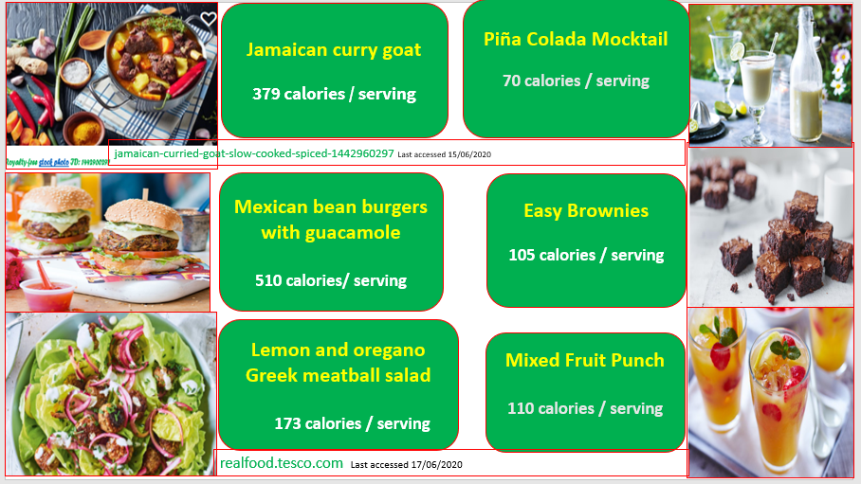

These recipes are excellent vegetarian alternatives and lower calorie well known traditional meat dishes, which will have a vegetarian option. Eating is one of the many great pleasures in life is enjoying your food and eating what’s good for you in moderation.
Packaging
The business will buy eco-friendly products from online vendors such as bidfood.com, eBay and amazon, as it is fast, simple, affordable and delivered next day on many items such as Candy striped paper bag pk 100 for £3 so I can get 500 for under £10 on amazon, free next day delivery.
Equipment
I will be buying quality, second-hand cooking equipment from places such as gumtree, eBay etc. I ill also join online group/s of people who are also in the trade such as a big pot for the vegetable sauces, which will be separated from the meat pot, there will also be 3 large woks, so to prevent cross-contamination of meat and veg products, most the dishes will be fast healthy food, on the go, that will be one of my unique selling points. I have a pizza oven, donated by friend, tarpaulin for coverage and a white one that will have the logo and tagline on it. I will learn to cook using a drum, as jerk chicken is going to be a recurring dish and its healthier version.

Price
I will be doing a quick research checking on competitors prices to set a comparable pricing structure and offer something extra like a free dessert/snack or drink, I can afford to pass on these savings and offer customers extra because of the offsetting of growing significant quantities of raw materials myself. That offers opportunity to increase market penetration by strategic pricing, and giving people quality of products and price.
Financial Resources
The business finance will be obtained from; wages, savings, I have an excellent recommendation for a guy that loves finding funding for people and he can be contacted at 216 High St Swansea. That will be the first place I will go find help with other funding organisations for small business such as startupdonut, startuploans, where they offer mentorship, insurance help and business advice to get a government grant for small business. Investors will be family, friends, crowdfunding, anywhere that will help me with minimal conditions and I will continue to work, as much as possible at ORS, to cover normal living expenses and put regular income into the business to help with the fixed costs such as rent and logistics.

Place
It’s going to be a food stall business. It will be in Swansea and outlying areas at first, sites with over 15 possible customers, as a secondary site, based on experience of family, who have worked a food truck they averaged 20 people a day at one building site, so I will be looking to get a stall in a city with a population of around 20,000 and growing with a thriving centre market with rental that’s affordable, good foot traffic and transport links for breakfast, lunch and hopefully into the evening as that would maximise the opportunity to reach a wider audience. The business will primarily be in a stable location but will look to investing into festivals/events, a target of 2 minimum in the first year adding to target each year, depending on cashflow.
Festivals are big business and can be a huge layout for mid to large festivals the figures are into the thousands. An example, an ice cream van business paid £11000 for a full stay pitch for Glastonbury, however weather was good in Summer 2019, and they made over £60,000. So that is a target for the business after a few years saving towards experiencing that level of business in the industry and Glastonbury.
Promotion
Company logo
Designed by a friend/work colleague that does logos and he’s a chef he will/is a source of great help.
The business will use varying promotional activities demonstrating the balance of its marketing mix to increase customer loyalty I will continually improve brand image through lifestyle, processes and as its key communicate that quality and value message to customers. The promotions helps to: Further coverage was gained through targeting key media at specific times with seasonal promotional message, increase demand for products of the healthy alternative choices on the go advertising aimed at a mass audience, highlight the convenience of having the calorie count available so speed of service trust in the health quality of our products and services. These include the media such as Facebook, LinkedIn, targeted e-mails to customers, 3rd party endorsement and awards local app for finding food vendors, that reach increase awareness and improve brand recognition a large a much larger audience than the regular leafleting, word of mouth and face to face free taster sessions I will conduct in situ. Paying for costly advertising in newspapers and on television has quickly become a defunct practice as there are free apps that people can download to their smartphones advertising the same information and with the added caveat of maps with directions and reviews. I will focus on a particular well sold/known dishes show our healthier option alongside or top and bottom on poster to illustrate the same look but less calories with the numbers clearly displayed with added information on how much weight that equates to in lbs in body fat or cholesterol displayed using humour which helps to build trust and an emotional connection with target audiences.
My target audience are people that use technology daily in their lives and over 85% percent positive response to the follow the business blog and to see if I could build loyalty of brand the going to festival/event would they come and share the experience with us others were quite a few maybes, you can build a relationship with continuity and social media is a very affordable, easy way to do that nowadays. Technologies popularity and uses are growing whether by personal choice or as part of the equipment used for work or study, everyone that has an internet connection or a public place that does for free can see my promotions and adverts 24/7, with quality pictures, up to date news and reviews.

People
Human Resources
I will be the front – line person, the organisation’s customers service is quality with a smile.
I will be advised and will do my own research into correct practices, policies in the workplace from ACAS and experienced network as the business develops.
SWOT Analysis of J’samo Greens
STRENGHTS | WEAKNESSESS
Innovative, building a solid network of more experienced people and the benefits thereof  Self-sustainable ethics and practices will keep running costs to minimum and build a trusted fun brand | Continual health problems of owner  Lack of finances  Lack of knowledge/skills/experience
OPPORTUITIES | THREATS
To grow into a holistic business model  To gain more growing spaces from neighbour’s gardens  To gain more market share while travelling | No funding found  Political environment in UK and world  Socio-economic uncertainty in macro environment

I have basic qualifications/skills or experience, I have family and friends who have years of experience running their own food truck/pitch and friends will help with working pith and with sourcing products, equipment, financial help and word of mouth recommendations on advice on legislation. I will need logistical help someone, who’s self-employ with a van, or rent a van and hire a driver. This was a very important question on the questionnaire as it shows potential sub-contractors that there’s plenty of interest in the extra service offered by the company, showing that there would be a market for the business to grow and that the owner is always conducting market research for opportunities to develop and expand.
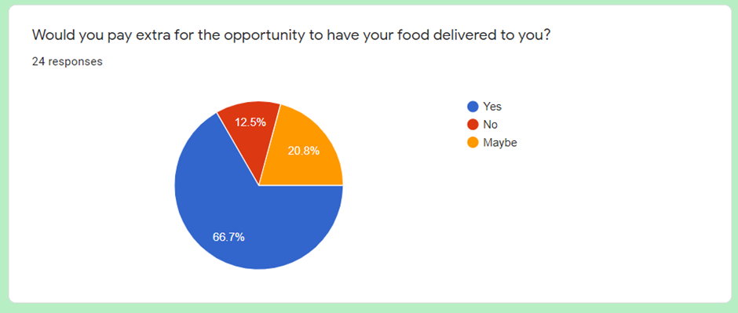

Process
The business will start from a food stall and all the cooking will be done on site as preparing cooked food from home would require more regulations than getting a licence for selling street food and the whole business goal is to be able to set up quickly, build up a pitch and be able to employ someone full time so the business can expand and become the main source of income for the sole owner namely myself, until I pass it on to the children or sell that branch off if I want to diversify and try to get more festivals. I will start with a menu that has popular fast foods wraps, pizza, burgers, pasta, salads as well as hot one pot style dishes like paella, variations of the stew and stir fries. The menu will also contain drinks that will mainly be purchased, as well as seasonings, snacks and flavourings.
the target of 50 people a day averaging £5 a head, with expenditures costing only £2 per head at the start.
The business is not going to market until all equipment needed for at least 4 different cooking styles for hot food is secure and tested. It is a basic set up around using very little to maximum effect and any other equipment will be purchased when needed and finances are available to buy second hand or rent, like a generator for running a freezer in Summer and equipment to chop up fruits in high volume for consistency and speed. Comfort will be a selling point as I will use every inch and next doors stall to provide coverage and seating/lean bar, if the dimensions of location allows, all helps to limit waste and keep costs down, by being able to give customers a good experience in all weathers and myself. Whatever the local councils and or private landowners will allow/negotiate.
Physical Evidence That will develop with process, location, covering and trends focusing on providing quality products that are cheaper and healthier alternatives to famous street food, thereby improving my marketing mix by connecting the marketing function much closer to both human resource management and operations.

Conclusion
I will take all the positive information and feedback and continue with my personal and educational development if possible, as key to the long-term success of what looks like it could be very profitable fun business that aims to be of benefit all around. As stated in skills for the workplace (pg392) that clear communication is essential in business and that’s something I am working on as it will cut time and save money. I will continue to experiment with the process and build a network of mentors/knowledgeable, experienced family/friends so when I am near ready for market, I will register the business and apply for my licence, while waiting use the time to scout for a pitch/stall. I will follow chefs that I like Ainsley Harriet and others books I bought to use as well as experienced growers like Charles Dowding as he and others are growing by the no dig method, which is part of the ethos of J’samo Greens.

References
amazon.co.uk
bidfood.co.uk
henryfaulkner Designing stuff for over 15 years 5.0 (26 reviews)
dicemechanicgames.co.uk
fiverr.com/henryfaulkner
Covey, S. (2005). The 7 Habits of Highly Effective People. London, Simon & Schuster
ebay.co.uk
ganttexcel.com
docs.google.com/forms
Maud. A et,al. 2017. Certificate in Higher Learning: Skills for the Workplace Student Yearbook London, Sage.
Morgan, P. 2017. The Business Student's Guide to Study and Employability, London, Sage
mindtools.com 2019 last accessed 20/03/2020.
ncasstraining.co.uk/food-hygiene-courses
ocw.unican.es/pluginfile.php/491/course/section/504/case_study_3-1.pdf
Sinek. S. 2019, Trusting Teams | THE 5 PRACTICES Youtube.com last accessed 03/20/2020
startupdonut.co.uk
startuploans.co.uk/business-advice/get-small-business-government-grant
tutor2u.net/business/reference/the-extended-marketing-mix-7ps

Appendices

Business Logo Design variations
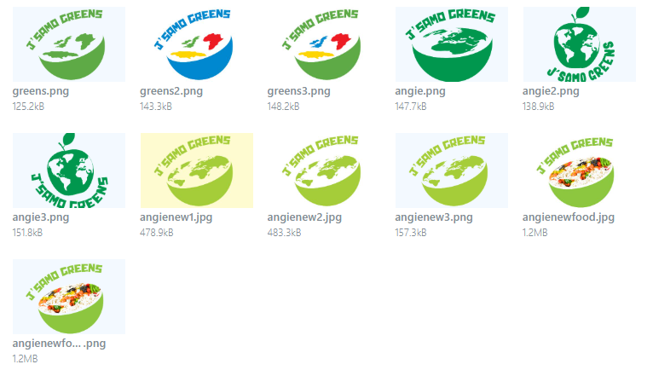

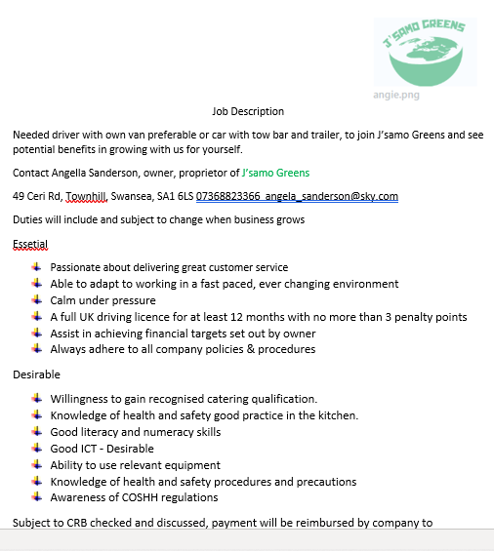

1 Year Financial forecast for J’samo Greens

