Module Code: LCHS4007
Module Title: Digital Skills and Research Methods
Assignment Tittle: Component 2-Research Report
Lecturer’s Name: Anika Tahsin Ahmed
Name: Maria Ajadalu
ID: 2506380

Content page

Introduction...........................................................3
Research Topic Identification.................................3
Research Methodologies........................................6
Data Collection......................................................7
Conclusion............................................................8
Reference..............................................................9

Title: Alzheimer’s Disease in Men in the United Kingdom: Effects and Symptoms

Introduction
This report explores the growing issue of Alzheimer’s disease among men in the United Kingdom, focusing on its impact on individuals, families, and healthcare services. Alzheimer’s is a progressive brain disorder that affects memory, thinking, and behaviour (NHS, 2024). Although it is more commonly diagnosed in women, the number of men affected has been steadily increasing in the United Kingdom (Alzheimer’s Society, 2023). Research says that men often experience faster cognitive decline once diagnosed, which increases the need for specialist support (Leroi et al, 2022). This report aims to identify why Alzheimer’s disease is a concern for men, analyse key research sources, and discuss suitable research methodologies and data collection methods. The purpose is to highlight the need for improved awareness, early diagnosis, and targeted interventions for men affected by Alzheimer’s (Public Health England, 2023).

Research Topic Identification

1.1 Identifying the Problem
Alzheimer’s disease is one of the leading causes of disability and dependency among older adults worldwide. In the UK, it is estimated that around 1 million people will be living with dementia by 2030, with Alzheimer’s accounting for about 60–70% of these cases (Alzheimer’s Society, 2023). While women make up the majority of those affected, studies show that men experience faster cognitive decline once diagnosed and often receive less emotional and social support (NHS, 2024). This inequality in care and understanding makes Alzheimer’s in men a significant public health issue. Figure1: Showed the estimated proportion of Dementia cases in the United Kingdom by type.

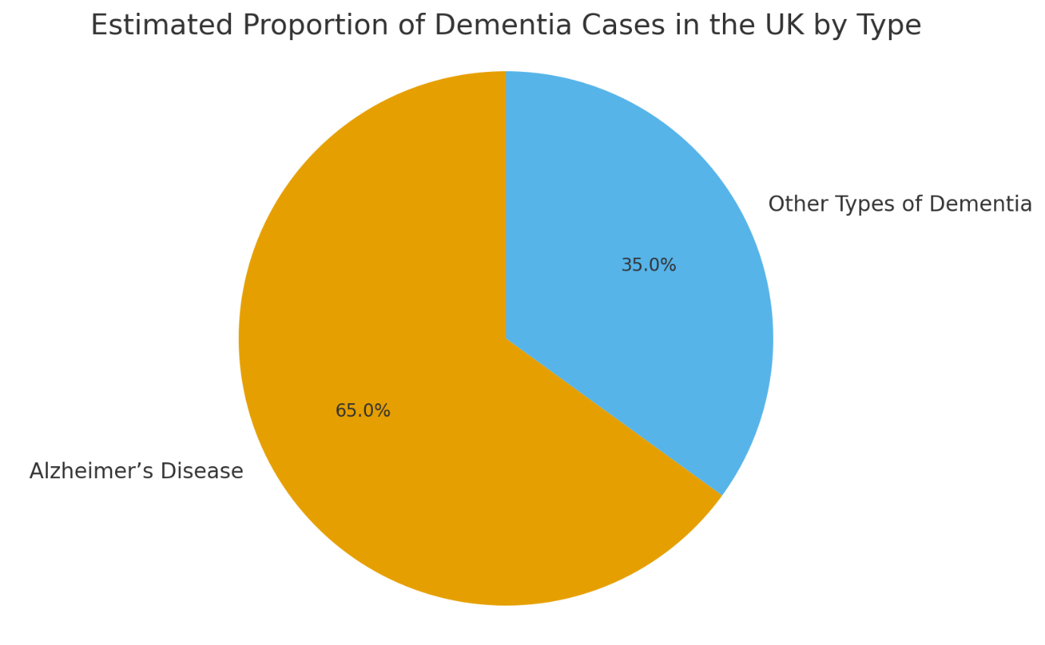
Fig 1

1.2 Reviewing the Literature
Research shows that men with Alzheimer’s are less likely to seek early diagnosis and more likely to manifest aggressive or withdrawn behaviour, which can make their symptoms difficult to manage (Leroi et al, 2022). The stigma surrounding memory loss and masculinity often prevents men from discussing their symptoms or accepting help. Furthermore, lifestyle factors such as higher alcohol use, cardiovascular disease, and smoking rates among men increase their risk of developing dementia later in life (Public Health England, 2023).
Existing literature also analyses the emotional and financial burden that Alzheimer’s places on families, particularly on female caregivers who support male relatives. The condition leads to a decline in independence, requiring increasing levels of care that strain NHS and social care services. The National Institute for Health and Care Excellence recommends early intervention and tailored care plans for men, but many remain undiagnosed until the disease is advanced (NICE, 2023).

1.3 Refining the Research Topic, Aims and Objectives
Research Aims:
To investigate the impact of Alzheimer’s disease on men in the UK.
To examine how healthcare services can better support early diagnosis and care.
Research Objectives:
- To identify the factors contributing to Alzheimer’s among men.
- To examine in detail the challenges men, face in accessing diagnosis and support.
- To suggest strategies for improving awareness, prevention, and care provision for men living with Alzheimer’s disease.

1.4 Choosing Three Supporting Sources
- Alzheimer’s Society (2023) – “Facts and Figures about Dementia in the UK”
This source provides up-to-date statistics on dementia prevalence, gender differences, and the projected rise of cases in the UK. It supports the report by providing reliable national data and identifying gaps in care for men. I chose this source because it is official, evidence-based, and directly relevant to UK healthcare planning.
- Leroi, I. et al. (2022) – “Gender Differences in the Progression of Alzheimer’s Disease: UK Cohort Study.”
This academic article explores how Alzheimer’s develops differently in men and women. It highlights that men tend to deteriorate faster and respond differently to medication. This source is useful because it adds scientific insight into biological and social differences, helping justify the need for gender-specific interventions.
- Public Health England (2023) – Dementia: “Risk Reduction and Early Diagnosis.”
This report discusses preventive strategies and early detection policies within UK public health services. It supports the argument that men often underuse health checks and memory clinics. The source was chosen for its, showing how national strategies could be improved to reach male populations more effectively.

1.5 Justification for Research
Alzheimer’s in men deserves focused research because it has been underrepresented in public discussions and policy approach. Men face unique challenges, such as reluctance to discuss health problems, higher risk factors, and limited emotional support. Understanding these barriers can help healthcare professionals design gender-sensitive interventions that promote early diagnosis and improve long-term care outcomes. In addition, the findings could guide NHS and local authorities in developing targeted awareness campaigns to encourage men to seek help sooner.
Therefore, researching Alzheimer’s in men not only supports individual well-being but also helps reduce pressure on families, health and social care system.

Research Methodologies:

2.1 Overview of Research Approaches
Research in health and social care can use quantitative, qualitative, or mixed methods approaches.
- Quantitative research focuses on collecting numerical data, such as statistics on prevalence, age, or treatment outcomes. It allows for measurable comparisons and generalisation of findings (Creswell, 2021).
- Qualitative research, on the other hand, explores experiences, feelings, and perceptions through interviews or observations. It helps understand the human side of a health issue.
- Mixed-methods research combines both approaches to provide a broader understanding of the topic.

2.2 Chosen Methodology and Justification
For this case, a qualitative research approach is most suitable. Alzheimer’s disease involves complex emotional and social challenges that cannot be fully understood through statistics alone. A qualitative approach allows investigation of how men experience memory loss, how it affects their identity, and how they access support.
Interviews or focus groups with male patients, caregivers, and healthcare professionals could provide rich insights into barriers and coping mechanisms. This method also aligns with ethical principles in health and social care, ensuring that participants’ voices are heard respectfully. Qualitative research thus offers insight and perspective, which are essential when addressing sensitive topics like Alzheimer in men.

Data Collection:

3.1 Overview of Primary and Secondary Data
Primary data refers to new information collected directly from participants, such as interviews, questionnaires, or observations (Silverman, 2020). It provides first-hand insights but can be time-consuming to gather.
Secondary data involves analysing existing sources like reports, journals, or statistics that others have already collected. It is useful for understanding wider patterns and trends.

3.2 Chosen Data Type and Justification
This research will primarily use secondary data. Since Alzheimer’s in men has already been studied by organisations such as the NHS, Alzheimer’s Society, and Public Health England, existing data provides a reliable foundation for analysis. Secondary sources allow examination of national trends, health inequalities, and care outcomes without requiring direct patient involvement, which can be ethically sensitive for people with cognitive decline.
In addition, secondary data is cost-effective and time-efficient, making it suitable for a 1,500-words academic report. Reviewing research articles, government statistics, and healthcare policies enables a comprehensive understanding of the issue. However, to enhance this, limited primary data such as interviews with healthcare staff could be considered in future research.
Using secondary data supports a qualitative approach by allowing the researcher to interpret existing findings through a gendered lens, helping highlight patterns that are often overlooked in general dementia research.

Conclusion

Alzheimer’s disease in men is a growing concern in the UK health and social care system. This report has identified that men often experience faster cognitive decline, face unique social challenges, and are less likely to access early support. By reviewing credible sources, the report has justified the importance of studying this underrepresented issue. A qualitative methodology supported by secondary data provides an ethical and practical way to explore men’s experiences and identify service gaps.
Overall, understanding Alzheimer’s in men is crucial for designing inclusive public health strategies, promoting early diagnosis, and supporting both patients and caregivers. Addressing this issue will contribute to more equitable and person-centred care across the United Kingdom.

References
Alzheimer’s Society (2023) Facts and Figures about Dementia in the UK. Available at: https://www.alzheimers.org.uk (Accessed: 5 November 2025).
Creswell, J.W. (2021) Research Design: Qualitative, Quantitative, and Mixed Methods Approaches. 5th ed. London: SAGE Publications.
Leroi, I., Ahmed, S. and Burns, A. (2022) ‘Gender differences in the progression of Alzheimer’s disease: UK cohort study’, Journal of Geriatric Psychiatry and Neurology, 35(6), pp. 456–465.
NHS (2024) Alzheimer’s Disease Overview. Available at: https://www.nhs.uk/conditions/alzheimers-disease/ (Accessed: 29 October 2025).
NICE (2023) Dementia: Assessment, Management and Support. London: National Institute for Health and Care Excellence.
Public Health England (2023) Dementia: Risk Reduction and Early Diagnosis. London: Department of Health and Social Care.

