University of Wales Trinity Saint David School of Engineering

Engine Cycle Investigation and Simulation
Lee Stewart 1700860
Motorcycle Engineering

14/12/2018
Motorcycle Technology
M4X00392



Contents
Introduction 3
Ford Sigma 1.6 “LUCID” Data Analysis 4
Engine simulation model 15
Validation of engine model 18
Limitations with the engine simulation model 21
Conclusion 22
References 23

Introduction
This report will provide the reader with an in-depth analysis of the four-stroke petrol engine cycle, demonstrating a detailed examination of the in-cylinder parameters using data gathered from Ford motor company’s engine analysis software “LUCID.” To analyse this data correctly graphs will be created from the data, meticulously studied and the results explained. This system will be repeated for each stage of the four-stroke cycle “induction, compression, power and exhaust.” This will give a comprehensive understanding of how the four-stroke petrol engine works and how these characteristics are reflected in the overall vehicles’ performance.
As well as this, to gain a further understanding of the thermodynamic process the engine experiences during its function, an engine simulation model will be created using Microsoft excel. To successfully do this, equations relating to the geometry and the processes of an engine must be entered. This will show a complete understanding of all the processes and physics involved in the engine cycle. To ensure this is done correctly the simulation model will be validated using the parameters gathered from the LUCID data. From here, any discrepancies and limitations of the simulation model can be analysed and understood.

Ford Sigma 1.6 “LUCID” Data Analysis

The first graph generated for analysis is the piston position in regards to the crank angle. This will produce the same trace no matter the RPM as the conrod length and the crank radius are fixed values meaning the piston will always be in the same position when the crank shaft is at the corresponding position.
The piston linear position can be found implementing the following equation:
$$S=a+l-\cos\left(∅\right)-lcos(\sin^{-1}(\frac{a}{l}\sin\left(∅\right))$$
Where; a = crank radius
l = conrod length
$∅$ = crank angle
As shown, the piston is at top dead centre at 180° and 540°. This means, the piston is at the top of its stroke at these corresponding crank angles, leaving only the clearance volume also known as the combustion chamber within the cylinder. Also shown, is the piston at bottom dead centre at 0°, 360° and 720°. This is when the piston is at the bottom of its stroke leaving the total volume in the cylinder.
$$Total Volume=Swept volume+clearence volume.$$
To calculate the clearance volume the following equation can be used;
$$Vc=\frac{Vs}{Cr-1}$$
Where; Vc = Clearance volume
Vs = swept volume (swept volume is the volume in the cylinder that the piston moves through)

Below is a graph generated to find where the piston is moving at its fastest within the cylinder. Piston velocity against crank angle. It is as follows;
from this, it is clear that the piston is moving at its fastest when the crank angle is at multiples of 90˚. This can seem surprising as it is commonly assumed the piston is moving at its fastest just after the explosion takes place on the power stroke. The reason for this is simply geometrical because as the crank shaft is at 90˚ the conrod attached to the crank shaft will be slightly changing its direction of rotation and carrying its stored momentum.
This is also shown on the graph below, it can also be seen the piston is at its fastest when its nearing the top or bottom of its stroke.
overlapping graph plots for piston position and piston acceleration clearly show that the piston reaches its greatest acceleration values at top and bottom dead centre. This acceleration rate is more visible when the piston is at top dead centre. This is because of the ignition process accelerating the piston back down the bore.
This graph shows the difference in piston velocities in different RPM ranges. As shown the velocities increase with the RPM, this is due to the crankshaft spinning faster and in turn increasing the velocity of the piston.
The next graph generated for analysis is the cylinder pressures at specific crank shaft angles. To ensure an accurate analysis the trace was produced over 3 different rev ranges. 3000 RPM, 5000 RPM and 6500 RPM.

As shown, the pressure increases as the piston moves up the cylinder and decreases the volume. It is also shown that the pressures start to increase at a much greater rate at around the -25° of crank angle mark. This is due to the combustion process. Once the explosion takes place within the cylinder the pressure increases at such a rate because of the heat energy being released and the expansion of the burnt gasses. As you can see from the graph even after the piston begins to move back down the cylinder the pressure is still increasing due to the burn still taking place. Once the burn start to subside and all the mass within the cylinder has been burnt, the pressures then decrease as the piston moves down its stroke.
Although the difference is slight it can be seen that the average cylinder pressures increase when the RPM increases. This is because the air/fuel mixture is being compressed faster, releasing more energy.

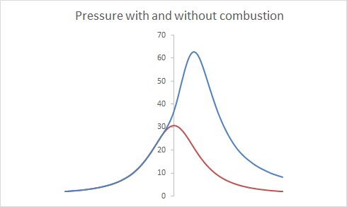
Shown below is cylinder pressures with and without combustion;
This graph shows that if the combustion process was not to take place, the pressure values would be much lower. As well as this it clearly shows that the pressure would start to decrease as soon as the piston starts to move down the cylinder increasing the volume. This is because of the heat energy not being released and the no expansion of the gasses in the cylinder due to the burn.

Another graph generated for analysis is the pressure volume diagram. This diagram shows the pressures in the cylinder at different cylinder volumes as the piston moves through the four-stroke cycle.

From this graph each stage of the four-stroke cycle can be seen. The chosen starting point for analysis is the intake stroke. This can be seen at the bottom of the graph where the pressure is low and the volume is increasing. This stage of the engines cycle is where the intake valve will be open and the piston is moving down the cylinder drawing in an air/fuel mixture. From here, the compression stroke can be seen. This is shown by the cylinder volume decreasing and the pressure is increasing. At this stage, the intake and exhaust valves will be closed and the piston will be moving its way up its stroke. The next stage of the engines cycle is the power stroke. This can be seen when the volume is reaching its smallest values and the pressure increases significantly because of the explosion that has just took place within the cylinder, forcing a flame front onto a still rising piston. Once the piston reaches the top of its stroke, it is forced back down the cylinder by the flame front and the expanding gasses due to the explosion. The next and final part of the engines cycle is the exhaust stroke. This is when the exhaust valve opens and the piston moves back up the cylinder, forcing the waste products and gasses out of the cylinder, down the exhaust and into the atmosphere.
Below is a graph detailing the perfect Otto cycle;
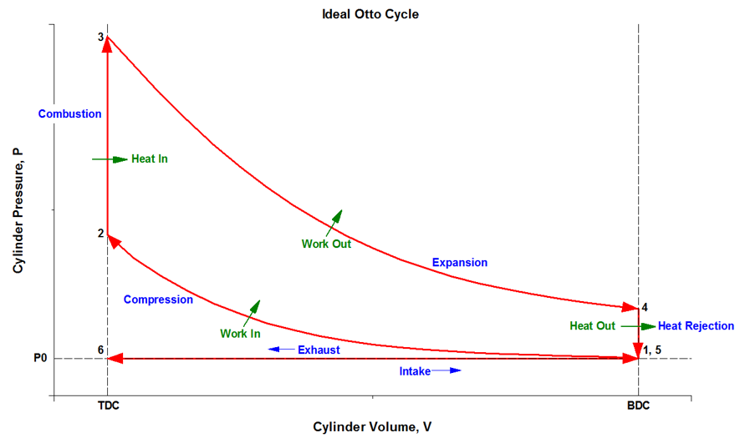
Although the perfect Otto cycle produces a similar trace to the one created from the LUCID Ford Sigma data there is a few fundamental and important differences. The most significant and noticeable difference is that when ignition takes place during the Otto cycle the explosion happens instantly releasing all of its energy immediately, when in fact this is a more gradual process. This is shown on the PV diagram produced from the LUCID data. As well as this, the expulsion of the waste gasses happens instantaneously and this like the burn process is more gradual. (Hall, 2015)

Although the pressure graphs shown previously give the viewer a approximate idea of when the spark plug ignites the air/fuel mixture, a rate of change of pressure against the crank shaft angle graph can be created to give a far more accurate depiction of this.
An example of this is as follows;
A close-up version of this graph was also created;

From this graph it is clear that combustion starts at around -28° of crank angle. From this the spark plug ignition timing can be found. In a typical four stroke engine the spark plug ignites 5-8 degrees before the burn starts. Meaning the ignition timing for this engine is between 20 and 23 degrees before top dead centre. The ignition timing alters with the RPM being used (the higher the RPM, the further away the piston is from top dead centre when the spark plug ignites.) this is to ensure the burn of the air mixture occurs at the correct time. At higher RPM the piston has a higher velocity, this means it will reach the point where the explosion should occur. Because of this, the spark plug fires earlier to initiate the burn faster.
As well as the engine pressures, from the information provided in the LUCID data the polytropic index of the engine can be determined. The polytropic index once known, allows the thermodynamic process to which the system adheres to be determined. The four thermodynamic processes that can occur are known as; an isothermal process, which is when a change in the system occurs but temperature remains at a constant. An isobaric process, this is the process where the pressure remains constant when heat is put into the system. An isochoric process where the volume remains constant. Or an adiabatic process which is the process where no heat transfer takes place and energy is only transferred to the surrounding through work. (Wood, 2019)
The graphs help calculate the polytropic index are as follows;
From this graph to work out the polytropic index, attention must be paid to the average values when the valves are closed and ignoring the large spikes in the data when the combustion process is occurring. From this graph the value calculated for the polytropic index is 1.3
The polytropic index is calculated by using the following equation;
$PV^{n}=C$
Where; P = Pressure, V = Volume, C = constant an n = The Polytropic index
This graph shows the log of pressure against the log of volume. Once plot on to a graph this information produces a gradient which is equal to the value of the polytropic index. The results from this graph also shows the polytropic index to be 1.3
It is clear from these two graph plots that the polytropic index for this specific engine is 1.3 This shows that the system is between an isothermal and an adiabatic process. This means that the process happens at a speed which heat transfer can take place but is also limited due to the process happening at such a high velocity. The majority of the heat energy created is from the ignition of the air/fuel mixture.

Another graph was then created to analyse the mass fraction burn within the cylinder. The mass fraction burn is the mass of the air/fuel mixture burnt including the rate of the burn. the mass fraction burnt is measured as a percentage of total mass burnt against a corresponding crank angle. (Mittal, 2009)
The plot generated is as follows;
This shows that the burn process starts at 8 degrees before top dead centre and finishes at 40 degrees after top dead centre, meaning the total burn lasts 48 degrees of crank shaft rotation. Calculating the mass fraction burn becomes of significant importance when trying to create an engine simulation model. This will be covered in further detail further on in this report.

A graph for cylinder temperatures against crank angle was created, it is as follows;
As shown the temperatures steadily increase as the piston moves up the cylinder. From here it is clear to see where the combustion process takes place as the temperatures dramatically increase to around 2600 Kelvin in around 60 degrees of crankshaft rotation. The temperatures then progressively decrease as the piston moves down the bore.

A graph depicting the work done was created and it clearly show as the piston moves up the cylinder negative work is being done. This is in fact the case as the work is being done by the system. This is the case until the piston reaches top dead centre and begins to work its way down the cylinder. The value then peaks as the combustion of the air fuel mixture forces the piston back down, meaning work has now been done on the system.

Engine simulation model
To create a valid engine simulation model the cylinder volumes with their corresponding crank shaft angles must be calculated. To do this the following equation can be used;$$S=a+l-\cos\left(∅\right)-lcos(\sin^{-1}(\frac{a}{l}\sin\left(∅\right))$$
Where; a = crank radius
l = conrod length
$∅$ = crank angle
This will calculate the pistons linear position within the cylinder at its related crank angle. From this the cylinder volumes at each stage of crank shaft movement is then calculated by using the subsequent equation;
$$Volume=Vc+\left(\frac{π × {Bore}^{2}}{4}\right)×s$$
Where; Vc = Clearance volume
S = Piston linear position

Once the volumes are calculated the next step is to get the non-combustion pressures. This can be achieved by implementing the following equation;
$$P2=P1×{(\frac{V1}{V2})}^{n}$$
Where; P1 = Pressure 1
V1 = volume 1
V2 = Volume 2
n = The polytropic index
to be able to achieve the pressures including the combustion process the mass fraction burn rate and the heat energy released must first be calculated. To do this the following equations must be be implemented. Firstly, the mass fraction burn equation;
$$MFB=1-e^{-a}{(\frac{∅-∅_{0}}{∆∅})}^{m+1}$$
Where; a = constant
m = constant
$∅$ = crank angle
$∅_{0}$ = crank angle at start of combustion
$∆∅$ = change in crank angle
To find the a and m constants known as the Wiebe function constants the curve fitting tool on MATLAB can be used. To do this, data detailing the percentage of fuel and air burnt at different crank angles must be extracted from the original Ford LUCID data. From this, a graph plotting this function can be created. The data is then transferred into MATLAB and curve fitting tool opened the custom MFB equation with the specific start and finish points of combustion is then entered. The Wiebe function unknows are then projected on the screen. A print screen showing this is as follows;
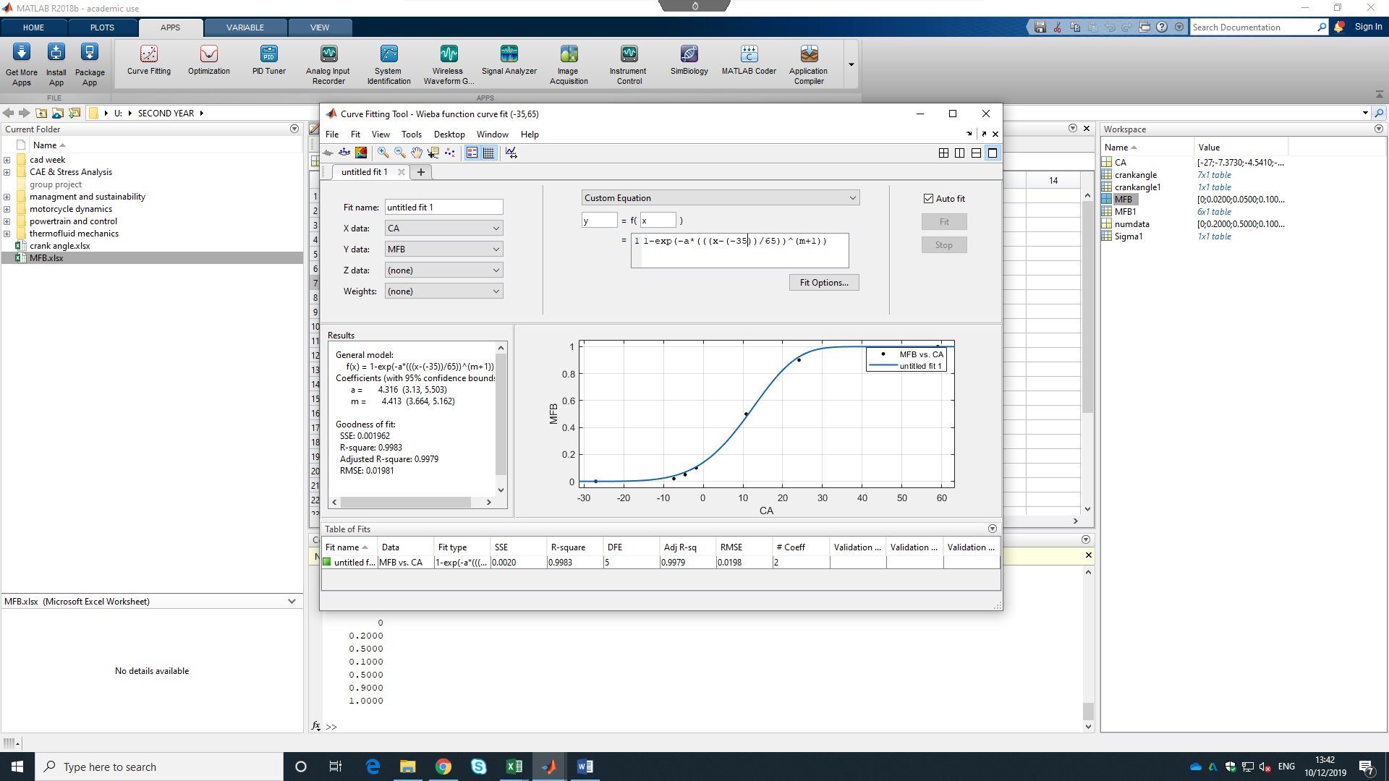
(please zoom to 200% to view)
Once this information has been gathered the heat released or dqr can be calculated using the subsequent equation;
$$dqr=mass of{air}/{fuel}mixture×calorific value of the fuel×combustion efficiency$$

The next stage is to calculate the pressures including the combustion process. The following revised pressure equation should be used;
$$P2=P1×({\frac{V1}{V2})}^{n}+\frac{dqr(γ-1)}{V2}$$
Where $γ$ = Ratio of specific heats

The next stage of created an engine simulation model is to calculate the temperatures within the cylinder. The equation to achieve this, the equation is as follows;
$$T=\frac{PV}{(mass of fuel+mass of air)×R}$$
Where R = the gas constant
Once the temperatures have been calculated the final stage of the engine model is to calculate the work done per degree and then the total work done by the system. To calculate this, the equation is as follows;
$$Work Done per degree=Pressure×Change is volume$$

Validation of engine model
To validate the engine model graphs can be made and placed along side the ones created from the actual engine analysis data to see if there is any variation in the plots.
The graphs created to do this are as follows;

As shown, the pressures within the cylinder match the same trendline as the one created from the engine model but the values are slightly different. The ones created from the engine simulation model seem to have a higher peak, meaning a higher pressure has been calculated.

The temperature trace created from the engine simulation model is completely wrong meaning that the simulation model could not be validated and something within the simulation is incorrect. The temperature trace created from the LUCID data is as follows;
As shown the plots created are vastly different. The main noticeable difference is that the temperature rises and does not come back down when the volume in the cylinder increases. This is obviously incorrect.

similar to the pressure traces, the work done trace generated follows the same trend as the one created from the lucid data but the values are significantly different. The work done graph made from the LUCID data has work done values at over double the values calculated from the simulation model. This is shown below;

Again, this is obviously incorrect meaning that the simulation can not be validated for work done.

Limitations with the engine simulation model
The limitations with the engine simulation other than the mistakes generated by the model which I designed are as follow;
- The mass fraction burn rate must be known, otherwise the pressures including combustion can’t be calculated. There will be no other way to calculate the heat energy released from the fuel and air.
- Real pressure data must be used and this information is not readily available. If the data is incorrect the whole simulation is incorrect.
- The Wiebe function unknowns can not be calculated without given data from a previous simulation.
- Many assumptions had to be made to create the model. Such as the combustion efficiency, lambda value and the polytropic index.

Conclusion
To conclude, a comprehensive analysis of a Ford Sigma 1.6 engines characteristics was undertaken. To accomplish this, graphs were creating using Microsoft excel to show in detail what is going on within the cylinder. It was found that the temperatures increase with the pressure as the volume decreases and the combustion process plays a significant part of the movements within the engine.
As well as this, an engine simulation model was created to further validate the results gathered from the LUCID data. Unfortunately, this model could not be validated as although, some of the values within the simulation are correct there is some fundamental and significant differences between the two data sets. This is likely due to mistakes being made as the simulation was generated.

References
Hall, N. (2015, May 5th). Ideal Otto cycle. Retrieved from nasa.gov: https://www.grc.nasa.gov/www/k-12/airplane/otto.html
Mittal, M. (2009, March 1st). Fast mass-fraction-burned calculation using the net pressure method for real-time applications. 3-6.
Wood, D. (2019). Thermodynamic processes. Retrieved from www.study.com: https://study.com/academy/lesson/thermodynamic-processes-isobaric-isochoric-isothermal-adiabatic.html

