

Write a report of 2,000 words which evaluates the effectiveness of the use of modern technologies within the workplace and explore social media as a tool for marketing, information gathering and communication within the workplace, creating their own professional online presence to illustrate and evidence this research.

Student Name: | Wafa Wajeeh Mustafa Nasser
Student Number: | 1703942
Module No: | BMSK4003
Module Title: | Digital Skills and Research Methods
Module Leader Name: | Renuga Jayakumar
Word Count: | 2,225 (including headings and links)

Content

Introduction………………………………………………………………………………………………………p.2
Digital devices……………………………………………………………………………………………………p.3
Web-conferencing…………………….………………………………………………………………………p.6
Facebook for Business………………………………………………………………………………………p.9
Twitter……………………………………..…………………………………………………………………..…p.11
LinkedIn……………………………...………………………………………………………………………….p.12
Conclusion………………………………………………………………………………………………….……p.14
References…………………………………………………………………………………………..………….p.15

Introduction
As digital technology continues to improve in current society, so does the importance of acquiring the skills of digital handling and technology literacy. It is clear that society is nearing in becoming a paperless one as digitalization becomes more prominent in the workplace (Hoechsmann and Poyntz, 2012). Therefore, it is very important that candidates know how to use digital technology. This report will express this notion by exploring the use of digital devices, web-conferencing and different social media profiles to improve workplace efficiency and employability skills. To achieve this, Section 1 will explore the suitability of the IPhone X and Samsung Galaxy Tab S3 as appropriate technology in the workplace. Then, the section will explore the effectiveness of Skype for Business and Google Hangouts Meet in the workplace. Following this, Section 2 will explore Facebook for Business, Twitter and LinkedIn. The report will conclude with a summary of the main points.

Smart Devices
In recent times, Samsung and Apple have monopolised the digital markets (Perez, 2017). This section will explore the similarities and differences the IPhone X and the Samsung Galaxy Tab S3 (SGTS3) and how they can be used in the workplace.

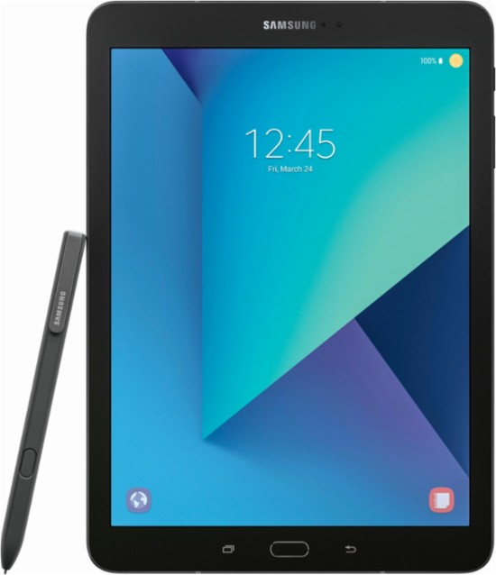
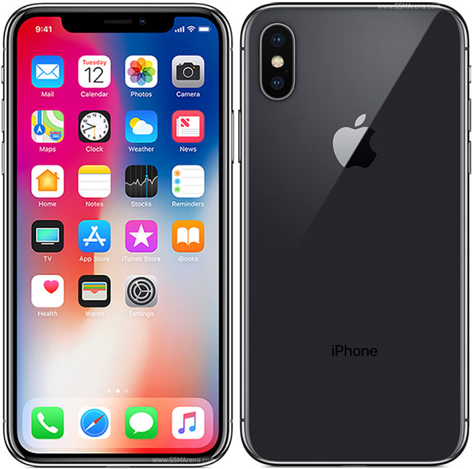

IPhone X | Samsung Galaxy Tab S3
- 5.8-inch display  - Up to 256GB internal storage  - Face recognition  - iCloud storage  - Multi-tasking window  - App store  - Super Retina HD display  - 12MP camera and portrait lighting  - Face ID  - Siri  - Fast charge: full charge in one hour  - Battery life: lasts up to 21 hours  - Support for multiple languages  - (Apple, 2018). | - 9.7-inch display  - 32GB internal storage. SD slot available, up to 256GB  - Samsung Cloud storage  - Multi-tasking window  - Play store  - AMOLED, HDR display  - 13MP camera  - 165 minutes for full charge  - Battery life: up to 12 hours  - Wi-Fi or 4G network  - Support for multiple languages  - (Samsung, 2018).

Both devices allow users to use communicate electronically through emails and video calling. As the iPhone X runs on a network sim, it also allows users to carry out phone calls (both video and voice) whereas the SGTS3 does not. This is important in the workplace as face-to-face interactions may disrupt business hours so these features make it possible to exchange messages without actually meeting. Also, the different dimensions have different benefits. As the iPhone X is smaller, it is more portable. As for the SGTS3, the larger screen makes it more ideal for typing; however, this does make it less portable than the iPhone X. In addition, both devices have App stores that allows users to download applications and software to their devices. Apps such as EverNote, Microsoft Word and Skype further enhance these devices by allowing users to carry out tasks such as creating documents or video-calling other users in the workplace.
A major benefit of these digital devices is that it makes communication easier. The process of sending emails and carrying out phone calls makes communication between users faster and more efficient. This allows the exchange between members who are not physically present. In addition, both devices have multilingual capacities; both devices have translating features and have keyboard options for multiple languages. This helps communication as businesses may have a foreign client or work with people who do not speak English that well. Therefore, these features help communicate in different languages.
Furthermore, both devices allow users to open multiple windows at the same time. This allows users to work on two things simultaneously. This improves workplace efficiency as it increases productivity and complete tasks faster. In addition, a feature that differentiates the iPhone X from the SGTS3 is the face recognition feature that unlocks the device. Privacy and security on digital media is important to prevent hacking or others accessing devices that may have private and confidential information. This feature ensures security as only that user has access to the device. However, this feature can also cause problems if the device is shared with other employees.
Digital literacy is very important in many current workplaces as most of them require employees to know the skills of communicating digitally via email and video-calling, for example. Being technology savvy increases your chances of finding employment as most recruiters expect it. Also, employees who take the initiative to keep up with technological advancements cut the cost of business having to train employees on how to use the new software every so often.
Web Conferencing
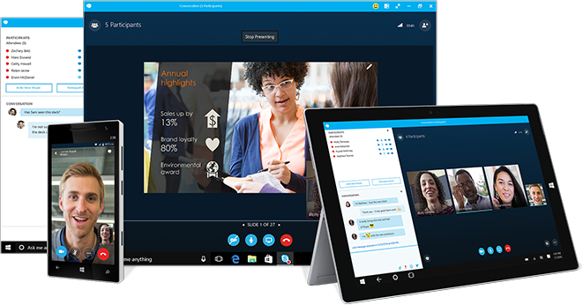
Skype for Business

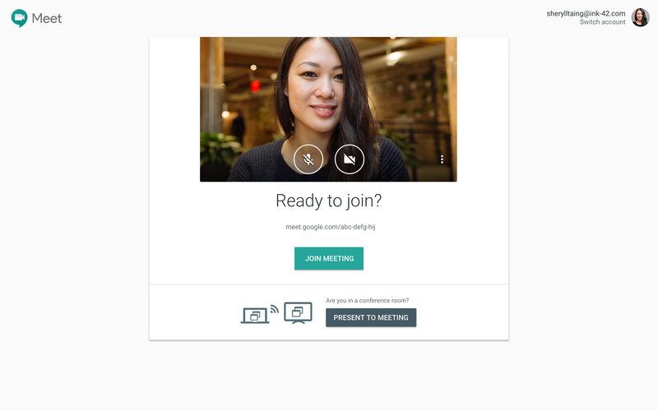
Google Hangouts Meet
Skype for Business | Google Hangouts Meet
- Compatible with tablets, mobile devices, Xbox one console and smartwatches  - Can call landline or mobile  - Multilanguage  - File sharing  - Photo sharing  - 1080pHD quality video  - Screen sharing  - Online meetings for 250 participants and broadcasts for up to 10,000 attendees  - Call forwarding: auto-attendant feature  - (Microsoft, 2018). | - Users can be messaged using their mobile numbers or Google+ account  - Can call landline or mobile  - Photo sharing  - Multilanguage  - File sharing  - Screen sharing  - Up to 1080pHD quality video  - 30 people per session  - Built in muting feature  - Invitation by URL  - Can schedule appointments and set call reminders  - Can broadcast sessions live via YouTube  - (Google, 2018).

Web-conferencing is an effective medium as it allows users to conference others from the comfort of their own office or house. Skype for Business and Google Hangouts Meet are two web-conferencing mediums that have several practical uses in the workplace. Both mediums are primarily used to simultaneously conduct video-conferences and instant messaging between members through a digital interface. Both mediums have different member capacity per session: Skype for Business allows up to 250 online participants whereas Google Hangouts Meet allows only 30 participants per session. This is a big variant. Regardless, both mediums allow multiple users to interact with each other without actually being in the same room as each other (Arrow Voice and Data, 2016). This improves workplace efficiency by making communication easier as this reduces the need to schedule actual conferences that can be time-consuming and laborious. Skype for Business goes one step further as it offers a call forwarding option that applies the user as an auto-attendant; this take into account users who cannot attend the live-streaming video-calls. This allows users to access the conference physically at any time if they miss the beginning or, if they cannot make it at all, they can read the written points made via instant messaging. Google Hangouts Meet does not have the auto-attendant feature; however, it does allow instant messaging so users can catch up on the web-conference’s important points this way. This ensures no important information is missed in the workplace.
Furthermore, during these sessions, participants can share files such as PDFs and Word Documents. For example, if the attendees are discussing sales figures, a corresponding spreadsheet can be shared. This increases workplace efficiency as members can access the data at a later time and always have it for reference. It also allows members to understand the discussion better. In addition, both mediums offer enhanced video quality of up to 1080pHD. This is important when showing other users tangible work such as physical documents in detail. In order to access this information later, users can print screen that moment and save it into their systems. The increased graphic quality allows users to see clear in real-time. Similarly, users can share real-time visual data through screen sharing. However, the Skype for Business interface is better than Google Hangouts Meet as with Google, users cannot enlarge their own screens to see if the information they are showing is clear enough.
As this form of communication has an increased presence in many professions, understanding how to use it in the workplace is therefore very important. Employees may be required to conduct web-conferences with other members of staff from the same business but in other sites. Also, some interviews in current society are conducted through video-calls (Swanson, 2013). Therefore, individuals must be familiar with this process to be considered an employable candidate.

Social Media Profiles
As society becomes paperless, so do the old-fashioned ways of applying to jobs and acquiring relevant workplace information (Gilster, 1997). Online presence is very important in the current job market (Beckingham, 2014). In contemporary society, social media profiles are integral in the information-gathering, marketing and communication processes in the workplace. Therefore, understanding how to navigate these platforms is necessary.

Facebook Business Account

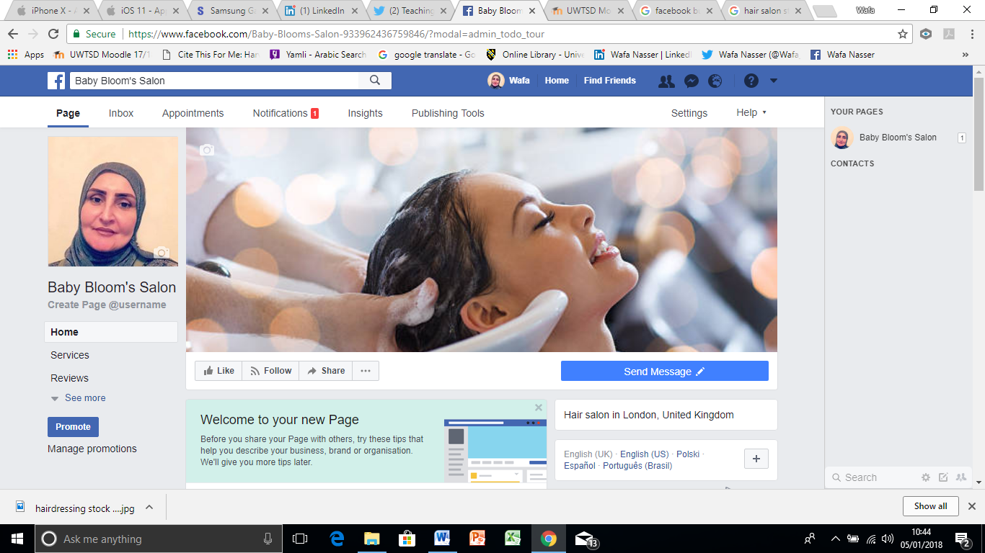
Link: https://www.facebook.com/BabyBloomsSalon

Several proponents of this platform enhance workplace efficiency. When users log into their business profile, the dashboard displays a trending section that shows the top trends in different fields such as politics, business and culture. This gives the user insight on current events and communicates what is popular; this is important in the marketing stage as it allows users to develop their services in accordance to what is current. Another way in which users can gather information is to use the search bar; this allows access to posts, people, pages, events etc. In addition, users can gain insight on their business presence and consumer satisfaction through the reviews section. Reviews communicate feedback to the business owner on how customers feel about their services and products. Also, reviews also help prospect clients assess the business. Users can help their business grow through successful user engagement and assessment of analytics.
Also, users can interact with one another through direct messaging. This makes the communication process quick. Through Facebook for Business, users are granted instant access to their inbox, which includes messages received and notifications of appointments booked or products purchased. Good communication online is integral as it also increases the likeability of word-of-mouth business; this helps businesses grow too.
There are currently 2 billion Facebook users (Constine, 2017). Therefore, having a Facebook presence can prove very fruitful as it grants accessibility to the online market. Also, Facebook allows users to promote their business through a small fee of £2; this includes any offers and discounts. Also, the users can publish posts that contain photos, videos, gifts and polls. This makes the posts more visually appealing and eye-catching. In addition, users can create custom URLs and use search engine optimisation tactics to make their business more approachable and accessible. This increases business success.

Twitter
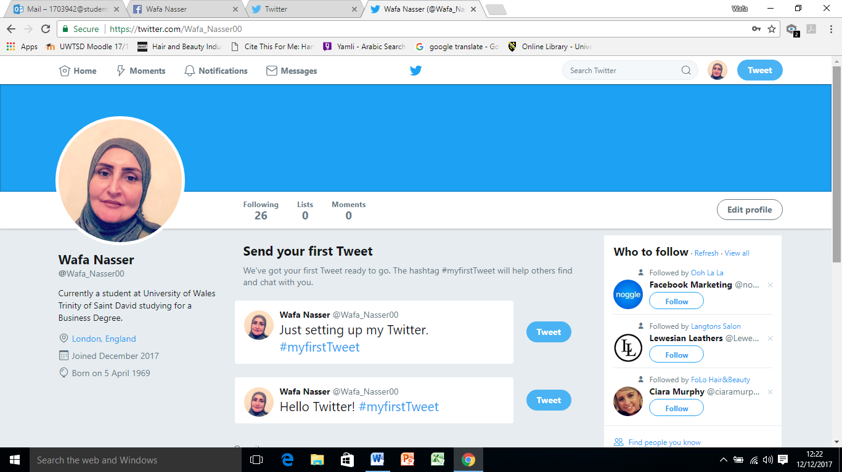
Link: https://twitter.com/Wafa_Nasser00

When creating a Twitter account, users are asked to register their interests. Twitter uses this information to recommend tailored posts. This is useful as users can stay up-to-date with recruiter updates. Also, the trending page informs users of trending news on different areas such as politics and popular culture. In addition, users can search specific keywords in the search bar to access tweets, people, news and broadcasts relative to the search. This makes information gathering easy and quick.
Twitter is also useful for communicating. Users interact with each other through Tweets: these are word-limited posts that may contain images, videos, GIFs and polls. This makes the communication more fun and informal. Also, the word limit makes the tweets more concise; this is important as some individuals are disengaged by information overloads (Poynter, 2010). Retweets and likes provide user engagement information and insight. In addition, users can directly message other users. This is important when users are enquiring about a job offer. Furthermore, users can ‘@’ other users in order to get their attention or direct them to a certain tweet.
Twitter also allows users to use Twitter Ads to market their business or service. This increases their presence by advertising on other users’ feeds. This increases views and interaction. In addition, the shortness of the tweets and the ability to customise them makes them more shareable. This more informal mode of communication makes users grow accustom to Twitter.

LinkedIn
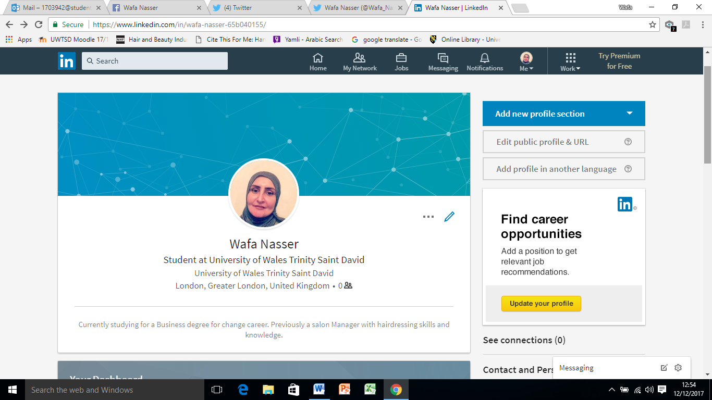
Link: https://www.linkedin.com/in/wafa-nasser-65b040155/
Through LinkedIn, users submit an electronic CV. This is important as it gives recruiters an insight of the applicant through a snapshot of their experience and skills. In addition, users can register their job interests and receive updates on relative, current job positions. There is also a record of saved and applied jobs that users can access at any time. This makes the information gathering process easy.
After applying the places an individual has worked or studied, LinkedIn connects users with other users they may know or companies they may want to follow. These tailored suggestions allow users to increase their network; networking makes an individual more employable (Firth, 2014). Also, after registering career interests, users can let recruiters know they are open. This increases employability as recruiters can request you immediately; this helps users stand out. Additionally, users can enhance their employability chances through direct messaging too. As LinkedIn provides a concise, easy to navigate digital CV, this makes users more marketable and easier to find by employers.
LinkedIn also offers a Premium Career feature that allows users to direct message recruiters, a Featured Applicant feature that moves users to the top of the list, Online video learning facilities through LinkedIn learning and Applicant Insight. This service is not free; however, it does increase employability chances. This is beneficial to both the user and the recruiter; users can increase their online presence and recruiters can enjoy easy access to the applicants.

Conclusion

To conclude, it is evident how important digital technology and social media is in the workplace. As a result, being familiar and proficient in digital handling and technology is important in increasing candidates’ employability prospects. In order to keep up with the current digital marathon, users must be technology savvy to keep up with the ever-flowing technological current. Therefore, much attention should be directed to these profiles. The nearing paperless workplaces demand these skills as a bare minimum.

References

Apple. (2018). iPhone X. [online] Available at: https://www.apple.com/uk/iphone-x/ [Accessed 6 Jan. 2018].
Arrow Voice & Data. (2016). The pros and cons of web conferencing solutions for business. [online] Available at: https://arrowvoice.com.au/blog/the-pros-and-cons-of-web-conferencing/ [Accessed 5 Jan. 2018].
Beckingham, S. (2014) Why you need a professional online presence. [online] Available at: https://www.slideshare.net/suebeckingham/why-you-need-a-professional-online-presence-and-how-to-do-it-rscon5.
Best Buy (2018). Samsung - Galaxy Tab S3 - 9.7" - 128GB - Black. [image] Available at: https://pisces.bbystatic.com/image2/BestBuy_US/images/products/6004/6004600_sd.jpg;maxHeight=640;maxWidth=550 [Accessed 1 Jan. 2018].
Constine, J. (2017). Facebook now has 2 billion monthly users… and responsibility. [online] TechCrunch. Available at: https://techcrunch.com/2017/06/27/facebook-2-billion-users/ [Accessed 3 Jan. 2018].
Firth, R. (2014). Social Media and Employability. [online] Guidance and support from SHU Careers and Employment Service. Available at: https://sites.google.com/a/my.shu.ac.uk/shusome/employability [Accessed 2 Jan. 2018].
Fortune (2018). Google Hangouts Meet. [image] Available at: https://imagesvc.timeincapp.com/v3/mm/image?url=https%3A%2F%2Ffortunedotcom.files.wordpress.com%2F2017%2F03%2F2b_web_greenroom_nomeetinginfo.png&w=800&q=85 [Accessed 6 Jan. 2018].
Gilster, P. (1997). Digital Literacy. 1st ed. New York: John Wiley & Sons.
GSMArena (2018). iPhone X. [image] Available at: https://cdn2.gsmarena.com/vv/pics/apple/apple-iphone-x-new-1.jpg [Accessed 1 Jan. 2018].
Gsuite by Google Cloud. (2018). Video and online conferencing for business and life | G Suite Hangouts. [online] Available at: https://gsuite.google.co.uk/intl/en_uk/products/meet/ [Accessed 6 Jan. 2018].
Hoechsmann, M. and Poyntz, S. (2012). Media Literacies: A Critical Introduction. 1st ed. Malden, MA: Wiley-Blackwell.
Microsoft (2018). Skype for Business. [image] Available at: https://c.s-microsoft.com/en-us/CMSImages/Hero_SFB_multi-device-image_645x346.png?version=9ec710c7-1ae5-30f8-70c9-b71cee2c9a0c [Accessed 2 Jan. 2018].
Perez, S. (2017). iOS and Samsung market share now tied in the US. [online] TechCrunch. Available at: https://techcrunch.com/2017/10/13/ios-and-samsung-market-share-now-tied-in-the-u-s/ [Accessed 3 Jan. 2018].
Poynter, R. (2010) The handbook of online and social media research: Tools and techniques for market researchers. United Kingdom: Wiley.
Skype (2018). Skype for business - with security and control of Microsoft. [online] Available at: https://www.skype.com/en/business/ [Accessed 5 Jan. 2018].
Swanson, D. (2013). 7 Tips To Nail A Skype Interview. [online] Forbes.com. Available at: https://www.forbes.com/sites/learnvest/2013/04/09/7-tips-to-nail-a-skype-interview/#3cded43f6835 [Accessed 3 Jan. 2018].
The Official Samsung Galaxy Site. (2018). Samsung Galaxy Tab S3. [online] Available at: http://www.samsung.com/global/galaxy/galaxy-tab-s3/ [Accessed 6 Jan. 2018].

