

Student name: Iohana-Eleonora Popa
Srudent number: 1921952

Modle title: Global business environment
Assigment title: Electric car manufacturing industry
Module lectuer’a name: Rexon Nting

An electric car is powered by the engine utilizing batteries which are rechargeable. The number of electric motors on a car may vary.
Introduction
After 2008, there has been a boom in the manufacturing of electric cars owing to developments in technology, worries about increasing energy costs and a drive to mitigate emissions. Many state and municipal governments have set up tax breaks, discounts and other opportunities to encourage the launch and now deployment of modern electric cars in the consumer market, based on the capacity of the car and the all-electric range. Electric vehicles are cleaner relative to automobiles with internal combustion ( IC) engines and have no tailpipe pollution. Electric cars can reduce greenhouse gas pollution compared with IC engines when recharged from low-emission electric power sources.
The electric cars were considered a luxury among the classic cars which used gas in the late 19th century and the beginning of the 20th century. The electric cars were also the favorite cars for the rich people who considered themselves spoiled when driving these kind of cars, while there were around 30,000 electric vehicles in the world. The engineers lessened the benefits of the electric cars in the first part of the 20th century in order to show how efficient they might be and how they can prevent pollution. Even the benefic factors of the electric cars were well known by the people, the gas engine cars still were a lot in the market and the oil market were continuously growing among all the 20th century until now.
The reduction of the pollution is notable in towns and big cities and this is the major advantage of the electric engine cars over the traditional internal combustion cars. The clean air is considerably felt in the cities with more electric cars because the emissions are lower and there is not that much gas to be burned.
The wide currents are responsible to charge the electric motor car in order to get the good range to power charging ratios and also they have smooth torque, almost 0. Most of the electric cars have limited motors while others have moderate acceleration or big engines in order to increase the power of the car. The electric cars have usually lowest power when accelerating while the traditional internal combustion cars with the same power accelerate faster. 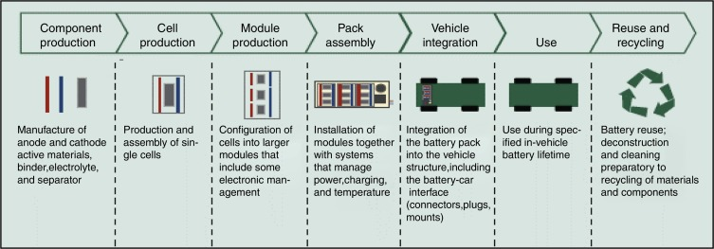

( Figure: www.sience.direct.com )

TESLA
Tesla company is manufacturing and selling only electric cars and it’s headquarter is in the United States of America, California, Palo Alto. They have a wider range of models according to all types of electric power motors in order to fulfill consumers requests. The Tesla electric cars ale helping to lower the consumption of carbon emissions in the air by using clean energy sources. Tesla is an automotive manufacturer headquartered in the USA that manufactures fully electric vehicles and a wide variety of other consumer goods that help people and companies minimize their carbon emissions by using clean energy sources. In the year of 2019th the selling of Tesla company was highly increased after launching the Concept 3 model which is a very affordable car among te other models Tesla is producing which are luxury and quite expensive cars.
Tesla is known worldwide for their creativity and innovation that’s because their cars have fitted a very smart technology, autonomous drive and safety features. These aspects help people to drive easier and also give them the feeling of safety while driving and in case of impact. Tesla is having a big accent on the comfort and luxury but also on pollution-free cars.
The supply chain was very well managed in the automotive market and network by Tesla, also in China where the demand raised significantly for Tesla cars. This is why Tesla is having a strong connection with China and its consumers like elsewhere in the world.
In 2019, after 11 years on the market, Tesla was named the number one worldwide in selling plug in battery electric cars. Tesla is having 17% of the market of electric cars worldwide and 23% in the electric batteries segment. Tesla 's global vehicle sales increased 50 percent from 245,240 units in 2018 to 367,849 units in 2019. Over one million of electric cars were selled by tesla at the beginning of 2020. The best seller is Model 3 which was sell in more than 500,000 shipped from the launching until now.
Tesla achieved a US$206 billion market capitalization, on 1st of July 2020 being in front of Toyota which was the world’s most profitable automaker

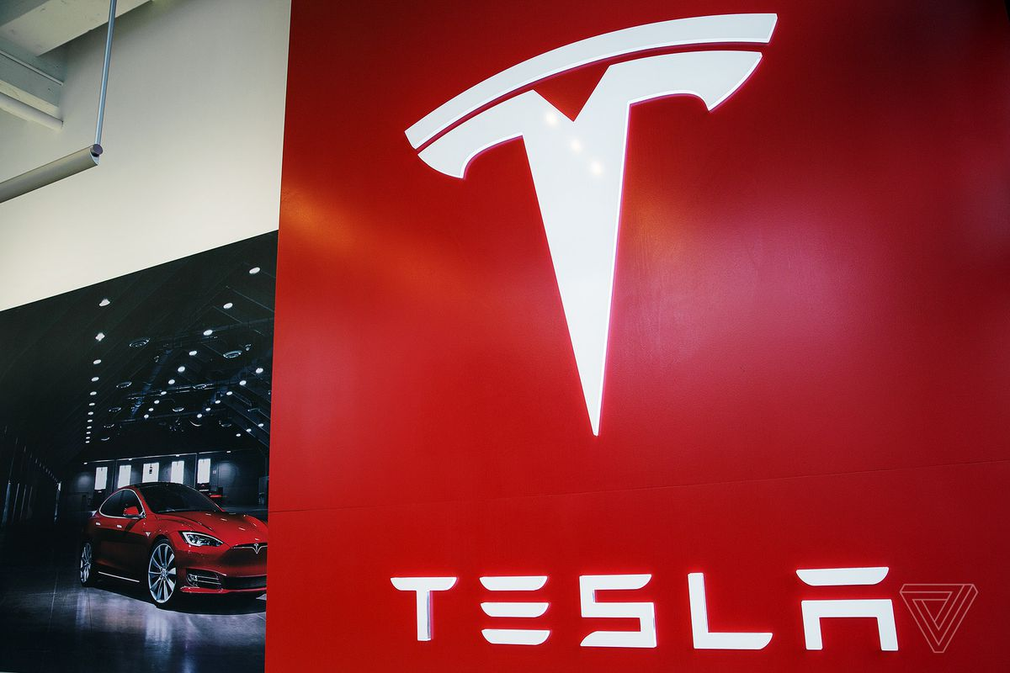

The value chain model
The idea of a supply chain was developed by Michael E. Porter of Harvard Business School. This model covers all kinds of activities from raw material sourcing to manufacturing, promotion, distribution, and after-sales support. These steps bring more value and credibility for the Tesla brand cars and power engine batteries by the analysis an optimization which bring a higher value for them. By optimizing their value chain, Tesla is increasing their operational efficiency, but also gives them competitive advantage on the automobile market. There are two forms of activities in Tesla company such as Primary activities and the activities that sustin the primary ones.
Primary Activities:
The primary activities within Porter's value chain are directly concerned with the creation of products or services for the Tesla brand which is always concerning in creativity and innovation.

Inbound logistics:
The inbound logistics is concerned about the processes of distribution, storage and shipping, while Tesla has a large number of warehouses around the world but the biggest one is located in Fremont, California. The warehouse from Fremont is used as a warehouse but also welding. There are many other locations of warehouses but the main ones are in Lathrop and Livermore California, Bethlehem, Pennsylvania, Sparks, Nevada, Taipei, Taiwan and Elkridge in Maryland.

Operations:
Tesla was created by a group of engineers in 2003 with the purpose of making electric cars feasible and affordable for everyone wants to drive one of these kind of cars0 The Roadster model was released in 2008 after that the S model was released and they became very successful among electric cars. With this big success, Tesla expanded their operations and the sales, supply chain and the global network of manufacturing so in Europe, the headquarter is situate in Netherland, city of Amsterdam. The main production plant of Tesla is located in Tilburg where it is provided the final product of the Model S and X, then being shipped to Europe. The Gigafactory 1 of Tesla is located in Outside Reno, Nevada, while the Gigafactory 2 is located in New York, Buffalo
Outbound logistics:
The Gigafactory 1is concerning about production facility in Tesla 's network of manufacturing companies. The Tesla Motors' Fremont, California plant is responsible about the final assemblance of the cars and their testing. Also, In the United states, Tesla has several warehouses in which they store final cars, or different car parts while in the Gigafactory 3 in China, city of Shanghai is responsible of shipping the Model 3 cars to it’s chinesse customers.
Marketing and sales:
The heavy competition is something usual in the car manufacturing and selling industry while some companies use marketing to promote their cars in both digital and conventional channels. But Tesla is spending less money resources on marketing than other automotive companies while the director, Elon Musk is engaging their followers on Twitter about the changes and the new released cars in Tesla company.
Tesla opened several stores and galleries around the world which also help in selling but also in the marketing process of the company which is concerned always about promoting and reinforce the brand but also to get feedback from the customers in order to now what and how to improve about the cars. In the major cosmopolitan markets there are situated galleries and outlets with big visibility in which there is possible to proceed the buying and the after-sale operation. It’s service center network is expanding continuously because the opening of new galleries will increase the level of demands which is a big benefit for the company. The network of expansion is now all over the world, in Europe, Asia and North America. Another strategy of Tesla is that the company maintained a strong image on the market and after-sales. A strong emphasis in Tesla company is that they are customer oriented and offer high quality products for its customers. The highest number of stores and galleries of Tesla are located in California, Texas and Florida but most of the retail outlets are in Nanjing, Guangzhou, Shenzhen and Shanghai.

Products and services:
The Model S, Model 3, Model X, Model Y, Cyber Truck and Roadster are the main sell cars in Tesla company. The Cybertruck is a newly released Tesla house truck model which looks very much like a Sci-Fi car. This car or also called truck is a very safe car and it brings a new experience for Tesla’s customers. Tesla is giving the opportunity of after-sales services for the customers due to their network all over the globe
Support activities:
Primary activities in Porter’s value chain are linked to support activities.
Technology:
The competitiveness has grown in a very rapid form in the automotive industry all over the world so Tesla needs to keep up with this fact in order to maintain the position in the market. The main rival of Tesla which has produced electric cars is BMW which intend to grow it’s production of hybrid and full electric cars. The decisional factor in remaining in the top of the electric car manufacturers is the technology such as autonomous driving and electric mobility. The company spent 1.46 billion dollars in research and development during 2018 so Tesla's R&D expenditures rose by $82.3 billion, or six trillion, relative to the previous year. Tesla was helped in improving the cars by the ultimate features of technologies but also to expand it’s network worldwide.
Infrastructure
The two major divisions of Tesla are the automobile industry section and the energy product division. The infrastructure of Tesla is in first place about Elon Musk who is the principal decision maker, Zachary J. Kirkhorn is the CFO and it is in charge of finance related fields.Tesla also has vice presidents to oversee many other divisions including manufacturing, infrastructure, distribution, accounting, etc.
HRM:
The total of full time staff in the Tesla company was 48.817 in 2018 which are all very skilled in order to perform well and the organization to grow. For the HR management is important to hire and retain the very skilled employees also, to achieve quicker improvement and growth in order to increase the value of the company for the competitive power.
Procurement:
Tesla is buying car parts from many suppliers around the world in order to give high quality cars for its customers and this is why they have a specific bond with some suppliers for several car parts such as cells and other key systems that are very important in the manufacturing process.. While Tesla has many suppliers of certain raw materials, it relies on single sources for many others. Panasonic is one of the main suppliers of Tesla an they keep the bond for long time for providing Tesla’s electric cells.

Tesla company is very successful worldwide in the automotive industry because of their concern about preventing pollution and global warming. Applying creativity and sharing interests is another thing Tesla is concerned about and this made them become the best company in the automotive industry, also for the high quality cars and services they provide. This is how Tesla made millions of dollar profit in such a short period of time and had such a major impact worldwide. Tesla is looking for fulfilling the customer demands also for improving their products and provide the best ones and the newest technology ever existed. The employees are also very important in the company because they are the main factors that can provide high quality products and services, by giving them good health services, discounts and professional workshops to improve their skills and knowledge. The main advantage of Tesla company is that they exploit the idea of eco-friendly cars and the sources of renewable energy. Frm Tesla’s patent, many car manufacturers started to make electric cars so this is how the company had a great impact in the automotive industry around the world.
Conclusion

Refferences:

- https://www.sciencedirect.com/science/article/pii/S180920391730027X#bib0005) accessed July 12, 2020
- https://www.annualreports.com/HostedData/AnnualReports/PDF/NASDAQ_TSLA_2019.pdf accessed July 12, 2020
- "Tesla Model S Beats Chevy, Toyota, and Cadillac for Ultimate Car of the Year Honors". Motor Trend. Retrieved September 4, 2020.
- Lambert, Fred (February 26, 2016). "Tesla is now ~80% vertically integrated, says Goldman Sachs after a Tesla Factory visit". electrek.co. Retrieved September 4, 2020.
- The Making Of Tesla: Invention, Betrayal, And The Birth Of The Roadster". businessinsider.com. Accessed September 4, 2020.
- Suba, Randall (March 9, 2020). "Tesla Giga Shanghai Update: Projected 2021 production, Model Y delivery schedule, Model 3 Long Range". Accessed September 4, 2020.
- "Elon Musk just announced the new Tesla Cybertruck". November 22, 2019.
- Consumer Reports Survey Says Tesla Has Highest Satisfaction Rate". InsideEVs. Accessed September 1, 2020.

