Name: Esther Rotimi Ogbe
Student number: 2508582
Programme: Certhe Computing Skills for workplace
Module name: Learning in the Digital Era
Module code: ACCA4025
Lecturer’s name: Martin Svejda
Assignment title: Assignment 1
E-Portfolio

Table of Contents
WELCOME PAGE: 3
TASK 1: IEEE REFERENCING AND WRITTEN SUMMARY 3
SECTION A: 3
IEEE REFERENCING AND WRITTEN SUMMARY ON ESSENTIAL ACADEMIC SKILLS: 3
IEEE REFERENCING AND WRITTEN SUMMARY ON ENPLOYMENT SKILLS: 4
ESSENTIAL ACADEMIC AND EMPLOYMENT SKILLS ON MY CAREER AS A DATA ANALIST AFTER MY GRADUATION: 4
VISUAL IMAGE: ESSENTIAL ACADEMIC AND EMPLOYMENT SKILLS 5
SECTION B: 5
REFLECTION ON SIMILARITY SCORE 5
TASK 2: MIND MAP & ACADEMIC POSTER 5
SECTION A: 5
MIND-MAP OF EFFECTIVE TEAMWORK 5
MIND-MAP (CANVA): KEY CONSIDERATIONS OF EFFECTIVE TEAMWORK 6
SECTION B: 7
ACADEMIC POSTER 7
TASK 3: AUTOMATIC REFERENCING TOOL 8
SECTION A: 8
FORMING A TEAM 8
REFERENCES USING REFWORKS: 8
KEY POINTS: 9
SECTION B: 9
TASK 4: E-PORTFOLIO CREATION AND VIEW: 11
SECTION A: 11
LINK: https://sites.google.com/view/acca4025e-portfolio/home 11
SECTION B: 15
REASON FOR USING “GOOGLE SITE” IN BUILDING AN E-PORTFOLIO 15
CONCLUSION: 16

WELCOME PAGE:
An e-portfolio shows samples of work that allow an employer to see your progress throughout your courses in key skills. This includes employment skills, learning skills, and working well with others. Evidence of skills like research, evaluation, and communicating your thoughts through well-written sentences will show your progression with learning skills. Employment skills include accomplishments and hands-on skills you've gained on the job as well as flexibility. Group projects that you include will show you work well with others. By showing that you can work on a team you display skills like cooperation and leadership. An e-portfolio will help you keep track of your progress and grow confidence in yourself. E-portfolios are great for learning, getting ready for careers, and showing off your skills [1]
Reference:
[1] A. Jones, “Digital portfolios in higher education: Tools and best practices,” IEEE Trans. Learn. Technol., vol. 13, no. 2, pp. 234–242, 2020.

TASK 1: IEEE REFERENCING AND WRITTEN SUMMARY

SECTION A:

IEEE REFERENCING AND WRITTEN SUMMARY ON ESSENTIAL ACADEMIC SKILLS:
IEEE referencing involves citing sources using bracketed numbers like [1] and [2] throughout your writing, which correspond to a numbered list of references at the end of your paper. This style allows you to write concisely without interruption. There are a number of academic skills that students should aim to learn. These include critical thinking skills, communication skills, time management skills and research skills. Critical thinking skills allow you to form your own opinions on information that you learn. Communication skills allow you to express your ideas through effective written assignments. Time management and research skills allow you to complete these written assignments on time. By using IEEE references in your written summaries, you will learn to improve your academic writing skills by building on the thoughts and ideas of others without plagiarising their work. You can cite your references using numbered brackets like [1] and [2] as shown in your reference list. Building your academic skill set will not only help you in your studies, but will also help you in your professional career [1], [2].
Reference:
[1] J. Smith, Academic Writing Skills, London: Routledge, 2020.
[2] A. Brown, “The importance of referencing in academic work,” Journal of Education, vol. 15, no. 2, pp. 45–50, 2019.

IEEE REFERENCING AND WRITTEN SUMMARY ON ENPLOYMENT SKILLS:
IEEE Style uses numbered citations such as [1] [2] within the text. These references are put into square brackets and numbers to easily identify each source used. This citation style keeps writing simple and professional while avoiding plagiarism. Employment skills are capabilities a person needs to have to effectively work. Examples include communication, teamwork, critical thinking, adaptability, and time management. These skills allow a person to interact and complete tasks within their work environment. Submitting a written summary that uses IEEE citations shows you can convey important information to your reader. It also shows you know how to avoid plagiarism by correctly giving credit to your sources. Employers will appreciate the time and effort you took to use proper citations which will showcase your professionalism [1] [2].
References:
[1] R. Kumar Professional Skills for Employment New York: McGraw-Hill, 2021.
[2] L. Green, “Developing employability skills in students,” International Journal of Education, vol. 18, no. 3, pp. 60–66, 2020.

ESSENTIAL ACADEMIC AND EMPLOYMENT SKILLS ON MY CAREER AS A DATA ANALIST AFTER MY GRADUATION:
Academic skills like research methodology, critical thinking, quantitative analysis, and writing reports benefit me by preparing me for my dream job as a data analyst after college. Work-related skills like communication and teamwork allow me to interact effectively with others in a workplace. By being a critical thinker, knowledge seeker, and organized in terms of time management; I will excel at my job as a data analyst by coming up with workable solutions. Employment skills I will need in the future include communication, adaptability, teamwork, problem-solving, and time management. In my line of work, I will interact with my team by scheduling daily stand-ups and explaining my reports to others who may not be as data literate. I will have to make crucial decisions based on the data I receive and communicate those findings with management. After graduating, both skill sets will allow me to not only meet expectations but exceed them in my career field. Having good work ethic skills and academic skills will allow me to feel more confident and professional at my job [1], [2], [3].
References:
[1] S. Bennett, Data Analysis Skills for Beginners. London: TechPress, 2021.
[2] M. Johnson, “Employability skills for data professionals,” Journal of Career Development , vol. 12, no. 2, pp. 34–40, 2020.
[3] A. Lee, “The role of academic skills in data science careers,” International Journal of Data Analytics , vol. 8, no. 1, pp. 15–22, 2019.

VISUAL IMAGE: ESSENTIAL ACADEMIC AND EMPLOYMENT SKILLS
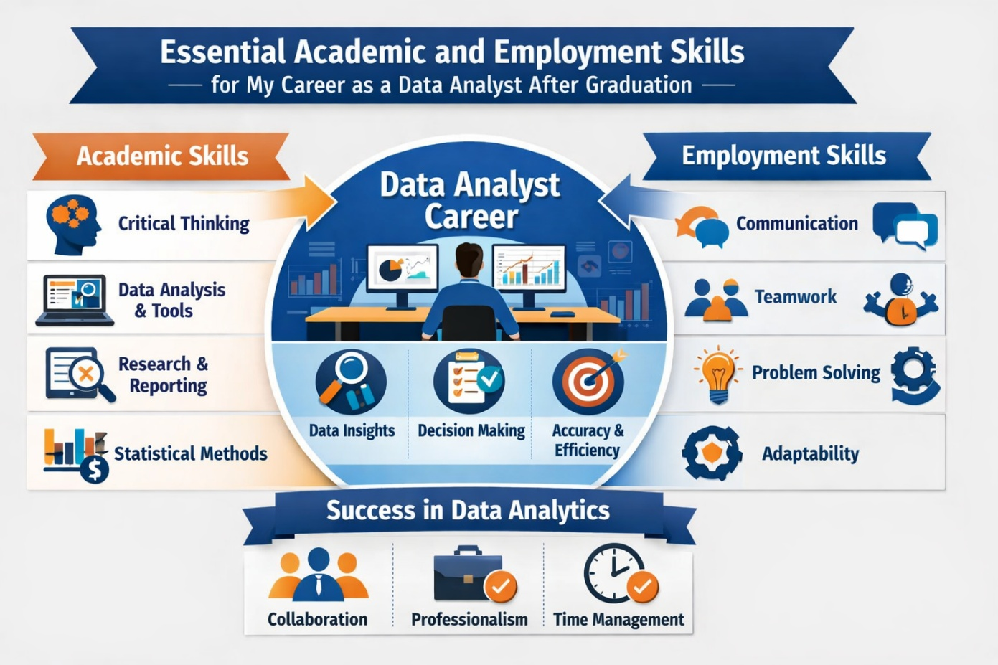

SECTION B:

REFLECTION ON SIMILARITY SCORE
The similarity score was 45% which is slightly improved but still shows I need to try harder to make my work more original. To improve further, I could work on getting my point across using my own words more, instead of using the wording of sources. I will paraphrase and summarise more effectively and make sure I completely understand what I am reading before I write about it. I will include more of my own critical thinking, interpretation of information, and examples to help make my work more original. I will make sure I double check my work and properly cite my references using IEEE. Lastly, I will make sure I run it through draft before final submission.

TASK 2: MIND MAP & ACADEMIC POSTER

SECTION A:

MIND-MAP OF EFFECTIVE TEAMWORK
Teamwork means working together, collaborating, and cooperating with others. When you have good teamwork, you share thoughts and ideas with others. You help support others on the team and work together to achieve a goal. Teamwork allows you to work efficiently and get more done. It allows you to come up with creative solutions to problems. When you know you can trust your team, you can make more effective decisions. Value everyone's input and take advantage of having a great group of people to work with.

MIND-MAP (CANVA): KEY CONSIDERATIONS OF EFFECTIVE TEAMWORK 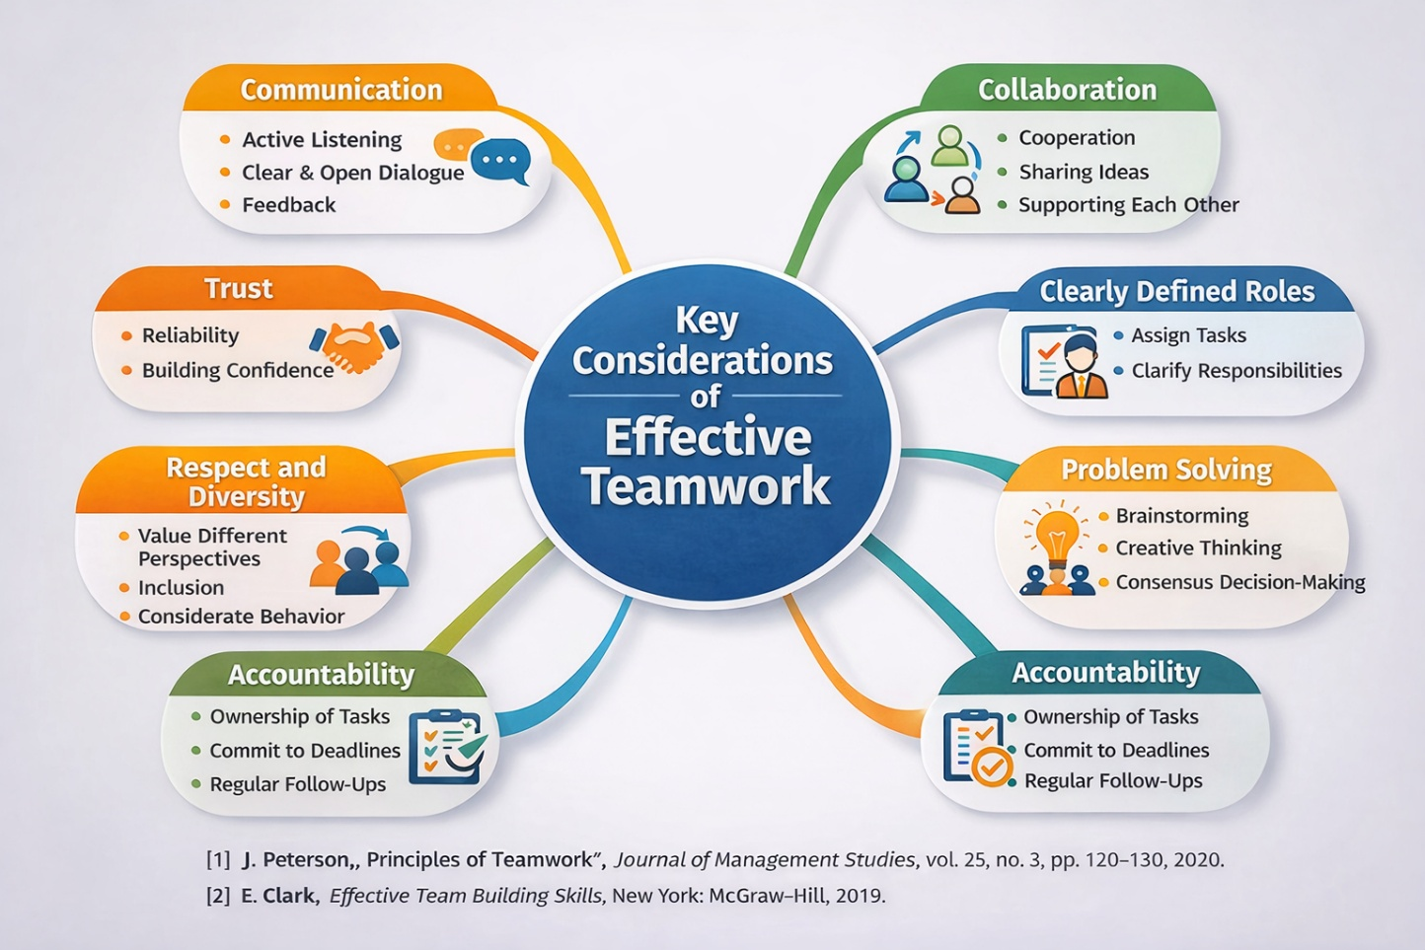

SECTION B:

ACADEMIC POSTER
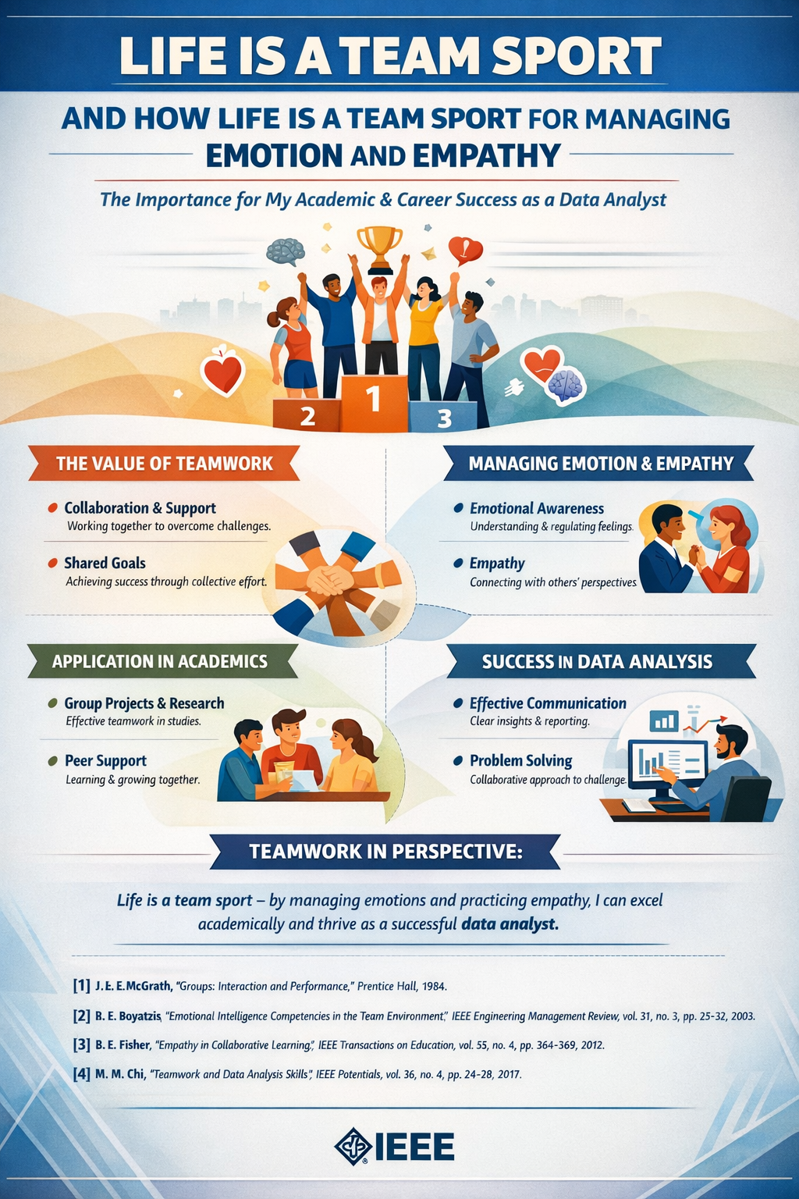

TASK 3: AUTOMATIC REFERENCING TOOL

SECTION A:

FORMING A TEAM
Team formation is the process by which a team comes together to align on objectives, identify and clarify roles and responsibilities, and develop initial levels of trust. Teams starting out together often feel uncertain about the goals of the team, what work needs to be done, who should do what work, and how teammates should work together. [1] Pairing Tuckman’s Team Development Model with a shared approach to visual collaboration can help set team members up for success early on in their formation. By running team development exercises that focus on visual collaboration during the Forming stage, team leaders can reduce uncertainty and help move teams into high-performance stages sooner.
The first stage in Tuckman’s model is the Forming stage. During this stage, team members will be polite, tentative, and eager for direction. Visual collaboration tools like flowcharts, mind maps, or team whiteboards help team members begin to ideate together and understand what knowledge and experience each teammate brings to the table. Whiteboarding goals together helps team members begin to form a shared vision of what success looks like and makes the tacit expectations of the team explicit. Goal visualization during the Forming stage helps set team members up for success by allowing everyone to get on the same page from the beginning. [2]
Using the FAST framework with visual collaboration in the Forming stage can be a real gamechanger for project launches. FAST: Frequently discussed, Ambitious, Specific, Transparent. Visualization tools can help a team ensure their goals are FAST. Create a shared vision of what success looks like by mapping out a goal that is ambitious for the team but also within reach. Post progress updates on a shared board or kanban-style tracker frequently to help maintain team alignment. Ensure all information is specific and transparent by allowing team members to add to shared diagrams or creating a role and responsibility matrix to define who is responsible for what tasks. [3]
The use of visuals during team collaboration can facilitate a fast progression from Forming into Storming. The Storming stage of team development is characterized by conflicts in ideas and ways of working. When teams collaborate visually, differences in opinions and approaches to work are unlikely to hide and can be more easily addressed, and visualization exercises like these can help reduce miscommunications and allow teams to begin creating shared mental models. Model FAST goals and use visual collaboration to reach them. [4]

REFERENCES USING REFWORKS:
[1] A. Zirar, N. Muhammad, A. Upadhyay, A. Kumar, and J. A. Garza-Reyes, “Exploring lean team development from the Tuckman’s model perspective,” vol. 36, no. 4, pp. 442–463, 2025.
[2] A. Zirar, N. Muhammad, A. Upadhyay, A. Kumar, and J. A. Garza-Reyes, “Exploring lean team development from the Tuckman’s model perspective,” vol. 36, no. 4, pp. 442–463, 2025.
[3] S. Peng, T. Amakasu, and H. Horii, “Teamwork visualization for team reflection based on changes in communication patterns,” vol. 9, no. 03, pp. 419–436, 2024.
[4] L. Etareri, “Fundamental stages of development through the relevance of team building,” vol. 3, no. 10, pp. 48–56, 2022.

KEY POINTS:
Teams can use visual collaboration to successfully navigate the challenges of team formation. Tuckman’s Team Development Model allows teams to understand the psychological processes of team dynamics. The FAST framework can be used in conjunction with visual collaboration to define team goals that are visible, align accountability, and motivate team members.

SECTION B:
RefWorks is an automatic referencing tool used to make researching and writing papers easier by keeping track of references, creating bibliographies, and allowing integration with word processors. During testing, participants used RefWorks to import citations from databases, organize their sources, and automatically format their citations in IEEE style. This saved time and helped participants avoid errors while creating consistent citations. According to a study conducted by Alharbi, reference management software increases efficiency and accuracy when writing scholarly articles, specifically for those within the engineering field [1].
Reference:
[1] K. S. Alharbi, “Evaluating reference management tools in academic research,” J. Acad. Librariansh. , vol. 46, no. 6, pp. 102-110, 2020.
Screenshot 1: RefWork
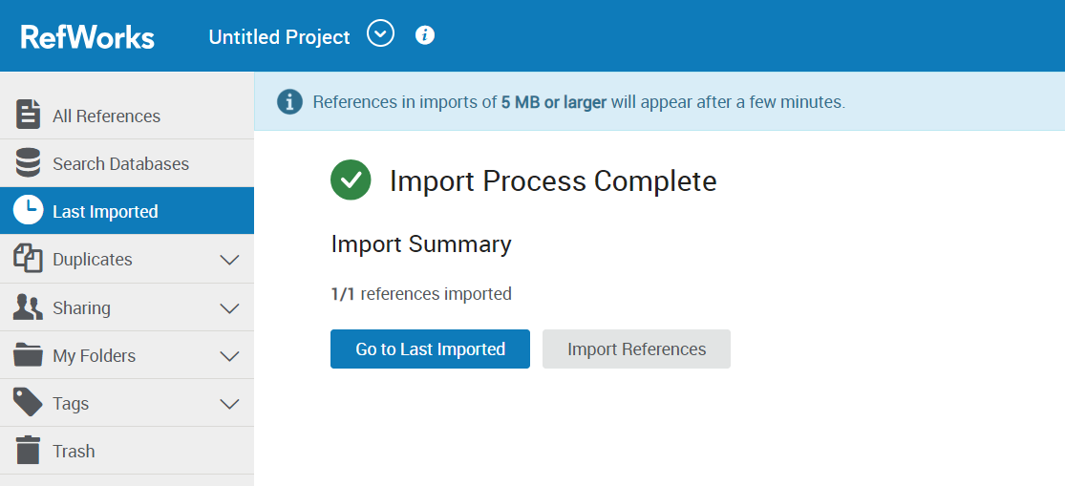
Screenshot 2: RefWork
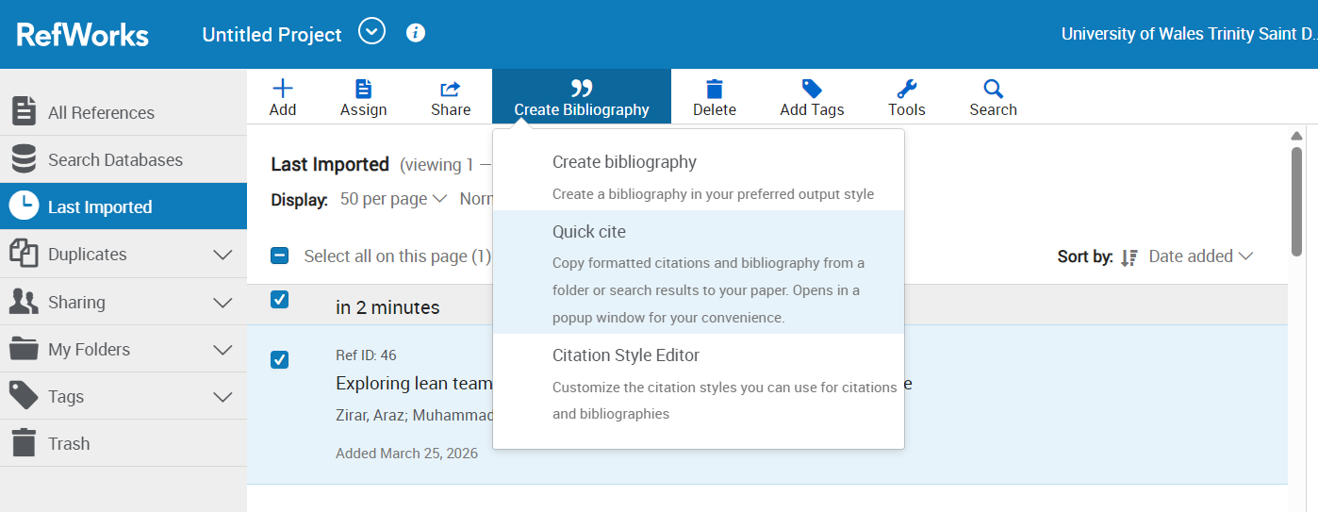
Screenshot 3: RefWork
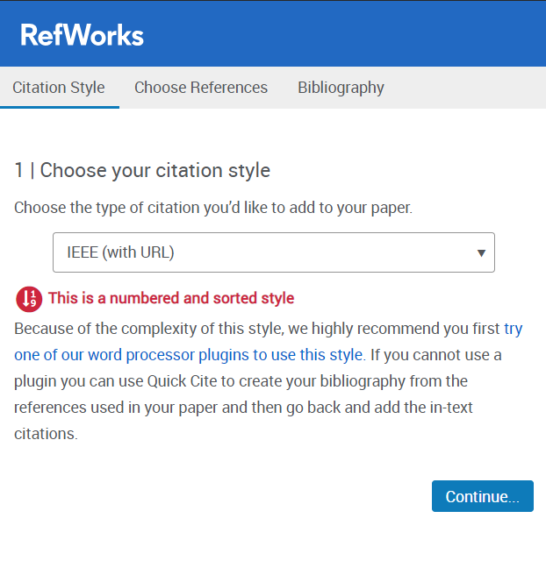
Screenshot 4: RefWork
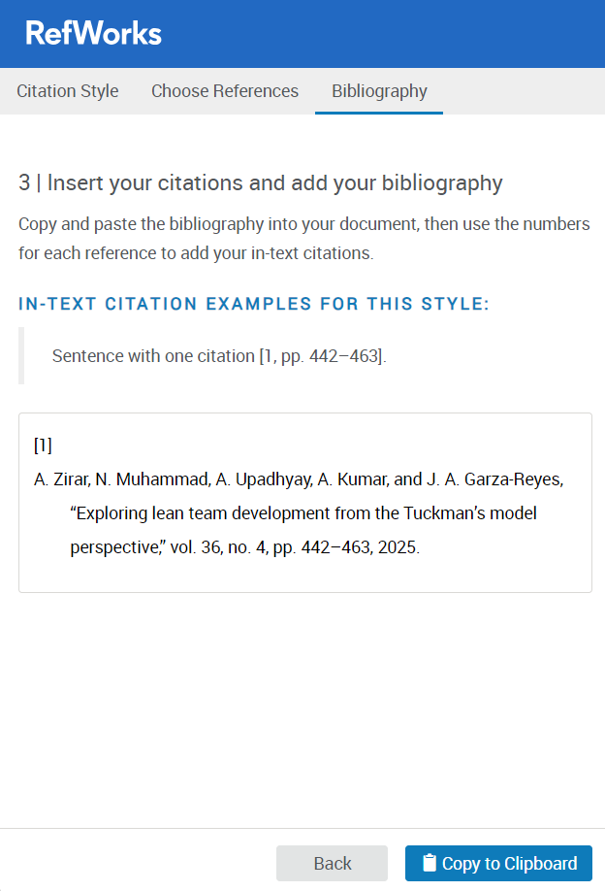

TASK 4: E-PORTFOLIO CREATION AND VIEW:

SECTION A:

LINK: https://sites.google.com/view/acca4025e-portfolio/home

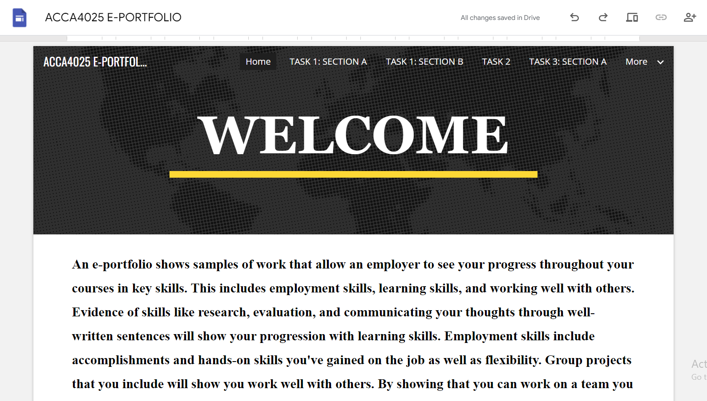

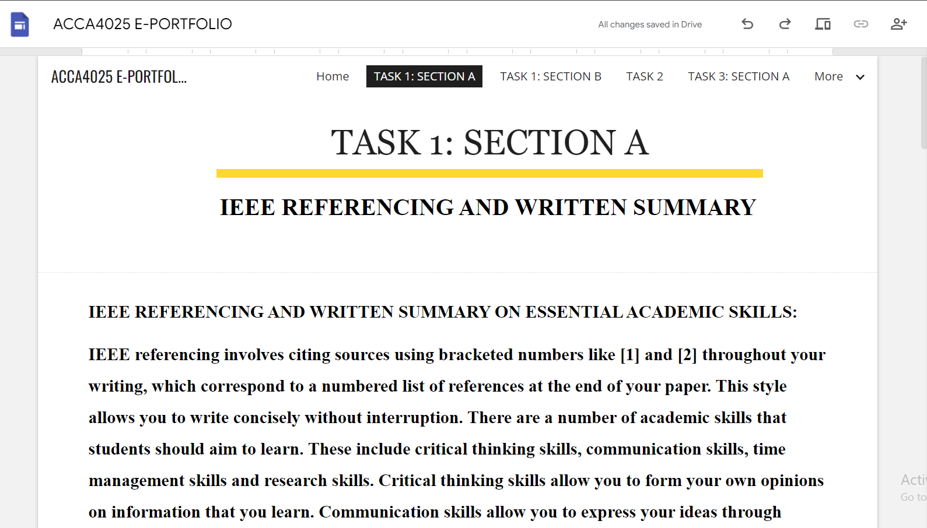

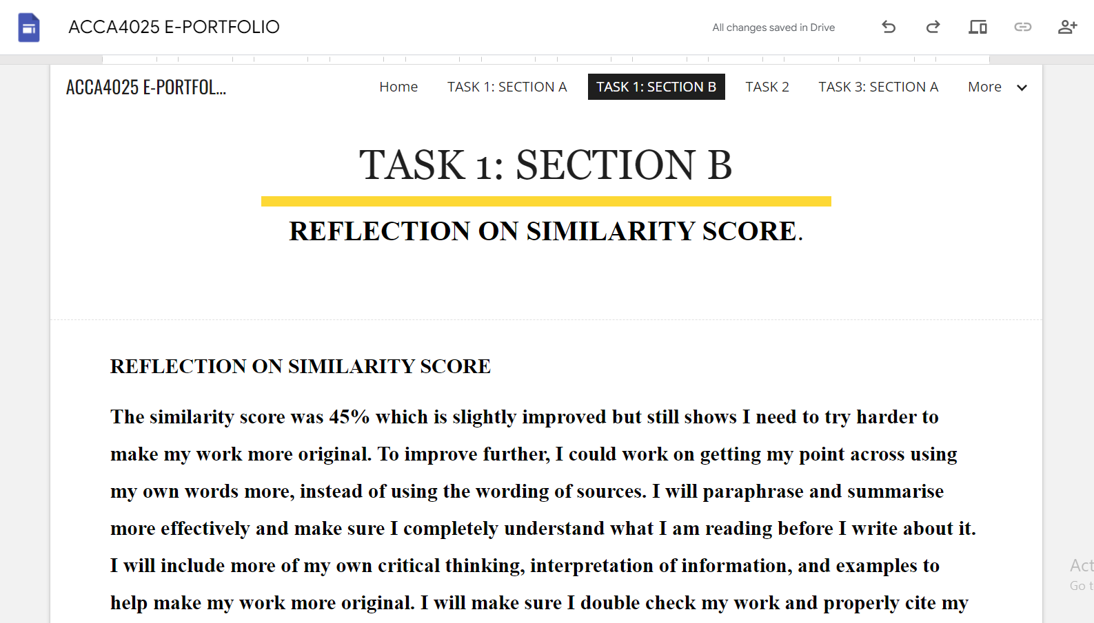

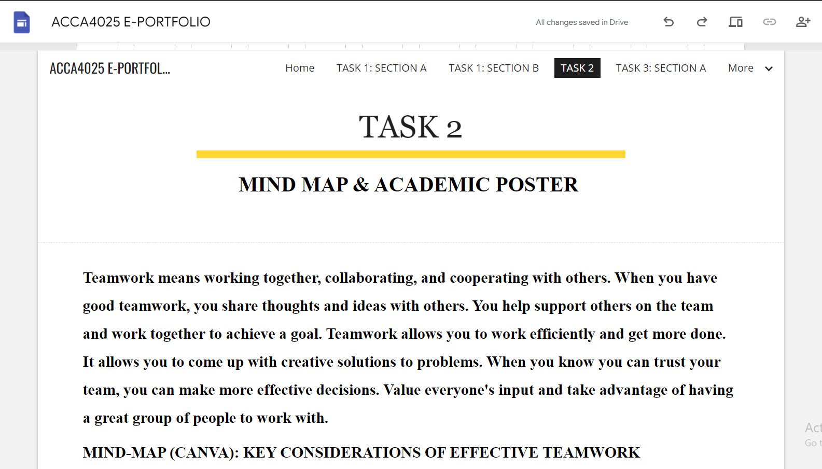

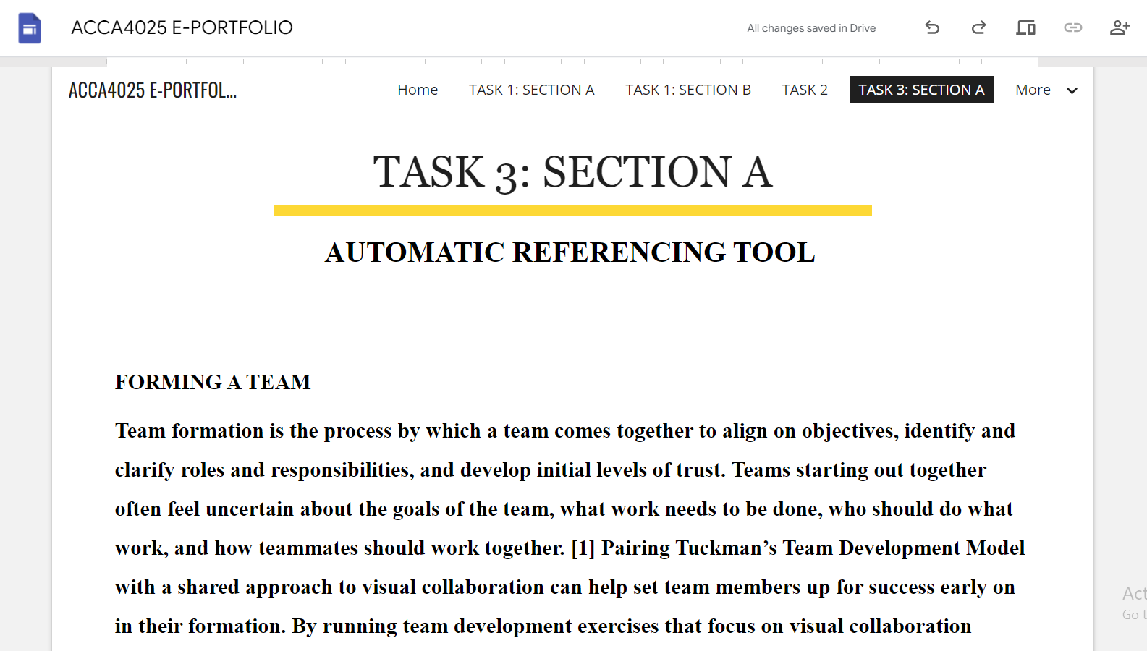

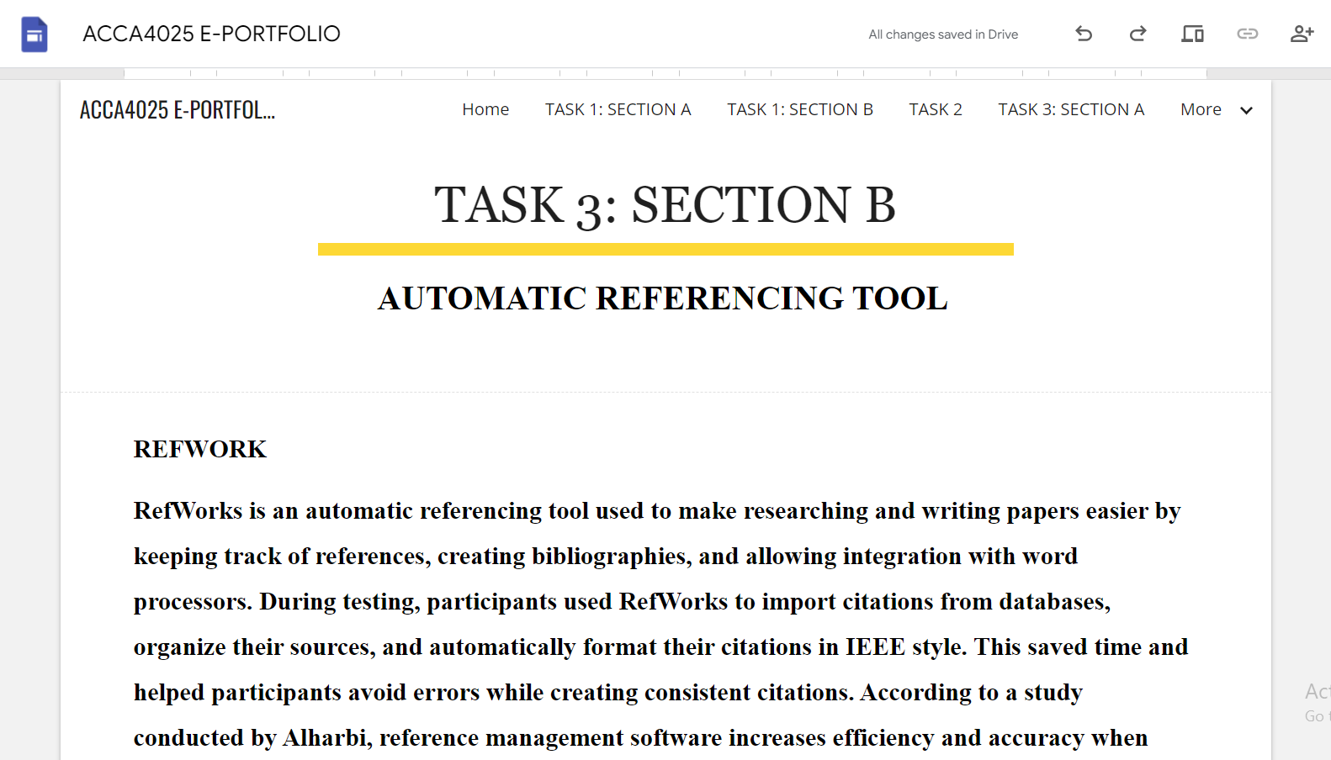

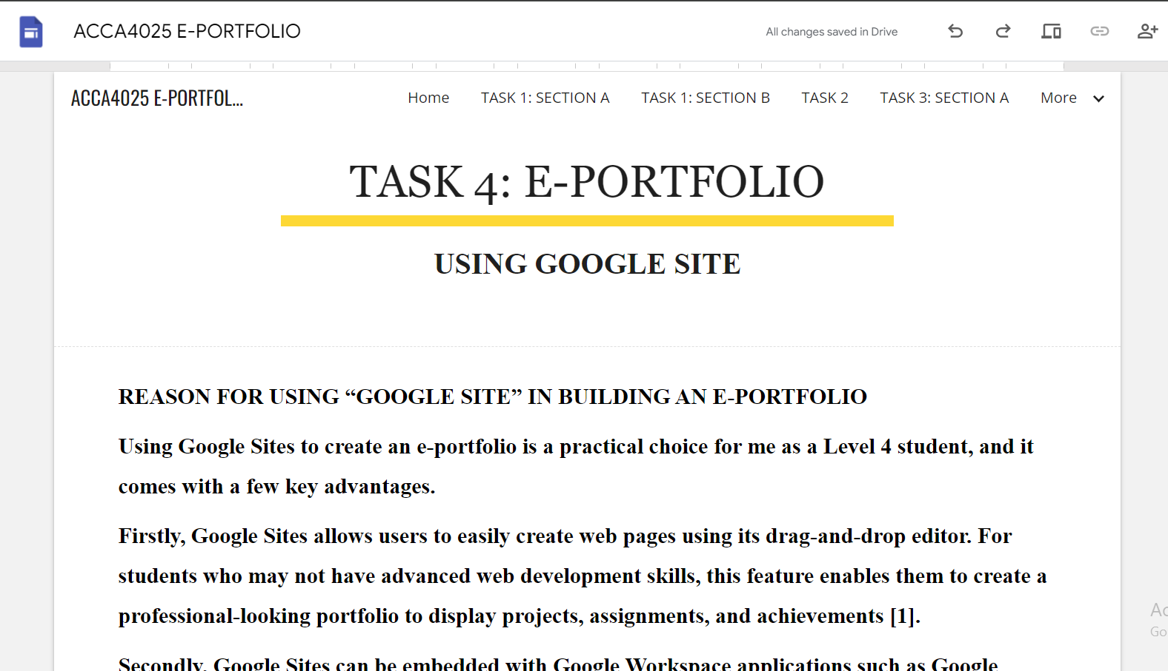

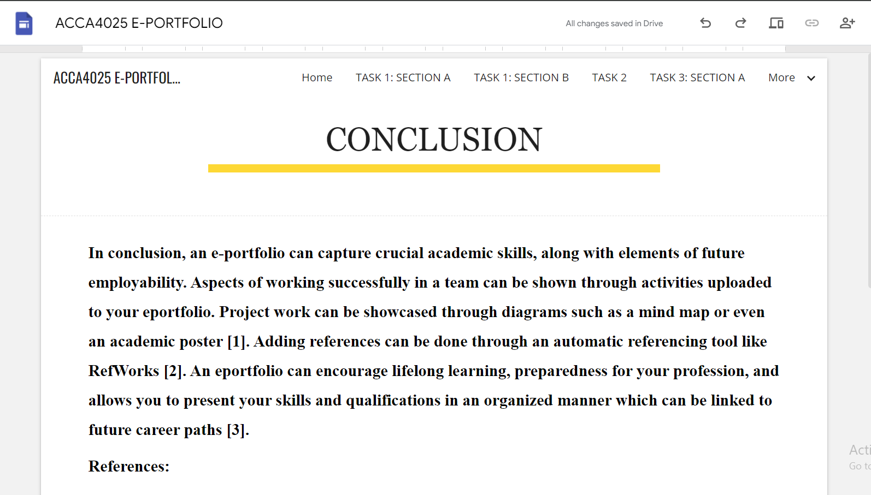

SECTION B:

REASON FOR USING “GOOGLE SITE” IN BUILDING AN E-PORTFOLIO
Using Google Sites to create an e-portfolio is a practical choice for me as a Level 4 student, and it comes with a few key advantages.
Firstly, Google Sites allows users to easily create web pages using its drag-and-drop editor. For students who may not have advanced web development skills, this feature enables them to create a professional-looking portfolio to display projects, assignments, and achievements [1].
Secondly, Google Sites can be embedded with Google Workspace applications such as Google Drive, Google Docs, and Google Slides. Students can easily add their documents, presentations, and other media to their e-portfolios [2].
Organizing and storing these elements on Google Sites can help students access their materials and receive feedback from peers and instructors, allowing for continual improvement and development throughout their academic career and into their professional careers.
References:
[1] A. Jones, “Digital portfolios in higher education: Tools and best practices,” IEEE Trans. Learn. Technol. , vol. 13, no. 2, pp. 234–242, 2020.
[2] M. Smith and R. Brown, “Leveraging cloud-based tools for student e-portfolios,” IEEE Access, vol. 8, pp. 156789–156797, 2020.

CONCLUSION:
In conclusion, an e-portfolio can capture crucial academic skills, along with elements of future employability. Aspects of working successfully in a team can be shown through activities uploaded to your eportfolio. Project work can be showcased through diagrams such as a mind map or even an academic poster [1]. Adding references can be done through an automatic referencing tool like RefWorks [2]. An eportfolio can encourage lifelong learning, preparedness for your profession, and allows you to present your skills and qualifications in an organized manner which can be linked to future career paths [3].
References:
[1] M. Smith and R. Brown, “Leveraging cloud-based tools for student e-portfolios,” IEEE Access, vol. 8, pp. 156789–156797, 2020.
[2] K. S. Alharbi, “Evaluating reference management tools in academic research,” J. Acad. Librariansh., vol. 46, no. 6, pp. 102–110, 2020.
[3] P. Williams, “Visual tools for learning: Mind maps and posters in higher education,” IEEE Trans. Educ., vol. 63, no. 4, pp. 276–283, 2020.

