
University of Wales Trinity Saint David
School of Engineering

Energy in a Flywheel
Engineering Science (M4X00385)

Taylor Winter
1901843

25/11/2019

Table of Contents
Introduction ii
Experimental Procedure iii
Equipment iii
Procedure iii
Results v
Analysis vi
Conclusion vii
Evaluation viii
References ix

Introduction

The aim of this experiment is to prove the theory for energy in a flywheel using various masses to enable a comparison between the difference in kinetic energy for these masses.

“A flywheel is a heavy wheel for opposing and moderation by its inertia any fluctuation of speed in the machinery with which it revolves” (Merriam-Webster, 2019).

When the flywheel is spun, the mechanism stores kinetic energy so when it is spun with a larger mass, a larger amount of kinetic energy is stored. To calculate the kinetic energy stored the equation KE=0.5I𝜔² can be used. Where ‘I’ is inertia measured in kg m² and 𝜔 is angular velocity measure in rads⁻¹. From this experiment the main aspiration is to be able to calculate an ‘I’ value from the data that was gathered and then compare this value to the nominal values to identify how accurate the experiment was. Another important aspect of this experiment is to recognise the association between the mass applied and the potential energy lost.

Experimental Procedure

Equipment
- Flywheel
- Pulley block
- Work panel and stand
- Weight hanger
- Chord
- 100g weights
- Magnetic ruler

Procedure

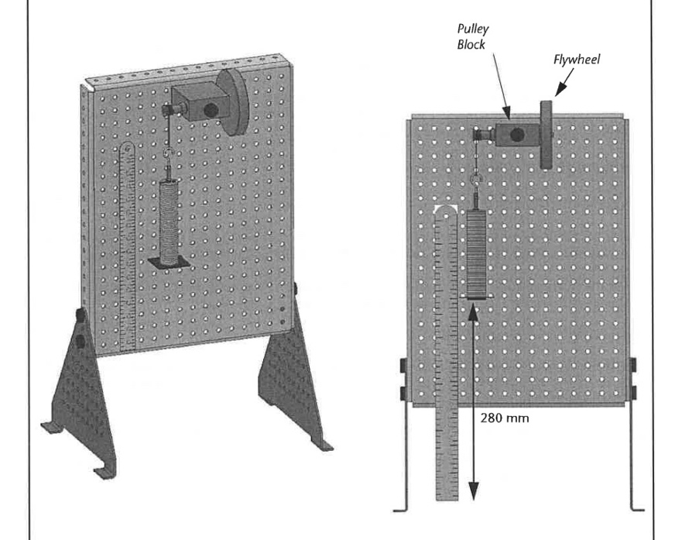
For this experiment the procedure was to firstly read the guidance notes, then setup the equipment as shown in the experiment setup in the guidance notes (as shown below in figure 1). To begin the setup, the plastic guide must be fitted to the bottom of the weight hanger. Attach the previously cut cord, which allows the weight hanger to drop by about 280mm. Then connect the magnetic ruler behind the weight hanger, the bottom of the hanger should be parallel to the 0mm line.
Figure 1


Once set up the apparatus should look as shown above. To begin the experiment, add nine 10g masses to the weighted hanger to give a complete weight of 100g. The flywheel should be turned very slowly as so the weights are not moved around drastically, the bottom of the weighted hanger should align with 280mm on the ruler. One or two people from a group should use a timer to measure the time taken for the weighted hanger to fall from 280mm to 0mm and rise from 0mm back to its maximum height. Its maximum height will also need to be recorded. This data gathered should then be entered into the table given (as shown below in figure 2).
Figure 2

Repeat this process three times to get an average of both the time taken to rise and fall and the height that the weight hanger rises to. From the average values the potential energy loss and potential energy loss adjusted can be calculated by imputing data from each mass into the equations;
- $PE loss= mgh1 – mgh2$
- $PE loss \left(adjusted\right)=PE loss x\frac{h1}{(h1+h2)}$

Falling time can be calculated by using the equation;
- $tf=tt x\frac{h1}{(h1+h2)}$

where h₁ is 0.28m and h₂ is the height recorded. The calculation of acceleration and velocity is required using the equations;
- $a=\frac{h1}{tf^{2}}$
- $v=a x tf$

As it is assumed that the string does not stretch, the force and torque are thought to be equal; therefore, the following equation can be used;
- $T=\left(mg-ma\right)r$

Angular acceleration should also be calculated from these values using the equation;
- $α=\frac{a}{r}$

From this the graph can be created to determine the moment of inertia; plot the torque ((mg - ma) r) against the angular acceleration (a/r) the gradient of this graph is equal to the Inertia value. This can be calculated using;
- $y=mx+c$

Finally, the kinetic energy can be calculated using the equation;
- $KE=\frac{1}{2}Iω^{2}$

Where I is the moment of inertia that was calculated from the graph.

All of the values used in this report are from Engineering Science 1 excel sheet and are available if required.

Results

Acceleration | 𝜔 | Velocity | a/r | (mg-ma)r | Nominal Inertia | I | KE
ms⁻² | Rads⁻¹ | ms⁻¹ | S² | N | kg m² | kg m² | J
0 | 0 | 0 | 0 | 0 | 0 | 0 | 0
0.058940519 | 19.7836171 | 0.12846535 | 9.06777212 | 0.00633819 | 0.0004696 | 0.0007 | 0.09189873
0.117299394 | 27.9091498 | 0.18122867 | 18.0460607 | 0.01260051 | 0.0004696 | 0.0007 | 0.18289057
0.173897665 | 33.9817387 | 0.22066116 | 26.7534869 | 0.0187904 | 0.0004696 | 0.0007 | 0.27113731
0.215465092 | 37.825718 | 0.24562212 | 33.1484757 | 0.02494579 | 0.0004696 | 0.0007 | 0.3359483
0.289814254 | 43.8690866 | 0.28486486 | 44.5868084 | 0.0309406 | 0.0004696 | 0.0007 | 0.45187184
Mass | PE | Time to fall and rise | H₂ | mg | PE loss | PE loss adjusted | Falling time
kg | J | S | m | N | J | J | S
0 | 0 | 0 | 0 | 0 | 0 | 0 | 0
0.1 | 0.27468 | 4.04 | 0.239 | 0.981 | 0.040221 | 0.021699191 | 2.179576108
0.2 | 0.54936 | 2.93 | 0.251 | 1.962 | 0.056898 | 0.030002712 | 1.545009416
0.3 | 0.82404 | 2.42 | 0.254 | 2.943 | 0.076518 | 0.040121798 | 1.268913858
0.4 | 1.09872 | 2.17 | 0.253 | 3.924 | 0.105948 | 0.055657486 | 1.139962477
0.5 | 1.3734 | 1.85 | 0.247 | 4.905 | 0.161865 | 0.08600038 | 0.982922201
Figure 4
Figure 5
Figure 3

Analysis

The page above displays the results from the experiment that was carried out at first look all of the results seem to follow a trend, suggesting that my results prove the theory for energy in a flywheel.

“A flywheel stores energy that is based on the rotating mass principle. It is a mechanical storage device which emulates the storage of electrical energy by converting it to mechanical energy. The energy in a flywheel is stored in the form of rotational kinetic energy … The flywheel speeds up as it stores energy and slows down when it is discharging, to deliver the accumulated energy.” (Amiryar, M. and Pullen K. 2017)

“The amount of energy stored in the flywheel depends upon the mass of the rim and the angular velocity of the wheel. Energy storage varies as the square of the rotational velocity. In theory, the amount of energy that may be stored in a given flywheel may be increased indefinitely with the speed of the flywheel” (Swartout, B. 1983)

Figures 3 and 4 show the results from excel and figure 5 shows the graph of torque against angular acceleration. As seen in figure 3, as the mass on the flywheel increases, the time taken to fall and rise decreases this means that there is a negative correlation between these values; this can be clearly seen below in figure 6. For example, when the mass is 0.1kg the calculated time taken to fall and rise is 4.04 seconds, however when the mass is 0.2kg to time is 2.93 seconds.

Figure 6

The potential energy of the flywheel increases as the weights rise back up to its maximum height this is due to the increase in gravitational energy. When the weights are travelling up the acceleration is decreasing therefore, energy is being imputed to the system this causes the increase of potential energy, when this energy is released, while the weights travel back down, the potential energy decreases.
While this is happening, the kinetic energy is working in the opposite way, when the weights are rising the kinetic energy decreases to its minimum value of 0 and when the weights travel from 0m to 0.28m the weights accelerate, increasing the speed, which causes an increase in kinetic energy. So, when the weights are at their minimum height, the kinetic energy is at its maximum. This can be proved by the equation;
- $KE=\frac{1}{2}Iω^{2}$

When angular velocity ($ω)$ increases, kinetic energy ($KE$) must also increase.

“Energy implies as the object’s capability to perform work. It is something that cannot be created or destroyed but can only be transformed. An object loses its energy, when it performs work, whereas it gains energy when the work is performed on it. Energy is broadly classified as kinetic energy and potential energy. While kinetic energy is the energy which an object contains because of a particular motion. On the other hand, potential energy is the stored energy, because of its state of rest.” (Surbhi, S. 2017)

Figure 7

The graph above shows the relationship between the potential energy loss and the mass added. This shows a clear positive correlation which suggests that the potential energy is directly affected by the amount of mass added. Therefore, the more mass added to a flywheel, the more potential energy is lost meaning that more kinetic energy is gained.

From the values in figures 3 and 4 the equation below can be used;
- $PE+PE loss=KE$

However, potential energy and potential energy loss are not equal to the kinetic energy. As shown in figure 8 below, where the total potential energy (potential energy + potential energy loss) has been compared to the kinetic energy. This is due to the fact that some of the energy is released from the flywheel in other forms, such as;
- Frictional forces
- Heat energy

Total PE | KE
J | J
0 | 0
0.314901 | 0.09189873
0.606258 | 0.18289057
0.900558 | 0.27113731
1.204668 | 0.3359483
1.535265 | 0.45187184

Figure 8

The inertia value given in the experiment and the inertia value that was calculated do not compare well. The inertia value given was 0.0004696kg m², however, the value calculated was 0.0007kg m².

“A quantity expressing a body's tendency to resist angular acceleration, which is the sum of the products of the mass of each particle in the body with the square of its distance from the axis of rotation.” (Oxford dictionary)

The difference in these values may be due to the values given for the equipment; these may not be the same for each set of equipment.

Conclusion

The results from this experiment prove the theory of energy in a flywheel. The relationship between the mass applied and the potential energy loss follow the trend of a positive correlation which has been proved in the analysis. However, there are discrepancies in the procedure which could affect the results.

The errors that were encountered in this experiment were;
- Parallax error
- Human error
- Cord may stretch
- Vibrations
- Incorrect measurements given

Parallax error:
“The error/displacement caused in in the apparent position of the object due to the viewing angle that is other than the angle that is perpendicular to the object.” (Farnell)
This error can be avoided by participants of the experiment reaching eyelevel with the bottom of the ruler, however, as the weights are moving this may be proven difficult. To improve on this error a slow-motion camera could be used by placing it parallel to the work panel. When participants watch the video back, they will be able to calculate a more accurate second height.

Human error:
“A person's mistake rather than on the failure of a machine” (Merriam-Webster, 2019)
This error is easy to avoid by having multiple participants view each part of the experiment to give a reliable average.

Another improvement for this experiment could be to use lasers to measure the displacement of the masses to give accurate results.

Evaluation

From this experiment it becomes apparent that the movement and forces acting upon the flywheel is comparable to that of a pendulum in simple harmonic motion.

“Oscillatory motion where the net force on the system is restoring force”
“A force acting opposite to displacement to bring the system back to equilibrium, which is its rest position. The force magnitude depends only on displacement, such as Hooke’s law.” (Khan Academy, 2019)

This is very similar to the motion of the flywheel. The resting position for the flywheel is at the bottom of minimum height (0.28m on the magnetic ruler).

Further Work

The information gathered from this experiment could be used for multiple other applications in the automotive industry, such as;
- High efficiency dc motor
- Batteries
- Magnetorheological brake
- Dual mass flywheel for passenger car

Batteries: “Today's flywheel batteries, embody technological advances, and they are serious contenders for a variety of important energy-storage applications. They are, for example, competitive with chemical batteries in applications like transportation or improving power quality, which involve many charge-discharge cycles and little in the way of long-term storage” (Hebner, R. Beno, J. Walls, A. 2002)

Magnetorheological brake: “A magnetorheological brake includes an outer, rotating flywheel member having a hollow interior space, and an inner fixed member disposed in the hollow interior space. The inner fixed member is sized so that a working space is provide between the surfaces of the fixed member and the inner wall of the rotating member. A controllable medium of magnetically permeable metal particles is disposed in the working space.” (Carlson, J. 2001)

Dual mass flywheel for passenger car: “An analytical expression for the frequency response function describing the rotational dynamics is derived and compared with experimental data. Sine sweep tests are used to characterise the system imposing constant amplitude excitation, i.e. the torque applied to the engine side of the DMF.” (Galvagno, E. Velardocchia, M. Vigliani, A. Tota, A. 2015)

References

Amiryar, M. and Pullen K. (2017) A Review of Flywheel Energy Storage System Technologies and Their Applications.
Available at: file:///Users/Taylor/Downloads/applsci-07-00286.pdf (Accessed 10th December 2019)

Farnell (no date) Parallax Error Definition.
Available at: https://uk.farnell.com/parallax-error-definition (Accessed 11th December 2019)

Flywheel (2019) The Merriam-Webster.com Dictionary.
Available at: https://www.merriam-webster.com/dictionary/flywheel (Accessed 26th November 2019)

Human error (2019) The Merriam-Webster.com Dictionary.
Available at: https://www.merriam-webster.com/dictionary/human%20error (Accessed 11th December 2019)

Khan Academy (2019) Introduction to Simple Harmonic Motion Review.
Available at: https://www.khanacademy.org/science/ap-physics-1/simple-harmonic-motion-ap/introduction-to-simple-harmonic-motion-ap/a/introduction-to-simple-harmonic-motion-review (Accessed 11th December 2019)

Oxford dictionary (no date) Definition of Moment of Inertia.
Available at: https://www.google.com/search?q=what+does+the+moment+of+inertia+mean&oq=what+does+the+moment+of+ineria+&aqs=chrome.4.69i57j0l7.8585j0j7&sourceid=chrome&ie=UTF-8 (Accessed 11th December 2019)

Surbhi, S. (2017) Difference Between Kinetic Energy and Potential Energy.
Available at: https://keydifferences.com/difference-between-kinetic-and-potential-energy.html (Accessed 11th December 2019)

Swartout, B. (1983) Flywheel for Kinetic Energy Storage.
Available at: https://patents.google.com/patent/US4370899A/en (Accessed 10th December 2019)

Figures

Figure 1: Experiment setup
Available at: https://moodle.uwtsd.ac.uk/pluginfile.php/324439/mod_resource/content/1/M4X00385_SEM1_CW_2019_2020.pdf

Figure 2: Results table
Available at: https://moodle.uwtsd.ac.uk/pluginfile.php/324439/mod_resource/content/1/M4X00385_SEM1_CW_2019_2020.pdf

Figure 3 and 4: Results from experiment.

Figure 5: Moment of Inertia.

Figure 6: Mass added against falling and rising time.

Figure 7: Mass added against potential energy loss.

Figure 8: Total potential energy and kinetic energy.

Further Research

Carlson, J. (2001) Magnetorheological Brake with Integrated Flywheel.
Available at: https://patents.google.com/patent/US6186290B1/en(Accessed 10th December 2019)

Galvagno, E. Velardocchia, M. Vigliani, A. Tota, A. (2015) Experimental Analysis and Model Validation of a Dual Mass Flywheel for Passenger Car.
Available at: https://www.sae.org/publications/technical-papers/content/2015-01-1121/(Accessed 10th December 2019)

Genta, G. (1985) Kinetic Energy Storage: Theory and Practice of Advanced Flywheel Systems.
Available at:
https://books.google.co.uk/books?hl=en&lr=&id=LKXpAgAAQBAJ&oi=fnd&pg=PP1&dq=the+theory+for+energy+in+a+flywheel&ots=FUP_Uz1XqZ&sig=-HLVJER6aplEffxXJYB2qJnAtms&redir_esc=y#v=onepage&q=the%20theory%20for%20energy%20in%20a%20flywheel&f=false (Accessed 10th December 2019)

Hebner, R. Beno, J. Walls, A. (2002) Flywheel Batteries Come Around again.
Available at: https://ieeexplore.ieee.org/abstract/document/993788 (Accessed 11th December 2019)

