Employee Engagement
Organisations spend a lot of time acquiring people with the necessary skills and experience that it requires through its effective recruitment strategies. Once employed, the organisations attentions shift to find ways of getting the best out of its people and manage their performance to ensure organisational outputs are met.
Defining Employee Engagement
Academic interest in employee engagement started with William Kahn in the 1990’s. Kahn (1990) observed through his studies, that “in engagement, people employ and express themselves physically, cognitively and emotionally”. Kahn’s definition of employee engagement suggests that it is a three-dimensional concept and is therefore complex.
ACAS (2014) provides a definition whereby “employee engagement describes the positive attitude or behaviour of someone at work”.
The definition given by CIPD (2017) suggests that engagement is “something that the employee has to offer and cannot be ‘required’ as part of the contract of employment contract”, therefore implying the discretionary nature of engagement, whereby it cannot be automatically presumed, and employees will not automatically be engaged in the workplace.
Bridger (2018) address that there are a broad range of definitions given to the term ‘employee engagement’ highlighting that the 2009 MacLeod Review found over 50 definitions of the term. The Macleod Review, initiated by the interested of the UK Government in 2008, made recommendations on promoting employee engagement, and recommends methods of Government support to ensure the relationships between employer and employees are at the centre of business strategies (Woods, 2009). MacLeod and Clarke (2009) also argues that employee engagement is “the heart of the workplace relationship between employer and employee” which, consequently, can have significant impacts on productivity.
Barnett (2019) agrees with this, suggesting there is a correlation between high levels of employee engagement and increased performance, with around 69% of respondents to a survey by The Harvard Business Review Analytic Services strongly agreeing that it is difficult to improve performance without also improving engagement.
The interest in engagement continued in 2011 with the creation of an ‘Engage for Success Task Force’, whose voluntary movement in alliance with the CIPD promotes employee engagement as better ways to work, benefiting individual employees, teams and whole organisations. Their approach to engagement looks at “the right conditions for all members of an organisation to give their best each day, committed to their organisations goals and values… with an enhanced sense of their own well-being” (Engage for Success, 2020).
More recent research by the CIPD (2012) supports Kahn, in that engagement is a complex concept. They suggest that there are two types of engagement: emotional and transactional engagement. Emotional engagement suggests that employees are emotionally attached to their work, whereas transactional engagement describes the engaging behaviours exhibited, however individuals are not necessarily attached to the workplace and will move onto pastures new if required.
Concepts of Engagement
CIPD (2019a) suggests that employee engagement is a new term used for older concepts such as work motivation and organisational commitment.
Organisational commitment is closely related to employee engagement, referring to an employee’s psychological attachment to the organisation. Taylor and Woodhams (2016) outline three ‘mindsets’ that can characterise an individual’s commitment to their organisation:
Similarly, to the definition of engagement given by the CIPD, ‘affective’ commitment is something that employees have to offer, and it cannot therefore be part of the employment contract. Alternatively, employees feel like they ‘have to’ remain committed to the organisation with ‘continuance’ commitment, and feel that they ‘ought to’ with ‘normative’ commitment. All three forms of commitment highly influence the length that employees stay with organisations.
Definitions of engagement highlight the need for employees to be happy, healthy, and motivated. Richardson (2017) describes motivation as “the force that compels people to act or decide to take a specific course of action”. Researchers suggest that not all motivation is the same, identifying ‘intrinsic’ and ‘extrinsic’ motivational factors. Burkus (2020) explains the differences of this, whereby extrinsic motivation accounts for any reason an individual carries out the work, other than the joy of doing the work itself, whereas intrinsic motivation refers to the activities carried out because of the enjoyment in doing so.
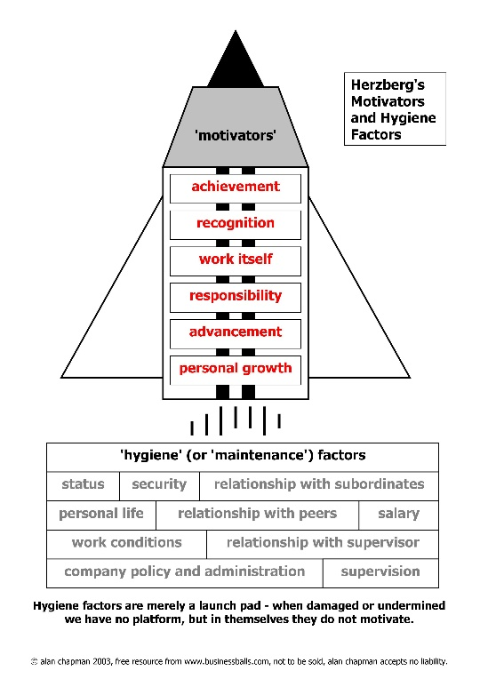
Frederick Herzberg’s studies identified two sets of factors affecting motivation and work: hygiene factors relating to the job environment, and motivators relating to the job content itself. He suggests that both need to be addressed not only to achieve good performance, but job satisfaction (Mullins, 2010).

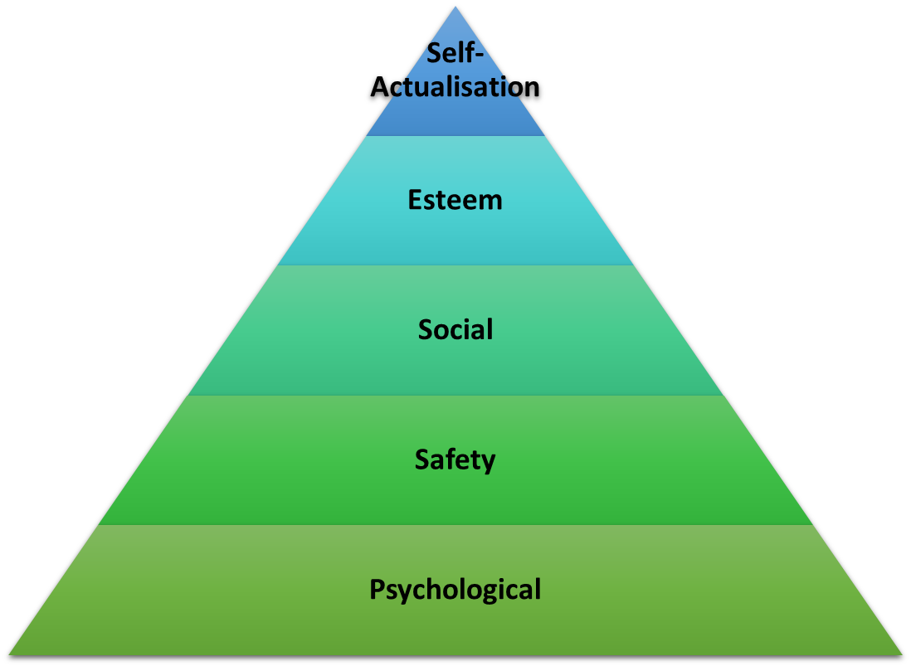

Abraham Maslow suggested that there are five hierarchies, or levels of needs, that explain how people are motivated. The five needs are: psychological, safety, social, esteem and self-actualisation. According to Maslow, an individuals unsatisfied needs become a motivating factor (Management Study Guide, 2020). He implies that each level of the hierarchy, needs to be addressed in order before and individual is fully satisfied and motivated.
Such theories suggest that there are multiple factors, which, when combined, can help to contribute to employee engagement and performance.
Key Characteristics of High Employee Engagement
Engagement has been highlighted as having various dimensions, however Purcell (2010) argues that there are common factors associated with engagement, known as ‘building blocks’ including:
- Trust in management
- Satisfaction with work
- Satisfaction with involvement in decision making in the workplace
- Quality of relationships between management and employees
- Satisfaction with the amount of pay received
- Job challenge
- Satisfaction with the sense of achievement from work
These building blocks can be seen as a starting point for engagement, and areas of interest for inclusion in HR policy and practice to encourage employees to exhibit discretionary effort.
MacLeod and Clarke’s research, identified four common themes that go together for successful employee engagement, known as the ‘four enablers of engagement’.
Emphasis on the role of managers in promoting an engagement culture have been highlighted by both MacLeod and Purcell. Bock (2016) uses the example of Google and their ways of management to depict elements of the enablers. Firstly, it removed all status symbols of its Managers in terms of their dress-code (Managers can be seen in casual wear and not suits), communal dining areas and parking spaces. The aim was to send a message to employees that Google live by their 10 values. The introduction of the ‘Googleist Survey’ annually asks around one-hundred questions, scored on a five-point scale, to around fifty-thousand Googlers to gauge their feedback on the organisation, and implement necessary changes if required.
The Institute of Employment Studies (IES) identified 25 ‘engaging managers’ who’s span of control varied from 4 people to over 5,000, who showed similar behavioural traits, that included: clear communication, a shared strategic vision, show an active interest in others and good leadership skills through positive role-modelling (Robinson & Hayday, 2009). It became apparent that the sample selected were also high-performance managers with high-performance teams, which in turn reflected in additional skills, such as dealing with and tackling poor performance quickly and effectively.
Pfeffer (1994) analysed the ways HR practices are used in the most successful and fastest growing organisations, compared to those of their less successful competitors. He concluded that a mixture of ‘best practices’ was used in most of these organisations. Purcell et. al (2003) suggests that performance is a function of people’s ability, motivation and opportunity, known as the AMO model. Purcell outlined eleven HR policies and practices that impacted on improving performance. The findings of such studies imply that when an organisation has in place ‘bundles’ or ‘high performing’ HR policies and practices, there is a positive response from employees. This is also reflected when there is a sense of shared purpose, and increased communication with line management.
The work by the Gallup Organisation aimed to address levels of employee engagement through a 12-question instrument. Harter et al (2002) states how by 2002, 198,514 people in 7,939 businesses had responded to the 12-question statements indicating whether they strongly agree, agree, disagree, strongly disagree or neither agree nor disagree to each statement.
The key findings suggest:
- Greater variation in the level of employee engagement between different business departments, compared to different organisations - due to the quality of the line management.
- Correlation between engagement scores and business performance
- Strong relationship between engagement and employee turnover
Both studies address the impact of HR policies and practices in helping to generate business performance by positively impacting on employees. The ‘black box’ studies use the term ‘discretionary effort’ to describe this, whereas the Gallup studies use ‘employee engagement’.
‘Best fit’ emphasises the importance of ensuring that HR strategies are appropriate to the circumstances of the organisation, including its internal and external environments. Best Fit strategies need to be vertically aligned with the business strategy, and horizontally aligned with all aspects of HR strategy so they are consistent and support each other. The greater the degree of horizontal and vertical integration with an organisation, the more effective HR strategy will be.
Some remain unconvinced by outcomes of such research. They suggest the likes of Google, Apple and Microsoft, use their superior performance leads to buy into and invest in a first-class approach to HRM and performance management, creating employee value propositions, becoming highly rewarding places to work.
Another explanation for the correlation is, if an organisation is professionally and efficiently managed and can generate more income for investment, this in turn could impact on performance and its approach to employment practices.
Rob Briner (2014) remains sceptical regarding employee engagement suggesting “there is no agreed definition, no evidence it can be reliably measures, its identical to ideas that have been around for 50 years, and there is currently no quality research showing it will increase performance”.
Importance of Employee Engagement
MacLeod (2009) claims that “engagement can be a triple win: for the individual at work, the enterprise or service, and for the country as whole”. This implies that engagement is beneficial to all. Towers Perrin 2007/2008 Global Workforce Study (2009) supports the positive impact of employee engagement, demonstrating links between high engagement and high performance. Other research has proven that engagement levels are positively associated with organisational commitment, customer satisfaction, employee loyalty, profitability and productivity (Harter et al, 2002).
Sir John Whitmore first published the GROW model in 1992. Organisations incorporate such models into their management processes and leadership models to engage people, encourage performance and maximise productivity by developing a coaching mindset. GROW stands for: Goal, Reality, Options and Will, and enables managers to ask questions in a carefully structured way promoting deeper awareness and greater responsibility (Performance Consultants, 2019).
Studies carried out by the Gallup Organisation have demonstrated huge organisational benefits when employee engagement and customer engagement are pursued in tandem. Similarly, these results were reflected in research carried out by Hutchinson and Purcell in 2003. They looked at four matched Tesco Stores in the UK and noted how simple changes in management style (moving away from top-down to freedom to respond to customers) improved the mood of the customer and employee.
Penhale Smith (2015) identifies two ways that HR can positively impact on employee engagement and commitment, the first by creating a culture where employees feel they fit in with the organisation and their visions and goals. This is something that can be addressed in the recruitment process and emphasised within the induction process. He notes that “skills can be taught, culture cannot”. By helping to create synergy between stakeholders and business objectives, and avoiding potential rifts between the two, HR are safeguarding the culture that employees align with.
Secondly, and as outlined by Herzberg and Maslow, showing appreciation and recognition towards employees helps to establish an appreciative work environment, which in turn continues to encourage and impact on employees.
Hearn (2020) argues that HR should not be solely responsible for employee engagement, when in fact it is the role of the whole organisation. He outlines that traditionally, HR have been responsible for collating necessary statistical data on such topic, however senior managers must drive the cultural shift, communication is a two-way system, line managers need to set an example and employees must be responsible for their own engagement.
As addressed by Maslow and Herzberg, it is not only internal factors that can impact on employees, a PESTLE analysis (CIPD, 2020) highlights the key Political, Economic, Sociological, Technological, Legal and Environmental, externals factors that are currently affecting an organisation.
Stakeholder Engagement
In a time where there is a lot of uncertainty, it is more important than ever that its stakeholders feel engaged with the goings on in the organisation and how it plans to successful move forward during the pandemic.
Customers are pivotal to organisations success, whether this is someone buying goods from their local shop, or an exchange in business, organisations rely on their trade. Organisations must ensure that company information is easily accessible either by including on their websites, or clearly setting out in contracts of employment. A clear and visible line of communication is vital to engaging effectively. Social media has proven to be an effective influencer, negatively and positively, however by spending time on such campaigns could work out beneficial.
Public sector organisations are heavily involved with Trade Unions which is of long-term importance in terms of engagement. There is the potential for a clash of ideologies, therefore engagement comes from a unitarist perspective, whereby the interest of management and employees is seen as being similar, and when conflict arises it is due to a misunderstanding. To eliminate any confusion, both the organisation and TU need to understand each other and build a level of trust.
Sources of Employee Engagement Data
Engagement data can be monitored internally using KPI’s and IDR’s. Cambridge University Press (2020) define Key Performance Indicators as “a way of measuring a company’s progress towards the goals it is trying to achieve”. Peter Drucker’s SMART approach explained by Mindtools (2019) enables specific, measurable, attainable, relevant and timely targets to be set and achieved. The use of KPI’s enables organisations to monitor organisational performance which is subsequently impacted by engagement such as sickness and employee turnover.
CareerSmart (2020) explain the purpose of an IDR from an organisation’s perspective is to “assess an individual’s performance and to reinforce the connection to the aims and objectives of the organisation”. The IDR process allows employees to express their feelings and highlight any concerns they may have, which can then be addressed.
Surveys are carried out internally and externally and allows for a wide range of opinions/views to be collated and help to identify where to take action to improve engagement and performance. A simple Google search identifies how common this method of collecting data has become, with hundreds of companies offering sample questions, or providing a service of creating a survey.
The UK Working Lives Report by CIPD (2019b) analyses survey data where respondents were asked to consider the work and jobs they do against various criterion of good work. This report highlighted the need for increased flexible working arrangements to focus on supporting better well-being and work-life balance, which is emphasised during the pandemic. The Office for National Statistics (2020) reported in April 2020 that 46.6% of people in employment did some work from home, 86% of whom did so as a result of the coronavirus pandemic.
Additionally, as an outcome of the Taylor Review of Modern Working Practices, highlighting 53 recommendations for the future of the UK labour market, the Governments responses formulated the ‘Good Work Plan’. As of April 2020, the Government had incorporated 51 of such recommendations into UK employment law (Hardes, 2020).
Key Trends in Employee Engagement
Human Resources Today (2020) along with Hearn (2019) explain that with the changes in society, comes the need for change in engagement and therefore predicts numerous trends for consideration by organisations in 2020.
Technology has already taken over the way in which HR and organisations function, making it easier for organisations to deliver quicker and better results. The people of this generation are adapting to technological changes, which for Millennials and Gen Zers, this is something they would struggle to work without. Technology is allowing for employees to connect with wider and more readily available information, providing opportunities for agile working. Engage for Success (2017) emphasises how “new tech tools can help employees and managers request, give and receive feedback on projects and goals in real time”.
Globalisation and technology have opened the doors to opportunities all over the world, therefore diversity and inclusion must prevail. People from different ethnicities, traditions and social structures enables unique ideas and different perspectives to be brought together. Inclusion in an organisation is the element that will encourage employee engagement. Globalisation has resulted in increased competition, which in turn, has resulted in organisations fighting against each other to attract the best talent.
Generation Y & Z are looking for different things out of the workplace, than that of 20 years ago. In view of this, consideration needs to be given to long-service schemes, and whether these are still relevant. This generation of workers are looking for career growth, therefore organisations must ensure that they foster an environment providing learning and development opportunities. Google’s ‘CareerGuru’ programme matches employees with Google executives whom provide one-on-one coaching and guidance.
Research from Gallup suggests that gender diversity brings a different dimension to engagement and performance. They suggest that female managers are more engaged with their employees, bringing distinctive viewpoints and ideas to the workplace. They also note heightened levels of engagement between female employees and female managers.
Future of Employee Engagement
The future of employee engagement is highly influenced by the external environment. Coronavirus has dramatically impacted engagement as a result of economic uncertainty, higher levels of unemployment, fears of losing their jobs and fears of sickness. Taylor and Woodhams (2016) expand on this, suggesting that employees are not necessarily engaged because they have a job, these factors may cause them to be non-engaged or even disengaged. They also note that whilst others are losing their jobs, an employee may become preoccupied in ensuring their own security, putting engagement on the back foot.
Technology will continue to transform the ways of working; therefore, efforts will be concentrated in ensuring that everyone is happy with such changes, offering support and advise where necessary. The emphasis on the need for technology has been heightened because of the pandemic. According to Grace (2020), by 2030, 75% of the workforce will be made up of Millennials, subsequently, organisations are going to have to adapt their engagement strategies to include open interaction, a good work culture, involvement, and achieving purpose and fulfilment.
She also goes onto imply that work-life balance is no more, instead taking the approach of work-life blend. Organisations will be required to embrace agile and flexible working to suit the needs of their employees and increase motivation.
Conclusion
It has been highlighted throughout, the importance of engagement to an organisation in terms of performance, and employee benefit. Times will continue to change and consequently, the ways of engagement will continue to change.

Reference List
ACAS (2014) The People Factor – engage your employees for organisational success. Available at: https://moodle.uwtsd.ac.uk/pluginfile.php/255715/mod_resource/content/1/Advisory-booklet-The-People-Factor.pdf (Accessed: 13 October 2020)
Barnett, J. (2019) ‘Why performance management and engagement should be linked’. Personnel Today. 20 December. [Online] Available at: https://www.personneltoday.com/hr/linking-performance-management-and-engagement/ (Accessed: 13 October 2020)
Bock, L. (2016) Work Rules! Insights from Inside Google that will transform how you live and lead. Great Britain: John Murray Publishers.
Bridger, E. (2018) Employee Engagement: A Practical Introduction. 2nd edn. London: Kogan Page.
Briner, R. (2014) ‘Don't believe the hype of employee engagement’ HR Magazine. 25 July. [Online] Available at: https://www.hrmagazine.co.uk/article-details/dont-believe-the-hype-of-employee-engagement (Accessed: 20 October 2020)
Cambridge University Press (2020) Definition of ‘KPI’. Available at: https://dictionary.cambridge.org/dictionary/english/kpi (Accessed: 21 September 2020)
CareerSmart (2020) Personal Development Review. Available at: https://careersmart.org.uk/your-career/appraisals-evaluations-reviews/personal-development-review (Accessed: 14 September 2020)
CIPD (2020) PESTLE Analysis. 26 February. [Online] Available at: https://www.cipd.co.uk/knowledge/strategy/organisational-development/pestle-analysis-factsheet (Accessed: 25 April 2020)
CIPD (2019a) Employee Engagement and Motivation. 19 December. Available at: https://www.cipd.co.uk/knowledge/fundamentals/relations/engagement/factsheet (Accessed: 13 October 2020)
CIPD (2019b) UK Working Lives. Survey Report. [Online] Available at: https://www.cipd.co.uk/Images/uk-working-lives-2019-v1_tcm18-58585.pdf (Accessed: 21 October 2020)
CIPD (2017) Developing Managers to manage sustainable employee engagement, health and well-being. Research Report. [Online] Available at: https://www.cipd.co.uk/Images/developing-managers-to-manage-sustainable-employee-engagement-health-and-well-being_2017_tcm18-18364.pdf (Accessed: 13 October 2020)
CIPD (2012) Emotional or Transactional Engagement: Does it Matter?. Research Insight. [Online] Available at: http://www.digitalopinion.co.uk/files/documents/Emotional_or_Transactional_Engagement.pdf (Accessed: 19 October 2020)
Engage for Success (2020) What is Employee Engagement? Available at: https://engageforsuccess.org/what-is-employee-engagement (Accessed: 14 October 2020)
Engage for Success (2017) How Technology is Helping to Transform Employee Engagement. Available at: https://engageforsuccess.org/technology-transform-employee-engagement (Accessed: 21 October 2020)
Hardes, H. (2020) ‘Good Work Plan: Important Legislation Changes for April 2020’. LighterHR. 11 February. [Online] Available at: https://lighterhr.co.uk/blog/good-work-plan-april-2020/ (Accessed: 21 October 2020)
Harter, J., Schmidt, F.L. and Hayes, T.L. (2002) ‘Business-unit-level relationship between employee satisfaction, employee engagement and business outcomes: a meta-analysis’. Journal of Applied Psychology. Vol 87, No 2.
Hearn, S. (2020) ‘Employee engagement isn’t just HR’s responsibility’. Personnel Today. 11 March. [Online] Available at: https://www.personneltoday.com/hr/responsibility-for-employee-engagement-hr/ (Accessed: 20 October 2020)
Hearn, S. (2019) 10 Employee Engagement Trends for 2020. 19 December. Available at: https://www.clearreview.com/10-employee-engagement-trends-for-2020/ (Accessed: 21 October 2020)
Human Resources Today (2020) 13 Employee Engagement Trends for 2020. 08 October. [Online] Available at: https://www.humanresourcestoday.com/2020/employee-engagement/trends/?open-article-id=12265293&article-title=13-employee-engagement-trends-for-2020&blog-domain=vantagecircle.com&blog-title=vantage-circle (Accessed: 21 October 2020)
Hutchinson, S. and Purcell, J. (2003) Bringing policies to life: the vital role of front-line managers in people management. London: Chartered Institute of Personnel and Development.
Kahn, W. (1990) ‘The psychological conditions of personal engagement and disengagement at work’. Academy of Management Journal. Vol 33.
Macleod, D. and Clarke, N. (2009) Engaging for success: enhancing performance through employee engagement. A Report to Government. London: Department for Business, Innovation and Skills.
Management Study Guide (2020) Maslow’s Hierarchy of Needs Theory. Available at: https://www.managementstudyguide.com/maslows-hierarchy-needs-theory.htm (Accessed: 14 September 2020)
Mindtools. (2019). SMART Goals – How to Make Your Goals Achievable. Available at: https://www.mindtools.com/pages/article/smart-goals.htm (Accessed: 12 February 2020)
Mullins, L.J. (2010) Management & Organisational Behaviour. 9th edn. Essex: Pearson Education Limited.
Office for National Statistics (2020) Coronavirus and homeworking in the UK: April 2020. Available at: https://www.ons.gov.uk/employmentandlabourmarket/peopleinwork/employmentandemployeetypes/bulletins/coronavirusandhomeworkingintheuk/april2020 (Accessed: 21 October 2020)
Penhale Smith, N. (2015) ‘The essential role of HR in employees’ engagement and commitment’ HR Zone. 29 January. [Online] Available at: https://www.hrzone.com/engage/employees/the-essential-role-of-hr-in-employees-engagement-and-commitment (Accessed: 20 October 2020)
Performance Consultants. (2019) The GROW Model. Available at: https://www.performanceconsultants.com/grow-model#:~:text=The%20GROW%20Model%20is%20a%20coaching%20framework%20used,for%20problem%20solving%2C%20goal%20setting%20and%20performance%20improvement (Accessed: 19 October 2020)
Pfeffer, J. (1994) Competitive Advantage Through People. Boston, M.A: Harvard Business School Press.
Purcell, J. (2010) ‘Building Employee Engagement’, ACAS Policy Discussion Paper [Online] Available at: https://archive.acas.org.uk/media/2672/Building-employee-engagement/pdf/Building_employee_engagement-accessible-version-Jun-2012.pdf (Accessed: 19 October 2020)
Purcell, J., Kinnie, N., Hutchinson, S., Rayton, B., & Swart, J. (2003) Understanding the People and Perfromance Link: Unlocking the Block Box, London: Chartered Institute of Personnel and Development
Richardson, B. (2017) ‘Are Employee Engagement and Employee Motivation the Same Thing?’ Forbes Magazine. 09 March. [Online] Available at: https://www.forbes.com/sites/paycom/2017/03/09/are-employee-engagement-and-employee-motivation-the-same-thing/#773c86ba2933 (Accessed: 19 October 2020)
Robinson, D. and Hayday, S. (2009) The Engaging Manager. Brighton: Institute for Employment Studies.
Taylor, S. and Woodhams, C. (2016) Human Resource Management: People and Organisations. 2nd edn. London: Chartered Institute of Personnel and Development.
Towers Perrin (2009) Global Workforce Study 2007/2008: closing the engagement gap – a road map for driving superior business performance. London: Towers Watson.
Woods, D. (2009) ‘Employee engagement is the key to innovation and competitiveness, says MacLeod Review’. HR Magazine. 16 July. [Online] Available at: https://www.hrmagazine.co.uk/article-details/employee-engagement-is-the-key-to-innovation-and-competitiveness-says-macleod-review (Accessed: 13 October 2020)

