Module: Changemakers: Building your Personal Brand for Sustainable Employment
Module code: BMHP5015
Assignment Title: Component 2: Assignment (Report)

Student Name:Sharm gill
Student Id: 2322793
Table of Contents
1. Introduction 3
2. Job Specification and Person Specification 4
3. Analysis of Employability Skills Required 5
4. Self-Assessment of Own Skills 6
5. Relevant Experience and Qualifications 7
6. Building My Personal Brand and Professional Identity 7
7. Building a Network for Successful Employment 8
8. Action Plan and Timeline 8
9. Communicating Skills to Employers 10
10. Conclusion 11
References 12
Appendices 14
Appendix A: Job Vacancy 14

1. Introduction
The report is dedicated to the work of the Health Care Assistant (HCA) on ward 10A of Mersey and West Lancashire Teaching Hospitals NHS Trust, which is a ward of frailty and aged care (Mersey and West Lancashire Teaching Hospitals NHS Trust, 2026). The goal is to analyse the employability skills required in this role, contrast my own skills with the requirements and create a viable professional development plan. The report will also look back into how I will be in a position to build my personal brand, sell my professional identity and build professional network that will assist me in getting a job in the field of health and social care in future.

2. Job Specification and Person Specification
The HCA role in Ward 10A is to provide personal care to the elderly and frail patients, working in the multidisciplinary team (MDT) and talking to the patients and their families in a caring way (Mersey and West Lancashire Teaching Hospitals NHS Trust, 2026). The major roles are to assist patients in their daily living, uphold patient dignity and privacy, record nutritional and fluid intake correctly, and play a role in a safe ward environment.
Person specification: NVQ Level 3 in Health and Social Care or equivalent, the Care Certificate and Literacy and Numeracy Functional Skills Level 2. Effective communication, collaboration, time management, resilience, and following professional advice and a non-judgmental and inclusive approach are the most important competencies (Mersey and West Lancashire Teaching Hospitals NHS Trust, 2026).
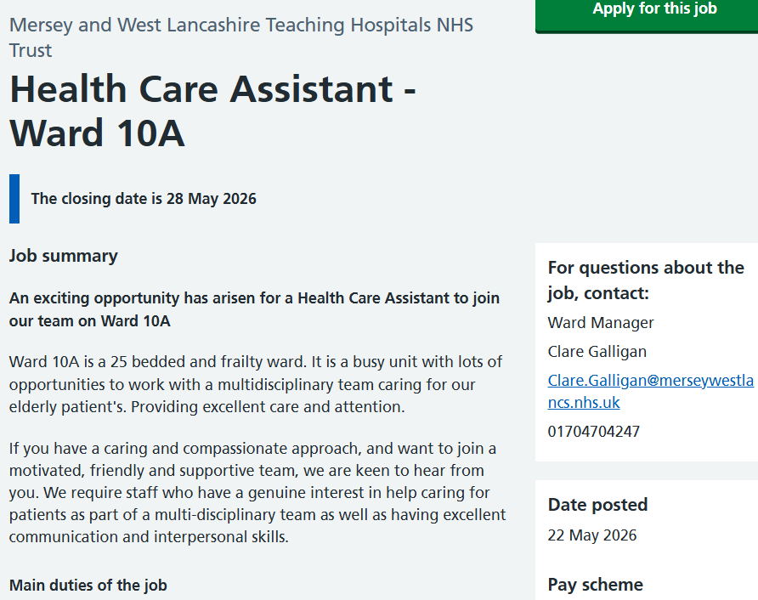
Source: (Mersey and West Lancashire Teaching Hospitals NHS Trust, 2026)
(Note: Full screenshot is given in appendix)

3. Analysis of Employability Skills Required
Employability skills are transferable skills and personal qualities that enable individuals to Transferable skills and personal qualities that allow people to work well in the workplace are called employability skills (Finch et al., 2019). As a Healthcare Assistant (HCA) in an old-age care facility, there are a number of critical skills that one will need. The kind of job that this is however, ensures that the emotional and physical demands of this job make sure that the demanded skills must be applied in stressful and at times high pressure circumstances.
Communication skills are essential in health and social care. HCAs have to speak with patients in an understandable and empathetic way, as they might be cognitively impaired or unable to articulate themselves (Bramhall, 2014, cited in McCormack and McCance, 2021). Nonetheless, the frailty ward communication may be challenging because of the large number of patients, distress, confusion, or end-of-life care scenarios, which demand the ability to be emotionally resilient (Maben et al., 2020).
Person-centred care entails the fact that patients are viewed as personalities and their needs and preferences are taken into account (Health Foundation, 2020). This is a best practice, but it has been established that in busy NHS environments where staffing issues are a problem, it is not always possible to deliver consistent person-centred care (Maben et al., 2020). This is how the ideal practice is different to the reality.
It is essential as teamwork is needed as HCAs work in multidisciplinary teams with nurses and other medical professionals. Teamwork can be beneficial in the work with patients and can decrease stress levels among the workers (West and Lyubovnikova, 2013, cited in Lyubovnikova et al., 2018). However, the hierarchical character of healthcare may sometimes lead to communication barriers, and it requires the skill to be sure and adaptable.
Resilience is particularly needed in frailty care because the latter is subjected to distressing circumstances most of the time. Nonetheless, resilience cannot be considered merely as an individual mandate. Traynor (2018) suggests that wellbeing is also influenced by such systemic factors as the level of staffing and workload pressure; thus, organisational support is also crucial.
Time management is essential since HCAs must pay attention to addressing the needs of different patients and maintaining records (NHS England, 2023). But it is not a simple task to practise prioritisation in the light of the growing work demands of the NHS.

4. Self-Assessment of Own Skills
In order to evaluate my skills, I used a SWOT analysis model to identify my Strengths, Weaknesses, Opportunities and Threats (Helms and Nixon, 2010, cited in Gurel, 2017). This helped me to match my current competencies with the job demands of the HCA. However, SWOT analysis is subjective and may lead to a bias in over-strengthening or under-strengthening the strengths or weaknesses, respectively (Gurel, 2017).
I was also more precise with the help of tutor feedback and Gibbs' reflective cycle (1988, cited in Bulman and Schutz, 2021). This assisted me in becoming more logical in my thinking regarding my experiences and problem areas of development. Nevertheless, the Gibbs model is not the most efficient model as it tends to be over-directed and does not promote further critical thinking in tricky situations (Bulman and Schutz, 2021).
Although these are the restrictions, a combination of both SWOT analysis and reflective practice offers a more balanced and dependable insight into my strengths.
Strengths | Weaknesses
- In the process of a degree in Health and Social Care.  - Excellent awareness of the values of care, dignity and person-centred care.  - Learned good communication and interpersonal skills at school.  - True sympathy and desire to work in care. | - Little clinical experience within a ward setting.  - Still to complete NVQ Level 3 or Care Certificate.  - The experience in using medical equipment, such as hoists.  - Continuing to build resilience to difficult and upsetting circumstances.
Opportunities | Threats
- University work experience.  - Widespread Care Certificate and NVQ courses.  - NHS provides methodical training and development of HCAs. | - The NHS HCA employment is very competitive.  - The pressures on the NHS workforce could restrict the training opportunities.  - The role can impact well-being on emotional needs.

Structured feedback can be used to identify and develop my skills with the assistance of my university lecturers and personal tutor. The NHS Staff Wellbeing will also help me in my emotional resilience because I will learn that it is not my work alone, but organisational support is needed (Traynor, 2018).

5. Relevant Experience and Qualifications
I have so far pursued a degree in Health and Social Care at university, and this has equipped me with a very good theoretical background of safeguarding, person-centred care, health legislation and good care practice principles. Studies have enabled me to have some familiarity with some of the most crucial legislation, like the Care Act 2014 and the Mental Capacity Act 2005, which are directly connected to the HCA position. Although I do not have any clinical work experience, my academic courses have developed transferable communication, reflective writing and professional values skills. I understand that it is a major drawback of being an applicant to the HCA job, insofar as clinical experience goes, so voluntary placements and the Care Certificate will have to be a priority on my action plan.

6. Building My Personal Brand and Professional Identity
A health and social care personal brand definition is how I can show my employers my values, skills and professional identity (Peters, 2019). This is because building a good personal brand is essential as it conveys my strengths and helps me build a career in a competitive healthcare setting.
I will develop my personal brand with the help of a professional LinkedIn profile, a customised CV, and a personal statement that would demonstrate NHS values, like care, respect and compassion (NHS England, 2023). My combination of academic qualifications in health and social care, my compassion towards the elderly patients and my desire to work in the NHS make me have my unique selling point. Skills for Care (2022) emphasises that personal values can be applied to care jobs just as much as technical skills, which is why this aspect can be located in my professional identity.
Some of the things I will engage in to develop my professional identity are reflective practice and continuing professional development (CPD). According to Trede and McEwen (2020), professional identity is developed when a person learns and participates in a professional community in a reflective manner. I will also use NHS Learning Hub and university resources to assist in the ongoing growth.

7. Building a Network for Successful Employment
One of the most important health and social care skills to seek employment and career advancement is networking (Hirschi, 2018). I will develop my professional network in a number of ways.
To start with, I will employ LinkedIn to reach the NHS professionals, HCAs, and other students. Healthcare is one of the trending sectors where LinkedIn allows me to track NHS Trusts, professional materials, and be exposed to potential employers (Ventola, 2019).
Second, I will visit university careers fairs and NHS job fairs during which I will face time with recruiters and practitioners. These events allow us to learn in various care environments and establish informal professional connections.
Third, I will do voluntary work in care environments. Placement networking will be used to build relationships with the HCAs and nurses who will provide guidance, mentorship, and references (Cruess, Cruess and Steinert, 2019).
Fourth, I will make an application to become an official NHS mentee after being employed. The concept of mentorship programmes can be characterised as a systematic support of more senior employees, job satisfaction and professional development (Jokelainen et al., 2019).
Finally, I know what is meant by professional supervision in healthcare. Supervision promotes safe practice and links practitioners with older colleagues who may facilitate career development (Hussein et al., 2022).

8. Action Plan and Timeline
The SMART action plan below details my plan of action in the next five years to realise and advance in the HCA role (Doran, 1981, cited in MacLeod, 2020). The SMART goals are Specific, Measurable, Achievable, Relevant, and Time-bound; this is why they are especially helpful as far as career planning in healthcare is concerned.
Timeframe | Action | Resource Needed
0–6 Months | Full Care Certificate; volunteer in a care facility; create a LinkedIn profile and resume; get a university mentor. | - Skills for Care  - university careers service  - volunteer organisations  - personal tutor.
6–12 Months | Take NVQ Level 3 Health and Social Care; acquire clinical skills via placement; network with other students on placement. | - Local college  - university placement team  - NVQ provider  - Placement supervisor.
Year 2 | Apply to HCA jobs; attend professional supervision after being hired; attend the NHS careers events and job fairs. | - NHS Jobs  - line manager supervision  - NHS job fairs  - reflective journal
Year 3 | Gain expert skills in frailty and elderly care; participate in the NHS mentorship scheme; participate in CPD seminars; develop LinkedIn contacts. | - NHS Learning Hub  - NHS mentor  - Skills for Care CPD resources
Years 4–5 | Advance to Senior HCA or nursing associate track; develop professional portfolio; develop peer mentoring relationships with new employees. | - NHS apprenticeship schemes  - Health Education England  - professional portfolio

9. Communicating Skills to Employers
I will inform my prospective employers about my skills using a well-organised CV that distinctly displays my qualifications, values and experience. I will also develop a professional profile on LinkedIn that will act as my representation over the internet. Ventola (2019) states that in the modern healthcare setting, a strong online presence of the professional can significantly boost visibility and employability. I will also draft a specific application cover letter for each application where the skills that I have match with the job person specification. I will also ask my university tutors to provide references, and they will be in a position to comment on my academic capacity and professional values, which are most needed at this stage, as I do not have much clinical practice at this stage.

10. Conclusion
This report has addressed the employability skills that I will need to work as an HCA in the Mersey and West Lancashire Teaching Hospitals NHS Trust and assessed my existing skills throu a SWOT analysis. Even though my academic background and values are rather in line with the NHS, I understand what aspects of clinical experience and resilience need to be improved.
Some of the greatest challenges of the job identified in the analysis included emotional pressures, work stress, and complexities in the team. The SMART action plan will offer a five-year plan that will offer me a clear development path in regards to qualifications, voluntary experience and networking of professionals.
Altogether, I would like to become an informed and caring Health Care Assistant through the creation of my personal brand, professional identity, and practice.

References
Bulman, C. and Schutz, S. (eds.) (2021). Reflective Practice in Nursing. 6th edn. Oxford: Wiley-Blackwell.
Care Act 2014. (2014). Care Act 2014. London: HMSO. Available at: https://www.legislation.gov.uk/ukpga/2014/23/contents [Accessed: May 2026].
Cruess, R.L., Cruess, S.R. and Steinert, Y. (2019). Supporting the development of professional identity: general principles. Medical Teacher, 41(6), pp. 641–649. doi: 10.1080/0142159X.2018.1536260.
Finch, D.J., Peacock, M., Lazdowski, D. and Hwang, M. (2019). Examining the factors that influence students' perceptions of employability. Education and Training, 61(1), pp. 62–75. doi: 10.1108/ET-09-2016-0143.
Gürel, E. (2017). SWOT analysis: a theoretical review. Journal of International Social Research, 10(51), pp. 994–1006. doi: 10.17719/jisr.2017.1832.
Health Foundation (2020). Person-Centred Care Made Simple. London: Health Foundation. Available at: https://www.health.org.uk/publications/person-centred-care-made-simple [Accessed: May 2026].
Hirschi, A. (2018). The fourth industrial revolution: issues and implications for career research and practice. Career Development International, 23(2), pp. 275–285. doi: 10.1108/CDI-08-2017-0142.
Hussein, S., Manthorpe, J. and Penhale, B. (2022). Supervision in adult social care: purposes, challenges and practice models. British Journal of Social Work, 52(3), pp. 1478–1496. doi: 10.1093/bjsw/bcab120.
Jokelainen, M., Jamookeeah, D., Tossavainen, K. and Turunen, H. (2019). Finnish and British mentors' conceptions of facilitating nursing students' placement learning and professional development. Nurse Education in Practice, 38, pp. 63–71. doi: 10.1016/j.nepr.2019.05.012.
Lyubovnikova, J., West, M.A., Dawson, J.F. and West, T.D. (2018). Is making error-free work the top priority? The role of error management culture in health care teams. Journal of Occupational and Organizational Psychology, 91(3), pp. 536–558. doi: 10.1111/joop.12206.
Maben, J., Taylor, C., Reynolds, E., McCarthy, I. and Leamy, M. (2020). Realist evaluation of Schwartz rounds for enhancing the delivery of compassionate healthcare. Southampton: NIHR Journals Library. doi: 10.3310/hsdr08290.
MacLeod, L. (2020). Making SMART goals smarter. Physician Executive, 38(2), pp. 68–72.
McCormack, B. and McCance, T. (2021). Person-Centred Practice in Nursing and Health Care: Theory and Practice. 3rd edn. Oxford: Wiley-Blackwell.
Mersey and West Lancashire Teaching Hospitals NHS Trust (2026). Job Advert. [online] Jobs.nhs.uk. Available at: https://www.jobs.nhs.uk/candidate/jobadvert/C9409-26-0501?country=GB-ENG&searchFormType=main&keyword=Social%20Worker&location=uk&language=en [Accessed 25 May 2026].
NHS England (2023). NHS Long Term Workforce Plan. London: NHS England. Available at: https://www.england.nhs.uk/long-read/nhs-long-term-workforce-plan [Accessed: May 2026].
Peters, T. (2019). The Brand You 50: Fifty Ways to Transform Yourself from an Employee into a Brand. New York: Knopf.
Skills for Care (2022). The State of the Adult Social Care Sector and Workforce in England. Leeds: Skills for Care. Available at: https://www.skillsforcare.org.uk [Accessed: May 2026].
Traynor, M. (2018). Resilience and its discontents: critiquing the concept of resilience in nursing. Journal of Research in Nursing, 23(8), pp. 639–641. doi: 10.1177/1744987118799370.
Trede, F. and McEwen, C. (2020). Educating the Deliberate Professional: Preparing for Future Practices. Professional and Practice-based Learning, 21. doi: 10.1007/978-3-030-58375-0.
Ventola, C.L. (2019). Social media and health care professionals: benefits, risks and best practices. Pharmacy and Therapeutics, 39(7), pp. 491–499.

Appendices

Appendix A: Job Vacancy



