Managing a Hardware/Software Project for Disaster Recovery

Name: Jonathan S. Davies
Student Number: 1707239
Lecturer: Susan Maw
Module: Project Management
Module Code: ACDA5004
Table of Contents
Introduction 3
1. Risk Management 3
1.1 Risk Identification 3
1.2 Risk Analysis 3
1.2.1 Qualitative Risk Analysis 4
1.3 Risk Planning 5
1.3.1 Accept 5
1.3.2 Lessen 5
1.3.3 Avoid 5
1.3.4 Share 5
1.4 Risk Register 6
2. Code of Practice - Sustainability 7
2.1 What is Sustainability? 7
2.2 The Effects of the Project 7
2.2.1 First Order (Direct Impact) 7
2.2.2 Second Order (Enabling Impact) 8
2.2.3 Third Order (Systematic Impact) 8
2.3 Effects of the Project Summary Table 9
3. Code of Practice - Legal and Ethical Issues 9
3.1 General Data Protection Regulations (GDPR) 9
3.1.1 Privacy 9
3.1.2 Right to Erasure 9
3.2 Codes of Conduct 9
3.2.1 British Computer Society 10
3.2.2 IEEE 10
3.3 Impact of Brexit on the Third Sector 10
3.3.1 Tax Reliefs 10
3.3.2 EU Funding 10
3.3.3 Economic Instability 10
3.3.4 Legislative Change 10
4. Quality Assurance 11
4.1 What is QA? 11
4.1.1 ISO (International Organisation for Standardisation) 11
4.1.2 How it Affects the Project 11
4.1.3 SQA (Software Quality Assurance) 12
References 13
Appendices 15
Appendix Section 1 (Expand to view) 15
Appendix 1A 15
Appendix 1B 15
Appendix 1C 15
Appendix Section 2 (Expand to view) 15
Appendix 2A 15
Appendix 2B 15
Appendix 2C 15
Appendix 2D 15
Appendix 2E 15
Appendix 2F 15
Appendix Section 3 (Expand to view) 15
Appendix 3A 15
Appendix 3B 15
Appendix 3C 15
Appendix 3D 15
Appendix 3E 15

Introduction

The goal of this report is to gain an insight into the risk management, sustainability, legal and ethical issues and quality assurance elements of the BeSafe project. Without these key fields, effective project management would not be possible. It ensures best practices are being learnt and implemented.

Risk Management

Risk Identification

The first step in combatting potential problems that may occur within this project is to ascertain the risks that it may pose or attract. The complete list of risks associated with the BeSafe project is likely to be far too extensive for this section of the report, so focus shall be placed on areas deemed the most probable for exposure. Whilst a range of tools and techniques has been considered to best extract potential risks, a simple brainstorming session with all project members was implemented to formulate the list of established risks [1]. Each risk can be categorised into one of three areas, Operational Risk, Short-Term Strategic Risk or Long-Term Strategic Risk [2]. In this report, both elements of the strategic risk are going to be merged into one field.

Operational Risk –
- Software incompatibilities (R1)
- Gold Plating (R2)
- Conflict of ideas or implementation (R3)
Strategic Risk –
  - Project is too technically demanding for the project members (R4)
  - Team members are taken ill or otherwise unable to work (R5)
  - Project members not completing their allotted work (R6)
  - An uneasy group dynamic (group members not getting along) (R7)
  - Legal complications surrounding Brexit (R8)

Risk Analysis

The analysis stage will take what was uncovered in section 1.1 and delve into the likelihood and impact of each risk. The outcome of this section will be a contributing factor towards a completed risk register. The two most commonly found methods of risk analysis are Qualitative and Quantitative. Both works to achieve the same goal but reach it in different ways. Qualitative analysis takes both the identified risks and an occurrence/impact table and creates Probability Impact Matrix. This matrix allows each risk to be plotted in accordance with its attached probability and impact rating. Once this is done, the numerical ratings of both the impact and probability can be multiplied to give a number that can be placed on a list in size order, thus showing the most severe risks to the project [3]. Quantitative takes a very similar approach except explicitly deals with the numerical value of each risk and prefers to display its output in a percentage. In this report, only the qualitative method shall be implemented.

Qualitative Risk Analysis
The Occurrence table (table 1) and Impact table (table 2), found below, contain the grading framework that will serve as a key for the Risk Assessment Matrix.

- Occurrence Table
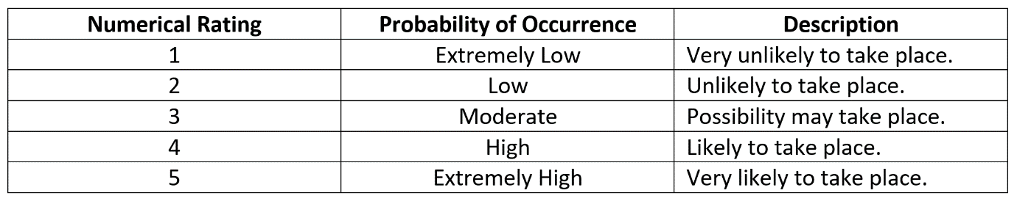
Figure 1 - Occurrence Table [4]

– Impact Table
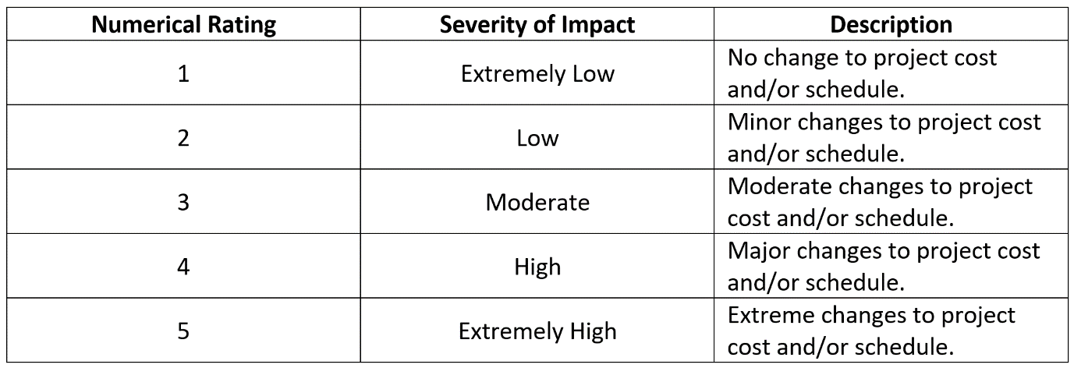
Figure 2 - Impact Table [4]

– Risk Assessment Matrix
Each point from the list in risk identification, section 1.1, corresponds to a point on the table. The line of tolerance has been outlined in orange.

Table 3 - Risk Assessment Matrix
Once each risk has been plotted into the matrix, both the values of their impact and occurrence score can be multiplied together and ordered numerically to show which risks need more attention.

Risk Planning

Each identified risk should have a risk plan attached to it. If this plan does not exist, and the risk evolves into an issue (i.e. it has transcended from potentially happening to actually happening), there will be no formal method to deal with any outcome or problem related to it. Listed below are the four main ways in which a risk can be planned for [5].

Accept
To accept a risk means to do nothing more to prevent it happening. This pathway is usually reserved for either low impact or low occurrence risks.

Lessen
If the risk carries a little more weighting, then lessening its likelihood or impact via targeted mitigation may lower the consequences.

Avoid
When risks seem like they may seriously affect the project and that the outcome of this would be catastrophic, then avoidance procedures should be put in place to ensure that it does not happen.

Share
Sharing the risk involves purchasing insurance that can help cover the financial loss should the risk occur.

Risk Register

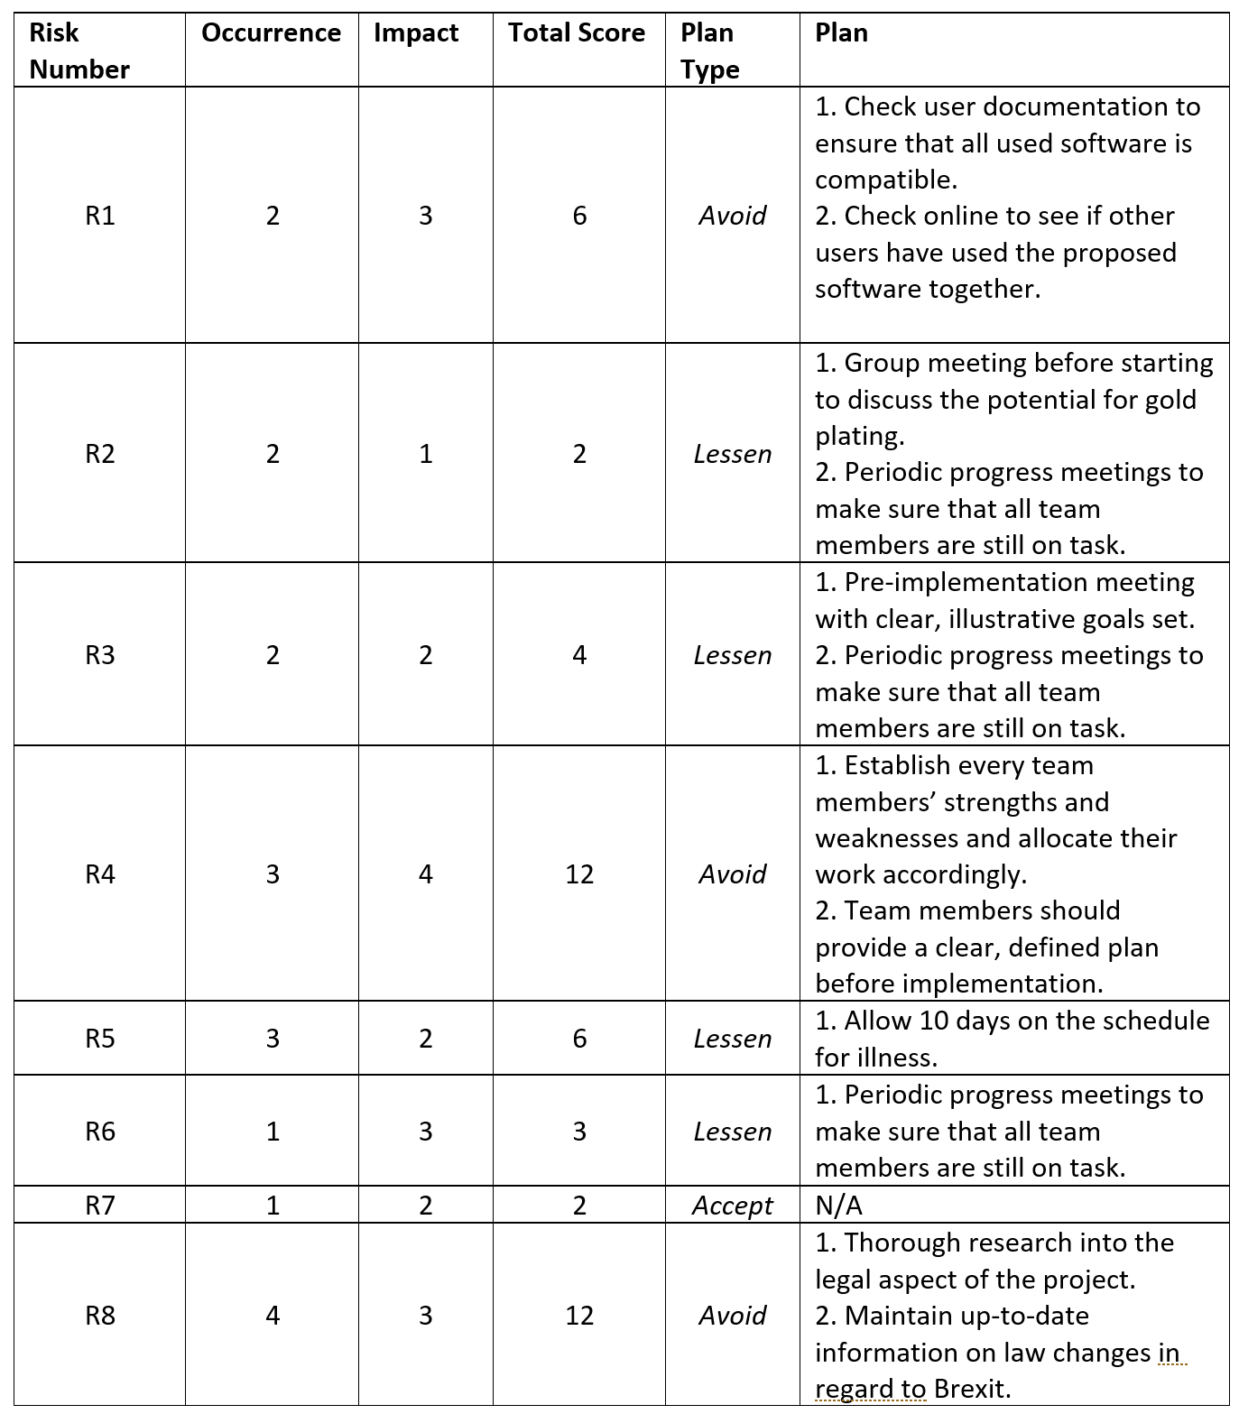
Figure 3 - Risk Plan Table

Code of Practice - Sustainability

What is Sustainability?

Sustainability is the act of using less than is replenished. In 2016, the Information and Communications industry used approximately 1.3mtoe (million tonnes of oil equivalent) in power usage [6] from fossil fuels. When referring to sustainability, we are talking about how to decrease this amount of energy as much as possible.

The Effects of the Project

Within this section, the effects of the project shall be analysed through the examination of the first, second and third order impacts on the environment (direct, enabling and systematic impacts). The direct impact relates to the physical outcome of the ICT industry’s presence, the enabling impact focuses on the way in which it may reduce other industries environmental footprint and the systematic impact relates to the long-term behavioural changes.

First Order (Direct Impact)

Production Supplies & Transportation of Devices
Each member of the group used either a laptop/desktop or mixture of both to complete this assignment. All of those devices have been manufactured at the cost of raw materials obtained from the environment and alarmingly only around 2% of these materials actually end up inside the device, the remaining 98% is wasted [7]. The country of production must also be considered, with most end-devices starting their life in countries like China or Malaysia, the cost of transportation to the rest of the world (both financial and environmental) must be noted.

Personal transportation
Much of the work that was undertaken by the team was done at the university. To get there, all members must use some form of motorised transport, whether personal or public, and this will produce CO2 emissions. In 2017, 34% of all UK carbon emissions came from road users [8].

Energy consumption (Personal devices and university)
The building in which the work for the project took place needed to provide the team members with adequate lighting, heating and power. The building itself is a 24-hour complex and whilst the lighting system is operated through motion sensors and where possible uses LED fixtures, there is still an environmental impact.

First Order Impact Conclusion
After examining the effects that the project has had on the first order impact has over been negative. Each of the areas considered has been of no benefit to the environment.

Second Order (Enabling Impact)

Going Paperless
One positive about the project is that it is entirely paperless. Every aspect of the research, design, implementation and evaluation phase was done via either computer or whiteboard. Paper usage is declining in the UK and around the world [9] due to the increase in digital platforms. Whilst it may seem that this is inherently a good thing as the deforestation and chemical footprint that paper creation leaves in its wake is devastating to the environment, many people and organisations believe that going paperless in favour of digital may not be so green. This is due the e-waste and extraction of raw materials needed to create these devices [10].

E-Communication
E-Communication involves working remotely so that the team does not need to physically meet up to work together. This project used a variety of technologies to alleviate the need of traveling such as Skype, Visual Studio Live, GitHub and a shared OneDrive folder. Combining these services provided the team with an excellent platform from which they were able to work from anywhere they chose. This ability to work remotely ensured that vehicles were not being driven unnecessarily and adding to the CO2 emission collective.

Second Order Impact Conclusion
Overall the project is considered to have a positive impact on the environment providing the digital impact is indeed less than its paper counterpart.

Third Order (Systematic Impact)

Transportation Volume
With team members traveling into the university each day, they are adding to the volume of traffic. Although the project is small, if it were to grow it could result in many project members commuting to and from the university potentially at peak travel times. The local council may decide that action needs to be taken to reduce congestion and could change road layouts or impose a congestion charge for the city centre like that of London.

Increase in Power Usage
In an identical scenario to the projects growth as seen in section 2.2.3.1, there may be a large increase for the demand for power. The university may need to change the way in which it distributes its electricity to its students or find ways in which to reduce the costs for it.

Third Order Impact Conclusion
The third order is viewed overall as to have a negative impact as it demands high electricity and road usage.

Effects of the Project Summary Table

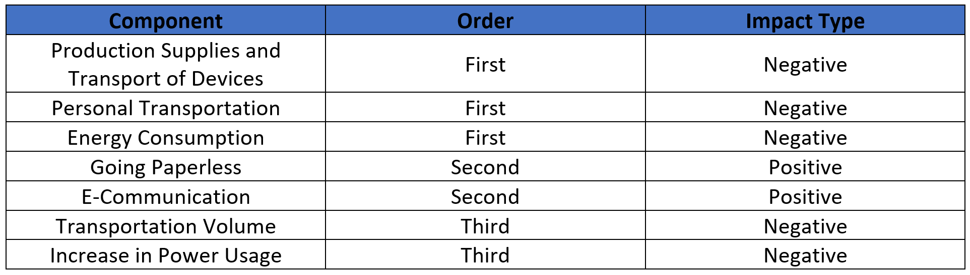

Code of Practice - Legal and Ethical Issues

General Data Protection Regulations (GDPR)

The GDPR is a replacement for the Data Protection Act 1998 that was introduced into UK law in 2018. It covers all aspects of privacy on individual’s data and ensures that such data is handled in a fair and appropriate manner.

Privacy
The BeSafe project is expected to hold data on individual’s that use the application and potentially people related to them. It is therefore expected that the application will hold personal data on the user. The definition of what constitutes as personal data is any data that can lead to the identification of an individual whether directly or indirectly [11]. The handling of this information needs to conform with all GDPR articles, but notable attention should be shown for article 6 (Lawfulness of processing), 7 (Conditions for consent), 24 (Responsibility of the controller) and 28 (Processer). The BeSafe application will need to ensure that users are made aware of their privacy rights and understand what will be done with their personal data.

Right to Erasure
The right to erasure essentially means that the individual in question holds the right to obtain all information regarding him or herself providing that one or more of six conditions is met [12]. Should an erasure be approved, the controller will need to take all measures to remove the data and delete it, whatever costs this may incur. Regarding the project, it is important that clients are fully aware that this is an option that is available to them if they choose.

Codes of Conduct

When working in the IT sector, adhering to a code of conduct is an important part of building a trust and rapport with clients, employers/employees and colleagues. It shows that the individual holds the value of the work to a high standard and does not use questionable tactics to secure work or engage in illegal activities.

British Computer Society
The BCS hold an extensive code of conduct [13] that all members must adhere too. The code is split into four sections:
- Public Interest – Values on discrimination, equal access and general regard for health.
- Professional Competency and Integrity – Not misleading people about your skillset, reject bribery and respecting others’ work.
- Duty to Relative Authority – Accepting responsibility for your work, not withholding information about services or products and avoiding conflict.
- Duty to the Profession – Hold up the reputation of the profession, look to improve current standards and support other members.

IEEE
The IEEE code of ethics [14] is not as in depth as the BCS’s code but does generalise around the same points. Just like the BCS, the IEEE focuses on honesty, integrity, professionalism and rejecting all forms of malicious or deviant behaviour.

Impact of Brexit on the Third Sector

Brexit is likely to have a catastrophic affect on third sector organisations. Four key fields have proven to be recurring areas in which the impacts will be greatest; tax reliefs, EU funding, economic instability and legislative change [15].

Tax Reliefs
If a UK citizen is donating to an EU charity, they are eligible to claim back the tax and vice versa for EU citizens. With Britain leaving the EU, this seems extremely unlikely to continue leaving many UK based charities that rely on EU donations in serious financial danger.

EU Funding
Charities that rely on EU funding will be hit very hard due to the fact that the EU sends UK charities approximately £300million per year. The effects of this can already be seen as 20% of European third sector staff have left [16].

Economic Instability
Charities are currently preparing for a worst-case scenario after the Brexit negotiations are finished and because of this, various local governments are stepping in to help the third sector by offering financial support [17].

Legislative Change
With Britain leaving the EU, charities may have the chance to create new rules and try to encourage new legislation to pass that will be more beneficial to them directly.

Quality Assurance

What is QA?

Quality assurance is the process of evaluating if a product reaches its proposed requirements. It ensures that the end-user is receiving the best possible version of the product/service.

ISO (International Organisation for Standardisation)
The ISO are a non-governmental, international group that standardises the development and requirements for thousands of products. The standards that they apply are globally accepted and this produces a safety net for consumers, making sure that any products with an ISO certificate are of sound quality [18].
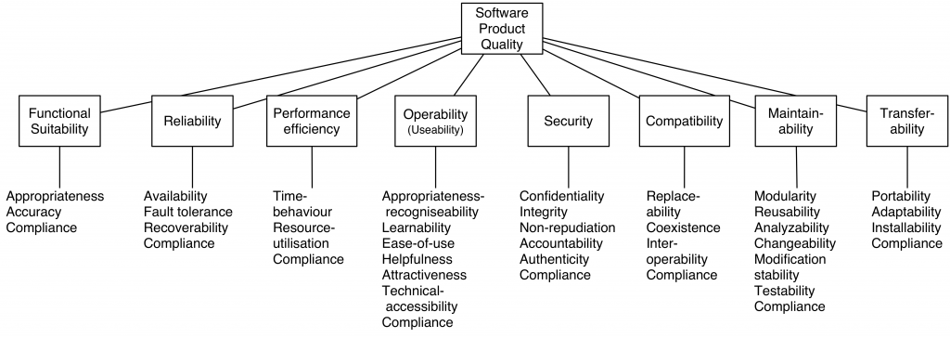
Figure 4 - Overview of ISO 25010 [19]

How it Affects the Project
Software Qualities | Relation to Project
Functional Stability | Because the project so far is a prototype, it will not adequately satisfy the users’ needs.
Reliability | This category is probably the most important for our project as the application is designed to be used in potentially life-threatening situations.
Efficiency | The product needs to have a very fast response time as it may be used in high-stress situations.
Operability | The application will be used in many different countries where English won’t be the first language. Because of this the app needs to have a natural and fluid layout that relies on self-explanatory images and icons instead of text.
Security | The users are expected to enter personal information into the app and this personal data will have to be handled properly.
Compatibility | The application will run on both android and IOS to cover the majority of mobile phones on the market.
Maintainability | Test environments would need to be implemented in order to add any new features to the application.
Transferability | The application will go through an optimisation stage where the actual size of the app will become as small as possible, thus making installation faster and easier.

SQA (Software Quality Assurance)
SQU is a stemmed branch of QA that covers software specifically. The reason that it is exists is that there are multitude of differences when testing and developing software compared to other industrial products. Two of the main issues that surround SQA are the complexity and visibility [20].
- Complexity – Software is usually a very complex thing, using thousands of operational elements.
- Visibility – As software is an invisible, or intangible, it is far more open to the overlooking of bugs or defects when compared to a physical product like a bicycle, where you can visibly see if something is wrong.

References

[1] | PMBOK, “Project Risk Management,” in A Guide to the Project Management Body of Knowledge, Project Management Institute, Inc., 2013, pp. 319-325.
[2] | A. R. N. O. E. O. Hans Petter Krane, “Categorizing risks in seven large projects—what risks do the projects focus on?,” in PMI Global Congress, Amsterdam, 2009.
[3] | S. S. Bonham, “An Enterprise Risk Management Methodology - Risk Assessment,” in Actionable Strategies Through Intergrated Performance, Process, Project and Risk Management, Boston, Artech House, 2008, pp. 194-195.
[4] | Project Management Skills, “Qualitative Risk Analysis and Assessment,” Project Management Skills, 2018. [Online]. Available: https://www.project-management-skills.com/qualitative-risk-analysis.html. [Accessed 09 01 2019].
[5] | P. Roberts, “How Do I Identify and Manage the Risks,” in Effective Project Management, London, Kogan Page Limited, 2011, pp. 145-148.
[6] | Office for National Statistics, “Energy: Total Consumption,” 12 July 2018. [Online]. Available: https://www.ons.gov.uk/economy/environmentalaccounts/datasets/ukenvironmentalaccountstotalenergyconsumptionbyindustry. [Accessed 12 January 2019].
[7] | V. S. Adib Kabir Chowdhury, “Information Technology: Impacts on Environment and Sustainable,” Pertanika Journal of Science and Technology, vol. 1, no. 23, pp. 128-129, 2015.
[8] | Department for Business, Energy & Industrial Strategy, “2017 UK Greenhouse Gas Emissions, Provisional Figures,” 2017. [Online]. Available: https://assets.publishing.service.gov.uk/government/uploads/system/uploads/attachment_data/file/695930/2017_Provisional_Emissions_statistics_2.pdf. [Accessed 22 01 2019].
[9] | M. Brunton, “UK Paper Dropped in 2015,” Brunton Publications, 22 February 2016. [Online]. Available: https://www.thepackagingportal.com/industry-news/uk-paper-production-dropped-in-2015. [Accessed 23 January 2019].
[10] | D. Carli, “Going Paperless: Not as Green as You May Think,” GreenBiz, 14 April 2010. [Online]. Available: https://www.greenbiz.com/blog/2010/04/14/going-paperless-not-green-and-tree-friendly-you-think. [Accessed 23 January 2019].
[11] | Intersoft Consulting, “Article 4 GDPR,” 25 May 2018. [Online]. Available: https://gdpr-info.eu/art-4-gdpr/. [Accessed 23 January 2019].
[12] | Intersoft Consulting, “Right to erasure (‘right to be forgotten’),” 25 May 2018. [Online]. Available: https://gdpr-info.eu/art-17-gdpr/. [Accessed 23 January 2019].
[13] | British Computer Society, “Code of Conduct for BCS Members,” 2015.
[14] | Institute of Electrical and Electronics Engineers, “IEEE Code of Ethics,” IEEE, [Online]. Available: https://www.ieee.org/about/corporate/governance/p7-8.html. [Accessed 23 January 2019].
[15] | E. Deane, “How Will Brexit Affect The Third Sector,” The STEP Blog, 7 September 2016. [Online]. Available: https://blog.step.org/2016/09/07/how-will-brexit-affect-the-third-sector/. [Accessed 14 January 2019].
[16] | J. Steadman, “The Potential Impact of Brexit on the Third Sector,” Red Brick, 28th November 2018. [Online]. Available: https://www.redbrickresearch.com/2018/11/28/impact-of-brexit-third-sector/. [Accessed 14 January 2019].
[17] | The Welsh Government, “Funding to help third sector prepare for Brexit,” Welsh Government, 21 October 2018. [Online]. Available: https://gov.wales/newsroom/people-and-communities/2018/third-sector-brexit-funding/?lang=en. [Accessed 24 January 2019].
[18] | International Organization for Standardization, “About ISO,” ISO, 2018. [Online]. Available: https://www.iso.org/about-us.html. [Accessed 23 January 2019].
[19] | No Complexity, “Overview of ISO 25010,” Business IT Design, 11 August 2016. [Online]. Available: https://nocomplexity.com/overview-of-iso-25010/. [Accessed 24 January 2019].
[20] | D. Galin, “The Software Quality Challenge,” in Software Quality Assurance, Harlow, Pearson Education Limited, 2004, pp. 4-7.

Appendices

- Appendix section 1 involves screen shots of the product in development in visual studio.
- Appendix section 2 shows the team communication tools that were implemented.
- Appendix section 3 displays the Gantt chart screenshots.

Appendix Section 1 (Expand to view)

Appendix 1A
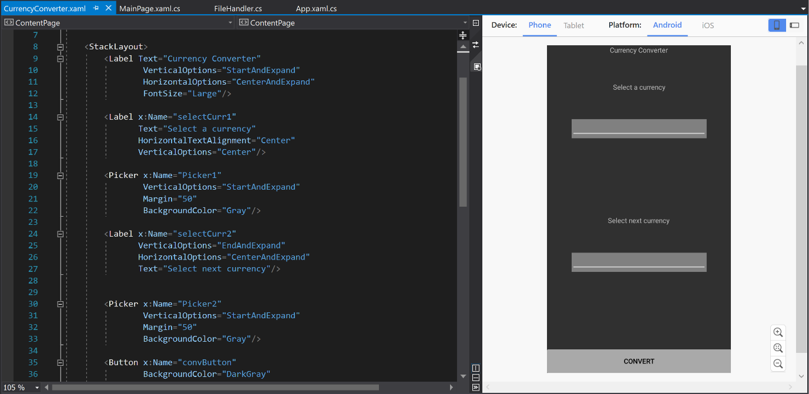
Appendix 1 – Currency Conversion Page Creation (XAML)

Appendix 1B

Appendix 2 - Currency Conversion Back-End (C#)

Appendix 1C
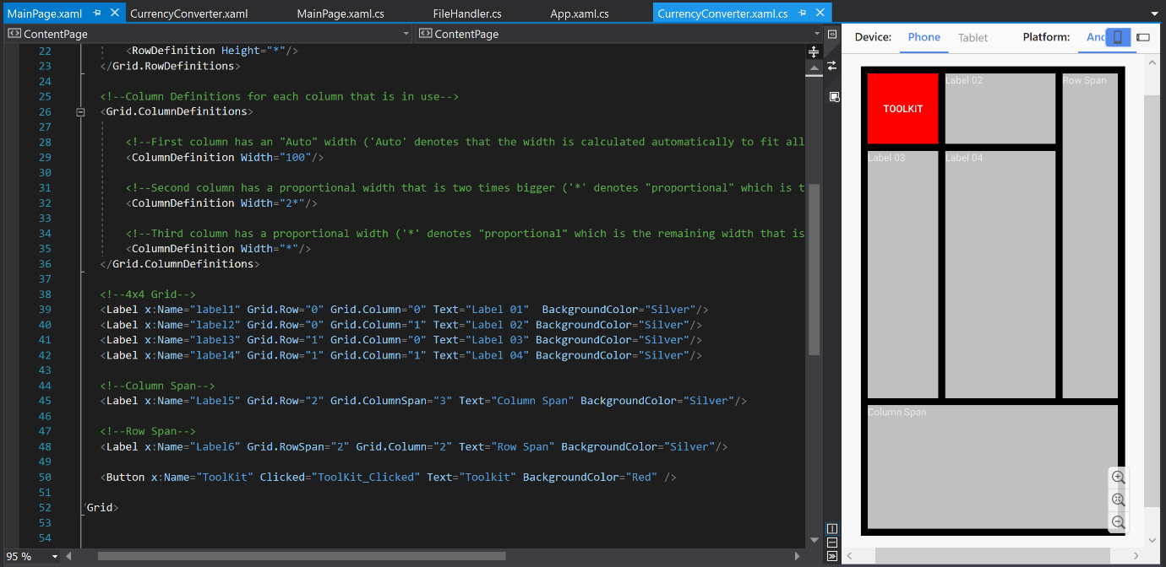
Appendix 3 - Main Page Creation (XAML)

Appendix Section 2 (Expand to view)

Appendix 2A
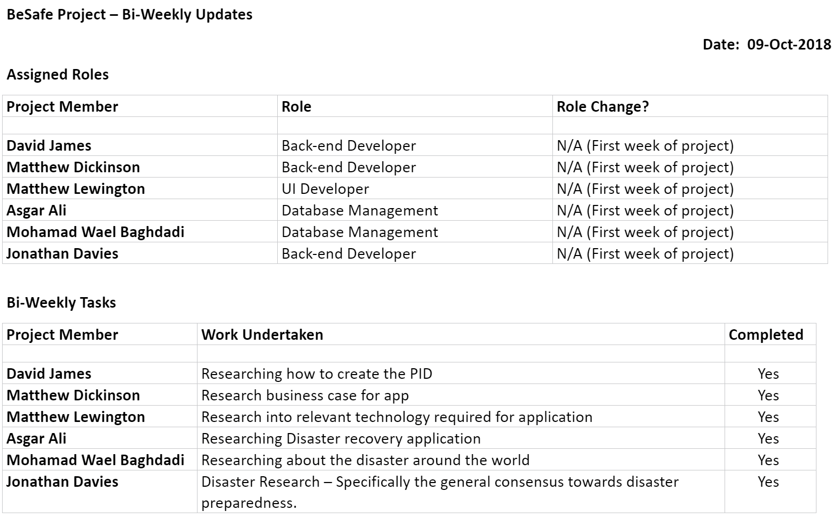
Appendix 4 - Weekly Meeting Sheet 1

Appendix 2B
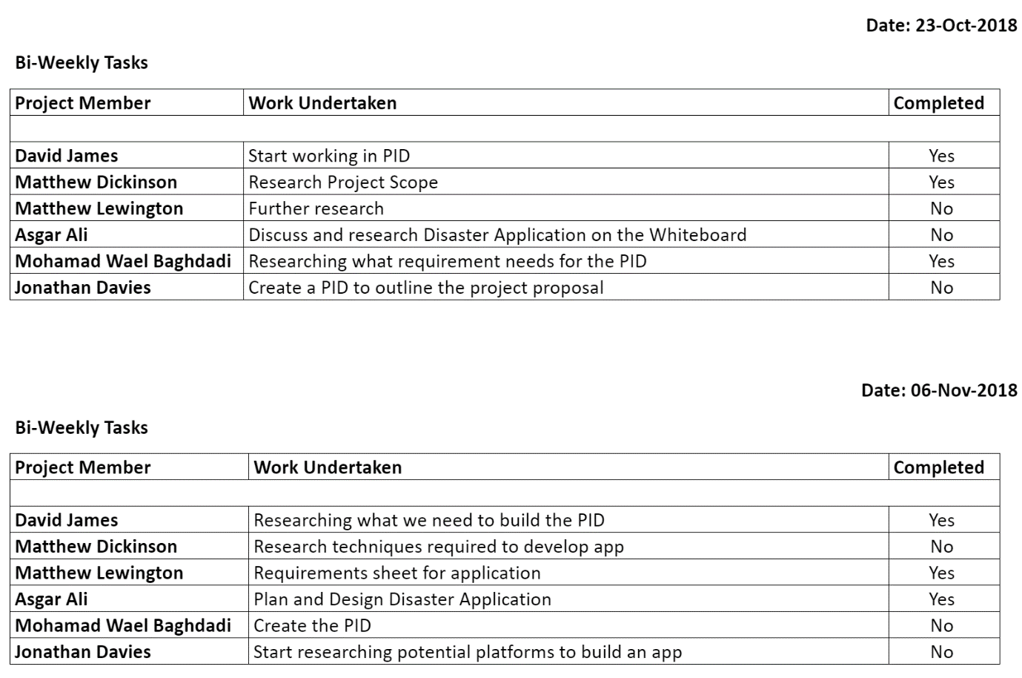
Appendix 5 - Weekly Meeting Sheet 2

Appendix 2C
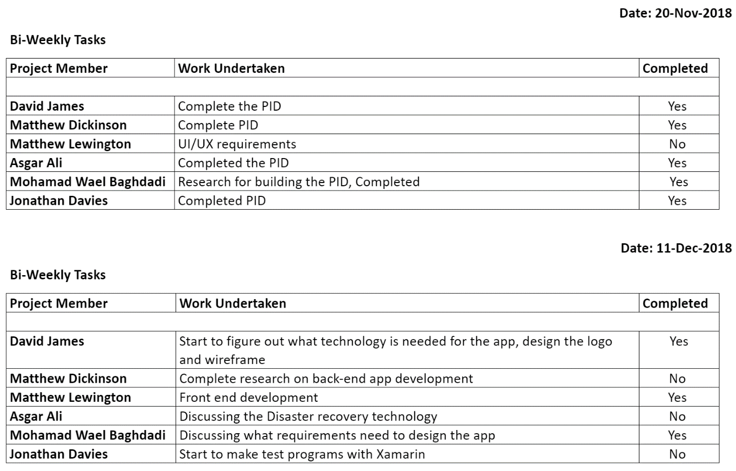
Appendix 6 - Weekly Meeting Sheet 3

Appendix 2D
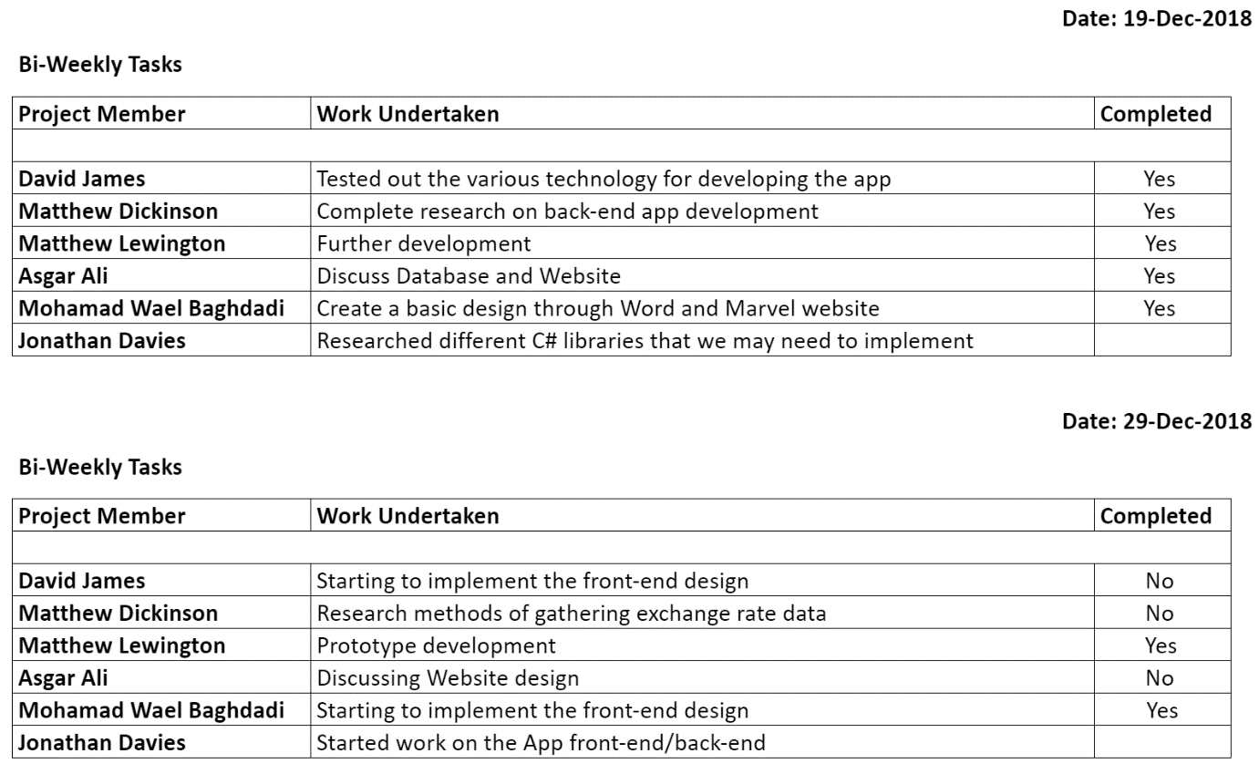
Appendix 7 - Weekly Meeting Sheet 4

Appendix 2E
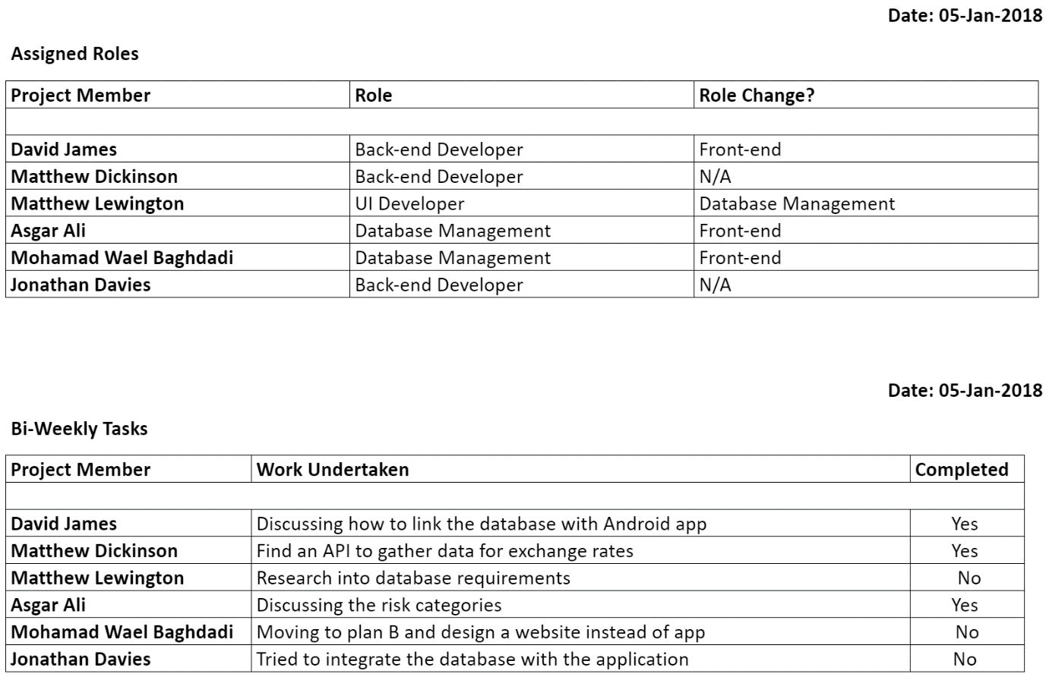
Appendix 8 - Weekly Meeting Sheet 5

Appendix 2F
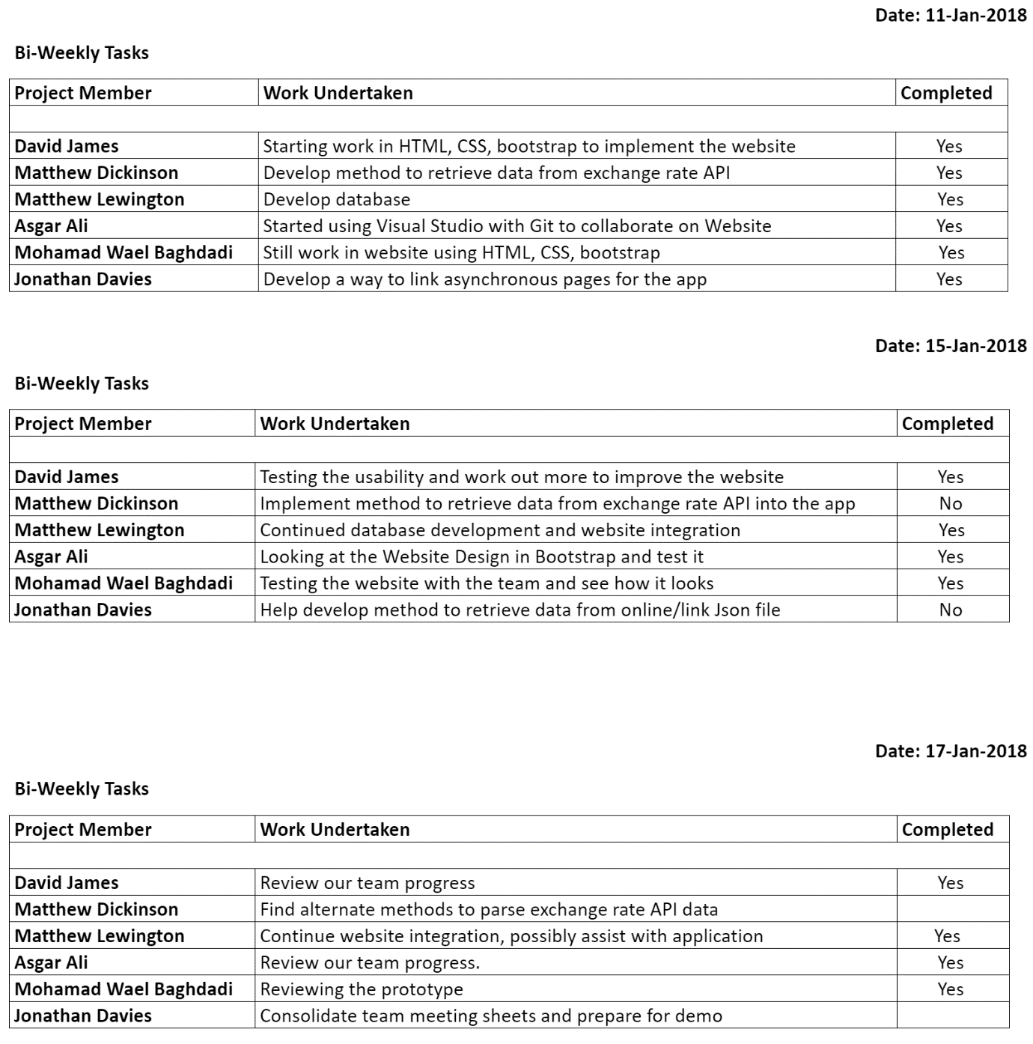
Appendix 9 - Weekly Meeting Sheet 6

Appendix Section 3 (Expand to view)

Appendix 3A
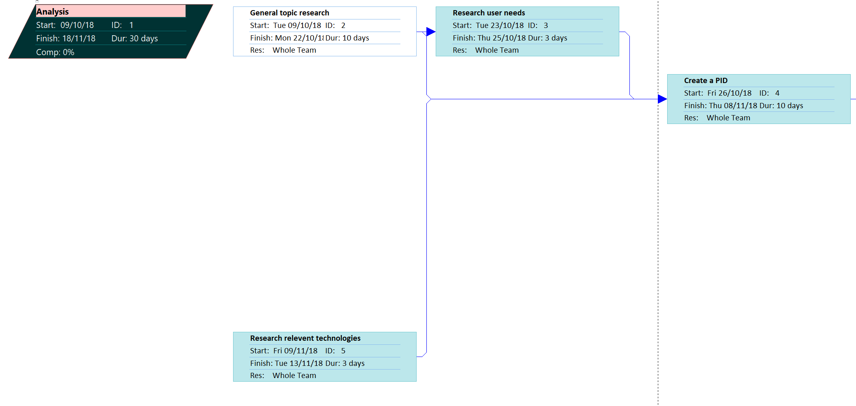
Appendix 10 - Gantt Chart Part 1

Appendix 3B
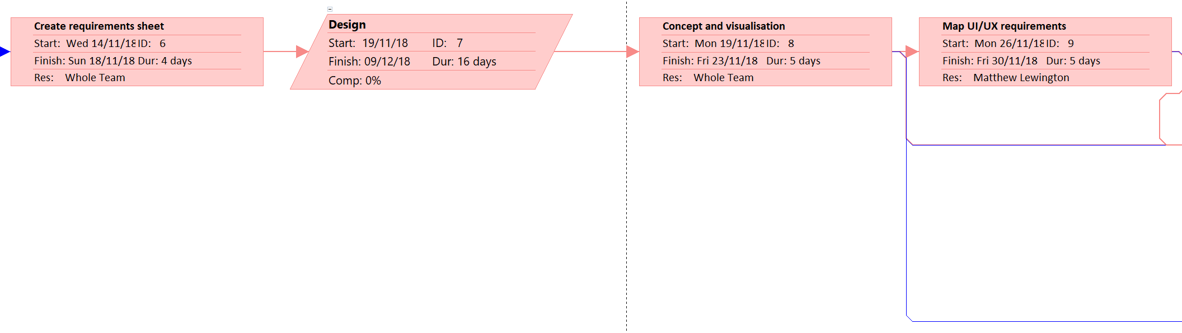
Appendix 11 - Gantt Chart Part 2

Appendix 3C
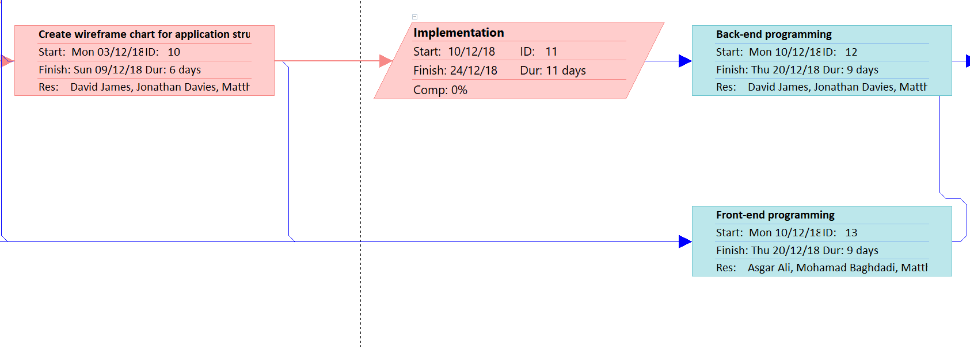
Appendix 12 - Gantt Chart Part 3

Appendix 3D
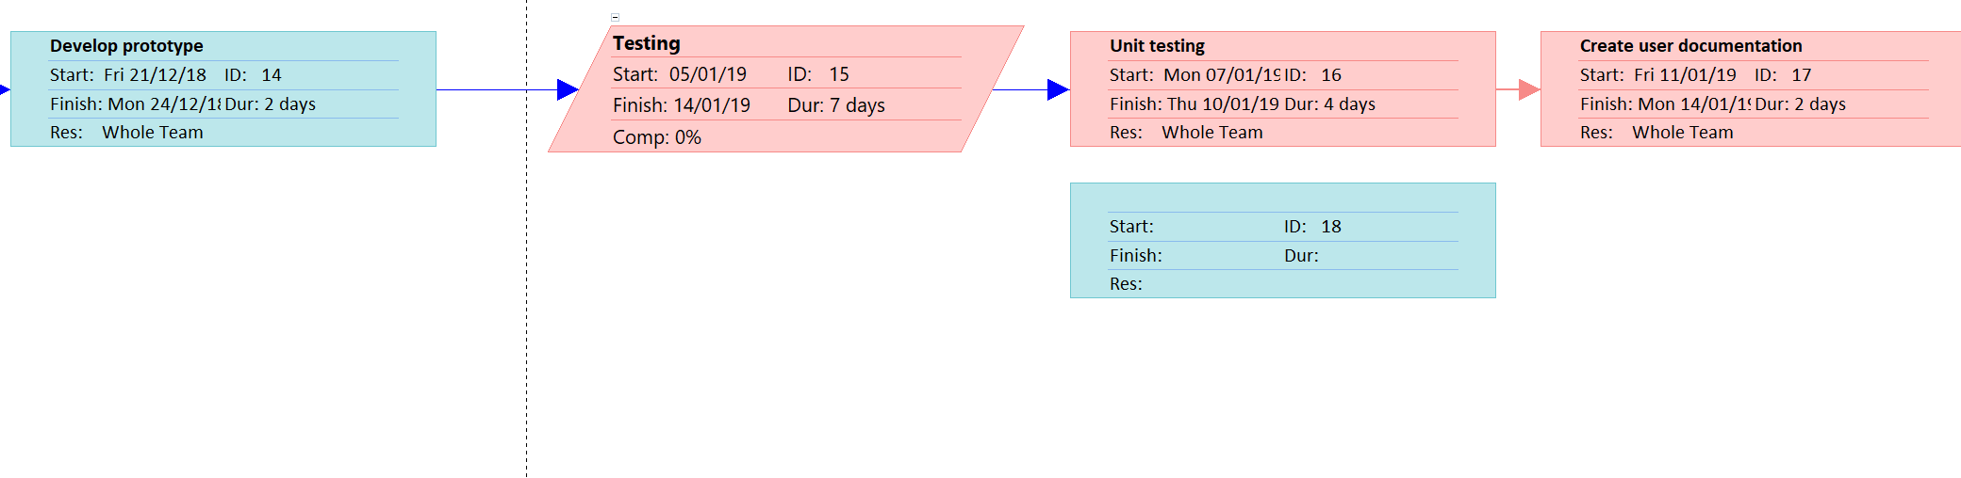
Appendix 13 - Gantt Chart Part 4

Appendix 3E
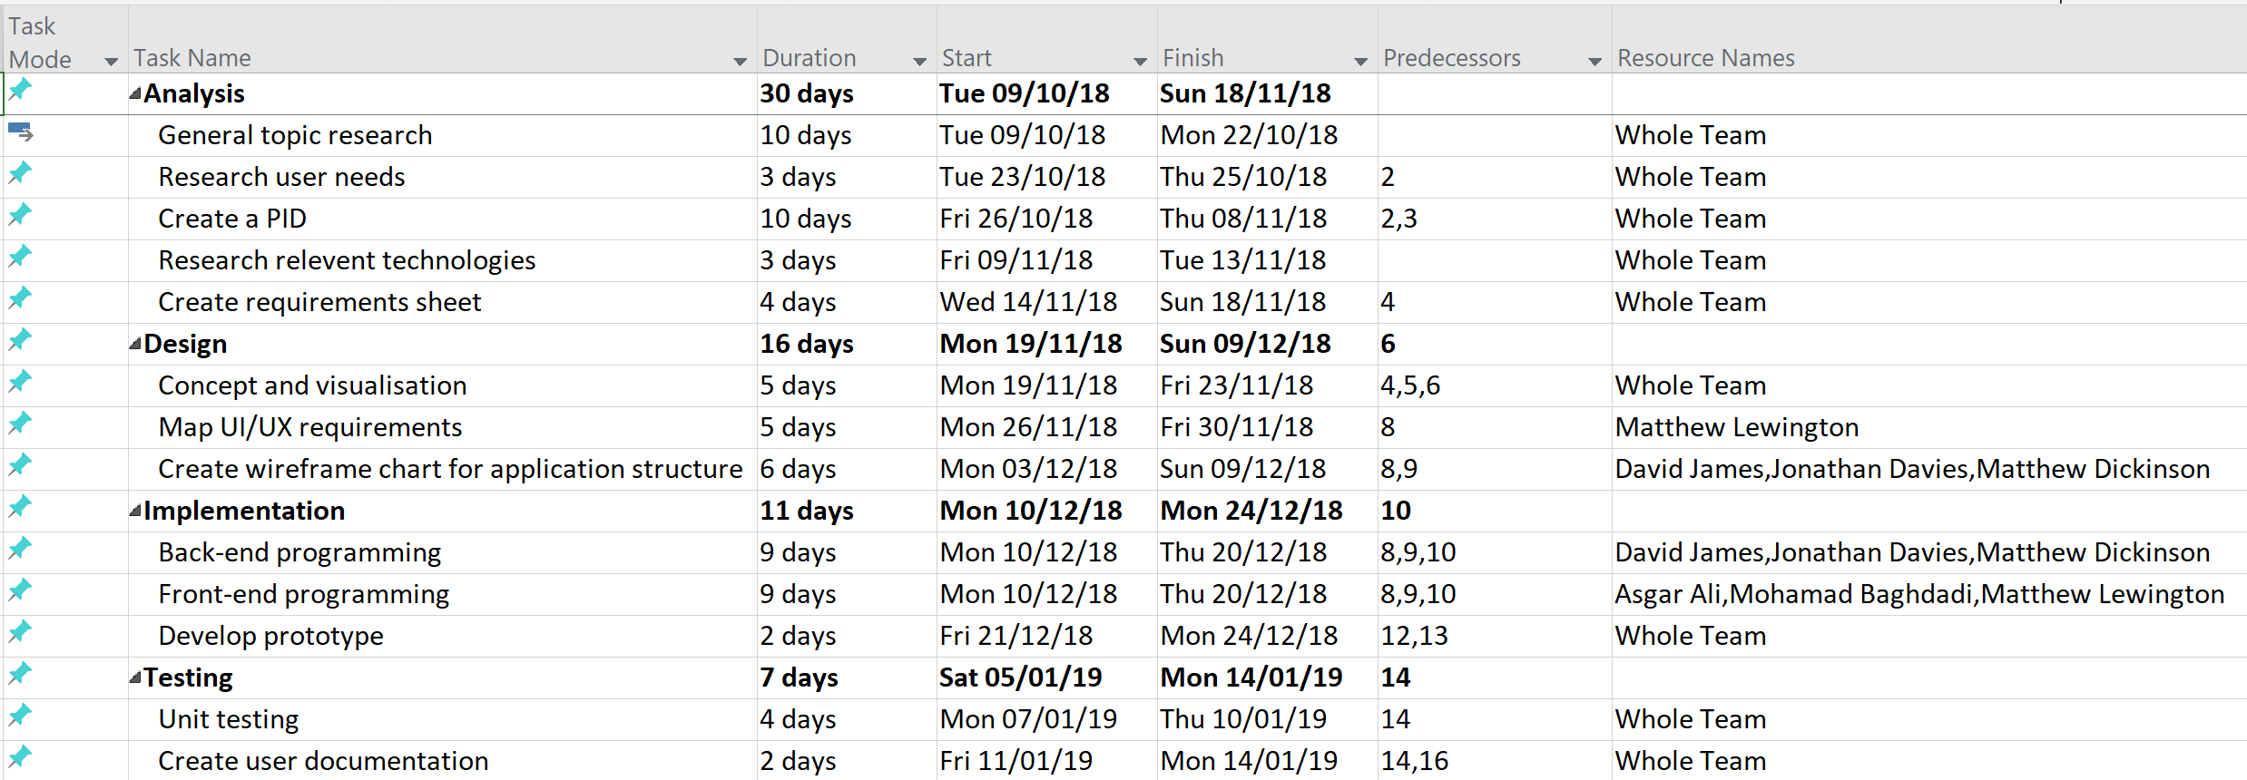
Appendix 14 - Gantt Chart Part 5

