

University of Wales Trinity Saint David M.A. (Ed.) Programme

Leading Learning and Teaching (Pedagogy)

Post Graduate Certificate

Student Number: 1817153

Level: 7

Assignment Number: 1 2 3 4

Tutor: Junnine Thomas-Walters

Guidance on this Assignment Portfolio

The purpose of this portfolio of work is to provide guidance regarding the implementation of the New Curriculum for Wales (CfW) currently launched in draft form in 2019. A key driver behind the CfW has been has been the report by Donaldson’s Successful Futures report (2015). The purpose of this work will be to consider and identify the opportunities and challenges that the implementation of a new CfW will have on schools in Wales. The particular focus will be to investigate pedagogical principles that have been identified by Donaldson (2015) and other academics, as this is a critical factor to the successful implementation of any new curriculum. The successful implementation of CfW will require an understanding of a range of pedagogical approaches and the ability for schools to implement this successfully in their own settings. The first section of this portfolio will try to investigate a range of relevant research and literature that will have a bearing when trying to consider which pedagogical approaches to implement in educational institutions.

Following this, a SWOT analysis, pertinent to my current educational setting, will focus on the implementation of the CfW and the recommendations from the Successful Report (2015). This will be supported by a strategic plan, which will be created to identify the steps needed to bring about organisational change and move to implement successfully the CfW in my own setting. Aspects of both the SWOT and strategic plan will be subsequently discussed and analysed in the rational section.

Finally, an academic poster will be created, which is aimed to promote staff in my own setting to engage in dialogue, related to the ‘Successful Futures Report’ (Donaldson 2015) and the CfW. This poster will be critiqued and its intentions evaluated as we move toward institutional change in preparation for the CfW.

A Curriculum for Wales
The Curriculum for Wales 2019 (CfW) is currently in draft form and will begin implementation and phased role out in 2022. The development of the new CfW was based on the report commissioned by the Welsh Government known as ‘Successful Futures’ produced by Professor Graham Donaldson in 2015. This was partly in response to Wales disappointing PISA rankings in comparison to the rest of the UK and other countries. “The disappointing performance of Wales in successive PISA surveys has been and remains a significant driver for change.” (Donaldson ,2015, P10 )
Development of a new education curriculum in Wales has required reflection by many academics and educational experts on what is the purpose of an educational curriculum and how to make meet the current and future needs of learners and society. The success of the CfW is seen as pivotal to the future generations of Wales. “…education is a vital component in efforts to both create better and cohesive societies and to address the economic, social and environmental conditions that potentially destabilise modern societies.” (Priestley & Philippou, 2019, p1).
The term curriculum has many different interpretations. It has been described as “...a course of study…with the notion of going somewhere in a predefined direction” (Priestly,2019 P4). Many agree that in terms of education, curriculum is an “Umbrella term denoting the totality of the learning experiences of children and young people in school.” (Priestly, 2019 P4). Current guidance has been provided in the draft documentation of the CfW 2019. The CfW has six Areas of Learning Experience (AoLE). Each AoLE will has a set of core ‘What Matters’ statements that provide some guidance to coverage. These are based on big ideas or over-arching concepts. The CfW allows all students to progress along a continuum of learning which will run from the ages 3-16 . Identified under each AoLE are progression steps, which will be measurable through achievement outcomes. At the heart the CfW is structure around four core purposes. It aims to develop students who are:
Ambitious, capable learners, ready to learn throughout their lives
Enterprising, creative contributors, ready to play a full part in life and work
Ethical, informed citizens of Wales and the world.
Healthy, confident individuals, ready to lead fulfilling lives as valued members of society.

(Welsh Government, 2019, Draft Curriculum for Wales)

While the CfW is driven by the four core purposes, Donaldson identifies that its success will greatly hinge on the pedagogical approach a school uses to approach the CfW. In chapter 5 of Successful Futures report (2015), Donaldson identified twelve pedagogical principles that underpins the whole CfW.
The CfW does not provide the prescriptive guidance that the previous National Curriculum of 2008 set out. Its success has been linked to teachers being able to develop their own teacher agency, collaborate and produce their own school based curriculum approaches. This will require schools to think carefully about the pedagogical approaches they use to implement the CfW. The purpose of this review will be to consider the opportunities and challenges that should be considered when developing a pedagogical approach to the CfW.

What is Pedagogy?

Pedagogy is defined by the Oxford dictionary as “The method and practice of teaching, especially as an academic subject or theoretical concept. Also: the theory or principles of education; a method of teaching based on such a theory”. (Oxford Online Dictionary: 2020)
Educational theorists discuss pedagogy in a range of ways, some take the view that it is not about a teacher imparting knowledge to a pupil, like a vessel being filled with knowledge, often referred to as passive knowledge. Instead, it goes beyond that by providing knowledge of how to learn and adapt what has been taught to a variety of contexts and provides a deeper understanding of the process of learning. “Pedagogy involves both knowledge about a subject and about a how to learn a subject.” (Thompson, 2014 P4). This is further supported that how something is taught is often more important than the knowledge retained. Choosing a range of pedagogical strategies, depending on the context of the learner and subject, is vital. “At the heart of the problem lies what is learned and how it is learned”. (Kerry, 2010 P5)
Hattie discussed the concept of visible learning being vital in the classroom. “What are the attributes of schooling that truly make a difference to student learning- the processing ‘attributes that make learning visible”. (Hattie J ,2011 P1). He continues to identify the importance of the pupils becoming aware of how they learn and becoming able to teach themselves “The visible aspect also refers to making teaching visible to the students, such that they learn to become their own teachers” (Hattie J, 2011 P1). Even Albert Einstein identified that education must use pedagogies that help pupils gain more than just knowledge. “Education is not the learning of facts, but the training of the mind to think” (Einstein 1879-1955)
In the Successful Futures report, chapter five identifies pedagogy as “...being more than teaching in the narrow sense of methods used in the classroom”. (Donaldson, 2015, P63) The description of pedagogy in chapter 5 also states that pedagogy is about:
‘..considered selection of those methods in light of the purposes of the curriculum and the needs and devilment stage of children. It combines theoretical and practical knowledge and skills with fine judgements about what is required to promote effective learning in particular contexts. (Donaldson 2015, P63)
The report goes on to identify twelve pedagogical principles (Appendix 1). It is important to note that Donaldson (2015) Identifies that each of the pedagogical principles is as important as the other. There is no hierarchy in the application of these principles but advises that teachers adopt all the principles at different times in direct response to the teacher conducting ongoing assessment for learning strategies (AfL) and then applying the most pertinent pedagogy that will support students to maximise their learning. “…the recommendations of this Review do not imply an emphasis on any particular teaching approaches: Decisions about teaching and learning are very context and purpose specific” (Donaldson, 2015 P 63)
Practitioners need the knowledge and understanding to apply different methods that fit with the needs of the learners and the classroom environment. The right approach must be judged on contextual circumstances, using knowledge of the curriculum and professional judgement must be used to maximise learning in the classroom. (Donaldson, 2015 P63)
This supports the ideology that the teacher is vital in role of facilitating effective learning for pupils by applying their “...subject and methodological expertise… and the ability to excite and inspire children to want to learn independently.” (Donaldson 2015 P 63)
‘Constructivism Learning Theory’ in contrast identifies seven key pedagogical principles. This theory “...hypothesizes that individuals will try to make sense of all the information they perceive, and that each individual will therefore ‘construct’ their own meaning form that information.” (Bada & Olusegun, 2015 P69)
A key concept in this theory is also that pupils experience learning first hand through authentic learning opportunities which is also identified as vital to the learning process by Donaldson (2015).
“For only experiencing the world directly can the learner derive meaning from it.” (Bada & Olusegun, 2015 P67) This argues against the traditional form of the teacher imparting knowledge and students regurgitating knowledge for the purpose of tests is antiquated; instead, it is more important to help facilitate learning and allow pupils to become involved in their own understanding and self-assess to improve their own learning. The teacher in Constructivist Learning classrooms therefore “…functions more as a facilitator who coaches, mediate, prompts and helps students...” (Bada & Olusegun, 2015 P68)
This theory has large support within education pedagogies and there is a movement away from the traditional view of a knowledge driven curriculum, typical of the early Victorian influenced teaching ideologies, in which students are passive learners, and the teacher imparts their wisdom. The traditional ‘Top Down’ leadership model and the hierarchy of a teacher in classroom environment is challenged and in its place, pupils are encouraged to take on the role of teachers in their own learning.
The classroom is no longer a place where the teacher (‘expert’) pours knowledge into passive students who wait like empty vessels to be filled. …students are urged to be actively involved in their own process of learning.” (Bada & Olusegun, 2015 P68)
The Sutton Trust also identified choosing the pedagogy as being vital to good quality teaching. They identified six components of great teaching. (See Appendix B) but identify the first component as ‘Pedagogical Content Knowledge’ and evidence suggests that this has a large impact on student outcomes. (The Sutton Trust, 2014 P2) They also suggests that effective teachers ‘…must also understand the ways students think about content, be able to evaluate the thinking behind students’ own methods, and identify students’ common misconceptions. (The Sutton Trust, 2014 P2) There is correlation between the pedagogical principles identified in chapter 5 of ‘Successful Futures’ (2015) and the six elements of great teaching outlined by The Sutton Trust. One contrast from Donaldson is identified as the role ‘Classroom Climate’ has in instilling the culture that pupils’ recognise their own ‘Self-worth’. This requires that a teacher attribute ‘student success to effort rather than the ability and valuing resilience to failure’ (The Sutton Trust, 2014 P3)
A further area identified by the Sutton Trust that differs from Donaldson’s pedagogical principles (Appendix A) is the direct importance attributed to ‘Classroom Management’ and the importance of the teacher to ‘make efficient use of lesson time, to coordinate classroom resources and space, and to manage student’s behaviour with clear rules that are consistently enforced.’ (The Sutton Trust 2014 P3)
Discussions that took place in our trust group identified that many educationalists identify different pedagogical principles that they feel underpin effective teaching. The National College for School Leadership identified “...nine strong claims about the characteristics of highly successful pedagogies” (National College for School Leadership, 2012 P2 appendix D)
While many pedagogical parallels can be drawn, including the importance of developing pupils prior learning experiences and the importance of ongoing assessment practices in Donaldson, The Sutton Trust and The National College for School Leadership, the later also mentions the need for developing ‘Higher thinking and metacognition’. (National College for School Leadership, 2012 P3)
Many schools have attributed importance to metacognition and have implemented training and school approaches to develop this further that links with the ideology put forward by both ‘Growth Mindset’ established by Stanford University psychologist Carol Dwek or ‘Building Learning Power’ (BLP) developed by Guy Claxton. Some schools have introduce SOLO Taxonomy (Structure of Observed Learning Outcomes) devised by Biggs and Collins in 1982. Schools have also attributed the importance of the ‘Learning Pit ‘and the ‘Power of Yet’ as metacognition strategies to facilitate the learner to become critically reflective on their own learning and to build resilience when they face difficulties. This process of developing reflective, resilient learners who can over come challenge links directly with the first of Donaldson’s four purposes. ‘Ambitious, capable Learners who are ready to learn throughout their lives’ (Donaldson, 2015)
In school A as part of the learning visit, we observed the development of metacognition and the use of the Learning Pit with pupils to create more resilience. From Reception through to Year 6, pupils developed learning characters but were able to discuss the characteristics that of the learning by self-reflecting on how they have emulated the traits of the character in relation to the given task. School B, which was a Secondary school, used ‘Growth Mindset’ terminology in the lessons observed and students were encouraged to internalise and reflect on how they were fulfilling different aspects of a growth mindset towards the task at hand and feed this back in group discussion and feedback. It was clear from the teacher questioning and the structured and modelled responses, that using a Growth Mind Set approach was embedded across the school.
The second of Donaldson’s four core principles identifies the need for students to be “Enterprising, creative contributors, ready to play a full part in life and work.”( Donaldson ,2015). In the twelve pedagogical principles creativity is identified as important. Other pedagogies also mention the importance of developing students’ creativity.
Juliet Desailly identifies the importance of developing creativity in students as being vital to facilitating learning.
While creativity is seen as having many benefits such as improved retention of information, raising self-esteem, personal fulfilment, authentic learning, help develop lifelong skills and enhances motivation and helps lifelong learning’ ( Desailly, 2012 P 24)
Pupils need to be creative in order to solve problems and this helps them personalise their learning experiences and further develops pupils’ engagement. It is also argued that developing a pupils’ creativity allows them the ability to develop resilience and self-reflection. “A child who learns creatively will be involved in understanding how they learn and how they learn best” (Desailly, 2012 P18). However, we must also understand there can be draw backs with developing a more creative classroom as it can be time intensive, can lead to unique or unconventional approaches and often produces less traditional evidence in books, which can in turn impact upon the pressures of accountability and coverage issues. (Desailly, 2012 P24) It may also be counterproductive is some instances, where a lack of scaffolding and support can become detrimental, if pupils are unable to develop their own ideas and solutions. “Encouraging a creative approach can lead to the ‘Blank sheet moment’ where personal interpretation may not live up to the desired outcomes or can effect self esteem.” (Desailly, 2012 P25)
School C, a case study from our talk group, introduced a culture of freedom, innovation and creativity that drove their curriculum across the school. They developed a ‘Room 13’, which was resourced with Art, modelling and DT equipment where every child was encouraged to be creative and innovative. It also focused on the local environment developing a ‘Forest School’ approach to learning and used the natural resources of the local marshlands as an outdoor classroom. Here, pupils raised and cared for animals and developed their learning in authentic contexts. Wellbeing, self-esteem where highly valued in the school and creativity was at the heart of the pedagogical approach they took towards education.
During our talk group discussions, we discussed the twelve pedagogical principles but also noted that the recent statutory teaching standards for Wales identify a section on pedagogy and describes “Pedagogy as Paramount.”(WG 2018 Professional Standards P 10) The professional standards identify seventeen pedagogy teaching standards, split into three sections of pedagogy “Refining Teaching, Advancing Learning, Influencing Learners” (WG, 2018 Professional Standards P 12) Several of the professional standards in the ‘Pedagogy’ section directly correspond to the those outlined in chapter five of Successful Futures .There are overlaps in relation to authentic learning, blended approach and developing mindsets. However, the ‘Four Purposes’ are identified explicitly, along with wellbeing which are absent from Donaldson’s twelve ‘Pedagogical Principles’. The Professional standards (Appendix C) also identify ‘Assessment and Differentiation as part of Pedagogy. In contrast Donaldson also identifies a separate section in Chapter Six of Successful Futures (2015) in relation to Assessment and many educationalists promote that AfL is integral to choosing the correct Pedagogy for teaching. The pedagogy section of the teaching standards believe that the sixteen principles will allow;
The teacher in a formal leadership role exercises accountability for the pedagogy of others by creating and sustaining the conditions to realise the four purposes for learners and achieve the best for them in terms of standards, well-being and progress’ (WG, 2018 Professional Standards P 2)
Leadership is absent from all the pedagogical approaches but is identified by Harris and Mujis, in ‘Improving Schools Through Teacher Leadership’ as being a decisive factor in a school’s ability to improve and develop change.
“Successful school improvement is co-constructed …where leadership is primarily about learning together.” (Harris & Mujis, 2005 P 13) Developing ‘Professional Learning’ and dialogue within the school and a gaining a shared understanding of pedagogy is a critical factor identified by Donaldson (2015) to the success of implementing the CfW. “Schools which are improving tend to be marked by a consistent interchange of professional dialogue, both formally and informally” (Harris & Mujis, 2005 P 13). It is important that a staff work together to and collegially to support each other and school to school working will become important when implementing the CfW. “In practice distributed leadership means giving opportunities to lead and take responsibility for areas of change.” (Harris & Mujis, 2005 P 13) Nick Waters, a leading educationalist, recommends that a ‘Pedagogy Lead’ should be appointed to develop and drive change within the school organisation. The work of the Pioneer Schools and Consortia will be vital in realising the ideals of Successful Futures (2015).
Study of international curricular can also provide guidance in relation to pedagogical approaches. “In the USA, Canada and Australia the notion of distributed Leadership is gaining popularity.” (Harris & Mujis, 2005 P 14) Traditionally in the UK Leadership in educational establishments is formal, following a ‘Top down’ approach and is led by the Head. “This formal role often viewed as an individual role and not a collective endeavour.” (Harris & Mujis, 2005 P 15) To develop true institutional change to implement the CfW successfully, a cultural shift in schools must be embarked upon and all stakeholders must collaborate to drive forward change.
A key driver for the success of the Scottish ‘Curriculum for Excellence’ (CfE) that teachers needed to be agents of change, however there dichotomy between implementing the policy and changes in classroom practice. “A major issue facing externally mandated reform is the ‘implementation gap’ (Supovitz, 2008) between policy intention and classroom practice.” ( Supovitz 2008 : Priestley and Minty, 2013, p.39)
There was no phased development for implementation for CfE and both Primary and Secondary education. Many teachers did not prepare for the changes when it was draft form. They consequently found it difficult to implement it when it became statutory. While the pedagogical approaches behind the CfE are closely linked to CfW, a lack of supporting documents led to the creation of over 2000 descriptors which reduced the creativity and autonomy of teachers in Scotland. They did not introduce change and continued to work as they did before. Little classroom change took place and pupils did not become empowered and instead the CfE became a knowledge driven curriculum that did not promote creativity, authentic learning, and self-reflective learners. (Priestley and Minty, 2013)
In Alberta in Canada they included all stakeholders in the process of educational change and agreed goals that developed a vision for 21 century education system knows as ‘The Three E's" of Education’. These outcomes link closely with the Four Principles of CfW.
Engaged thinker – Alberta must cultivate students with an inquisitive, engaged mind.
Ethical citizen –Our children and grandchildren must be ethical, compassionate and respectful to truly grow and thrive.
Entrepreneurial spirit – To shape innovative ideas into real-world solutions, to develop motivated, resourceful and resilient citizens. (Alberta Government, 2009, p6-7).
Under the Canadian system, pupil voice and learning autonomy of pupils was highly valued. Problem solving and cross circular approach to learning was a key driver. Teachers were encouraged to undertake professional research using the ‘Spiral of Inquiry’ approach to help become facilitators of learning and pupils were encouraged to become collaborators and resilient. Alberta is regarded as one of the strongest Canadian education systems and is ranked highly in PISA rankings. We can draw many parallels with the CfW. Teachers’ professionalism and agency and the ability to share and support from school to school were key to their success.
In contrast, in our trust groups we had a guest speaker who taught in School C in North Carolina in USA. The system was very prescribed with all lessons pre-planned and teachers had to follow a state agreed syllabus. A high focus on formative assessment took place, with testing every three months. This was a fast-paced knowledge driven curriculum, timetabled with very little creativity and authentic learning. Teachers conducted continual professional, development and research, as they had to regain accreditation for teaching posts to be renewed every year. Despite this, teachers had little teacher agency and were unable to institutionalise change. This resulted in little autonomy in pedagogy and the methods of teaching implemented in the schools was very prescribed.
From research and discussion in our trust groups we found out that Japan have implemented lesson studies to develop professional development and investigate the effectiveness of different teaching pedagogies. Groups of teachers, in some cases up to twenty teachers, planned together and identify desired pupil outcomes. Then one teacher delivers the lesson and reflects and gives feedback on the observed impact on case pupils. This creates a shared understanding of what pedagogies and strategies work best. The draw back is the heavy investment in time it takes to collaborate on such a grand scale. Professional dialogue however is promoted and shared goals implemented unilaterally across the organisation.
In contrast, Singapore has a highly successful education system but it relies heavily on “textbooks, worksheets, worked examples and lots of drill and practice. They also strongly emphasise mastery of specific procedures” (Hogan, 2014) There is very little focus on pupils developing resilience and becoming their own facilitators of learning. Classroom discussions are often teacher-dominated and teachers make “limited use of checking a student’s prior knowledge or communicating learning goals and achievement standards.” (Hogan, 2014) Part of the success of Singapore often cannot be emulated by other countries as the culture around the educational system is unlike that of any other on the world. “Singapore’s unique configuration of historical experience, instruction, institutional arrangements and cultural beliefs has produced an exceptionally effective and successful system.” (Hogan, 2014)
For effective teaching and learning to take place a range of ‘blended teaching’ strategies must be implemented that use a range of effective pedagogical approaches. In our talk groups we discussed the model put forward by Mark Priestly who identifies a ‘Holistic curriculum’ in which he identifies pedagogy as vitally important component to effective teaching. Other factors such as leadership, teacher agency, staff collaboration and ongoing professional research and development within a school organisation will also have a huge impact of the development of pedagogical approaches and the successful implementation of the CfW 2022. Dylan Williams a leading educationist described in his address hosted by School, Students and Teachers Network that ‘Pedagogy trumps Curriculum’ and went on to elaborate further that “A bad curriculum well taught will trump a good curriculum badly taught.”( Williams, 2013) This shows the importance that a teacher has in using the correct pedagogical principles to facilitate learning.
“Of all the factors inside the school that affect children’s learning and achievement, the most important is the teacher-not standards, assessment, resources or even school leadership, but the quality of the teacher.” (Hargreaves & Fullen, 2012 P12)

The development of CfW will require institutional change in education in Wales. Developing pedagogical approaches can be influenced by many factors including the school culture, faith, ethnicity and locality. However, in our talk groups we discussed that a schools approach to pedagogy can be seen as the dynamic relationship between learning, teaching and culture. We must always remember “At the heart of the education process lies the child.” (Plowden, 1967 P9)
In this section there will be a SWOT analysis highlighting the potential strengths, weaknesses, opportunities and threats of implementing the CfW in my current organisation. This will be followed by a strategic plan which will consider the pedagogical approaches and processes required to implement the CfW in the school organisation. A rational section will discuss the issues around both the SWOT analysis and the strategic plan.
SWOT Analysis
Strengths | Weaknesses
Leadership – A culture of developing ideas and approaches as a whole school is evident. Support from the Head teacher and SLT is supportive to new ideas. Staff are encouraged to develop ideas and time has been allocated in INSET for staff to feedback findings and become the leaders. A collegiate management style is introduced. A distributed leadership style is adopted when appropriate. There is evidence of “Multiple groups of individuals in a school who work at guiding and mobilising staff in the instructional change process” Harris & Maijs, 2005 p31)  Implementing Adaptive Approaches- Currently a NQT training school and Professional Learning Lead School, previously a Foundation Phase Lead school.  Strong Cluster Working – We have established good links with our cluster schools and the feeder High Schools. We also have had many visitors to the school to share working practices.  Embedding New Technologies – A large investment made in technology within the school and this can support a new way of facilitating learning with pupils. | Resistance to Change- Staff can be resistant to organisational change and may not become engaged in learning dialogues. They may fall back onto what is done previously and not introduce institutional change.  Financial Constraints – It is difficult with current budgets to allow all staff to effectively collaborate and enter professional dialogue over the new curriculum. It is difficult to release staff on mass as even many of the INSET has been already booked in the previous financial year or addresses other School Development Plan priorities.  Lack of Consistency between Secondary and Primary Education.-While cluster working is strong it is difficult for secondary to emulate the learning environments and opportunities that are presented in primary school. The subject specific nature of lessons and generic classroom environments provides less flexibility. Secondary school seem to be exam focused and there is ambiguity with assessment procedure currently.
Opportunities | Threats
Develop Teacher Agency -The new CfW will need teacher to develop teacher agency. The teachers will be empowered to develop resources and use pupil voice to develop simulating learning opportunities for pupils.  Collectively Develop a School curriculum- There is an opportunity to develop our own school based curriculums that is fit for the needs of our pupils that encompasses the values we want to develop. We are able to use the local environment and develop authentic learning opportunities that engage our learners. Staff are able to work collaboratively and share ideas to develop a shared vision for learning in the school.  To Develop Professional Learning- Currently we have several staff undertaking action research in the school and opportunities in INSET and staff meeting have been given to feed this back to all staff. Professional Learning has inspired changes in planning and all stakeholders are informed to develop their own professional learning. CPD is highly regarded and supported in the school. Three members of staff are currently studying the PG Cert, Two members of staff are attending the Professional Lead Schools and producing case studies on this. | Time Constraints for Professional Learning-  It is difficult to direct time for professional learning to take place. While AoLE teams have been created and triad working is taking place it is time consuming to conduct action research, implement it and feed back to staff. The difficulty is lies in what to research do we prioritise on things linked to the SDP or is it a personal choice? How is it monitored and implemented? Often implementing research may have a financial or resourcing implication. Whose ideas are chosen and how is information shared? Are staff meeting open forums or are do they have strict agendas that do not allow professional dialogue?  Accountability  The ability for teacher autonomy in designing a curriculum can lead to new methods of teaching. Promoting creativity can result in less work in books in contrast to strict timetabling and subject coverage. Rich tasks which are cross curricular may be used but will coverage be an issue? Are the teaching standards (Appendix C) or Excellence in Teaching Framework used to monitor lesson observations? Decisions on what will be monitored and formal assessment procedures will need to be clarified. Will this fit the new curriculum if based on previous ideologies and approaches?  Staff Wellbeing – Many teachers will be concerned with the lack of guidance in relation to coverage in comparison to the National Curriculum 2008. Will it be the bird in the cage analogy, that when the cage door is open the bird will stay within the environment it knows.(Talk group) The time constraints to try implement and review aspects of developing a new curriculum may result in mistakes and this may adversely effect pupils learning. There is little guidance on what good looks like from the pioneer Schools or Esytn in relation to implementing a new pedagogical approach to the CfW. Indeed the CfW does not mention pedagogical practices this is only discuss in Successful Futures chapter 5. (Donaldson, 2015). Is this enough guidance for teachers to raise standards and become excellent teachers? The wellbeing of staff and work life balance is also an important consideration as it will take time to redevelop, resource and implement new approaches.

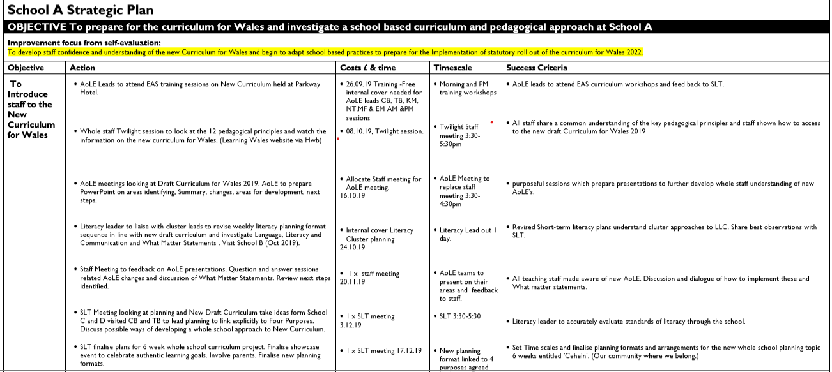
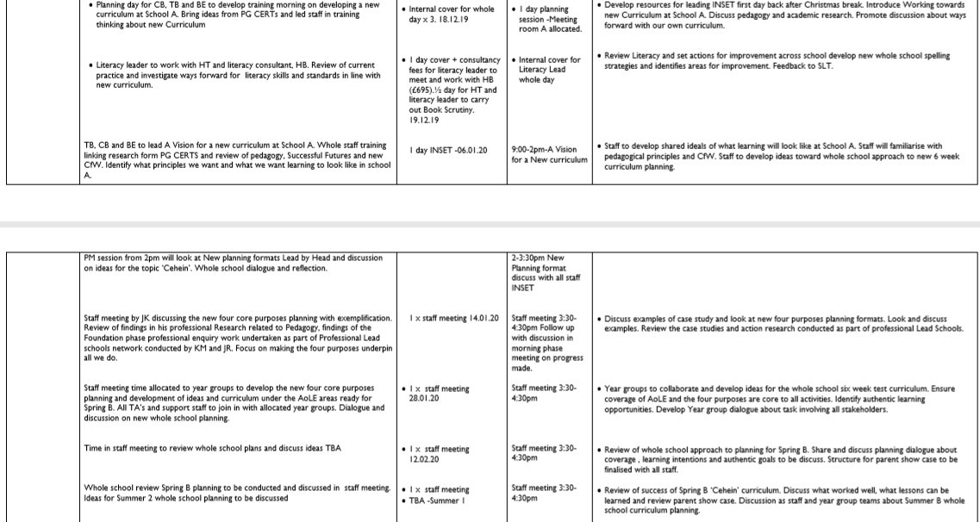
Rationale
It is evident from the SWOT analysis that School A is currently engaging with the CfW and is looking to develop a school-based curriculum that engage and excite learners. The existing culture of School A has been one of support and they are willing to try new ideas. A true strength of School A is that leadership from the Head, who is also an ESTYN inspector, who is supported by the SLT to encourage a culture of enquiry, which values all the stakeholders in whole school decision making processes. “Leadership can be defined as providing vision, direction and support towards a different and preferred state- suggesting change.” (Harris & Muijs, 2005 p14). The importance of involving all staff in bringing about institutional change is vital. There is a culture of support in School A, which allows discussing ideas and sharing best practice. This will be instrumental if changes and approaches are going to be consistent and effective. “Schools which are improving tend to be marked by a consistent interchange of professional dialogue both formally and informally.” (Harris & Muijs, 2005 p14) This is also evident in the Strategic Plan as staff meeting and INSET time has been devoted to working towards the CfW. Staff are able to discuss their ideas, share authentic learning goal and discuss and co-construct the curriculum for the learners. In our talk group, we discussed if the format of staff meeting needed to be more open forums so professional dialogue can be developed in contrast to the more traditional current trend, where staff become passive learners from which information was cascaded from above. This shows a constructivist approach to leadership in School A, that is developing a collective response to the CfW, which ensure all staff have an input if desired. Discussion around pedagogical approaches and successes are shared. “This process of collaboration and reflection, mediation, formulating agreed collective actions is in essence, teacher leadership in action.”(Harris & Muijs, 2005 p13)
Institutional change in a school can often be resisted by staff , but the adaptive approaches and practices undertaken by School A has resulted it in being a previous ‘Lead School’ for Foundation Phase. School A has adopted a Foundation Phase approach across the whole school, students are able to learn through a variety of authentic contexts, and collaboration is promoted. Pupils are able to develop independent learning opportunities and teachers will support pupils in smaller groups on rotation to help deeper learning and facilitate learning. The Foundation Phase approach being used across the school was also seen as part of the learning visit arranged at school B and the similar approach echoed the pedagogy instilled at school A. The Head Teacher of School B,(Previous Acting Head of School A) has transformed the Pedagogical approach to learning in School B. At the heart of every planning theme is an authentic learning goal, involvement of pupil voice, collaboration on tasks and creative interpretation of tasks is actively encouraged. This has resulted in pupils being more motivated in their learning. “Many schools have been adapting what and how the learning is organised to make it more holistic, more engaging, more personalised and more creative.” (Juliet Desailly, 2012 P1) Staff have been involved in all stages and research and support has underpinned this new approach.
School A has also been involved in Lead Schools in Maths and is undertaking action-based research, in related to Foundation Phase pedagogy. The school is also a regional NQT training school and effective learning is shared with new teaching professionals. School A also has good cluster links with other Primary schools in the local area and with the feeder secondary schools. Transition programmes start in Year 4, which expose students to a range of subject disciplines. “Building professional capital is therefore an opportunity and responsibility for all of us-from supporting the teacher next door, to transforming and entire system.” (Hargreaves & Fullen, 2012 P17) Close discussion in transition meeting and AoLE Coordinators have opportunity to meet and share best practice and approaches. This is evident in the recent LLC cluster meeting evident in the strategic plan. “Professional capital is about collective responsibility not individual autonomy.” (Hargreaves & Fullen, 2012 P15)
An opportunity identified an actioned in the strategic plan is to develop professional learning. Several staff members have been supported by being given time and financial support to develop their own pedagogical understanding. Three members of the current staff in School A are undertaking the PG CERT university course, to further develop their own professional learning. The strategic plan highlights that these staff have been empowered to lead whole school INSET on develop what learning will look like at School A and have shared ideas and findings on the academic research investigated with all staff. This investment shows willingness by leaders to empower staff to implement change. “In practice distributed leadership means giving opportunities to lead and take responsibility for areas of change” (Harris & Muijs, 2005 p14)
As evidenced in the strategic plan an ESTYN visit will take place as work toward a case study is being produced on how nurture and support of pupils coupled with school metacognition strategies develop resilience with different group of learners. This is due to the recent Inspection being graded excellence in this area. A key area of this is the development of metacognition strategies and utilising Learning Pit, Solo Taxonomy and developing Growth Mind Set strategies with the development of school based learning characters that display different traits of learning. (Persevere with Pop, be resilience with Robbie, collaborate like Cal, be reflective like Rylee, be resourceful with Ruby, be motivated with Marty). School A have also embedded Solo Taxonomy in KS2 to allow pupils to be reflective on their learning journey. They use the terminology of the learning pit to help build resilience and use a range of whole school behaviour strategies such as ‘Good to Be Green’ and ‘Class Dojo’.
A range of support groups which target pupil wellbeing are evident from the strategic plan, including Thrive, Lego Therapy, Forest and Coastal School programmes, Gypsy Traveller support group and intervention and catch up programmes all run to help foster and nurture pupils needs and develop pupils’ self-confidence. This range of support helps the learners and provision is being made to; “…best meet their present needs and equip them for their future lives in 21st Century”. (Donaldson, 2015 P 5)
A lack of clear understanding of assessment arrangements, ambiguous guidance on content and exemplification will result in a heavy reliance of developing teacher agency to develop a school-based curriculum. This can lead to variation from school to school. Pioneers schools may provide some guidance but often the curriculum is context specific to pupils and locality and not always transferable. The lack of guidance and open interpretation of the draft CfW 2019 could result in variation between schools. Staff may not embrace teacher agency and will revert to what they always done. “It will be critical that the transition for teachers to move away from existing practices and develop teacher agency and strive to provide rich learning experiences for students that deeper their understanding” (Priestley and Humes, 2010, P4) The bird in the cage analogy, discussed in our talk group, is pertinent here. If the cage door is opened, will the bird fly out and soar or choose to remain and stay in the security and familiarity of the cage? This ‘try it and see’ approach could result in a lack of coverage and disadvantage pupils. Staff well-being may be effected and a lack of clear vision or exemplification unnerving. Lessons must be learnt from the Scottish Curriculum for Excellence where it was seen that:
“Too much good practice has been thrown out as everyone interprets CfE in their own way due to the wooliness of the documents” (Priestley and Minty, 2013, P46 )
The Journey that School A is embarking upon is unknown, like others in Wales. The approaches it takes will only be successful if all stakeholders both staff, pupils, parents and wider school community are involved in developing an approach to the CfW that suits the needs of the learners that are in the school. A culture of collaboration needs to be fostered, the ability to feedback, develop a shared action, monitor changes and review and adjust will be needed to implement change that put the learners at the core of all we do.
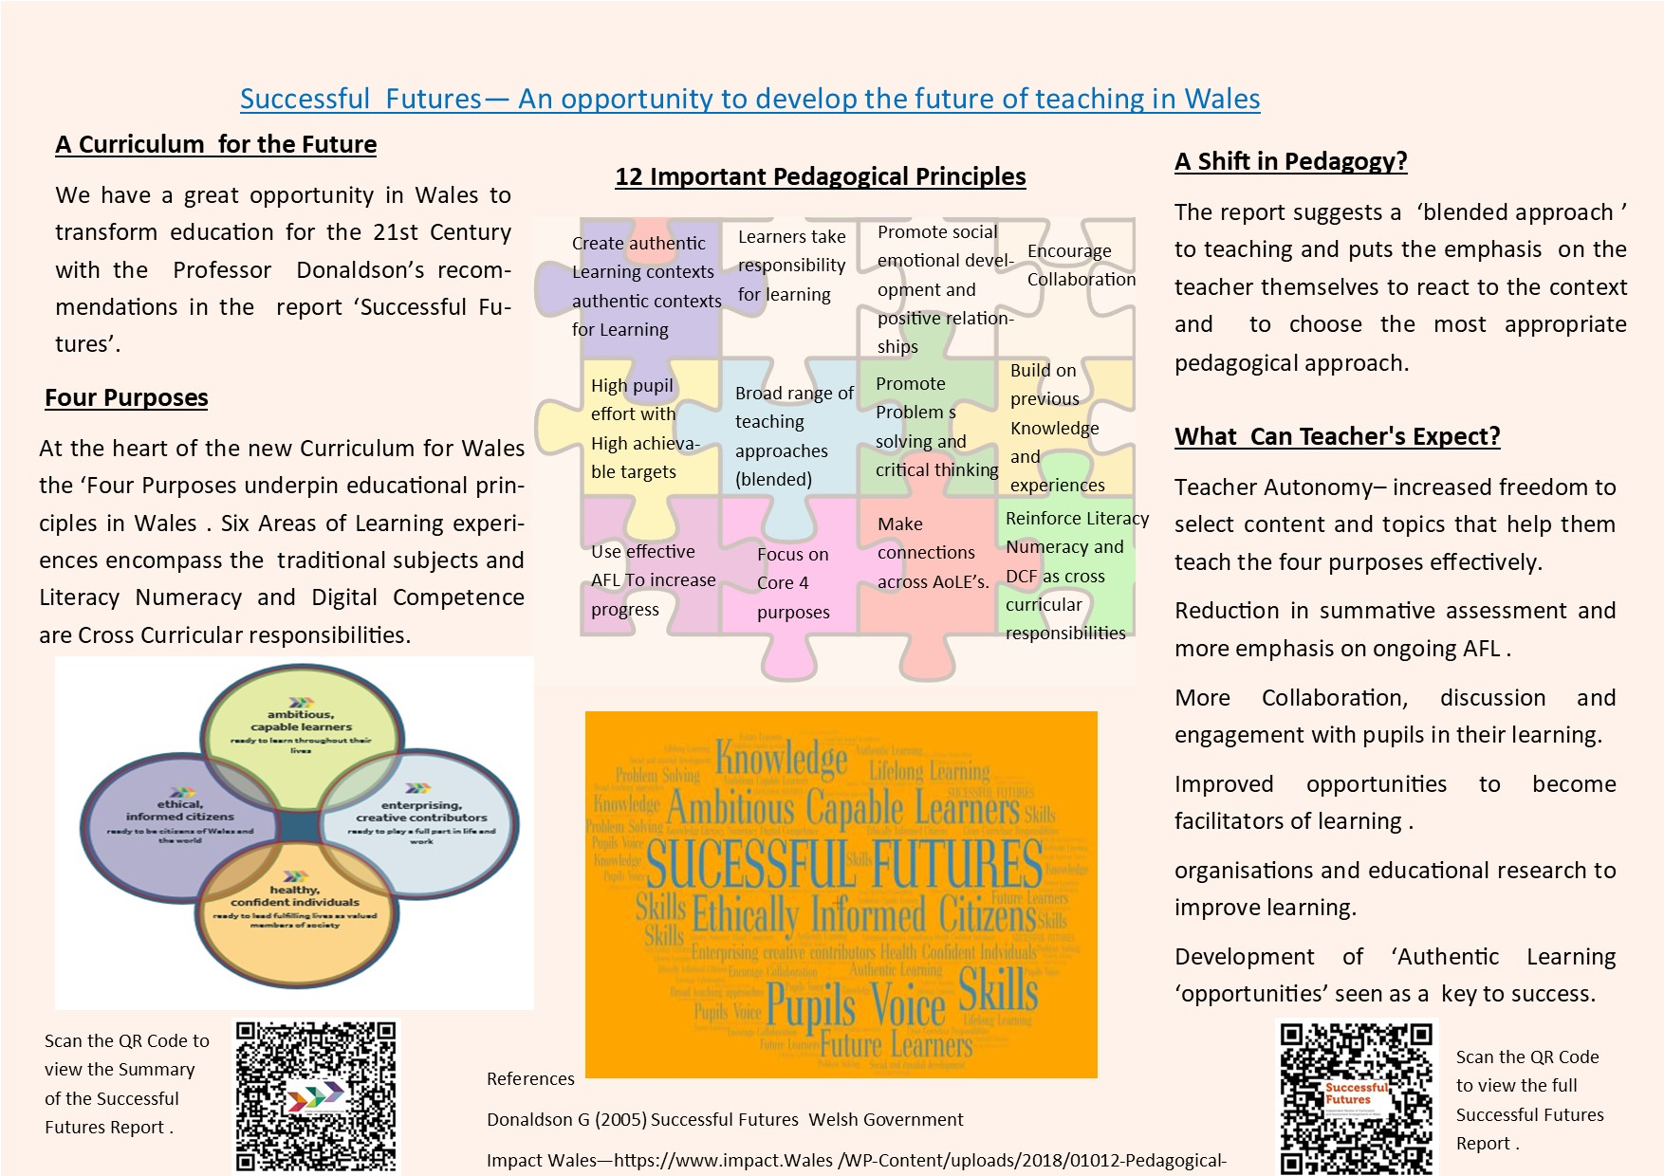
Academic Poster

Academic Poster Rationale
The Layout and structure of the poster is split into 3 sections. Each third is roughly equal. I tried to include elements of symmetry with the two main bodies of text forming opposite columns and then two main illustrations, one related to the twelve pedagogical principles and the other a ‘Word Art’ which displayed key words taken from ‘ Successful Futures Report.’ (Donaldson, 2015) The text was set out under sub headings and the language used was concise and direct. In the original draft the (See Appendix E) The fonts was not justified and words expanded over two lines. This has been subsequently adjusted and the whole font size was changed and resized for greater clarity. The content was chosen because it built on INSET training undertaken in school related to the CfW. Professional dialogue has been undertaken in staff meetings and on an INSET day around Successful Futures and CFW. A deliberate focus was chosen around the ‘Four Purposes’ that underpin the CfW because staff are familiar with these as we have be using these as the core of long term planning in the school for over two years. More recently, we have adopted a new planning format, which starts with identifying how we address the Four Purposes in the learning experiences provided to the pupils.
“Teachers should apply the pedagogical principles identified in this report when planning their teaching and learning, to ensure that the activities related directly to the curriculum purposes.’ (Donaldson , 2015 P 71)
The importance of the four core purposes was reinforced with the inclusion of the diagram that first appeared in the Successfully Futures Report (Donaldson, 2015 P 31)
The word art was created using selected words from the core purposes and the Key vocabulary for the Successful Futures report, such as pupils voice, collaboration, resilience, achievement, etc. The colours chosen were complimentary colours of orange and blue but the printed version is not as clear as the digital copy. The automated selection of words in the Word Art programme resulted in some words presented in a larger text than others and words such as ‘Skills’ are larger than others. I would have preferred to have been able to choose the size of the font making the statements or words I feel are important to Successful Futures larger and consequently giving them more emphasis. The contrast on the hard copy is poor due to ink quality. Photo chromatic paper would provide a deeper contrast and clarity to the poster.
The image of the Jigsaw design was chosen as a background to display the twelve pedagogical principles against as the CfW will only be full realised when all the twelve pedagogical principles are implemented together to promote effective teaching and learning. No one strategy is more important than another but a whole blend of the pedagogical principles is needed to fulfil the needs of the learner. The Welsh Government‘s statutory Teaching Standards identify ‘A Blended Approach’ as one of their 16 pedagogical principles. Often there is overlap in the pedagogical principles so the image of them fitting together to complete a whole approach to CfW is a relevant analogy. Also, completing a jigsaw requires the person to be reflective, to see where the pieces fit together. This can also reference the educators’ need to observe, the learners, know the next steps , look for patterns, make links and apply what fits to provide a holistic learning experience for students. The idea that all the educators involved with learners all have a part to play and help build the full potential picture of a child’s potential.
The ‘Twelve Pedagogical Principles’ were chosen as this links to INSET training and staff meetings previously undertaken at School A. It is a visual reminder of the importance of pedagogy and the principles that they can apply to their own classes and pupils. The pedagogical principles are at the top centre of the poster as this is where the eye will be typically drawn to this section first and it is the most important feature of the poster. Pedagogy is vital to the success of the CFW. Without applying the correct pedagogical approaches to facilitate the learning experiences for students the CfW will not have the impact it aspires to evoke. Dylan Williams a leading educationist alluded to this point in talk to the SSTN stating that ‘Pedagogy trumps Curriculum’ .This is further supported by the Sutton Trust who described the importance of implementing the correct pedagogical approach is vital. “ Pedagogy has a large impact on student outcomes.” (The Sutton Trust 2014 P2).
In the talk group several discussions about the use of QR codes to link to further reading was discussed and we agreed it promoted continuing professional development. I added two QR codes, from my original draft. (See appendix E) to promote staff engagement with The Successful Futures Report. (Donadlson 2015). The Welsh Government official Summary and the full Successful Futures report are both linked to the poster. When you search for an online version of the Successful Futures, the full report is often difficult to find. All staff are allocated an iPad and they are able to download the PDF versions of both reports, hosted by Learning Wales, by scanning the QR code. These documents can be saved to ‘iBooks’ and viewed offline at the teachers convenience. This will hopefully promote more engagement with the reports and can help deepen their own understanding of the documents. The document can also be referred back to once scanned in iBooks, as we have used these in subsequent staff meeting and whole inset training in relation to the new CfW.
From discussion in our talk groups I would have liked to add the School A’s vision mission and core values on the outside edges of the poster but when I attempted to do this it ruined the format and layout of the other areas so I removed this as it pushed the references off the page. The poster is displayed in natural warm pastel colours. This is chosen as the phycology of colour identifies as yellow and orange are warm, non-threating colours which link to staff not being alarmed about interacting with Successful Futures document and instead see it as an opportunity to help them put our learners at the centre of all we do. In contrast, there is a brighter multi-coloured Jigsaw that contrast to the background to stand out as the pedagogical principles are important.
I would like to add a link to the teaching standards (Appendix C) by a third QR code effected the poster layout and look. This would be useful for staff to compare the seventeen pedagogical principles identified in the statutory Teaching Standards for Wales.
Overall, I feel the poster suits my current staff as we are promoting interaction and it reinforces several areas of training areas undertaken. Other posters in our talk groups were far more detailed and academic in their approach but I feel my poster promotes several key messages that will help my organisation and encourage teachers to embrace and interact further with these important documents.

Conclusion
Developing and implementing a shared school approach to the new CfW is a difficult task. “We are facing the greatest challenge to the teaching profession that has occurred in more than half a century.” (Hargreaves & Fullen, 2012 p 15)
Success will hinge on the involvement of all staff who are best placed to know the needs of our learners. They are able to utilise a given locality to provide authentic learning opportunities and are able to use a blended approach to teaching pedagogies. Hattie gives a compelling argument that educator’s roles are vital in moving learning forward. Good teaching will require continual evaluation of the learning thus enacting a range of pedagogies to facilitate effective learning. “Teachers and school leaders need to be critical evaluators of the effects they are having on their students.” (Hattie, 2011 p15) Leadership has been key to empowering staff to become involved in developing an approach to the CfW at School A. ”…to construct a curriculum on the basis of what pupils and society need- to begin not form the content by form the learners.” ( Kerry , 2010 P9)
It is a fine balance to move toward enacting the aims of Successful futures and the CfW. It will require teacher agency and innovation to move forward to realise the four core purposes. While teacher agency is essential, good teaching “Involve guiding the agency of the learner to actions that strengthen their understanding of tasks and their impact on them.” (Thompson, 2014 P 9)

Appendix E
Draft Academic Poster 

