(Everstock Developments Ltd, 2023)  Building Evaluation  Construction Technology 2 | Abstract  New Student Accommodation  Caitlyn Moore

Table of Contents
Table of Figures 1
Introduction 2
Site Details 2
Prefabrication or on-site construction of different elements 3
Foundations 3
Ground conditions 3
Structural Frame 4
Building Envelope 5
Materials 6
Below Ground Drainage 7
Drainage System 8
Building Services 8
The Building Design 9
Weather/climate conditions in the area 9
Planning (bore holes etc) 10
Method Choices 11
Conclusion 12
References 13
Bibliography 14

Table of Figures
Figure 1 3
Figure 2 5
Figure 3 6
Figure 4 7
Figure 5 8
Figure 6 Figure 7 9
Figure 8 10
Figure 9 11

Introduction
This report will focus on providing an evaluation of the design elements, the types and choice of materials used, and the location of the student accommodation development. Key points to look at will be accessibility during and after construction, safety of the development, and the integration of the surrounding buildings into the design. The report will provide a comprehensive understanding of the choice of design elements to contribute to enhancing student living in the Swansea area.

Site Details
The image taken from a map shown in figure 1 below shows the area of where the proposed building will be located. The location is situated at Swansea waterfront on a brownfield rectangular site, it is assumed that the approximate area is roughly 0.885 acres. The site provides views looking into the town of Swansea across the River Tawe. The surrounding land has a mixture of uses such as bars and restaurants in period buildings that have been converted for the current use, multi storey apartments, new build offices and a campus for the University of Wales Trinity St David. It is assumed that the accommodation will house the students that will attend UWTSD. (Gerald Eve, ND)

Figure 1
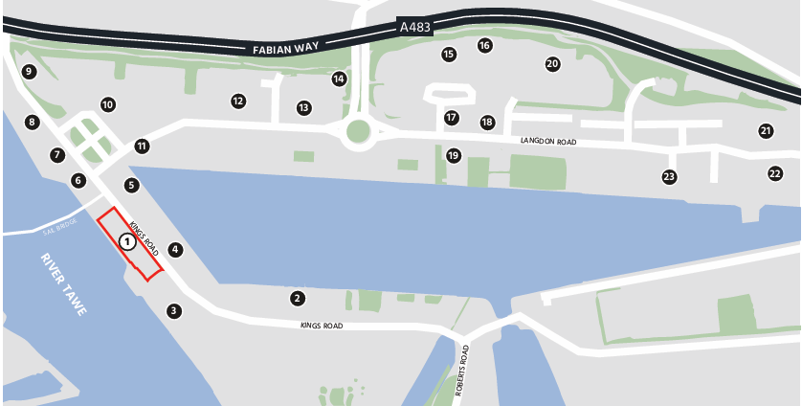

Prefabrication or on-site construction of different elements
Throughout this project a mix use of on-site and off-site construction which is referred to as ‘Hybrid construction’ will be used. The reason for choosing this way of construction is to save onsite time and cost savings etc.
Once the building starts to be constructed the space onsite will be very limited therefore constructing onsite will become more difficult as the project progresses, this is an example of why prefabricated materials will be used throughout the project alongside on-site construction.
The only disadvantage to using prefabricated materials is the delivery to site, this can be overcome by planning ahead. There will be two onsite cranes to assist with the deliveries and the construction elements.

Foundations
For this building pile foundations will be used to evenly distribute the load into the ground where the soil can hold the weight. Due to the watercourse being so close to the building this is another reason why the decision was made to go ahead with piles as they are suitable for areas where groundwater tables are high.
Piled foundations also have minimal impact on the environment as less excavation is required which will result in less disturbance for the surrounding neighbours. Piles are required to be designed accurately and once installation is completed, they will require to be tested to ensure that they can withhold the desired weight of the building, if not it is likely that the piles will fail. (Ninian MacQueen , 2023)

Ground conditions
The site is situated on a brownfield site, and it is likely to be contaminated from coal subsidence, iron residue and toxic chemical from the industrial period. It is assumed that the ground is made up of sand, clay, and mud rocks.

Structural Frame
Reinforced concrete structural frame is best suited to the environment due to its specific advantages to resist harsh conditions in settings such as a marine environment. The concrete frame will be corrosion resistant and will require minimal maintenance.
Due to the marine environment the frame will be exposed to a high level of moisture and salt, concrete will preform well in these conditions due to its low permeability. This will also result in the concrete frame having a longer life span in comparison to other materials.
Overall concrete is a thermal, fire resistant, adaptable, and feasible material that is best suited to the design of the building and the loads. (Construction Civil Engineering, ND)
Hybrid construction will be used to construct the frame itself. This means that the ground floor slab will be insitu poured on site using a concrete pump, the floors above will be precast concrete planks which are constructed offsite and then delivered and fitted, and some of the columns will also be precast with the others being poured on site.
There will be two staircases situated within the building, these will be precast concrete stairs with insitu landings, this will save on site time and less formwork. There will also be two lifts in the building, the lift cores will be incorporated into the strength of the concrete. Both of these will comply with Building Regulations M as they will be firefighting stairs/lifts.
The basement of the building will be classed as a classification one due to the water table, due to this a waterproof concrete mix will be used to ensure that the building is watertight.

Figure 2
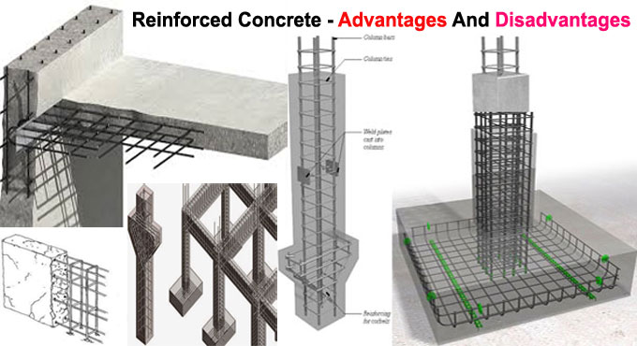 (Web Frames, 2022)

Building Envelope
The Student Accommodation development will consist of 104 units which will be split across –
- Two blocks made up of four storeys plus ground floor.
- Eight blocks made up of three storeys plus ground floor.
- Two blocks made up of 5 storeys plus ground floor.
- A basement.
The reason for the number of different sixed storey blocks is to be able to evenly distribute the load of the building into the ground successfully.
The ground floor will facilitate a cycle store, a bin store, a café, a study area, and a gym. (Swansea Council, 2019)

Materials

Fire Protection
To comply with building regulation the whole building will have sprinklers installed in case of a fire. Fire alarms will be fitted, and fire extinguishers will be placed at the relevant points.
To comply with approved document B the use of fire safety plasterboards will be used within the designated areas in the building, fire doors will be installed at specific points. A smoke excavation system will be installed, and a clear emergency exit plan/sign will be in place.
Each unit will be contained separately, so if a fire was to break out it should stay within its contained compartment to allow the occupants to escape. (Hannah, 2025)

Architectural Features
The construction of the walls will consist of a cavity between a layer of concrete blocks, insulation and finished with a dark red brick on the external façade. Brick ties will be used, and expansion joints will also be incorporated into the brickwork to allow room for movement, without these the brickwork could potentially crack.

Figure 3
 (Shutterstock, 2021)
Aluminium windows will be installed with a treatment to ensure that they are suitable for the environmental exposure. The window openings will be large enough to allow enough natural light in whilst also being a good thermal conductor. (Thames Valley Window Company, 2023)
The pitched roofs will be constructed using timber trusses which will be fireproofed. Layers of membrane and insulation will be fitted, the roof will then be covered with concrete tiles to provide water tightness and an aesthetically pleasing finish. Flashings will be installed across the full perimeter of the building to ensure that large amounts of water does not rushing down the building. (Emma Walshaw, 2021)
Figure 4 below provides a visual example.

Figure 4
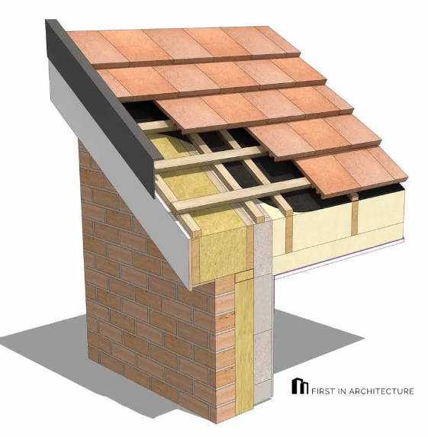 (Emma Walshaw, 2021)

Below Ground Drainage
The below ground drainage is a system of pipes that sits beneath the ground which allows wastewater to be transported to a sewer, these systems also allow surface water to soakaway. This is a system that will be incorporated into the design of the building, a key point for this system will be access points to allow future access for maintenance purposes etc. (Vicki James, 2023)

Figure 5

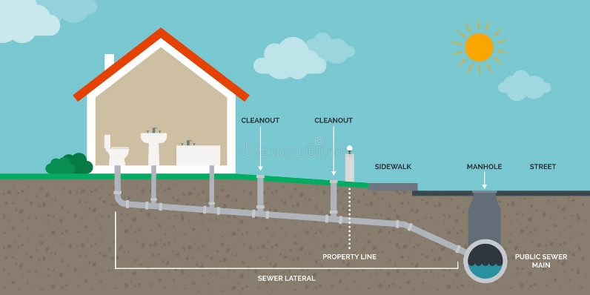 (Dkna Abza, 2022)

Drainage System
The drainage system for the building will consist of –
- Stormwater Drainage system.
- Sanitary Drainage system.
- Infrastructure such as manholes, inspection chambers, sewers and outlets as previously mentioned.
The above systems will be installed to ensure that the building complies with Approved Document H, without compliance the building wouldn’t be signed off which would mean the occupants would not be allowed to move in.

Building Services
The building will be fitted with the essential modern services such as electricity supply to provide lighting and power supply.
A sufficient water supply will be installed, this will be heated through a centralised system which is a boiler. A cold-water supply will be sourced along with a warm water supply. The warm water will be heated with gas, this means that a gas system will also be installed.
Heat source to ensure that the building is at the correct temperature weather that means warm or cold, MVHR units will be installed to circulate ventilation etc.
Each room will have a wall mounted control to adjust the temperature as and when required.
Internet and phone lines which are possibly the most modern service in comparison to the others.
Modern services are required to ensure that human comfort levels are met to allow the building to occupy humans to live.

The Building Design
There is a masterplan in place for the SA1 area where the student accommodation will be situated and that is to embrace the industrial heritage of a traditional feeling. The surrounding buildings are mostly consisted of pitched roofs with red bricks which provides an industrial feel for the history of the dockland area. (Richard Youle, 2018)
The design of the student accommodation will respect the original character of the neighbouring listed buildings and incorporate a pitched roof and red brick design as shown in the example in figure 2 & 3 below.

Figure 6 Figure 7
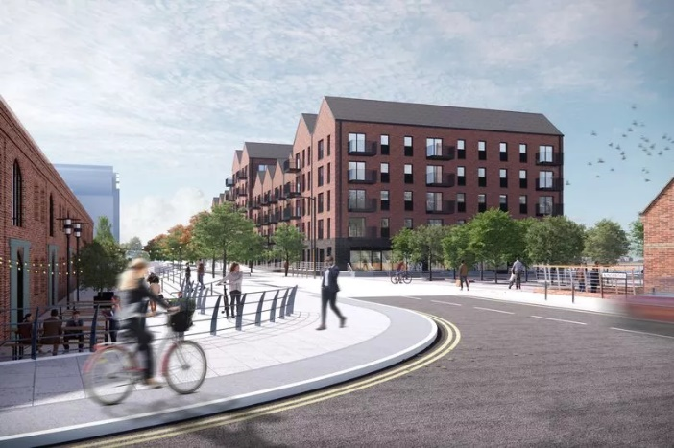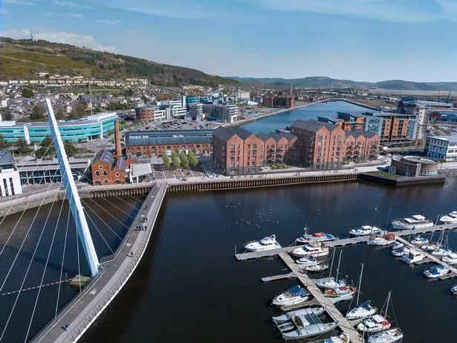 (Everstock Developments Ltd, 2023)
Each apartment will comply with Approved Document L. A sustainable process will also be incorporated into the design such as rainwater harvesting to ensure a more sustainable running building, the rainwater will be used to flush toilets etc, solar panels will also be installed. Materials will also be sourced from local businesses to keep the business within the area whilst also keeping emission levels low with deliveries to site.

Weather/climate conditions in the area
The location of the site is set as a high-risk alert for flooding due to the close proximity of the river Tawe. The area sees a lot of rainfall and windy conditions throughout the year so this will be taken into consideration when choosing materials. Due to the high risk of flooding the first-floor level will be raised above the surrounding ground levels to ensure that the risk of flooding is eliminated. (Swansea Council, 2019)
Figure 4 below provides an insight of the monthly average of the climate condition in Swansea.
(The Global Historical Weather and Climate Date, ND)

Figure 8
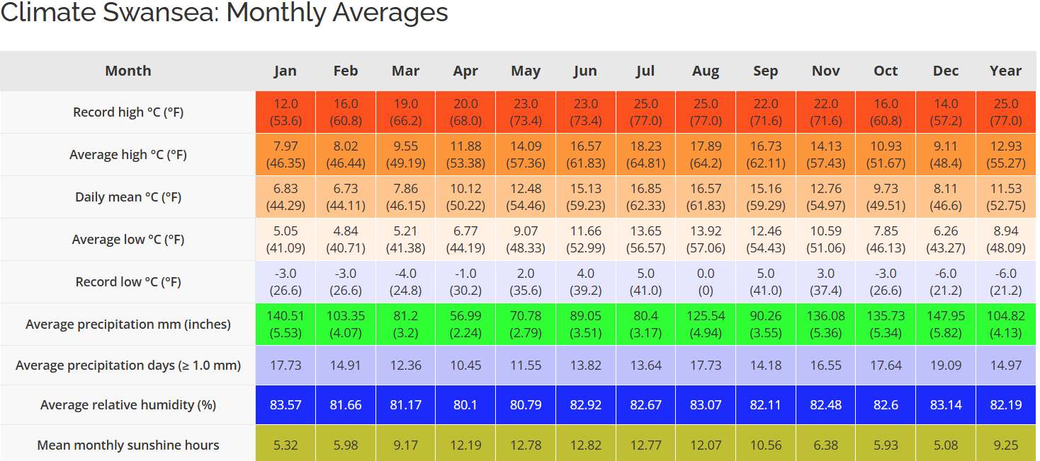

Planning (bore holes etc)
It is assumed that Planning for this development was originally submitted in 2006 and then it was resubmitted & approved in August 2019. (Swansea Council, 2019).
There are no bore hole reports available for Plot B3, but having found a report from a surrounding area it is assumed that the ground is made up of sand, clay, muck rocks, gravel, and coarse sand. (BGS, ND)
The figure below shows a snippet of the report from the surrounding area.

Figure 9
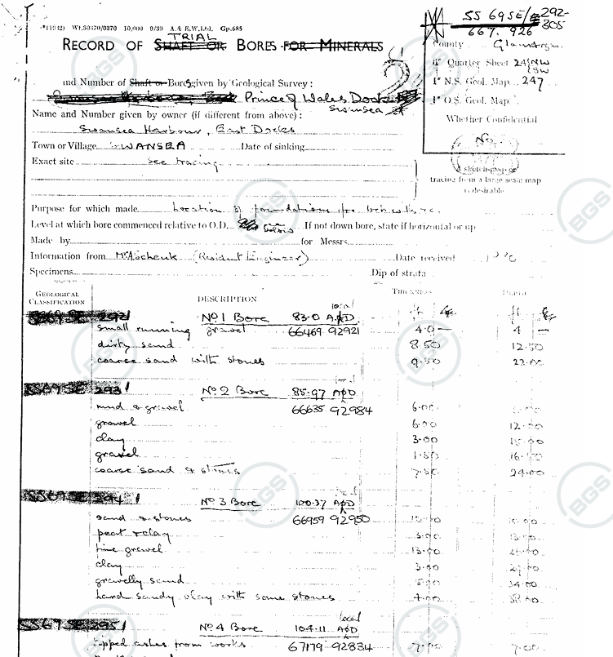 (BGS, ND)

Method Choices
Certain methods of construction were chosen to suit the whole project to ensure that the project duration isn’t extended due to delays.
A traditional method of construction that will be demonstrated throughout the project is the construction of the brickwork external façade and the internal blockwork skin.
Another method of choice that will be demonstrated as mentioned previously will be the prefabrication of the precast concrete elements.
In addition to the above method choices, hybrid construction will be one of the main methods used throughout.
The three method choices were chosen because of the project’s requirements, this way the use of the three methods has the potential to speed up the construction process overall whilst taking the environmental factors and cost into consideration. (Doug Vincent, 2025)

Conclusion
To conclude, a reinforced concrete frame building with varying storey heights is an ideal choice for marine environment due to its durability, structural flexibility, adaptability, and cost effectiveness. This approach ensures functionality while maintaining durability against harsh marine conditions. The design prioritises the comfort and safety for the occupants. One of the key factors throughout this project is to achieve the ‘industrial’ feel by incorporating the surrounding buildings aesthetic feel into the design, this is a key point due to the heritage of the area, the design of building will also contribute to the SA1 development plan.
It is important to recognise the importance of coordination when constructing a building especially when the site is located on a busy regularly used road and it also has limited space onsite to move around. The reason why it is important to remember the importance of coordination is to ensure that the design moves smoothly, and any risks are eliminated before constructing, otherwise the construction process will be prolonged due to poor organisation etc.
Each factor of the design elements and construction have been carefully considered to ensure that the materials are suitable for the area, costs are on target, programme doesn’t overrun, and the environmental factors are considered throughout along with other points. This is to be able to deliver a fully compliant, durable, and aesthetically pleasing student accommodation for the area.

References
BGS, ND. British Geological Survey. [Online]
Available at: https://api.bgs.ac.uk/sobi-scans/v1/borehole/scans/items/370193
[Accessed 03 January 2025].
Construction Civil Engineering, ND. Reinforced Concrete Frames in Construction: Advantages, Disadvantages and Application Methods. [Online]
Available at: https://www.constructioncivilengineering.com/reinforced-concrete-frame.html#:~:text=Advantages%20of%20Reinforced%20Concrete%20Frames%201%201.%20Strength,6%206.%20Cost-Effectiveness%3A%20Sowing%20Seeds%20of%20Savings%20
[Accessed 06 January 2025].
Dkna Abza, 2022. Types of residential drainage systems. N/A: DKNA.
Doug Vincent, 2025. Ultimate Guide to Project Delivery in Construction. Mast, 2 January, pp. 11-15.
Emma Walshaw, 2021. Pitched Roof Details Guide. [Online]
Available at: https://www.firstinarchitecture.co.uk/detail-post-pitched-roof-details/
[Accessed 6 January 2025].
Eve, g., n.d.
Everstock Developments Ltd, 2023. Block of 104 Housing Assosiation Flats. Swansea: Wales Online.
Gerald Eve, ND. Residential Development Site for Sale. [Online]
Available at: https://d39qj8qlyfrchd.cloudfront.net/images/20211129/1-98501767.pdf
[Accessed 06 January 2025].
Hannah, 2025. Martyn Young Fireproofing Consultant. [Online]
Available at: https://fireproof.co.uk/fire-safety-in-student-accommodation-protecting-young-adults/#:~:text=Essential%20Fire%20Safety%20Measures%201%20Fire%20Detection%20Systems,6%20Regular%20Inspections%20...%207%20Building%20Maintenance%20
[Accessed 11 January 2025].
Ninian MacQueen , 2023. What are piled foundations and will your project need them?, N/A: Home Building.
Richard Youle, 2018. The Success and Failure of Rebuilding Swanseas Docklands, Swansea : Wales Online .
Shutterstock, 2021. Red Bricks. NA: Shutterstock.
Swansea Council, 2019. Planning Application. [Online]
Available at: https://property.swansea.gov.uk/online-applications/applicationDetails.do?keyVal=PU49H0EVI2V00&activeTab=summary
[Accessed 6 January 2025].
Thames Valley Window Company, 2023. Are Marine Grade Windows the Best Glazing Solution for Coastal Housing?. [Online]
Available at: https://www.tvwindows.com/blog/are-marine-grade-aluminium-windows-the-best-glazing-solution-for-coastal-properties
[Accessed 06 01 2025].
The Global Historical Weather and Climate Date, ND. Weather and Climate. [Online]
Available at: https://weatherandclimate.com/united-kingdom/swansea
[Accessed 4 January 2025].
Vicki James, 2023. Underground Drainage: Introduction, s.l.: Drainfast.
Web Frames, 2022. Advantages and Disadvantages of concrete frames. NA: Web Frames.

Bibliography
BGS, ND. British Geological Survey. [Online]
Available at: https://api.bgs.ac.uk/sobi-scans/v1/borehole/scans/items/370193
[Accessed 03 January 2025].
Construction Civil Engineering, ND. Reinforced Concrete Frames in Construction: Advantages, Disadvantages and Application Methods. [Online]
Available at: https://www.constructioncivilengineering.com/reinforced-concrete-frame.html#:~:text=Advantages%20of%20Reinforced%20Concrete%20Frames%201%201.%20Strength,6%206.%20Cost-Effectiveness%3A%20Sowing%20Seeds%20of%20Savings%20
[Accessed 06 January 2025].
Dkna Abza, 2022. Types of residential drainage systems. N/A: DKNA.
Doug Vincent, 2025. Ultimate Guide to Project Delivery in Construction. Mast, 2 January, pp. 11-15.
Emma Walshaw, 2021. Pitched Roof Details Guide. [Online]
Available at: https://www.firstinarchitecture.co.uk/detail-post-pitched-roof-details/
[Accessed 6 January 2025].
Eve, g., n.d.
Everstock Developments Ltd, 2023. Block of 104 Housing Assosiation Flats. Swansea: Wales Online.
Gerald Eve, ND. Residential Development Site for Sale. [Online]
Available at: https://d39qj8qlyfrchd.cloudfront.net/images/20211129/1-98501767.pdf
[Accessed 06 January 2025].
Hannah, 2025. Martyn Young Fireproofing Consultant. [Online]
Available at: https://fireproof.co.uk/fire-safety-in-student-accommodation-protecting-young-adults/#:~:text=Essential%20Fire%20Safety%20Measures%201%20Fire%20Detection%20Systems,6%20Regular%20Inspections%20...%207%20Building%20Maintenance%20
[Accessed 11 January 2025].
Ninian MacQueen , 2023. What are piled foundations and will your project need them?, N/A: Home Building.
Richard Youle, 2018. The Success and Failure of Rebuilding Swanseas Docklands, Swansea : Wales Online .
Shutterstock, 2021. Red Bricks. NA: Shutterstock.
Swansea Council, 2019. Planning Application. [Online]
Available at: https://property.swansea.gov.uk/online-applications/applicationDetails.do?keyVal=PU49H0EVI2V00&activeTab=summary
[Accessed 6 January 2025].
Thames Valley Window Company, 2023. Are Marine Grade Windows the Best Glazing Solution for Coastal Housing?. [Online]
Available at: https://www.tvwindows.com/blog/are-marine-grade-aluminium-windows-the-best-glazing-solution-for-coastal-properties
[Accessed 06 01 2025].
The Global Historical Weather and Climate Date, ND. Weather and Climate. [Online]
Available at: https://weatherandclimate.com/united-kingdom/swansea
[Accessed 4 January 2025].
Vicki James, 2023. Underground Drainage: Introduction, s.l.: Drainfast.
Web Frames, 2022. Advantages and Disadvantages of concrete frames. NA: Web Frames.

