Understanding the Business Context of Human Resources

Jodie Barnett

CIPD course number: 5CBIC

CIPD Membership number: 2224083X

Activity 1 - word count excluding cover sheet and reference list: 1,787 (maximum 2000 words)
Activity 2 – word count: 360 (500 words)

By signing below, I confirm that the work/evidence presented is my own, unaided work. I understand the regulations pertaining to candidate malpractice and the action that may be taken as a result.

Signed: 
Date: 16th March 2020

- Comparison of two different types of organisation and their operational/business purpose.
Neath Port Talbot County Borough Council (NPTCBC) is a large public sector organisation employing over 5000 individuals. As a Local Authority, it offers a wide range of public services across 5 directorates: Chief Executives, Social Services, Health and Housing, Finance and Corporate, Education, Leisure and Lifelong Learning and Environment. The Council’s hierarchy consists of a Chief Executive and 4 Directors responsible for the day to day management of the Council and its services. Each Directorate will have their own structure/teams with some Directorates operating between two i.e. Financial Services interlink between Directorates for budgetary purposes.
The Council publishes a yearly Corporate Plan which sets out the Council’s priorities for improving the services delivered to the public and communities (NPTCBC 2020b).
The Council is made up of 64 locally elected Councillors who represent 42 divisions of Neath and Port Talbot. They make decisions on how the Council is run and how to improve local services on behalf of local people. The way in which Councillors make decisions is informed by the ideas of the political parties they represent (NPTCBC 2020a).
(Local Government Group 2010) refers to most council services being mandatory as they are under a duty to do so by law.

Mind is a mental health charity known as a third sector small voluntary organisation employing an average of 420 employees in 2019 (Mind 2020a). As a charity, Mind relies on donations from the public, companies, other funders and sales from their charity shops.
They have 8 members of their Senior Management team that has overall corporate responsibility for their charity’s strategy, leadership, management and organisation performance. They have a board of trustees known as the Council of Management that is accountable for everything they do and support and empower the Senior Management team by setting strategic direction and scrutinising performance. Mind is a federated network, with over 130 Mind’s delivering services and supporting local communities.
Mind’s 2016-21 strategy is called ‘building on change’ sets out the charity’s vision and values to reduce the stigma associated with mental health and promote awareness (Mind 2020b).

2. Assess how business type and purpose affects the HR function
(CIPD 2015) acknowledges that there are several factors an organisation needs to consider, and these may have an influence on their HR structure, agenda and practices i.e. type of sector, size and location of sites. CIPD refer to the importance of organisation design ‘The process and the outcome of shaping an organisational structure, to align it with the purpose of the business and its context in which the organisation exists’.
(Taylor & Wilkinson, 2016) argues that although HR practices are carried out similarly across all types of organisations, it is important to recognise that business objectives vary noticeably. Different organisations vary vastly with diverse commercial and regulatory pressures and gaining an understanding of the business objectives and the contexts in which they operate is fundamental to an effective HR.
(Taylor & Wilkinson, 2016) refer to large private sector companies employing teams of HR specialists to carry out people management work with the HR functions assuming a higher profile with a strategic focus on key business objectives. Administration duties tend to be delegated to line managers, outsourced or centralised. Smaller companies do not have a significant HR function and may employ a HR specialist to undertake basic HR tasks and rely on outside help when managing HRM.
(Taylor & Wilkinson, 2016) refer to public sector organisations being largely funded by taxpayers and are subject to public accountability. These usually have large HR functions and includes influential and prominent HR directors who promote good practice i.e. legal compliance. A combination of specialists and generalists will undertake a wide range of tasks. NPTCBC has a large HR function which operates with both generalists and specialists. The Head of HR makes strategic decisions as part of the board of directors. Line managers are more involved in HR activities such as recruitment and training and development.
HR is mainly used to undertake administrative duties in the third sector and resources can be limited are these organisations are operated on a not-for-profit basis.

3. Explain how different organisational structures and management roles can impact on the HR function.
(Kew & Stredwick, 2016) refers to different models of organisational structure:
- Bureaucracy
- Divisionalisation
- Matrix
- Networks
- Virtual
- Strategic Alliances
Different structures can shape the HR function within an organisation. For example, (Kew & Stredwick, 2016) refer to large divisionalised organisations setting up several separate divisions which are each responsible for operational decisions including HR. This reduces the need for a HR function as management are responsible for HR decisions.
(Farnham, 2015) argues that it is widely recognised that managerial roles cover ten fields of activity and this includes managing people or human resources tasks. He refers to management roles being very much dependant on the organisational structure and their standing varies widely in different organisations - what the HR departments do, how they are structured, their role in strategy determination, their size, their relationships with senior management, line managers and employees.
NPTCBC adopts a hierarchical bureaucratic organisation and the HR function very much applies the same. Those higher in the function will give instruction to those lower down.

4. Explain the role of the HR function in formulating organisational strategy.
(Farnham, 2015) acknowledges that organisations approach to strategy formulation differs depending on the type of markets they operate in, culture, management style, external context and so forth.
(Taylor & Wilkinson, 2016) argues that there are three basic approaches to distinguish when strategy is formulated by organisations:
- Rational/classical
- Symbolic/radical
- Emergent/logical incrementalism
Mintzberg is known to be the most influential thinker in this field. He is known for formulating a contingency model which sets out the circumstances when the above types of formulation processes are appropriate. Mintzberg in 1994 referred to key variables being the complexity of the organisation, its environment and the rate of change in that environment.
In 1985, Larry D. Alexander, identified 5 main features of successful strategy implementation and HR plays an important role in this process:
- Communicating
- Starting with a good idea
- Gaining employee commitment and involvement
- Providing sufficient resources
- Developing an implementation plan
(Farnham, 2015) argues that to be effective in the business world, HR professionals need to understand the external and internal contexts i.e. PESTLE/SWOT analysis, in which their organisation operates and the levers driving change within it. He refers to current good practice indicates that the HR function is critical to the formulation and deliverance of business and HR objectives and promoting appropriate HR activities. (Taylor & Wilkinson, 2016) refers to a success strategy being entrusted to senior managers and that their job is to undertake a continual appraisal of both the external and internal environments by using an analysis tool such as the SWOT analysis (figure 1) and the use of such information will formulate goals, aims and objectives for the organisation.
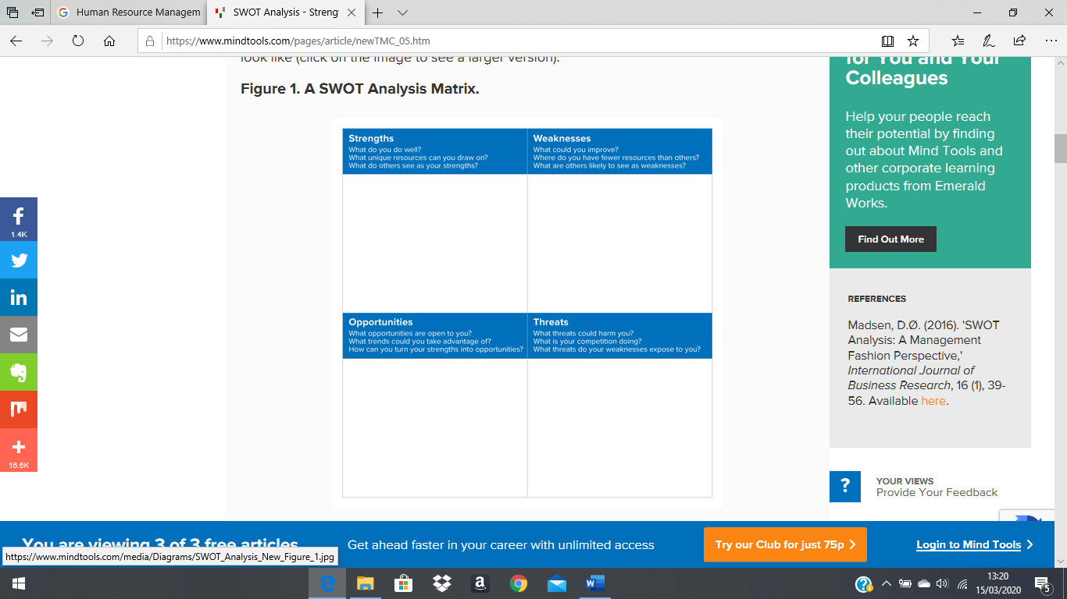
Figure 1: Source: www.mindtool.com

HR needs to understand the business, its markets and the forces driving the sector where the business operates to carry out their role. HR can contribute and influence on organisational strategy by participating at different levels i.e. HR board member, providing data and information on current skills and capability of the current workforce i.e. workforce planning. HR will need to develop policies and procedures that assist with the organisational strategy as well as assist with consultation of strategy by communicating this to senior/line managers.
(CIPD 2020) refers to the organisation’s culture affecting every aspect of how an organisation operates and how work gets done. In the pursuit of sustainable performance, ensuring the culture is fit for the future is a high priority for many.
It is worth acknowledging “The Cultural Web” (figure 2) designed by Johnson and Scholes in 1992 which helps approach organisational culture and can play a key role in formulating strategy.
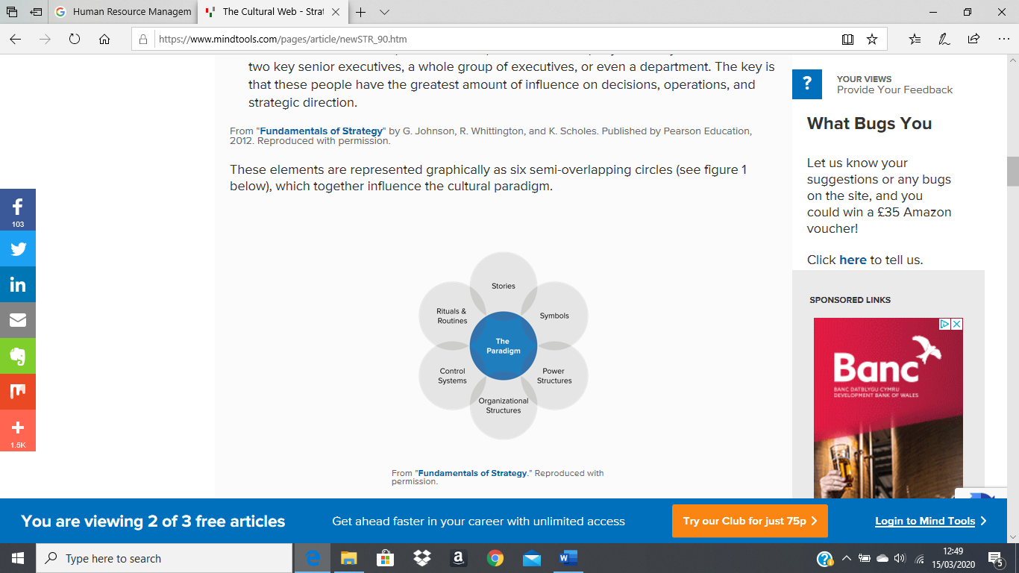
Figure 2: Source: www.mindtools.com

5. Explain how organisational strategy is translated into HR strategy and policy
(Farnham, 2015) defines HR strategy as a “set of ideas, policies and practices which management adopt in order to achieve a people- management objective”. A main characteristic of an effective HR strategy is its assimilation with the business strategy.
(Farnham, 2015) argues that the idea of using ‘best practice models’ is the claim that a number of specific HR strategies and practices can bring improved organisational performance.
(Farnham, 2015) refers to there being a number of models for HR strategy and each is supported by the theory that HR policies and practices needs to support the organisation goals, in order to be effective. He refers to HR strategies needing to have some element of “external fit” with business strategies as well as being “vertically” integrated with them. Vertical integration therefore refers to the links between business strategy, external contexts and HR policies and practices.
An “internal fit” relates to the need to be horizontally aligned with all aspects of HR strategy so that there is consistency and support within.
(Taylor & Wilkinson, 2016) acknowledges that an organisation enhances the likelihood of successfully achieving should they established a meaningful HR strategy to support the wider organisational strategy. For many years’ managers have made use of contingency thinking and models in order to help align HR strategies with the business strategies.
Michael Porter adopted a highly influential model in 1985 and this focuses on alternative ways that organisations gain competitive advantage. He identified three core strategies that firms follow:
- Cost leadership (value for money)
- Differentiation (through quality enhancement or innovation)
- Focus (using cost leadership or differentiation in a niche market)
The kind of HR policies and procedures that need to be in place in order to effectively support the three will be different. For example, (Taylor & Wilkinson, 2016) go on to add that an organisation that pursues a cost leadership strategy, the HR strategy will certainly be focused on keeping the wage bill as low as possible.
(Deloitte, 2018) outlines that future HR strategies and policies should be preparing for tomorrow’s workforce and the Fourth Industrial Revolution. Such strategies should align with the changing landscape of youth globally and this includes developing promising talent strategies as well as investing strategically in workforce training approaches.
(Phillips & Phillips, 2014) refer human capital being the most critical part of an organisation and HR’s role and influence needs to change relative to the environment. The challenge is to connect important external changes to the human capital strategy. Other forces to be addressed and included in a such strategy include engagement, turnover, productivity and the business impact this has on the entire organisation. Such forces are best addressed and managed by HR and should incorporate in the organisations practices and policies.

Activity 2
- Identify an organisation of your choice, and using 2 analysis techniques, such as PESTLE or SWOT, identify the current external factors impacting on the organisation. Your analysis should, as a minimum, consider market forces, social trends, technological developments, legislation and globalisation / international factors.
PESTLE / SWOT analysis undertaken on Pembrokeshire County Council in a group with other students.
Pembrokeshire County Council
PESTLE Analysis
 | External Factor | Internal Factor on PCC | Importance to organisation – PCC HR
Political | GOVERNMENT FUNDING  BREXIT – staff | The budget for an LA is determined by Government/Welsh Government. Last year the budget for PCC was decreased by 0.5%, as stressed on an ITV Wales broadcast in 2019.  The impact of such cuts has been highlighted with the suggested increase in Council Tax in Pembrokeshire of 5%.  A flat budget has also been in place since 2018/19 with in the intention that department will have to make further staff cuts to meet their budget.  PCC employs a large amount of staff who come from the European Union (EU) which will mean that when the UK leaves the EU many of these staff will be affected. | The HR function will have to assist with any employee implication e.g. redeployment, restructuring, redundancy.  This will include employee consultations, working with unions etc.  Recruitment to replace staff who choose/are unable to continue working.  Policies will need to be updated introduced  Regulatory paperwork completed to meet new guidelines for those employees who remain.
Economic | Living wage | As highlighted in an article by the Press Association (2019) the national living wage has increased. Although implementation of this wage is voluntary, PCC honours it to ensure that all staff are paid at least £9 per hour which has a big impact in a large amount of staff employed by the organisation. | As a result of the new living wage HR will need to develop and implement new pay scales and policies to reflect the change.
Sociological | Welsh Language  AGILE WORKING | As a Local Authority, PCC have a responsibility to adhere to the Welsh Language Standards. These are a set of legally binding requirements which apply to Welsh Government since March 2016. The consequences of meeting these standards can be a significant fine.  The advancement of technology has resulted in staff at PCC being able to work in a more agile way. As stated in an article by Rigby et al (2018) working agile gives employers the opportunity to be able to work from various locations that suit both their needs and the needs of the business. | New internal policies and procedures have been introduced. HR have been required to update their recruitment policy to include Welsh as ‘Essential’ to some role and desirable to most. Staff in customer facing roles have been identified to undertake Welsh classes which have to be delivered within their working hours and at no cost to the employee.  HR are also involved with issues linked to those employees who have challenged learning Welsh.  This will affect HR as it will mean that an appropriate policy and procedure around agile working will need to be implemented. HR will also have to deal with any complaints from employees who have been refused the opportunity to work in an agile way.
Technological | ARTIFICIAL INTELLIGENCE/ ROBOTICS | Technology is evolving and the information we output for statistical purposes is high demand. PCC has developed a robotic system known as ‘penfro’ which will be used to respond to common questions through the customer service centre. | HR will be required to communicate such changes to line managers/employees and ensure that employees remain engaged in their roles. Developing this system could put potential jobs at risk, but save money.
Legal | EMPLOYMENT LAW – Parental bereavement leave | Whenever different laws are developed staff at PCC will need to ensure they are abiding by them. An example of this is the new parental bereavement leave and pay that will come into force on 6th April 2020 subject to approval being laid today (23/01/20) www.gov.uk.news | HR are responsible for updating policies relating to any changes in rules rule & regulations. A new policy will need to be written to meet the introduction of parental bereavement leave and pay.
Environmental | RECYCLING TARGETS | PCC are set targets to ensure they are abiding by the recycling regulations (2019). In order to help meet the required standards PCC recently went through a huge recruitment initiative to employ a further 30 staff in this area. | The HR function has been involved in all areas of specialism from recruitment, payroll and training to support this initiative.

Pembrokeshire County Council
SWOT Analysis
 | Factor | Impact on PCC | Impact on HR
Strengths | EMPLOYMENT | PCC is one of the largest employers within Pembrokeshire. As an employer it offers:-  - Stability/security  - Attractive salary package which includes paid holidays/sickness/holidays  - Promotion opportunity  - Training & development  - Flexible working | Significant number of applications for all posts advertised
Weaknesses | > FUNDING | As a local authority PCC is heavily dependent on the amount of funding that ‘Westminster’ allocates to Wales and thus Welsh Government to Local Authorities. We have also become dependent on European Funding and Brexit will have a huge impact on the funding we already hold coming to end. | The impact of reduced funding could potentially mean an organisation restructure and redundancies/redeployment. All of this will mean HR will be supporting Line Managers & employees with communications, consultations etc.
Opportunities | > TECHNOLOGY | The PCC Contact Centre have recently introduced an AI robot called ‘Penfro’. This robot will respond to calls to the contact centre answering common questions. It has the ability to develop its memory and thus answer more complicated queries. At first the contact centre staff were concerned about their own job security; however, this has now become an opportunity for them to be developed and their roles less repetitive. As an organisation is highlights how we are embracing technology and using it to be more effective and productive. | HR provided support to contact centre Line Managers with communications and change of role for some staff.
Threats | BREXIT  > BREXIT | The uncertainty of Brexit the unknown of how it will impact PCC has been ‘hanging’ around for a long time.  It is challenging to set this aside and continue with a business as usual approach. PCC does a ‘plan’ in place but there are many unknowns e.g. employing migrant workers, possible to change in guidelines or standards. | The implications could be an increase or reduction of staff. Change in employment law and regulations. The requirement for new policies etc.

- Once stage 1 is completed, further consider how the specific forces impacting on the organisation, might affect the organisation’s HR function.
As you can see from the PESTLE and SWOT analysis undertaken on Pembrokeshire County Council (PCC), column 4 on both analysis techniques has addressed the impact these forces have had on the PCC HR function going forward.

- Write a short report briefly explaining the analysis techniques/tools you used and summarising the conclusions from both stages.
PESTLE analysis
The PESTLE analysis tool is used to identify the external factors that affect the organisation. Identifying such factors can help shape the organisational strategy and minimise any risks.
(CIPD, 2020) refers to a PESTLE analysis being a review of six external impacts on an organisation – these being:
- Political – this includes tax policy; tariffs; environmental restrictions.
- Economic – inflation and wages; minimum wage; working hours; cost of living; unemployment rates.
- Sociological – population growth rates; age allocation; health and safety.
- Technological – new technology such as Artificial Intelligence (AI); its effect on products and services.
- Legal – changes to employment legislation; taxation.
- Environmental – global warming; ethical sourcing.
Conducting such an analysis will help organisations gain an understanding into these external influences that may impact strategy and business decisions. This tool allows HR and management to assess any potential risks specific to the industry in which they work and use that knowledge to advise on their decisions.
PCC’s PESTLE analysis has helped identify the external forces affecting local government and therefore, PCC can utilise a forward-thinking approach and adopt any change in legislation that HR needs to incorporate in policies and practices. For example, change in National Minimum Wage from 1st April will have an adverse effect on current policies and procedures in place. These will need to be updated in line with Government regulations.

SWOT analysis
(Farnham, 2015) describes a SWOT analysis focuses on strengths, weaknesses, opportunities and threats related to strategy. They provide a valuable way of vetting strategic decisions. Please refer to figure 1 in my activity 1 report for an example of a SWOT analysis.
PCC’s SWOT analysis has identified that there is a lot of work that HR is required to do in terms of communication to line managers and employees in order to adopt new working practices. Without HR involvement and reassurance to these employees, there is a risk for lack of motivation/engagement. For example, PCC’s identified weakness is the potential lack of Government funding and uncertainty around BREXIT. HR will need to identify any potential jobs at risk and commence the management of change process ensuring that the employees at risk are fully engaged and communicated too.

References
CIPD, 2011. Developing organisation culture. (Online) Available at: https://www.cipd.co.uk/knowledge/culture/working-environment/organisational-culture-report (Accessed 14 March 2020)
CIPD, 2015. Changing HR operating models. (Online) Available at: https://www.cipd.co.uk/knowledge/strategy/hr/operating-models (Accessed 06 March 2020).
CIPD, 2020. PESTLE analysis. (Online) Available at: https://www.cipd.co.uk/knowledge/strategy/organisational-development/pestle-analysis-factsheet#7986 (Accessed 14 March 2020)
Deloitte, 2018. Global Business Coalition for Education. Preparing tomorrow’s workforce for the Fourth Industrial Revolution.
Farnham, D., 2015. Human Resource Management in Context. London: CIPD.
Kew, J. & Stredwick, J., 2016. Human Resource Management in a Business Context. 3rd ed. London: CIPD.
Local Government Group, 2010. Local Government Structure Overview. (Online) Available at: https://www.local.gov.uk/sites/default/files/documents/local-government-structur-634.pdf (Accessed 04 March 2020).
Mind, 2020a. About us. (Online) Available at: https://www.mind.org.uk/about-us/ (Accessed 04 March 2020).
Mind, 2020b. Building on change: Mind’s 2016-2021 strategy. (Online) Available at https://www.mind.org.uk/media/4205494/building-on-change_booklet_final_pdf_21march16.pdf (Accessed 04 March 2020).
Mindtools, 2020. The Cultural Web: Aligning your organisational culture with strategy. (Online) Available at: https://www.mindtools.com/pages/article/newSTR_90.htm (Accessed 14 March 2020)
Mindtools, 2020. SWOT analysis – how to develop a strategy for success. (Online) Available at: https://www.mindtools.com/pages/article/newTMC_05.htm (Accessed 14 March 2020)
NPTCBC, 2020a. How the Council works. [Online] Available at: https://www.npt.gov.uk/5841 [Accessed 03 March 2020].
NPTCBC, 2020b. Corporate Plan 2018-2022. (Online) Available at: https://www.npt.gov.uk/14478 (Accessed 03 March 2020).
Phillips, J.J. & Phillips, P.P., 2014, Strategic HR Review. Developing a human capital strategy in today’s changing environment: eight forces shaping HC strategy. Vol 13, pg 130.
Taylor, S. & Woodhams, C., 2016. Studying Human Resource Management. 2nd ed. London: CIPD.

