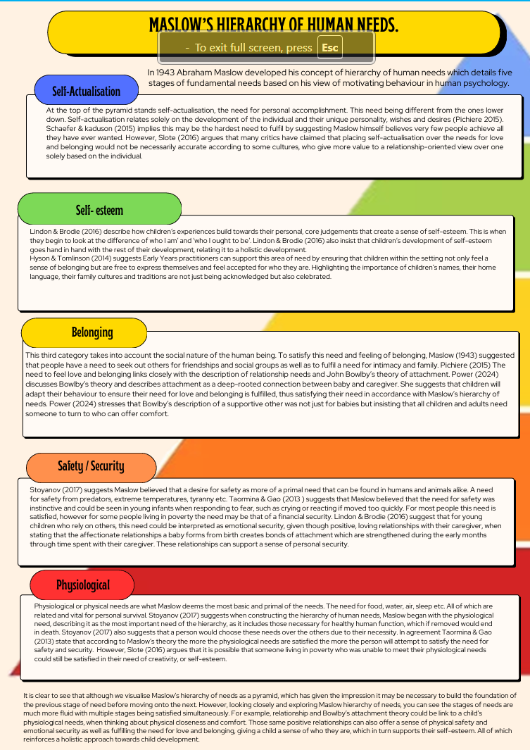

The Concept of Holistic Child Development
The concept or idea of holistic child development is to look at children's development as a whole, where every area of learning, development and growth is interconnected with each other (Brodie 2018). Looking at Maslow’s hierarchy of human needs from a holistic perspective rather than linear and identifying how certain needs such as positive relationships, safety and play are important for holistic development in regards with Maslow’s hierarchy of needs.
Stoyanov (2017) states Maslow himself understood that the stages of needs happen simultaneously, when he stated that most people are both partially satisfied and partially unsatisfied in all areas of needs at the same time. Brodie (2018) points out that children develop differently due to their individual circumstances, their biology, their personality and their perspective. It come to no surprise when she goes on to add that siblings and even twins can learn and develop at different rates, which would see sibling or twins who appear similar to need more support in one area of need than the other or developing more skills in one area of development before the other.
Brodie (2018) states holistic development is not about just recognising the links between the stages of need and areas of development but also viewing them from different perspectives. She suggests Early Years practitioners should regularly reflect on practice to ensure it is not aimed at fulfilling just one or two areas of needs.
Hyson & Tomlinson (2014) highlights the impact across multiple stages of needs from positive relationships between children and their caregiver. They describe these relationships as the heart of baby and toddlers’ development, giving those positive relationships more credit for overall development then other environmental or sensory experiences. They state that the relationship between baby and their caregiver holds the greatest influence on developing, shaping and strengthening neural connections that are needed for later learning and development. This is reinforced by Lindon & Brodie (2016) who believes that a secure attachment between children and their caregiver is critical for laying the foundations for healthy development. Adding that loving relationships between a baby and their caregiver forms from birth, which creates bonds of attachment that are strengthened during the early months through time spent together. These relationships support a sense of personal security. Brunton & Thornton (2010) agree with this, stating that positive relationships with caregivers fulfil children’s emotional need for comfort, affection, respect and approval. When these needs are met children develop emotional security which supports their need for safety. It builds their confident to tackle challenges and solve problems for themselves as well as offers resilience. All of which can build a child's self-esteem linking again with Maslow's hierarchy of needs.
Hyder (2004) describes part of ensuring a safe setting environment for children and their families, is to build positive relationships, where children feel a sense of belonging and where families can feel safe and have opportunities to be listened to. Hyder (2004) also reflects on the similarities between Maslow's needs and United Nations Convention of the Right of the Child, such as article 19 – children’s right for protection against violence, abuse and neglect, which corresponds with Maslow’s need for safety and Article 24 – children’s right to good quality health care, clean water, nutritious food, and a clean environment which links with the physiology need (Unicef 2022). However, Hyder (2004) also highlights differences between both as meeting needs can appear as an optional action however the concept of rights implies a duty by law to be upheld.
The Funded non maintained curriculum implemented by Welsh Government (2022) has been designed to provide children with a sense of belonging and pride while celebrating the diverse culture of Wales. It focuses on the needs the developing child through five developmental pathways. It is through these pathways that the links to Maslow's hierarchy of needs can be seen. Whilst emphasising on play as a fundamental part of the curriculum it ensures a holistic approach to support all areas of development. This highlights how important play is when looking at children’s holistic growth and development. Brodie (2018) stating “Play is by virtue of its breadth and depth is truly holistic” with play promoting skills such as learning to solve problems, have social interactions and encouraging children in expressing their own personality (Dowling and Walsh 2017). Hyder (2004) emphasises how important play is within the Early Years, especially with children overcoming trauma. Providing safe and structured play opportunities can be one of the most healing experiences for children. The United Nations Convention of the Right of the Child defines play as any type of activity, behaviour or process that is initiated, structured and controlled by a child or children. Play should not be compulsory and should be undertaken for its own sake and not a means to an end with the main objective being enjoyment and fun with uncertainty, possible challenges and flexibility for change at any time (Unicef 2022). Schaefer & Kaduson (2021) agree with this definition of play, adding that when used as a therapy, play allows children to express experiences and emotions safely, it can be used to problem solve and overcome challenges, it can promote well-being and positive relationships, develop resilience and support self- regulation and self- esteem. All of which can be link with Maslow hierarchy of needs.
It is clear that there is much evidence to support the benefits of a holistic approach to child development with obvious links with Maslow’s hierarchy of needs. Needs that we see as the foundation of current laws and legislation and most recently as unpinning the Early Years curriculum for Wales. As children and babies do not subdivide their learning but develop across all areas at once in make sense that learning within the Early Years is from a holistic perspective (Brodie 2018).

Maslow’s significance in understanding child development

To be able to support children’s development in an Early Years environment, it is important to know the theories behind the practice by looking closely at examples of Early Years practice such as understanding the basic needs of children, creating a safe and stable environment and supporting transitions and why these are so important.
Understanding the importance of basic needs:
In accordance with the United Nations Convention or the Rights of the Child, children have a right to the best possible health, this would include clean water, nutritious food, a clean environment and sufficient health care (Unicef 2022). Davies & Troy (2020) discusses the outcomes of studies in relation to children’s living conditions in Romanian orphanages in the 1980s. During this time babies, toddlers and even older children who were institutionalised were severely neglected of both physical and medical needs, underfed and lacking stimulation and interaction and as a result children displayed the severe effects of deprivation, which included failure to thrive, malnutrition, health problems, global development and cognitive delays as well as difficulties in self- regulation and attachment. The studies, though extreme, shows the importance of children’s basic needs and the impact of not satisfying these needs has on children. Welsh Government (2024) created a new curriculum for funded non-maintained nursery settings which includes these basic needs as well as other needs of Maslow’s hierarchy as they link so much with children’s development.
Creating a safe and stable environment:
Clean, safe and secure environments contribute to enabling appropriate spaces for nurturing care. Clean air, safe and secure surroundings as well as opportunities for physical activities are essential conditions for children to survive and thrive (Welsh Government 2024). Maslow (1943) describes how children indicate a need for safety through preference of routine, rhythm, predictability and order. Sudden change or a lack of consistency can leave a child feeling anxious or unsafe. The curriculum for funded non-maintained nursery settings proposes to look at both the physical space and emotional climate within any Early Years settings. Settings should be able to offer environments that promote a curiosity and wonder. That promote and encourage children to explore, solve problems, develop their creativity and critical thinking. The environment in Early Years settings should be welcoming and promote a sense of belonging where children can celebrate and feel celebrated, where diversity is valued and inclusivity is demonstrate. Children should feel safe to follow their interests and to express themselves creativity and imaginatively, both independently or with others. The environment should also offer emotional stability and security where children are able to express their emotions through safe experiences They should offer time and protected quieter spaces to support self- regulation and reflection to support children’s well-being.
Supporting transitions:
Transitions are the changes the happen within a child's life and that require them to adapt to new circumstances. Some transitions may be big changes for children such as the loss of a loved one, parental divorce, moving home or starting in a childcare setting. Smaller transitions can be just as significant, but they take place within the setting such as moving from room to room or activity to activity. Some children find transitions, whether big or small more challenging than others. In these cases, these children will require more support to develop the skills needed to cope for the future. Welsh Government (2024) describes Three main types of transitions horizontal - transitions through the day, vertical - the major changes that occur in their life. Multiple - Transitions that occur multiple times in one day all week. A lack of support through the transition process can lead to a negative effect on the child, this can result in low self-esteem and affect relationships as well as reduce resilience to cope with change. By ensuring a child centred approach for transitions can have a more positive influence and support children in making adjustments to any challenge or opportunity of new situation. Planning transitions with the individual needs of the child in mind as every child is different and some need more support than others working in partnership with parents and carers to understand the individual needs of each child and work together to make transitions a smooth possible.
Based on John Bowlby’s theory of attachment O’Connor (2018) believes early attachment experiences impact on how children deal with change and uncertainty. Poor attachment experiences can cause stress which can influence how a child deals with transitions, whereas children with stronger attachment experiences can build feelings of security, well-being which increases emotional resilience. Early Years practitioners can support transitions by providing positive secondary attachment with by ensuring that their interactions with children are warm, caring and responsive and that they are in tune with them as individuals.
Conclusion
Looking at the example of Early Years practice, it is clear that theory and evidence is the foundation of how children Early Years experiences are set.

Refence list

Brodie, Kathy. The Holistic Care and Development of Children from Birth to Three : An Essential Guide for Students and Practitioners, Taylor & Francis Group, 2018. ProQuest Ebook Central, https://ebookcentral.proquest.com/lib/trinity/detail.action?docID=5257704.
Pichère, P., & Cadiat, A.-C. (2015). Maslow’s hierarchy of needs (C. Probert, Tran.). Lemaitre Publishing.
Brunton, P., & Thornton, L. (2010). Science in the early years : building firm foundations from birth to five. SAGE. London
O’Connor, A. (2017). Understanding transitions in the early years : supporting change through attachment and resilience (Second edition.). Routledge, H. (Eds.). (2021). Play therapy with children : modalities for change. American Psychological Association

Stoyanov suggests when constructing the hierarchy of human needs Maslow began with the physiological need, describing it as the most important need of the hierarchy that is as it includes those necessary for healthy human function which if removed would end in death. Stoyan also suggests that a person would choose these needs over the others due to their necessity however Slote suggests some one living in poverty could still be maintaining their needs of creativity, or self-esteem.

Brunton, P., & Thornton, L. (2010). Science in the early years : building firm foundations from birth to five. SAGE. London
Brodie, Kathy. The Holistic Care and Development of Children from Birth to Three : An Essential Guide for Students and Practitioners, Taylor & Francis Group, 2018. ProQuest Ebook Central, https://ebookcentral.proquest.com/lib/trinity/detail.action?docID=5257704.
Hyder, Tina. War, Conflict and Play, McGraw-Hill Education, 2004. ProQuest Ebook Central, https://ebookcentral.proquest.com/lib/trinity/detail.action?docID=290427.

MARILOU HYSON; HEATHER BIGGAR TOMLINSON. The Early Years Matter: Education, Care, and the Well-Being of Children, Birth to 8. New York: Teachers College Press, 2014. Disponível em: https://research-ebsco-com.ezproxy.uwtsd.ac.uk/linkprocessor/plink?id=ec612ac0-2b54-37c0-b9af-472640dd039b. Acesso em: 30 nov. 2024.
Pichère, P., & Cadiat, A.-C. (2015). Maslow’s hierarchy of needs (C. Probert, Tran.). Lemaitre Publishing.
Schaefer, C. E., & Kaduson, H. (Eds.). (2021). Play therapy with children : modalities for change. American Psychological Association
Slote, Michael. Human Development and Human Life, Springer International Publishing AG, 2016. ProQuest Ebook Central, https://ebookcentral.proquest.com/lib/trinity/detail.action?docID=4557256.
Stoyanov, Stoyan. An Analysis of Abraham H. Maslow's a Theory of Human Motivation, Macat International Limited, 2017. ProQuest Ebook Central, https://ebookcentral.proquest.com/lib/trinity/detail.action?docID=4906588.
JENNIE LINDON; KATHY BRODIE. Understanding Child Development 0-8 Years 4th Edition: Linking Theory and Practice. London: Hodder Education Group, 2016.
Taormina, R.J & Gao, J.H. (2013 ) Maslow and the Motivation hierarchy: measuring satisfaction of the needs: American journal of psychology. Summer 2013. Vol 126. No 2. By the board of trustees of university of Illinois

