  Belive in your selfie  Project Plan | Tian Currie  BMSW 5104 – Managing Projects in the Workplace – Sujeewa Herath

Table of Contents
Executive Summary 3
Project Outline 3
Project Scope 5
Stakeholder Analysis 6
Power of Interest Matrix 7
Stakeholder Engagement 8
Quad Chart 8
Work Breakdown Structure (WBS) 9
Project Schedule 12
Gantt Chart 12
Reference list 13
Consideration of Resources 16
Staffing 16
Budget 16
Risk Management 17
Advantages 20

Table of Figures

Figure 1: Examples of Believe In Your Selfie Sets 5
Figure 2: Believe In Your Selfie Stakeholders 7
Figure 3: Believe In Your Selfie Power of Interest Matrix 9
Figure 4: Believe In Your Selfie Quad Chart 10
Figure 5: Believe In Your Selfie WBS 12
Figure 6: Believe In Your Selfie Gantt Chart 16
Figure 7: Believe In Your Selfie Project Plan 17
Figure 8: Believe In Your Selfie Risk Assessment 19

Executive Summary
Almost everyone takes selfies these days, and almost everyone is looking for that “Insta-worthy” photo with an aesthetically pleasing background. Frequent questions and comments that are asked include:
- “Where can we go to get a good picture?”
- “How did you get a good background?”
- “I need a new location for my pictures”
- “Did you use a professional photographer? “
Believe In Your Selfie aims to eradicate these issues that people face by creating an inspiring space for people to relax, create interesting images using a variety of backgrounds and props without the need for a professional photographer.
The aim is to create visually stunning setups that enable users to take and share visually stunning images across social media and feel empowered.

Project Outline

“To create a space for individuals to create unique photography content without the need for a professional”
To create an immersive “Selfie” Photography Studio which allows customers to create a portfolio of images with unique and creative backgrounds, lighting, props, and sets. With 92 million selfies taken each day, this new and exciting project can be a great way to get friends and family together for a fun night out, used for art projects, music videos or simply used in the growing trend of posting images on social media. The project plans to work with local event decorators and artists to create an extraordinary immersive photography experience allowing individuals to create that ever lasting memory or that ultimate epic social media post. Believe in your Selfie will feature 6-8 rooms each with a pre-made set ups that will be easy to change monthly. This will be easily achieved as the props and paint are inexpensive and can be utilised in diverse ways. These rooms will range from a room filled with balloons and balloon wall, to makeshift locker rooms, a room covered in newspaper, art deco style wallpaper and décor or a room filled with just lightbulbs. Every room will also feature a light stand which will allow customers to attach their mobile phones or cameras enabling them to capture that perfect selfie without the need for a professional photographer or expensive studio. To encourage repeat custom, each month a room will be rotated with a new backdrop or prop. Believe In Your Selfie will be open to individuals and can also be hired in its entirety, giving the individual or group private use for that personal and intimate settings. The project will also involve local vendors, selling artwork and products to the public to attract a wider audience and customers.
To achieve this, a suitable location will be required with easy public access, such as a large shop frontage in the inner city or a large-scale warehouse or building on the outskirts of town which has public transport or high footfall. Customers will be able to enter the building for a flat rate fee which includes entrance and a 2-hour window to create stunning images. Walk-ins will also be available providing capacity is not reached from pre-bookings.

Figure 1: Examples of Believe In Your Selfie Sets
As mentioned above, the premade set rooms will rotate on monthly basis, examples of the types of set ups that will be created are shown below.
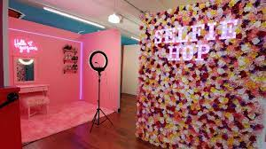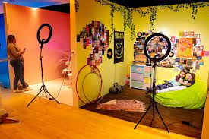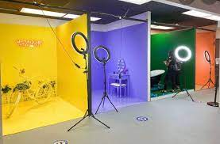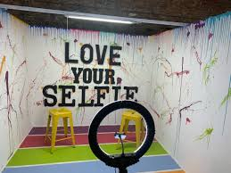
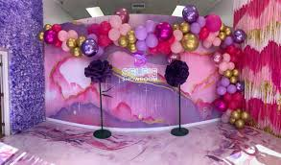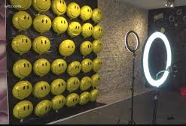
(Image Credits – Google Chrome)

Project Scope
The project scope is designed to help understand the full details that are required to accomplish the projects objectives or goals and the work that is required. (PMI, 2006)
- Find suitable location
- Order relevant equipment
- Decide on name
- Acquire domain for website
- Design logo
- Create social media accounts
- Design set rooms
- Agree design completion with vendors and decorators
- Arrange contract start date
- Locate set designers and event decorators
- Register Business
- Invite shareholders, stakeholders, and local press to open event
- Identify suitable property in location
- Research suitable location
- Plan social media marketing campaigns
- Identify any building works required
- Apply for relevant licences to trade#
- Advertise for 2 x part time members of staff
- Research suitable funding available
- Acquire investment from shareholders
- Create budget sheet
- Arrange building contractors
- Plan open event & confirm date
- Identify and purchase website builder or company
- Arrange building signage
- Decide on name and branding
- Design and print marketing materials for distribution
- Agree on property rental price and term
- Ensure relevant health & safety regulations are in place
- Agree contract with cleaning contractors
- Apply for relevant insurances
- Select suitable employees and agree employment contract
- Allocate funding to relevant areas of project as per budget
- Apply for loans and grants
- Arrange staff training
- Agree on share or repayment of investment
- Plan and build website
- Agree building works completion dates

Stakeholder Analysis
A stakeholder is defined as anyone who is involved, an interest or can be affected by or have an impact or influence on the project (Cambridge Dictionary, 2019). Stakeholders can be both internal or external to the project and each one will bring their own expertise or finance into the project; however, they also require something in return which varies dependant on the stakeholders’ position. (Watt, 2014)
These stakeholders will play an intergyral part in the success of the project so there is immense importance in understanding who they are and the part that they will play (Schoenhard, 2017). Whilst Stakeholders may change over a period, a list of Stakeholders for Believe In Your Selfie has been identified and listed below.

Figure 2: Believe In Your Selfie Stakeholders
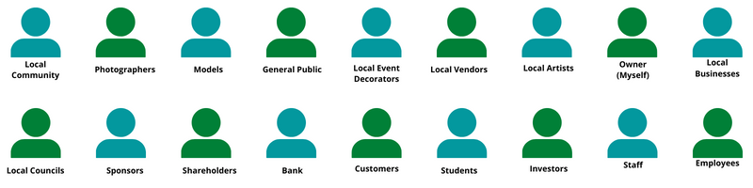

Power of Interest Matrix
Once the stakeholders have been identified, it is important to understand how much power or influence they will have within the business (Frontiers, 2015). To do this, a categorisation matrix is used to understand what power these stakeholders essentially have, what interest they hold and how involved they need to be. The 4-part grid which was created by Mendelow (1991), analyses stakeholders and plots them based on the power and the interest that they hold within the project:
- High Power, Low Interest: Whilst they hold power within the project their interest is low, however it is still important that their needs and requirements are met to keep them satisfied.
- High Power, High Interest: These stakeholders are key players in the project, so it is important to engage closely as they can determine the success or failure.
- Low Power. High Interest: Although stakeholders in this category hold no power, they have a personal stake in the project and should be kept informed of changes and plans.
- Low Power – Low Interest: This group is the least important and requires minimal effort or contact. They don’t require excessive communication but should still be monitored.
(Eriksen-Coats, 2018)
The ability to categorise and identify stakeholders is crucial because it allows strategies to be developed on how to engage with all parties. Also, it provides an action plan to communicate with stakeholders effectively to reduce resistance and increase support (Ackermann and Eden, 2011).
The table below maps the stakeholders and the power/ influence they hold within this project.

Figure 3: Believe In Your Selfie Power of Interest Matrix

Stakeholder Engagement
Following from the stakeholders being identified and the power of interest they hold, the need to establish how they will be kept engaged and communicated with. The Power of Interest also identifies how often the stakeholders should be communicated and kept engaged.

Quad Chart
A Quad chart is a 4-part quadrant that is designed to help understand the full scale of the project, who will be involved, what are the desired outcomes and how the success will be measured. It Is a visual and descriptive summary of the project details and helps those involved have insight into the project in digestible format (mercersec.org, n.d.).

Figure 4: Believe In Your Selfie Quad Chart
The Quad Chart below identifies the aims and objectives, who the main stakeholders are, what the end goals and objectives are and will it be classified as complete or successful.

Work Breakdown Structure (WBS)
A WBS is all the work that is involved in the project that has been identified in the scope and the steps required to achieve the projects goals. It allows a large-scale, complex projects with multi-steps to be broken down and divided into categories to see what needs to be completed in which order (Tausworthe, 1979). The allows the scope of the project to be visualised and explained to stakeholders with the detail of the work required sectioned into manageable components. It allows for the project manager to understand what resources are required, align resources and the timeframe that this needs to be completed within. This is a vital component within Project management and the PMI institute define it as “Representing the sum total decomposition of all work that the project encompasses, from beginning to end” (Brotherton, Fried and Norman, 2008).
Below a detailed WBS for Believe In Your Selfie has been provided by Mind Mapping. This is a non-linear approach to project planning and allows for a visual representation on how tasks are grouped together (Buzan and Buzan, 2006).

Figure 5: Believe In Your Selfie WBS
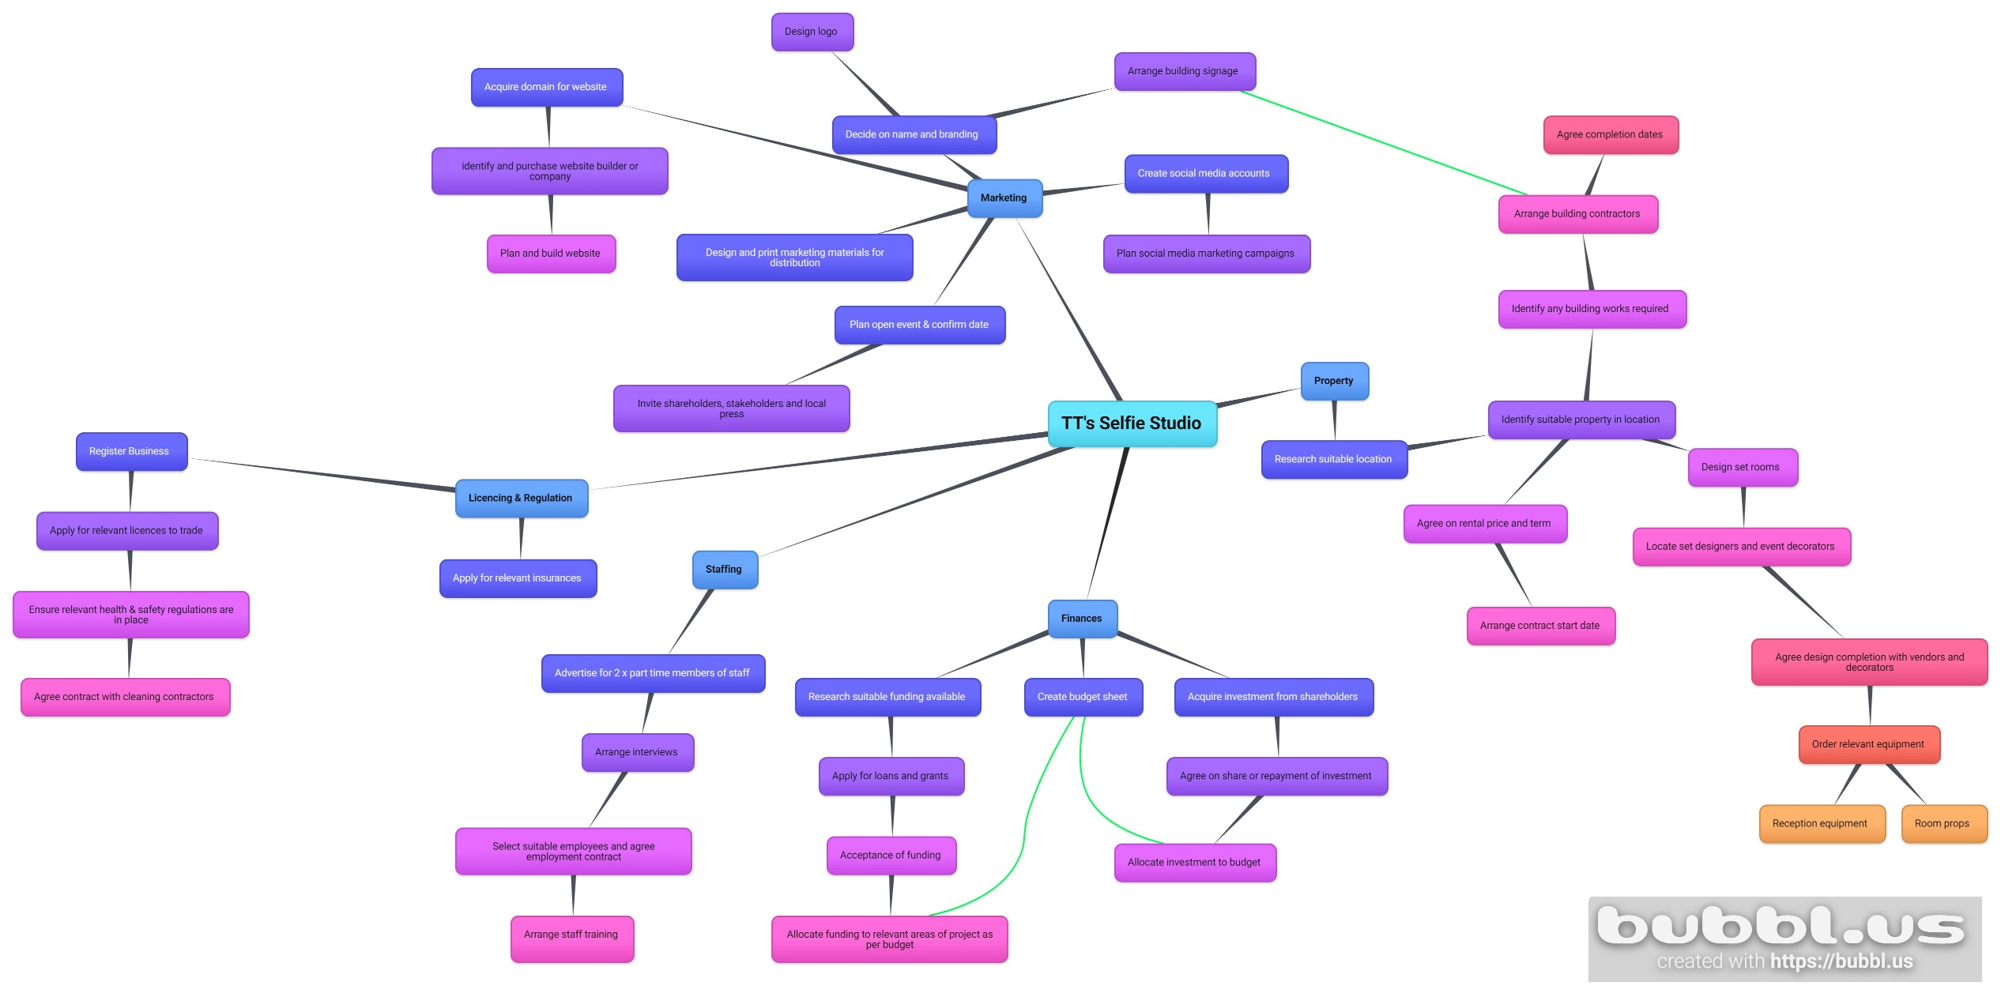 (For visibility access - https://ibb.co/sQHnpqh)

Project Schedule
Now the steps that are required for the project to be a success, a project schedule needs to be created. Essentially this is a list of the project’s tasks and the estimated time they will take to be completed. It will also include what resources needed, which allows for the cost for this resource to be identified. It is an essential tool for planning, managing, and communicating the tasks required, the timeframe for these to be completed and who needs to be involved (Demeulemeester and Herroelen, 2002).

Gantt Chart
Gantt charts are effective visual tools for project management because they are simple to create and easy to understand. From a glance, the chart shows the projected timeline required to complete tasks within the project. (Clark, 2019)
The Gantt Chart below identifies what work is required to be done to achieve Believe In Your Selfie’s projects objective.

Reference list
Ackermann, F. and Eden, C. (2011). Making Strategy: Mapping Out Strategic Success. 2nd ed. London: Sage.
Baker, S. and Baker, K. (2000). The complete idiot’s guide to project management. Indianapolis, In: Alpha Books.
Brotherton, S.A., Fried, R.T. and Norman, E.S. (2008). Applying work breakdown structure to project lifecycle. [online] Pmi.org. Available at: https://www.pmi.org/learning/library/applying-work-breakdown-structure-project-lifecycle-6979.
Buzan, T. and Buzan, B. (2006). The Mind Map book with Barry Buzan. Essex Bbc Active.
Cambridge Dictionary (2019). STAKEHOLDER | meaning in the Cambridge English Dictionary. [online] Cambridge.org. Available at: https://dictionary.cambridge.org/dictionary/english/stakeholder.
Clark, W. (2019). The Gantt chart: a working tool of management. Miami, Fl: Hardpress Publishing, Hardpress Publishing.
Cooper, W.E. (1998). Risk Assessment and Risk Management: An Essential Integration. Human and Ecological Risk Assessment: An International Journal, 4(4), pp.931–937. doi:10.1080/10807039891284884.
Demeulemeester, E.L. and Herroelen, W. (2002). Project scheduling: a research handbook. Boston: Kluwer Academic Publishers.
Eriksen-Coats, F. (2018). What Is Mendelow’s Matrix and Why Is It Useful for Marketers? [online] Oxford College of Marketing. Available at: https://blog.oxfordcollegeofmarketing.com/2018/04/23/what-is-mendelows-matrix-and-how-is-it-useful/.
Frontiers (2015). Figure 1: Stakeholder mapping: the power versus interest grid. The gird... [online] ResearchGate. Available at: https://www.researchgate.net/figure/Stakeholder-mapping-the-power-versus-interest-grid-The-gird-shows-stakeholders-on-a_fig2_275894050.
Harrin, E. (2019). 3 Types of Essential Resources For Your Project. [online] PM Tips. Available at: https://pmtips.net/article/3-types-of-essential-resources-for-your-project.
Health and Safety Executive (2015). Controlling the risks. [online] Hse.gov.uk. Available at: https://www.hse.gov.uk/toolbox/managing/managingtherisks.htm.
Mendelow, A. L. (1991) ‘Environmental Scanning: The Impact of the Stakeholder Concept’. Proceedings From the Second International Conference on Information Systems 407-418. Cambridge, MA.
Mendelow, A. L. (1991)
mercersec.org. (n.d.). Quad Chart | Mercer Science and Engineering Fair. [online] Available at: https://mercersec.org/help/fair/presentation/quad-chart [Accessed 8 Aug. 2022].
photutorial.com. (2022). 20+ Selfie Stats, Demographics & Fun Facts (2022). [online] Available at: https://photutorial.com/selfie-statistics/.
Project Management Institute (2006). The standard for program management. Newtown Square, Pa: Project Management Institute.
Project Management Institute (2021). A guide to the Project Management Body of Knowledge: (PMBOK® guide). 7th ed. Newtown Square, Pennsylvania, USA: Project Management Institute.
Schoenhard, L. (2017). 4 Ways Stakeholders are Important to a Project | Proficient Learning. [online] Proficient Learning. Available at: https://proficientlearning.com/4-ways-stakeholders-are-important-to-a-project/.
Tausworthe, R.C. (1979). The work breakdown structure in software project management. Journal of Systems and Software, 1, pp.181–186. doi:10.1016/0164-1212(79)90018-9.
Watt, A. (2014). Stakeholder Management – Project Management. [online] Opentextbc.ca. Available at: https://opentextbc.ca/projectmanagement/chapter/chapter-5-project-stakeholders-project-management/.

Figure 6: Believe In Your Selfie Gantt Chart
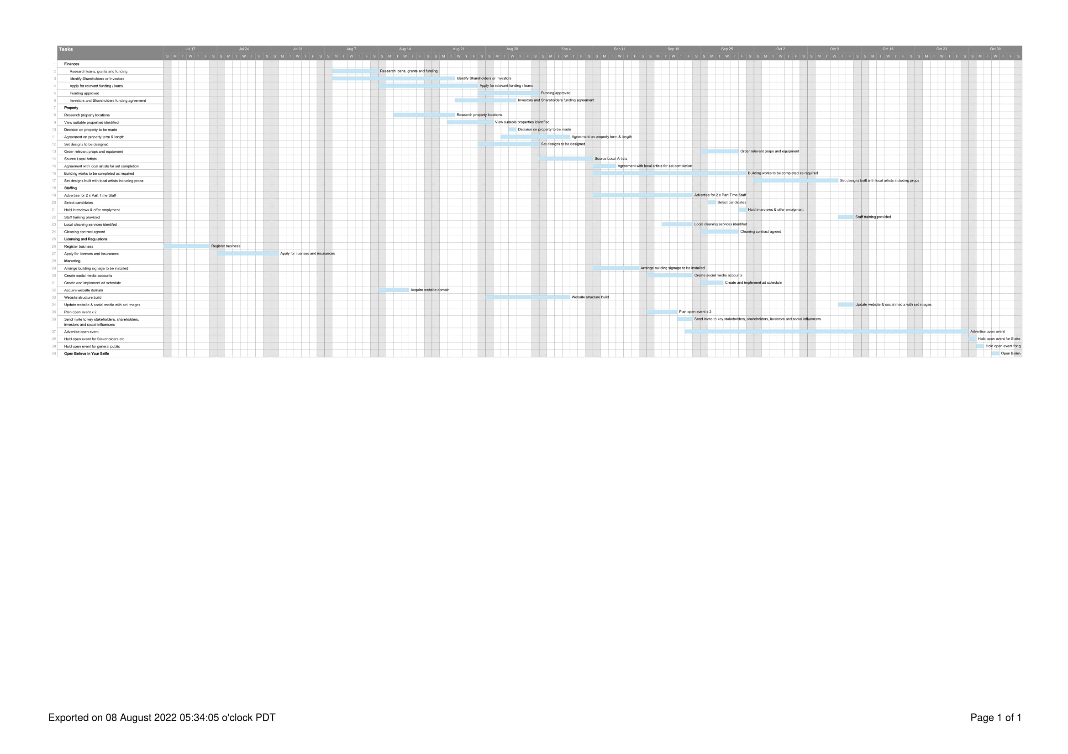

Consideration of Resources
Resources are classified as anything that is required to complete the tasks identified within the project. This can include but is not limited to money, people, equipment property (Harrin, 2019).

Staffing
As Believe In Your Selfie is a self-managed photography studio, the need for staffing will be minimal. Along with the project manager, there will be 2 x part time staff who will cover opening and closing times, engagement with customers, responding to booking enquires and general social media. The project manager will oversee general management responsibilities, social media management and advertising, engaging with key stakeholders and designing sets with artists. As the studio expands and starts to grow, the staffing will be revisited and potentially expanded to include a full-time general manager.

Budget
The next section of this report will conduct a review of the finances required to complete the project with a budget sheet, which identifies the full amount of money required to start and complete projects.
The budget sheet below identifies what money is required to finance the project. The purpose of this budget allows individuals to track finances, see where money is being spent and how, whilst giving a greater understanding of the costs involved (Baker and Baker, 2000).
This budget has taken yearly costs into consideration as well as monthly costs. The total budget required for year of the project is £89,039.

Figure 7: Believe In Your Selfie Project Plan
Type | Yearly Cost | Monthly Cost | Payment Frequency
Property
Rental | £20,000 |  | per year
Builders | £4,000
Decorators / Decorating supplies | £5,000 |  | per year
Electricians | £2,000
Flooring | £850
Utility Bills | £14,400 | £1,200 | per month
Total | £46,250
Marketing
Website Domain | £30 |  | per year
Website Builder | £500
Social Media | £3,600 | £300 | per month
Printed Literature | £1,100 |  | per year
Signage | £2,000
Open Event | £1,500
Total | £8,730
Staffing
2 x Part Time Staff | £20,000 |  | per year
Payroll taxes | £1,220 |  | per year
Staff beverages | £480 | £40 | per month
Total | £21,700
Finances
Insurances | £5,040 | £420 | per month
Loan Repayments | £4,299 | £358 | per month
Total | £9,339
Equipment
360 Camera Booth | £1,500
Ring Lights x 6 | £420
Props | £600 |  | per month
Sound Speakers | £500
Total | £3,020
Year 1 Project Total | £89,039

Risk Management
For the project to be a success, any risks that may cause project failure need to be identified. There is no guarantee that any of these risks will occur, however it is important to be prepared for any event (Cooper, 1998).
By completing a risk assessment, this allows all parties involved in the project to understand what the risks may be, who is at risk, how likely the risk will occur, what precautionary measures will be taken to avoid the risk and who is responsible if they do happen (Health and Safety Executive, 2015). In essence, this helps to understand what could go wrong, how it is prevented and gives an opportunity to minimise these risks happening.
The table below shows the main risks involved for the project by using the decision matrix risk assessment (DMRA) technique.
“(Highley, 2018)

Figure 8: Believe In Your Selfie Risk Assessment
Potential Hazard | Risk | Who is at Risk | Risk Rating | Precautions | Responsibilities
Project not completed within budget or timeframe | Project failure | Stakeholders  Owner | 6/10 | Ensure funds are allocated as per budget sheet and project schedule | Project Manager to
People in set rooms | Too many people in the set rooms, can cause over crowding and fire hazard and potential damage to equipment | Customers | 6/10 | Session numbers will be limited – only a certain number of tickets on sale | Shift staff to control number of walk ins  Project manager to set limit on booking numbers on website
Lighting (Ring Lights) Tripods | - Overheating  - Fire Hazard  - Tripods falling over causing harm | Staff  Customers  Building | 8/10 | Ensure lights are switched off when not in use  Secure ring lights to reduce falling  Avoid crowding around lights  All wiring to be taped down securely | Shift staff to ensure all lights are switched off when not in use and at end of day  Every shift to check lighting tripods are secure and wiring is taped down
Slips, trips, and Falls | Spills from drinks causing wet surfaces  Tripping over wiring | Staff and customers | 5/10 | All wiring to be taped down securely to avoid trips  Any spills to be cleaned up immediately | Staff to maintain cleanliness and ensure cleaning up any spills  Staff to check wiring is taped securely  No open cups in set rooms
Theft of equipment | Building could be broken into  Theft of props | Building and property | 3/10 | Ring lights to be secured  Alarm on building | Project manager to install alarm & CCTV system  Staff to ensure alarm is set at the end of every shift
Aggression & violence | Customers could potentially be intoxicated  Aggression and violence towards staff | Staff and other customers | 5/10 | Staff to refuse entry to anyone overly intoxicated  Staff to go on aggression handling course | Project manager to ensure all staff are trained and completed course
Damage to property and props | Set rooms and props could become damaged or broken  Damage could cause injury to people | Staff, customers, and props | 4/10 | Staff to walk around set rooms during sessions | Any broken props to be reported and removed immediately

Advantages
At this stage there are no direct competitors in the Birmingham area. Whilst bars and clubs offer areas with unique backdrops, murals, and lighting, there are no other venues that are purpose built or established solely for creating images to be shared across social media sites. The closet direct competitor can be found in Leicester, which give Believe In Your Selfie an advantage in the Birmingham area as those who are looking to take images as well as an “influencer” no longer need to travel.
Each set will be purpose built and made for photos to post on social media, each room will be uniquely designed, with quality props to take peoples breath away will determine the success of the project. All users need to bring is themselves and a phone or camera. Believe In Your Selfie’s goal, is to be the go-to place to get a great photo.

