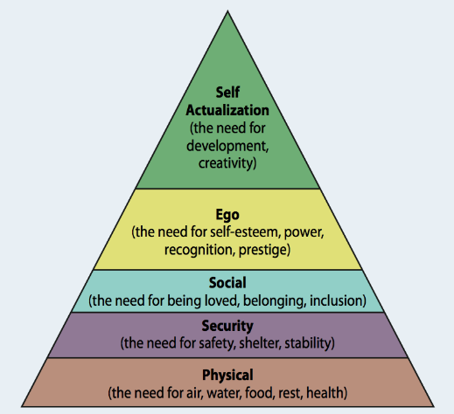
Dyslexia
Ffion Parry 1400798 EAEC6002

According to The Dyslexia Association (2018) Dyslexia is a special educational need, which tends to make learning difficult. People with dyslexia tend to have strong visual, creative and problem skills. No one who has dyslexia, is the same and everyone will have different strengths and weaknesses. I decided to discuss dyslexia because I want to find out the different strategies that are available for children and gain more knowledge, to implicate it in to practice if I ever need too.

Introduction

According to Department for Education and Skills (2015) The Curriculum and planning is one strategy which can support children with dyslexia, and teachers can plan according to the Foundation Phase. However they will need to change the planning to childrens individual learning needs. Teachers will follow the Foundation Phase when planning lessons, however they will need to make sure that it is structured, commutative, multisensory, thorough, active and useful. All these points will support children with dyslexia, when they are learning as Drifte (2012) states. Also teachers need to make sure they are positive and encouraging, so that the child gains self-esteem and feel like they are going to succeed as Reid (2011) states. According to Pavey (2007) Dyslexia can be a sensitive subject, this may be because not many understand it to have much knowledge on how to adapt to it. Many people when dealing with children who have dyslexia, but have not been diagnosed, see them as a disturbance, naughty or shy. Furthermore, it is essential that all teachers and practitioners who work with children who have dyslexia to understand and gain knowledge about it and how to adapt to it.
Strategy 1

As The department for education and skills (2015) states children who have disabilities within early years, the setting should make changes to make sure the child is included. These include:
- Access to the curriculum,
- Make physical improvements to increase participation for the child
Settings should seek advice if they are not sure how to make these reasonable adjustments, how to alternative activities and gain access to appropriate equipment and resources, which may be used to support the full participation of all children.
Equal opportunities

According to Reid (2017) there are many factors within the environment to consider, when teaching children with dyslexia. These include how the organisation promotes learning for the child, how attention is maintained, how sequencing is applied, how interaction is adapted, how learning preferences are identified and how independent learning is available. These factors can be applied to all children within the classroom, however the responses and understanding can have implications for teaching and learning of children with dyslexia. As department of Education (2007) suggests enabling a dyslexic friendly environment it is important to consider practical policies, identification and monitoring, parent participation, training and additional support. According to The department for education and skills (2015) states play is a huge part of childrens learning, and making sure the environment allows children to play will allow them to learn.
Strategy 2

The Dyslexia Association. (2018) ‘What is Dyslexia?’ http://www.dyslexia.uk.net/what-is-dyslexia/
Rose, J. (2009) ‘Identifying and Teaching Children and Young People with Dyslexia and Literacy Difficulties’, DCSF. [On-line]. Available at: http://dera.ioe.ac.uk/14790/7/00659-2009DOM-EN_Redacted.pdf
Reid, G. (2017) Dyslexia in the Early years: A handbook for practice. London: Jessica Kingsley Publishers. [e-book]. Available at: https://books.google.co.uk/books?id=DxqZDQAAQBAJ&printsec=frontcover&dq=support+for+dyslexia+in+early+years&hl=en&sa=X&ved=0ahUKEwjiz5OwtZfbAhWQVsAKHQ9oALUQ6AEILDAB#v=onepage&q=support%20for%20dyslexia%20in%20early%20years&f=false
Reid, G. (2011) Dyslexia: A complete guide for parents and those who help them. Oxford: John Wiley & Sons. [E-book]. Available at: https://books.google.co.uk/books?id=UEHK86sSHpIC&pg=PT162&dq=barriers+children+with+dyslexia+may+face&hl=en&sa=X&ved=0ahUKEwiMw8z67JbbAhUOLlAKHUyNBW4Q6AEIRTAF#v=onepage&q=barriers%20children%20with%20dyslexia%20may%20face&f=false
Karande, S. and Kulkami, M. (2005) ‘poor school performance’, Indian Journal of Pediaries, Volume 72, November. [On-line]. Available at: http://medind.nic.in/icb/t05/i11/icbt05i11p961.pdf

Further reading

(Source:Burton:2012)

According to Hull city council (2016) Children with dyslexia may face different barriers such as Social situations, Self Esteem, learning and knowledge and understanding about dyslexia, however as CPD (2015) children learn to cope with them, for example memorise text or adapt behavioural traits, such as having a tummy ache or forgotten books.
According to The Dyslexia Association (2018) it is very important for practitioners to be aware of these barriers, so that strategies can be put in place. However, parents may go to the school for help, but sadly the parent is left unsure if dyslexia is causing learning problems for their child and hinders their ability.
Barriers

Conclusion

To conclude, there are many barriers that children with dyslexia can face within an early year settings. However, with the help and support of the teachers and the setting, making learning easier for the child, those barriers do not seem scary or daunting. Furthermore, schools need to gain more knowledge if the still do not know what dyslexia is and parents need to speak out if they think they child is not getting support for their child. It is crucial that children feel included within the setting and abiding by Education Act 2002 allows settings to do so.

(Source: Karande and Kulkami,2005)

