Site Waste Management Plan –
Paxton Street Car Park, Swansea

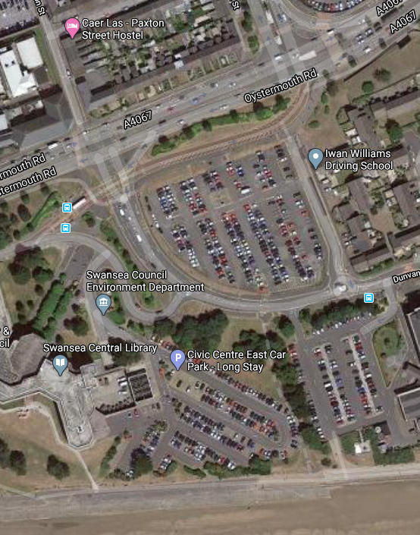

James Cullen (p151951)

Project Information
Project Name: Paxton Street office development.
Project Location: Local Authority Carpark, Paxton Street, Swansea, SA1 3SQ.
Site Location Description: Site currently in use as a public carpark operated by Swansea County Council and is bounded by Swansea civic centre, Marriott Hotel and Swansea Marina. Access to location is via Oystermouth Road.
Project Cost (approximate): £20m.
Footprint Area: 900m₂.
Project Start Date: Summer 2021.
Project End Date: Spring 2022.
Client: City and County of Swansea Council.
Principle Contractor: Cullen Construction Ltd.

Document Version: 1 (March 2020).

Responsibilities
 | Name | Company | Role | Contact Details
Who is responsible for drafting the SWMP? | Joe Rodon | Cullen Construction LTD | Lead Consultant | Joe.Rodon@CullenC.co.uk  07896536719
Who is responsible for implementing the SWMP | Ben Cabango | Cullen Construction LTD | Waste Coordinator | Ben.Cabango@CullenC.co.uk  07896536716
Project Manager | Liam Cullen | Cullen Construction LTD | Project Manager | Liam.Cullen@CullenC.co.uk  07896536756
Client Representative | Steve Cooper | City and County of Swansea Council | Contracts Manager | Steve.Cooper@Swancc.co.uk  07896536722

SWMP storage: 1) Electronic copy: City and County of Swansea Council intranet.
2) Electronic copy: Cullen Construction Ltd intranet.
3) Hard copy: Site office, Paxton Street, Swansea.

Declaration (Client and contractor to sign to agree to work collaboratively to keep waste to a minimum):
Client Representative:
Contractor Representative:

Legislation / Guidance applicable
This document has been compiled with reference to:
- Waste Framework Directive 2008/98 + 2018/851 update.
- Commission Decision 2014/955/EC about waste classification.
- Commission Notice on technical guidance on the classification of Waste (2018/C 124/01).
- The List of Wastes (LoW) (England) Regulations 2005 + 2015 update.
- Guidance on the classification and assessment of Waste. Technical Guidance WM3 (2015).
- Waste (England and Wales) Regulations 2011 (Ammended in 2012).
- Environmental Permitting (England and Wales) Regulations 2010.
- Hazardous Waste (England and Wales) Regulations 2005 (Ammended in 2009).

Construction Method
Work Phase | Method of Construction | Materials Used
1)Site Preparation | Mechanical Excavation | N/A
2)Foundation | Raft Foundation Installation | Concrete and Steel
3)Basement | Diaphragm Wall Installation | Concrete and Steel
4)Superstructure | Pre-cast fabricated frame Installation | Concrete and Steel
5)Cladding | Pre-fabricated brick clay wall Installation | Brick and Mortar

Site Preparation and waste produced
Mechanical Excavation of site required to a house foundation and 3 storey basement to a depth of roughly 11m:
Waste produced by action | Waste Management Code | Waste Classification | Total Wastage  Volume | Total Wastage  Mass | Action for Material Produced
Soil | 17.05.04 | Inert | 9900m₃ | 12375 tonnes | 100% Re-use for site landscaping

Foundation installation and waste produced
Roughly 1m thick raft foundation to be installed:
Waste produced by action | Waste Management Code | Waste Classification | Total Wastage  Volume | Total Wastage  Mass | Action for Material Produced
Concrete | 17.01.01 | Inert | 36m₃ | 43.56 Tonnes | To be removed from site (and subsequently 100% recycled)
Steel | 17.04.05 | Non -hazardous | 8.57m₃ | 3.6 Tonnes | To be removed from site  (and subsequently 100% recycled)

Basement installation and waste produced
Diaphragm wall to be installed:
Waste produced by action | Waste Management Code | Waste Classification | Total Wastage  Volume | Total Wastage  Mass | Action for Material Produced
Concrete | 17.01.01 | Inert | 10.2m₃ | 12.65 Tonnes | To be removed from site  (and subsequently 100% recycled)
Steel | 17.04.05 | Non -hazardous | 12.57m₃ | 5.28 Tonnes | To be removed from site (and subsequently 100% recycled)

Superstructure installation and waste produced
Roughly 200mm thick pre-fabricated concrete and steel frame be installed, 20 storeys’ high, 30m x 30m x 30m 30m:
Waste produced by action | Waste Management Code | Waste Classification | Total Wastage  Volume | Total Wastage  Mass | Action for Material Produced
Concrete | 17.01.01 | Inert | 0m₃ | 0 Tonnes | n/a
Steel | 17.04.05 | Non -hazardous | 0m₃ | 0 Tonnes | n/a

Cladding installation and waste produced
Pre-fabricated off-site brick cladding to be installed for 20 storeys’ high, 30m x 30m x 30m 30m:
Waste produced by action | Waste Management Code | Waste Classification | Total Wastage  Volume | Total Wastage  Mass | Action for Material Produced
Brick | 17.01.02 | Inert | 0m₃ | 0 Tonnes | n/a
Mortar | 17.09.03 | Inert | 0m₃ | 0 Tonnes | n/a

Overview of waste produced in total
Work Phase | Waste Type Produced | Total Wastage  Volume | Total Wastage  Mass | Action for waste
Site Preparation | Soil | 12375m₃ | 12375 tonnes | Re-use
Foundation | Steel | 8.57m₃ | 3.6 Tonnes | Removal from site
 | Concrete | 36m₃ | 43.56 Tonnes | Removal from site
Basement | Steel | 12.57m₃ | 5.28 Tonnes | Removal from site
 | Concrete | 10.2m₃ | 12.65 Tonnes | Removal from site
Superstructure | None | 0m₃ | 0 Tonnes | n/a
Cladding | None | 0m₃ | 0 Tonnes | n/a
Packaging | Various | 150 m₃ | 31.5 Tonnes | Removal from site

Overview of actions and costs associated with waste being transported from site
All waste sorted on site into specific skips in readiness for removal by accredited carriers and disposers.
Type of Waste | Total Volume produced | Total Mass Produced | To be Removed by | Cost
Concrete | 46.2m₃ | 56.21 Tonnes | Skip Hire Swansea, Baldwin’s Crescent, Swansea, SA1 8QB | £1848
Steel | 21.11m₃ | 8.88 Tonnes | Skip Hire Swansea, Baldwin’s Crescent, Swansea, SA1 8QB | £1108.80
Packaging | 150 m₃ | 31.5 Tonnes | Skip Hire Swansea, Baldwin’s Crescent, Swansea, SA1 8QB | £5544

Total cost anticipated for waste removal: £8750.

Implementation of Waste Management Plan
- All operatives on site to be trained and regularly briefed in Waste Management and training records kept.
- Procedural documents to be disseminated to staff and displayed on notice boards.
- Records of all waste produced, its classification, its amount to be kept.
- Details of waste removal from site, when and by whom to be kept.

Monitoring of Waste Management
- Waste champion to constantly monitor waste management on site.
- All actions and orders to be recorded.

Review of Waste Management
- Whole scheme to be reviewed upon completion.
- Lessons learnt to be discussed and recorded in a register.
- Actual and forecast volumes and cost comparison.

Appendix

Excavation calculations
Excavation volume: 30m x 30m (site footprint) x 11m (depth of excavation) = 9900m₃.
9900 x 1.25 t / m₃ (soil bulking & conversion factor) = 12,375 Tonnes.

Foundation calculations
Foundation slab volume: 30m x 30m (site footprint) x 1m (slab thickness) = 900m₃ total volume.
30m x 30m (site footprint) = 900m₂ x 100kg/m₂ (concrete to steel ratio) = 90,000kg ÷ 1000 = 90 Tonnes.
90 Tonnes x 4% wastage = 3.6 Tonnes of steel wastage.
3.6 Tonnes ÷ 0.42 t / m₃ (steel bulking & conversion factor) = 8.57m₃ volume of steel wastage.

900m₃ (total volume) x 4% wastage = 36m₃ Volume wastage.
36m₃ x 1.24 (concrete bulk factor) = 43.56 Tonnes wastage.

Basement calculations
Diaphragm wall volume: 30m x 4 (perimeter) x 0.5m (wall thickness) x 11m (height) = 255m₃ total volume.
30m x 4 (perimeter) = 120m x 11m (height) = 1320m₂ total surface area of diaphragm wall.
1320m₂ x 100kg/m₂ (concrete to steel ratio) = 132,000kg ÷ 132 Tonnes.
132 Tonnes x 4% wastage = 5.28 Tonnes of wasted steel.
5.28 Tonnes ÷ 0.42 t / m₃ (steel bulking & conversion factor) = 12.57m₃ volume of steel wastage.

255m₃ (total volume) x 4% wastage = 10.2m₃ volume wastage.
10.2m₃ x 1.24 t / m₃ (concrete bulking & conversion factor) = 12.65 Tonnes wastage.

Superstructure calculations
Concrete and Steel pre-fabricated steel frame required: 30m x 4 = 120m Perimeter.
120m x 66.6m (building height) = 7992m₂ total area of frame required.
7992m₂ x 0.2m (frame thickness) = 1598.4m₃ total volume of frame required.

Cladding calculations
Brick and Mortar pre-fabricated cladding required: 32m x 4 (Rough Perimeter of building frame) = 128m
128m x 66.6m (building height) = 8524.8m₂ total area of cladding required.
8524.8m₂ x 0.1m (cladding thickness) = 852.48m₃ total volume of cladding required.

Packaging calculations
Various materials from derived from resources delivered to site roughly totalling 150 m₃.
150m₃ x 0.21 t / m₃ (packaging bulking & conversion factor) = 31.5 Tonnes of packaging wastage.

Totals:
Steel volume wastage: 8.57m₃ + 12.57m₃ = 21.11m₃.
Steel mass wastage: 3.6 Tonnes + 5.28 Tonnes = 8.88 Tonnes.

Concrete volume wastage: 36m₃ + 10.2m₃ = 46.2m₃.
Concrete mass wastage: 43.56 Tonnes + 12.65 Tonnes = 56.21 Tonnes.

Number of skips (volume: 10.7m₃) required

Skip Hire Swansea, Baldwin’s Crescent, Swansea, SA1 8QB charges £369.60 per skip removal.

Concrete total volume wastage: 46.2m₃.
46.2m₃ ÷ 10.07m₃ = 4.59 (5 skipfulls).
5 x £369.60 = £1848.

Steel total volume wastage: 21.11m₃.
21.11m₃ ÷ 10.07m₃ = 2.09 (3 skipfulls).
3 x £369.60 = £1108.80.

Packaging total volume wastage: 150 m₃.
150m₃ ÷ 10.07m₃ = 14.90 (15 skipfulls).
15 x £369.60 = £5544.

5 + 3 + 15 = 23 skips total.

Therefore £369.60 x 23 skips = £8500.80.

