

University of Wales Trinity Saint David (London)
Module: Introducing the Modern Workplace
Module code: LCBB4003
Lecturer: Aparna Venkatesan
Assignment Title: Assessment 1 (Report) Organizational Structure & Culture in industry
By: Kristina D. Ralcheva
Date: January 2023

Contents
1. Introduction
2. Organisational Structure
3. Organisational Culture
4. Motivation
5. How do the organisation structure and culture affect its performances?
6. Different factors in the organisation which influence its employees’ behaviour
7. Conclusion
8. References

Introduction.
To begin with, the purpose of this report is to analyse the relationship between structure, culture, and motivation in Scrivens Opticians and Hearing Care UK in a consistent manner.
Furthermore, the author will explain how the organisational structure and culture affect its performance and will explain different factors in Scrivens that influence an employer’s behaviour.
Scrivens Opticians and Hearing Care is an optometric company that has operated in the UK since 1938.
The company provides eye test appointments, hearing test appointments, and contact lens appointments.
They have a lot of branches across the country, with their main office based in Birmingham.
In Scrivens Opticians, everyone works as part of one big family, and the hierarchy is obvious. All the branches are operated by branch managers, and above them are area managers.
Each area manager reports to the head office and makes sure all the work is done properly.

Organizational structure.
According to Mullins (2019), when a company produce a good organizational structure, the performance is obviously better. However, if the company allows to produce poor organizational structure, no one in the company will be able to produce good performance.
What is an organizational structure? An organization's organisational structure describes how its procedures are organised. Employees are arranged by function (such as finance or operations), region, or product line under traditional organisational structures, which are inflexible. Less conventional structures are looser-knit and more adaptable, which enables them to swiftly change to evolving business scenarios.
Scrivens Opticians works through hierarchy principles. This form of organizational structure is centralized. To get the task done, there is a worker hierarchy with leaders at the top, people below, and supervisors in between. It is more of a linear operating system, with top management delegating authority.
This structure concentrates decision-making at the highest possible level. As a result, because new ideas must pass through numerous layers of administration, the organisation suffers from a lack of uniqueness. Furthermore, each employee communicates solely with their immediate supervisor and subordinates. This reduces coordination at different levels of authority and departments. Nonetheless, it is a prominent element of most government institutions. For instance, if there is no rule in eye test conduction or hearing aids aftercare, the main decision is taken from the Head office.

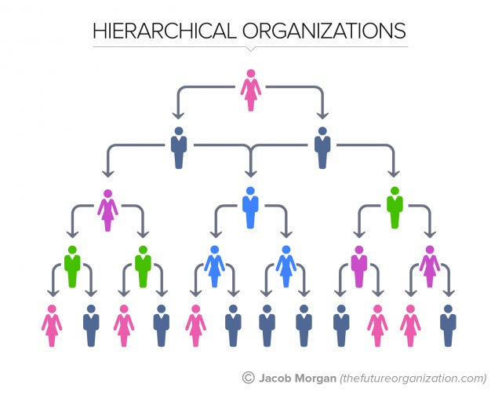
Figure 1. Hierarchical organizations (Morgan, 2015)

Organizational culture.
The author explained about the organizational structure; however, it is vital to explain for organizational culture as well to help the audience to understand better.
All team members' actions are influenced and shaped by the collective beliefs, expectations, and practises that make up an organization's culture. Think of it as a collection of characteristics that define the business. In contrast to a dysfunctional corporate culture, which may harm even the most successful organisations, a strong corporate culture exhibits positive attributes that promote greater performance.
The importance of organizational culture is work ethic and organizational performance.
There is strong and weak organizational culture. In Scrivens is strong organizational culture as employees there have strong connection between shared values and behaviors. Moreover, they can tell stories about company history or heroes such as: Solomon and Rafique Ahmed (most qualified Optician across the Southwest UK).
This company is not a franchise, and they try to maintain the culture as strong as possible.
There are several types of organizational culture, however the author can relate role culture only. Role culture is typically characterised as a bureaucracy based on logic and rationality. Strong organisational 'pillars' such as finance, purchasing, and production promote role culture. Position is frequently more important than the individual, and position is the fundamental source of power. For instance, in this business, people take roles such as Opticians and Audiologist, which is more about the role and the education required to take the role.

Motivation.
While the organizational structure and culture are crucial, motivation is the key. How can the employer motivate his employee enough to build that trust and efficiency?
Employee involvement and efforts are critical for optimal organisational achievement. The more motivated the employees, the more likely the organization's success in meeting its goals and objectives. Motivation is at the heart of every organizational action. The manager must understand how to best elicit
the cooperation and motivation of employees and steer their efforts toward the achievement of the organization's goals and objectives.
Consider the goal of "doing business" in general. It all comes down to using an imagination and thinking to address the difficulties of the consumers. It is about producing products and services that satisfy clients
while also making a profit for the firm. This is a vital source of motivation for the business team: if they can see how they are impacting and improving the lives of others, they will work even harder and smarter, searching out new solutions and overall boosting the efficiency and bottom line of the business.
Goal theory, often known as goal-setting theory, is a theory that is commonly included under the topic of motivation to work. This concept is mostly based on Locke's work. The basic concept is that people's goals or intentions impact their conduct. According to expectation theories of motivation, Locke emphasises the importance of perceived value and contends that these values give rise to the experience of emotions and needs. Goals direct work behaviour and performance and produce consequences or feedback. People strive hard to achieve their goals to satisfy their emotions and desires. Locke also brought out the idea that 'goal-setting is more effectively regarded as a motivating behaviour rather than as a formal theory of motivation'. For instance, the author relates that to Scrivens Opticians. The line manager set a goal for the opticians, dispensing opticians, and sales advisors to see x people this month. Eye exams and contact lens appointments must be conducted by the end of the month. Usually, the line manager has at least a Dispensing Optician degree, which allows him to dispense. Ergo, he takes part in the job to be done and breaks down the goal into small parts (e.g., performance per day or per week) and gives tasks to each member (e.g., optometrists to see people for eye tests and dispensing opticians to dispense glasses). The manager will give feedback afterwards.

To make sure that the employees complete the process correctly, the author discusses the above points. As with everything, the process is mutual; therefore, the employer must be sure that the employees are satisfied with what they are doing. It is called job satisfaction.
Job satisfaction is diverse and multifaceted, and various people define it differently. It is more of an attitude, an internal mood, and might relate to a personal sense of quantitative or qualitative performance. The nature of the relationship between motivation, satisfaction, and performance is constantly being disputed. Job satisfaction is a challenging concept to define as a single concept. For example, Herzberg's two-factor theory is more of a theory of job satisfaction. Although work happiness may influence motivation, this is not always the case.

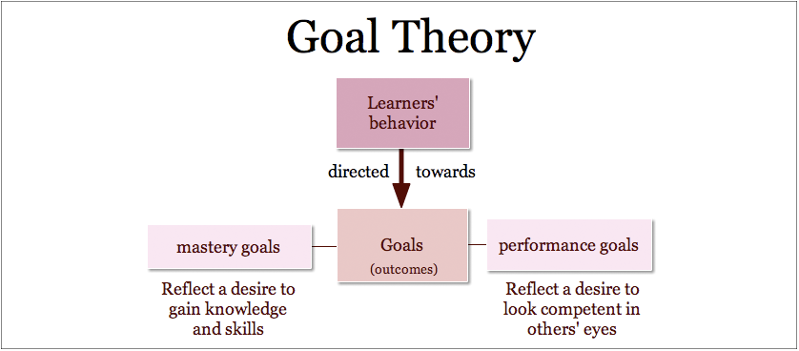
Figure 2. Goal Theory (Chelniciuc, 2014)

How do the organisation structure and culture affect its performance?
According to Schuetz (2017), organizational structure and culture can have an impact on business performance. If policies and procedures are not defined and enforced throughout the organisation, performance management strategies such as reviewing organisational goals, prioritising work, identifying specific measures, and product improvement will fail. However, connecting employees' aspirations with the organization's strategic objectives may be beneficial. Among the steps in the process is determining how effectively a person performs inside the business. For example, if Scrivens Opticians implements a ratings system with three levels: below expectations, meeting expectations, and exceeding expectations, and conducts appraisals, this could lead to promotions, lateral moves, or increased responsibility, which is critical when aligning with the company strategy plan.

Different factors in the organisation which influence its employees’ behaviour.
Muayad (2021) points out, that managers and leaders have a large influence on how people perform in the workplace. It is the responsibility of leaders to offer direction to team members. When employees have harsh bosses, it has been observed that they do not want to go to work in most cases.
Muayad (2021) proposes directing and assisting them in their daily activities, as well as assisting them in learning new skills and improving their knowledge. Make them feel important. The leader must be an excellent motivator for his or her subordinates. He must be a role model for his team and show them how to follow the rules.
Employees must feel at ease in the workplace to remain optimistic and happy. Everyone should follow the same rules and regulations.

In addition to that, employees should be encouraged to respect their bosses and follow the company's code of ethics. Do not rely on intricate reporting systems.
At all levels, transparency is necessary. The team member must be informed of what the leader is doing, and vice versa. Job security is one of the most critical factors determining employee behaviour. Stick with the squad when things go tough. Do not throw them away in bad times.
Moreover, employees should be asked to perform to the best of their abilities. Employees should not be overburdened. The leader should encourage them to improve their talents on a regular basis.

Managers must engage effectively with team members. When employees feel alienated, they lose interest in their employment. They must have a voice in major organisational decisions.

Image that one of the members has some conflicts with their family member, they will be agitated throughout the rest of the day.
People who have experienced trauma or have had a difficult home life have been seen acting erratically at work.
Employees often prefer to remain late at work when they are under stress from home obligations, which has an impact on the work environment. People from low-income families are more likely to carry items home from work. Stress and irrational behaviour are results of personal problems. People should refrain from bringing personal matters to work.

The author supports the idea that it is essential have a good communication with the team members and even attend to team building. You need someone to talk to, discuss, and share your experiences with.

Conclusion.
To summarize, Scrivens Opticians is not a small business to run, but by following all the steps and having a good organisational structure, culture, and personal motivation for their employees, they may be able to rise even higher in the market.
They have a hierarchy-based organisational structure and a positive, strong organisational culture, paying enough attention to motivating and supporting their employees.
It is vital for businesses like this to be aware that having a strong connection within the team could lead only to success.

References.

- Chelniciuc, A. (2014) What is a goal-setting theory? [Figure 2] Available at: https://www.performancemagazine.org/what-is-goal-setting-theory/ (Assessed: 4 January 2023)
- Cole, G. A. and Kelly, P. (2020) Management theory and practice, 9th Ed, Hampshire: Cengage Learning EMEA.
- Higgins, E.T. (2012) Beyond pleasure and pain how motivation works. Oxford University Press.
- Huczynski, A. and Buchanan, D.A. (2019) Organizational behaviour. 10th Ed. Harlow: Pearson
- Lathan, Gary P. (2016) Work motivation: history, theory, research, and practice. (2nd edition.), SAGE.
- Locke, E.A. and Latham, G. P. (2013), New developments in goal setting and task performance, Routledge
- Morgan, J. (2015) Types of organisational structures-hierarchy [Figure 1]. Available at: https://www.forbes.com/sites/jacobmorgan/2015/07/06/the-5-types-of-organizational-structures-part-1-the-hierarchy/?sh=8e387bd52529 (Assessed: 4 January 2023)
- Muayad. Al. (2021) ‘Factors Affecting the Behaviour of Employees and their Relationship to Personal Characteristics (Analytical Exploratory Research of a Sample of Employees in Technical Education)’, ResearchGate, November. Available at: https://www.researchgate.net/publication/355958322_Factors_Affecting_the_Behavior_of_Employees_and_their_Relationship_to_Personal_Characteristics_Analytical_Exploratory_Research_of_a_Sample_of_Employees_in_Technical_Education (Accessed: 5 January 2023)
- Mullins, L. J. (2019) Organisational behaviour in the workplace. 12th Ed. Harlow: Pearson Education Limited.
- Robbins, S., and Coulter, M. (2020) Management, Global Edition. 15th Ed. Pearson.
- Schuetz, A. (2017) ‘Effective Leadership and its Impact on an Organisation’s Success’, Research Gate, February. Available at: https://www.researchgate.net/publication/314166742_Effective_Leadership_and_its_Impact_on_an_Organisation's_Success (Accessed: 5 January 2023)

