Component 2 - Research Report
Student Name: Beniamin Avram
Student Number: 2131588
Lecturer Name: Seyed Navid Nasipour
Module: BMSW4003_BIRM Digital Skills and Research Methods.
Title: Report – Research report

Table of Contents
Introduction 3
Research design 4
Research Questions 4
Method 4
Ethical considerations 5
Results 6
Discussion 10
Conclusion 11
Reference List 12
Appendix – A blank copy of your questionnaire. 13

Introduction
The following report aims to analyse independently and write up a research report by using the data collected as a group, data that analysed MS Teams as a tool to collaborate with others during the time spent at the university. The questionnaire was created in order to analyse what tools students use in order to collaborate and if MS Teams is a good tool to use. Using digital tools to collaborate has become even more important after the Covid-19 pandemic, where people were forced to work and do everything in the digital world. According to FE Week (2022), the UK government estimates that around 17 million people in the country lack the essential digital skills required for work and life. In a world that is dominated by technology is not only necessary but essential to have at least basic digital skills, and it is important to learn them as early as possible in life. Some of the essential digital skills that each person needs to have included using devices and handling information, creating and editing documents, communicating and sharing information, managing online transactions, and being safe and responsible online. Although there is a big gap in digital skills, it is easier for younger people to acquire these skills early in their studies rather than later in their careers.

Research design

Research Questions
In order to create the overall research design and address the research problem in a coherent and logical way, the questions chosen for the questionnaire that aimed to identify if MS Teams is a good tool for students to collaborate during their time spent in the university include:
- Consenting to take part in the questionnaire in a voluntarily way.
- What is your age?
- Are you familiar with Microsoft Office 365?
- Is MS Teams the most used platform for student communication?
- Rank these applications according to how frequently you use them to collaborate with others on the OneDrive
- I use MS Teams most frequently to collaborate with others
- What is the most used application to communicate with other students?

Method
As seen from above, the research questions were chosen in order to ensure that the participants are appropriate in age for the questions asked, to find out if Microsoft 365 and especially MS Teams is one of the tools they use in order to communicate with other students and what other apps do students use in order to make their lives easier and collaborate better within their time at the university. The participants were recruited amongst friends and colleagues in order to make sure they were neutral and don’t make assumptions related to the data expected to be collected, they were reliable to ensure correct results, and they were honest about their answers. For a further and more in-depth research, the survey can be improved, added a couple more questions, and people can be recruited either from personal or professional connections, via fliers, newspapers, emails and letters, through face-to-face interactions, or through different online tools such as social media and website. The research was a quantitative one, and insights can be drawn from the answers about the way students use technology to collaborate. The survey was also explanatory research that tried to prove the researcher’s idea that MS Teams is one of the most used tools by students in order to collaborate during their time at the university (Question Pro, 2022). For this particular study, the research method chosen was the survey, but other methods could be introduced, such as observation, interviews, focus groups, experiments, secondary data analysis or some mixes from the methods mentioned in order to have a more precise and clear data (Virginia Tech, 2022).

Ethical considerations
Primary research is extremely important and useful when conducting research, but it needs to take into consideration the human aspect and respect some of the major ethical considerations such as the validity of the research questions, the consent given, and the voluntary participation of the people, sampling of the participants, the confidentiality of the information provided and transparency regarding where and how the information provided will be used (Enago Academy, 2022). For the current questionnaire, all the participants were adults and were properly informed of the reason for the questionnaire and where the results will be used.

Results

The results of the questionnaire were similar to the ones expected, with most of the people being familiar with the Microsoft Office and knowing how to use other tools in order to communicate efficiently. For the first question, everyone consented to take part in the questionnaire in a voluntarily way.
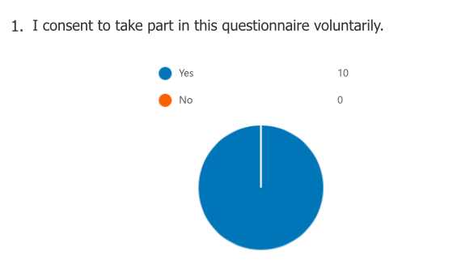

The second question asked the participants their age, and the age range varied from 19 to 43 years old.

The third question proved that nine out of ten people are familiar with the Microsoft Office 365.
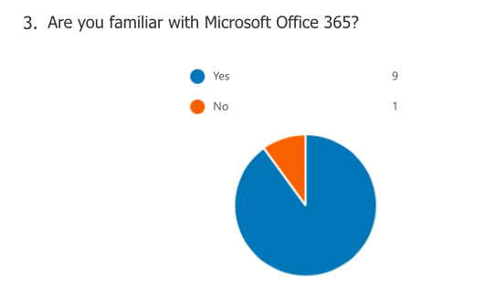
For the fourth question, the people replied 50% yes that they had used the MS Teams platform before, and 50% said they had never used it.
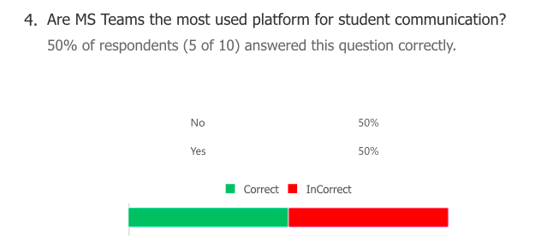

The fifth question asked people to rank MS Forms, MS Streams, MS Excel, MS Word, and MS PowerPoint based on the frequency people use them in order to collaborate with others on OneDrive. The most common tool, as seen from the chart, is MS PowerPoint.

For the sixth question, people were asked how often they use MS Teams in order to collaborate with others, the answers being that 60% agreed, 30% disagreed, and 10% of the people are neutral.
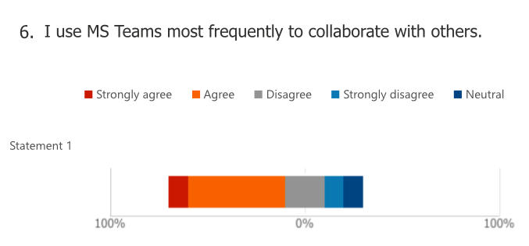

The last questions tried to identify which are the most used applications students use to communicate with others, and the answers identified that MS Outlook and MS Teams are more used by students when they need to collaborate for an academic project, rather than Zoom or WhatsApp.

Discussion
The results of the survey created, although there were only a small number of participants and may not be entirely relevant, they showcase that people seem to all know the MS Office package and had at least some interaction with it, especially within their courses at the university. Another important result showcased that people over 30 to 40 years old are less interested in the digital application and prefer to collaborate with their colleagues in an offline manner. Based on the research done in the introduction, which states that around 17 million people in the country lack essential digital skills required for work and life, it is clear to see even from such a small survey that younger people are more interested in technology and even if the older people are learning now how to use certain applications it may still take them a longer time than the people who were born in the era of technology. Another thing that could be identified in the survey that may be an issue for some people is that there is a multitude of applications and programs that people can use digitally, so different people use different tools based on their knowledge and what they got used to in their personal lives or in their previous jobs. Related to one of the aims of the survey, to identify if MS Teams is one of the most used apps to collaborate with colleagues, the response was positive, with over 60% of people using it on a frequent basis or have used at least once the app to collaborate with other people. The only hypothesis that was not confirmed was that people use more apps like WhatsApp or Zoom when doing academic work, even if they use these apps on a daily basis in their personal lives. It can be seen that they prefer more professional tools in order to collaborate regarding university work. Gov Connection identifies that fostering creativity and digital teaching skills to all the students helps them develop skills such as problem-solving, critical thinking and expressing their own ideas. Some of the main advantages of developing digital literacy in both students and teachers include the boost in student engagement by using different digital tools in order to collaborate, the improvement of academic performance by sharing their ideas in new and innovative ways, the fact that students will stand out in the job market and differentiate themselves with the new skills they acquire, the university becomes more competitive, and it makes it easier for both parties to collaborate and create inspired work. It is extremely important to have at least minimum digital skills in a world where every industry is introducing more and more technology every day, the bare minimum required skills for every job include writing emails, researching online information, handling virtual ecosystems, collaborating through clouds, creating and managing spreadsheets and databases, device management, video calls and managing schedules by using online tools and calendars (UNLV, 2021). For students to create their own surveys and ask people to complete them is a basic skill, but it gives them the opportunity to see by themselves how important are the digital skills, how people treat this knowledge and how they can improve themselves to be more competitive in a market where everyone needs to know at least some basic skills. The Digital Marketing Institute identified in an article from 2021 that skills such as social media managing, search engine marketing, data analytics, content marketing, email marketing, mobile marketing, planning and strategy, social selling, pay per click marketing, and video, are instantly making students employable and putting them on top of the employer’s choices. As soon as students understand by themselves how important digital skills are for their future and how easy and creative it can be to learn a digital skill, their career perspectives will change instantly. Having so many options in the digital world makes it almost impossible for each student to find something they like to learn and become experts at.

Conclusion
In conclusion, by analysing both the literature and the answers given by students to the survey created, it is clear to see that digital skills are some of the most important tools to learn while being a student and extremely helpful for a successful future career. As seen from the results of the questionnaire MS Office is a very helpful pack to use for students, and MS Teams is frequently used for students to collaborate when given a group work. Tools like MS Word, MS Excel and MS PowerPoint are being used almost on a daily basis by students, and there is no student that doesn’t know how to use them at a basic level. As identified in the report above, having advanced digital skills gives students a great advantage during their first interviews and first jobs and makes them stand out from other people. Having digital skills is extremely important and valuable in a world where technology surrounds everyone in all the industries available on the market.

Reference List
Digital Marketing Institute (2021) 10 Digital marketing skills that can make students instantly employable in 2022, available at: https://digitalmarketinginstitute.com/blog/10-digital-skills-that-can-make-students-instantly-employable (Accessed at: 29 Jul 2022)
Enago Academy (2022) What are the ethical consideration in research design, available at: https://www.enago.com/academy/what-are-the-ethical-considerations-in-research-design/ (Accessed at: 15 Jul 2022)
FE Week (2022) The importance of digital skills in adult education and employment, available at: https://feweek.co.uk/the-importance-of-digital-skills-in-adult-education-employment/ (Accessed at: 15 Jul 2022)
Gov Connection (2022) 5 benefits of digital literacy, available at: https://www.govconnection.com/~/media/pdfs/brands/a/adobe/adobe-hied-5-benefits-digital-literacy.pdf?v=1&la=en (Accessed at: 29 Jul 2022)
Question Pro (2022) Research Design: what it is, elements and types, available at: https://www.questionpro.com/blog/research-design/ (Accessed at: 15 Jul 2022)
UNLV (2021) What are digital skills? Available at: https://digitalskills.unlv.edu/digital-marketing/what-are-digital-skills/ (Accessed at: 29 Jul 2022)
Virginia Tech (2022) Research methods guide: research design and method, available at: https://guides.lib.vt.edu/researchmethods/design-method (Accessed at: 29 Jul 2022)

Appendix – A blank copy of your questionnaire.


