

LEVEL 4

SEMESTER 1 & 2

MODULE CODE: SHSS4062
PROFESSIONAL DEVELOPMENT AND PRACTICE
aSSESSMENT TYPE: PRESENTATION
Assessment/Component: 2

COMPONENT WEIGHTING: 50 %

DURATION: 10 MINUTES

MODULE TUTORS: GERAINT FORSTER, ALISON CONNAUGHTON AND CHRIS CASHIN

Task

You must investigate a profession linked to your course of study, and conduct some research into the requirements of that chosen profession. You must then give a 10 minute presentation that describes the competencies and qualifications required for that profession, as well as any relevant codes of practice/ethics. You must also evaluate where you currently stand with regards to those competencies and qualifications, and how you intend to acquire them between now and your graduation.

SUBMISSION DETAILS: Presentation to take place during week of 29th March 2019 - final details to be provided by your programme director.

School of Sport, Health & Outdoor Education

Assessment Feedback Sheet

Student No. and Name: 1802407 Jessica Fletcher Badrick
Module: Professional Development and Practice
Module Code: SHSS4062

Personal Evaluation – to support your academic progress please complete the section below BEFORE submitting your work.
What do you consider to be the best aspects of this work? |  |  | I believe I have found some good quality references and have spent a good amount of time researching the topic.
Which aspects do you consider could have been improved in this piece of work? |  |  | I feel that I have made the topic sound quite dry, rather than exciting and interesting.
What have you found most satisfying whilst undertaking this submission? |  |  | I enjoyed finding out lots more about the different roles of a dietitian and the many different paths that one can take once qualified.
ASSESSMENT CRITERIA | Learning  Outcomes |  | GRADE
ASSESSMENT CRITERIA |  |  | Poor  0-25% | Unsatisfactory  26-39% | Satisfactory  40 – 49% |  | Good  50 – 59% | Very Good  60 – 69% | Excellent  70 – 85% |  | Exceptional  86– 100% | %
Awareness of competencies and qualifications required for chosen profession. | 1,2 |  |  |  |  |  |  |  |  |  |  | 25%
Awareness of relevant code of practice/ethics | 1,2 |  |  |  |  |  |  |  |  |  |  | 25%
Evaluation of current ability, including future action plan | 2 |  |  |  |  |  |  |  |  |  |  | 25%
Presentation skills | 1 |  |  |  |  |  |  |  |  |  |  | 25%
It is expected that students will present work that is proof read, correctly referenced and adheres to the Assessment Checklist. Therefore a range of 0 – 10 marks will be deducted for non-completion of any of the points on the checklist below.
TUTOR COMMENTS:

Submission date: 28/03/19 |  | Return date:  (at least within 4 weeks) |  |  |  | Tutor: |  |  |  | Mark:

Assignment Checklist

- Please complete the Personal Evaluation section of the Assessment Feedback sheet, add your name and details, and paste the whole of this assignment document into the front of your assignment

- Submission is a single word file, clearly labelled with your name and module code
- Font style - Times New Roman, size -12 for text and 14 for headings
- Ink colour – black only
- Line spacing – 1.5 line spacing and 2cm- 2.5cm page margins
- Quotations more than three lines to be indented 1 line spacing
- One line space between paragraphs, paragraphs must be left aligned
- Pagination (your assignment should have page numbers)
- Word count checked and written at end of text (before references and any appendix)
- Assignment is within 10% of the word limit (excluding references and any appendices)
- All references in the text are included in the reference list
- Correct referencing following the Harvard style, as described in the UWTSD Reference Guide.
- Correct spelling using UK English
- Correct use of punctuation
- Grammar and syntax correct- double check anything that has a green line under it
- I have read my assignment out loud to myself and it makes sense and is easy to read
- Somebody else has read my work and it makes sense to him or her!
- I have checked and I have not plagiarised
Failure to follow these guidelines will cost you marks!

A Brief Introduction to Studying and Practicing Dietetics in Wales,
Focusing on Paediatric Dietetics

Slide 1: Title slide
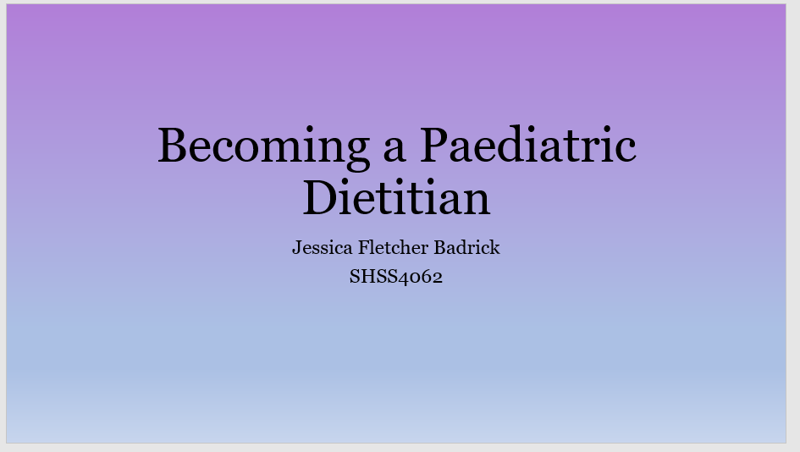

Welcome, everybody, to this presentation about my chosen career path. My name is Jess and today I would like to give you a brief introduction to the topic of studying and practicing dietetics in Wales, and then to focus on the area of paediatric dietetics. I will discuss the required competencies and qualifications that one needs in order to be a practicing dietician in the UK, and try to evaluate where I am in terms of my current ability. I will also share with you my action plan for becoming a dietitian in the future. I love working with children so I have a special interest in paediatric dietetics, in which I may wish to specialise after a few years. I’ll put up a reference list at the end of the presentation and at that point there will be an opportunity for you to ask me any questions.

Dieticians play a pivotal role in the detection, diagnosis and treatment of many diseases (Watling, 2009) at an individual level and also work at a wider public health level (British Dietetic Association, 2017a). They are also the only nutrition professionals in the UK to be statutorily regulated and governed by an ethical code. Dietitians usually work as part of a team in a hospital or in the community and support patients for whom quality of life is closely linked with their diet (British Dietetic Association, 2017a). Registered Dietitians have access to a wide range of job roles, including jobs in the food industry, public health, education, research, sports nutrition, working with local schools and care facilities or the media. Some dietitians also work with charities to do with chronic disease and give general advice to people who wish to manage those conditions as best as they can through diet (Diabetes UK, 2019).

Dietitians usually choose to specialise in a certain area of health after gaining some experience in general dietetic practice (Mustapha et al., 2013). They may choose to specialise in treating people with certain conditions, or to specialise in working with certain population groups, for example children. Regular contact with registered dieticians has been proven to substantially improve BMI results in obese youth taking part in comprehensive weight management programmes (Kirk et al., 2015).

On the other end of the spectrum, a Registered Dietician specialising in paediatrics may see many young patients suffering from eating disorders such as anorexia nervosa or bulimia. Ideally working alongside a psychologist and other members of a multidisciplinary team, the role of the dietician in these cases would be to provide assessment, education, and guidance relating to food and nutrition, as well as establishing goal weight and designing and implementing meal plans (Ariail et al, 2018). They would work very closely with the parents or guardians of the child. A paediatric dietitian would also usually be involved if a child required enteral (tube to stomach or jejunum) or parenteral (direct-to-vein) feeding.

Slide 2: Competencies and Qualifications
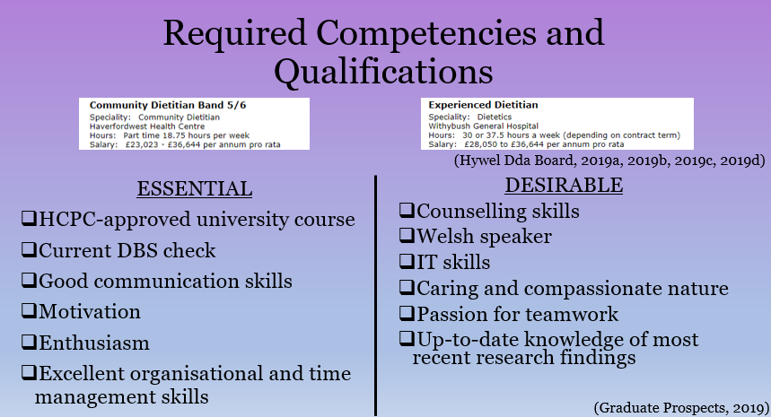

I would now like to discuss the competencies and qualifications required to become a qualified and practicing dietitian in the UK.

In mid-March 2019, the Hywel Dda University Health Board advertised three dietitian positions for candidates with different levels of experience and different areas of expertise. The three posts, however, all had very similar essential and desirable competencies and qualifications. Obviously, anyone applying for such a role must have appropriate UK professional registration. It is a requirement that practicing dietitians are registered with the Health and Care Professions Council. Many also choose to register with the British Dietetic Association.

In order to qualify as a dietician, one must first undertake a dietetic programme at a university, which has been approved by the Health and Care Professions Council (Callan, Champion and Radbone, 2017) and accredited by the British Dietetic Association. There are just 13 approved undergraduate degrees in the UK which carry this approval, only one of which is based in Wales, but there are also about 15 postgraduate programmes which have been accredited by the British Dietetic Association (British Dietetic Association, 2017b).

A current Disclosure and Barring Service check is also a necessary requirement for anyone wishing to fill a dietitian role within the NHS in Wales.

Almost every dietitian job specification mentions good communication skills, often labelled as an essential quality. This is because dietitians must able to discuss broad topics and specific situations with a wide range of different people. They may typically have to have very clinical conversations at a very professional level with surgeons and General Practitioners, but they will also need to be able to discuss quite complicated scientific information on a level that lay people will be able to understand (King, cited in Hilpern, 2010).

All three jobs listed motivation as an essential quality in a candidate, as well as enthusiasm, as both are key traits for anyone working with people in the health service (Graduate Prospects, 2019). It could be argued that one needs to be motivated themselves in order to successfully motivate others. Other essential competencies required from a dietitian include excellent organisational and time management skills, which makes sense as busy patient caseloads can be demanding (Graduate Prospects, 2019).

A dietician may provide counselling to clients making major lifestyle changes, and so a degree of understanding and a certain amount of empathy is required. When dietitians have been trained in counselling skills, patients have reported positive counselling outcomes such as an increased knowledge of what to eat, and an increased sense of control over their condition (Watling, 2009).

In all cases, since these posts are for jobs in Wales, the ability to speak Welsh is desirable. IT skills are also desirable, although they are arguably essential for most dietitians these days as records are now kept electronically, and the use of software such as Nutritics is commonplace.

A caring nature is a desirable quality for a dietitian (Graduate Prospects, 2019), as people in this sort of role will need to have a compassionate approach towards the feelings of other people in order to successfully help them make positive changes.

Many dietitian job specifications mention teamwork, as dieticians frequently have to work with other members of care teams in order to ensure a patient gets everything he or she needs. This is generally the case whether they are working in general dietetics or have chosen to specialise.

Paediatric dietitians must stay abreast of the very latest research findings to ensure they are giving out up-to-date advice and guidance to all patients and their guardians. The BDA also offers continuous professional development courses for members and certain non-members who are involved in similar fields.

Slide 3: HCPC Standards of Conduct
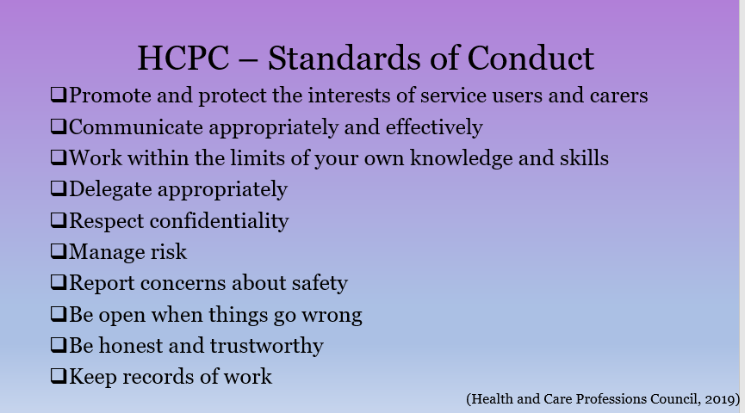

The Health and Care Professions Council (2019) expect all registrants to promote and protect the interests of service users and carers, to communicate appropriately and effectively, to work within the limits of their own knowledge and skills and to delegate appropriately. They are also expected to respect confidentiality, manage risk, report any concerns about safety, be open in a timely manner when anything goes wrong, be honest and trustworthy and to keep records of their work.

Slide 4: BDA Code of Professional Conduct
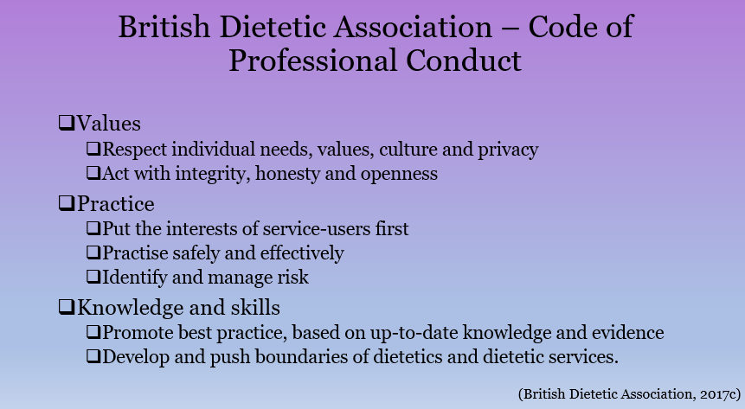
The British Dietetic Association (2017c) also has a Code of conduct, which in many ways mirrors that of the HCPC. All dieticians registered with them are expected to respect individual needs, values, culture and privacy, to act with integrity, honesty and openness, to put the interests of service-users first, to practice safely and effectively and to identify and manage risk. All registrants are also expected to promote best practice, based on up-to-date knowledge and evidence, and to develop and push boundaries of dietetics and dietetics services.

Slide 5: Current Ability and Qualifications
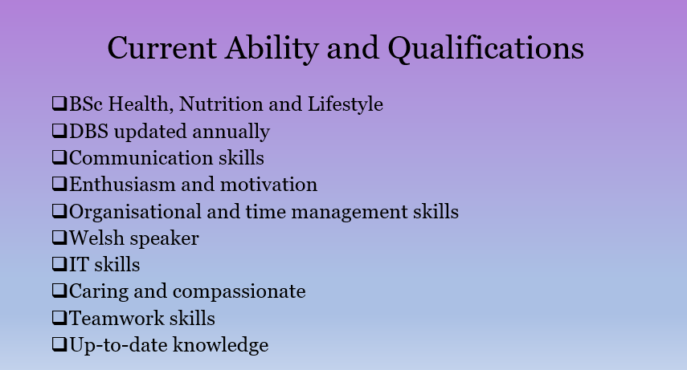

Using the list of essential and desirable qualities from the earlier slide, it is possible for me to compare my current status with the level at which I need to be in order to gain employment as a dietitian in Wales.

I am currently studying a BSc in Health, Nutrition and Lifestyle which, though not HCPC-approved, should lead on to a Postgraduate Diploma if I am able to attain an extra 20 credits of biochemistry in addition to my normal modules. I have a current DBS check which gets automatically updated every year. Being on the course is helping to improve my communication skills. My passion for the subject means that I am naturally enthusiastic and motivated about dietetics. I have quite good organisational skills, though my time management skills need some improvement. I currently speak some Welsh, as I have learned up to Canolradd (Intermediate) level, although having seen Welsh mentioned so often in job specifications, I have decided to progress my learning even further and study the next level up, which is Uwch. I have quite good IT skills as I am used to working with devices and computers. I believe I have quite a caring and compassionate nature, which should serve me well when working as a paediatric dietitian. Attending lectures for my current course has helped me to improve my teamwork skills, and they shall be developed even further next year when I take part in the Health Promotion module. I shall try to ensure that my knowledge is always up-to-date by staying engaged with recent research findings via journals and library services.

Slide 6: Action Plan
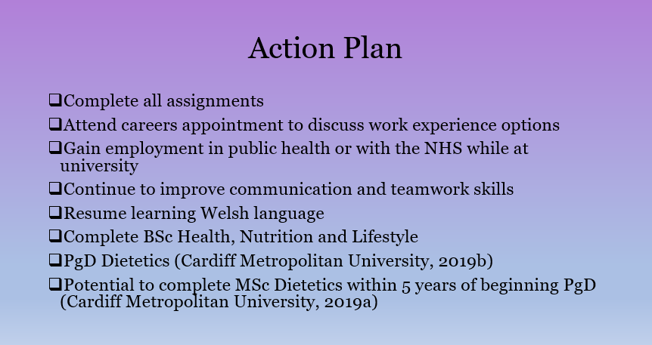
To achieve the dream goal of becoming a paediatric dietician, the use of an action plan seems sensible. Action plans containing aims and objectives are an effective way of ensuring completion of goals. Regular setting of short-term goals which are specific, measurable, action-oriented, realistic and time-phased can be a useful way of staying on track for a chosen career. In my case, many of my short-term goals at the moment involve completing various assignment tasks for my BSc in Health, Nutrition and Lifestyle. I also plan to meet with a careers advisor to discuss the possibility of gaining work experience and maximising my chances of getting a relevant job within a clinical or a community setting.

Completing these short-term goals should enable me to progress to year two of my degree, which is a medium-term goal of mine, and then on to the third year, during which I will complete a dissertation. Completing my BSc will allow me to progress to my long-term goal of becoming a dietitian via a two-year Postgraduate Diploma with Cardiff Metropolitan University. It is the only university in Wales which is currently accredited by the Health and Care Professions Council and the British Dietetic Association. Achieving this long-term goal will ensure I am on track to achieve my ‘Dream’ goal, which is to be a dietitian who specialises in paediatrics. Many dietitians complete the MSc in Dietetics while working for the NHS, so this is a possibility for me as long as I start it within five years of beginning the Postgraduate Diploma.

Alongside my studies, I will also be striving to improve my communication and teamwork skills. I shall also be improving my Welsh language skills. In order for goals to be realistic, it will be important to continue to assess current ability levels and to ensure that any knowledge or training gaps are filled.

Slides 7 - 10: References
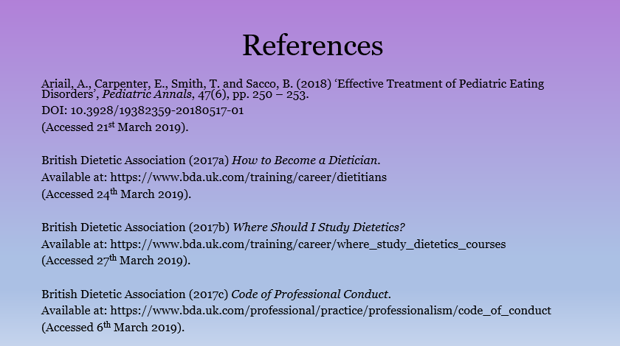

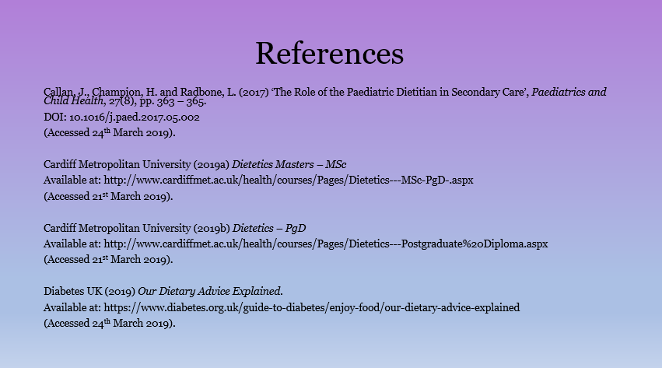

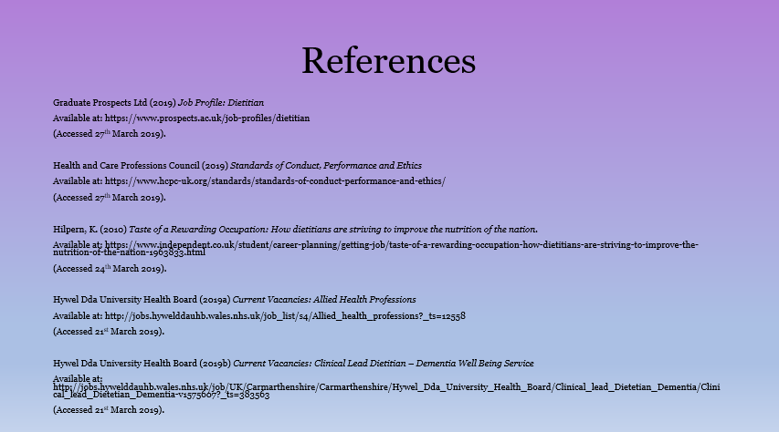

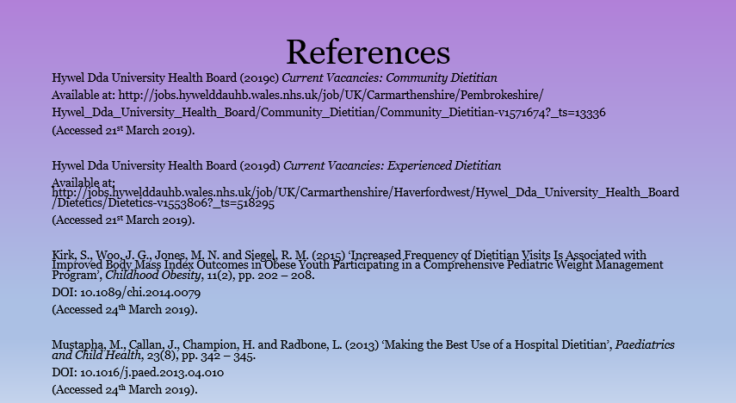

Does anybody have any questions?

Word count:
1,892 words.

References

Ariail, A., Carpenter, E., Smith, T. and Sacco, B. (2018) ‘Effective Treatment of Pediatric Eating Disorders’, Pediatric Annals, 47(6), pp. 250 – 253.
DOI: 10.3928/19382359-20180517-01
(Accessed 21st March 2019).

British Dietetic Association (2017a) How to Become a Dietician.
Available at: https://www.bda.uk.com/training/career/dietitians
(Accessed 24th March 2019).

British Dietetic Association (2017b) Where Should I Study Dietetics?
Available at: https://www.bda.uk.com/training/career/where_study_dietetics_courses
(Accessed 27th March 2019).

British Dietetic Association (2017c) Code of Professional Conduct.
Available at: https://www.bda.uk.com/professional/practice/professionalism/code_of_conduct
(Accessed 6th March 2019).

Callan, J., Champion, H. and Radbone, L. (2017) ‘The Role of the Paediatric Dietitian in Secondary Care’, Paediatrics and Child Health, 27(8), pp. 363 – 365.
DOI: 10.1016/j.paed.2017.05.002
(Accessed 24th March 2019).

Cardiff Metropolitan University (2019a) Dietetics Masters – MSc
Available at: http://www.cardiffmet.ac.uk/health/courses/Pages/Dietetics---MSc-PgD-.aspx
(Accessed 21st March 2019).

Cardiff Metropolitan University (2019b) Dietetics – PgD
Available at: http://www.cardiffmet.ac.uk/health/courses/Pages/Dietetics---Postgraduate%20
Diploma.aspx
(Accessed 21st March 2019).

Diabetes UK (2019) Our Dietary Advice Explained.
Available at: https://www.diabetes.org.uk/guide-to-diabetes/enjoy-food/our-dietary-advice-explained
(Accessed 24th March 2019).

Graduate Prospects Ltd (2019) Job Profile: Dietitian
Available at: https://www.prospects.ac.uk/job-profiles/dietitian
(Accessed 27th March 2019).

Health and Care Professions Council (2019) Standards of Conduct, Performance and Ethics
Available at: https://www.hcpc-uk.org/standards/standards-of-conduct-performance-and-ethics/
(Accessed 27th March 2019).

Hilpern, K. (2010) Taste of a Rewarding Occupation: How dietitians are striving to improve the nutrition of the nation.
Available at: https://www.independent.co.uk/student/career-planning/getting-job/taste-of-a-rewarding-occupation-how-dietitians-are-striving-to-improve-the-nutrition-of-the-nation-1963833.html
(Accessed 24th March 2019).

Hywel Dda University Health Board (2019a) Current Vacancies: Allied Health Professions
Available at: http://jobs.hywelddauhb.wales.nhs.uk/job_list/s4/Allied_health_professions?_
ts=12558
(Accessed 21st March 2019).

Hywel Dda University Health Board (2019b) Current Vacancies: Clinical Lead Dietitian – Dementia Well Being Service
Available at: http://jobs.hywelddauhb.wales.nhs.uk/job/UK/Carmarthenshire/Carmarthenshi
re/Hywel_Dda_University_Health_Board/Clinical_lead_Dietetian_Dementia/Clinical_lead_Dietetian_Dementia-v1575607?_ts=383563
(Accessed 21st March 2019).

Hywel Dda University Health Board (2019c) Current Vacancies: Community Dietitian
Available at: http://jobs.hywelddauhb.wales.nhs.uk/job/UK/Carmarthenshire/Pembrokeshire/
Hywel_Dda_University_Health_Board/Community_Dietitian/Community_Dietitian-v15716
74?_ts=13336
(Accessed 21st March 2019).

Hywel Dda University Health Board (2019d) Current Vacancies: Experienced Dietitian
Available at: http://jobs.hywelddauhb.wales.nhs.uk/job/UK/Carmarthenshire/Haverfordwest/
Hywel_Dda_University_Health_Board/Dietetics/Dietetics-v1553806?_ts=518295
(Accessed 21st March 2019).

Kirk, S., Woo, J. G., Jones, M. N. and Siegel, R. M. (2015) ‘Increased Frequency of Dietitian Visits Is Associated with Improved Body Mass Index Outcomes in Obese Youth Participating in a Comprehensive Pediatric Weight Management Program’, Childhood Obesity, 11(2), pp. 202 – 208.
DOI: 10.1089/chi.2014.0079
(Accessed 24th March 2019).

Mustapha, M., Callan, J., Champion, H. and Radbone, L. (2013) ‘Making the Best Use of a Hospital Dietitian’, Paediatrics and Child Health, 23(8), pp. 342 – 345.
DOI: 10.1016/j.paed.2013.04.010
(Accessed 24th March 2019).

Watling, R. M. (2009) ‘The Positive Impact of Dietitians in Paediatric Healthcare’, Paediatrics and Child Health, 19(9), pp. 400 – 404.
DOI: 10.1016/j.paed.2009.05.004
(Accessed 24th March 2019).

