How to Use Wix
https://www.websitebuilderexpert.com/website-builders/wix/how-to-use-wix/

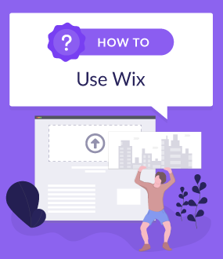

How to Create a Wix Website That Shines
Wix is the world’s most popular website design platform. It serves over 110 million people in 190 countries, with 45,000 new sign-ups every day. Looking to join them? Our step-by-step guide will show you how to use Wix, and just how easy it is to get started. So if you’re wondering how to create a Wix website that’ll impress every visitor, it’s totally doable – as a drag-and-drop website editor, Wix is super easy to learn and use.
So, Wix is popular, that much is clear. Since it launched in 2006, it’s transformed the mysterious kid that was web design into the most likeable student on campus. But how? Simple – Wix has made web design quick, easy, and fun for everyone.
The rise of Wix has also saved companies thousands of dollars on web designers. And everyone loves something they’ve created, right? Just like your IKEA wardrobe.
So why do we, at Website Builder Expert, love Wix? It’s flexible and easy to use. The drag and drop feature is fluid, you can easily customize media, and you have access to hundreds of handy apps.
And it’s not just us who think so. We got people just like you to test Wix too. During our testing, one user said:
“It’s really easy to use, even for those without the design skills.”
In fact, Wix came out on top in our user testing and research as the best all-around website builder, with strong performance in every category:

Best All-Around Website Builder
4.7out of 5
TOP CHOICE

Is There More than One Way to Make a Website on Wix?
Go to the top
Designing a website with Wix can be done in two ways.
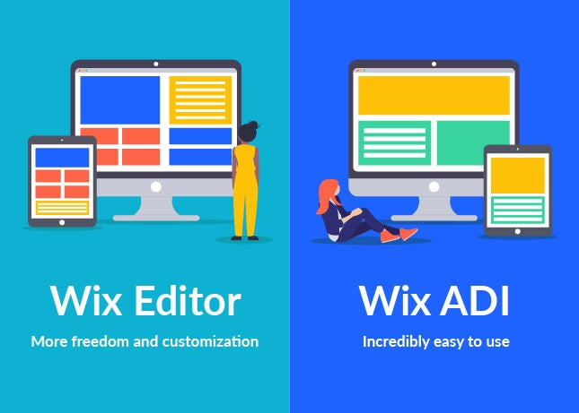
Wix Editor is the standard website builder we know and love. To start, you choose from over 500 templates. Once you’ve picked your ideal canvas, you can drag-and-drop different text and image elements to customize it. The best feature of Wix Editor is the extensive menu of options to play with.
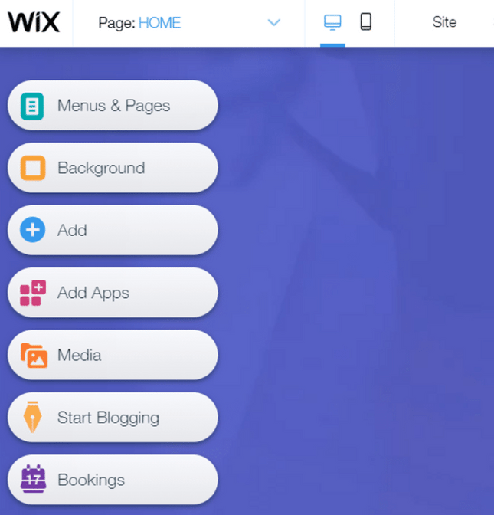
The menu in Wix Editor is easy to navigate, and provides a ton of options for customization.
So who is Wix Editor for? Wix Editor allows you to create a beautiful website in just a couple of hours or so. This makes it ideal for users such as:
- Small businesses
- Restaurants
- Online stores
- Bloggers
- Photographers
The second Wix option is the first of its kind: Wix ADI (Artificial Design Intelligence). Using advanced technology, it creates stunning websites automatically. This is how to build a Wix website with no work involved on your part.
So how does Wix ADI work? Just provide some basic information, such as your business type, contact information, and online presence, and it does the rest. You can even make small design changes to suit your taste once the site is generated.
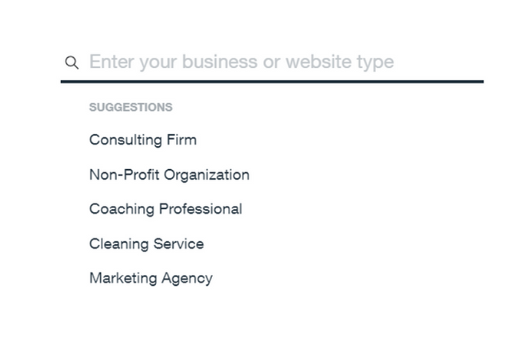
All you have to do is answer a series of questions about your site, and Wix ADI will create an impressive one for you.
So given its ease of use and impressive design speeds, Wix ADI is best for:
- Less tech-savvy users
- Busy business owners
- Time-constrained bloggers
With Wix ADI, you’ll have a bespoke website in a few minutes. Amazing, isn’t it? But with such simplicity comes less flexibility. You can’t seamlessly drag and drop elements such as images, videos and apps like the Wix Editor. You’re more restricted.
But whichever tool you choose, you’ll find it quick and simple to build a beautiful website. Can’t decide which one is for you? Well, we’ve produced a Wix how-to for each tool that shows you how to create a site for sore eyes (sorry, couldn’t resist).

How to Use Wix Editor
Go to the top
To make things simpler, we’ve broken down the Wix Editor process into 12 steps:
- Sign up
- Choose a template
- Update text and images
- Personalize the background
- Add pages/site navigation
- Add apps
- Set up a blog
- Add an online store
- Optimize for search engines
- Make it look good on mobile
- Choose a domain name
- Publish

Step 1: Sign Up
If you’ve compared the top website builders out there and come to the conclusion that Wix is for you, then a lot of your work is already done. But there’s still one more decision to make before Wix does the rest of the heavy lifting: you need to pick a pricing plan.
Wix offers eight pricing plans, so there are a few different places you can start. As with all subscriptions, the more you pay, the more features you get. You can also choose a free plan, but you’ll have to sacrifice a professional domain name and deal with on-site ads, which give websites a more amateur look.

Step 2: Choose a Template
To get started, select Create a New Site from the drop down menu in the top right corner of the dashboard. Once you click, Wix will ask what type of website you want. There are options for everyone, from online stores to personal portfolios.
Based on your selection, you’ll be taken to a page of relevant templates to choose from – and when it comes to Wix templates, you’re spoiled for choice. There are over 500 templates in total, so if your dream template isn’t in your selected category, you can always use the search bar to find more.
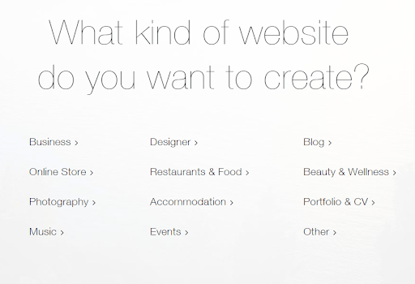
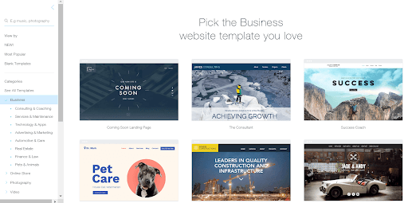Wix has over 500 templates to choose from
The one downside of all this choice is that once you choose your template, you can’t change it. You’ll therefore want to make sure you’re happy with the template you choose, but don’t worry – Wix’s flexible editing features make it easy to spice up whatever design you do choose at any time.

Step 3: Update Text and Images
At this point, you’ll get to see a preview page of your chosen template. This is where you can play around with simple but brilliant editing features, like the drag-and-drop design and text boxes.
For some in-depth assistance, check out this video on building with Wix:
First, you’ll want to update your company, portfolio, or blog details. Simply click on the text you want to change, then rewrite – it’s that easy. You can also change the font size and color, and typeface favorites like italics and bold are also there for some extra font-based fun.
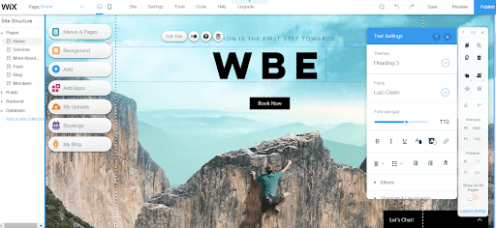
Editing text on Wix is easy
If your template comes with images, these can be changed too. This is what makes Wix the best – you can really make the website your own, one click at a time. Don’t like an image? Click it and switch it out for something you do like. It could be a saved photo from your business, or one of Wix’s free images – there are tons of design possibilities to be explored here.

Step 4: Personalize the Background
If small images aren’t enough, you can also change your template background. The left-hand sidebar features a ‘Background’ button, which you can use to click and change with ease.
We recommend adding a video to your background – they’ve become one of the most popular UX (User Experience) trends of 2019, and will generate more interest. In fact, 85% of the American internet audience watches videos online!
Read our article on the best UX trends.
When you edit the background of your Wix site – or any other part, for that matter – you’ll have two toolbars to work with: one on the right-hand side of the screen, and one on the left-hand side.
The toolbar on the left is for adding extras to your site, such as backgrounds, more pages, images, or even apps (we’ll explain apps in step 7!).
Once you’ve included everything you want, you can use the right-hand toolbar to duplicate, rotate, or delete your various new additions.
You can also go rogue and stir your add-ons around with the drag-and-drop, using the dotted lines to help with symmetry (if that’s your style).

Step 5: Add Pages
Once you’ve created a stunning homepage, there are a few other pages you should add to ensure your website has everything visitors are looking for. For example, make sure to include an “About” page and a “Contact Us” page.
We’ve made a handy guide on how to write an “About Us” page.
To add a page to your site with Wix Editor, click the down arrow next to your current page at the top of the editor, then click “Manage Pages.”
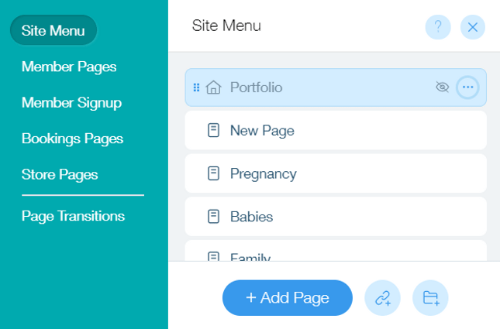
From the resulting menu, you’ll be able to add pages and customize them to serve different purposes.

Step 6: Add Apps
By this point, you’ve customized your site’s template and added some solid images and pages. But if your site still feels a little plain, there’s no need to worry – adding some exciting bells and whistles is a lot easier than it seems. Wix’s App Market has over 250 amazing applications to boost your site, and they cover everything from restaurant orders to interactive quizzes. The apps don’t just look great, either – they also provide your website with the modern interface necessary to stay competitive.
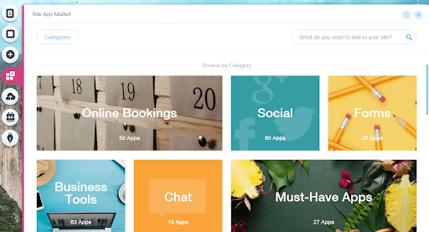The Wix App Market has over 250 options
Take a virtual wander through the marketplace and pick out your favorites. Each app has a thumbnail preview, with a ‘Free’ or ‘Premium’ price option (or both). And best of all, unlike most markets, you won’t need to haggle for prices.

Step 7: Set Up a Blog
Keep your audience in the loop with a professional-looking blog page, fully integrated with your site. The new Wix Blog can be found by clicking the pen-shaped ‘Start Blogging’ button, which can be found at the bottom of the builder menu.
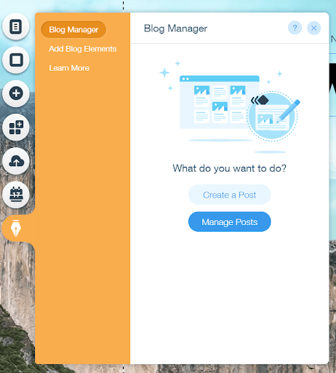Integrating a Wix blog is a breeze
For a choice of blogging apps, search the ‘Add Apps’ button on the same menu. You have a choice of blog apps, but we recommend Wix Blog for its ease of use and sleek appearance.
The app itself is easily manageable, too. Click the same pen-shaped button, then ‘Add Blog Elements’ to throw in some handy features, such as an Instagram feed, events, or an RSS (Really Simple Syndication) button used for sharing content online.
The Beginner’s Guide to Starting a Blog

Step 8: Add an Online Store
If you’d like your site to function as an online store, then you’ve made a good choice using Wix. In fact, we’ve rated it as the best website builder for small businesses.
By clicking the “+” icon in the left-hand menu, you’ll be presented with a list of add-ons for your site. From this list, click “Store,” and you’ll see the following menu:
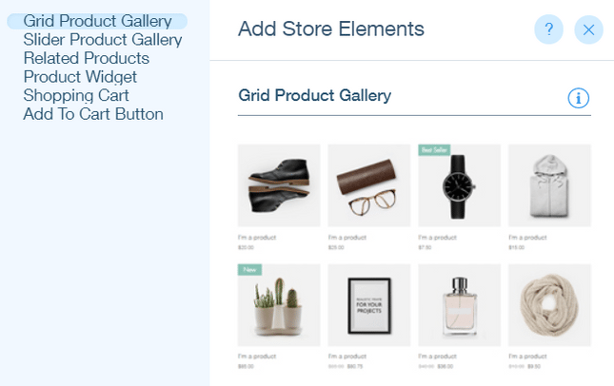
From here, Wix will automatically set up ecommerce functions on your site for you, including product galleries, multiple payment methods, and inventory management.

Wix’s ecommerce functions allow you to sit back and start selling in the blink of an eye.
Read our Wix Ecommerce Review for more detail
For tips and tricks, check out our guide to selling online

Step 9: Optimize for Search Engines
Wix Editor makes it straightforward to work with your site’s SEO (Search Engine Optimization) capabilities. On the left side of the site editor, you can click “Menus and Pages,” then click on the ellipses next to any page to be presented with this list of options:
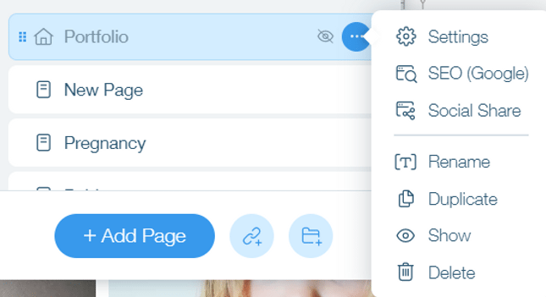
Then, click “SEO Google” to get to this box:
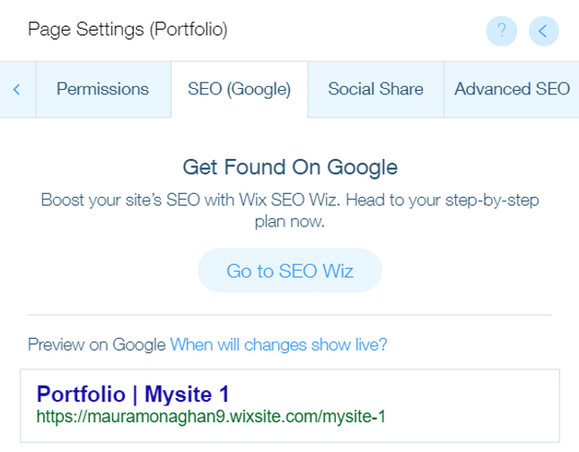
Here, you’re given control over all of your site’s basic SEO functions, from the keywords that you tag your page with to the site description that will show up on SERPs (Search Engine Results Pages) – all of which you can edit with ease.

Step 10: Make It Look Good on Mobile
Making sure the mobile version of your site looks great is vital to its success, since mobile is pretty much taking over the world – these days, 40% of people search only on a smartphone.
Thankfully, with Wix Editor, mobile optimization is as easy as it is important. To start, hover your mouse over the desktop screen at the top of the editor.
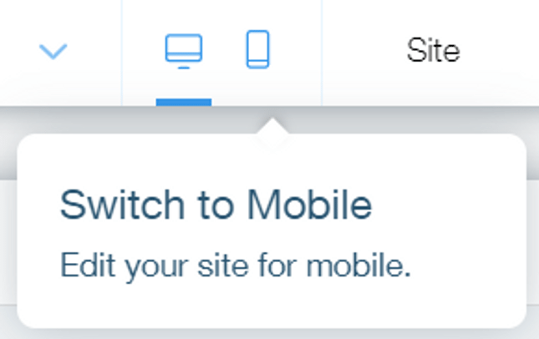
Then, click the mobile icon to see what your site will look like when viewed from a phone screen.
Odds are, Wix has taken care of mobile view for you, and your site already looks awesome in this format. But you can still make as many changes as you want – and any changes you make in mobile view will not affect the desktop version of your site.

Step 11: Choose a Domain Name
Before you publish your Wix site, you’ll need to set your domain name (Wix will prompt you to do this when you click “Publish”).
If you’re using Wix’s free plan, then you won’t be able to use a regular domain name like “www.mysite.com” or “www.mysite.net” (domains like this come with Wix’s paid plans). Instead, your site will follow the format www.yourname.wixsite/yoursite, which is enough to get it up and running. But if you’re going for a more professional look, then we recommend upgrading to a paid plan to secure a more polished domain!

Step 12: Publish!
By now, your Wix Editor site will be ready to go. Throughout the Wix editing process, you can preview your masterpiece with the button in the top right corner. Once you’re satisfied, simply click ‘Publish’ next to Preview, and… it’s live!
You can always edit your Wix site after publishing, so don’t feel like it’s a permanent commitment to the changes you’ve made. Just open your site’s dashboard, click “Manage Site,” then “Edit Site,” and off you go. To re-publish, just click ‘Publish’ again in the top right corner.

Wix Editor Roundup
Ready to get going? First, let’s recap the steps for using Wix Editor:
- Choose a price plan
- Decide what kind of website you need
- Select a template
- Edit text boxes and navigation menus
- Customize background
- Drag and drop elements
- Add Apps
- Check that mobile and SEO functions are in place
- Preview
- Publish
There’s a reason why Wix is our highest rated website builder (see our comparison table). It’s easy, fun, and lets you take control. Follow these steps to end up with a website that you’re proud of – with none of the headache you may have anticipated.
Go to the top

How to Use Wix ADI
Go to the top
Wix ADI (Artificial Design Intelligence) has made it easier than ever to design a website. You’re asked a few questions and then given a stunning website, just like that. As if Wix couldn’t get any easier, right?
Read more about artificial intelligence and the future of web design
While Wix Editor is straightforward, Wix ADI is for less tech savvy users, or those who simply don’t have the time to create a website from scratch. So if you’re busy juggling invoices and phone calls, with Wix ADI, a Wix website can be yours in just 8 easy steps:
- Get started
- Add features
- Input your contact details
- Design your site
- Select a style
- Make sure it’s SEO and mobile-friendly
- Choose a domain name
- Publish

Step 1: Getting Started
After signing in, click the ‘+ Create New Site’ button and then ‘Start with Wix ADI’.
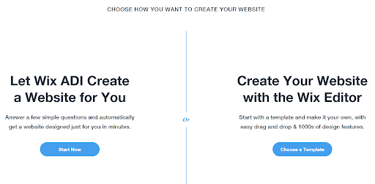
Select Wix ADI to save time and creative effort

Step 2: Add Features
You’ll then be asked which features you might need. Tick the relevant boxes, then click ‘Next’ on the bottom right-hand side. Don’t worry if you change your mind, or even your business model – you can edit Wix ADI at any time.

Personalize your site with Wix features

Step 3: Input Your Contact Details
Wix ADI will ask you for the contact details you’d like to include on your site. Try to provide as much information as possible, as this allows the ADI to create detailed navigation menus, footers, headers, and contact pages with ease.
And remember – the more accurate your answers, the more Wix ADI can customize the perfect site for you.

Fill out the contact detail page for high quality headers, contact pages and navigation menus

Step 4: Design Your Site
Yes, the design is up to the ADI, but you can still have some input if you want it. The ADI can produce billions of text combinations and images, so you’re guaranteed a website that’s sleek and unique.
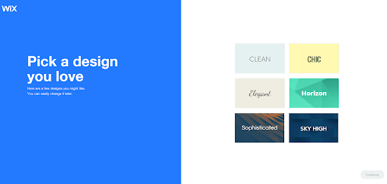
Picking a color theme with Wix ADI is straightforward
Now that the ADI knows what you need, it will take you through the design process. Once you click “Start,” you’ll be presented with some color schemes. Take your pick, but don’t stress too much – you can change these later if you like. After this, you will have a brand new homepage suggested within minutes.
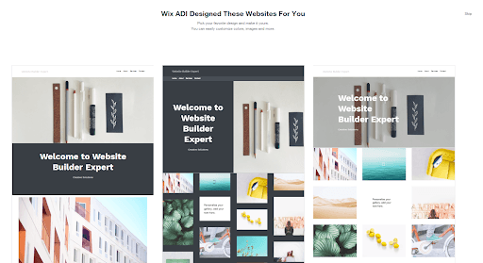
Wix ADI homepage suggestions
How to choose a color scheme for your website

Step 5: Select a Style
Happy with the overall appearance? You can now personalize it further by changing fonts, adding media, and introducing a whole host of other functions with the help of Wix ADI’s smart assistant. It’s fast, and gives you a small amount of creative control. It’s like handing an artist the paints you’d like them to brush with.
However, the smart ADI assistant is far more restrictive than Wix Editor. So if you’ve been inspired to really put your stamp on your site – or if you’re simply not happy – you can easily switch to Wix Editor mode whenever you like. Think about it, though, because it’s harder to reverse the process; you’d need to save your last ADI version, then restore it.
Wix ADI will now give its final proposal. From here, you can go over the previous steps and make some changes. This is important – if you’re not completely happy, then chances are your visitors won’t be either.
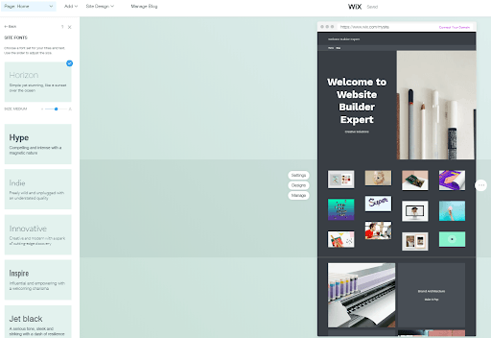
Wix ADI's simplistic editing page

Step 6: Make Sure It’s SEO and Mobile Friendly
If you thought SEO and mobile functions were easy to implement with Wix Editor, then we have good news: it only gets easier with Wix ADI.
To edit the SEO functions of any page on your site, click on the page in the left-hand toolbar and choose “Page SEO.”
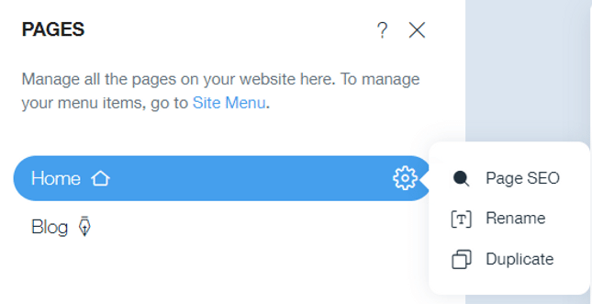
You’ll see the following screen:
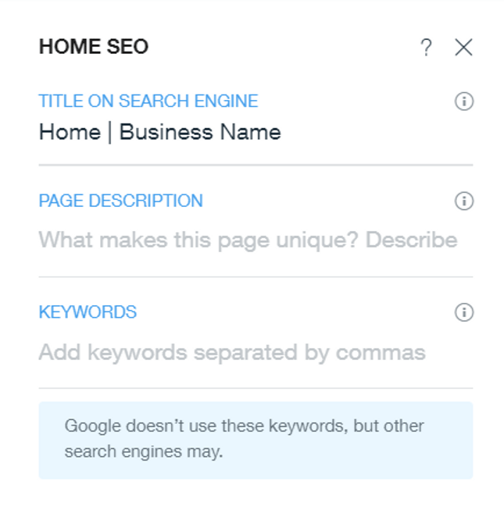
Try Wix ADI Today
From here, all you have to do is input the keywords, title, and page description that you want to add!
Read Our Wix SEO Review
Optimizing your Wix ADI site for mobile requires even less effort than SEO. When you click on the desktop icon on the top menu of your site page, you’ll be able to switch to a cell phone icon.
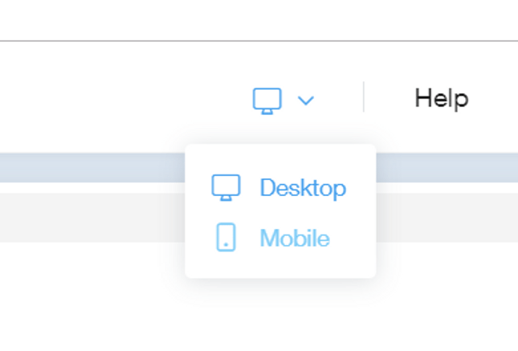
Clicking this will take you to the mobile view of your site, which you won’t have to make any changes to (unless you want to). Wix ADI has already prepared your site to look sleek for viewers on-the-go – which is most viewers, since mobile traffic has been higher than desktop traffic since 2015.

Step 7: Choose a Domain Name
When you’re done creating your site, you can click “Publish” in the upper right-hand corner of the screen, and you’ll get this page:
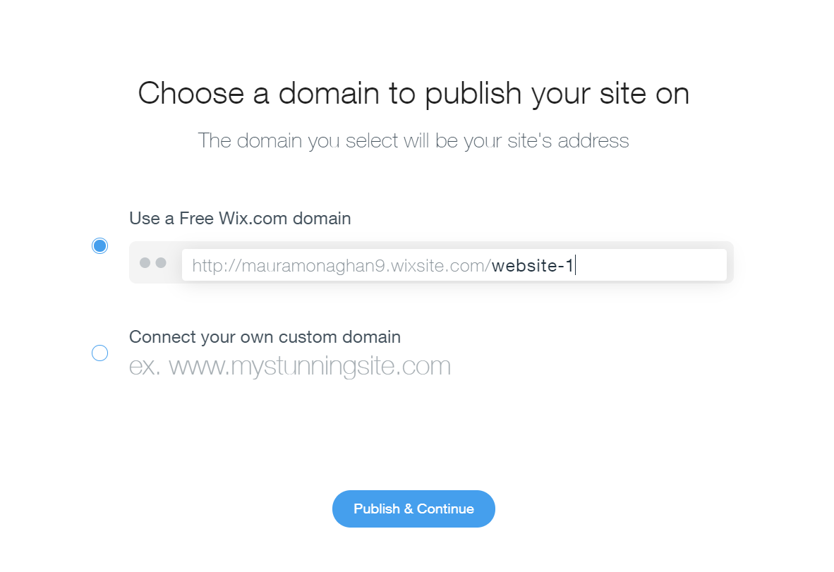
Upgrading to a paid plan is the only way to secure a domain in the regular format of “www.mysite.com.” If you’re using Wix’s free plan, you’ll have to use a domain with the format www.yourname.wixsite/yoursite.

Step 8: Publish!
Your final product is now ready to publish. Click ‘Preview’ at the top of the ADI screen to have one last check, then simply press the X icon to return to the editing page. Now, hit ‘Publish’ at the top.
Doubting the design? You can make edits after publishing on Wix ADI at any time. Just go into your dashboard after signing in, click “My Sites,” then “Edit” on your ADI website.

Wix ADI Roundup
Now that you’re ready to create with Wix ADI, let’s recap the steps:
- Sign up
- Say who you are
- Select what features you need
- Add name and location
- Get stylish with the assistant
- Check that mobile and SEO functions are in place
- Set your domain
- Preview
- Publish

Get to Know the Wix Dashboard
You’ll be using the Wix dashboard pretty much from the get-go, whether your site was built with Wix Editor or ADI. Once your site is live, the Wix dashboard will be where you can make any updates or changes to your account – so it’s best to get comfortable with this page as soon as you can!
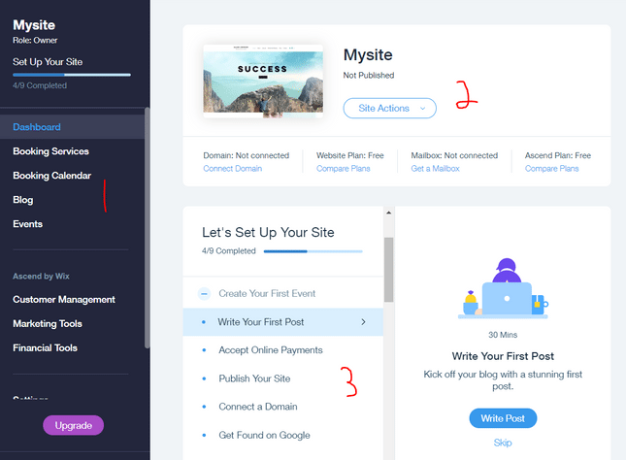
We’ve labeled the Wix dashboard according to the three sections that we think are most relevant. Section 1 is the analytical hub, where you can control potential site functions like an online store (“Financial Tools”), marketing and publicity (“Marketing Tools”), and a blog (you guessed it, “Blog”).
Section 2 is your gateway back to the site editor, where you can make more creative changes. By clicking on the “Site Actions” menu, you’ll be given this list of options:
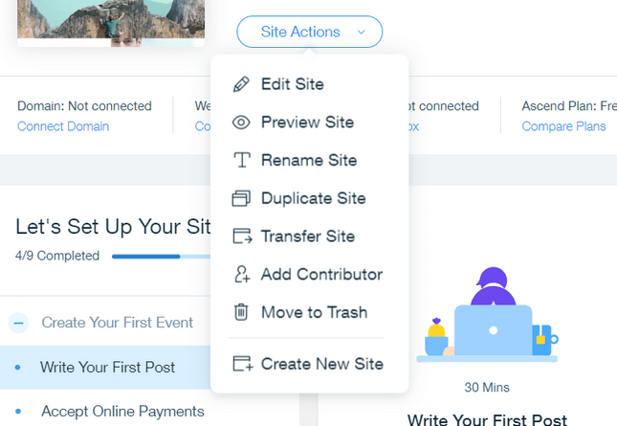
From this section, you can also upgrade your Wix plan and edit your domain name.
Section 3 is a scrolling to-do list that you can work your way through in order to create the most effective site possible. When it comes to add-ons and ideas, Wix has thought of everything for you, so you can take your time picking and choosing which options you’d like to implement.

How to Make a Wix Website: Conclusion
We think Wix ADI is changing the world of websites. It’s the first artificial intelligence tool created to design a website for you, and it’s turned a once-mentally draining task into a breeze: you just answer a few questions, pick your favorite colors, and move a few things around.
However, this lack of creative control can be frustrating. Wix ADI is not nearly as flexible as Wix Editor, which offers smooth drag-and-drop design and easily editable text boxes. So, while you can enjoy simplicity with both Wix tools, the Wix Editor offers more freedom. It also builds more personal sites, thanks to its Premium plan upgrades and wide choice of apps.

