


BA Leadership and Management
BMSW6104 Strategic Management for SMEs
Skills for The Workplace
Lecturer: Paul Bocij
14/04/2022
Samina Zia
1709440

Table of Contents:
Introduction: 3
UWTSD’s Mission/Vision Statement: 4
Mission: 4
Vision: 4
Current Strategy: 5
Porter’s 5 Forces: 6
Threat of new entrants: 7
Bargaining power of customers: 8
Porter’s Value chain (VC) analysis: 8
PESTEL: 9
Political: 10
Economical: 10
Social: 10
Technological: 11
Legal: 11
Environmental: 11
Swot: 12
Stakeholder analysis 12
Strategic growth options for UWTSD: 13
Ansoff Matrix: 14
Three strategic growth options: 15
Option one: Product Development 15
Option two, More programs of study and staff training: 16
Option three, Diversification: 16
Competitors Reaction: 17
Conclusion: 17
References: 19

Introduction:

The key objective of this report is to critically assess and evaluate the current strategic focus of University of Wales Trinity Saint David (UWTSD) Campus at Sparkhill, in Birmingham.
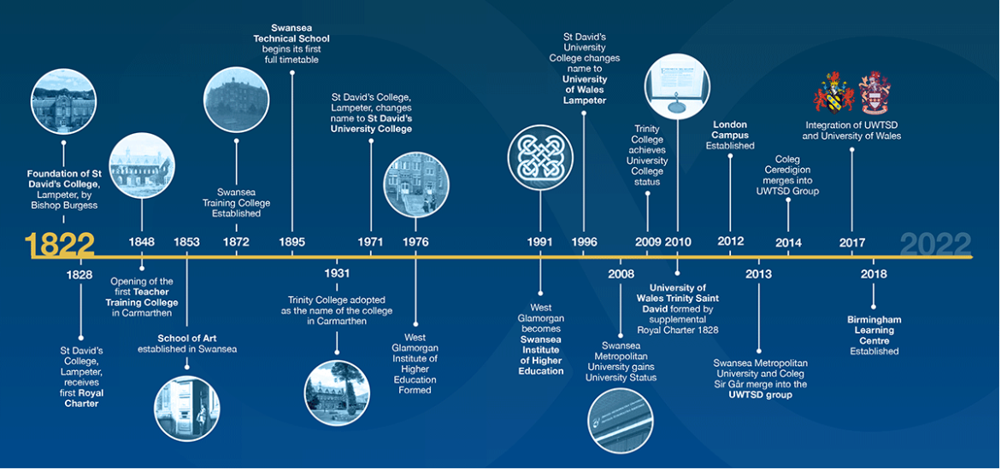
Figure 1 (History and Timeline UWTSD) (History and Timeline | UWTSD, 2022)
Although the University originates from Wales and is celebrating its’ 200th year of formation this year, (Press Releases 2022 | University of Wales Trinity Saint David, 2022), it opened its’ Sparkhill campus doors for the students in March 2018, where students from multiple backgrounds are provided with opportunities to study different programmes at a higher education level, (Press Releases 2022 | University of Wales Trinity Saint David, 2022). The campus is in a vibrant neighbourhood of Sparkhill, surrounded by a community of mixed backgrounds and origins. It has become very popular amongst the locals since it opened, due to its location and an ease of commuting for the attendees. Birmingham Campus consists of around 119 staff members including Senior Management, Academic Staff and Support Staff. From time to time, the University also recruits Hourly Paid Lecturers and Support Staff (Birmingham Campus Staff | UWTSD, 2022).
In this report the mission and Vision of UWTSD will be viewed, and its’ current strategic plan will be checked, using Porter’s five Forces tool, to see how effective it is. Many other theories, models and tools including SWOT, Porter’s 5 Forces and PESTEL will help to see the strengths and weaknesses of the organisation as well as its’ performance so far. PESTLE will provide a detailed internal/external view and findings of the university. By using other tools, such as, VRIO, VMOST and Ansoff matrix as well as SAF, strategic growth of the University will evaluate the progress, give an in-depth information about this small campus of an international institution of studies and provide guidelines to improve any flaws within the system.

UWTSD’s Mission/Vision Statement:

Mission:

A mission statement is a popular strategic tool for emphasising a company's individuality and ethos, (Ines et al., 2018)
UWTSD Mission is “Transforming Education, Transforming Lives” (Mission and Vision | UWTSD, n.d.).
UWTSD’s mission is exceptionally good and clear as it summarises the universities purpose as well as the direction and goals it is practicing. For example, University of Wales is an international university, welcoming students from all parts of the world, (Press Releases 2020 | University of Wales Trinity Saint David, 2022), and provides new skills for the workplace and develop/improve students’ existing skills and increase self-confidence to achieve their goals of getting better jobs or setting up their own businesses. It also makes them different and better recognised compared to their competitors. What sets them apart is that they provide a level 4 certificate for Workplace to many mature students who have gained a lot of experience throughout their working lives since they left education early and went straight to work. Although these students have a lot of experience but not having the right education, pushes them back from reaching for their goals and achieving their targets of going for better jobs. Through this, the university is giving those students recognition and a chance to reach for their goals or go for further education and becoming more successful in future.
However, providing full support for the students lacks many aspects. Majority of the students at UWTSD Birmingham Campus consists of mature students, it means that they need extra support as most of them have returned to education after several years and are not familiar with the new technology or the education system, compared to those students have continued their education from school, college, to university level. Birmingham Campus of UWTSD must investigate to improve their strategic policy for these students. This will result in stronger position for the University itself as well as bring in more students.

Vision:
Their vision is the development and implementation of a dual sector university environment that educates learners of all ages and backgrounds while stimulating economic and social development in their region across Wales and beyond is central to their agenda, (UWTSD, 2022). The vision, however, seems to be focused on the University for Wales, with achievement to the nation's well-being and heritage at the heart of everything that they do, with this objective in mind. Nevertheless, this vision is outdated now and needs to be updated and changed as UWTSD is no longer based in Wales only. The campus was opened in Birmingham in March 2018 and has helped a lot of the students change their lives for better. There are plans to expand the campuses further and as a result the vision needs to be updated. Although, it mentions economic development beyond Wales but overall, the focus fully shows to be on Wales. Vision needs to be updated through focusing on the mission of transforming education, transforming lives. with students attending the university campus in Birmingham from multicultural backgrounds, all ages, and of different experiences, it is inevitable for the university to update its vision.

Current Strategy:
A strategy is a plan established to explain an organization's mission, vision, and goal, (Ravanfar,2015). Strategic management, according to Lynch (2018), is an act of setting goals that determine an organization's long-term performance.
Strategic Management can be a systematic process that Involves determining the purpose/aims of the organization and involves creating plans to achieve goals and targets over a set period, to ensure it continues to succeed. It also helps protect the SME from a sudden surprise of loss and provides advantages against competition, which can help find the differences between the organisation and the competitors according to the Harvard Business Review (Harvard business review manager's handbook, 2017).

UWTSDs’ Strategic plan provides an insight and to communicate its’ mission, vision, and its goal. This long-term strategic plan 2017-2022 concentrates on four priorities:
- Students of all backgrounds and circumstances are welcomed and supported.
- Teaching, scholarship, and applied research excellence.
- Collaboration for educational commercial potential through partnerships.
- University of Sustainable Development Values
Furthermore, UWTSD also develops a short-term strategy to correspond with the long-term strategic plans' key performance measures. This helps the management to understand how well the performance is and if any changes are needed to be made.

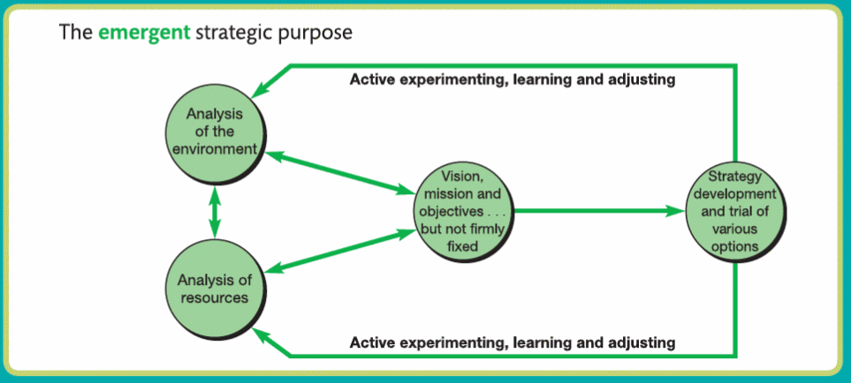
Figure 2 Strategic Purpose, (Lynch, 2018)
This report will use Porter’s 5 Forces tool to look at the overall effectiveness of the existing plans and how the changes, if any, can be made to improve services provided by the university.

Porter’s 5 Forces:

This tool is commonly used by organisations to observe the competition in the sector to understand their competitive advantages as well as the restrictions. It can help organisations to arrange a plan for a successful and unique strategy, that will help their business progress further. It can also help formulate research, using the 5 forces that define the degree of industry competitiveness and rivalry, as well as how appealing this sector is for investment to make of revenue, (Porters Five Forces PowerPoint Diagram - SlideModel, n.d.).
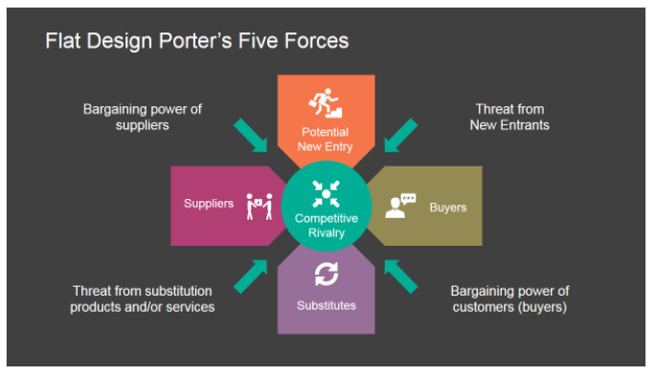
Figure 3(Porters Five Forces PowerPoint Diagram - SlideModel, n.d.)

The P5 table below will help us to analyse the threats that could possibly impact negatively on UWTSD Birmingham.

Force | Threat | Impact | Mitigation
Threat of new entrants | Low | Low | Chances for other universities to open campuses are very low within the Sparkhill location as they will have to offer a course like what UWTSD offers its students at present.
Threat of substitutes | Medium | High | If another university decides to provide similar courses as UWTSD then it will endanger the position of the Campus as it will have to introduce something new or at a reduced cost to maintain the current success it has.
Bargaining power of customers | High | High | UWTSD must listen to and act on their students as it will have to be dealt with sooner, rather than later. Students’ must be prioritised and new ideas as well as plans must be shared on a regular basis to continue the successful achievement progress.
Bargaining power of suppliers | High | High | Having strong relationships with students will gain the confidence and trust of the students by ensuring to have contracts with various lecturers to provide a better outcome for both, the University as well as the students.  It will also be useful to have lecturers from different backgrounds to reduce cultural differences and increase equality and diversity
Industry rivalry | High | Medium | Offer extra support to students to ensure their success, which will result in further flow of the students each term.  Introduce other varieties of programmes and offers for the students. Introduce support for students with disability.
Table 1, Porter's 5 Forces

Threat of new entrants:

Threat of new entrants is found to be low in the Porter’s 5 Forces. This is due to the location and surrounding area as it will be difficult for other universities to create/build a smaller campus nearby. However, it doesn’t reduce the threat of other universities that are within the 3mile range of the campus, for the students to migrate or change their universities. UWTSD however, still has an upper hand on those universities as they are providing students with a course that is only available at UWTSD within the region with almost no prior qualification required, (Skills for the Workplace (CertHE) | UWTSD, n.d.). They must, however, continue to sustain the level of teaching and providing facilities to keep students’ devotion and boost appreciation through student engagement.

Bargaining power of customers:

This came at a high level of threat on Porter’s 5 Forces analysis. Since students have a choice of going to other universities, they can choose to migrate if any issues that they are facing are not met by the university. UWTSD must also prioritise students and ask for feedback on a regular basis to continue to improve their services and products.

UWTSD already provides three times to start the term in each year, gives them a better chance of getting more students in, as other universities are not as flexible with times or dates. According to Porter’s research however, UWTSD can consider investing in other methods to provide high level of education for the students. For example, an addition of Hybrid learning. Since the Pandemic, it has become a popular method for many employers and education sectors to provide facilities at a more convenient way for the students and other members of staff. They can also monitor what other universities are doing regularly to ensure they have all the right tools to hand; in case a competitor is trying to emerge as a threat, or an opportunity that can give a boost to their business.

Porter’s Value chain (VC) analysis:

In order to diagnose competitive advantage, it is critical to establish a company's value chain while competing in a certain industry. Starting with the general chain, individual value activities in the specific firm are identified. Each generic category can be used to organise discrete activities. Separation of activities requiring different technology and economics is required when defining a major value activity (Porter, 1985).
... A value chain is the entire set of actions that take place from the creator to the ultimate consumer and include a mix of physical transformations and the input of various provider services. (Kaplinsky, 2000). It focuses on market collaboration amongst various suppliers, producers, processors, and buyers who hold different degree of market power (Mangubhai et al., 2017).

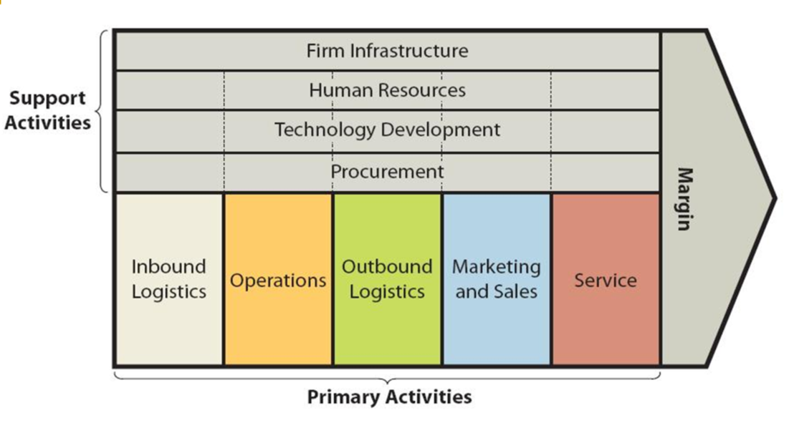
Figure 4, (Porter's Value Chain- porter, 2014.)

PESTEL:
As an acronym of Political, Economic, Social, Technological, Environmental, and Legal elements and their impacts on an organisation, PESTEL is known as a process for assessing an organisations macro environment. this tool can help identify the pros and cons of the business strategies and create a plan that will help flourish the business. PESTLE will help to highlight any changes that are required to be made internally, based on external environment.
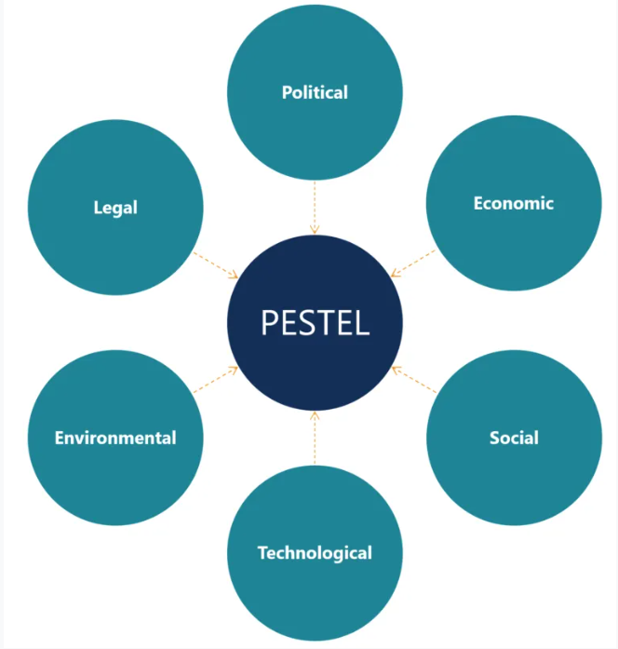
Figure 5, (PESTLE Analysis, n.d.)
Below is a PESTLE analysis of UWTSD.

Political:
Covid-19 and the national as well as international lockdown has been one of the major factors to have impacted every aspect of life on a global level. UWTSD was also impacted severely as a result with a complete lockdown and going onto remote teaching and delivery of the courses, by strictly following the government’s guidelines. Ukrainian war, although does not directly impact on here, it has however, inflated the living costs for consumers, including fuel, sustenance and energy bills increase, and as a result can impact on the University’s performance. however, provide an understanding and an overview of the overall growth nationwide and internal growth of UWTSD to anticipate its continued performance.

Economical:
Despite an increase in inflation, UWTSD has opened Its 2nd branch in Birmingham and plans to continue to expand further. This as a result has created opportunities for jobs as well as education for many more students. However, with the level of recession rising, it can become difficult for the University to continue with the expansion plans, unless a plan is in place, ahead of time. Interest rate increase can also jeopardise the plan for expansions.

Social:
This is a very motivating factor for UWTSD as it helps develop/create strong professional relationships. It is equally important for the university to provide resources that can help students and staff be supported during their time at the university, whether it is through their studies or their work. Students in UWTSD expecting to achieve desired grades through their academic year and the university must accommodate the needs of every student through demographics such as age, special needs, learning disabilities by providing the right and constant support. This is an increasing and very important factor that will have a lot of impact in the way the university is seen internally by higher levels of authority and externally through future students looking at joining the university.
Access to facilities such as bursaries and extra support for an individual’s circumstances regardless of their background during their time at UWTSD are important social factors and will impact heavily on the environment and outcome of when the students complete their studies. Access to facilities is important and impacts the social environment as it will enable staff to teach students properly to achieve the qualifications needed in order to succeed higher.

Technological:

Technological factors include the use of technological equipment. Internet access, software, hardware and renewing outdated equipment is crucial for the maintenance in operations at the university whether they are student to staff, administrations or higher-level communications. It holds a high impact and needs ongoing updating. Without technology, UWTSD would be unable to operate as the use of technology is at a global level, so it is of high-level importance. Since Covid-19 Pandemic and global lock-down, it has become far more inevitable to have an up-to-date technical system to ensure staff and students can reach their best. This is because of everything being moved online, including teaching and learning. With the new technology it became even more important to monitor the older system was breaking up to date but no viruses as that would result in impacting on students learning and teachers’ delivery after teaching in lectures. Security measures for technology is just as important to ensure that all the data is protected and handled appropriately.

Legal:

Just like any other sector, UWTSD must follow the legislations and laws set by the government and the education authority.
This is a positive factor as it ensures the safety and security of all stakeholders in the university. This is something that holds a lot of importance as without it the university cannot operate. The only changing that could occur is if there are new laws that are introduced or amended which may apply to the university.

Environmental:

A pandemic was the greatest challenge facing the education sector in 2020 and 2021. There is a need to take immediate action to coordinate activities in response to and adaptation to climate change, (2021). UWTSD has worked on reducing their carbon footprint by reusing and recycling. Where Birmingham Campus is based, is an area where mostly local community attends the campus and as a result there is minimal traffic involved, providing further support in environmental success.

Swot:
Strengths  - A chance to increase level of education for students.  - Support system for students  - Offering students, the chance to work as well while they study.  - Variety for more students to get back into education after leaving to work or other issues. | Weaknesses  - Not a very well-known university as compared to other universities in Birmingham.  - Campuses are in remote locations. It would be hard to find the university.  - Not enough training for staff
Opportunities  - Expanding the Birmingham campuses  - Increase the programmes offered at UWTSD Birmingham campus.  - Offer new training to increase staff skills and abilities. | Threats  - Other universities offer more programmes so students would be more inclined to study there.  - May be budget cuts due to not reaching the required turnover in the year.

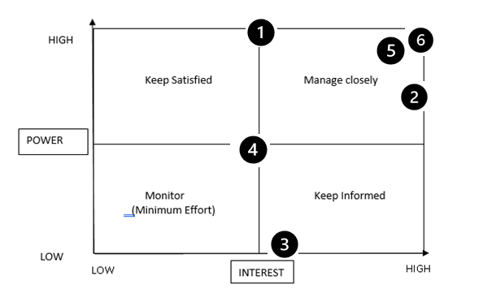
Stakeholder analysis
This is the stakeholder analysis for the UWTSD. The analysis of stakeholders is crucial to understand how well a stakeholder contributes to an organisation as well as having something to take from the organisation itself. How well the organisation contributes also determines their level of importance as a stakeholder towards the company, in this case the university of Wales trinity saint David.
There are many stakeholders at the University of Wales.
1.Students:
study for a degree (Higher Qualification). The most interesting to UWTSD as without students the university would have no reason to operate.
2.Staff:
Teach students in return for a suitable wage. Offering equipment and access to course information will help staff to instruct students as well as giving them a suitable wage in return for their efforts.
3.Alumni:
May want to return for higher education. Constantly sharing progress through social networking and other areas will invite graduated students to re-join and develop their education/skills further.
4.Student union:
Will want to make environment better for students whilst studying at the university. Regular meetings between classes and student groups will enable the student union to identify any concerns/complaints from other students and then report back to senior staff/management.
5.Directors:
Will want to make sure that all faculties are running smoothly, and the campus is a success whilst abiding by the laws. Regular updates and records of each department’s accomplishments will help the Board of directors to see what departments are meeting the criteria needed to continue operating the university and which need improvement. This will also help them to manage the budget set to them by the government further.
6.Government:
Interested in a successful place of education for the city overall. Will want to make sure the university is following laws and legislations in order to authorise it as a university and enable it to offer degrees. Meeting the board of directors will help the government to make an informed decision as to whether the university is up to standard with the curriculum and laws/legislations in order to keep recognising the university as a place that offers degrees under UK Law.

Strategic growth options for UWTSD:

VMOST:

This report will provide three strategic options for the university to use for its growth based on a VMOST tool (Bleistein, Cox, and Verner, 2005), used for analysis purposes. A table below provides an understanding of the current strategic policy and how improvements/adjustments can be made to its existing plan. Although VMOST provides an easily understandable analysis, it does not however, give guarantee that every member of the staff will perform at their best level and as a result the strategy might not give the best result that it is originally designed to.

Vision | To become a university for Wales, with a focus on the nation's well-being and legacy at the heart of what is done to achieve the maximum potential.
Mission | Transforming education, Transforming lives
Objectives | Providing educational programmes that foster entrepreneurial and development and employment, allowing students to have the best chance of finding work and contributing to their communities' development. A SMART view of the objectives.
Strategy | To achieve a successful target, there needs to be a successful strategy in place by having a strategic objective.  Ensuring all members are proactive in providing the best service to the students to gain maximum success.
Tactics | Identify and tackle the competition by providing a better alternative and rewarding the best performing staff can also achieve successful result.
Table 2

Ansoff Matrix:

According to (Hussain, et al,2013), using the Ansoff tool is crucial strategic approach that provides a framework for businesses, administrators, and retailers to establish techniques for future growth. Through using this method, UWTSD can adopt different types of methods to not only just improve their performance, but also improve their existing products and services. Since it is difficult to predict how best the strategies will work successfully, Ansoff Matrix can help in understanding some underlying dangers and prepare a backup plan.
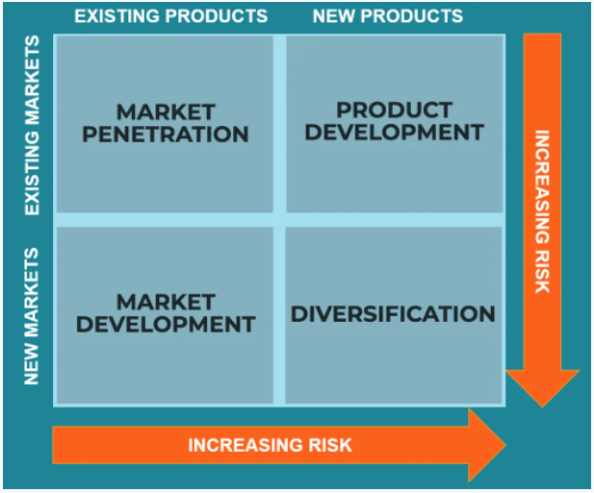
Figure 5 (Finlay, 2021)

Market Penetration:

Education relating to the skills for the workplace provided by the UWTSD. Introduce a friend scheme is also run by the university where the person can win £100 Amazon voucher.

Product Development:

UWTSD continues to introduce new systems and products to provide best learning and teaching experience for the students as well as staff members.

Market Development:

The university has already merged with London Campus and has opened a 2nd Campus in Birmingham. It is also continuing to expand with another Campus opening in May 2022, with potential to further expansion soon.

Diversification:

UWTSD introduced new objectives to decrease inequalities within the communities and to promote healthy and inclusive learning communities, (n.d.).

Three strategic growth options:

Option one: Product Development

Although UWTSD has introduced some new systems within the organisation, it is still far from reaching out to everyone who is involved within the education system. As this is the university for the mature students, it needs to introduce products and services to the students based on their individual needs. To bring their mission of Transforming education, transforming lives, they must transform the system to provide maximum level of success and thrive further. This will result in providing learners with not only just the education, but also the drive to achieve further success in future and improve their self-esteem and confidence.

Option two, More programs of study and staff training:

As the SWOT analysis above shows that there are other universities within the are that provide larger number of programs, UWTSD could lose out on potential students who might prefer to study at this Campus but decide to go elsewhere due to not having the program of their choice. Some members also need their skills improved as their behaviour is not of a professional standard as expected and as a result can disappoint some newcomers.

Option three, Diversification:

UWTSD Must create invalid stablished an effective plan in place. A regular review process that will evaluate on the impact and outcomes of the actions as well as wanted to the performance off effectiveness of this plan. This will help the university to achieve planned success and take any actions needed to progress further in equality and diversity. Since other universities within the region also follow diversification plans it is important for UWTSD to create something different and unique.
Engagement and communication barriers must also be decreased to improve the level of confidence within the learners and professional relationships amongst the staff, the students, and other communities Also must be improved. As a result, this will improve students’ confidence on the university, help improve their learning skills as well as participation in academic and non-academic activities. This as a result will improve their employment Chances and increase their confidence.
SAF Matrix | Strategic Options
SAF Matrix | Option one  Product Development | Option two  More programs of study and staff training | Option three  Diversification
Suitability | 9 | 9 | 8
Acceptability | 8 | 7 | 6
Feasibility | 6 | 5 | 5
Total | 23 | 21 | 19
Table 3
The SAF table from above shows how these grow strategies can help university to improve its services and products. Product development as option one produced a highest score, compared to the other two. It shows how the university must work on their product development/improvement to achieve bigger capital in return. Suitability of option one will help the university reach its goals as provide a guidance to monitor if the strategy is working effectively for the university or not.
Acceptability aspect is about measuring the return, risk and stakeholder reactions returns can be measured by using this option and it can help the university to review its policy to determine the progress as well as performance of all the stakeholders. Acceptability can also help the university to measure risks and sensitivity analysis to deem how appropriate the strategy is.
When something comes down to it, the feasibility section of the SAF methodology is what determines whether a strategy is successful. Because financial feasibility must be determined by forecasting and analysying cash flows, doing break-even analysis, and a variety of other financial tests, it is critical to determine whether the university has the resources, aptitude, and ability to really implement the strategy.
Other factors to consider when determining the feasibility of a strategy include how much labour, equipment, management power, and materials a company has, as well as if they have the organisational structure and markets required to make a strategy successful.

Competitors Reaction:

UWTSD Birmingham campus’s strategic planning has a strong potential for success and as a result can attract several competitors. A flexible 7-day classes attract a lot of students from across Birmingham as well as the surrounding cities. Other universities could possibly try and attempt this as well, however, if they are not consistent, they can end up ruining their reputation. As the originator of certain plans and strategies, UWTSD can use investment and resources to achieve more success by innovating and transforming further in difference to their opponents.

Conclusion:

This report consists of a brief identification of a small enterprise demonstrating an understanding of strategic management. Porter’s 5 Forces and Ansoff Matrix was used to piece this report. Porter’s 5 Forces held a great role in analysing the business’s current strategic agenda and allowing the organisations mission to be understood correctly. This alone has opened up many doors to analyse the operating process of the organisation that determines the capability and competitiveness in terms of its industrial profitability. Ansoff Matrix being something that provides each business with a structure to aid senior managers, executives etc. This has given the report the ability to identify which strategy the organisation should utilise, and which procedures would be best to develop their position in the market. The organisation’s internal and external environment has been assessed looking at every perspective identified as Strengths, Weaknesses, Opportunities and Threats (SWOT) and how the organisation can be praised for its current approach. Each stakeholder’s role and power of hierarchy was identified and strategically assessed giving ideas on how they can be managed and what can be improved to create a general overview of power and for the best interests of the organisation. A number of 3 growth options were decided for the organisation and how the specific chosen strategy can give the organisation the ability to uphold and secure its long-term goals. Competition is something that is found within every industry, since there is no surprise that the competition may find its way here, a number of points to deal with have been outlined towards the end of this report.

References:

- 2017. Harvard business review manager's handbook. Boston (Massachusetts): Harvard Business Review Press, pp.256, 257, 258, 259.
- Alegre, I./ Berbegal-Mirabent, J., Guerrero, A., & Mas-Machuca, M. (2018). The real mission of the mission statement: A systematic review of the literature. Journal of Management & Organization, 24(4), 456-473. Doi:10.1017/jmo.2017.82
- Assets.publishing.service.gov.uk. 2021. [online] Available at: https://assets.publishing.service.gov.uk/government/uploads/system/uploads/attachment_data/file/1031454/SCC_DRAFT_Strategy.pdf [Accessed 28 March 2022].
- Bing.com. n.d. Porter's Value Chain Model Template for education sector - Bing. [online] Available at: https://www.bing.com/images/search?view=detailV2&ccid=KhozzRKq&id=E9C1324F6C0F41F03F26024024F7B3F37AA49B01&thid=OIP.KhozzRKqXvm994pNPTR0xgHaEb&mediaurl=https%3a%2f%2fth.bing.com%2fth%2fid%2fR.2a1a33cd12aa5ef9bdf78a4d3d3474c6%3frik%3dAZukevOz9yRAAg%26riu%3dhttp%253a%252f%252fdbcvp67z11udb.cloudfront.net%252ftreks%252fshirly-ronen-harel_porters-value-chain1402810718910.PNG%26ehk%3dNOkpKt2GxBzlj2HpAtqdJtVrsHE0ehJENFr3cToO77s%253d%26risl%3d%26pid%3dImgRaw%26r%3d0&exph=671&expw=1121&q=Porter%27s+Value+Chain+Model+Template+for+udecation+sector&simid=607986972185807615&FORM=IRPRST&ck=ED0E1C50E2C4362561CFE1883459D73A&selectedIndex=9&ajaxhist=0&ajaxserp=0 [Accessed 25 March 2022].
- Bleistein, S.J., Cox, K. and Verner, J., 2005, March. Strategic alignment in requirements analysis for organizational IT: an integrated approach. In Proceedings of the 2005 ACM symposium on Applied computing (pp. 1300-1307).
- Corporate Finance Institute. n.d. PESTEL Analysis. [online] Available at: https://corporatefinanceinstitute.com/resources/knowledge/strategy/pestel-analysis/ [Accessed 25 March 2022].
- Finlay, E., 2021. Ansoff Matrix. [online] Corporate Finance Institute. Available at: https://corporatefinanceinstitute.com/resources/knowledge/strategy/ansoff-matrix/ [Accessed 8 April 2022].
- Kaplinsky, R., 2000. Globalisation and unequalisation: what can be learned from value chain analysis?. Journal of development studies, 37(2), pp.117-146.
- Kaplinsky, R., 2004. Spreading the gains from globalization: What can be learned from value-chain analysis? Problems of economic transition, 47(2), pp.74-115.
- Lynch, R., 2018. Strategic management. Pearson Education.
- SlideModel. n.d. Porters Five Forces PowerPoint Diagram - SlideModel. [online] Available at: https://slidemodel.com/templates/flat-porters-five-forces-powerpoint-template/porters-five-forces-powerpoint-diagram/ [Accessed 16 March 2022].
- Uwtsd.ac.uk. 2017. [online] Available at: https://www.uwtsd.ac.uk/media/uwtsd-website/content-assets/documents/strategies-policies/UWTSD-Strategic-Plan-2017-22_English_FINAL.pdf [Accessed 20 March 2022].
- Uwtsd.ac.uk. 2022. Birmingham Campus Staff | UWTSD. [online] Available at: https://www.uwtsd.ac.uk/birmingham/staff/ [Accessed 7 March 2022].
- Uwtsd.ac.uk. 2022. History and Timeline | University of Wales Trinity Saint David. [online] Available at: https://www.uwtsd.ac.uk/about/history/ [Accessed 20 February 2022].
- Uwtsd.ac.uk. 2022. Press Releases 2020 | University of Wales Trinity Saint David. [online] Available at: https://www.uwtsd.ac.uk/news/press-releases/press-2020/uwtsd-welcomes-international-students-to-wales.html#:~:text=Having%20started%20its%20Study%20Abroad,a%20full%2Dtime%20undergraduate%20degree. [Accessed 20 March 2022].
- Uwtsd.ac.uk. 2022. Press Releases 2022 | University of Wales Trinity Saint David. [online] Available at: https://www.uwtsd.ac.uk/news/press-releases/press-2022/uwtsd-celebrates-its-bicentenary.html [Accessed 20 February 2022].
- Uwtsd.ac.uk. 2022. Press Releases 2022 | University of Wales Trinity Saint David. [online] Available at: https://www.uwtsd.ac.uk/news/press-releases/press-2022/uwtsd-celebrates-its-bicentenary.html [Accessed 20 March 2022].
- Uwtsd.ac.uk. n.d. [online] Available at: https://www.uwtsd.ac.uk/media/uwtsd-website/content-assets/documents/strategies-policies/Strategic-Equality-Plan-2020-2024.pdf [Accessed 10 April 2022].
- Uwtsd.ac.uk. n.d. Mission and Vision | UWTSD. [online] Available at: https://www.uwtsd.ac.uk/mission/#:~:text=is%20dedicated%20to%20realising%20the,all%20aspects%20of%20sustainable%20development. [Accessed 27 March 2022].
- Uwtsd.ac.uk. n.d. Skills for the Workplace (CertHE) | UWTSD. [online] Available at: https://www.uwtsd.ac.uk/birmingham/cert-he-skills-for-the-workplace/ [Accessed 21 March 2022].
- Weicht, R. and Jónsdóttir, S.R., 2021. Education for social change: The case of teacher education in wales. Sustainability, 13(15), p.8574.

