
Project planning
Amy Davies 2117453

January 10, 2022

Contents
1.0 Project Information 2
2.0 Project Description 2
3.0 Time 2
3.1 Gantt Chart 6
4.0 Resource 7
5.0 Cost 8
6.0 Reference 9

Pre-Start Site Report

1.0 Project Information
 | Project Title - | Fabian Way
 | Project Address - | Fabian Way Swansea SA13EF
 | Principle Contractor - | ALD Construction
 | Principle Contractors Address - | 47 Album Way, Swansea Industrial Estate SA23YH
 | Reference - | NB08

2.0 Project Description
This Project Consist of 3no FOGs to be constructed in the SA1 area of Swansea. The Units will be built using a timber frame structure, concrete tile roof and a rendered finish.

3.0 Time
When discussing and organising time periods in construction it is important not to take too long as this can have a negative effect on a contractor’s reputation as well as increasing costs through prelims, however it is important not to allow too little an amount of time and risk not hitting completion dates. The completion time will normally be agreed and specified within the contracts. In this case, failure to complete by the obligated completion date would be a material breach of contract and may entitle the other party to damages, Coroner-i (2019). When estimating time, the steps below will help:
- What is Required? – Highlight what need to be done within a project. Make sure to allocate enough time for meetings, communication, any reports, all project task and any other critical task that will be required to ensure a successful project
- Put the actives in order – the next step is to put the actives in order that they will need to be completed in. It isn’t vital at this stage to add time scales to the task however it would be proactive to identify any important milestones.
- Identify who is required in the project – This can be discussed with team members and colleagues. It is important to discuss these points with people who will be carrying out the works. This will put ownership on them which will make them work harder in order to meet their own deadlines.
- Estimate your time – When estimating time it is import to estimate the time for each task not the entire project. List any constraints, exclusions or assumptions this will help highlight any risks and or opportunities. It is best to assume your resources will only be 80% productive. This will allow for sickness, mechanical failure and any other unforeseen events that will impact your time. Finally, be sure to remember people tend to be optimistic and may not be realistic so this should be considered, Mind Tools (2021).

The Site Set Up will be commencing on the 08/02/2022 with Practical Completion set for 22/04/2022 (10wks 3days).
Below are snapshots of the stages with commencement and completions set out.
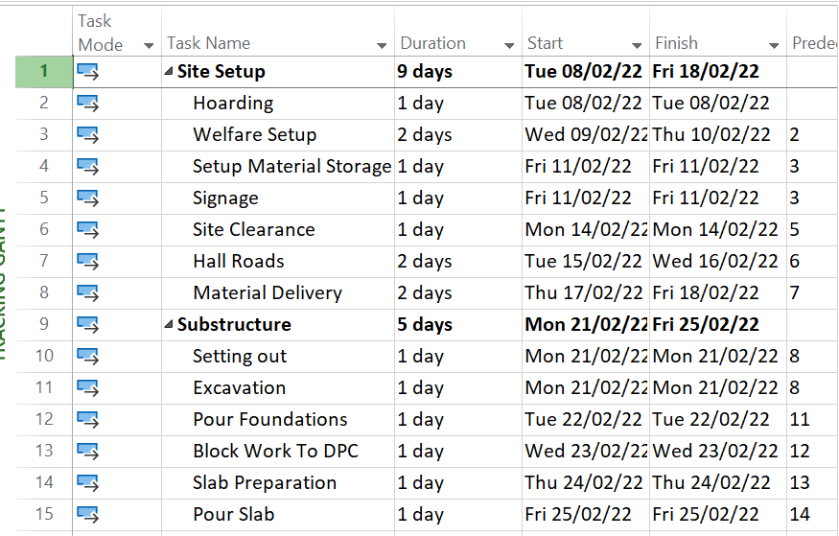
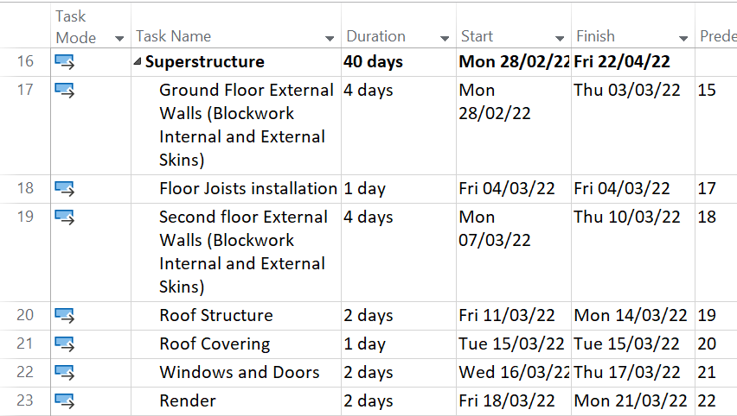

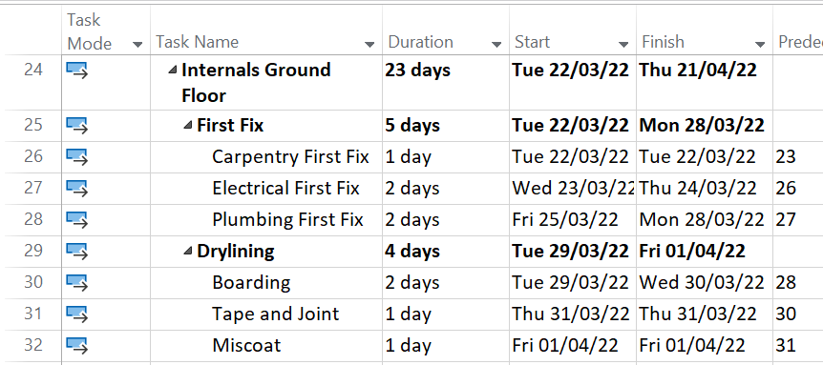
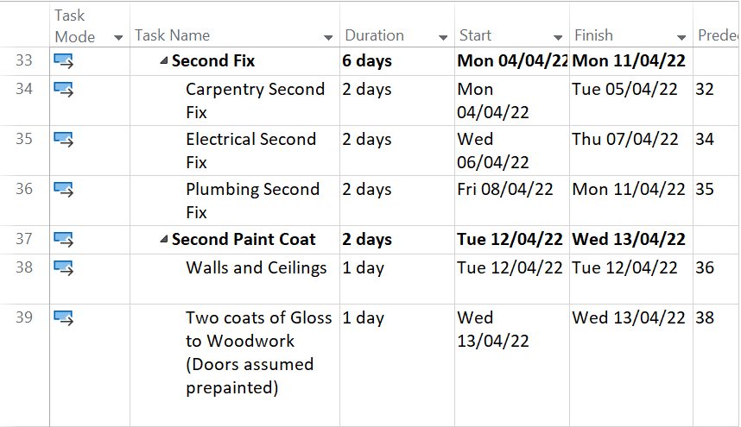
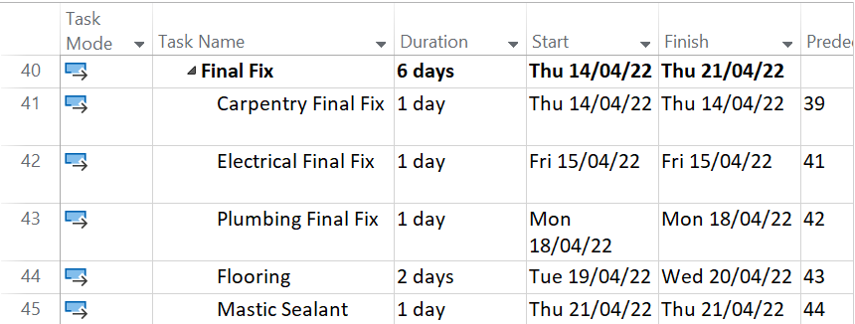
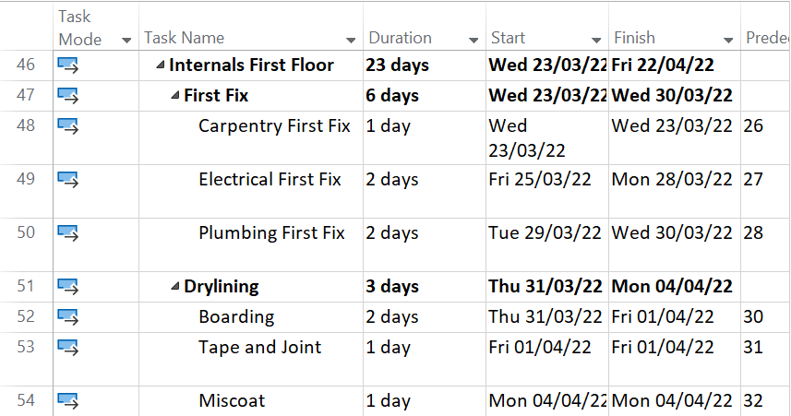
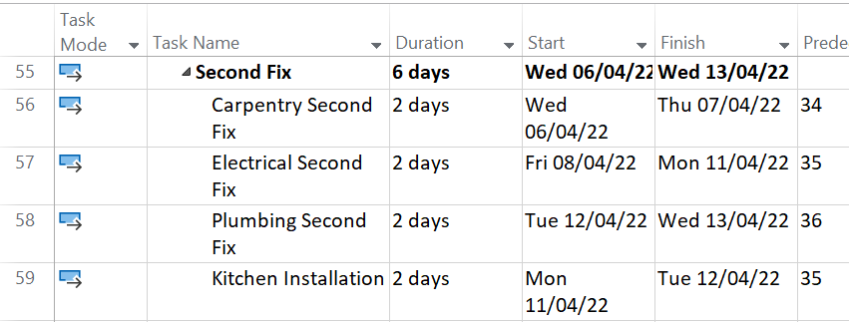
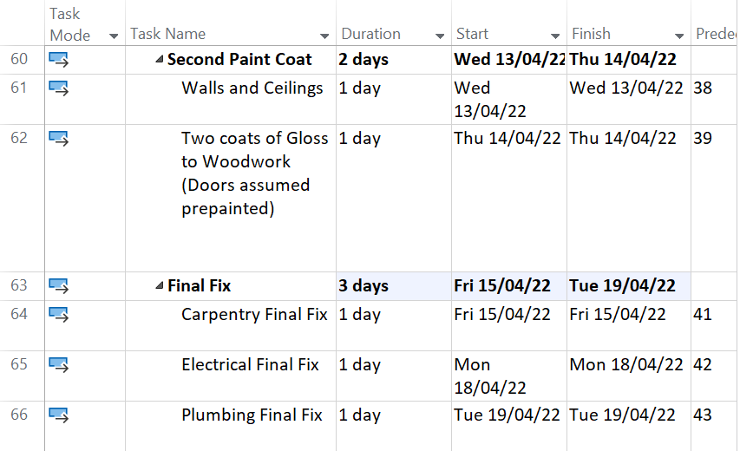
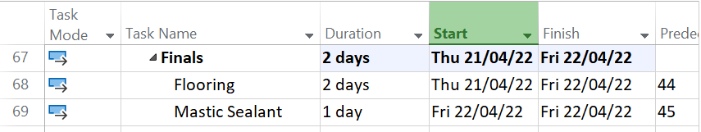

3.1 Gantt Chart
Below Shows a clear link between each phase of the construction, identifying how each task relates to each other. The Gantt Chart also shows the critical path.
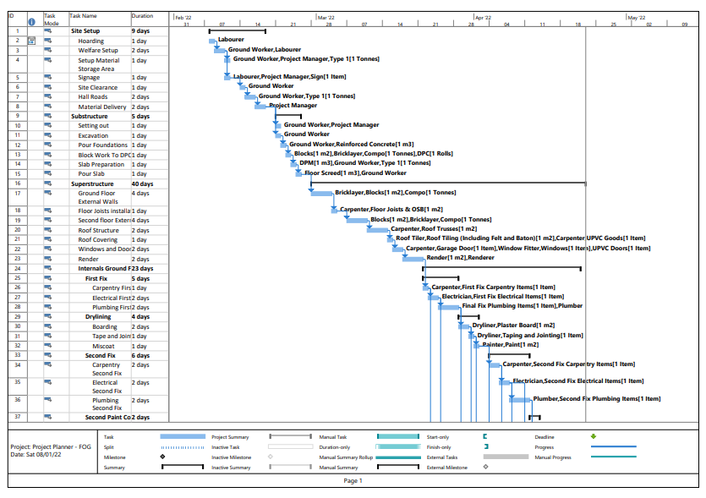
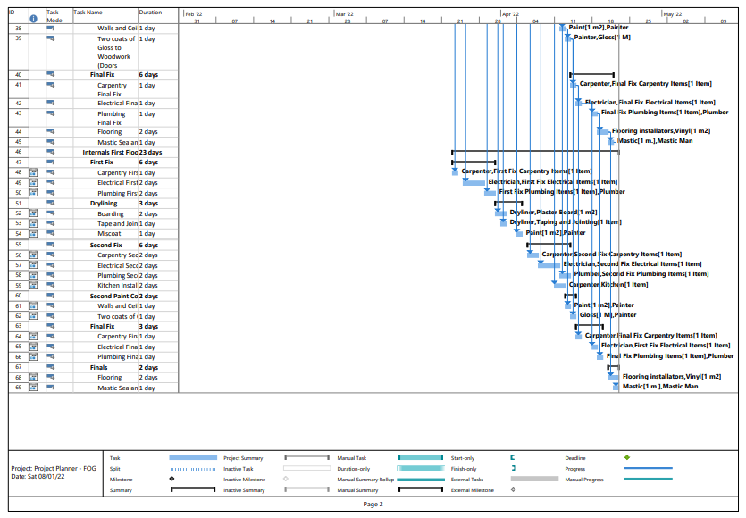

4.0 Resource
A challenge that construction firms can face is undertaking complex structures on time within budget and maintaining a reasonable profit margin. To aid in making a project successful resource management is key. This is the process of planning and allocating the resources to undertake the projects requirements. It will help keep the project on programme by meeting the projects resource demands. It will also maximise the resources utilisations between projects. Inadequate resource management can cause projects to drag on and not meet milestones or deadlines. This can cause the project to be unprofitable. Ideally you want timely and adequate resources as well as maximising utilisation Designing Buildings Wiki (2021)
The tables below show the resources that will be required to carry out the project within the given time.
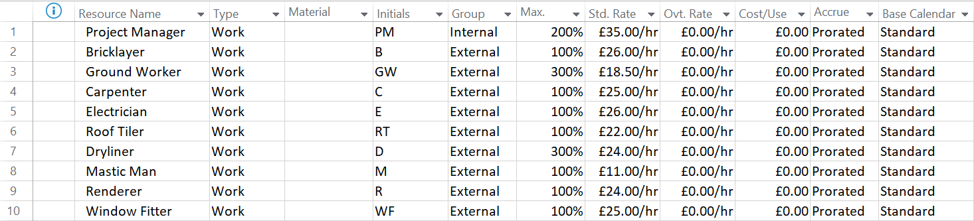
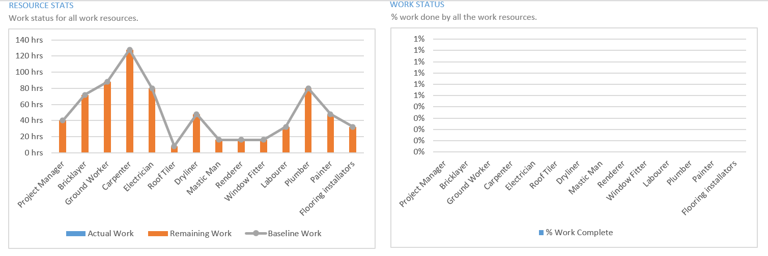

5.0 Cost
Cost Control in construction allows project managers to minimise cost overruns by issuing outlined estimates as well as forecasting cost for labour, material and overheads. The reason for cost control plans is to aid the delivery of a project on time within budget and within scope. Cost reports will normally be based on cash flows, proposed final costs and current costs. Incorrect estimates can have a dire effect on a project success possibly resulting in no profit margins. Construction management software can help with communicating with all individuals involved in the project, on any changes to the scope. It also helps with allocating cost to individual tasks allowing easier tracking Micheala Wong (2019). Please see Cash Flow Resource Cost and Task Cost

Cash Flow
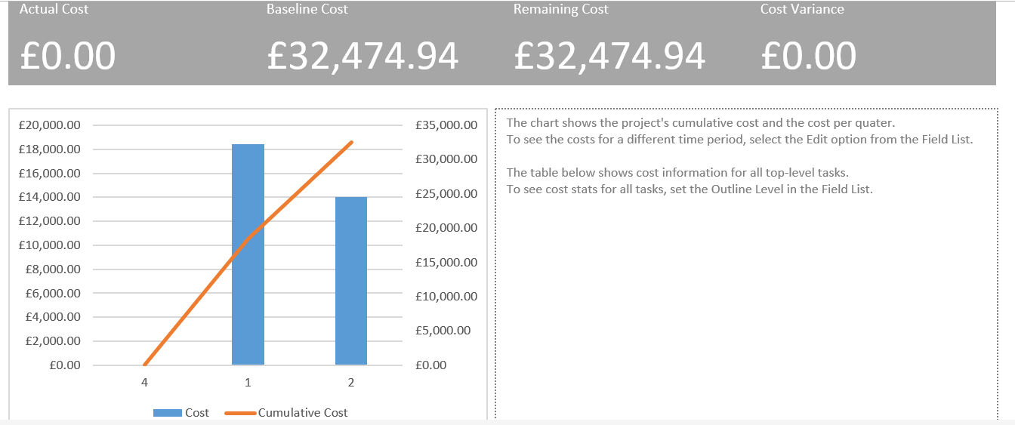

Resource Cost
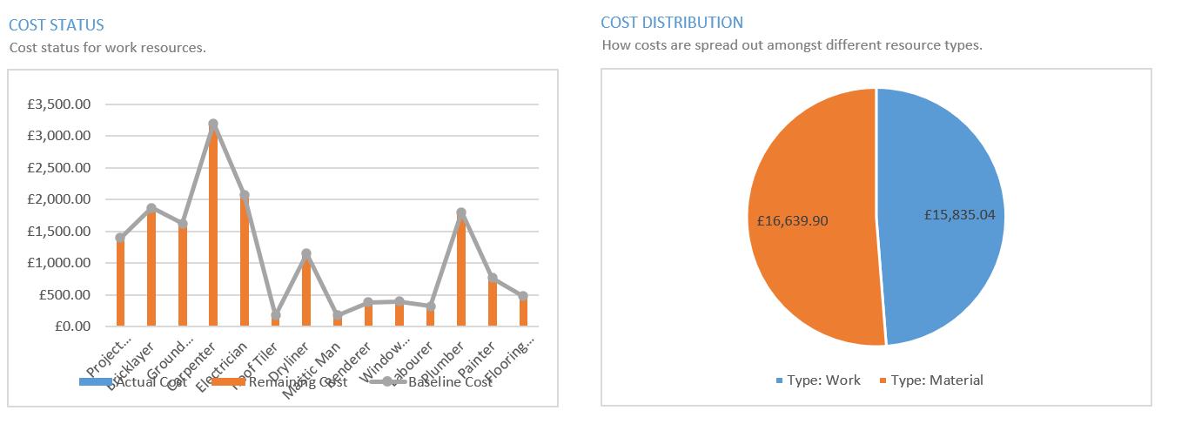

Task Cost
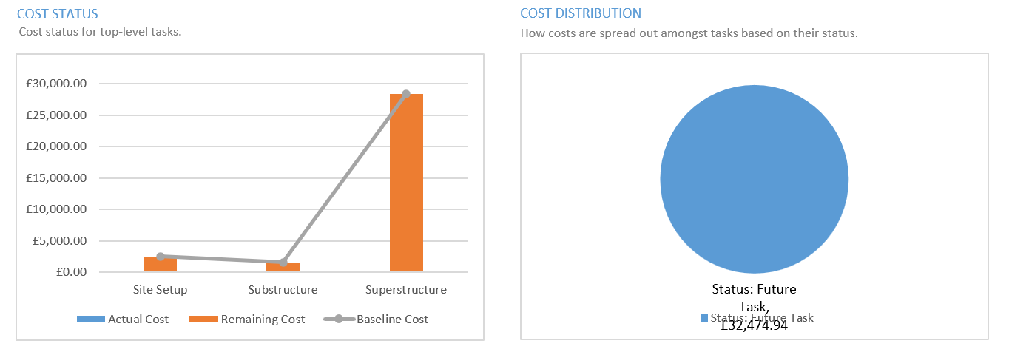

6.0 Reference
Coroner-i (2019) The importance of time in construction contracts [online] @ The importance of time in construction contracts | Croner-i (croneri.co.uk) Accessed 03/01/2022
Designing Buildings Wiki (2021) Resource Management in Construction [online] @ Resource management in construction - Designing Buildings Accessed 31/12/2021
Micheala Wong (2019) 5 Tips for Construction Cost Control [online] @ 5 Tips for Construction Cost Control (esub.com) Accessed 02/01/2022
Mind Tools (2021) Estimating Time to Complete [online] @ Estimating Time to Complete - Project Management Skills From Mind Tools Accessed 31/12/2021

