Llanllyr Field Journal 2024
13 April I began reading The 5 Minute Archaeologist: In the Southern Levant. It was intriguing to me as the first chapter mentioned how archaeology is classified as a subfield of anthropology in North America, but as its own field in humanities in most other parts of the world. The reading prompted several questions in my mind. Does archaeology and excavation become increasingly slower as we move through time, because new ways of analyzing and receiving data are thought of and introduced? Does it get balanced out somewhat because of higher/newer technologies that work faster, or does it lead to being increasingly slower and meticulous? I was then thinking how it is a shame excavation destroys the record, but sometimes it’s the only way to learn and know, so when do you decide to wait and leave it for later vs when to move forward and excavate now?
My questions were addressed another day when reading chapter 8 addressing why Archaeologists don’t excavate the entire site. A few points that were mentioned were the amount of time and cost it would take, that techniques of excavation and analysis will improve through time, new questions and problems will arise, and the time needed to analyze and publish the finds exceeds excavation time, and yet is one of the most important moral obligations of the dig (Shafer-Elliott, 2016). I had never really thought about sites not being entirely excavated, but it makes sense and is reassuring that there is untouched evidence that can be returned to at a later date and also allows for more time to excavate and analyze properly to make it worthwhile and beneficial. Unless of course it’s rescue/commercial archaeology, taking place rather quickly and completely in the areas the land is going to be disturbed and built upon. It’s purpose is to collect and preserve as much knowledge from the site before it gets destroyed or inaccessible during the construction of a new building (DaSilva, 2019).
15 April, the first day on site, I was very grateful I had gotten my wellies to wear into the field, because it was very wet and boggy in parts of the fields and on the path to the site. The site is on a farm used for livestock. The fields we were in had marsh grass in the lower parts. We learned how to identify past trenches and excavations which were found on the mounds. Past trenches were positioned near the bottoms of the mounds near to the marsh grass. The edge of an old glacial lake was pointed out, to the south of the trenches.
In our groups we did some field walking to observe features of the landscape and decided where we might place a new trench. Field walking is a simple and non-invasive method of observing possible archaeological features in the land like mounds, banks, and ditches (Catling, 2009). I discovered 50 meters is about 63 of my normal strides. Two of the trenches were chosen and the other two groups were stationed on either side of trench 10 from the previous year. My group (Gwen, Isaac, Apollo, Caitlyn, and I) was stationed in trench 10 North.
We gathered around where trench 13 was about to be and were shown how to use Pythagoras theorem to set out the trench and keep right angled corners, so it’s easier to plot and record and find again post excavation. We used a ranging pole at two corners to measure from.

Figure 1
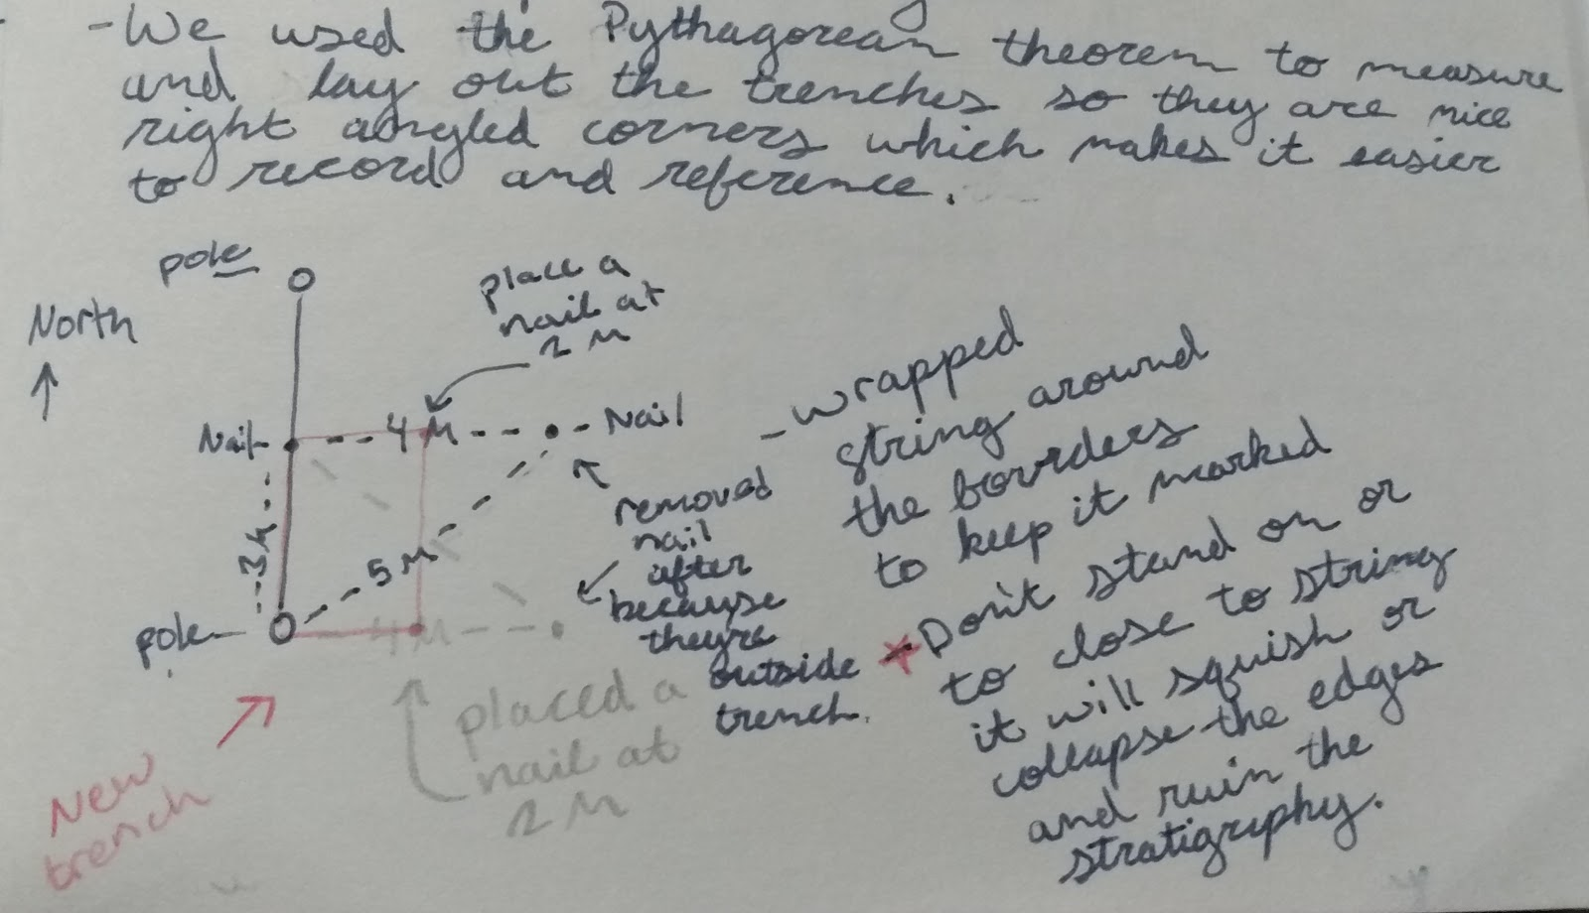

Figure 2
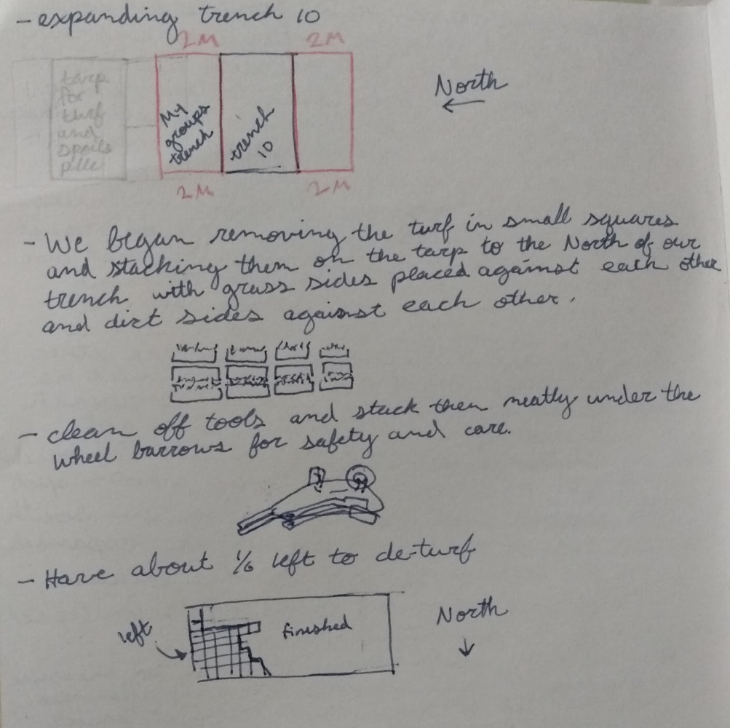

We laid out our trench on the north side of trench 10 and another group laid theirs out on the south side. Last year there were several finds in trench 10, there were also charcoal remains found. Either side of the trench was expanded this year to see if the scatter pattern extended and continued either way.
After setting out our trench, we began de-turfing. Which took all the rest of the day and partly into the following day. De-turfing is the process of removing the topsoil and vegetation to get access to the layers that may contain archaeological finds (Catling, 2009). We also used mattocks to finish removing root clumps and flatten out the trench before we began to trowel, we only passed over the trench with the mattocks once so we weren’t going too deep and digging up too much that we might be digging up the flint as well. We stacked the blocks of turf in a wall in the tarp to the north of our trench to put our spoil tip on and keep the deposits that we have removed out of the way, from where we are working in the trench to keep the trench and the site clean for safety and so it doesn’t get in the way of identifying change in the color of the layers (Catling, 2009).
Keeping your spoil continuously cleaned out of the area you are troweling allows you to notice the small artefacts that would otherwise be lost in with the spoil if you are troweling where the spoil from your last pass is. I noticed this quickly in our trench with the first flint flake I found. Luckily, I was looking closely enough when I was cleaning up my loose that it noticed it as I scraped it into the hand shovel with my trowel. I didn’t know the exact location where the flint turned up but I knew within the width of the hand shovel and the small space I had cleaned and so we were able to estimate the location. After that I was more cautious and observant about not only watching while I scooped up my loose, but also being aware to keep my loose back from where I was trowelling so my trowel didn’t scrape anything up while going under already loose spoil, even if it wasn’t much loose on the surface.
We also went through the process of sieving our waste material as we remove it from the trench before we dump it into the spoil tip. A sieve is used to sift the loose earth through a mesh or grated bottom to sort the sediment and material remains as the earth flows through the holes more slowly and larger pieces are caught from passing through. More of the spoils get sifted on a prehistoric excavation than would on an excavation of later periods because the finds are going to be smaller and the sites more limited (Shafer-Elliott, 2016). It’s good to note that there are different methods of archaeology that work better for some periods than others and so methods will differ depending on the excavation and its goals.
Gwen found the first flint on the 16 May in the Northwest corner of the trench while she was troweling (about 2:20 pm). A nail was placed where it was found to mark the context. Gwen and I walked back to the tent with Sam with the flake. Sam explained that it could be from the Mesolithic or the Neolithic or the Bronze Age, but every find that has been diagnostic has been dated to the Neolithic or the Mesolithic. Many things have been nondiagnostic so there still could be bronze age stuff, but thus far we have no evidence, so it’s more likely one of the others (Samantha Brummage, personal communication, 16/4/24). The scatter did in fact continue northeast into T10 (N) as we began finding more flint flakes.

Figure 3
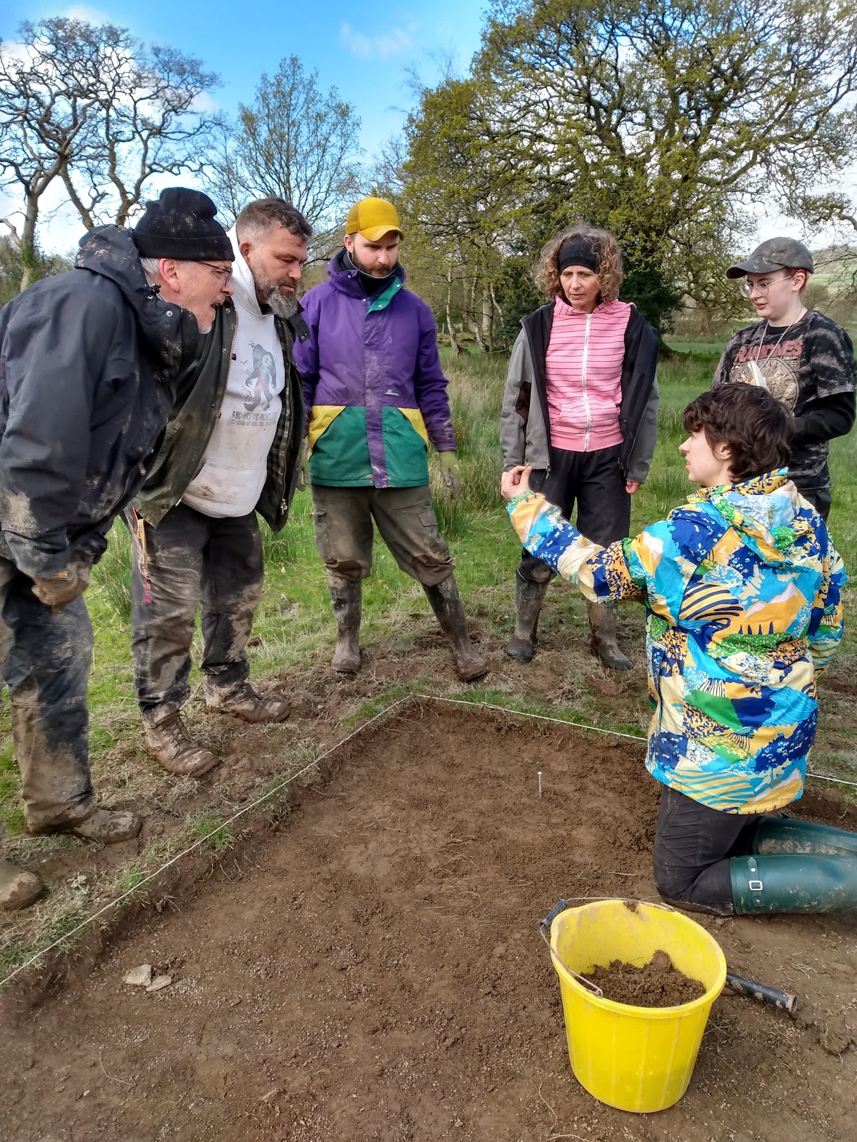
The majority of the flakes we began finding were a caramel brown colour, but we soon also began finding white flakes as well, after I expressed an unsurety that I would be able to identify any other colour of flint. Even some very tiny white flakes were found as small as 2x3mm. The different coloured flint flakes indicate that there were at least two different nodules of flint being knapped. The question arises, were they knapped at the same time, by the same group or are these different coloured flakes from two different sets of time? If they were knapped at different times, were they knapped by the same group of people who returned to the same location or were they knapped by a separate group of people in the same place? I think because they are so close to each other and follow the same projected scatter pattern that they were likely knapped at the same time, perhaps by two different people in the group. If they were sitting with their backs to the fire, presumably in T10 (S) where much of the charcoal was found, then the direction of the wind could have affected the place they sat and the direction they faced as they knapped, but it could also not have played that much of an impact if it typically blows the same way. There were bits of charcoal or charred bedrock found in the trench and even more so in T10 (S). If not knapped at the same time, it still could be likely that the same place and projection was used if the fire pit was seen and used by another group or reused by the same group. I would say it is also very plausible that they were knapped by the same people at different times given that humans tend to be creatures of habit and if they are also following the animals they hunted they would have returned to the same places in correlation with the seasons and migrations.
Fortunately, almost all the small finds were found in situ, which means they will provide us with more insight because we know the context and coordinates where they were found. Each time we found a small find, we marked its location with a nail (and once we had them, with tags), measured from the corner of the trench designated origin so that measurements were consistent, and then measured with the dumpy level to get the distance above mean sea level or the above ordnance datum (AOD). There is no base measurement nearby, so a temporary one was used. Each time the level is repositioned, so each day after it’s been set up, a backsight reading must be taken. The backsight reading is added to the temporary benchmark value to get the instrument height, then when we place the staff on the location of a find, we determine a foresight value, that value is subtracted from the instrument height to get the real or reduced level (Connolly, 2005). That is our z coordinate for the find. These coordinates allow us to plot the finds and see where they were found in relation to each other providing a scatter pattern that can then be analyzed and interpreted.

Figure 4
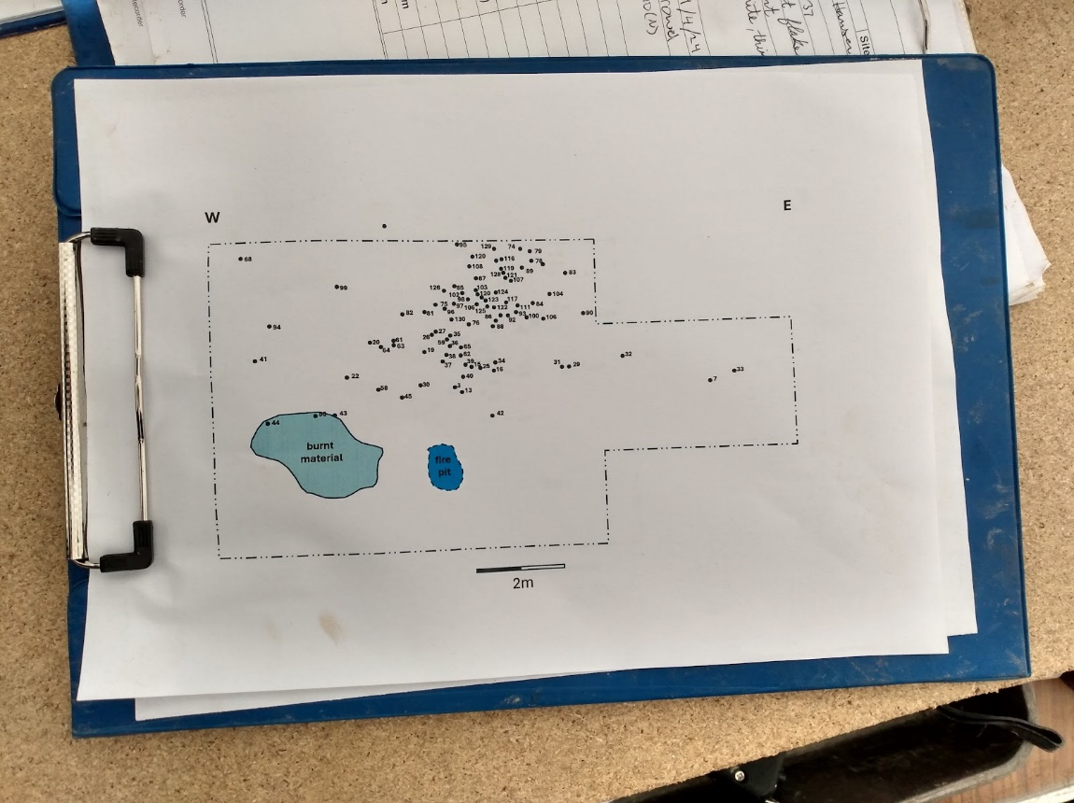

Monday 29 April was a wet and windy day. Even though it wasn’t the best weather we still found 7 flint flakes in our T10 (N) before lunch, the closer to lunch though the stickier the mud became and the harder it was to sieve and to trowel. I was extra attentive as I troweled and took off thinner layers with each pass of my trowel, wiping any mud that stuck to it off, so I would be sure to see any flints. Smaller pieces could’ve been hidden by the clay mud as it was clinging to itself if I was careless. At lunch more rain came, and it was too wet to work anymore. It was too slippery to be safe and our boots would pick up the mud that we might also be picking up the flints on the bottom of our boots (Martin Bates, personal communication, 29/4/24). Keeping the site clean is important for the surgical process of excavation, recording accurate findings, and not contaminating or destroying the information before it can be recorded (Carver, 2009). Even just walking along the side of the trench was slippery and one wrong move could squish the edge of the trench and ruin the stratigraphy.
2 May paperwork was checked and finished. Trench record sheets were filled out. Two people from each trench stayed after tea break to complete the paperwork while the rest went back to finish back-filling trench 14. All the backfilling was completed by lunch time. Tools were cleaned and everything was taken off site except the tent. We finished up just in time for a downpour of rain. Though the excavation is over for now, all the data, artefacts, and samples still need to be processed and there is much to do in the labs.

Work Cited
Carver, M. (2009). Archaeological investigation (1st ed.). Routledge.
Catling, C. (2009). Archaeology step -by - step a practical guide to uncovering the past. Anness Publishing.
Connolly, D. (2005, July). Survey laying out trenches and levelling. http://www.bajr.org/BAJRGuides/10. Basic Survey - Setting Out and Levelling/BasicSurvey.pdf
DaSilva, R. T. (2019, December 13). Rescue/ commercial archaeology. digitiwithraven. https://www.digitwithraven.com/single-post/commercial-archaeology#:~:text=Because%20these%20excavations%20take%20place,history%2C%20they%20personal%20cultural%20heritage.
Shafer-Elliott, C. (2016). The five-minute archaeologist in the Southern Levant. Equinox.

