AHHI5016 – Introduction to American History
WEEK 7
The New Urban Americans: From the White City to ‘the Shame of the Nation’
Perspectives on New York City

Charles Dickens, ‘New York’ in American Notes (1842)
The beautiful metropolis of America is by no means so clean a city as Boston, but many of its streets have the same characteristics; except that the houses are not quite so fresh-coloured, the sign-boards are not quite so gaudy, the gilded letters not quite so golden, the bricks not quite so red, the stone not quite so white, the blinds and area railings not quite so green, the knobs and plates upon the street doors not quite so bright and twinkling. There are many by-streets, almost as neutral in clean colours, and positive in dirty ones, as by-streets in London; and there is one quarter, commonly called the Five Points, which, in respect of filth and wretchedness, may be safely backed against Seven Dials, or any other part of famed St. Giles’s.
The great promenade and thoroughfare, as most people know, is Broadway; a wide and bustling street, which, from the Battery Gardens to its opposite termination in a country road, may be four miles long. Shall we sit down in an upper floor of the Carlton House Hotel (situated in the best part of this main artery of New York), and when we are tired of looking down upon the life below, sally forth arm-in-arm, and mingle with the stream?
Warm weather! The sun strikes upon our heads at this open window, as though its rays were concentrated through a burning-glass; but the day is in its zenith, and the season an unusual one. Was there ever such a sunny street as this Broadway! The pavement stones are polished with the tread of feet until they shine again; the red bricks of the houses might be yet in the dry, hot kilns; and the roofs of those omnibuses look as though, if water were poured on them, they would hiss and smoke, and smell like half-quenched fires. No stint of omnibuses here! Half-a-dozen have gone by within as many minutes. Plenty of hackney cabs and coaches too; gigs, phaetons, large-wheeled tilburies, and private carriages—rather of a clumsy make, and not very different from the public vehicles, but built for the heavy roads beyond the city pavement. Negro coachmen and white; in straw hats, black hats, white hats, glazed caps, fur caps; in coats of drab, black, brown, green, blue, nankeen, striped jean and linen; and there, in that one instance (look while it passes, or it will be too late), in suits of livery. Some southern republican that, who puts his blacks in uniform, and swells with Sultan pomp and power. Yonder, where that phaeton with the well-clipped pair of grays has stopped—standing at their heads now—is a Yorkshire groom, who has not been very long in these parts, and looks sorrowfully round for a companion pair of top-boots, which he may traverse the city half a year without meeting. Heaven save the ladies, how they dress! We have seen more colours in these ten minutes, than we should have seen elsewhere, in as many days. What various parasols! what rainbow silks and satins! what pinking of thin stockings, and pinching of thin shoes, and fluttering of ribbons and silk tassels, and display of rich cloaks with gaudy hoods and linings! The young gentlemen are fond, you see, of turning down their shirt-collars and cultivating their whiskers, especially under the chin; but they cannot approach the ladies in their dress or bearing, being, to say the truth, humanity of quite another sort. Byrons of the desk and counter, pass on, and let us see what kind of men those are behind ye: those two labourers in holiday clothes, of whom one carries in his hand a crumpled scrap of paper from which he tries to spell out a hard name, while the other looks about for it on all the doors and windows.
Irishmen both! You might know them, if they were masked, by their long-tailed blue coats and bright buttons, and their drab trousers, which they wear like men well used to working dresses, who are easy in no others. It would be hard to keep your model republics going, without the countrymen and countrywomen of those two labourers. For who else would dig, and delve, and drudge, and do domestic work, and make canals and roads, and execute great lines of Internal Improvement! Irishmen both, and sorely puzzled too, to find out what they seek. Let us go down, and help them, for the love of home, and that spirit of liberty which admits of honest service to honest men, and honest work for honest bread, no matter what it be.
… This narrow thoroughfare, baking and blistering in the sun, is Wall Street: the Stock Exchange and Lombard Street of New York. Many a rapid fortune has been made in this street, and many a no less rapid ruin. Some of these very merchants whom you see hanging about here now, have locked up money in their strong-boxes, like the man in the Arabian Nights, and opening them again, have found but withered leaves. Below, here by the water-side, where the bowsprits of ships stretch across the footway, and almost thrust themselves into the windows, lie the noble American vessels which have made their Packet Service the finest in the world. They have brought hither the foreigners who abound in all the streets: not, perhaps, that there are more here, than in other commercial cities; but elsewhere, they have particular haunts, and you must find them out; here, they pervade the town.
… Let us go on again; and passing this wilderness of an hotel with stores about its base, like some Continental theatre, or the London Opera House shorn of its colonnade, plunge into the Five Points. But it is needful, first, that we take as our escort these two heads of the police, whom you would know for sharp and well-trained officers if you met them in the Great Desert. So true it is, that certain pursuits, wherever carried on, will stamp men with the same character. These two might have been begotten, born, and bred, in Bow Street.
We have seen no beggars in the streets by night or day; but of other kinds of strollers, plenty. Poverty, wretchedness, and vice, are rife enough where we are going now.
This is the place: these narrow ways, diverging to the right and left, and reeking everywhere with dirt and filth. Such lives as are led here, bear the same fruits here as elsewhere. The coarse and bloated faces at the doors, have counterparts at home, and all the wide world over. Debauchery has made the very houses prematurely old. See how the rotten beams are tumbling down, and how the patched and broken windows seem to scowl dimly, like eyes that have been hurt in drunken frays. Many of those pigs live here. Do they ever wonder why their masters walk upright in lieu of going on all-fours? and why they talk instead of grunting?
So far, nearly every house is a low tavern; and on the bar-room walls, are coloured prints of Washington, and Queen Victoria of England, and the American Eagle. Among the pigeon-holes that hold the bottles, are pieces of plate-glass and coloured paper, for there is, in some sort, a taste for decoration, even here. And as seamen frequent these haunts, there are maritime pictures by the dozen: of partings between sailors and their lady-loves, portraits of William, of the ballad, and his Black-Eyed Susan; of Will Watch, the Bold Smuggler; of Paul Jones the Pirate, and the like: on which the painted eyes of Queen Victoria, and of Washington to boot, rest in as strange companionship, as on most of the scenes that are enacted in their wondering presence.
What place is this, to which the squalid street conducts us? A kind of square of leprous houses, some of which are attainable only by crazy wooden stairs without. What lies beyond this tottering flight of steps, that creak beneath our tread?—a miserable room, lighted by one dim candle, and destitute of all comfort, save that which may be hidden in a wretched bed. Beside it, sits a man: his elbows on his knees: his forehead hidden in his hands. ‘What ails that man?’ asks the foremost officer. ‘Fever,’ he sullenly replies, without looking up. Conceive the fancies of a feverish brain, in such a place as this!
… Here too are lanes and alleys, paved with mud knee-deep, underground chambers, where they dance and game; the walls bedecked with rough designs of ships, and forts, and flags, and American eagles out of number: ruined houses, open to the street, whence, through wide gaps in the walls, other ruins loom upon the eye, as though the world of vice and misery had nothing else to show: hideous tenements which take their name from robbery and murder: all that is loathsome, drooping, and decayed is here.

Our leader has his hand upon the latch of ‘Almack’s,’ and calls to us from the bottom of the steps; for the assembly-room of the Five Point fashionables is approached by a descent. Shall we go in? It is but a moment.
Heyday! the landlady of Almack’s thrives! A buxom fat mulatto woman, with sparkling eyes, whose head is daintily ornamented with a handkerchief of many colours. Nor is the landlord much behind her in his finery, being attired in a smart blue jacket, like a ship’s steward, with a thick gold ring upon his little finger, and round his neck a gleaming golden watch-guard. How glad he is to see us! What will we please to call for? A dance? It shall be done directly, sir: ‘a regular break-down.’
The corpulent black fiddler, and his friend who plays the tambourine, stamp upon the boarding of the small raised orchestra in which they sit, and play a lively measure. Five or six couple come upon the floor, marshalled by a lively young negro, who is the wit of the assembly, and the greatest dancer known. He never leaves off making queer faces, and is the delight of all the rest, who grin from ear to ear incessantly. Among the dancers are two young mulatto girls, with large, black, drooping eyes, and head-gear after the fashion of the hostess, who are as shy, or feign to be, as though they never danced before, and so look down before the visitors, that their partners can see nothing but the long fringed lashes.
But the dance commences. Every gentleman sets as long as he likes to the opposite lady, and the opposite lady to him, and all are so long about it that the sport begins to languish, when suddenly the lively hero dashes in to the rescue. Instantly the fiddler grins, and goes at it tooth and nail; there is new energy in the tambourine; new laughter in the dancers; new smiles in the landlady; new confidence in the landlord; new brightness in the very candles.
Single shuffle, double shuffle, cut and cross-cut; snapping his fingers, rolling his eyes, turning in his knees, presenting the backs of his legs in front, spinning about on his toes and heels like nothing but the man’s fingers on the tambourine; dancing with two left legs, two right legs, two wooden legs, two wire legs, two spring legs—all sorts of legs and no legs—what is this to him? And in what walk of life, or dance of life, does man ever get such stimulating applause as thunders about him, when, having danced his partner off her feet, and himself too, he finishes by leaping gloriously on the bar-counter, and calling for something to drink, with the chuckle of a million of counterfeit Jim Crows, in one inimitable sound!
The air, even in these distempered parts, is fresh after the stifling atmosphere of the houses; and now, as we emerge into a broader street, it blows upon us with a purer breath, and the stars look bright again. Here are The Tombs once more. The city watch-house is a part of the building. It follows naturally on the sights we have just left. Let us see that, and then to bed.
What! do you thrust your common offenders against the police discipline of the town, into such holes as these? Do men and women, against whom no crime is proved, lie here all night in perfect darkness, surrounded by the noisome vapours which encircle that flagging lamp you light us with, and breathing this filthy and offensive stench! Why, such indecent and disgusting dungeons as these cells, would bring disgrace upon the most despotic empire in the world! Look at them, man—you, who see them every night, and keep the keys. Do you see what they are? Do you know how drains are made below the streets, and wherein these human sewers differ, except in being always stagnant?

George Catlin, Five Points (1827)
For information on Catlin, consult The Smithsonian American Art Collection profile: http://americanart.si.edu/collections/search/artist/?id=782
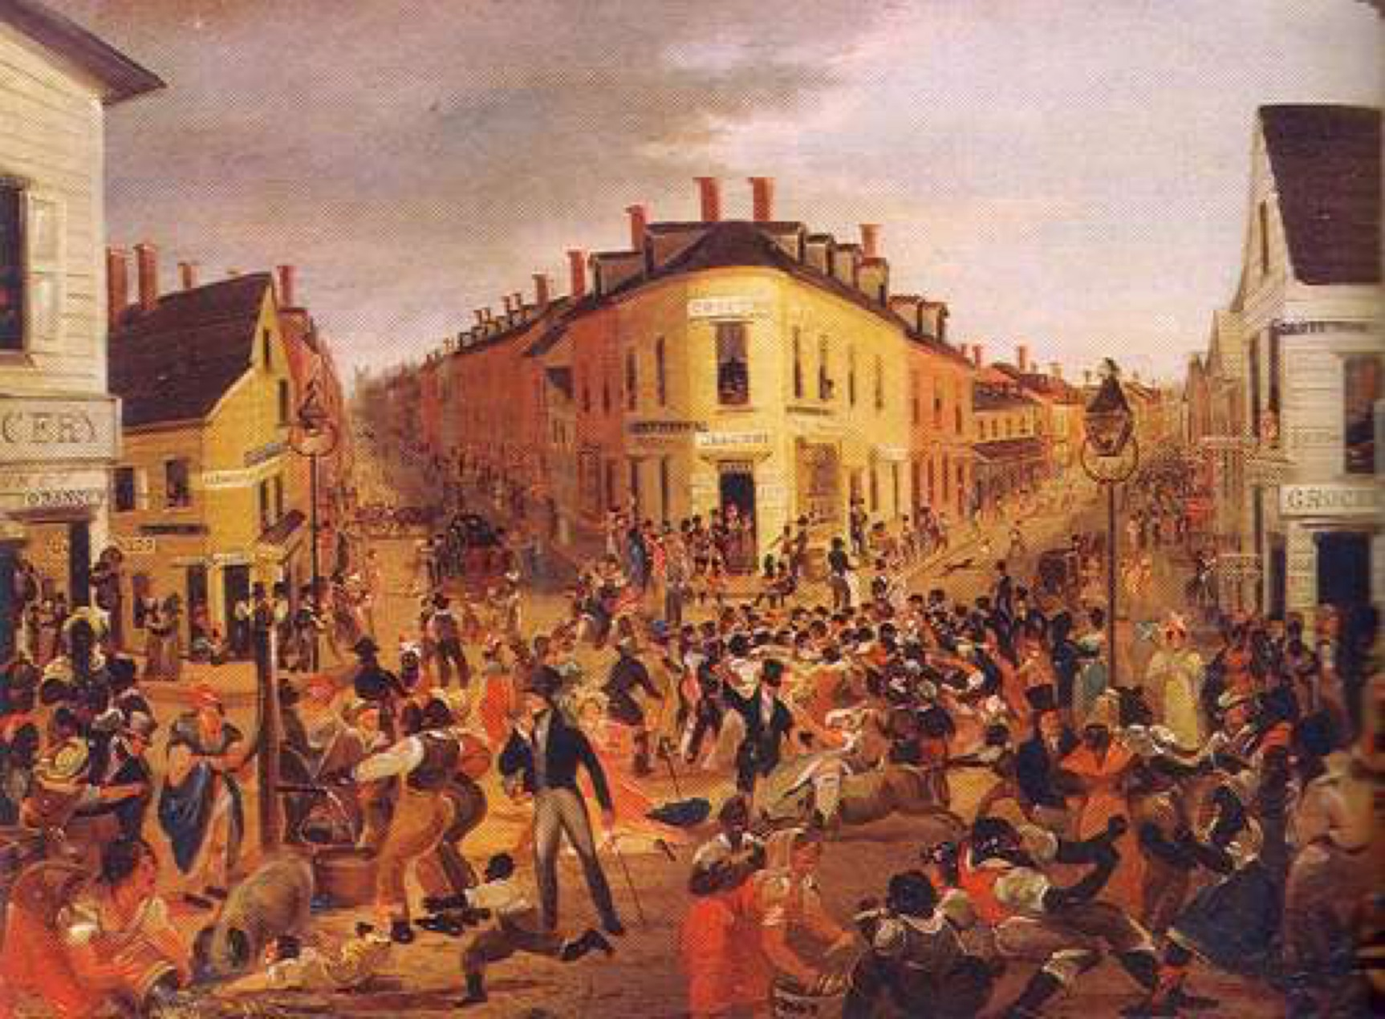
Jacob Riis, How the Other Half Live: Studies Among the Tenements (1890)
On Riis, see The Oxford Dictionary of American Art and Artists entry: http://www.oxfordreference.com/view/10.1093/acref/9780195373219.001.0001/acref-9780195373219-e-1124?rskey=e4iAut&result=4
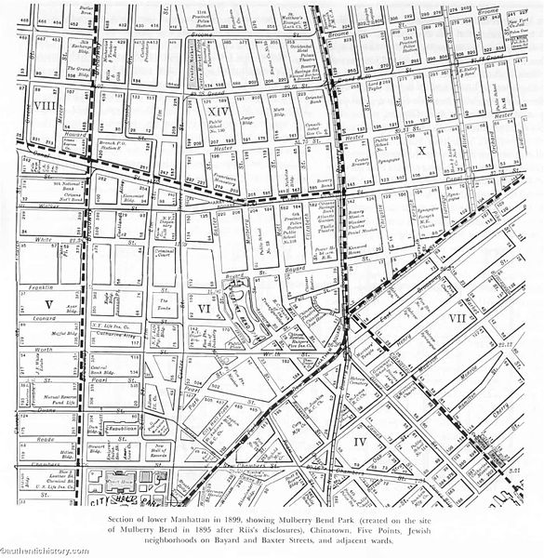
The area of the lower east side of Manhattan that Riis surveyed during his work on How the Other Half Lives

‘The Italian in New York’
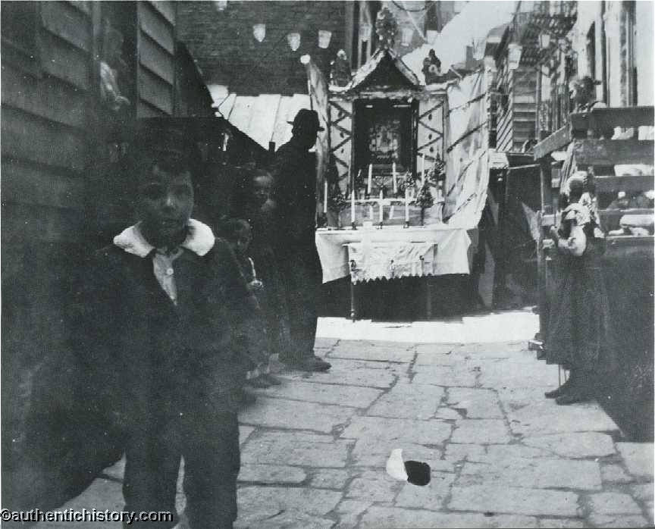
Feast of Saint Rocco, Bandits' Roost, Mulberry Street
CERTAINLY a picturesque, if not very tidy, element has been added to the population is the "assisted" Italian immigrant who claims so large a share of public attention, partly because he keeps coming at such a tremendous rate, but chiefly because he elects to stay in New York, or near enough for it to serve as his base of operations, and here promptly reproduces conditions of destitution and disorder which, set in the frame-work of Mediterranean exuberance, are the delight of the artist, but in a matter-of-fact American community become its danger and reproach. The reproduction is made easier in New York because he finds the material ready to hand in the worst of the slum tenements; but even where it is not he soon reduces what he does find to his own level, if allowed to follow his natural bent.
The Italian comes in at the bottom, and in the generation that came over the sea he stays there. In the slums he is welcomed as a tenant who "makes less trouble" than the contentious Irishman or the order-loving German, that is to say: is content to live in a pig-sty and submits to robbery at the hands of the rent-collector without murmur. Yet this very tractability makes of him in good hands, when firmly and intelligently managed, a really desirable tenant. But it is not his good fortune often to fall in with other hospitality upon his coming than that which brought him here for its own profit, and has no idea of letting go its grip upon him as long as there is a cent to be made out of him.
… With all his conspicuous faults, the swarthy Italian immigrant has his redeeming traits. He is as honest as he is hot-headed. There are no Italian burglars in the Rogues' Gallery; the ex-brigand toils peacefully with pickaxe and shovel on American ground. His boy occasionally shows, as a pick-pocket, the results of his training with the toughs of the Sixth Ward slums. The only criminal business to which the father occasionally lends his hand, outside of murder, is a bunco game, of which his confiding countrymen, returning with their hoard to their native land, are the victims. The women are faithful wives and devoted mothers. Their vivid and picturesque costumes lend a tinge of color to the otherwise dull monotony of the slums they inhabit. The Italian is gay, lighthearted and, if his fur is not stroked the wrong way, inoffensive as a child. His worst offense is that he keeps the stale-beer dives. Where his headquarters is, in the Mulberry Street Bend, these vile dens flourish and gather about them all the wrecks, the utterlywretched, the hopelessly lost, on the lowest slope of depraved humanity. And out of their misery he makes a profit.

‘Chinatown’
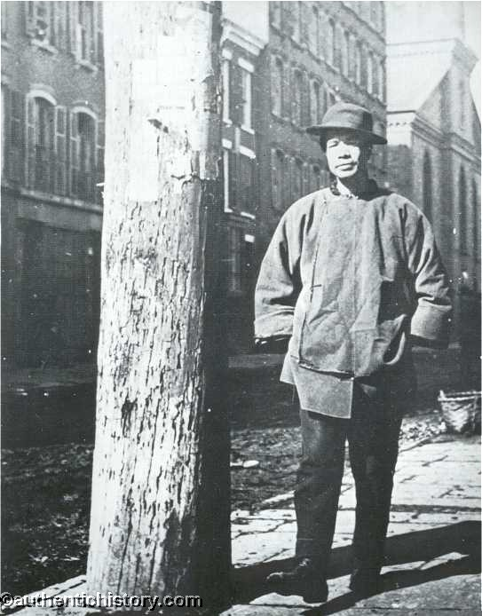
BETWEEN the tabernacles of Jewry and the shrines of the Bend, Joss has cheekily planted his pagan worship of idols, chief among which are the celestial worshipper's own gain and lusts. Whatever may be, said about the Chinaman being a thousand years behind the age on his own shores, here he is distinctly abreast of it in his successful scheming to "make it pay." It is doubtful if there is anything he does not turn to a paying account, from his religion down, or up, as one prefers. At the risk of distressing some well-meaning, but, I fear, too trustful people, I state it in advance as my opinion,based on the steady observation of years, that all attempts to make an effective Christian of John Chinaman will remain abortive in this generation; of the next I have, if anything, less hope. Ages of senseless idolatry, a mere grub-worship, have left him without the essential qualities for appreciating the gentle teachings of a faith whose motive and unselfish spirit are alike beyond his grasp. He lacks the handle of a strong faith in something, anything, however wrong, to catch him by. There is nothing strong about him, except his passions when aroused. I am convinced that he adopts Christianity, when he adopts it at all, as he puts on American clothes, with what the politicians would call an ulterior motive, some sort of gain in the near prospect--washing, a Christian wife, perhaps, anything he happens to rate for the moment above his cherished pigtail. It may be that I judge him too harshly. Exceptions may be found. Indeed, for the credit of the race, I hope there are such. But I am bound to say my hope is not backed by lively faith.
Chinatown as a spectacle is disappointing. Next-door neighbor to the Bend, it has little of its outdoor stir and life, none of its gayly-colored rags or picturesque filth and poverty. Mott Street is clean to distraction: the laundry stamp is on it, though the houses are chiefly of the conventional tenement-house type, with nothing to rescue them from the everyday dismal dreariness of their kind save here and there a splash of dull red or yellow, a sign, hung endways and with streamers of red flannel tacked on, that announces in Chinese characters that Dr. Chay Yen Chong sells Chinese herb medicines, or that Won Lung & Co.--queer contradiction--take in washing, or deal out tea and groceries.
… Granted, that the Chinese are in no sense a desirable element of the population, that they serve no useful purpose here, whatever they may have done elsewhere in other days, yet to this it is a sufficient answer that they are here, and that, having let them ill, we must make the best of it. This is a time for very plain speaking on this subject. Rather than banish the Chinaman, I would have the door opened wider--for his wife; make it a condition of his coming or staying that he bring his wife with him. Then, at least, he might not be what he now is and remains a homeless stranger among us. Upon this hinges the real Chinese question, in our city at all events, as I see it. To assert that the victims of his drug and his base passions would go to the bad anyhow, is begging the question. They might and they might not. The chance is the span between life and death. From any other form of dissipation than that for which Chinatown stands there is recovery; for the victims of any other vice, hope. For these there is neither hope nor recovery; nothing but death--moral, mental, and physical death.

‘The Sweaters of Jewtown’
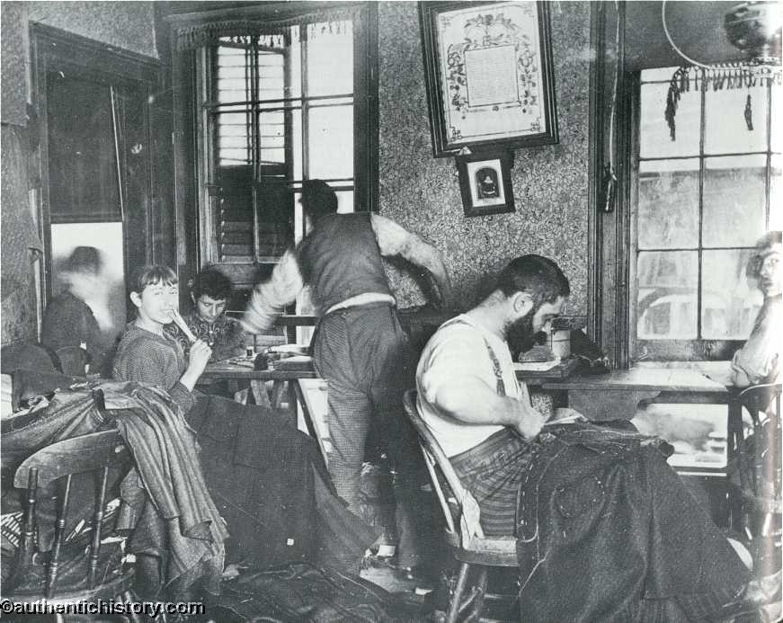
Many harsh things have been said of the "sweater," that really apply to the system in which he is a necessary, logical link. It can at least be said of him that he is no worse than the conditions that created him. The sweater is simply the middleman, the sub-contractor, a workman like his fellows, perhaps with the single distinction from the rest that he knows a little English; perhaps not even that, but with the accidental possession of two or three sewing machines, or of credit enough to hire them, as his capital, who drums up work among the clothing-houses. Of workmen he can always get enough. Every ship-load from German ports brings them to his door in droves, clamoring for work. The sun sets upon the day of the arrival of many a Polish Jew, finding him at work in an East Side tenement, treading the machine and "learning the trade." Often there are two, sometimes three, sets of sweaters on one job. They work with the rest when they are not drumming up trade, driving their "hands" as they drive their machine, for all they are worth, and making a profit on their work, of course, though in most cases not nearly as extravagant a percentage, probably, as is often supposed. If it resolves itself into a margin of five or six cents, or even less, on a dozen pairs of boys' trousers, for instance, it is nevertheless enough to make the contractor with his thrifty instincts independent. The workman growls, not at the hard labor, or poor pay, but over the pennies another is coining out of his sweat, and on the first opportunity turns sweater himself, and takes his revenge by driving an even closer bargain than his rival tyrant, thus reducing his profits.
The sweater knows well that the isolation of the workman in his helpless ignorance is his sure foundation, and he has done what he could--with merciless severity where he could--to smother every symptom of awakening intelligence in his slaves. In this effort to perpetuate his despotism he has had the effectual assistance of his own system and the sharp competition that keep the men on starvation wages; of their constitutional greed, that will not permit the sacrifice of temporary advantage, however slight, for permanent good, and above all, of the hungry hordes of immigrants to whom no argument appeals save the cry for bread. Within very recent times he has, however, been forced to partial surrender 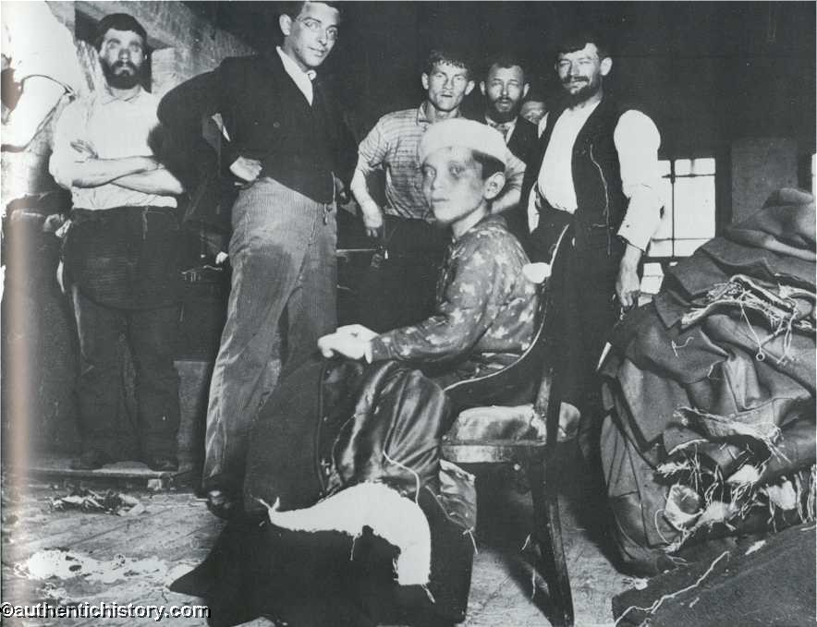 by the organization of the men to a considerable extent into trades unions, and by experiments in co-operation, under intelligent leadership, that presage the sweater's doom. But as long as the ignorant crowds continue to come and to herd in these tenements, his grip can never be shaken off. And the supply across the seas is apparently inexhaustible. Every fresh persecution of the Russian or Polish Jew on his native soil starts greater hordes hitherward to confound economical problems, and recruit the sweater's phalanx. The curse of bigotry and ignorance reaches halfway across the world, to sow its bitter seed in fertile soil in the East Side tenements. If the Jew himself was to blame for the resentment he aroused over there, he is amply punished. He gathers the first-fruits of the harvest here. The bulk of the sweater's work is done in the tenements, which the law that regulates factory labor does not reach. To the factories themselves that are taking the place of the rear tenements in rapidly growing numbers, letting in bigger day-crowds than those the health officers banished, the tenement shops serve as a supplement through which the law is successfully evaded. Ten hours is the legal work-day in the factories, and nine o'clock the closing hour at the latest. Forty-five minutes at least must be allowed for dinner, and children under sixteen must not be employed unless they can read and write English; none at all under fourteen. The very fact that such a law should stand on the statute book, shows how desperate the plight of these people. But the tenement has defeated its benevolent purpose. In it the child works unchallenged from the day he is old enough to pull a thread. There is no such thing as a dinner hour; men and women eat while they work, and the "day" is lengthened at both ends far into the night. Factory hands take their work with them at the close of the lawful day to eke out their scanty earnings by working overtime at home. Little chance on this ground for the campaign of education that alone can bring the needed relief; small wonder that there are whole settlements on this East Side where English is practically an unknown tongue, though the people be both willing and anxious to learn. "When shall we find time to learn?" asked one of them of me once. I owe him the answer yet.

‘The Bend’
On either side of the narrow entrance to Bandit's Roost, one of the most notorious of these, is a shop that is a fair sample of the sort of invention necessity is the mother of in "the Bend." It is not enough that trucks and ash-barrels have provided four distinct lines of shops that are not down on the insurance maps, to accommodate the crowds. Here have the very hallways been made into shops. Three feet wide by four deep, they have just room for one, the shop-keeper, who, himself within, does his business outside, his wares displayed on a board hung across what was once the hall door. Back of the rear wall of this unique shop a hole has been punched from the hall into the alley and the tenants go that way. One of the shops is a "tobacco bureau," presided over by an unknown saint, done in yellow and red--there is not a shop, a stand, or an ash-barrel doing duty for a counter, that has not its patron
saint--the other is a fish-stand full of slimy, odd-looking creatures, fish that never swam in American waters, or if they did, were never seen on an American fish-stand, and snails. 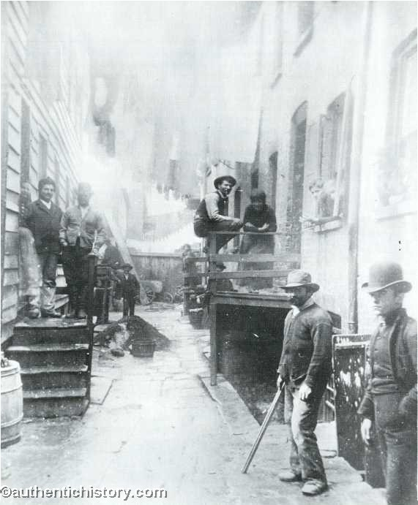Big, awkward sausages, anything but appetizing, hang in the grocer's doorway, knocking against the customer's head as if to remind him that they are there waiting to be bought. What they are I never had the courage to ask. Down the street comes a file of women carrying enormous bundles of fire-wood on their heads, loads of decaying vegetables from the market wagons in their aprons, and each a baby at the breast supported by a sort of sling that prevents it from tumbling down. The women do all the carrying, all the work one sees going on in "the Bend." The men sit or stand in the streets, on trucks, or in the open doors of the saloons smoking black clay pipes, talking and gesticulating as if forever on the point of coming to blows. Near a particularly boisterous group, a really pretty girl with a string of amber beads twisted artlessly in the knot of her raven hair has been bargaining long and earnestly with an old granny, who presides over a wheel-barrow load of second-hand stockings and faded cotton yarn, industriously darning the biggest holes while she extols the virtues of her stock. One of the rude swains, with patched overalls tucked into his boots, to whom the girl's eyes have strayed more than once, steps up and gallantly offers to pick her out the handsomest pair, whereat she laughs and pushes him away with a gesture which he interprets as an invitation to stay; and he does, evidently to the satisfaction of the beldame, who forthwith raises her prices fifty per cent without being detected by the girl.

