An Early Years Practitioner’s Handbook
on the importance of Effective
Communication during Transitions.

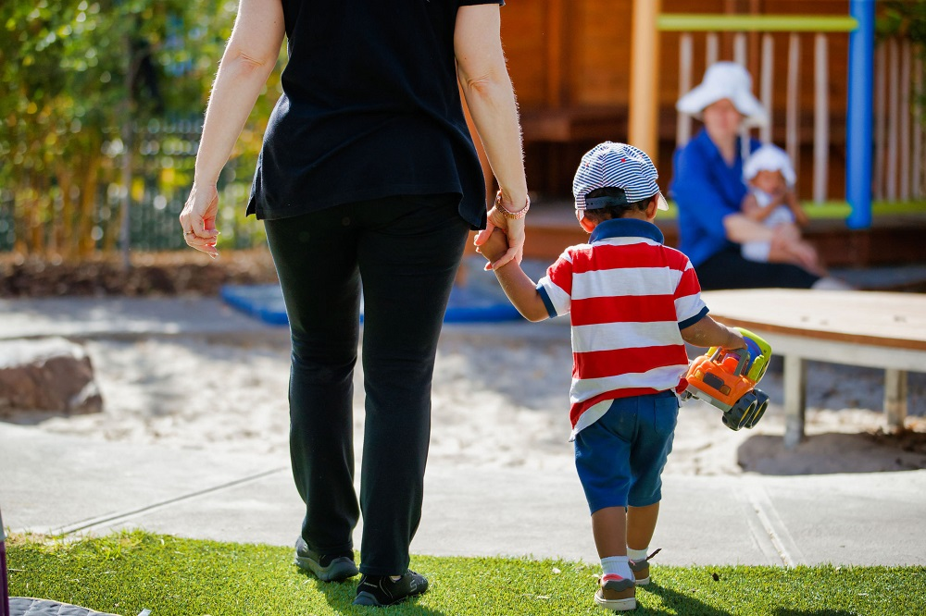
Source ECMS (December 2019) Google search

Contents

Contents Pg 2
Introduction – Pg 3
The Role of the Adult – Pg 4-6
The Needs of the Child – Pg 7-9
Partnerships – Pg 10-11
Interventions – Pg 12-13
Proposed Outcomes – Pg 14
References – Pg 15-17

Co

Introduction

Aims

This handbook is a guide to support Early Years Practitioners with best practice to support young children and their families transitioning from a home environment to an Early Years setting for the first time.
The handbook is set out into five key areas which are, the role of the adult, the needs of the child, partnerships, interventions, and proposed outcomes.
In each area practitioners will see that effective communication is essential to successful transitions. Practitioners will begin to understand why policies and procedures are put into place and imbedded into daily practices.
The handbook will also investigate theories as to why the transition process is important to get right and how this can affect children later in life if dealt with incorrectly.

Firstly, what is Transition?
Queensland Government (2021) state that transitions “occur throughout life” and that they could be minor adjustments to everyday routines or could be significant milestones such as transitioning from a home environment to an Early Years setting.
Brooker (2008) states the most significant transition for young children is the move from home to Early Years settings or school and states that poorly handled transitions can have an effect on self-esteem, self-confidence, and self-efficiency.

What is Communication?
Communication according to Oxford Learners Dictionary (2022) is ‘the activity or process or expressing ideas and feelings or giving people information’. During transitions communication is key to the success of a child settling into an unfamiliar environment.
World of Work (2021) say that there are seven C’s in communication that you should use to ensure that the person you are communicating with hears what you are saying. They are, to be clear, correct, complete, concrete, concise, considered, and courteous.

The Role of the Adult

Brooker (2008) discussed the “father” of transitional studies Urie Bronfenbrenner. Bronfenbrenner’s research is based on the child being in the centre of the “ecological system.” He believes that children should be situated in the social world and believes that any changes to that world could have a long-term impact on the development.
Bronfenbrenner’s ecological theory now has five systems which are all interrelated. The child at the centre’s development will all depend on the relationships built in each of the other systems.
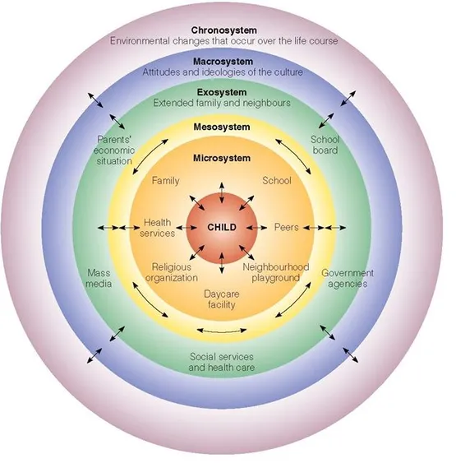Source: Simply Psychology (2020) Google Search
Guy-Evans (2020) describes each system as follows: -
The Microsystem
This is the immediate environment the child is in, it is where they spend most of their time, so positive experiences need to be built here so that the child can develop affectively.
The Mesosystem
This is made up of the relationships with the people in the microsystem. For example, how a parent develops their relationship with their child’s key worker could affect the way in which the relationship is built with the child.
The Exosystem
This system involves factors that can affect the child’s development but may not be a direct link.
The Macrosystem
This system is linked to cultural elements and how they can affect the child’s development, such as wealth, poverty, and ethnicity and how this is viewed by people in the system.
The Chronosystem
This system has been added later, but consists of changes that occur in a lifetime, such as major transitions and historical events, but it also includes transitions that occur such as moving schools or parents divorcing.

Brooker (2008) discusses the importance of Bowlby (1978) and Ainsworth’s (1978) work into attachment and how this has tended to be the focus on young children’s experiences, especially during transitions. Bowlby and Ainsworth research showed that if a child’s bonds with their main carer were broken then the child may display behaviours that were “evolutionary mechanisms” such as crying, screaming, and holding onto their main care giver, which is a way in which the child shows their displeasure at being left and can make the main care giver guilty for doing so. As an Early Years setting and practitioner it is important to have and follow a settling in policy and have a key person that the child and parent can form a bond with which links in with Bronfenbrenner’s Mesosystem.

Parents and Key Workers.
Firstly, it is recognised by National Minimum Standards (2016) how a child needs to form attachments whilst being at a day care setting. Standard 8.6 states that babies and young children should have a consistent carer or several regular carers for them to form attachments. The NMS also states that parents should be given an opportunity to discuss their child’s preferences, needs and abilities and be given time to pass on any other information that they feel pertinent to their child settling into the setting. Standard 3.3.
The initial introduction with the parent and child is an opportunity for the keyworker to discuss the child and how the parent supports them in the home environment. It is important that both parties are open and honest about how they feel things will work so that the relationship starts on a good path. The Welsh Government (2017b) states that a transition needs to be managed and planned effectively and careful consideration needs to be given to the child’s needs and that as a keyworker you respect parents as partners in supporting the transition process and the child’s learning. The key to this is communication, all practitioners must develop the skills of effective communication to ensure that the needs of the child are met and positive relationships with the parents are built.
Brooker (2008) points out that the key workers role as “critical” to the child settling in and believes that the child will shape the way in which they want to settle into the unfamiliar environment, some may need emotional support whilst others maybe more independent and will seek out help when needed.
Trodd (2012) says that young children who enter Early Years settings have most probably never been left in a group environment without their parents/carers, so it is hard to determine how the children are going to react to separation. It becomes the key workers job to manage this situation sensitively and using Maslow hierarchy of needs will be beneficial to this as the keyworker will be able to understand why a child needs to feel safe and secure in their unfamiliar environment before being able to develop in other areas, such as making friends and new attachments.
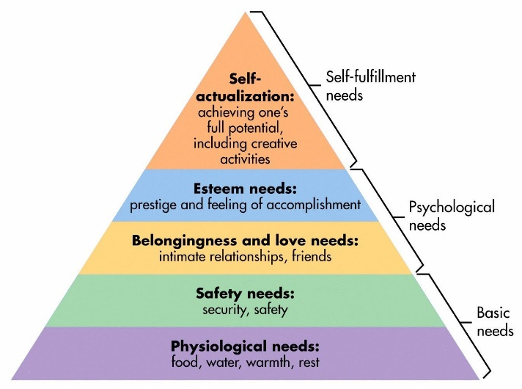Source: Simply Psychology (2022) Google search
Ricciardi (2012) discusses the importance of values and training in transitions. She believes that the key worker will be required to understand the child’s needs and respect them whilst trying to bond with the child. The key worker will also need to build up a relationship of trust with the parent so that they can see that the best interests of their child are your focus throughout their time at the setting. Ricciardi (2012) also discusses the importance of staff in the setting supporting each other, as it can become challenging if a child is struggling to settle and can sometimes lead to the key worker feeling helpless, so having a good team around you helps you as a key worker.
Brooker (2008) points out that parents, psychologists, and educators all understand that children need to have change in their lives as it helps them to develop further, so children moving into new environments could be beneficial to them. Children who have rich and varied environments can continue to learn new things as well as enhance what they have already learnt through these new environments.
Lindon and Brodie (2016) say that the best people to support young children are adults who care about the well-being of children in their care. Lindon and Brodie (2016) believe that adults also need to have an understanding of children’s development so that they can understand what happens as babies and children grow and understand how and why development evolves.

The Needs of the Child

Welsh Government (2017b) says that children are ‘unique’ and learn at different rates. Each child has a wide range of characteristics, skills, abilities, background, and experiences, so moving into an unfamiliar environment may prove difficult for some to handle. It could become stressful which will influence the child’s emotional well-being and ability to learn and make friends, which links to Maslow’s Hierarchy of needs, as to be able to make connections first you need to feel safe and secure in the environment.

According to Lindon (2012) practitioners need to understand the theoretical studies of children and their development in order for them to show what is important in the process. Lindon (2012) says that theory shapes the way in which education and practices are carried out, which is proven as the new Welsh Government Curriculum is focussed on children having ‘access to experiences, knowledge, and skills that young people will need in employment, lifelong learning, and active citizenship’ (Hwb 2002) which are some of the focuses of the theorists below.

Froebel believed that children should be allowed to be children and adults should not be concerned about what comes next. He believed that the environment was an important part of a child’s learning, and they should be given access to play in nature and have lots of space and light to develop. Adults should then support this play rather than change it to fit what they think needs to be learnt. Froebel’s wanted the childcare experience to be a ‘cultivation of family life, a forming of national life and even of all humanity.’ (Pound (2005)
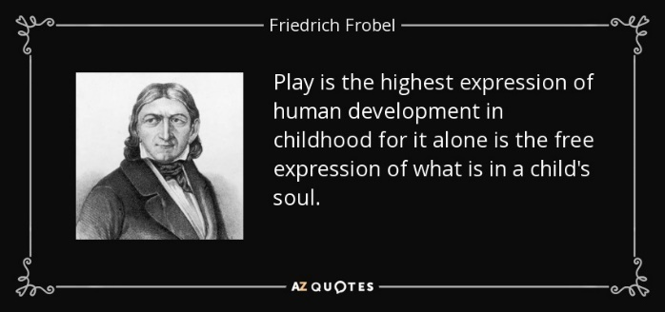 Source: AZ Quotes (no date) Google Search

Dewey’s theory of ‘Learning by doing’ is similar to Froebel’s in that children learn by carrying out tasks, but he also added that education should be based on real life situations and children should be allowed to experiment and be independent in their learning. (Pound 2005)
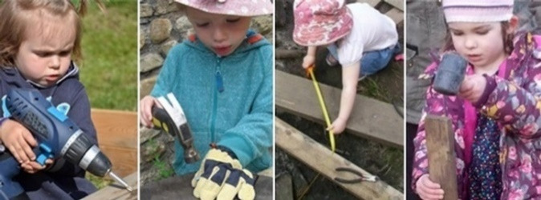 Source: Day Nurseries (2022) Google Search

Vygotsky’s theory of ‘zone of proximal development’ describes what a child can do alone and when we as adults’ step in to help. Vygotsky believed that children learn through instruction and communication is key to this, which other theorists such as Piaget disagrees with. Vygotsky’s theory relies on observation of what children can do and planning activities which will challenge the individual child’s capabilities. (Pound (2005)
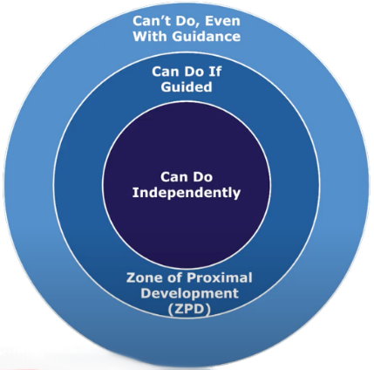Source: Lets Go Learn (2022) Google Search

The new Welsh Government curriculum as discussed above includes the importance of children learning through play and how adult observations can further develop individual children’s interests and skills, but it also promotes the rights of the child, for example Article 3 is about the best interests of the child, Article 12 involves respecting the views of the child, Article 13 involves freedom of expression and Article 31 expresses that children have the right to leisure, play and culture. UNICEF (no date). It is important that as a practitioner you are aware of the UNCRC and that they are embedded into your practices daily.

All childminders and day care settings in Wales must comply the National Minimum Standards, which have 24 standards on how to ensure that the child is cared for in a safe and secure environment. Most providers must prove how they meet these standards through CIW inspections. Standard 4 is linked to how the setting and practitioner can meet the individual child’s needs, including children with disabilities or additional needs. Practitioners will need to be able to show how they have listened to the parents’ wishes during transitions and ensure that they are meeting each child’s individual needs within the setting. (Welsh Government 2006)

According to Welsh Government (2017b) babies and young children can express their views and opinions in several ways. Young children can communicate their feelings using gestures, sounds and actions, then later by speech. It becomes the job of the keyworker to look out for these signs of communication via observation, so that they are meeting the child’s individual needs.

Early Years Matters (2022) says that babies and young children learn in each area of development in their own time and way. They say that every child is ‘unique and are consistently learning to be resilient, capable, confident, and self-assured throughout their lives.’ Keyworkers need to understand this and be able to adapt their practices to suit the needs of each individual child in their care.

According to Trodd (2012) Bowlby’s attachment theory will provide children with a sense of security, promote communication and expression of feelings. Attachment will also allow children to explore the area they are in and learn about self-regulation and control and will allow the children to develop a sense of self. A key working system will support this theory and allow the child to be able to explore their new environment and learn in their own way.

Partnerships

As discussed previously in the handbook, keyworkers and parents must build up a relationship of trust and communicate with each other effectively to ensure that the child’s needs are always met. There may be occasions whereas a practitioner you will need to have difficult conversations with the parents regarding their child’s behaviour or development, practitioners must ensure that these conversations are dealt with sensitively and professionally. There are several organisations that can help parents with these concerns, and it will be the job of a manager/keyworker to signpost the parents to the suitable agencies.

Children who are in a Flying Start catchment area will have access to funded, quality part time childcare for 2–3-year-olds, intensive health visiting service which flags up any additional support that is needed. Referrals can then be made before the child attends the setting, which will enable a specialist teacher to come to the setting to visit the child and support the staff team in the transition process and onwards. Parents are also able to access parenting groups to enable them to understand the ways in which they can support their child. They will also have access to speech and language classes and therapists to support their child if needed. This multidisciplinary approach enables the child and parent to access the best support available to them which in turn means that the child is getting all its needs met and the parent is getting the support that they need to ensure that their child meets their full potential. (Welsh Government 2017a)
 Source: Flying Start (no date) Google Search

Families who are not in Flying Start catchment areas can be signposted to agencies such as FIS, Families First, Support Parenting Programmes and many more whose links will be on the FIS website. They can also speak to their family Health Visitor who will be able to make referrals to specialist help. (Welsh Government 2017b)
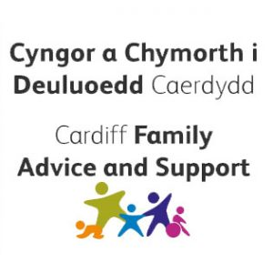 Source: Flying Start (no date) Google Search

As a key worker in a playgroup, you will need to work in partnership with your team to ensure that they are aware of your keyworkers needs too. This can be done via staff meetings. Welsh Government (2017b) say that team meetings allow for information to be passed on regarding children and their families and can be a place for support to staff who might need new strategies in dealing with issues.

 Source: Shutterstock (no date) Google Search

Interventions

Below is a list of ways in which you can support a child transitioning from home to an Early Years setting. These interventions are ways in which we can develop and maintain the link with the child’s family and ensure that the transition process is as smooth as possible.

Home Visits
Pacey (2016) recognises the importance of finding information about the child prior to them starting at setting. This could be via a home visit so that keyworkers are able to see the children in their natural environment or if you are unable to do this, they recommend that keyworkers have an information sheet about the child prior to their start date. Information collected could be things such as people who are important to them, their likes and dislikes, things they may need help with and if they have attended any classes for socialising prior to them starting at the setting.
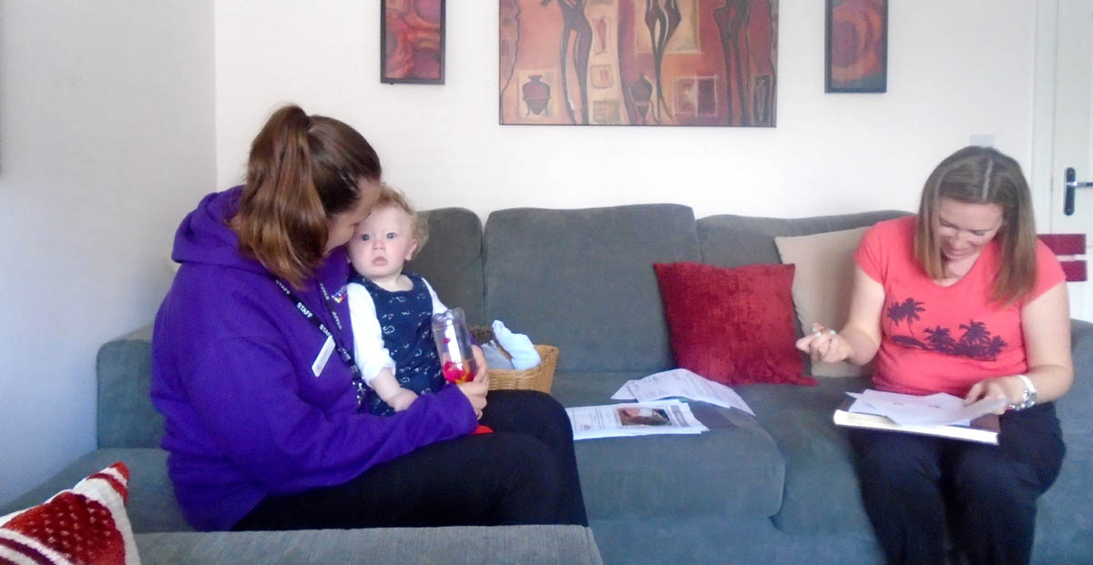Source: Village Nursery (2016) Google Search

Items from home
Winnicott believed that transitional objects will support the child whilst dealing with separation from their main carer giver. (Pound 2005)
 Source: Good Parenting Brighter Children (no date)
Google Search
Settling In Sessions
Pacey (2016) also recommend that children have a period of settling in sessions, they stress the importance of these being a gradual process for both child and parent. Every child will be different in how they settle, so it will be the job of the key worker to support this and ensure that effective communication is used throughout the process.

Stay and Play Sessions
Once the child has settled into the playgroup you can invite the parents back into the setting so that they can stay and play with their children. These sessions demonstrate to the parents the things that their children are learning and how they can support them at home too which is maintaining the parents as partners relationship. This time will also enable the keyworker and parents to continue to develop their relationship. (NDNA no date)

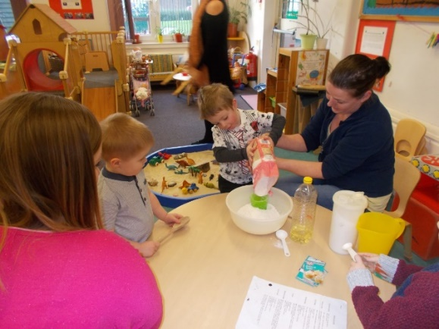Source: Knightsridge Early Years Centre (2016) Google Search
Proposed Outcomes

For a keyworker to know if the transition process has been successful close observations need to be undertaken. If a child is happy playing and developing in their environment then this could suggest that they are safe and secure in their new environment and that their needs are being met, whereas a child that shows signs of challenging behaviour and upset maybe trying to communicate their fears, frustrations or dislike to the environment or activities available to them. (Welsh Government 2017b)

According to Welsh Government (2017b) the purpose of effective transitions is to ensure that parents and children experience practical and emotional support throughout the transition process which supports continuity of care, development, and learning. It will also enhance the wellbeing and ensure that they experience change as a positive experience.

 Source: Joy Kids (2020) Google Search

Reference List

Ackerman, Courtney, E. (2018) What is attachment theory? Bowlby’s 4 stages explained. Available at: - https://positivepsychology.com/attachment-theory/ (Accessed 17 November 2022).
AZ Quotes (no date) [Image] Friedrich Froebel Quotes. Available at: - https://www.azquotes.com/author/54686-Friedrich_Frobel (Accessed 20 November 2022).
Brooker, L. (2008) Supporting Transitions in the Early Years. Berkshire: Open University Press.
DayNurseries.co.uk (2022) [Image] Young children experience ‘risky’ play using saws, hammers and mallets. Available at: - https://www.daynurseries.co.uk/news (Accessed 20 November 2022).
ECMS - (2019) [Image] Tips for a positive transition for your child to preschool or childcare. Available at: https://www.ecms.org.au/tips-positive-transition-your-child-preschool-or-childcare (Accessed 8 November 2022).
Early Years Matters (2022) A Unique Child. Available at: - https://www.earlyyearsmatters/eyfs/a-unique-child/ (Accessed 20 November 2022).
Flying Start Cardiff (no date) [Images] Welcome to Flying Start. Available at: -https://www.flyingstartcardiff.co.uk (Accessed 30 November 2022).
Good Parenting Brighter Children (no date) [Image] 4 Fascinating Reasons Children Treasure their blankets. Available at: - https://goodparentingbrighterchildren.com/reasons-children-treasure-blankets/ (Accessed 26 November 2022).
Guy-Evans, O. (2020) Bronfenbrenner’s ecological systems theory. Available at: -https:// www.simplypsychology.org/Bronfenbrenner.html (Accessed 12 November 2022).
Hwb (2021) Introduction to Curriculum for Wales guidance. Available at: -https://hwb.gov.wales/curriculum-for-wales/introduction (Accessed 18 November 2022).
Joy Kids (2020) [Image] Playgroup. Available at: - https://joykids.in/play-group/ (Accessed 27 November 2022).

Knightsridge Early Years Centre (2016) [Image] Successful stay and play sessions for our 2-year-olds. Available at: - https://blogs.glowscotland.org.uk/wl/KnightsridgeEYC/2016/02/02/successful-stay-play-session-for-our-2-olds/ (Accessed 26 November 2022).
Let’s Go Learn (2022) [Image] What is the zone of Proximal Development?. Available at: - https://letsgolearn.com/reading-assessment/what-is-zone-of-proximity-development/ (Accessed 19 November 2022).
Lindon, J. (2012) Understanding Child Development: 0-8 years. 3rd edn. London: Hodder Education.
Lindon, J. and Brodie, K. (2016) Understanding Child Development 0-8 years. Linking theory and Practice. 4th edn. London: Hodder Education.
NDNA (no date) Transition and Partnership Working Toolkit – User guide for settings – Wales. Available at: - https://ndna.org.uk/wp-content/uploads/2022/08/Transition-and-Partnership-Working-Toolkit-User-Guide-For-Settings.pdf
Oxford Learners Dictionary (2022) Communication. Available at: - https://www.oxfordlearnersdictionaries.com/definition/english/communication (Accessed 19 November 2022).
PACEY (2016) Transitions and Settling in. Available at: - https://www.pacey.org.uk/Pacey/media/website-files/PACEY%20member%20practice%20guides%20(PDFs)/PG10-transitions-and-settling-in-pdf (Accessed 26 November 2022).
Pound, L. (2005) How children learn from Montessori to Vygotsky. Educational theories and approaches made easy. London: Practical Pre-School Books
Queensland Government (2021) Transitions in the Early Years. Available at: -https://earlychildhood.qld.gov.au/early-years/transitions (Accessed 9 November 2022).
Ricciardi, A. (2012) ‘Starting at Pre-School’, in Trodd, L. Transitions in the Early Years working with children and families. London: Sage Publications Ltd
Simply Psychology (2020) [Image] Bronfenbrenner’s ecological systems theory. Available at: - https://www.simplypsychology.org/Bronfenbrenner.html (Accessed 12 November 2022).
Simply Psychology (2022) [Image] Maslow Hierarchy of Needs. Available at: -https://www.simplypsychology.org/maslow.html (Accessed 19 November 2022).
Shutterstock (no date) [Image] Staff meeting. Available at: -https://www.shutterstock.com/search/staff-meeting (Accessed 30 November 2022).
UNICEF (no date) UN Rights of the Child. Available at: - https://www.unicef.org.uk/wp-content/uploads/2019/10/UNCRC_summary-1_1.pdf
Village Nursery (2016) [Image] Village Nursery Home Visits. Available at: - https://village-nursery.co.uk/2016/10/13/homevisits/ (Accessed 26 November 2022).
Welsh Government (2006) National Minimum Standards for regulated childcare for children up to the age of 12 years. Available at:- https://gov.wales/national-minimum-standards-nms-and-guidance-regulated-childcare (Accessed 22 November 2022).
Welsh Government (2017a) Flying Start Health Programme Guidance. Available at: - https://gov.wales/sites/default/files/publications/2019-07/flying-start-health-programme-guidance_0.pdf (Accessed 18 November 2022).
Welsh Government (2017b) Flying Start Annex – Transition guidance. Available at: - https://gov.wales/sites/default/files/publications/2019-07/flying-start-transition-guidance-for-professionals.pdf
World of Work (2021) The seven 7’s of communication. Available at: -https://worldofwork.io/2019/07/the-7-cs-of-communication/ (Accessed 30 November 2022).

