Case Study: The Seaview Resort.

Student – IOAN BLEDEA

Student ID- 2126257

Financial Management for the Hotel Industry, BMIH5007

Lecturer – TRISTAN HAWKINS

Table of contents

1. Introduction
2. Scope and objective
3. Financial Analysis
4. SWOT Analysis
5. Turnaround strategy
6.Financial projections
7.Risk assessment
8. Conclusions

Introduction

The Sea View Hotel is a hotel property with 25 beds, which has a bar and a restaurant. Located on the sunny shores of the Mediterranean, for years the hotel has been a successful business for customers interested in the luxurious and relaxing services offered by the hotel resort which owner is James Henderson.
Considering that the owner has not invested much in his property in the last 20 years, the quality of services has deteriorated, moreover, 3 new hotels have opened in the last 5 years near his location. From the good old days when the hotel was full of wealthy tourists over the age of 60 years who sought refuge and relaxation in Henderson's hotel, now the area was filled with tourists of all categories, it had become a noisy place, and the elderly tourists based on Henderson's business were beginning to look for other, more secluded areas to relax.
Under these conditions, the hotel's occupancy started to decrease in the last 5 years, from over 95% to 60% in 2022. With a net loss of £47,500 for 2022, Mr. Henderson is looking for a recovery solution.

Scope and Objectives

Under these conditions, analyzing the market and the financial situation, the purpose and objective of this analysis is to find solutions to Mr. Henderson's desperation to save his business from bankruptcy. An analysis of the financial situation for the last 3 years will be carried out, as well as an analysis of the competition on the hotel market in the area.

Financial Analysis

In this section we will analyze the financial situation for the last 3 years of Mr. Henderson's hotel business. According to the income statement analysis and balance sheet, the situation is presented as it is in the table below.
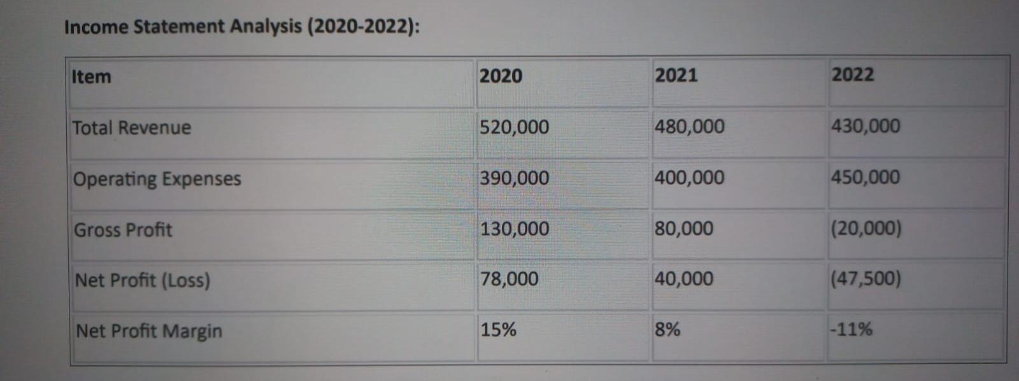
1Income Statement

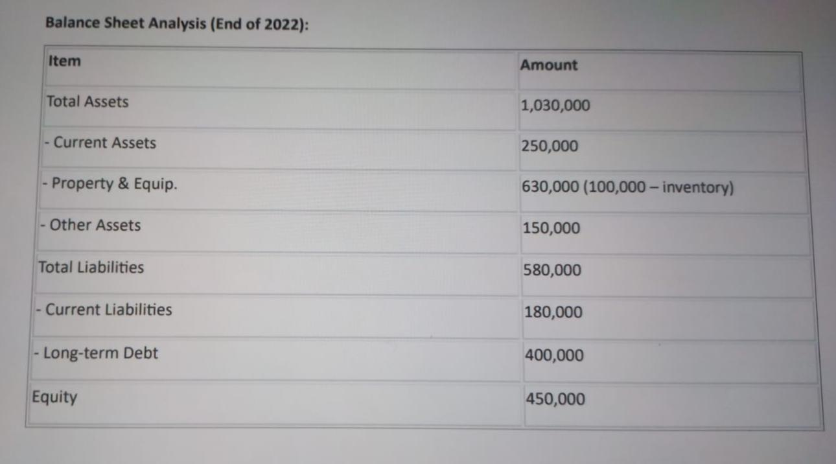
2 Balance Sheet

Average Room Rate (ARR) Occupancy Rate:
• 2020: 70% • 2020: 250
• 2021: 65% • 2021: 230
• 2022: 60% • 2022: 210

Current ratio: 250,000/180,000=1,39
Quick ratio:(250,000-100,000)/180,000=0,83
Debt-to-Equity Ratio:580,000/450,000=1,29

Comparing the financial data, it is evident that the revenue decreased every year simultaneously with an increase in operating expenses. Also, although there were slight reductions in room prices every year, their occupancy rate decreased progressively every year.
From what it seems, the simple decrease in room prices is not a solution to increase the income and the occupancy rate, considering that the operating costs have increased, either due to the increase in the prices of utilities and amenities, or due to the salary increase according to the legal norms, but also offers on the labor market. Also current liabilities are quite important reported to current assets. In this way, the business will go bankrupt in 2 years, with debts greater than the revenues achieved. Although the financial situation is critical, a decrease in operating costs as well as an even greater reduction in the selling prices of the rooms will not be a saving solution.

SWOT ANALYSIS

- Strenghts: positioning in a geographical area of ​​great tourist interest, good weather, good location on the seashore, a loyal number of elderly customers, traditional food from local area, located near a company of small boats and ships that customers can rent for trips in the nearby marine areas, the location is near an important seaport, easily accessible transport routes.
- Weakness: the hotel is too little known outside the country of origin, it is a destination especially for a small group of rich elderly people. It has luxury furniture, although a bit outdated. Not too many investments have been made in terms of ecological protection. The restaurant serves good food, but nothing has changed in the menu for 20 years. The hotel was not promoted on the media networks, customers frequenting the hotel more from the recommendations of other customers.
- Opportunities: thanks to the excellent area where the hotel is positioned, it can diversify its offers to attract customers of different ages, the possibility of being promoted in the online media. Being a sunny area, it can install solar panels for the production of ecological solar energy. There are countless ecological farms nearby from where can be bought organic food. The business can also be expanded by purchasing old buildings nearby that can be renovated and decorated to the liking of a growing number of tourist clients from that area.
- Threats: the competition on the market and the opening of big hotels with low prices for the rooms and services offered is the main threat, it is also the main reason for the decrease in the number of customers and the bad financial situation the hotel is going through. The lack of investment in property maintenance and offering new products to customers is another risk factor that leads to the loss of customers.

Turnaround Strategy

1. It is obvious that the decrease in the number of customers is due to the competition in the area. It is recommended to attract and other segments of customers, such as businessmen or tourists interested in sea sports and boat or ship trips, not only elderly rich people.
2. The manager of the company and the management team must be changed, who, although they noticed a decrease in the number of tourists, did nothing to improve the situation of the services offered, the same kind of amenities have been used for over 20 years, the beds are no longer comfortable to sleep because they are worn, the decoration of the rooms is old and shabby. The restaurant has been serving the same types of dishes for years. For years, the lack of investment was also based on a small number of competitors in the area, which ensured the success of the business but also the natural beauty of that area.
3. Although operating expenses have increased and the quality of services has not improved, we can also assume an embezzlement of funds by the hotel's accountants, the recommendation would be to change them and send them to court for the recovery of damages.
4. Promoting the hotel's services in the online media, in order to attract tourists from other geographical areas, creating a hotel website, promoting advertising on facebook, twitter, and tourist sites.
5. Cutting too high and unnecessary operating costs, investing in improving the quality of the services offered to customers, changing the amenities, introducing new offers in the restaurant menu, renovating the decorations in the rooms, changing the degraded furniture. These are absolutely necessary investments for attracting new customers.
6.Collaboration with certain travel agencies from different countries, to ensure a continuous flow of clients throughout the year. Collaboration with other hotels in the area to accommodate a surplus of tourists that they might have in some periods of the year.
7.Refinancing the existing debt or renegotiation the contracts with creditors, selling some assets to improve liquidity.
8.Partenership with another company to expand the business, by acquisition of new building in that area, raising thus the number of rooms, and the diversification of customer segment, to ensure high occupancy of the rooms.
9 Orientation towards ecological practices, the use of solar energy, ecologically produced food products, avoiding the waste of food, separation of household waste to be recycled.
10. If all these strategies will prove to be ineffective, then the last and most bleak solution is to declare bankruptcy and liquidate the business by selling the assets to pay the debts and obligations

Financial Projections

If the recovery strategies will be successfully applied in the next 3 years, a significant increase in revenue and net profit, an expansion of the number of rooms as well as a greater influx of customers can be foreseen.
Income statement analysis(2023-2025)

Items | 2023 | 2024 | 2025
Total revenue | 550,000 | 600,000 | 650,000
Operating expenses | 400,000 | 350,000 | 350,000
Gross profit | 150,000 | 250,000 | 300,000
Net profit(loss) | 71,500 | 150,000 | 195,000
Net profit margin | 13% | 25% | 30%

Balance sheet analysis end of 2025

Total assets | 2,000,000
Current assets | 800,000
Property & equipment | 1,000,000
Other assets | 200,000
Total liabilities | 600,000
Current liabilities | 50,000
Long term liabilities | 550,000
Equities | 450,000

Risk Assessment

Considering the need for investments in equipment and in the renovation of the property, the costs for these investments will increase the long-term debt of the hotel, either through bank loans or by attracting new investors, which means bank interest and increased dividends for investors.
The reduction of some operational costs, such as salaries that are too high for a part of the staff employed, could create problems and the lack of employees until finding other employees available to work on lower salaries. Collaboration with certain travel agencies, although beneficial, would involve additional costs by paying commissions to them. Investments in protecting the ecosystem, such as solar panels, purchasing only organic food, will further increase the existing debts of the hotel and the charging costs for customers. Expanding the business and collaborating with other hotels means more work, more employees and the danger of conflicts with the managers of the other hotels on certain issues regarding attracting customer loyalty. That is why a well-trained management team, well-trained accountants are necessary. Loans from banks with the lowest interest rates should be made. Good communication with investors and renegotiation of long-term debts is necessary.

Conclusion

As it is proven in the case of Seaview resort, any business, no matter how profitable it may be in a certain period, will go into decline either due to the competition on the market, or the lack of adequate investments over the years to keep it in good condition the property or services offered to clients. Also, the tastes and demands of clients change from one generation to another. Thus, a continuous market study of demand and supply, improvement of product promotion methods through online advertising and social media is necessary. Anchoring in the past and not reforming a business to make it competitive on the current market can lead to the decline or bankruptcy of the business.
Also, a good manager or a good management team is the guarantee that a business will be successful, because they will take the necessary measures at the right time, and it will not be passively expecting that only external factors will change the business situation for the better. A good manager is like a good head of state or a good king. He knows when to take the necessary measures and at the right time. An incompetent head of state brings disasters and misfortunes to the people he leads, so does a bad manager to the company he leads.

REFERENCES

1.Drury C (2021) Management and Cost Accounting,
London, Prentice Hall
2.Seal W (2019) (6th Ed), Management Accounting, London, McGraw Hill
3. Walker J (2021) Introduction to Hospitality, Harlow, Pearson
4. Atrill P, McLaney (2021) Management Accounting for Decision Makers, FT Prentice Hall
5. Bhimani A, (2006) Contemporary Issues in Management Accounting , Oxford
6. Guilding,C.(2014) (3rd Edition) Accounting Essentials for Hospitality Managers, London, Routledge
7. Jagels,M. (2007) Hospitality Management Accounting, London, Wiley.
8. Seal W, Garrison RH, Noreen E (2008) Management Accounting, McGraw Hill
9. Tranter,K. Stuart-Hill,T. Parker,J. (2014) Introduction to Revenue Management for the Hospitality Industry, London, Pearson

10.Further Wild J (2018) Fundamental Accounting Principles, New York, McGraw Hill
Kotler, P. Bowen, J.T., Makes, J.C., Xie, Y & Liang, C(2006).Marketing for hospitality and tourism. New Jersey: Prentice hall

11.Kotler,P and Kartajaya,H. (2017). Marketing 4.0 :Moving from Traditional to Digital . New York: Wiley

12.Jobber, D. & Fahy J.(2012), Foundations of Marketing, London:McGraw Hill.

13.Jobber, D. & Ellis-Chadwick, F. (2012) Principles and Practice of Marketing, London, McGraw Hill 7th

14.Middleton V., Fyall A., Morgan M., (2009) Marketing in Travel and Tourism, Oxford: Butterworth Heinemann.

15.Tresidder R. and Hirst C., (2012) Marketing in Food, Hospitality, Tourism and Events.Oxford: Goodfellow.

16. Smith, P.R.& Zook, Z.E. (2020) Marketing Communications. 7th Ed, London :Kogan Page

17. https://bstrategyhub.com/marriot-swot-analysis/
18. https://corporatefinanceinstitute.com/resources/management/turnaround-recovery-strategies/
19.https://www.irwin-insolvency.co.uk/what-are-the-main-steps-of-a-turnaround-strategy/#:~:text=A%20business%20turnaround%20strategy%20is,a%20reverse%20in%20financial%20fortunes.
20. https://www.socialtables.com/blog/hospitality/failing-hotel-turn-around-strategies/
21. https://www.ezeeabsolute.com/blog/how-to-save-failing-hotel-business/
22. https://www.hospitalitycourses.co.za/turnaround-strategy

