Fundamentals of construction- Assignment 1

Presented by: Joshua Albrighton

Presented for: Allan Nantel

Word Count: 2726
Contents
1. Executive Summary- Page 4
2. Introduction- Page 5
3. Historical Appraisal- Page 6
4. Findings from Desk Study- Page 7
5. Desk Study continued (present day)-Page 8
6. Building Regulations/ Codes of Practice- Page 13
7. Conceptual Ground Models- Page 14
8. References- Page 18

List Of Illustrations
- Overhead view of site area
- Swansea Civic Centre
- Swansea South Dock 1859-1971
- Borehole Records page 1
- Borehole Records page 2
- Borehole Records page 3
- Rainfall Averages, UK
- Rainfall Records, Swansea
- Isolated Footing Foundation Illustration
- Combined Footing Foundation Illustration
- Drilled Shaft Foundation Illustration
- Pile Foundation Illustration
- Executive Summary
For this report I was tasked with being a junior construction professional, tasked with initiating a preliminary study for a site investigation for a new building in Swansea. The proposed building is a new restaurant and ice-cream parlour (with a second floor for a manager’s apartment) this would be around 300 square metres and would share car parks with the neighbouring buildings. This desk study sets out to look at the history of the area as well as the state of the area at current to see if there are any obvious concerns with the area in order to suggest areas to investigate when on the site as well as to help identify the correct foundations to use to prevent any complications with the build that may slow progress. There are a few issues highlighted within the report such as ground contamination by copper or iron and possible flooding of the area which are described in more detail within the report. Looking at the ground reports show that any shallow foundation would not be suitable for the site as the surface layer of the ground is man made ashy, sand like ground which consists of many small particulates and after that man made ground at 4.95 metres the ground becomes clay right down until 18.6 metres. This alone shows that deep shaft foundations are the suitable option and my suggestion for the foundation to use is pile foundations as the end bearing capabilities would be most appropriate against the mudstone at 18.6 metres.

- Introduction
In this report I will begin to look at the site in its entirety and the surrounding area of the site. This will give experts a good idea of the lands layout and any issues that may occur during construction of the building or after construction. The first thing I will do is look at the site and its surroundings and look into the history of the area to see if I can get a background on the site.
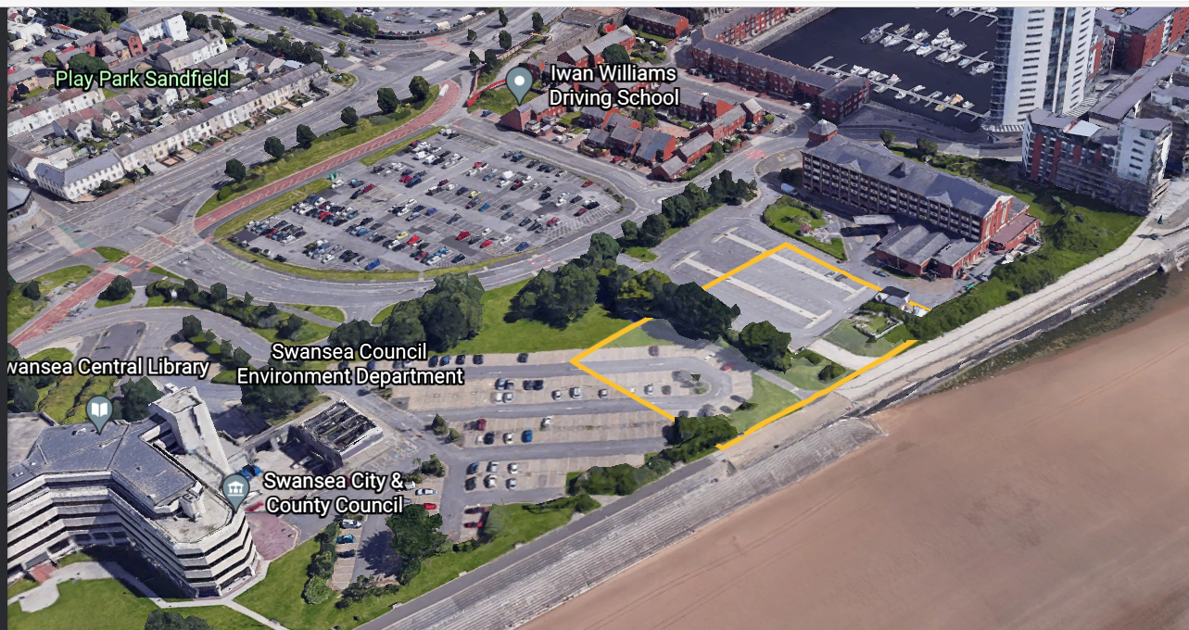
- Overhead View of Site Area)

Approximate site plan/ size. Located on Oystermouth road in between Marriott hotel and Swansea civic centre. Near Swansea marina (Old South dock).

- Historical Appraisal
The Swansea Civic centre, adjacent to the building site, was first opened in 1982 as the county hall and it was the headquarters for the former West Glamorgan County Council. (welshicons.org, n.d.)
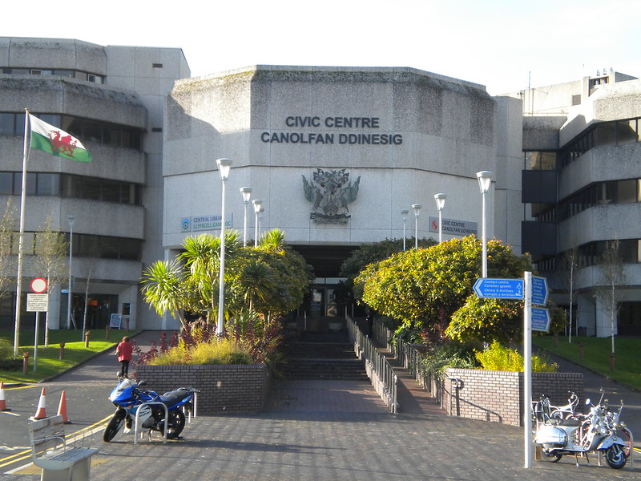
The Marriot hotel on the other side of the build site is built right next to what once was Swansea’s South dock. The dock was originally opened in 1859. The dock was well known for exporting fish and coal, but it was not limited to this. Iron ore, sand, gravel and timber are just a few of the other cargoes that were exported using this dock. (www.swanseadocks.co.uk, n.d.) The dock eventually closed in 1971 due to the decline in business and since then it has been developed by the Swansea council into the Swansea marina which is there today. (www.swanseadocks.co.uk, n.d.) According to (historypoints.org, n.d.) Swansea had extremely high amounts of copper imported from Cornwall, Anglesey and other places. Also, according to (historypoints.org, n.d.) One ship named the St Patrick exploded in the south dock carrying a shipment of coal in 1905.
(2. Swansea Civic Centre)
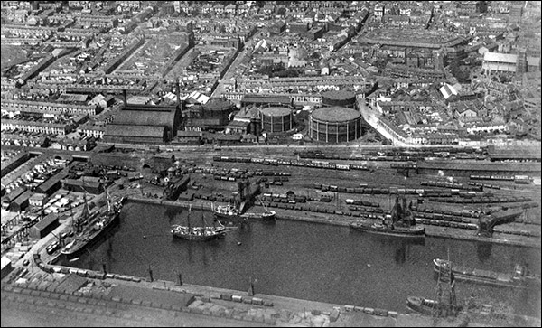
(3. Swansea South Dock 1859- 1971)

Another historical point that is relevant is that Oystermouth road was host to the Swansea and mumbles railway, which was built in 1804, invented to carry passengers as well as transporting goods back and forth from the dock such as limestone, iron ore and coal. The service began with horses pulling the minerals and the passengers but was replaced with steam in 1877 and then to overhead electric cables in 1929. (Worldwide Trams Wiki, n.d.)

- Findings from desk study

From my brief study of the site area in Swansea I have found a few key points about the history that may give some more information as to what tests need to be done. During my investigation into the areas past I have discovered that the area was once used as a dock used for imports and exports such as coal, iron ore, copper, limestone, gravel, sand and many other resources. This information may be vital for looking into the contamination of the ground as more research has shown that the old Swansea railway would have brought these materials through this site as the railway used to run from the docks down to mumbles.
One resource which can leave the ground contaminated is copper, this can be very serious to the build site as according to (WorldAtlas, 2018) copper can create a toxic environment for micro-organisms such as bacteria as well as having effects on human health. High levels of copper can lead to nausea, diarrhoea, chest pains and irritation of the respiratory tract. (WorldAtlas, 2018)
Another possible contamination that needs to be checked for by a geo technician is iron contamination. According to (Water Quality and Health Council, 2017) high levels of iron in water sources can lead to a build-up of bacteria that cause and unpleasant taste to the water, oil sheen on water’s surface, excessive corrosion of pipes and plumbing components and rusty slime build up on surfaces. This slime can be found on the boreholes as well. (Water Quality and Health Council, 2017)
One other point of interest is the ship that exploded on the dock in 1905. That will need to be looked at by the Geo technical engineer to see if there are still any traces of coal or any other poisonous substances from the explosion.

- Desk Study continued (present day)
The first thing I want to look at for this site is the most recent bore hole records.

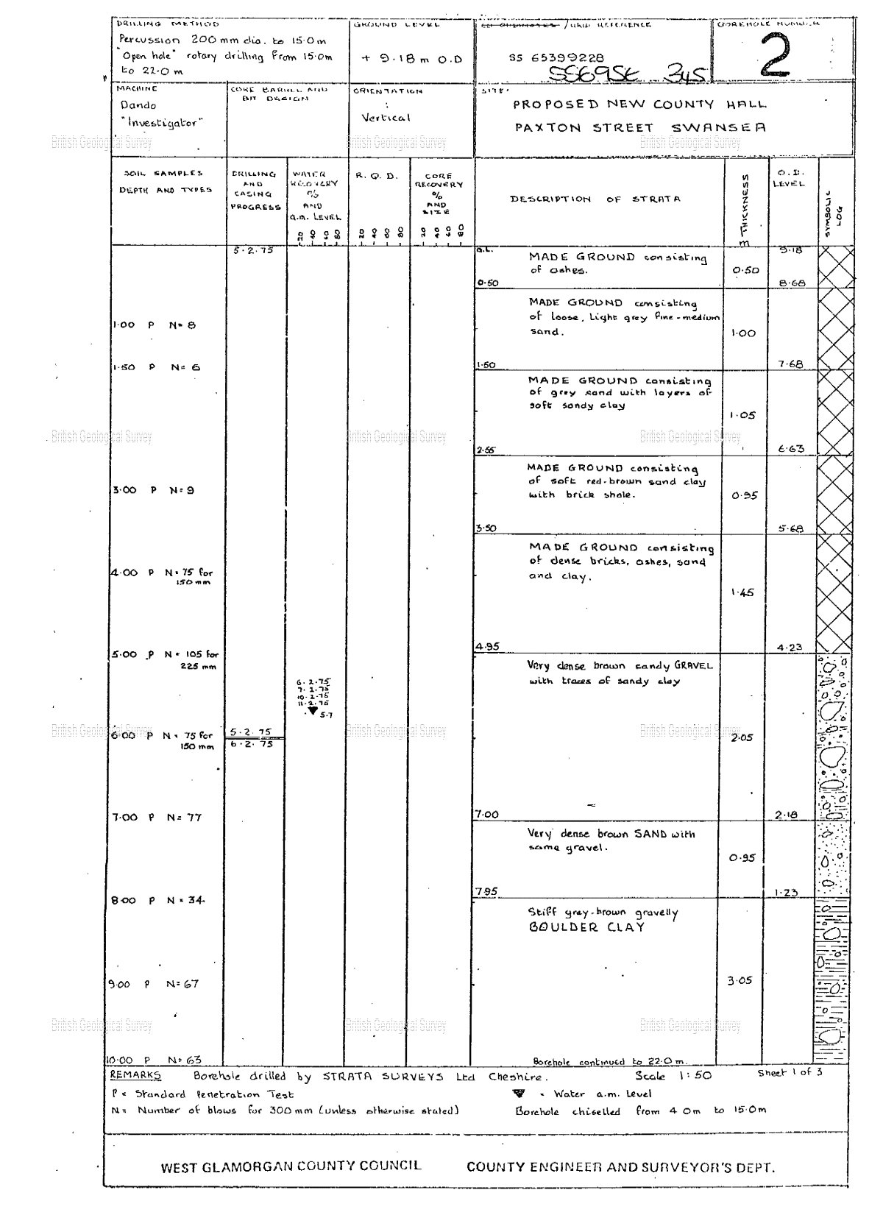
(4,5 & 6. Borehole Records)

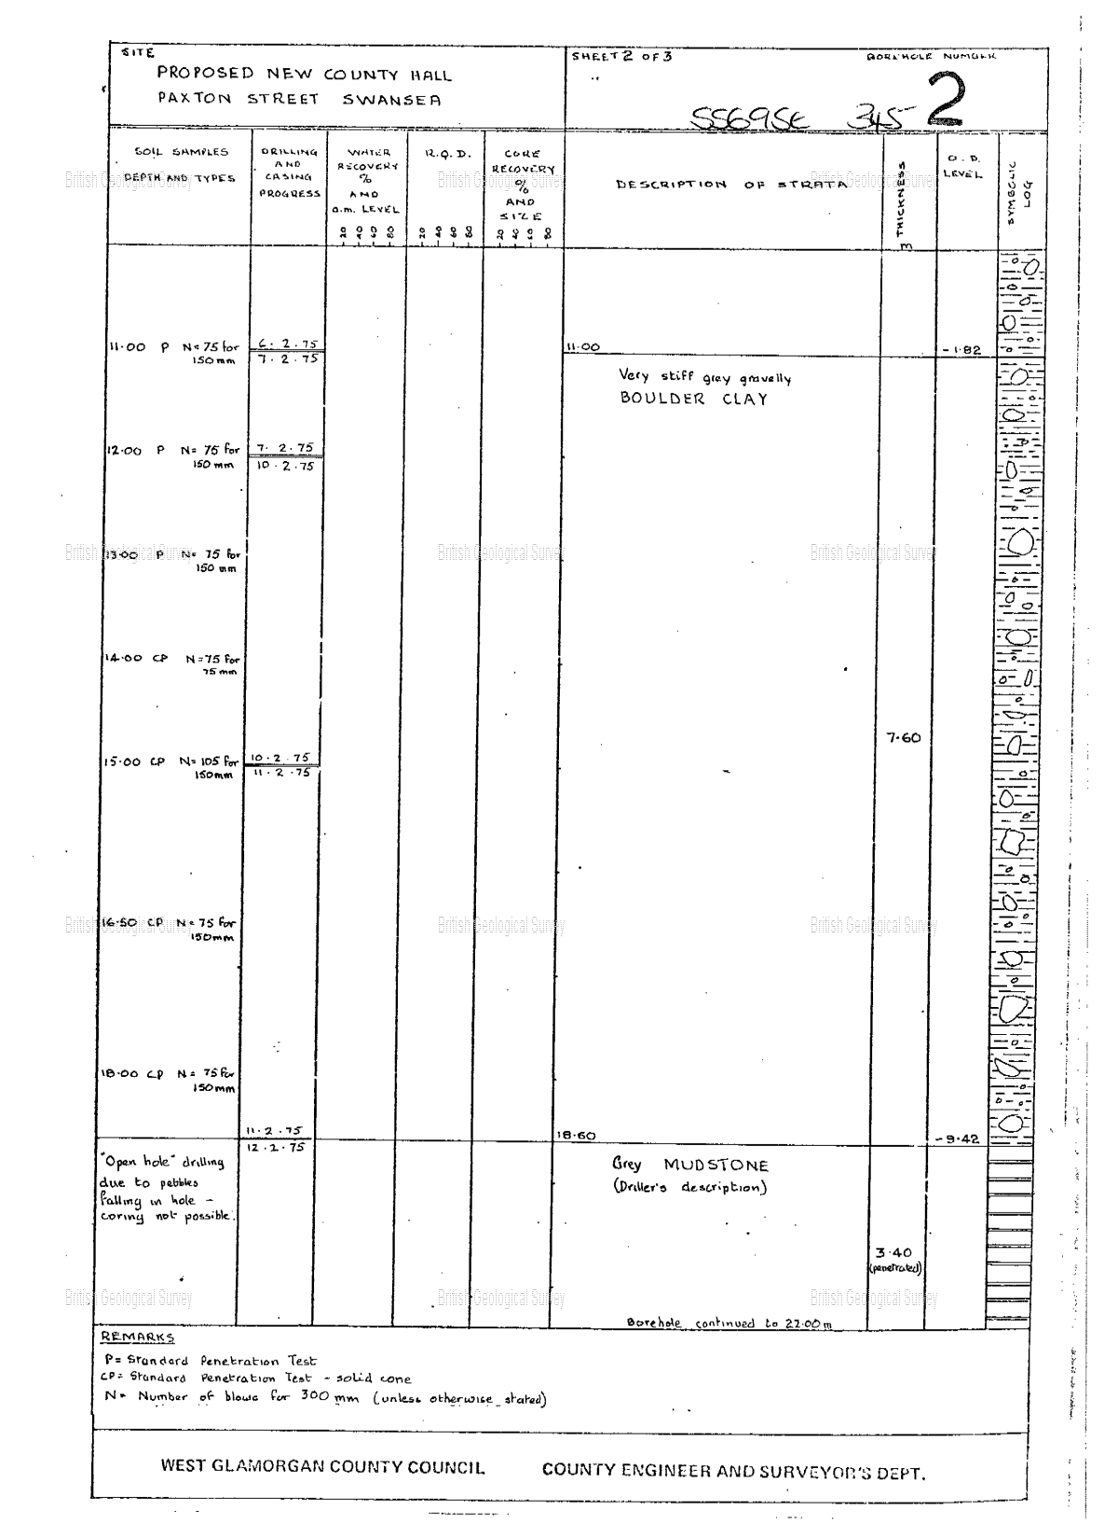
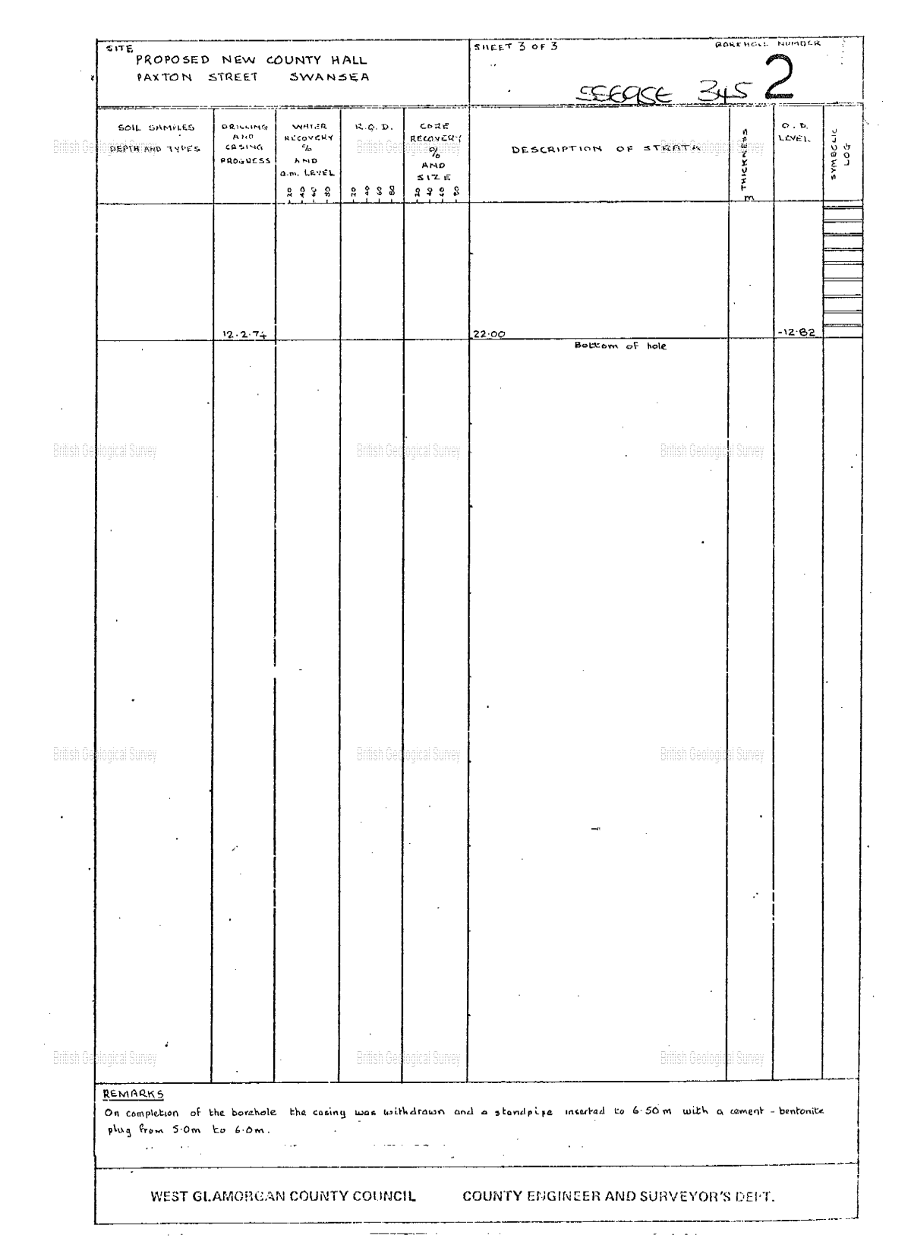
Bore holes are records made by Geotechnical engineers and surveyors that give us an insight on how the ground beneath us is made up. They are extensive records which show the different samples of soil, how deep they are and what they are made up of as well as a description of the water recovery and the drilling methods in the different layers.
This bore hole record shows that the holes were made using a percussion 200mm diameter drill from 0 to 15 metres and then used “open hole” rotary drilling from 15 to 22 metres.
These bore holes give an extensive look into the grounds make up and are extremely useful. Immediately you notice that the top 5 layers are man-made layers that are made up of small particulates such as ash, sand and soft sandy clay. This means that a shallow foundation will not be suitable for this site. After 4.95 metres the man-made ground stops and the ground below that becomes dense brown sandy gravel with traces of clay. Right below that then is a very dense brown sand with some gravel in it showing the ground is starting to become thicker. After 7.95 metres the ground becomes stiff grey-brown gravelly boulder clay which goes on until 11 metres where the ground then becomes very stiff grey gravelly boulder clay. This level shows that this site would be more suited to deep shaft foundations. The only concern with creating foundations in clay ground is the possibility of subsidence which is where the ground beneath a property shifts or shrinks by a marginal amount. This can cause a property to become unstable, can cause cracks in surfaces and in extreme examples of subsidence can tear apart the building.
Clay can sometimes cause subsidence because it retains water so if the water was to somehow escape the clay (one way of this happening is by too many trees being planted in the area so the roots of the trees sap up the water) they clay will begin to shrink causing subsidence.
Below the boulder clay, at 18.6 metres, there is grey mudstone which is a tougher sedimentary rock made up of a mixture of clay and silt which has settled (Auckland.ac.nz, 2019). This goes on until 22 metres which is the bottom of the bore hole.

The next thing I want to look at for the site is the rainfall levels of the area.
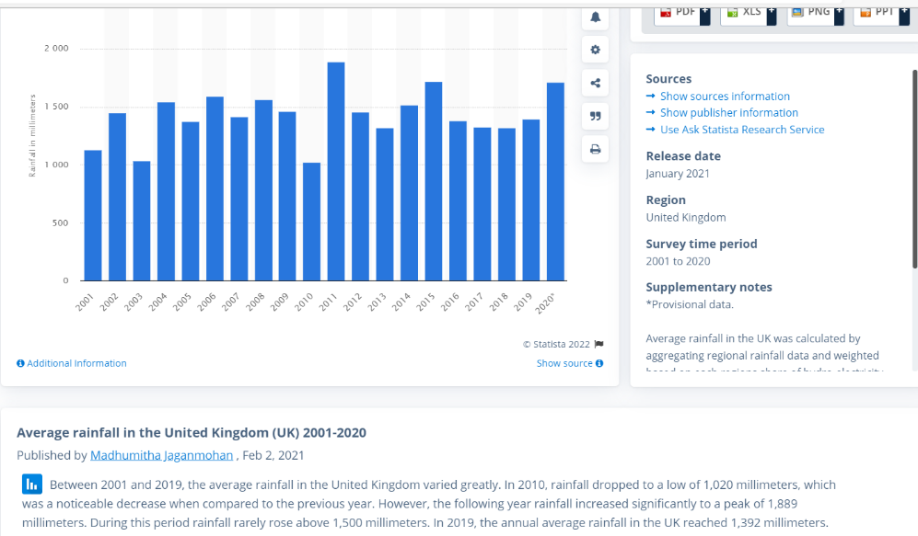
(7. Rainfall Averages, UK)

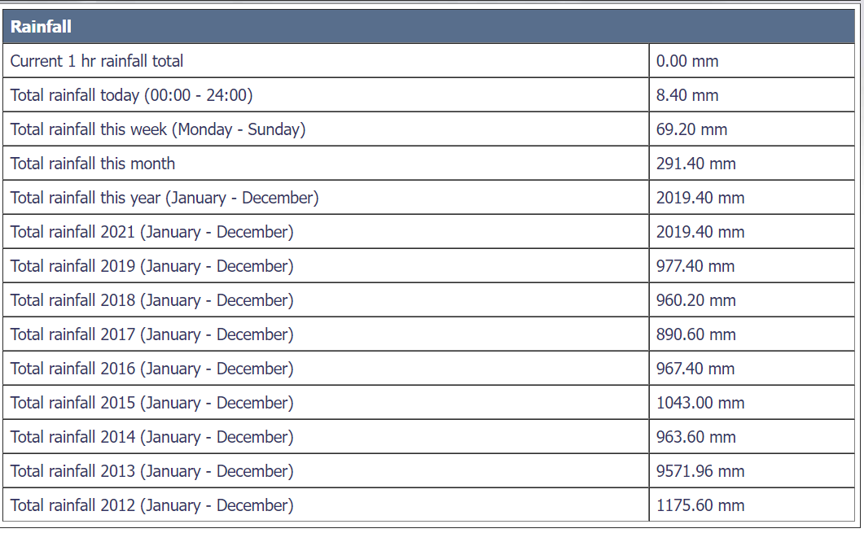
(8. Rainfall Records, Swansea)

The top chart is a chart showing average rainfall across all the UK from 2001 up to 2020 and the bottom table shows rainfall across the years just in Swansea from 2012 right up to 2021. As you can see here, most years the rainfall in Swansea is below the UK average but in 2013 and 2021 it is well above the average. The rainfall in 2013 is shown to be an anomaly compared to the other years surrounding it but hopefully it is the same case with 2021 otherwise there may be some problems that occur for the build as the build is already close to the sea so there is a high risk of flooding.

- Building Regulations/ Codes of Practice
Building regulations are a set of laws made to keep staff on site and the general public safe during and after a build is complete.
When building in Wales and all of the UK building regulations and codes of practice must be adhered to otherwise the company in charge of the construction site will be faced with a large penalty or they may have to hand the job over to another company to complete.
One Building regulation that applies to this building site is The Construction (Design and Management) Regulations 2015. This outlines the general duties of construction managers, clients and designers in terms of safe working and safe practice. Part of this regulation is ensuring that there is a safe site for workers to build on. Contaminated would not be considered safe so that would be in violation of the regulation. Also, since we will need to do an excavation for the supports, we will need to follow the guidance on excavations. It states in the regulation that all practicable steps must be taken to ensure that no part of the excavation collapses or traps anybody, no person or work equipment falls into the excavation hole, the ground next to the excavation isn’t overloaded with work equipment and there is suitable battering or supports for safety. (Legislation.gov.uk, 2015)
Another regulation that must be followed is the Management of Health and Safety at Work Regulations 1999. This was put in place to help employers identify hazards in a workplace and take steps to eliminate the hazard or if not possible prevent the hazard as much as possible. In this case there are a few hazards that can be easily identified on the site from my desk research alone. One of the hazards that has been identified is the possibility of flooding due to the high levels of rain and the site being so close to the sea. Unfortunately, there is nothing that can be done to completely prevent this as it is hard to stop the weather, but workers can be given waterproof clothes to protect them from the weather and make sure drainage works properly all throughout the area and make sure no equipment is left out to be damaged. Another risk that needs to be assessed is the ground of the site. Although we can be relatively sure that the site is safe to work on because there are other buildings a ground contamination inspection does need to be carried out to look for dangerous elements such as iron which can cause bacteria build up as excessive rust meaning that it will cost the company more in maintenance, copper is also another element that needs to be checked for as an excessive amount of copper on the site can cause harm to human health such as causing nausea.
As well as these regulations, there are also British standards that have been followed to collect my findings, some of them being: Ground testing (BS 5930), Quality management systems (BS EN ISO 9001), Geotechnical investigation and testing (ISO 14688-1:2002+A1:2013)

- Conceptual Ground model

There are many different options for foundations which are used in the construction industry. I briefly mentioned the 2 types of foundations when looking at the bore hole records, and they are shallow foundations and deep shaft foundations which are both self-explanatory names.

In this part of the report, I will demonstrate a few different types of shallow foundations and deep shaft foundations and explain why they may or may not be suitable.

Shallow Foundations

- Isolated footing
This is the most common type of foundation used in the construction industry. isolated footing foundations are shallow foundations where the columns go into the shallow ground and have square or rectangle footings at the end to support the weight which is calculated based on the size of the columns and the safe bearing capacity of the soil. (TheConstructor, 2018). Even though these are the most common foundation types, they are not suitable for this build as they rely on the shallow ground to be secure whereas the ground under this site is man-made and consists of small loose particulates.

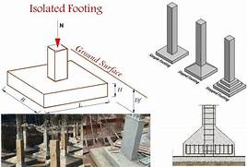
(9. Isolated footing Foundation Illustration)

- Combined footing
This type of foundation is constructed when columns are close enough together that their isolated footings overlap. Although they are like isolated footing foundation, they are structurally different as the footings are made u of rectangles instead off squares as they bear more horizontal weight (TheConstructor, 2018). This type of foundation is once again not suitable for the site as it is another shallow foundation and the top layers of soil under this site consist of loose particulates.
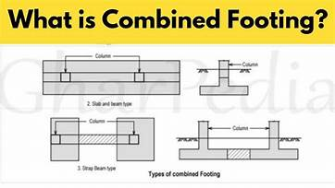
(10. Combined Footing Foundation Illustration)

Deep Shaft Foundations
- Drilled Shafts
This is where a cylinder hole is excavated into the ground and then filled back up with reinforced steel and concrete. It supports the pillars by skin friction between the concrete and the adjacent soil. (DRILLED SHAFTS Section 465 of Standard Specifications, n.d.). This is used in situations where the top layers of soil are not solid enough to bear weight so it would be more suitable for this site as deep shaft foundations are needed except for the fact it relies on the ground surrounding the concrete supports to be solid and the ground around this site mainly consists of boulder clay which is water bearing so would not be great for this foundation type.

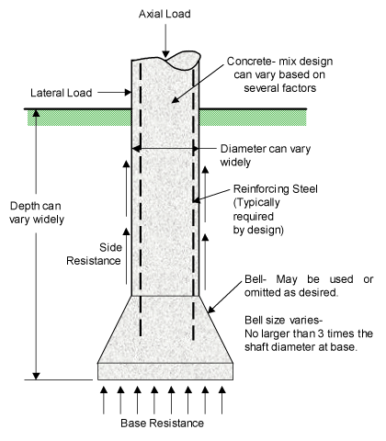
2. Pile Foundations
(11. Drilled Shaft Foundation Illustration)
This type of foundation aims to transfer the heavy load of a structure down much further into a rock’s strata. This type of foundation is essentially a long column that reaches down anywhere below the surface between 5 and 50 metres. Pile foundations not only work through skin friction (similarly to drilled shaft foundations) but they also work by end bearing. (TheConstructor, 2018) I think this type of foundation would be perfect for this build and I highly recommend using this foundation as not only does it solve the problem of having boulder clay by using end bearing on the grey mudstone beneath it but it also solves the problem of possible settlement differentials as they are going straight past the weaker soils that are likely to cause settlement and are loaded onto the stronger rock below. (TheConstructor, 2018)
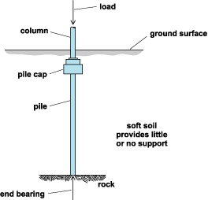

(12. Pile Foundation Illustration)

- References
welshicons.org. (n.d.). Welsh Icons News | Civic Centre, Swansea. [online] Available at: https://welshicons.org/cymrupedia/buildings-structures/civic-centre-swansea/ [Accessed 30 Dec. 2021].
‌ www.swanseadocks.co.uk. (n.d.). Swansea and Port Talbot Docks Website. [online] Available at: http://www.swanseadocks.co.uk/docksnewsite/southdock.html [Accessed 30 Dec. 2021].
‌historypoints.org. (n.d.). History Points - Swansea marina. [online] Available at: https://historypoints.org/index.php?page=swansea-marina [Accessed 30 Dec. 2021].
earth.google.com. (n.d.). Google Earth. [online] Available at: https://earth.google.com/web/@51.61310458 [Accessed 30 Dec. 2021].
‌hamster! (2009). Swansea Civic Centre. [online] Flickr. Available at: https://www.flickr.com/photos/33672038@N05/5021403218/.
Worldwide Trams Wiki. (n.d.). Swansea and Mumbles Railway. [online] Available at: https://trams.fandom.com/wiki/Swansea_and_Mumbles_Railway [Accessed 30 Dec. 2021].
‌WorldAtlas (2018). What Are The Sources And Effects Of Copper Pollution In The Environment? [online] WorldAtlas. Available at: https://www.worldatlas.com/articles/what-are-the-sources-and-effects-of-copper-pollution-in-the-environment.html.
Water Quality and Health Council. (2017). Keeping Iron Bacteria out of Your Well. [online] Available at: https://waterandhealth.org/safe-drinking-water/keeping-iron-bacteria-well/ [Accessed 15 Jan. 2020].
‌Auckland.ac.nz. (2019). Geology - rocks and minerals. [online] Available at: https://flexiblelearning.auckland.ac.nz/rocks_minerals/rocks/mudstone.html.
Statista. (2018). UK: average rainfall 2001-2018 | Statista. [online] Available at: https://www.statista.com/statistics/322810/average-rainfall-in-the-united-kingdom-uk/.

swansea.airqualitydata.com. (n.d.). Swansea.airqualitydata.com - City and County of Swansea Air Quality Monitoring. [online] Available at: https://swansea.airqualitydata.com/cgi-bin/currentreadings.cgi?met&1009 [Accessed 1 Jan. 2022].
‌Legislation.gov.uk (2015). The Construction (Design and Management) Regulations 2015. [online] Legislation.gov.uk. Available at: https://www.legislation.gov.uk/uksi/2015/51/contents/made.
Gov.uk (2011). The Management of Health and Safety at Work Regulations 1999. [online] Legislation.gov.uk. Available at: https://www.legislation.gov.uk/uksi/1999/3242/contents/made.
TheConstructor (2018). Types of Foundation and their Uses in Building Construction. [online] The Constructor. Available at: https://theconstructor.org/geotechnical/foundation-types-and-uses/9237/.
The Constructor. (2019). Types of Isolated Footings. [online] Available at: https://theconstructor.org/geotechnical/types-isolated-footings/34464/ [Accessed 2 Jan. 2022].
‌www.youtube.com. (n.d.). What is Combined Footing? - Combined Column Footing. [online] Available at: https://www.youtube.com/watch?v=W-zwNtJfv3g [Accessed 2 Jan. 2022].
DRILLED SHAFTS Section 465 of Standard Specifications. (n.d.). [online] Available at: https://dot.sd.gov/media/documents/Chapter4DrilledShafts.pdf [Accessed 2 Jan. 2022].
‌Anon, (n.d.). Drilled Shaft – Texas Shafts, Inc. [online] Available at: https://texas-shafts.com/education/drilled-shaft/ [Accessed 2 Jan. 2022].
‌

‌

‌

‌

‌

‌

‌

‌

‌

hamster! (2009). Swansea Civic Centre. [online] Flickr. Available at: https://www.flickr.com/photos/33672038@N05/5021403218/.
historypoints.org. (n.d.). History Points - Swansea marina. [online] Available at: https://historypoints.org/index.php?page=swansea-marina [Accessed 30 Dec. 2021]. ‌
scans.bgs.ac.uk. (n.d.). Page 1 | Borehole SS69SE345 | Borehole Logs. [online] Available at: http://scans.bgs.ac.uk/sobi_scans/boreholes/370246/images/10677923.html [Accessed 1 Jan. 2022]. ‌
scans.bgs.ac.uk. (n.d.). Page 2 | Borehole SS69SE345 | Borehole Logs. [online] Available at: http://scans.bgs.ac.uk/sobi_scans/boreholes/370246/images/10677924.html. ‌
scans.bgs.ac.uk. (n.d.). Page 3 | Borehole SS69SE345 | Borehole Logs. [online] Available at: http://scans.bgs.ac.uk/sobi_scans/boreholes/370246/images/10677925.html [Accessed 1 Jan. 2022].
Statista. (2018). UK: average rainfall 2001-2018 | Statista. [online] Available at: https://www.statista.com/statistics/322810/average-rainfall-in-the-united-kingdom-uk/. ‌
swansea.airqualitydata.com. (n.d.). Swansea.airqualitydata.com - City and County of Swansea Air Quality Monitoring. [online] Available at: https://swansea.airqualitydata.com/cgi-bin/currentreadings.cgi?met&1009 [Accessed 1 Jan. 2022]. ‌
The Constructor. (2019). Types of Isolated Footings. [online] Available at: https://theconstructor.org/geotechnical/types-isolated-footings/34464/ [Accessed 2 Jan. 2022]. ‌
www.youtube.com. (n.d.). What is Combined Footing? - Combined Column Footing. [online] Available at: https://www.youtube.com/watch?v=W-zwNtJfv3g [Accessed 2 Jan. 2022]. ‌
Anon, (n.d.). Drilled Shaft – Texas Shafts, Inc. [online] Available at: https://texas-shafts.com/education/drilled-shaft/ [Accessed 2 Jan. 2022]. ‌
TheConstructor (2018). Types of Foundation and their Uses in Building Construction. [online] The Constructor. Available at: https://theconstructor.org/geotechnical/foundation-types-and-uses/9237/. ‌

