

University of Wales Trinity Saint David

Module: Marketing Management
Assessment Title: Marketing Strategies Portfolio
Module Code: LCMB7024
Student name: Sherife Aleksieva
Student ID:2211682
Lecturer: Taonga Kaonga Sobere-Snithers

Table of Contents
Introduction 3
Element 1: Brand Extension Poster Presentation 3
Element 2: Develop a Segmentation, Targeting, Differentiation, and Positioning (STDP) Analysis for the brand extension 4
Element 3: Marketing Mix 7
Element 4: Reflection 10
Conclusion 11
References 13
Appendix 15

Introduction
This portfolio analyses brand development from a strategic perspective as a means of driving growth through a potential brand extension for Apple Inc. The application of STDB, SMT and the Extended Marketing Mix allows to assess how Apple Inc. can use innovation, sustainability and strategic alignment to increase brand equity and create a long-term competitive advantage.

Element 1: Brand Extension Poster Presentation
Apple Inc. is an international tech leader with the best quality when it comes to innovating, designing, and integrating physical and digital products. One of the significant areas of growth for Apple Inc. is wearables and digital health and therefore should create an additional digital health offering (Siahaan, 2023).

Image 1: Company Logo
(Source: Companies-explained.com. 2025)
As more consumers seek more proactive and individualised care options as a result of changes such as an ageing population and the rising cost of healthcare.
Delivering timely insights into personal health status and remote or telehealth using data from both their Apple Watch and iPhone provides both healthcare providers and consumers with a competitive advantage (Daviset al.,2022).In addition to providing a more proactive and individualised experience than what currently is offered today; the new digital health offering from Apple will be designed with a focus on sustainability, through energy efficiency, use of recycled materials and remote monitoring of consumers. Apple Health+ will positively impact brand loyalty through increased service revenue and position Apple as the leader in providing sustainable, tech-enabled digital solutions to help consumers improve their overall health and well-being (Apple (United Kingdom)). n.d.

Element 2: Develop a Segmentation, Targeting, Differentiation, and Positioning (STDP) Analysis for the brand extension
To effectively extend a brand, marketers must use market structure and consumer needs to identify the desirable poor-performing psychological segments of their customers or prospects. This segmentation helps geographically as well as demographically, psychographically, and behaviourally by analysing a potential target for each of these households via Apple Health.
Market Segmentation | Market Segmentation targets primarily developed urban markets; North America and Western Europe have high Digital Health Infrastructure, Disposable Income, and Smart Home Adoption Rates. Urban and suburban households experience time constraints, high healthcare costs, and good digital connectivity, all reasons why they are influenced by AI home health solutions (Msn.com. 2026).  Demographic Segmentation focuses on adults between 30 to 65 years old and the majority of this demographic continues to be Professionals and Older Consumers with a medium to high income. Most of these adults are now experiencing more health issues like Cardiovascular Risk, Sleep Disorders, and Stress-Related Problems, and as such, they have more means to purchase quality technology and subscriptions-based health services (Thapa et al., 2020). Therefore, Education Level also plays an important role in Health Consciousness and Adoption of Preventive Health Technologies.  Consumers focused on psychographics tend to place importance on their health, optimising themselves, and the technological advancements that come with it. They are individuals who are proactive, conscious about their health and want to have control over their health outcomes by choosing what data they want to share through technology. Their level of concern for privacy when sharing data is considered a major psychographic trait and influences their level of trust in the security of their personal data (Wardana et al., 2023).  Consumers who use behavioural segmentation are considered ‘early adopters’ of digital technology; specifically, those who use the iPhone/iPad and the watch as part of Apple’s ecosystem, and have used health apps and the health features in the Apple Watch and provided consistent data to the Apple ecosystem through the Apple Health application. This consumer segment is highly loyal to Apple and frequently uses Apple products and subscribes to Apple services. Consumers in this segment prefer integrated products over disparate products that create multi-brand products (Thapa et al., 2020).
Targeting Strategy | According to the segmentation analysis performed, Apple Health+ utilises a differentiated targeting strategy, which focuses primarily on health-oriented, urban professionals between the ages of 30 to 55 years who are currently integrated into Apple's ecosystem (Shabdanov, 2023). This group has considerable lifetime value, significant purchasing power and is very likely to adopt AI-enhanced health-related technologies; therefore, they represent a strategically advantageous target segment for Apple Health+.  A second target group is older people ages of 55 – 65 years with early-stage chronic illness or those who are interested in implementing preventative healthcare solutions. Although this group may show less confidence with technology than younger consumers, the intuitive design and seamless user experience of Apple products are expected to create minimal barriers to adoption (Jiang, 2024). Both groups likely value convenience, trustworthiness, and reliability when considering healthcare information, which makes them good candidates for a unified brand strategy.  Apple has intentionally decided to exclude price-sensitive customers, as well as those that oppose using technology altogether from its core target market due the pricing of its services and the way it uses a data-driven service model, which does not seem to fit within the expectations or capabilities of these customer segments. By identifying these target consumers are not a part of Apple's target markets, the company's decision to exclude these consumers provides Apple with an opportunity to enhance its brand image, through its exclusivity and provide continued protection over its premium price position in each of its market segments.
Differentiation Strategy | Apple Health+ provides a substantial distinction in the competitive digital health marketplace by virtue of three unique competitive positionings that integration with other parts of our ecosystem, privacy leadership, and the premium user experience provided by the Apple ecosystem (Bakker et al., 2025). In contrast with many of the competitors, where product offerings tend to be fragmented through the use of third-party integrations, Apple Health+ is fully integrated into the Apple ecosystem and thereby provides seamless integration of hardware, software and services.  Privacy is another key competitive differentiator. While most of the competitors like to monetise their users’ data for advertising or analytics, Apple places privacy as a core value of our brand (Ogunmokun, Balogun and Ogunsola, 2025). The use of end-to-end encryption and on-device AI processing builds trust between Apple and the customer, which is particularly true when considering the sensitive nature of health data. As privacy concerns remain a significant barrier to the adoption of digital health solutions, this differentiation is strategically important.  Apple Health+ focuses on providing preventive care rather than reactive care through diagnosis. The use of artificial intelligence (AI) to conduct data analysis on customers’ health patterns and risks earlier provides Apple Health+ with the ability to provide significant, actionable insights and move beyond just tracking to long-term management of well-being (Liang et al., 2025). By doing this, Apple Health+ differentiates itself from the majority of fitness-based wearable products while establishing a position in closer proximity to long-term wellness.
Positioning Strategy | Apple Health+ has been positioned in the following way, "Apple Health+ is an innovative, privacy-centric AI health solution delivered directly to consumers, enabling them to proactively manage their health at home." This positioning reflects Apple's overall brand positioning of innovation, trust and user empowerment as well as the emotional benefits of providing a sense of security and control for individuals while also delivering numerous functional benefits through accurate diagnostics and streamlined integration with existing Apple product ecosystems (Kpmg.com. 2026).  From the perceptual perspective of consumers, Apple Health+ occupies a space of both advanced technology and trusted solutions, clearly differentiating it from both low-cost health products and technologically advanced data solutions. This position also establishes a clear definition for Apple and its overall brand equity, making the transition from an advanced technology provider to an established and trusted partner in managing their personal health (Lamichhane and Neupane, 2022).

Element 3: Marketing Mix
Apple Health AI Home Diagnostics will utilise the marketing mix to create an appropriate way of bringing its products to consumers while supporting the premium brand image of Apple. The proposed new service will have a technology aspect paired with a service aspect and therefore the use of the 7Ps marketing mix aids in ensuring comprehensive and strategic alignment of product design, customer experience and long-term brand equity.
Product | Apple Health+is a cross-breed of smart diagnostic hardware with AI software and a digital subscription service. The primary benefit of the product is focused on preventive healthcare in that it allows consumers to track their own health metrics from the comfort of their homes. The augmented features of the product include, but are not limited to, effortless integration with Apple Watch, iPhone and the health app as well as providing telemedicine capabilities.  In terms of strategic alignment, the product complements existing Apple technological capabilities and brand reputation through its brand extension principle. Unlike many competitors who offer traditional brick-and-mortar type products, Apple Health+ provides an ecosystem solution that creates high switching costs and builds customer loyalty (Qiet al.,2017). The emphasis on privacy-as-a-priority AI processing will enhance consumer perceptions of product quality and reduce consumers' risk, which is essential for adoption of technology in the healthcare domain.
Price | The way that Apple Health+ is priced mirrors their overall brand strategy and value-based approach to price. The overall Apple Health+ pricing is made up of two distinct components; a hardware purchase for the diagnostic hardware plus a monthly subscription fee for the advanced artificial intelligence analytics and personalised health insights. The use of this hybrid pricing strategy doesn't just allow for generating recurring revenue from Apple Health+, but also makes it easy to access core features of the service (Dwivedi, Nayeemand Murshed, 2018).  Consumers perceive products of high value because of their trusted brands, and because of that they are willing to pay a premium price for themand particularly when they are in critical areas such as healthcare where privacy and data are major concerns. Additionally, through subscription pricing and long-term relationships between customers and Apple, the company has the ability to continually make improvements to their services, while being aligned with the company's overall strategic plans of service-led growth.
Place | The distribution strategy of distributing Apple directly to consumers using their omnichannel strategy by combining online and offline experiences will allow consumers to purchase Apple Health+ from Apple’s direct sources such as the Apple website, Apple retail, and third-party authorised retailers. With regards to the in-stores, Apple provides consumers with an experience of what it’s like to use the health technology by providing consumers with demonstrations and individualised assistance to support their adoption of this new technology (Wan, 2022).  Apple utilises its online platform and its existing device ecosystem, it is able to create a seamless and streamlined process for purchase, installation, and use. Apple's controlled distribution strategy offers consistent brand presentation and service quality throughout the entire distribution channel and will enable them to capture important customer data. By keeping distribution of contenting their channels only Apple, offers exclusivity and the ability to keep the image of the brand as being a premium brand.
Promotion | The advertising approach is focused more on building customer relationships via education and trust than through hard sales techniques. Apple Health+ is being promoted via launch events, storytelling through digital media, and by utilising content marketing that demonstrates real-world examples and benefits of the service; thus, focusing on preventative health care, wellness, and peace of mind instead of treating illnesses in the clinic. With many of Apple's owned media platforms being the primary sources for promoting its products, it will engage in minimal paid media use to support their messaging (Budionoand Ellitan, 2024).
People | The Apple Health+ value proposition heavily relies on individuals both customer support staff and those who engage in-store with consumers. The Apple Specialist team is well trained on how best to communicate complicated technology in an uncomplicated and comforting way. It is essential to offer this type of human connection within Health-related circumstances, as providing consumers with confidence and comfort can greatly impact their decision to use at service. Working with certified partners and healthcare professionals adds more credibility to at service (Gibsonet al.,2023).
Process | The design of the service process aligns with Apple's design philosophy by being user-centred and designed so that users can easily navigate their way through all phases of the service with very little difficulty using the guided onboarding and the automated synchronisation of data, as well as receiving information through AI-directed insights which are easy to read and understand - this emphasis on simplicity reduces the perception of complexity which is one of the most significant barriers for people using Digital Health Technologies (Lemola, 2024).
Physical Evidence | The quality of physical evidence improves confidence in sustainability via high-end design, eco-friendly materials and simplistic appearance demonstrating long-life expectancy and social responsibility for the product. Compact and recyclable packaging assists Apple when making its commitments to overall sustainability (Lutsenko, Tkachenkoand Olefirenko, 2024).  The health+ application on digital platforms provides evidence of professionalism, ease of use and reliability associated with managing personal health history through use of each of these elements such as relatable graphics and tailored dashboard capabilities.

Element 4: Reflection
Creating Apple Health+ AI Home Diagnostics' brand extension proved to be one of the most meaningful learning experiences I have had. Through this experience, I developed my strategic thinking skills as well as my analytic and reflective ability. I was required to go from theoretical comprehension to practical application of marketing concepts that are generally thought of as abstract in the context of a realistic business environment. By replicating theoretical models into a coherent strategic direction for how to develop a brand extension, I gained a greater understanding of how theory informs practice. For example, applying STDP and the extended marketing mix informed my understanding that even though strategic marketing decisions should be made in an integrative and mutually reinforcing fashion; they should also not be viewed/acted upon in isolation.
Through the creation of the brand extension, one of my initial insights was the importance of finding a strategic fit before you conduct successful brand extensions. Although Apple had high brand equity and has strong technological capabilities, my analysis found that not every brand extension was appropriate or credible. As a result of analysing the marketplace and emerging trends in digital healthcare, preventative care and sustainability; my ability to conduct systematic analyses; and justify strategic decisions with evidence rather than assumptions, increased my ability to apply critical thinking and make sound decisions. Ultimately, this experience developed my judgment and critical thinking skills in dealing with complex and uncertain market conditions.
My abilities of communication and persuasion have further developed through my preparation and delivery of a poster presentation. In order to create visuals of complex and strategic information that were time-limited, I needed to focus on clarity, relevance to the audience, and the priorities of the project. This subsequently improved my ability to communicate strategic value propositions to investors and customers.
This project has developed my digital literacy and ethical awareness about data privacy and sustainability within the context of health technology. Through increased knowledge about privacy-focused positioning as a method of differentiating from competitors, I have also gained a better understanding of the contemporary marketing issue, as well as the responsibilities of marketers. The project has helped me to develop skills for both personal and professional growth in problem solving, making decisions with incomplete information, and working independently.
In future endeavors, I plan to employ a variety of quantitative analysis methods and utilise more consumer-centric primary research in developing strong strategic rationales. In addition, I will seek more frequent and earlier feedback from peers and/or tutors as a way of refining my ideas iteratively throughout the development process.

Conclusion
This portfolio demonstrates how the strategic brand extension, supported by a comprehensive analysis and theoretical frameworks, can be an important driver of long-term business growth. This project demonstrates the role and relevance of connecting STDP, marketing mix, and reflective practice to achieve sustainable business success by building an understanding of the connections between brand values, market needs, and innovation in the current state of marketing management.

References
‌Wardana, M.A., Masliardi, A., Afifah, N., Sajili, M. and Kusnara, H.P., 2023. Unlocking purchase preferences: Harnessing psychographic segmentation, promotion and location strategies. Jurnal Informatika Ekonomi Bisnis, pp.713-719.
Apple (United Kingdom). n.d. Healthcare. [online] Available at: https://www.apple.com/uk/healthcare/. [Accessed Date: 9th Feb, 2026]
Bakker, J.P., Izmailova, E.S., Clement, A., Hoffmann, S., Leptak, C., Menetski, J.P. and Wagner, J.A., 2025. Regulatory pathways for qualification and acceptance of digital health technology‐derived clinical trial endpoints: considerations for sponsors. Clinical Pharmacology & Therapeutics, 117(1), pp.56-72.
Budiono, K. and Ellitan, L., 2024. The Efficiency and Performance of Apple’s Supply Chain Management. ULIL ALBAB: Jurnal Ilmiah Multidisiplin, 3 (5), 46, 67.
Companies-explained.com. 2025. Apple Inc. - Company Overview | Companies Explained. [online] Available at: https://companies-explained.com/companies/apple.html. [Accessed Date: 9th Feb, 2026]
Davis, M., Kirwan, M., Maclay, W. and Pappas, H. eds., 2022. Closing the care gap with wearable devices: Innovating healthcare with wearable patient monitoring. CRC Press.
Dwivedi, A., Nayeem, T. and Murshed, F., 2018. Brand experience and consumers’ willingness-to-pay (WTP) a price premium: Mediating role of brand credibility and perceived uniqueness. Journal of Retailing and Consumer Services, 44, pp.100-107.
Gibson, C.B., Gilson, L.L., Griffith, T.L. and O’Neill, T.A., 2023. Should employees be required to return to the office?. Organizational Dynamics, 52(2), p.100981.
Jiang, B., 2024. Apple’s Journey: The strategic evolution from startup to tech Giant. In SHS Web of Conferences (Vol. 207, p. 01027). EDP Sciences.
Kpmg.com. 2026. Welcome To Zscaler Directory Authentication. [online] Available at: https://kpmg.com/in/en/insights/2025/10/ai-in-healthcare-reimagine-care-with-ai-driven-transformation.html [Accessed Date: 9th Feb, 2026]
Lamichhane, B. and Neupane, N., 2022. Improved healthcare access in low-resource regions: A review of technological solutions. arXiv preprint arXiv:2205.10913.
Lemola, M., 2024. Towards user-and customer-centricity: service design maturity and user experience capability in organizational transformation.
Liang, W., Mary, B.J., Aidoo, S., Hamzah, F., Taofeek, A., Mathew, B. and Blessing, M., 2025. AI-Augmented Business Intelligence and Wearable Health Tech: Converging Consumer Insights and Personalized Medicine Through Real-Time Analytics.
Lutsenko, A., Tkachenko, P.I. and Olefirenko, O.M., 2024. Impact of corporate environmental responsibility on business competitiveness and sustainability.
Msn.com. 2026. MSN. [online] Available at: https://www.msn.com/en-us/technology/artificial-intelligence/apple-reportedly-drops-plans-for-ai-doctor-in-health-app/ar-AA1VRBMO?ocid=BingNewsSerp[Accessed Date: 9th Feb, 2026]
Ogunmokun, A.S., Balogun, E.D. and Ogunsola, K.O., 2025. The role of business analytics in enhancing revenue optimization and competitive advantage in e-commerce. Gulf Journal of Advance Business Research, 3(3), pp.952-963.
Qi, J., Yang, P., Min, G., Amft, O., Dong, F. and Xu, L., 2017. Advanced internet of things for personalised healthcare systems: A survey. Pervasive and mobile computing, 41, pp.132-149.
Shabdanov, B., 2023. STRATEGIC ANALYSIS REPORT ON APPLE INC. Journal of Entrepreneurship & Innovation, 15(15).
Siahaan, M., 2023. Analysis and Evaluation of the Business Innovation Strategy: A Case Study of Apple Inc. Enigma in Economics, 1(2), pp.42-48.
Thapa, D.K., Visentin, D.C., Kornhaber, R. and Cleary, M., 2020. Prevalence and factors associated with depression, anxiety, and stress symptoms among older adults: A cross‐sectional population‐based study. Nursing & Health Sciences, 22(4), pp.1139-1152.
Wan, X., 2022. Omnichannel distribution to fulfill retail orders. Manufacturing & Service Operations Management, 24(4), pp.2150-2165.

Appendix

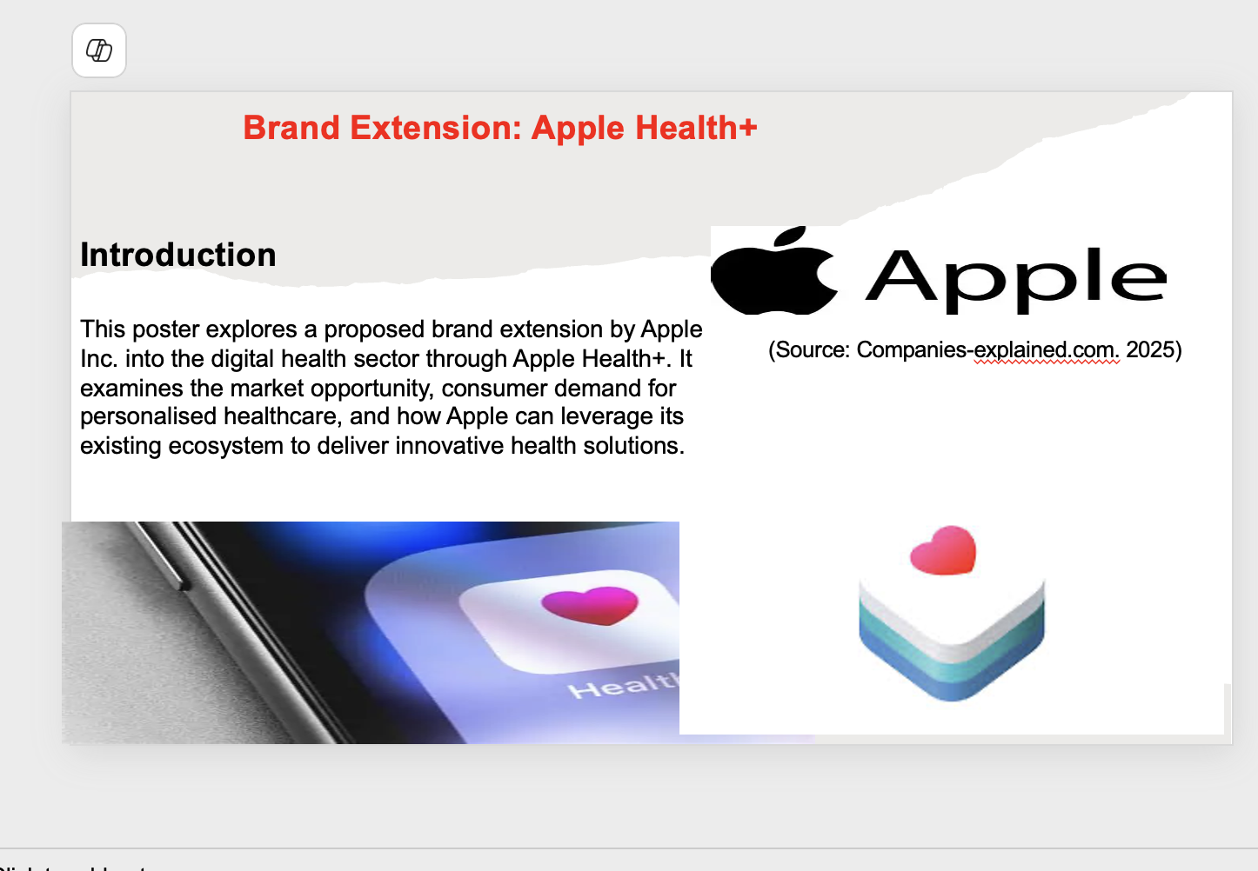

Appendix


