Data Security, Governance and Compliance
Security Frameworks, Governance Design, and Regulatory Compliance
Case Study: FinSure Bank (FSB)

MUHAMMAD AKTERUZZMAN

1. Introduction
Over the past decade, financial services have transformed so rapid that many of the risk frameworks organisations relied on in the early 2010s are barely recognisable today. The move towards fully digital, cloud-hosted banking has brought obvious benefits — lower operating costs, faster product development, and broader customer reach — but it has also created a threat surface that is wider, more dynamic, and considerably harder to defend than anything the sector previously faced [1]. FinSure Bank (FSB) sits squarely in the middle of this challenge. As a digital-first institution with more than 90% of its infrastructure running on external cloud platforms, FSB has accumulated risk considerably faster than it has accumulated governance structures, and the gap is beginning to show in ways that regulators and customers are both likely to notice.
What makes FSB's situation particularly difficult is the number of pressures converging simultaneously. The bank is expanding across multiple countries, which brings regulatory obligations in every jurisdiction it enters. It is simultaneously allowing employees, contractors, and external partners to access internal systems from personal devices under a Bring Your Own Device (BYOD) model that has not yet been underpinned by robust policy. Its customers are increasingly using mobile banking applications, raising legitimate concerns about data privacy, identity fraud, and the integrity of financial records. And yet, despite handling some of the most sensitive personal and financial data imaginable, the organisation operates without a unified security governance model, without a formal risk management strategy, and without structured compliance auditing [2]. Each of these gaps, taken individually, would represent a serious concern. Together, they represent a systemic vulnerability.
This assessment addresses that vulnerability directly. It begins by examining four of the most widely adopted information security frameworks — ITIL v4, ISO/IEC 27001, the NIST Cybersecurity Framework (CSF 2.0), and COBIT 2019 — and considers what each offers an organisation in FSB's position. It then draws on those frameworks to propose a Unified Security Governance Architecture (USGA) for the bank: a practical, scalable design that is grounded in internationally recognised standards and calibrated to FSB's specific risk profile. The final section engages with a broader question: why is it not merely sensible, but genuinely necessary, for regulatory standards to keep evolving? The discussion is anchored in the factors the assignment identifies — compliance law, governance, security policy, risk management, contingency planning, protection mechanisms, and service level management — and supported by evidence from industry research and regulatory practice.

2. Research into Security Frameworks and Models
Understanding the available frameworks is not merely an academic exercise. Each of the frameworks discussed below represents decades of accumulated knowledge about what actually works when organisations try to manage information security at scale — and, crucially, what fails. For FSB, the challenge is not picking one and ignoring the rest. As Figure 1 (the Unified Governance Architecture presented in Section 3) shows, the most effective approach is understanding how these frameworks complement and reinforce one another [15].

2.1 ITIL — Information Technology Infrastructure Library
ITIL is best understood as a framework for making IT services run reliably and in alignment with what the business actually needs. Its fourth iteration, ITIL v4, introduced the Service Value System (SVS) — a model that encourages organisations to think of IT not as a collection of technical components, but as an integrated system for co-creating value with customers and stakeholders [2]. The guiding principles are deceptively simple: focus on what delivers value, work collaboratively, think holistically, and improve continuously [19]. None of these sound like security principles on the surface, but they are — because security that is not embedded in the value chain will always be treated as a constraint rather than an enabler.
For FSB, the most immediately useful parts of ITIL are its incident management, problem management, and change management processes. When a security breach occurs — and in the current threat environment it is a question of when rather than if — having a structured incident management process already in place makes an enormous practical difference to the speed and quality of the response [26]. ITIL's supplier management guidance is equally critical given FSB's dependence on third-party vendors and cloud providers: it provides a ready-made structure for defining security expectations, measuring performance, and enforcing compliance through formal service review processes. The Continual Service Improvement (CSI) loop, meanwhile, ensures that security is never treated as a project with an end date [2].

Figure 1: ITIL 4 Service Value Chain — Security Touchpoints for FSB
ITIL Stage | Key Activity | Security Relevance for FSB
Plan | Strategic direction & governance | Define security policies, risk appetite, board reporting lines
Engage | Stakeholder interaction | Third-party & contractor security onboarding and vetting
Design & Transition | Service design and testing | Secure system architecture, BYOD policy design, cloud controls
Obtain/Build | Sourcing & development | Secure SDLC, cloud vendor risk assessment, IaC scanning
Deliver & Support | Operations & incident management | Incident response, DLP controls, real-time fraud detection
Improve | Continual service improvement | Security audit cycles, KPI measurement, post-incident reviews
Figure 1: ITIL 4 Service Value Chain and Security Touchpoints for FSB

2.2 ISO/IEC 27001 and the ISO 27000 Family
If ITIL provides the operational logic for running secure services, ISO/IEC 27001 provides the management system that holds everything together. It is the internationally recognised standard for Information Security Management Systems (ISMS), and it works by requiring organisations to systematically identify their information risks and then apply a proportionate, documented set of controls to manage them [4]. The 2022 revision reorganised the Annex A control set from 114 controls across 14 domains to 93 controls across four themes — organisational, people, physical, and technological — a restructuring that better reflects the realities of modern cloud-heavy environments and removes the implicit assumption that a physical perimeter is the primary security boundary.
The broader ISO 27000 family extends the coverage significantly. ISO 27002 provides detailed implementation guidance for each control. ISO 27005 (updated in 2022) offers a structured, iterative approach to information risk management that integrates naturally with the ISMS. ISO 27701, a privacy extension, maps directly onto GDPR requirements — which makes it immediately relevant to FSB's obligations across European markets [24]. Achieving ISO 27001 certification would also serve a commercial purpose for FSB: it signals to regulators, corporate clients, and sophisticated retail customers alike that the bank takes information security seriously enough to have it independently verified — a meaningful differentiator in a sector where trust, once lost, is extraordinarily difficult to rebuild [22].

2.3 NIST Cybersecurity Framework (CSF 2.0)
The NIST Cybersecurity Framework was originally designed for critical infrastructure operators in the United States, but its practical flexibility has driven adoption far beyond that initial scope [5]. Unlike ISO 27001, it does not prescribe a specific management system or require certification; instead, it organises cybersecurity activity around six functions — Identify, Protect, Detect, Respond, Recover, and the Govern function added in the 2024 update — that map onto the natural lifecycle of managing cybersecurity risk [14]. The addition of Govern is significant: it reflects a growing consensus that cybersecurity cannot be managed sustainably from the technology function alone, and that board-level ownership is a prerequisite for genuine resilience.
For FSB, the NIST CSF provides an excellent operational lens that complements ISO 27001's management rigour. Importantly, the two frameworks are designed to be used in conjunction — NIST provides the operational vocabulary and functional structure, while ISO 27001 provides the documented management system and audit trail that regulators and certification bodies require [16].

2.4 COBIT — Control Objectives for Information and Related Technologies
COBIT 2019, developed by ISACA, operates at a different level to the other frameworks. Where ITIL focuses on service delivery and ISO 27001 on security management, COBIT focuses on IT governance itself — the structures, processes, and accountabilities by which an organisation's leadership directs, monitors, and evaluates the use of technology [6]. Its Evaluate, Direct, and Monitor (EDM) domain is particularly relevant for FSB: EDM01, the objective concerned with ensuring the governance framework is properly established and maintained, provides a board-level template for formally taking ownership of information security risk [25]. The broader COBIT framework also maps its objectives directly onto legal and regulatory requirements — including GDPR and sector-specific financial regulations — making it a practical tool for gap analysis and producing the audit-ready documentation that regulators increasingly demand [21].

3. Proposed Security Governance and Compliance Design for FSB

3.1 Design Philosophy and Architecture
The fundamental problem with FSB's current position is not a shortage of good intentions — it is the absence of a coherent structure through which those intentions can be translated into consistent, auditable security practice. The proposed Unified Security Governance Architecture (USGA) addresses that by layering COBIT at the governance level, ISO 27001 as the ISMS core, NIST CSF as the operational framework, and ITIL as the service delivery mechanism [1]. Each layer supports and reinforces the others; none is optional.
Deloitte's 2023 analysis of operational resilience in financial services found that institutions which integrate governance frameworks architecturally — rather than bolting them together reactively after an incident — demonstrate significantly lower mean times to detect and contain security breaches [20]. McKinsey's 2024 cybersecurity research for banking institutions reaches a similar conclusion: the banks that have navigated the current threat environment most successfully are those that treated security as a governance discipline from the outset, not as an IT problem to be delegated downward [27].

Table 1: FSB Unified Security Governance Architecture — Framework Mapping
Governance Domain | Primary Framework | Supporting Framework | FSB Priority
Strategic governance | COBIT 2019 | ISO 27001 | Board accountability, risk appetite, ISSC
Risk management | ISO 27005 | NIST CSF (Identify) | Cloud, BYOD, third-party, insider threat
Security operations | NIST CSF | ITIL 4 | Threat detection, incident response, SOC
Compliance & audit | ISO 27001 | COBIT MEA | GDPR, UK GDPR, FCA, PCI DSS
Service management | ITIL 4 | COBIT DSS | SLAs, supplier management, vendor review
Continuity & recovery | ISO 22301 | NIST CSF (Recover) | BIA, RTO/RPO, DR testing, tabletop exercises
Table 1: FSB Unified Security Governance Architecture — Framework Mapping

3.2 Governance, Strategic Planning, and Policy
Governance without clear accountability is, in practice, just documentation. For FSB, establishing real governance means creating structures in which named individuals at the highest levels of the organisation are formally responsible for security outcomes. Concretely, this requires an Information Security Steering Committee (ISSC) — chaired by a properly resourced CISO, with representation from the board, legal, operations, and technology — that meets quarterly to review risk posture, compliance status, and emerging threat intelligence [6]. The COBIT EDM01 objective is directly applicable here: it requires that the governance framework itself — the policies, structures, and processes through which IT-related decisions are made — be formally evaluated, directed, and monitored by leadership [25].
Policy hierarchy matters as much as governance structure. At the apex, a board-endorsed Information Security Policy sets the organisation's commitment and risk tolerance. Beneath that, domain-specific policies address: BYOD and mobile device management; cloud security and third-party access; data classification; authentication and access management; incident response; and acceptable use [4]. The BYOD question is particularly urgent. Every unmanaged personal device connecting to FSB's cloud environment is, effectively, an uncontrolled entry point. Devices must be enrolled in a Mobile Device Management (MDM) platform, meet minimum security standards — full-disk encryption, current OS patching, active lock-screen — and be subject to remote wipe capability in the event of loss or compromise [18].

3.3 Risk Management
Effective risk management is a continuous cycle, not a one-time audit exercise. ISO 27005 provides the methodological backbone, covering context establishment, asset identification and classification, threat and vulnerability analysis, risk evaluation, treatment selection, and ongoing monitoring [24]. Integrated with NIST CSF's Identify function — which drives the asset inventory, threat modelling, and vulnerability identification work — this gives FSB a comprehensive risk management process with clear ownership and escalation paths. Every risk in the register needs an owner, a documented treatment plan, a review timeline, and a mechanism for reporting residual risks to the ISSC.

Table 2: FSB Risk Register — Illustrative Top Risks
Risk | Likelihood | Impact | Rating | Treatment
Unauthorised BYOD access | High | Critical | Critical | MDM enrolment, NAC, mandatory MFA
Third-party / supply chain breach | Medium | High | High | Vendor risk assessments, right to audit, contractual SLAs
Cloud misconfiguration | High | High | Critical | CSPM tooling, IaC scanning, cloud security baseline
Insider threat / data exfiltration | Medium | Critical | High | DLP controls, UEBA, privileged access review
Ransomware attack | Medium | Critical | High | Endpoint protection, immutable backups, tested IRP
GDPR / regulatory non-compliance | Low | Critical | High | DPO appointment, DPIAs, 72-hour breach notification
Table 2: FSB Risk Register — Illustrative Top Risks

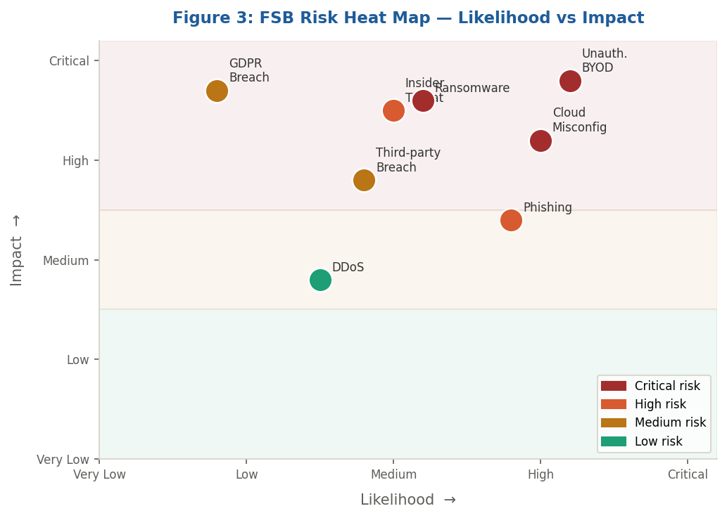
Figure 3: FSB Risk Heat Map — Likelihood vs Impact Assessment

Figure 3 visualises FSB's key risks plotted against likelihood and impact axes. Unauthorised BYOD access and cloud misconfiguration emerge as the most critical concerns — both high likelihood and critical impact — confirming they must be prioritised in the treatment plan. The heat map also illustrates an important principle: organisations that focus exclusively on high-likelihood risks miss the catastrophic-but-less-frequent threats such as GDPR non-compliance, which sits in the lower left but carries critical impact should it materialise [9].

3.4 Protection Mechanisms and Technical Controls
Technical controls must be layered across every tier of the technology stack: perimeter, network, identity, application, and data. At the perimeter, Next-Generation Firewalls (NGFWs) and Web Application Firewalls (WAFs) provide the first line of defence, while Cloud Access Security Brokers (CASBs) give FSB visibility and control over data flowing to and from cloud services [1]. Network segmentation limits the blast radius of any breach that penetrates the perimeter; Zero Trust Network Access (ZTNA) principles ensure that no user or device is implicitly trusted simply because it has authenticated once [23].
Identity is, in many contemporary assessments, the new perimeter. Multi-Factor Authentication (MFA) must be mandatory for all privileged accounts and all remote access without exception. Privileged Access Management (PAM) tools should govern administrative credentials. Data at rest must be encrypted using AES-256; data in transit must use TLS 1.3 as a minimum [18]. A SIEM platform integrated with User and Entity Behaviour Analytics (UEBA) provides the real-time detection capability needed to catch anomalous patterns — whether from an external attacker or a malicious insider — before they escalate into a reportable breach [17]. Annual penetration testing, combined with continuous automated vulnerability scanning, ensures the control framework is stress-tested against real-world attack techniques rather than theoretical threats [23].
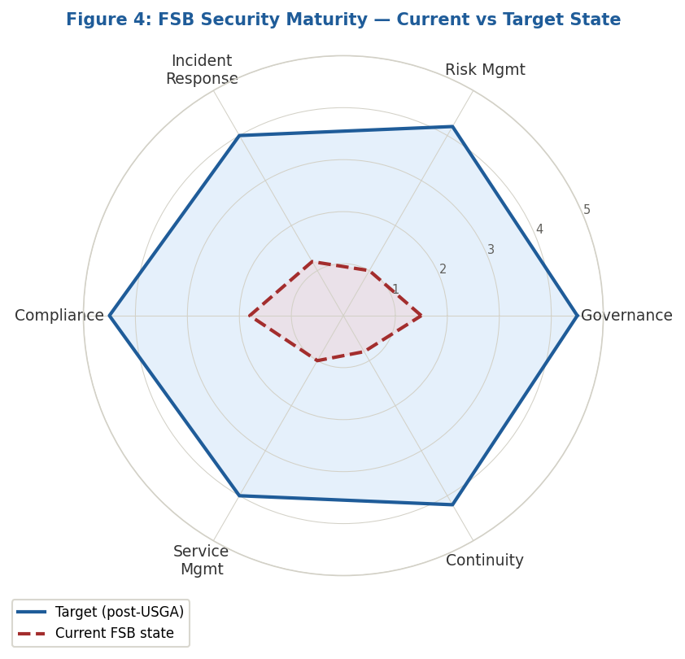
Figure 4: FSB Security Maturity — Current vs Target State (scale 1–5)

Figure 4 illustrates FSB's current security maturity against the target state the USGA is designed to achieve. The gap is widest in risk management, incident response, and business continuity — precisely the areas where the bank's cloud-first, BYOD-exposed profile creates the greatest exposure. The radar chart is not merely illustrative: it provides a practical tool for the ISSC to track progress across dimensions, set investment priorities, and communicate posture improvements to the board in non-technical terms [20].

3.5 Compliance — Laws, Ethics, and Multi-Jurisdictional Obligations
Compliance in a multi-jurisdictional financial institution is unavoidably complex, but it is important not to reduce it to box-ticking. FSB's compliance obligations span multiple overlapping frameworks. GDPR applies wherever the bank processes personal data belonging to EU or EEA residents — which, given FSB's expansion across multiple countries, almost certainly means it applies everywhere [7]. The UK GDPR imposes broadly equivalent obligations for UK data subjects post-Brexit. In practice, this means FSB needs a Data Protection Officer (DPO), documented lawful bases for every processing activity, a robust data subject rights process, Data Protection Impact Assessments (DPIAs) for high-risk processing, and a tested procedure for notifying the relevant supervisory authority within 72 hours of discovering a breach [12].
Financial services regulation adds further layers. The FCA's operational resilience framework requires UK-regulated firms to identify their important business services, set impact tolerances, and demonstrate they can remain within those tolerances during severe but plausible disruption [28]. PCI DSS v4.0 governs card payment processing security [29]. Ethically, FSB's fraud detection and credit-scoring algorithms carry real potential for discriminatory outcomes if not designed and monitored with fairness in mind. A Privacy by Design approach — embedding data minimisation and transparency into product development from the outset — is increasingly both a regulatory expectation and a competitive necessity [7].

3.6 Contingency Planning and Service Level Agreements
Contingency planning is an act of institutional honesty: a recognition that controls fail, systems go down, and what separates a resilient organisation from a fragile one is not the absence of failures but the quality of the response [8]. ISO 22301 provides the Business Continuity Management System (BCMS) framework. A Business Impact Analysis (BIA) identifies critical processes and their maximum tolerable period of disruption, from which Recovery Time Objectives (RTOs) and Recovery Point Objectives (RPOs) are derived. These parameters drive the design of Disaster Recovery Plans (DRPs) and the cloud resilience architecture — multi-region deployments, automated failover, and immutable backups [13]. The Incident Response Plan (IRP) needs to be a detailed, role-specific document tested through tabletop exercises at least twice annually [17].
SLAs with cloud providers and third-party suppliers are, in effect, security controls. Key clauses must address: availability guarantees with meaningful financial consequences for breach; incident notification timelines that satisfy GDPR's 72-hour window; data sovereignty guarantees; audit rights; data return and deletion procedures on termination; and liability provisions for supplier-caused breaches [2]. ITIL's Supplier Management process provides the ongoing governance structure for monitoring compliance through regular service review meetings and formal escalation processes when SLAs are breached [26].

4. Critical Discussion: Why Regulations and Standards Must Keep Evolving
It is worth pausing to ask a question that is sometimes taken for granted in discussions of regulatory compliance: why do standards need to change at all? If ISO 27001 was adequate in 2013, and GDPR was carefully drafted before its enforcement in 2018, why are we already talking about revisions, updates, and new directives? The answer, when examined, reveals something fundamental about the nature of information security as a discipline.

4.1 The Threat Landscape Is an Adversarial System
Cybersecurity is not like food safety or traffic law regulation, where the underlying risks are relatively stable and the challenge is primarily one of enforcement. It is an adversarial domain in which attackers actively study, probe, and adapt to whatever defences organisations put in place [9]. Nation-state actors, organised criminal groups, and individual opportunists continuously develop new techniques, discover new vulnerabilities, and exploit new technologies. The emergence of AI-powered attacks over the past two years illustrates this vividly: deepfake social engineering, AI-generated phishing campaigns indistinguishable from legitimate communications, and automated vulnerability exploitation are not threats that any pre-2023 security framework was designed to address [27].
For FSB specifically, the proliferation of mobile banking has created an attack surface that barely existed a decade ago. Early PCI DSS versions were written with fixed-terminal card processing in mind; they did not contemplate the risk profile of a customer conducting a bank transfer from a personal smartphone on a public Wi-Fi network. The ISO 27001:2022 revision addressed some of this through new controls on threat intelligence, cloud security, and data masking [4]. But the point is that the standard had to change because the world changed. A map drawn in 2013 is unreliable for navigating a city that has been comprehensively rebuilt since.
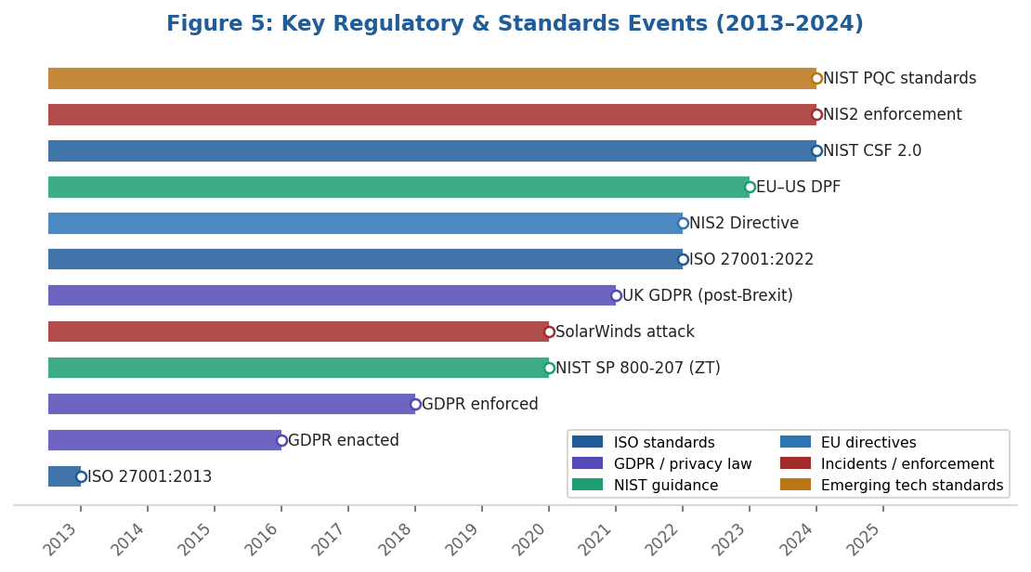
Figure 5: Key Regulatory & Standards Events (2013–2024) — Incidents Driving Legislative Change

4.2 Regulatory Learning from Real-World Incidents
Some of the most significant regulatory developments of the past decade have been driven directly by major security incidents. Figure 5 makes this connection visible: the SolarWinds supply chain attack of 2020 directly influenced the supply chain security provisions incorporated into NIS2. The Capital One cloud misconfiguration of 2019 demonstrated that financial institutions' governance frameworks had not kept pace with the shift to cloud infrastructure [1]. NIS2, enforceable from October 2024, substantially raises the bar: stricter incident reporting timelines, explicit top-management accountability, and mandatory supply chain security measures [10]. The Meta fine of €1.2 billion imposed by the Irish Data Protection Commission in 2023 signals that regulators now impose penalties commensurate with the scale of non-compliance, not token fines that can be absorbed as a cost of business [12].
For FSB's compliance function, this pattern carries a practical implication. Regulatory change is not random — it tends to follow a discernible sequence: a significant incident exposes a systemic gap, regulatory review follows, updated requirements emerge within 12 to 36 months. Organisations that monitor this pattern can often anticipate and prepare for regulatory changes before they become mandatory. That is proactive compliance; it is also, as the evidence increasingly shows, the cheaper option [20].

4.3 Technology Creates New Risks That Standards Must Address
It is not only the threat side of the equation that drives regulatory evolution. The technology organisations adopt to run their businesses also creates new risks that existing governance frameworks were not designed to manage. Two current examples are particularly salient for FSB.
The first is quantum computing. Current public-key cryptographic algorithms derive their security from mathematical problems that classical computers cannot solve in a reasonable timeframe. A sufficiently powerful quantum computer could undermine this, rendering the encryption protecting today's sensitive data theoretically vulnerable [5]. NIST's Post-Quantum Cryptography standardisation project, which published its first approved algorithms in 2024, represents proactive regulatory response to a threat that is credibly anticipated even if not yet fully realised [14]. Financial institutions implementing cryptographic controls today need to design for 'crypto-agility' — the ability to migrate algorithms without requiring complete infrastructure rebuilds. The second is Zero Trust. The traditional perimeter-based model has been progressively invalidated by cloud adoption, remote working, and BYOD. NIST SP 800-207 formalised Zero Trust architecture precisely because regulators recognised that the old model prescribed controls around a boundary that no longer meaningfully existed [23].

4.4 Harmonisation, Divergence, and the Value of International Standards
For multi-jurisdictional organisations like FSB, the proliferation of national regulations creates a compliance matrix of genuine complexity. EU GDPR, UK GDPR, and the financial regulations of every country in which FSB operates each impose different — and sometimes conflicting — obligations [7]. International standards like ISO 27001 serve a critical harmonisation function by providing a common baseline that satisfies the risk management intent of multiple regulatory regimes simultaneously [4]. However, harmonisation is never complete. The adequacy decision framework under GDPR — through which the EU assesses whether third countries provide equivalent data protection — has been legally contested through Schrems I and Schrems II. The EU-US Data Privacy Framework, adopted in 2023, represents the latest attempt to resolve a tension that technology, commerce, and differing legal philosophies keep regenerating [7]. FSB must monitor these developments actively. Cross-border data flows that are lawful today may require reassessment tomorrow.

4.5 The Strategic and Commercial Case for Proactive Compliance
It would be easy to read the preceding analysis as an argument for reluctant compliance — doing the minimum required to avoid regulatory sanction. The evidence does not support that reading. IBM Security's 2023 Cost of a Data Breach Report found that organisations with fully deployed security AI and automation experienced breach costs averaging $1.76 million less than those without, and that organisations with high security maturity contained breaches an average of 108 days faster than low-maturity peers [9]. Figure 6, derived from this data, illustrates the relationship between governance maturity and both breach cost and detection time across a spectrum from no security programme to the USGA proposed for FSB.
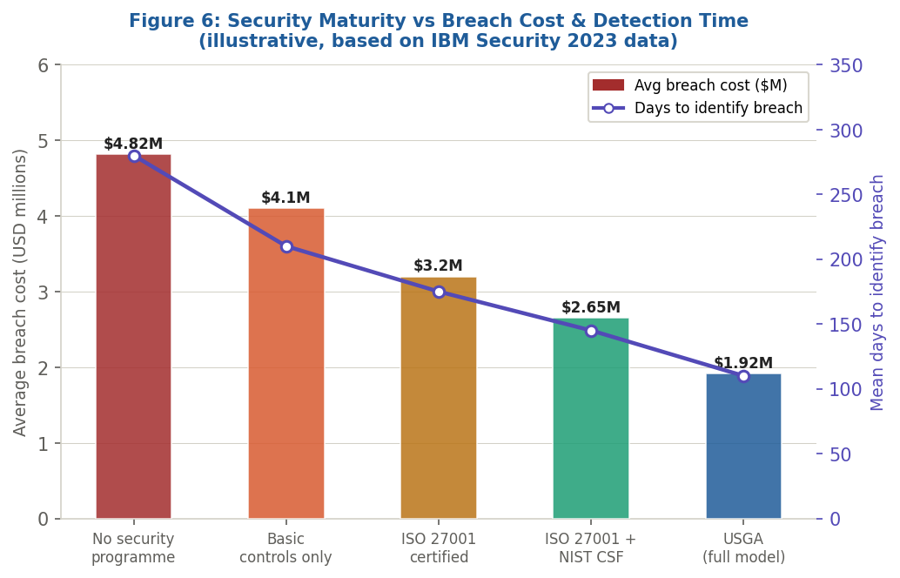
Figure 6: Security Maturity vs Average Breach Cost & Mean Detection Time (illustrative, based on IBM Security 2023 data)

Figure 6 makes a compelling business case. The organisations represented by the rightmost bar — those operating with a fully integrated governance model — experience not only the lowest breach costs but the shortest detection windows. Rapid detection is itself a form of cost control: a breach identified in 110 days causes substantially less damage than one that runs for 280 days before it is discovered. For FSB, this reframes the investment in governance, training, and technical controls not as a compliance cost but as a capital allocation decision with a measurable expected return [27].
McKinsey's 2024 research for banking institutions reinforces this framing: institutions that treat cybersecurity as a strategic capability — rather than a technical function that reports upward only when something goes wrong — are better positioned to win the trust of customers who are increasingly aware of and concerned about data privacy [27]. For FSB, positioning itself as a leader in security and privacy could become a genuine competitive differentiator, particularly as the customer base expands into markets where digital trust is still being established. The cost of a serious breach, in direct financial terms, regulatory fines, and reputational damage in the financial sector, consistently and significantly exceeds the cost of the controls that would have prevented it [20].

5. Conclusion
FSB's situation is serious but recoverable — and the path to recovery is clearer than it might appear. The bank's core problem is not technical but structural: it has grown its infrastructure and customer base faster than it has grown the governance frameworks that should underpin them. Closing that gap requires a deliberate, architecturally coherent response, and that is what the Unified Security Governance Architecture proposed here is designed to provide.
The USGA draws on the complementary strengths of four established frameworks — COBIT 2019 for governance, ISO 27001 for the ISMS core, NIST CSF 2.0 for operational cybersecurity, and ITIL v4 for service delivery — to address FSB's most pressing vulnerabilities: unmanaged BYOD exposure, cloud misconfiguration risk, third-party supply chain vulnerability, insider threat, and fragmented compliance across multiple regulatory jurisdictions. The risk heat map, maturity radar, and breach cost analysis presented above are not decorative: they provide FSB's leadership with practical tools for prioritising investment, tracking progress, and communicating the business case for security governance in terms that resonate at board level.
The broader argument of this assessment — that regulatory standards must continue to evolve — is, ultimately, a recognition that information security operates in a permanently dynamic environment. Threats adapt, technologies change, and the legal and political frameworks that govern cross-border data flows shift in response to forces that no single organisation can control. The organisations that navigate this most successfully are those that treat compliance as a floor rather than a ceiling, and governance as a continuous discipline rather than a periodic audit. For FSB, the starting line is now — and the evidence suggests that acting decisively and comprehensively at this stage is far less costly than addressing the consequences of delay.

References
- K. Scarfone and P. Mell, "Guide to Intrusion Detection and Prevention Systems (IDPS)," NIST Special Publication 800-94, National Institute of Standards and Technology, Gaithersburg, MD, USA, 2007.
- AXELOS, ITIL Foundation: ITIL 4 Edition. London, UK: The Stationery Office, 2019.
- A. Bousdekis, D. Apostolou, and G. Mentzas, "A proactive event-driven service oriented architecture for real-time enterprise resource planning," Procedia Computer Science, vol. 97, pp. 396–405, 2016.
- ISO/IEC, Information Security, Cybersecurity and Privacy Protection — Information Security Management Systems — Requirements, ISO/IEC 27001:2022. Geneva, Switzerland: International Organization for Standardization, 2022.
- National Institute of Standards and Technology (NIST), "The NIST Cybersecurity Framework (CSF) 2.0," NIST CSWP 29, Gaithersburg, MD, USA, Feb. 2024.
- ISACA, COBIT 2019 Framework: Governance and Management Objectives. Rolling Meadows, IL, USA: ISACA, 2018.
- European Parliament and Council, "Regulation (EU) 2016/679 (General Data Protection Regulation)," Official Journal of the European Union, vol. L 119, pp. 1–88, Apr. 2016.
- ISO, Security and Resilience — Business Continuity Management Systems — Requirements, ISO 22301:2019. Geneva, Switzerland: International Organization for Standardization, 2019.
- IBM Security, Cost of a Data Breach Report 2023. Armonk, NY, USA: IBM Corporation, 2023. [Online]. Available: https://www.ibm.com/reports/data-breach
- European Parliament and Council, "Directive (EU) 2022/2555 (NIS2 Directive)," Official Journal of the European Union, vol. L 333, pp. 80–152, Dec. 2022.
- European Union Agency for Cybersecurity (ENISA), "NIS2 Directive: A Factsheet," ENISA, Athens, Greece, 2023.
- European Parliament, "General Data Protection Regulation — Implementation and Enforcement," European Parliamentary Research Service, Brussels, 2023.
- ISO, Security and Resilience — Business Continuity Management Systems — Guidance on the Use of ISO 22301, ISO 22313:2020. Geneva, Switzerland: ISO, 2020.
- NIST Computer Security Resource Center, "Post-Quantum Cryptography Standardization," NIST, Gaithersburg, MD, USA, 2024. [Online]. Available: https://csrc.nist.gov/projects/post-quantum-cryptography
- ORNA, "NIST, ISO, COBIT, ITIL — Which Cyber Framework Rules Them All?," ORNA Pty Ltd, Sydney, Australia, 2022.
- ACSMI, "Cybersecurity Frameworks Compared: NIST CSF, ISO 27001, and COBIT," ACSMI, 2025.
- SANS Institute, "Incident Handler's Handbook," SANS Reading Room, Bethesda, MD, USA, 2021.
- Microsoft, "Cloud Security Best Practices," Microsoft Documentation, Redmond, WA, USA, 2023.
- Gartner, "IT Service Management and ITIL 4: Market Guide," Gartner Research, Stamford, CT, USA, 2024.
- Deloitte, "Operational Resilience in Financial Services: Building Adaptive Capacity," Deloitte Insights, London, UK, 2023.
- EY, "Cybersecurity Governance and Risk Management: From the Boardroom to the Front Line," Ernst & Young, London, UK, 2024.
- PwC, "Integrating ITIL and ISO 27001 for Financial Institutions," PricewaterhouseCoopers LLP, London, UK, 2023.
- NIST, "Security and Privacy Controls for Information Systems and Organizations," Special Publication 800-53 Rev. 5, NIST, Gaithersburg, MD, USA, Sep. 2020.
- ISO/IEC, Information Security, Cybersecurity and Privacy Protection — Guidance on Managing Information Security Risks, ISO/IEC 27005:2022. Geneva, Switzerland: ISO, 2022.
- ISACA, "COBIT EDM01: Ensured Governance Framework Setting and Maintenance," in COBIT 2019 Design Guide. Rolling Meadows, IL, USA: ISACA, 2019, pp. 44–49.
- AXELOS, ITIL 4: Drive Stakeholder Value. London, UK: The Stationery Office, 2020.
- McKinsey & Company, "Cybersecurity in Banking: A Strategic Imperative for 2024 and Beyond," McKinsey Global Institute, New York, NY, USA, 2024.
- Financial Conduct Authority (FCA), "Operational Resilience: Building Resilience in Financial Services," FCA Policy Statement PS21/3, London, UK, Mar. 2021.
- Payment Card Industry Security Standards Council, "Payment Card Industry Data Security Standard (PCI DSS) v4.0," PCI SSC, Wakefield, MA, USA, 2022.
- B. Schneier, Data and Goliath: The Hidden Battles to Collect Your Data and Control Your World. New York, NY, USA: W. W. Norton & Company, 2015.

