Charlie Wilkins
2104032
ACCB5029
Network Programmability Report

Table of Contents
Abstract 2
Introduction 2
Application Programming Interface 2
API functionality 3
API importance for business 3
The benefits of using APIs 4
The challenges of using APIs 4
The 4 types of API 4
API Standards and architectures 4
Exploring REST API Architecture 4
Advantages 6
Web API implementation 6
Critically review Automation of security and compliance policies and API security and privacy. 6
Automate API Governance & Data Compliance 7
Network Programmability dimensions. 7
Network automation, Network APIs etc and its significance focusing today’s trends. 7
Network Automation 7
Benefits of Network Automation 8
Network Automation tools 8
Enterprise multidomain architecture 9
Network Automation maturity 9
Network Automation market trends 9
IT Automation and Orchestration Trends in enterprise 10

Test Automation frameworks and tools 10

Test Automation Frameworks and Types 10

Test Automation Frameworks Type: 11
Network Automation Strategy 12
Reflect on the available resources at developer.cisco.com. 13
Research and find other similar resources available that are relevant to Sandbox, Code Exchange, Ecosystem Exchange etc available at developer.cisco.com. 13
Conclusion 15
References 16

Table of Figures
Figure 1 3
Figure 2 5
Figure 3 9
Figure 4 12
Figure 5 13

Abstract
This report explores the dimensions of network programmability and its significance in today’s automated world. I have researched automation frameworks and tools, API Standards and architectures and the existing measures to improve API security and privacy. During this I have looked at Network Programmability dimensions and resources available to a developer at developer.cisco.com.

Introduction

Application Programming Interface
API stands for Application Programming Interface. In the context of API; Application refers to any software with a distinct function, Interface is the contract of service between two applications. This programme contract defines how the two communicate with each other using requests and responses. The API defines how the developer requests services from an operating system (OS) or other application, and exposes data within different contexts and across multiple channels. This builds on the concept of integrating data and applications from different sources which was called a mashup. Any data can be shared with an application programming interface. APIs are implemented by syntax composed of verbs and nouns described in the application documentation [1] These are specific to the tasks required for the specific environment.

API functionality
APIs are made up of two related elements:
- A specification that describes how information is exchanged between programs in the form of a request for processing and a return of the necessary data; and
- A software interface written to that specification and published in some way for use.
The software that wants to access the features and capabilities of the API is said to call it, and the software that creates the API is said to publish it. Web APIs can be called through any programming language, and webpages created in Hypertext Markup Language (HTML) [2]or application generator tools can also access them.
Access is authenticated to a service or portion of functionality using predefined roles that govern who or what service can access specific actions and data. APIs provide an audit trail of who and what have had system access and when it happened.
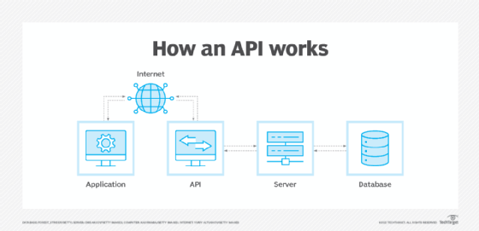
Figure 1: API structure

API importance for business
APIs improve the quality and delivery of software and services, developed for specific purposes and written to reference APIs that provide features useful in a variety of contexts. This reduces development time, cost and the risk of errors. APIs provide a digital layer for a company's data and enterprise assets with associated governance and security. There are a growing number of web services through APIs which has encouraged the creation of cloud-specific applications, internet of things [3]efforts and apps to support mobile devices and users.
These enhance customer, employee and partner interactions, improves the customer experience and creates new monetisation opportunities for businesses.

The benefits of using APIs
APIs are a set of rules. They standardise how developers write application code, improving an organisation's internal software development processes.

The challenges of using APIs
API development can be complex and costly to integrate with the systems and data they represent and in some cases, robotic process automation may be more appropriate. APIs are vulnerable to cyber-attacks related to data exposure, user authentication, object-level and function-level authorisation, mass assignment and injection attacks.
APIs require a stringent and codified testing regime, lifecycle management and deprecation of old APIs to keep documentation up to date.

The 4 types of API
There are four widely agreed-upon web APIs: open APIs, partner APIs, internal APIs, and composite APIs.

API Standards and architectures
The most common architectures for APIs are Representational State Transfer (REST) [4] and Simple Object Access Protocol (SOAP), [5] which defines a standard communication protocol specification for a message exchange based on Extensible Markup Language or XML. SOAP requires less low-level infrastructure-related code than REST. However, REST APIs are easier to scale and redeploy, and simpler to implement and integrate with websites and services. REST APIs are most often used today, particularly for web interactions.
https://learn.microsoft.com/en-us/azure/architecture/best-practices/api-implementation [6]

Exploring REST API Architecture
When building APIs to handle HTTP messages it is necessary to consider decisions about URL route structures, request methods, headers, payloads, status codes, safe and idempotent behaviour, and more.
Roy Fielding, the inventor of REST Architecture outlines REST as an architectural style for distributed applications with 6 constraints [2]_{[1]}:
- Client-server architecture - The client-server model separates clients, e.g. browsers and crawlers, from data storage. Clients make requests to servers and receive responses.
- Caching - Responses are labelled as cacheable or non-cacheable and caching is restricted to the client or an intermediary between the server. This is referred as client-cache-stateless-server.
- Layered System - A set of hierarchical layers restricts components to interact only with the adjacent layer. For example, a 4-tier architecture has the client layer, web server layer, API layer with caching, and data layer. Each of these interact with their adjacent layers. Intermediaries can include load balancers, proxies, and security.
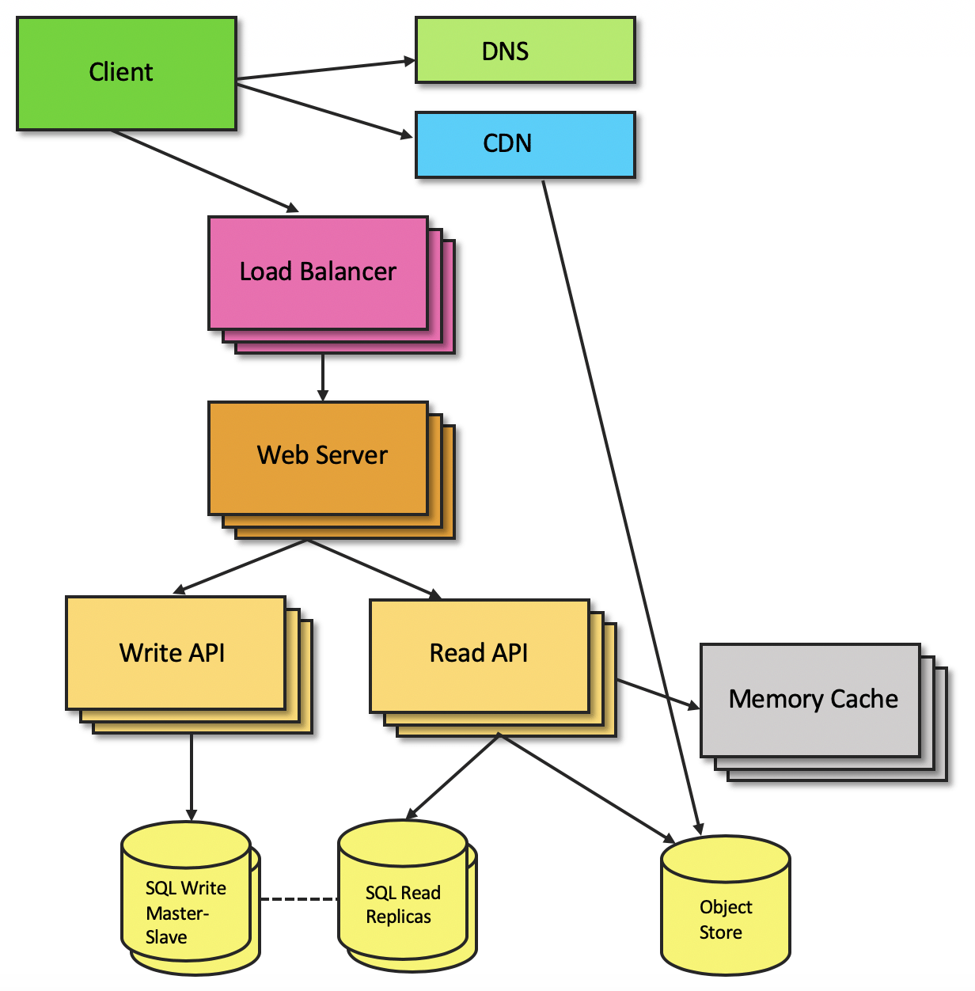
Figure 2: REST API Architecture.
- Uniform Interface - A central feature of REST is a set of interfaces between clients and servers. These 4 interfaces include Resource identification, Representations manipulate resources, Self-descriptive request and response messages, Hypermedia as the engine of application state.
- The server is stateless as each request contains all data necessary for the server to fulfill it, rather than one request split and managed on the server across multiple partial requests. Session state is kept entirely on the client.
- Code-On-Demand - An optional and often unnecessary constraint. Clients can download and execute code in the form of scripts.

Advantages
Flexibility - Client/server design with uniform interfaces allow clients and servers to have different implementations and develop independently. A layered system enables intermediaries e.g. proxies, gateways, and firewalls without changing interfaces. Hypermedia-as-the-engine-of-application-state allows clients to decouple from servers. Stateless server enables intermediaries to view requests in isolation, which may be necessary when services are dynamically rearranged.
Performance - Caching can significantly improve performance, especially when a layered system adds more network requests.
Scalability - A stateless server model eases horizontal scaling, avoids shared state problems, and simplifies concurrent requests. A layered system allows hardware resources to scale at specific layers.
Maintainability - Uniform interfaces include messages as self-descriptive and visible to intermediaries which helps for debugging and network tracing.

Web API implementation
A carefully designed RESTful web API defines the resources, relationships, and navigation schemes that are accessible to client applications, supporting Platform independence and Service evolution.
https://learn.microsoft.com/en-us/azure/architecture/best-practices/api-design [3]

Critically review Automation of security and compliance policies and API security and privacy.
“Traditionally developers like to focus on the data and functionality of their APIs while the security team is concerned with the enforcement of API security controls and policies. This siloed approach has led to inefficiencies and bottlenecks in the DevSecOps’ cycle that are delaying the release of APIs and creating cost over runs Organisations can overcome this challenge by adopting a “security as code” approach to automate their API protection.”
https://42crunch.com/automate-api-protection-with-security-as-code-webinar-recording/ [4]
https://nonamesecurity.com/whitepaper-api-governance-data-compliance [5]

Automate API Governance & Data Compliance
Data privacy is an absolute requirement for organisations and non-compliance can result in escalating fines, reputational damage, and lost revenue. Oganisations need to secure data locations, data movement between applications, data access.

Network Programmability dimensions.

Network automation, Network APIs etc and its significance focusing today’s trends.
https://www.cisco.com/c/en/us/solutions/collateral/executive-perspectives/network-automation-strategy-wp.html [6]

Network Automation
Network automation is the process of automating deployment, configuration, testing/validation and operation of network devices, that can be physical (routers, switches, access points, firewalls, etc) or virtual (public cloud networking, virtual machines, containers, virtual network functions, etc). Network automation can be applied to a broad range of enterprise and service provider network services.
Enterprise automation:
● Data center networks including access ports, port-channels, routing, quality of service, firewalls & load balancer policies, hypervisors, virtual machines and containers among other.
● Public Cloud tenants, virtual networks, subnets, security groups, load balancers, compute services, storage services and serverless functions.
● Campus and OT (Operational Technology) networks including wired and wireless access, network access control, macro-segmentation and micro-segmentation.
● Wide Area Network (WAN) customer premises equipment, overlay virtual private networks, application aware routing, quality of service and routing policies.
Service Provider automation:
● Residential ADSL and Fiber To The Home (FTTH).
● Small and Midsize Business (SMB) and Enterprise Virtual Private Network (VPN) access, security and routing policies.
● Virtual Network Functions (VNF) including routers, firewalls, load balancers and virtual Evolved Packet Core (vEPC) components.
● Enterprise to public cloud VPN connectivity including cloud edge routers.
Network automation applies to the full-service lifecycle including day 0 network onboarding, day 1 configuration and day 2 operation and optimization. The automation use cases in each stage of the lifecycle will be different.

Benefits of Network Automation
Manual network changes [2 [12]] can lead to inconsistent networks because of configurations being built by different engineers, poor documentation, or human errors. These configuration inconsistencies often result in network downtime, decreased service velocity and increased operational costs.
Network automation has advantages over manual interventions in the following areas:
● Faster response to new requirements.
● Higher reliability.
● Reduced operational expenses.
● Standardized configurations.
● Faster network changes.
● Facilitate offsite IT teams.
● Augmented intelligence.
● Dynamic optimization/remediation.
● Simplified troubleshooting.
● Better network insights.
● Enhanced security.

Network Automation tools
There are numerous automation tools on the market: Terraform, Ansible, Chef, Kibana, Grafana, Splunk and Python. Most are modular tools that can be adapted to achieve network automation goals.
There are also network controllers, a proliferation of software-defined networking solutions, which are architectures that separate the data plane from the control plane such as Software-Defined WAN (SD-WAN). In a software-defined network the intelligence is centralized in a network controller which performs multiple functions including the automation of the network. Other examples are Software-Defined campus LAN (SD-LAN) and Software-Defined Data Center (SD-DC).

Enterprise multidomain architecture
Automation also refers to the use of AIOps - artificial intelligence for IT operations and complementary processes and workflows automation. Process automation and network automation tools need to be integrated.
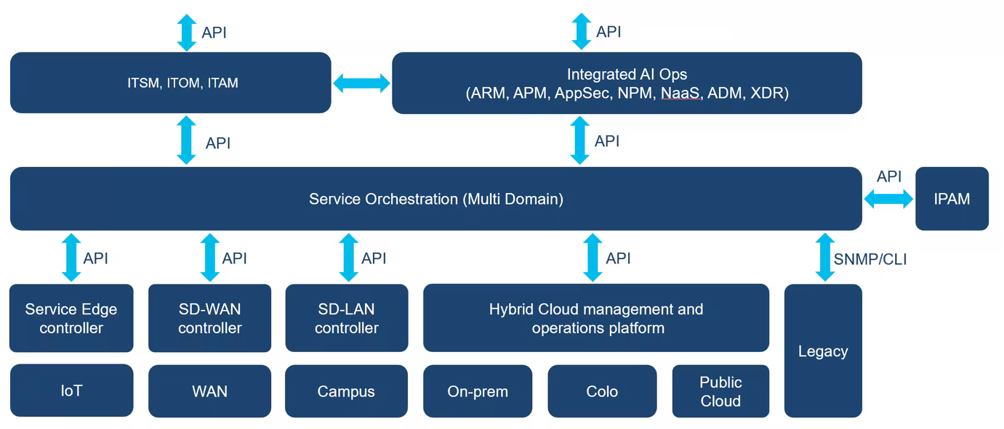
Figure 3: Sample multidomain enterprise architecture.

Network Automation maturity
The maturity level of an organisation’s network automation can be classified according to one of the following categories:
- Manual device configuration.
- Basic configuration automation.
- Controller-based per-domain automated provisioning.
- Controller-based, network-wide automated provisioning.
- Automated provisioning of devices in a self-organized, self-diagnosing and dynamically updated network.

Network Automation market trends
Businesses require IT to achieve more agile changes, higher availability for the services and reduced operational costs. Combined with the increase in network size and complexity this increases the role network automation plays on IT organisation.

IT Automation and Orchestration Trends in enterprise
As described in Gartner’s Market Guide for Network Automation and Orchestration Tools, [7] “network automation and orchestration tools are moving from niche functions used by individual employees within Infrastructure and Operations (I&O) to providing robust solutions that allow network operations to be increasingly automated[3].” This can be called Hyperautomation, which is a “business-driven, disciplined approach that organisations use to rapidly identify, vet and automate as many business and IT processes as possible[4], this includes network automation.” Hyperautomation is irreversible and inevitable; everything that can be automated will be automated because of competitive pressures for efficiency, efficacy and business agility.
The trends to achieve hyperautomation include: improved network agility, acceleration of automation/orchestration, acceleration of digital and cloud initiatives, maturation of automation and orchestration initiatives by implementing complementary tools and management.

Test Automation frameworks and tools

https://www.clariontech.com/blog/what-are-test-automation-frameworks-and-types [8]

Test Automation Frameworks and Types [9]
Software testing is a crucial part of the development cycle to ensure good quality deliverables; all software needs to be tested before it is released to users. Automation testing is preferable to manual testing as it is more time efficient, accurate, cheaper and efficient. Test Automation is a collection of tools and processes working together in a framework to support standardised automated testing of any application. It integrates various functions like libraries, test data, and various reusable modules.
Importance of Automation Framework in Software Testing
- Maintain a well-defined strategy across the test suites,
- Enhanced speed at which testing progresses,
- Maintaining the test code will be easy,
- The URL or Application can be tested accurately,
- Continuous testing of coding and delivery will be achieved.

Test Automation Frameworks Type:
Each test automation framework has its own architecture, advantages, and disadvantages. Some of these test automation frameworks are:
- Linear Automation Framework
- Modular Driven Framework
- Behavior Driven framework
- Data-Driven Framework
- Keyword-Driven Framework
- Hybrid Testing Framework
https://www.lambdatest.com/blog/best-test-automation-frameworks-2021/ [10]
Automation frameworks enable automation testers by simplifying the test development and execution activities. A typical automation framework provides an environment for executing test plans and generating repeatable output. They are specialized tools to assist test automation tasks such as; test runner, action recording tool, web testing tool, to remove the hard work from building test scripts and leave time for quality checks. Test Automation [11]is a proven, cost-effective approach to improving software development.
Source [18]
The State of open source survey, [12] reports that “37% of organisations now integrate test automation into their Continuous Integration and Continuous Delivery(CI/CD) [13]process, enabling developers to instantly know whether or not the latest code change broke any aspect of the application after it’s deployed to production. When paired with the number of testers doing test automation testing with each sprint (40%), organizations have reported that more than 75% of their projects can perform test automation at least every two weeks.” This confirms the ease of integration and the benefits of test automation.
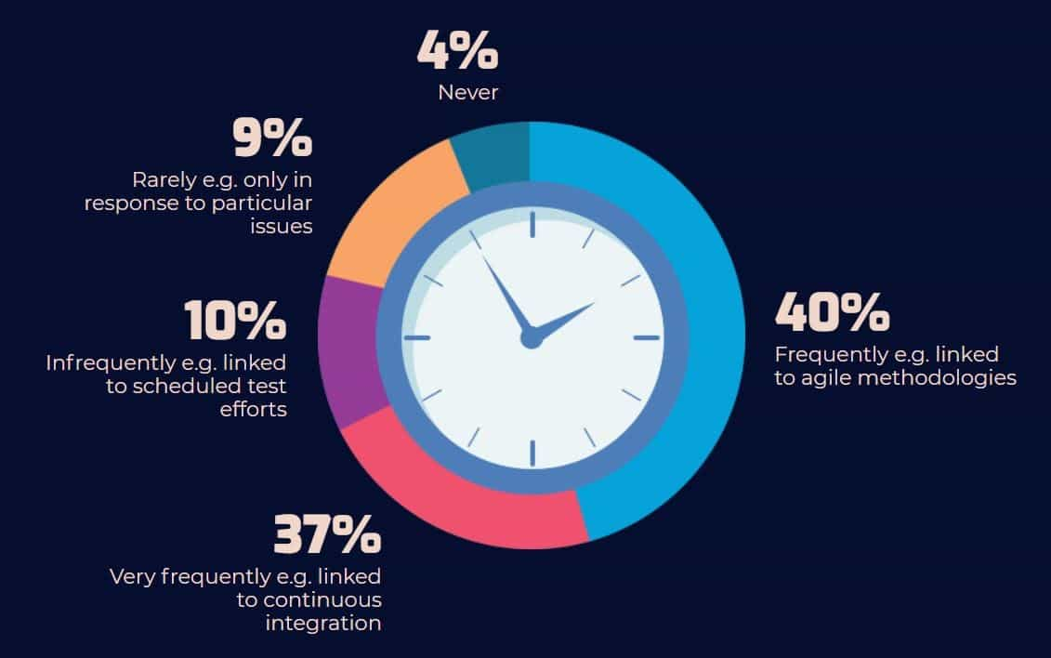
Figure 4: Frequency of test automation.
Source [21]

Network Automation Strategy
Trends in business processes recommend that enterprise and service provider IT organisations should have a Network Automation Strategy. A network automation strategy which represents where the organisation is, where they want to go, and the path to get there [14][10]. A network automation strategy should be supported by five pillars as shown below:
● Business alignment – It should support and enable the business.
● Technology adoption – It should reflect what technologies are in use and which will be adopted.
● Operating model – It should reflect owners and maintainers for projects and tools.
● Roadmap – It should document what is ahead in terms of projects, decommissions and tools.
● Skills – It should display what skills are required or will need to be acquired.
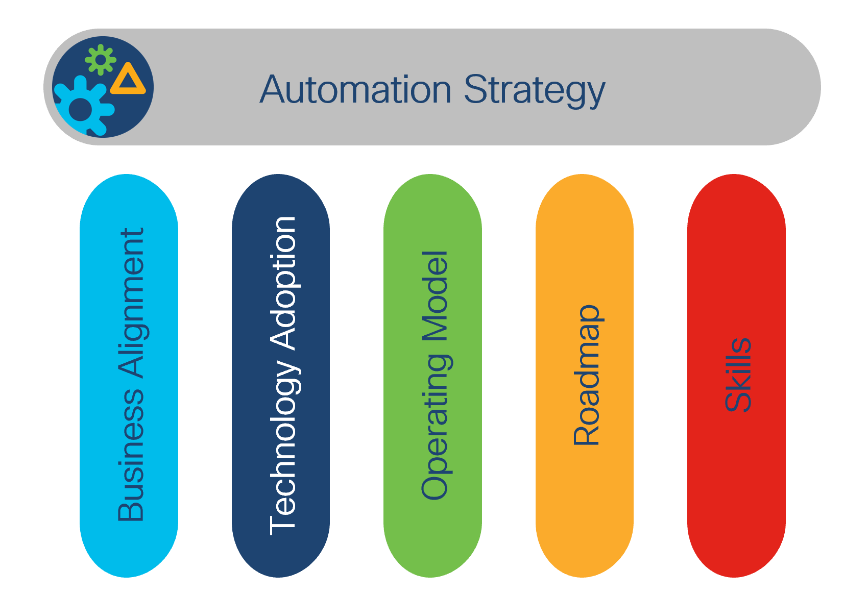
Figure 5: Automation Strategy Pillars
Network Automation provides numerous benefits when properly adopted by enterprise and service provider IT organisations.

Reflect on the available resources at developer.cisco.com.

Research and find other similar resources available that are relevant to Sandbox, Code Exchange, Ecosystem Exchange etc available at developer.cisco.com.
https://blogs.cisco.com/networking/defining-network-programmability [15]
Anne Robotti et al stated that “Network programmability is a generic term, like SDN and the whole Software Defined X paradigm, that it means different things to different people. Not so long ago network programmability was synonymous with Openflow but as time passed and pragmatism kicked in, the industry settled around a common view.” They went on to identify the benefits of time and cost savings, reduction of human error, customisation and innovation. This describes network programmability as a set of tools and best practices to deploy, manage and troubleshoot network devices.
XX Agreement on Network Programmability Cisco DevNet dCloud Anne Robotti Steve Dickson Adrian Iliesiu
DevNet is a developer community created by Cisco to help developers and network engineers build applications and integrations with Cisco products and technologies. Developer.cisco.com [16] is the primary platform for accessing DevNet resources, which provides a variety of tools, learning materials, and resources to help developers build and test network applications.
These are some of the available resources at developer.cisco.com: [17]
• Learning Labs: DevNet Learning Labs are self-paced, hands-on tutorials designed to help developers learn how to use Cisco products and technologies to build network automation and programmability solutions. The labs cover a variety of topics, including network automation, software-defined networking, and network security.
• Sandboxes: DevNet Sandboxes provide a virtual environment for developers to test and experiment with Cisco products and technologies. These sandboxes are pre-configured with all the necessary software and tools, making it easy for developers to get started with Cisco APIs and SDKs.
• Code Exchange: DevNet Code Exchange is a platform for sharing and collaborating on code snippets, scripts, and applications. It is a repository of open-source code created by developers and engineers, making it easy to find and share code with others.
• Ecosystem Exchange: DevNet Ecosystem Exchange is a directory of third-party solutions and services that work with Cisco products and technologies. It provides a platform for developers to find and integrate with Cisco-compatible solutions and services.
In addition to these resources, there are also other similar resources available that are relevant to Sandbox, Code Exchange, and Ecosystem Exchange. For example:
• Google Cloud Platform: Google Cloud Platform offers a similar platform to DevNet Sandboxes, called Google Cloud Shell. This platform provides a web-based command-line interface for managing and testing applications on Google Cloud Platform.
• GitHub: GitHub is a popular platform for sharing and collaborating on code. It offers a similar platform to DevNet Code Exchange, where developers can share and collaborate on code repositories.
• Amazon Web Services: Amazon Web Services offers a similar platform to DevNet Ecosystem Exchange, called AWS Marketplace. It is a directory of third-party solutions and services that work with AWS products and technologies.
• Microsoft Azure: Microsoft Azure offers a similar platform to DevNet Sandboxes, called Azure Sandbox. This platform provides a virtual environment for developers to test and experiment with Azure products and technologies.
• Sand boxes are useful because you can run apps and programmes which can be dangerous without the risk of it to reaching your main network.
Overall, developer.cisco.com [18] and its resources are a valuable platform for developers to learn and experiment with Cisco products and technologies. In addition, there are other similar resources available from other cloud providers that provide similar services and platforms for developers to build, test, and collaborate on code and solutions.

Conclusion
The benefits of using APIs include enhancing customer, employee, and partner interactions, improving the customer experience, and creating new monetization opportunities for businesses. APIs standardize how developers write application code, improving an organization's internal software development processes. However, API development can be complex and costly to integrate with the systems and data they represent. APIs are vulnerable to cyber-attacks related to data exposure, user authentication, object-level and function-level authorization, mass assignment, and injection attacks. API testing and lifecycle management are crucial for keeping documentation up-to-date.
The four types of API are open APIs, partner APIs, internal APIs, and composite APIs. The most common architectures for APIs are Representational State Transfer (REST) and Simple Object Access Protocol (SOAP). REST APIs are easier to scale and redeploy and simpler to implement and integrate with websites and services, while SOAP requires less low-level infrastructure-related code.
REST API architecture follows six constraints outlined by Roy Fielding, the inventor of REST Architecture. These six constraints include a client-server architecture, caching, a layered system, a uniform interface, statelessness, and optional code-on-demand. Advantages of REST API architecture include flexibility, performance, scalability, and maintainability.
Organizations can automate their API protection by adopting a "security as code" approach. This approach automates API protection by automating the enforcement of API security controls and policies.
Network automation involves automating the deployment, configuration, testing/validation, and operation of network devices. It can be applied to a broad range of enterprise and service provider network services. Enterprise automation includes data center networks, including access ports, port-channels, routing, quality of service, firewalls, and load balancer policies, among others.

References

[1] | [Online]. Available: https://www.techtarget.com/whatis/definition/syntax.
[2] | [Online]. Available: https://learn.microsoft.com/en-us/azure/architecture/best-practices/api-implementation.
[3] | [Online]. Available: https://learn.microsoft.com/en-us/azure/architecture/best-practices/api-design.
[4] | [Online]. Available: https://42crunch.com/automate-api-protection-with-security-as-code-webinar-recording/.
[5] | [Online]. Available: https://nonamesecurity.com/whitepaper-api-governance-data-compliance.
[6] | [Online]. Available: https://www.cisco.com/c/en/us/solutions/collateral/executive-perspectives/network-automation-strategy-wp.html.
[7] | [Online]. Available: https://www.gartner.com/en/documents/3990134.
[8] | [Online]. Available: https://www.clariontech.com/blog/what-are-test-automation-frameworks-and-types.
[9] | [Online]. Available: https://www.clariontech.com/blog/author/bhavana-bhavar.
[10] | [Online]. Available: https://www.lambdatest.com/blog/best-test-automation-frameworks-2021/.
[11] | [Online]. Available: https://www.lambdatest.com/automation-testing.
[12] | [Online]. Available: https://www.tricentis.com/state-of-open-source-2020/.
[13] | [Online]. Available: https://www.lambdatest.com/blog/what-is-continuous-integration-and-continuous-delivery/.
[14] | [Online]. Available: https://www.cisco.com/c/en/us/solutions/collateral/executive-perspectives/network-automation-strategy-wp.html#_ftn10.
[15] | [Online]. Available: https://blogs.cisco.com/networking/defining-network-programmability.
[16] | [Online]. Available: https://developer.cisco.com.
[17] | [Online]. Available: https://developer.cisco.com.
[18] | [Online]. Available: https://developer.cisco.com.

