ACCOUNTING FUNDAMENTALS
COMPONENT 1
LCBB 4001-BIRM

Lecturer: MUNODZINESA ZUWIRAI
Student: CLAUDIU PINDICI
Student ID: 2246687

Table of Contents

1.Introduction 3
2.Task 1 4
3.Task 3: Going Concern 16
4.Conclusion 19
References 20

1.Introduction
Accounting and financial management can be complex and difficult, yet in the same way, it serves as an intermediary of different methods in the field essential to the performance. This article outlines three fundamental methods, one for each, in which an array of accounting features can be seen clearly to highlight the nature of fluidity within accounting and financial management.
In the first task In Task 1, the writer analyzes the financial statements for a Company which will start on December 1st, 2023. The author places special attention paid to earnings statements and the equitable sheet. Analyzing the cash flow includes analysis, ability to determine cost for settling bad debts as well as the assessment of financial standing.
In contrast, task 2 is particularly on the process using accounting principles in application, we'll examine "T . This task will focus on actual business transactions that are based on reality and their effects on financial statements. The task includes assessment of capital write-offs and asset transactions, as well as cash flow management receivables and payables assignment of the daily routine. This task provides a macro-level analysis of the effects of everyday transactions on a company's financial standing at the scale of a minimum unit. It also highlights transactions as an important method to sustain or boost the financial position and encourage growth (Anthony 1999).).
Task 3 examines arguably one of the most important "going concern" concepts in accounting. This ensures that an organization will be operational throughout its life. Based on this that it is based using the valuations of balance sheets along with the recognition of revenue and liability in the belief of shareholders.
These activities help to understand the basics of financial and accounting management that's primary objective is the maintenance of exact records that allow for accurate reporting. A good sense of sensitivity and understanding to make financial choices and expanding quality products or services is dependent on planning, forecasting as well as all other aspects that require precision.

2.Task 1

Adjusted Trial Balance
Account Title | Debit | Credit
Purchases | £95,000
Sales |  | £160,000
Sales Returns | £4,000
Purchase Returns |  | £5,000
Bank Balance | £5,000
Capital |  | £25,000
Drawings | £13,000
Furniture | £15,000
Accumulated Depreciation on Furniture |  | £5,000
Rent | £2,500
Salaries | £28,000
Discounts Received |  | £200
Discounts Allowed | £700
Trade Receivables | £17,000
Trade Payables |  | £2,300
Inventory (Opening) | £3,000
Provision for Doubtful Debts (Opening) |  | £500
Vehicle at Cost | £28,500
Accumulated Depreciation on Vehicles |  | £7,000
Loan (five years) |  | £10,000
Interest on Loan | £1,000
Electricity and Gas Expense | £1,500
Vehicle Maintenance | £800
Adjustments
Inventory (Closing) | £5,000
Accrued Salaries | £3,000
Prepaid Rent | £300
Vehicle Maintenance Owing | £150
Bad Debts (specific) | £800
Increase in Provision for Doubtful Debts | £350
Depreciation on Furniture | £1,800
Depreciation on Vehicles | £4,275

Income Statement
Description | Amount (£)
Sales | 160,000
Less: Sales Returns | -4,000
Net Sales | 156,000
Opening Inventory | 3,000
Plus: Purchases | 95,000
Less: Purchase Returns | -5,000
Less: Closing Inventory | -5,000
Net Cost of Goods Sold | 88,000
Gross Profit | 68,000
Expenses
Salaries | 28,000
Plus: Salaries Accrued | 3,000
Rent | 2,500
Less: Rent Prepaid | -300
Discounts Allowed | 700
Vehicle Maintenance | 800
Plus: Vehicle Maintenance Owing | 150
Electricity and Gas Expense | 1,500
Total Operating Expenses | 36,350
Depreciation
Depreciation on Furniture | 1,800
Depreciation on Vehicles | 4,275
Total Depreciation | 6,075
Bad Debts
Specific Bad Debt Written Off | 800
Increase in Provision for Doubtful Debts | 850
Less: Opening Provision | -500
Net Bad Debts | 1,150
Net Profit | 24,425

Assets | Amount (£) | Liabilities and Equity | Amount (£)
Bank Balance | 5,000 | Trade Payables | 2,300
Trade Receivables | 17,000 | Loan (five years) | 10,000
Less: Provision for Doubtful Debts | -850 | Salaries Accrued | 3,000
Net Trade Receivables | 16,150 | Vehicle Maintenance Owing | 150
Closing Inventory | 5,000 | Total Liabilities | 15,450
Furniture | 15,000 | Capital | 25,000
Less: Accumulated Depreciation on Furniture | -6,800 | Add: Net Profit | 24,425
Net Furniture | 8,200 | Less: Drawings | -13,000
Vehicle at Cost | 28,500 | Total Equity | 36,425
Less: Accumulated Depreciation on Vehicles | -11,275 | Total Liabilities and Equity | 51,875
Net Vehicles | 17,225
Prepaid Rent | 300
Total Assets | 51,875

By the 31st of December in 2023 The company is able to claim a strong financial state as shown by its annual Report. The company boasts a dazzling gross sales of P156,000 with a profit gross of PS68 by 00. This will show that the business has a good grasp of cost-of-living directly as evidenced in 43.construction questions are scattered throughout the essay's body as well as the conclusion, and even to glossary entries. Specific terms are included. is the primary idea of maximising that have developed the margin. This help determine the firm's efficiency level at which she can manage her production or delivery expenses. The profit net of PS 24,425 is a reflection of the ability of the business to handle the company's expenses and revenue and with a high likelihood.

The balance sheet, assets of PS51,875 indicate that the company is in a good financial position. The liquidity situation appears to be at the mid-point of the range, as the whole is compensated by spending PS 55,000 with a banking institution and net trade receivables worth just PS16 150. However, a comprehensive analysis using methods of the liquidity ratio will reveal a clearer picture of financial health in the near-term. The cost of investment in permanent assets, such as automobiles and furniture is very high. This accumulation of depreciation to demonstrate that these assets is a need for consistent replacement in the form of depreciation to preserve the value of these investments that directly impact efficiency when working (Berishvili 2020).
The total liabilities amount to PS15.450 The majority of it being a an extended-term loan in the value of 10.000PSs. The amount of debt required is absolute control in order to fulfil an ongoing sustainable and sustainable state of affairs. The equity portion, the case in this instance comprising PS36425 the balance, after deducting net profits, capital and drawing represents the business's potential earnings power that will be required in the future.
In conclusion, the study of the business reveals an efficient business that can operate and a sensible concern of shareholders about capital expenditure and asset usage. The present state of its financial situation is a good basis for expansion however, constant vigilance is required to avoid focusing too much on the condition of management and assets (Deegan,2013).

2.Task 2

Ledger T Account

Capital Account

Van Account
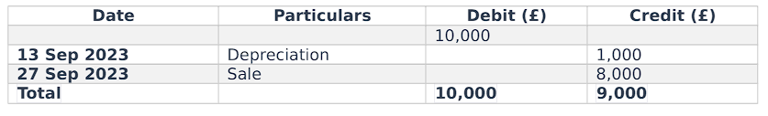
Bank Balance Account
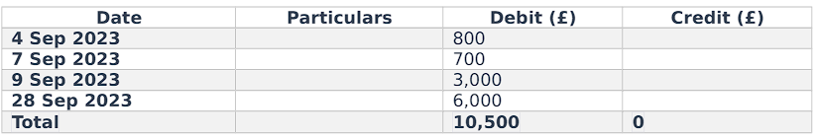Cash Balance account
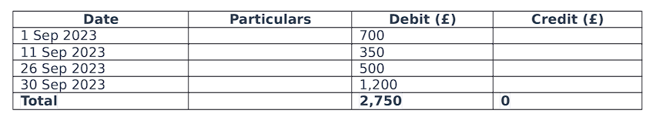

Receivable amount
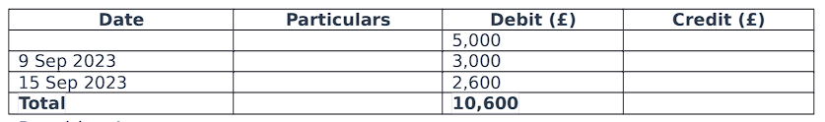
Payable Amount

Expenses (Depreciation, Petrol, Wages, Advertisement, Insurance)
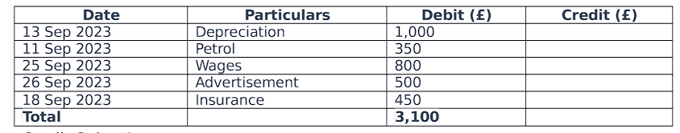

Credit Sales Account

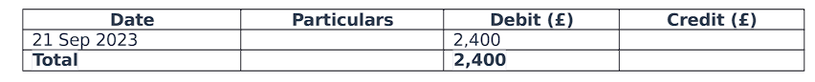

Trial Balance

Initial Balances and Transactions
- Capital: £30,000 + £700 (additional capital) = £30,700
- Van: Original £15,000
- Bank: £10,000 starting balance
- Cash: £2,000 starting balance
- Receivables: £5,000 starting balance
- Payables: £2,000 starting balance

Transaction Details
- Maria contributes additional capital in cash: +£700 to Cash.
- Maria purchases a computer by cash: -£1,000 from Cash.
- Maria pays a supplier by bank transfer: -£800 from Bank.
- Maria purchases products for resale and pays by cheque: -£700 from Bank.
- Maria receives payment from a receivable into her bank: +£3,000 to Bank.
- Maria pays for petrol with a debit card: -£350 from Bank.
- Maria receives a cash payment from another receivable: +£2,600 to Cash.
- Maria pays for insurance by debit card: -£450 from Bank.
- Maria purchases additional products for resale on credit: +£1,200 to Payables.
- Maria invoices a new customer on credit terms: +£2,400 to Receivables.
- Maria pays cash for wages: -£800 from Cash.
- Maria pays for advertising in cash: -£500 from Cash.
- Maria sells her used van: Receives £8,000 cash, then deposits £6,000 to Bank, keeps £2,000 in Cash.
- Maria withdraws cash for personal use: -£1,200 from Cash.

Calculation of Accounts
- Cash: £2,000 + £700 + £2,600 + £2,000 (from van sale) - £1,000 (computer) - £800 (wages) - £500 (advertising) - £1,200 (withdrawal) = £3,800
- Bank: £10,000 + £3,000 (receivable) + £6,000 (deposit from van sale) - £800 (supplier) - £700 (products) - £350 (petrol) - £450 (insurance) - £1,200 (Maria's withdrawal) = £16,500
- Receivables: £5,000 + £2,400 (new invoice) - £3,000 (payment) - £2,600 (cash payment) = £1,800
- Payables: £2,000 + £1,200 (new purchases) - £800 (payment made) = £2,400
- Van Depreciation: Assuming 5-year life with no salvage, annual depreciation = £15,000 / 5 = £3,000. Monthly depreciation = £3,000 / 12 = £250 (for February).
- Loss on Van Sale: Sale price £8,000 - Book value after depreciation (£15,000 - £250) = £14,750, Loss = £14,750 - £8,000 = £6,750

Account | Debit (£) | Credit (£)
Bank Account | 16,500
Cash Account | 2,800
Receivables | 1,800
Inventory | 1,900
Computer Equipment | 1,000
Van (Depreciation) | 250
Petrol Expense | 350
Insurance Expense | 450
Wages Expense | 800
Advertising Expense | 500
Loss on Van Sale | 6,750
Payables |  | 2,400
Capital |  | 30,700
Total | 33,100 | 33,100

● Capital Gain: Maria expanded her capital from PS 30000 by adding PS700. This brought her total up in the range of PS 30,75PS. This is a sign of investment in company growth, specifically the need to purchase a laptop PC in this very short amount of amount of.
* Van transaction: The balance to be found in the account of the van is an important debit that is due to the original price (PS15,000) Depreciation PS1,000 and loss from sales PS6 9. In comparison to the account value in the book, i.e. it is taken out of the books PS14 9, 9. The depreciation of the PS6,000 represents amount of depreciation as well as the value sold for the van within the county of shire (Jennergren,2018).
* Bank Activity This transaction was made through the account of the bank. But, the balance equalized due to receivables collections (PS3000) and also the cash outflow due to van disposal (lb6. Personal drawdowns and fee payments of PS2,000 slowed this increase.
* Cash movement: The account for cash was able to handle a variety of inflows, including the collection of receivables and capital costs, and outflows for computer purchase and gasoline amounts of wages were used from advertising expenditures . This demonstrates the cash flow and liquidity of operational flow of the business operating.
* Receivables and payables: The capability of Maria to collect the payment can be a sign of her ability to manage receivables effectively. This is mainly due to the payment account is in balance meaning that its supplier relationships are maintained and credit purchases remain in place (Pratt,2010).
* Expenses and Purchases This entry from the accounts for purchases is for restocking to sale (PS1,900) that should be laid out new needs while operating Maria's company. Insurance (PS450) and advertising (PS500) and wage are typical business expenses in the Iil the tuo, Iil as well as PSiii account (Pontoh,2020).
* Asset Disposal and Depreciation The account for depreciation reflects the depreciation of assets due to the production capacity which is not a concern for revenue and expenses that are made from profits and losses. Then, we can go on and check that the liability impacting the total value as well as the profit position is Profit/Loss from Selling of Van liabilities compatible to the statement account Van sale, loss 1230.
Receivables management and payables constitute the main business areas in active capital management which Maria's Cleaning Service takes advantage of due to its efficient process of handling receivables and the ability to pay. The sale of a van, in spite of its negative impact to society, is the strategic aspect of asset management. Current assets, such as funds flowing into banks and balances can be significant in ensuring the liquidity strength of your business and operating continuity.

3.Task 3 3.Task 3: Going Beware
The notion of "going concern" which is a fundamental element of accounting and is required for preparing financial statements, is also relevant to the critical analysis required for finding out the viability or stability of a business financially. When assessing the status of"going concern," it's presumed that the business continues to run its business successfully throughout the years to come and not be liquidated or experiencing any significant turmoil. Through this brief paper, the idea is discussed and analyzed in relation to its significance in financial accounting (Nguyen,2021).
Concept of Going In Concern
As a backdrop for going worry is the idea that the business will continue to exist in perpetuity as a living thing or over a time span that is defined. Based on this notion accountants evaluate financial statements with the expectation that the company goes through its daily business activitiesand will be affecting its customers, completing obligations, and generating utilities from assets.
The notion of going-to-market has deep roots in the idea that the majority of businesses are created by a business model that is focused on profit, and will create worth over the long term for both the shareholders and owners. It is this principle that forms the base on how financial statements are developed and is the basis for determining asset valuations as well as liabilities' inscriptions and the classification of a company's performance (Sabastian,2021).
The application of the Going Concern
While the idea may appear as if it is a supplement to the field of accounting but its usage is all-encompassing. When accounting is involved in the production of financial statements, it's quite obvious that financial decisions will need to be taken by accountants based on estimations and judgments based on an assumption that the company will exist operating as a viable business (Tkhagapso,2020).
* Asset Valuation in the context of the assumption of going concern, assets are valued based on their historic cost, and the fair market value, not liquidation prices. The assumption is that assets built upon the concept of depreciation will be considered to have a long-term value and could generate cash flow over a long period of length of.
• Liability recognition: Valueful assumption are made here that is the side that covers liabilities on the balance sheet in other words, when they are due to becomes due, the business will be able to be able to pay. This is the process of identifying obligations incurred such as loan interest as well as contingent liabilities and other loans (Saputri,2024).
* Amortisation and Depreciation: Therefore, amortisation and depreciation charges, based upon the anticipated life expectancy of assets and the respective streams of income to be as assets - are justifiable through their role in operating.
The income recognition process is a simple one. Amount is recognised when it generates and can be realized by the process of cash payments, which could be deferred to a later date. It is a presumption that the company's revenues will grow in the future (Weygandt in 2018,).
Important to have a the Going In the Right Direction
The importance of the notion of going concern accounting can't be overestimated because it has implications such like a financial report making decisions, and evaluating the firm's fiscal situation as a result of capitalization.
Affirmative Financial Statements Going concern is a an enviable foundation to build financial statements which reflect the an organization's financial performance. The restraining of property by angry traders is so acrimonious that technology companies face a an initial obstacle of a high magnitude in this liquidation (Anthony 1999).
* Investor Confidence: These financial statements assist shareholders and investors in making their decisions. Going concern concepts give an investor the assurance of stability in their investment portfolios and ensures continuity in activities that are based on the amount that will be brought in the future from the investment of any kind as a result of the ROI (Berishvili 2020).
"Creditor's confidence Lenders as well as other creditors calculate the true state of a company's credit through statements that evaluate these. If they take the given assumption of going concern, they know the likelihood that a company is capable of meeting the loan obligation, which decreases the chance of a default.
* Long-Term Plan: Management makes use of the assumption of going concern for its perspective on planning. It allows them to make informed decisions about potential investments, growth efforts and strategic goals, assuming the fact that they are for sure that the operation will be smooth (Deegan,2013).
* Compliance with Legal and Regulations No matter how much criticism it could get, there's numerous laws and bylaws which require IFRS as well as GAAP declarations to be based upon the principle of going concern. Compliance with such guidelines is mandatory when the transparency of accountability and disclosure are required (Jennergren,2018).
Yet it is true that the notion of going concern is a key rule in accounting which ensures forecasts that do not affect credibility and effectiveness of the financial statements. This allows stakeholders to assess the their company's financial performance and assess whether it's appropriate or not in light of the decisions made by the firm to have confidence in sustainable factors. If this is not the case, it means that, in the absence of relevant data in a structured and stimulating setting to enable an accurate analysis of financial reports, it could be a challenge in the industry (Pratt,2010).

4.Conclusion
Task 1 delve further into the financials of a firm to determine the financial year that ends 31 December, by providing a detailed breakdown of the financials. It includes sales, the cost of selling goods, operational expenses, capital depreciation as well as bad debts, to provide the net profit amount, which is the other costs included in the trading accounts totalling PS 24,425. The balance sheet also gets scrutinized where assets, liabilities and equity figures are included in order to offer a comprehensive overview of the assets and liabilities that the company is able to hold in relation to the outstanding debts. In this study, it is apparent that there's a noticeable appearance of strength, with an impressive net sales which has produced PS156,000 as well as a gross profits of PS of 68,00. The management is able to manage direct expenses effectively as well as enjoy an overall healthy profit. Balance sheet data shows an amount of PS51.875 for assets. The amount of balance is determined adequate to the current state of affairs which is reflected in a positive liquidity balance and fixed assets. The equity balance of PS15450 proves the capability of generating as well as the retention of income.

Task 2 is focused on Maria's T' business accounts for February 2024 and examines operational financial aspects like the capital rise of credit and debit of van transactions, banking transactions, vans' transactions and the movement of cash. Van sale was worthy of mention because of the losses and had a negative impact on the productivity, however the business remains stable and efficient in terms of receivables/payables, and also has the cash flow that is generated by operations.
Task 3 focuses on an examination of the Going Concern principle, foundational in financial statements. It is based on the assumption that companies will operate for a long time, and this influences the value of assets, liability accounting, and the recording of revenue. Important for trust in investors as well as legal compliance This ensures that the company has accurate and reliable financial statements, helping stakeholders make informed decisions regarding the state of the business.
Overall they provide an extremely thorough introduction to accounting for financial statements, the accounting for transactions, along with the major principles of accounting fundamentals. They also highlight the importance of a well-functioning financial control system and the consequences of the business deal regarding its financial health and the accounting assumptions helps to organize an account of what the business is doing.

References
Anthony, R.N., Hawkins, D.F., Merchant, K.A., Wang, L. and Du, M., 1999. Accounting: text and cases. Irwin/MrGraw-Hill.

Berishvili, V., 2020. Industry average financial ratios for Georgia. Ecoforum Journal, 9(3).

Deegan, C.M., 2013. Financial accounting theory/Craig Deegan. In Accounting Forum (Vol. 20, No. 5, pp. 63-73). in Australia by McGraw-Hill Education (Australia) Pty Ltd Level 2, 82 Waterloo Road, North Ryde NSW 2113.

Jennergren, L.P., 2018. A note on the linear and annuity class of depreciation methods. International Journal of Production Economics, 204, pp.123-134.
Pratt, J. and Salimi, A.Y., 2010. Financial accounting in an economic context. Issues in Accounting Education, 25(1), pp.178-179.

Pontoh, W. and Budiarso, N.S., 2020. Keputusan Investasi Pada Usaha Mikro, Kecil, Dan Menengah. The Studies of Social Sciences, 2(1), pp.27-32.
Nguyen, T., Chen, J.V. and Nguyen, T.P.H., 2021. Appropriation of accounting information system use under the new IFRS: Impacts on accounting process performance. Information & Management, 58(8), p.103534.

Sabastian, B. and Prijadi, R., 2021. Analysis of cost behavior in air transportation business before and during COVID-19 pandemic: Case study of Garuda Indonesia. International Journal of Business and Technology Management, 3(2), pp.123-130.

Saputri, A., 2024. Penerapan Sistem Pembukuan Sederhana Pada Kantor Kelurahan Lanto. Jurnal Pengabdian Masyarakat Bangsa, 1(11), pp.3248-3251.

Tkhagapso, R., 2020. Transformation of Fundamental Accounting Principles in the Context of a Company Insolvency from the Perspective of the Digital Economy. In Digital Science 2019 (pp. 75-85). Springer International Publishing.

Weygandt, J.J., Kimmel, P.D. and Kieso, D.E., 2018. Financial accounting with international financial reporting standards. John Wiley & Sons.

