Caitlin Vivian 1800517
Portfolio

Interpreting Sarah and Hagar’s relationship from a Feminist perspective

Rationale
In my portfolio, I will be using a feminist perspective/interpretation on the relationship of Sarah and Hagar within Genesis 16. The aim of a feminist interpretation is to re-examine the significance and role of named and unnamed women in the Bible. For example, Mary Magdalene’s role as a follower of Jesus. A secondary aim of a feminist interpretation is to assess the femininity of male biblical characters. For example, Jacob. I have chosen the feminist perspective as it brings out ideology not thought of before, such as how women are marginalized in The Bible and used as plot devices. This interests me as it can be argued, the portrayal of women in The Bible contributes towards the negative attitudes towards women even today. I have chosen this because I find the themes of the passage interesting, such as the themes of infertility, prophecy and objectification. I also find the consequences of the passage interesting. I will approach the passage be using a range of sources such as commentaries and books with a feminist interpretation.
*See Page 3 for a copy of poster – original uploaded
Exegetical Poster Report
16 Now Sarai, Abram’s wife, bore him no children. She had an Egyptian slave-girl whose name was Hagar, 2 and Sarai said to Abram, “You see that the LORD has prevented me from bearing children; go in to my slave-girl; it may be that I shall obtain children by her.” And Abram listened to the voice of Sarai. 3 So, after Abram had lived ten years in the land of Canaan, Sarai, Abram’s wife, took Hagar the Egyptian, her slave-girl, and gave her to her husband Abram as a wife. 4 He went in to Hagar, and she conceived; and when she saw that she had conceived, she looked with contempt on her mistress. 5 Then Sarai said to Abram, “May the wrong done to me be on you! I gave my slave-girl to your embrace, and when she saw that she had conceived, she looked on me with contempt. May the LORD judge between you and me!” 6 But Abram said to Sarai, “Your slave-girl is in your power; do to her as you please.” Then Sarai dealt harshly with her, and she ran away from her.
In this exegetical report, I will focus on Genesis 16. This passage is about how Sarah and Abraham, called Abram and Sarai in the passage, cannot conceive a child. Thus, Sarah suggests to Abraham to use her slave, Hagar, a foreign person; To conceive a child. However, Sarah becomes jealous of Hagar once a child is conceived and punishes her.
A key theme of this passage is baroness, focusing on Sarah and her desire to obtain a child by any means. It is therefore suggested that Sarah is the main character of the passage. In this passage Hagar is treated as an object rather than a person as ‘go in to my slave-girl; it may be that I shall obtain by her.’ conveys.
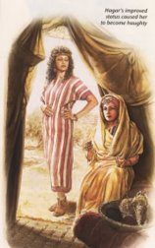
Fig.1 Sarah and Hagar
I will examine this portrayal of Sarah and Hagar from the Jehovah ‘s Witness Bible website. In the picture, Hagar is described as ‘haughty’, which means she uses her position against Sarah. This is a stark contrast from Genesis 16 in the New Standard Revised Version, as Hagar is depicted as being objectified and marginalized. However, in this depiction, Hagar and Sarah are the only characters seen in the picture. Hagar is portrayed as a strong and confident individual. Whereas, Sarah is portrayed as a sad and weak woman. From a feminist perspective, this is an interesting depiction of Sarah and Hagar as Abraham is not present and Hagar’s position is quite powerful as it is the center of the picture. The picture agrees with the Elaine James’ commentary on Sarah from the Women’s Bible Commentary. James’ interpretation is that omits her treatment of Hagar, this leads Sarah to become unrightfully jealous of Hagar and to become entangled in moral dilemmas.
To conclude, rather than Abraham being the main character for Genesis 16, typical roles have been reversed and the women are the main characters. This passage has theological and historical significance as the baby conceived would become Ishmael, the Patriarch of Islam. Secondly, even though Hagar is objectified, she is the most powerful person in the passage as she can conceive a child.

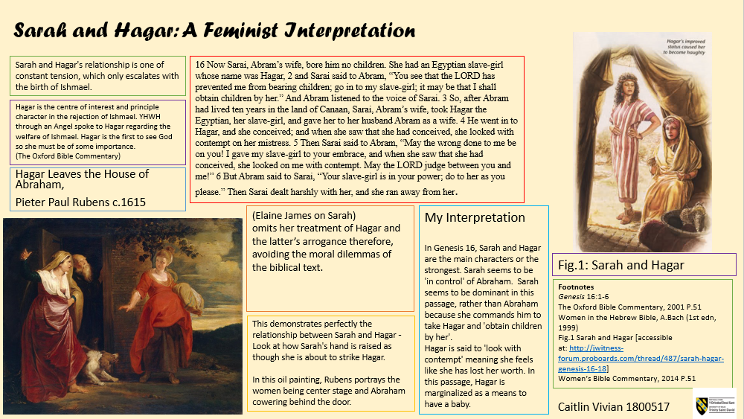

Commentaries :
The Oxford Bible Commentary, 2001 P.51 Hagar is the centre of interest and principle character in the rejection of Ishmael. YHWH through an Angel spoke to Hagar regarding the welfare of Ishmael. Hagar is the first to see God so she must be of some importance.
Women’s Bible Commentary, 2014 P.51 (Elaine James on Sarah) omits her treatment of Hagar and the latter’s arrogance therefore, avoiding the moral dilemmas of the biblical text.

