
Programme: MSc Public Health and Social Care in Practice
Module: Quality Assurance and Service Improvements
Module code: LCHS7006
Assignment Title: Component 2 Service Improvement Report
Case organisation: Countess of Chester Hospital
Student Name:
Student ID:
Table of Contents
1. Introduction 3
1.1 Background Context 3
1.2 Rationale for the Chosen Issue 3
1.3 Aim and Scope of the Report 4
2. Main Body 4
2.1 Analysis of the Root Causes of the Patient Safety Failure 4
2.2 Systematic Identification of Contributing Factors: Fishbone Analysis and 5 whys analysis 5
2.3 Evaluating Quality of Neonatal Care: Donabedian Model 7
2.4 Policy and Governance Analysis 9
2.5 SWOT Analysis for Service Improvement Capacity 9
2.6 Implications for Quality Improvement: Synthesis of Findings 10
3. Recommendation 11
3.1 Recommendations 11
3.2 Implementation and Sustainability Strategy 12
4. Conclusion 13
References 15

1. Introduction

1.1 Background Context
The safety of the patients is the core element of the quality of healthcare, as failures in care can cause avoidable harm to the patient, loss of life and loss of trust in health services by the public. It is estimated that around 10% of all patients suffer harm while receiving health care and over half of this is preventable (Bhati et al., 2023). This is especially relevant in neonatal services where babies are a vulnerable group, and need appropriately skilled staff, effective communication, timely escalation to support and robust clinical governance.
The present report builds on the case study analysed in Component 1, regarding the Countess of Chester Hospital neonatal unit and the Lucy Letby case. There are 18 neonatal deaths recorded in the Thirlwall Inquiry, 10 in 2015 and 8 in 2016 (Rodríguez and Borges, 2022). The concerns identified by the staff in component 1 were related to staffing capacity, access to specialist neonatal expertise, communication, escalation, infrastructure and organisational governance.
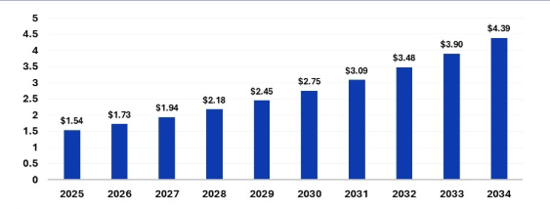
Figure 1: Healthcare Quality Management (QMS) Market Size
(Source: Precedence Research, 2026)

1.2 Rationale for the Chosen Issue
The case offers a valuable quality-improvement context, as patient-safety risks are not only within the actions of individual patients (NCBI, 2026). Risks can be missed or not adequately managed as a result of interaction between workforce pressures, clinical processes, leadership, communications and governance. This ensures that the principles of patient safety and organisational governance are suitable as a quality issue for critical analysis of the neonatal patient.

1.3 Aim and Scope of the Report
This report aims to critically review the organisational factors associated with neonatal patient-safety issues at Countess of Chester Hospital and to highlight the opportunities for change based on the evidence. It utilises Fishbone analysis, the 5 Whys, the Donabedian Model and strategic analysis, and then formulates recommendations and a PDSA-informed implementation approach. This is an extension of the root cause analysis and continuous improvement from component 1.

2. Main Body

2.1 Analysis of the Root Causes of the Patient Safety Failure
Root Cause Analysis can be illustrated with tables to illustrate the relationship between the initial problem of patient safety and the underlying issues within the organisation and the system (Chen et al. 2024). The analysis is based on the systems approach that was outlined in Component 1.
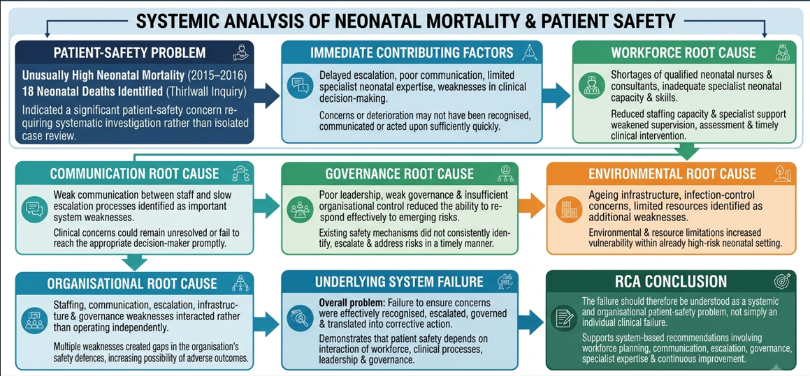
Figure 2: Root Cause Analysis for the Chosen Issue
(Self-developed)
Interpretation: The Root Cause Analysis illustrates the chain of cause-and-effect relationships that are connected as follows: Insufficient strength of the workforce and capacity of specialists leads to problems with communication and escalation, which results in a delayed reaction from the organisation, which results in weakened safety barriers and increased risk for patient safety (Gedefa Bayisa et al. 2025). It corresponds with the Swiss cheese approach of Component 1, where staffing, supervision, environment, delayed escalation and governance represent various defence layers with holes in them. Thus, RCA serves as the cause-and-effect framework for further Fishbone and Donabedian analyses.

2.2 Systematic Identification of Contributing Factors: Fishbone Analysis and 5 whys analysis
The Fishbone analysis can be applied alongside RCA to classify multiple contributing factors as well as identify connections between the causes. In Component 1, staff, processes, environment, and management/policy are already identified as important parts. The analysis can be additionally improved with the help of the following:
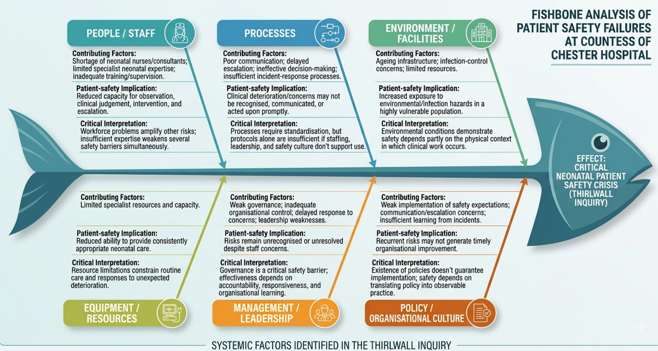
Figure 3: Fishbone Analysis of the Chosen Issue
(Self-developed)
The value of Fishbone analysis is that it demonstrates connections—how it happened—who failed—who influenced who. It will support the conclusion of Component 1. The Fishbone analysis has its limitations—it classifies the causes while health care failures are dynamic and interconnected (Reliable Plant, 2026). Therefore, it should not be considered as an explanation of a single cause of failure but alongside RCA and the Donabedian model.
5 Why Analysis
The Five Whys technique is used to uncover the underlying cause-and-effect chain of the patient-safety breakdown following the Fishbone approach. This adds to the Fishbone framework by offering a better insight into the organisational causes behind the contributing factors. The analysis follows the same line of thought as the one in Component 1, where the following overlapping vulnerabilities were uncovered: staff shortage, delayed escalation, communication breakdown, and poor governance.
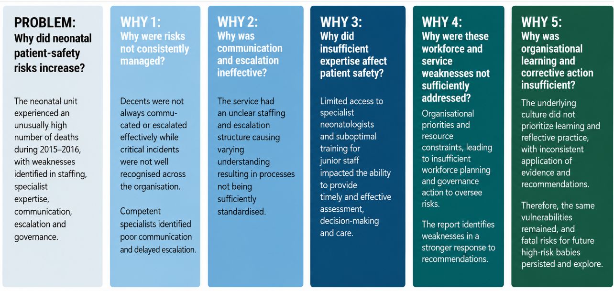
Figure 4: 5Why Analysis of the Chosen Issue
(Self-developed)
From the Five Whys analysis, the findings from the above analyses are again confirmed. The patient-safety risks arose from several organisational issues that were not individually responsible for the situation but together created them (Gedefa Bayisa et al. 2025). The analysis goes from an observed problem of high risk of neonates to the deeper problems of workforce capacity, expertise, communication, escalation and governance. In this way, it supports Component 1, systems approach, when several safety defences were found to be weak.
The key point here is that it is not said that the Five Whys method proves the existence of a single cause of the issue. Healthcare failures can occur due to several reasons and have many levels of causation focus (The Guardian, 2025). The strength of the Five Whys model is in providing insight into a causal pathway and in identifying where improvement interventions should. The learning is relevant for all three recommendations: support for the neonatal workforce and specialist capacity, communication and escalation, and governance and organisational learning.

2.3 Evaluating Quality of Neonatal Care: Donabedian Model
The model of Donabedian that was developed has been widely used to measure the quality of healthcare, and the literature on neonatal care has indicated that it can be used to determine the indicators of quality of neonatal services from the perspective of structure, process and outcome (Peter et al. 2026). This model is particularly applicable in this instance because of the number of deficiencies present in Component 1.
Structure: The structural aspect refers to the availability of resources and organisational aspects which can be used in ensuring the safety of care. The main structural deficiencies in the Countess of Chester neonatal unit included: inadequate staffing, shortage of appropriately qualified neonatal staff, the absence of expert knowledge of neonatologists, old infrastructure, infection control problems and governance problems (McCullough et al. 2023).
As can be seen from the model, there is no divide between quality and capacity. While the staff may consist of competent individuals, poor staffing or specialist provision may affect their ability to deliver safe care (Peter et al. 2026). Hospital statistics also indicate that there are important linkages between structure, process, and outcomes, implying that the quality of the structure has an influence on the quality of the clinical process that can be delivered safely (WHO, 2023).
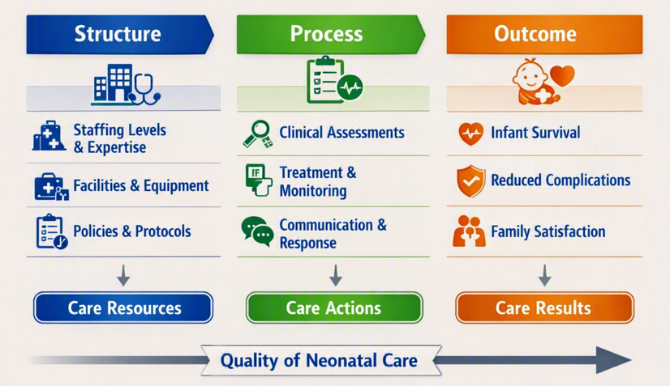
Figure 5: Donabedian Model applied to the Chosen Issue
(Self-developed)
Process: This dimension refers to the activities carried out by health care practitioners while providing health care; for instance, when assessing, communicating, escalating, and making clinical decisions (‌Australian Commission on Safety and Quality in Health Care, 2026). In this case, deficiencies within the process include ineffective communication, late escalation, and inadequate organisation to address the issues (Ghofrani et al. 2024). Lack of effective communication and late escalation are listed among the key contributors within Component 1.
Structure and process are clearly linked because without proper staffing and expertise, it will be more difficult to communicate, manage and escalate. More robust processes will help alleviate some of the structural issues; multidisciplinary review, structured communication and escalation processes are examples of such processes (Safety and Quality, 2026). Evidence exists regarding the significance of communication; a systematic review concluded that poor communication was an important cause of patient-safety events, but there are significant methodological issues with the available evidence (Yang et al. 2025).
Outcome: The outcome dimension deals with the effects of delivering care in relation to patients' health and safety and the effect of the care delivered to the organisation (De Rosis, 2024). Among the outcome measures that can be used in neonatal services are mortality rate, morbidity rate, avoidable deterioration, infection, adverse events, and family experience. For this particular case, high mortality rates experienced in 2015-2016 were among the outcome measures used and organisational consequences included investigation, disruptions, and loss of public trust. There have been a total of 18 neonatal deaths noted by the Thirlwall inquiry; 10 in 2015 and 8 in 2016. One major limitation is that outcomes can only determine causation and not vice versa (The Guardian, 2025).

2.4 Policy and Governance Analysis
In the case of the Countess of Chester Hospital, governance is an effective tool for the identification, escalation and learning from patient safety risks. Component 1 identified risk factors as weak governance, delayed responses to concerns, inadequate staffing and insufficient organisational control as interconnected factors (NCBI, 2026). This indicates that the quality problem was not only a problem of clinical practice but also a problem of organisational management.
The NHS policy today emphasises system-based learning more. Organisations are required to establish processes under the Patient Safety Incident Response Framework (PSIRF) that will allow learning to take place following a patient-safety incident, which will then be incorporated into a clinical-governance and quality-improvement system (Mistri et al., 2023). One of the key aspects of PSIRF is to shift the focus from incidents as single events to considering contributory system factors. It is very similar to the Swiss Cheese and Root Cause Analysis approaches taken in Component 1.
However, the presence of policy does not ensure effective governance. The Letby case illustrates how formal governance structures and arrangements can fall short of their implementation (Aryasinghe et al., 2025). Good governance thus needs to be transparent, with clear accountability, independent escalation, and clear reporting and evidence that identified risks result in measurable corrective action. This gives a good argument for augmenting clinical process, workforce and governance interventions.

2.5 SWOT Analysis for Service Improvement Capacity
Strengths. The first strength relates to the existence of clinical governance and patient safety frameworks within the NHS. There are mechanisms to monitor incidents and review performance and risks (Bhati et al., 2023). It allows for improvement on an organisational level. Another strength is related to access to specialists in neonates. This is because the use of a multi-disciplinary team could assist with more effective decision-making and competency acquisition. Finally, the existence of improvement frameworks such as PSIRF and PDSA is the third strength.
Weaknesses: Staffing shortages constitute an internal weakness due to a lack of adequate staffing levels and specialist skills in the neonatal population (Hardie et al., 2022). In addition, Component 1 uncovered communication gaps, poor escalation and poor governance. Such issues are important in this case because additional policies will not help improve the situation if there is no capacity, power and ability to apply them.
Opportunities: PSIRF provides an opportunity to learn more about the organisation by switching focus from blaming the individual to identifying the system issues that contribute to the problem (Ahmed et al., 2023). This opportunity is important for the analysis of the problem based on a systems approach made in Component 1. Furthermore, PDSA will provide an opportunity to test staffing, escalation and communication measures incrementally and to change those that are unsuccessful.
Threats: Sustainability of efforts might be threatened by constant staffing challenges that may exist despite the application of new processes (NCBI, 2026). An organisational threat exists due to the reluctance to address escalation issues in the past. Another threat is reputational damage and loss of confidence.

2.6 Implications for Quality Improvement: Synthesis of Findings
Overall, the results show that there were several factors at play and interconnected issues to consider with regard to the patient-safety problems that had arisen at the Countess of Chester Hospital, and that it is inappropriate to blame a single failure. The Root Cause Analysis (RCA) revealed a chain of events and a lack of workforce capacity and specialist expertise led to communication and escalation issues, resulting in delayed organisational responses, failing to maintain safety barriers and the additional risk to patient safety (Daniels et al., 2022). This is in line with the Swiss Cheese perspective developed in Component 1, with several defence layers failing because of weaknesses in staffing, supervision, environment, escalation, and governance.
The Fishbone analysis also shows that no single factor can be improved as the four factors are in dynamic interplay (Adesokan-Imran, 2025). The Donabedian Model supports this conclusion by demonstrating the impact of structural deficits (such as staffing, specialist provision, infrastructure and governance) on the clinical process and ultimately patient outcomes (including mortality, morbidity, infection and adverse events).
Policy and SWOT analysis suggest that there is a need for effective local action to be achieved through the existing NHS governance and PSIRF structures (Deloitte, 2025). So, enhancing workforce, structured communication and escalation, improved accountability, multidisciplinary working and ongoing PDSA learning should be integrated into any improvement. These findings serve as evidence to support the recommendations and implementation plan that will follow.

3. Recommendation

3.1 Recommendations
Recommendation 1: Strengthen Neonatal Workforce and Specialist Capacity
Staffing and specialist capacity issues that were identified during the Root Cause Analysis and Donabedian Model should be first on the list for addressing weaknesses. There should be increased access to suitably qualified neonatal nurses and consultant expertise, with structured specialist training and clinical supervision (Limiri, 2025). The first step in a PDSA cycle is to try increased staffing and specialist cover in a limited timeframe. Pre- and post-implementation measures should be taken for staffing, escalation delay and neonatal safety incidents. This way, interventions can be tailored based on the evidence instead of the problem being solved by extra staff.
Recommendation 2: Improve Communication and Clinical Escalation
Implement structured and multidisciplinary communication and recognised escalation pathways to minimise delayed recognition and organisational responses. Escalation pathways should be standardised to outline when concerns should be reviewed by senior staff who review the neonates and what is done with unresolved concerns (Naeem and Jacob, 2025). Lean principles can help with this intervention by uncovering unnecessary delays and process variation. Escalation procedures and response times should be monitored regularly and should be filled in with incident reports.
Recommendation 3: Strengthen Governance and Organisational Learning
There needs to be improved governance with transparent incident reporting, accountability and systematic learning based on PSIRF and PDSA. Incident findings should lead to action as well as documentation. The implementation, outcomes and new risks should be tracked through regular multidisciplinary safety reviews (Jones et al., 2022). This directly tackles the governance weaknesses identified in Component 1 and contributes to sustainable improvement by ongoing organisational learning.

3.2 Implementation and Sustainability Strategy
The proposed implementation strategy will facilitate translating the three recommendations into action items: improving the neonatal workforce, enhancing communications and escalations and governance and organisational learning. The present report acknowledges that the PDSA cycle of improvement and the Lean methodology are effective tools for reducing delays and process variation. In order to enhance this process, Six Sigma can be utilised to reduce the variation and detect defects, as well as monitor whether improvements have been achieved regularly (Escobar et al. 2022). The PDSA and Six Sigma cycle is an appropriate process for the present situation since PDSA enables testing of solutions regularly and Six Sigma provides a framework for monitoring performance based on measurements.
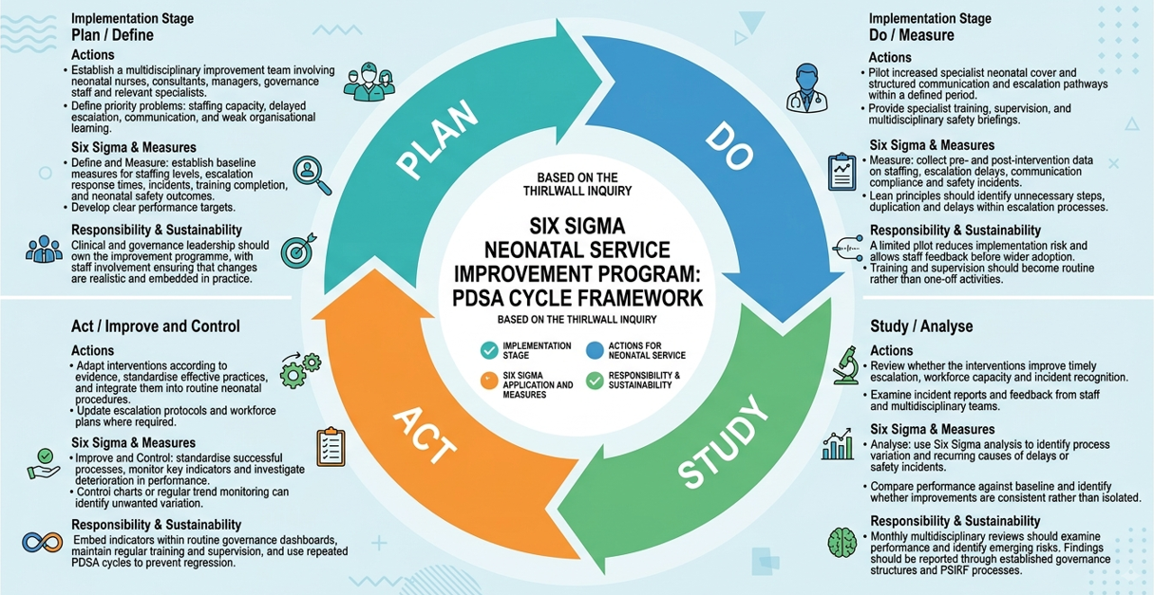
Figure 6: Implementation Plan using PDSA Framework and Six Sigma Model
(Self-developed)
PDSA cycle is not something that should happen in one project. In the Plan stage, there is setting of the intervention and the baseline; the Do stage is about testing the intervention in a manageable size; the Study is about analysing the qualitative and quantitative evidence, and Act is about either standardising the intervention or changing it to repeat the whole cycle (Salameh et al. 2025). This clearly shows a recommendation of the report where it talks about assessing and testing the increase in staffing and specialist cover by using the pre and post-implementation measures. The same goes for communication and escalation processes, where the monitoring is done using response time and incident reports.
In terms of Six Sigma, sustainability is achieved because it requires improvement to be based on measurable variation and not on any assumption (Hossain et al. 2024). Therefore, there needs to be an analysis following several indicators, including neonatal staffing capacity, specialist cover, escalation response time, structured communication compliance, incident report trends, completion of training and relevant neonatal safety outcomes. Of utmost importance is the need to use outcome data together with structural and process data because, according to the Donabedian analysis, these two were related to processes and outcomes of clinical care (McCullough et al. 2023).
Both governance and organisational learning are critical to sustainability, not only in the short term but in the long term too. Any actions taken in response to the incident must be captured in findings from the incident, and not just noted down (Orca Security, 2026). This helps take care of the problem of governance that exists in this particular case, as it is consistent with the PSIRF/PDSA recommendation of systematic learning. Staff shortage and lack of funds, changes in organisation, and loss of public trust are the major risks involved (Escobar et al. 2022). Therefore, PDSA’s experiment and adjust model can be used to integrate Six Sigma concepts of measure and control.

4. Conclusion
It is clear from the findings that the patient safety issues on the neonatal unit at the Countess of Chester arose as a result of the existence of several system and organisational problems rather than due to one factor alone. These include staff shortages, shortage of specialism, poor communication, delays in escalation, infrastructural issues and poor governance, which have been found using the use of root cause analysis and fishbone analysis, respectively. The Donabedian model was also useful in revealing how structure and process deficiencies can lead to poor neonatal safety outcomes. From the analysis, it has emerged that the necessary conditions for effective governance are accountability, transparency, timely escalation and organisational learning, which have been achieved through PSIRF. The improvements therefore would focus on improving the neonatal workforce, ensuring communication and escalation processes are standardised, and governance and incident learning. Finally, the combination of PDSA and Six Sigma would allow for a measurable approach for implementing change by way of testing, evaluating and sustaining the intervention measures.

References
Adesokan-Imran, T.O., (2025). The impact of cybersecurity governance on national security by strengthening critical infrastructure through IT auditing and risk management. Asian Journal of Research in Computer Science, 18(4), pp.301-322. https://doi.org/10.9734/ajrcos/2025/v18i4621
Ahmed, M.I., Spooner, B., Isherwood, J., Lane, M., Orrock, E. and Dennison, A., (2023). A systematic review of the barriers to the implementation of artificial intelligence in healthcare. Cureus, 15(10). https://www.cureus.com/articles/170025-a-systematic-review-of-the-barriers-to-the-implementation-of-artificial-intelligence-in-healthcare.pdf
Aryasinghe, S., Carenzo, C., Barnett, K.A., Khalid, R., Greenaway-Harvey, K., Sherlock, C., Clark, L., Croft, K., Orchard, T. and Mayer, E., (2025). Increasing the ethnic diversity of senior leadership within the English National Health Service: using an artificial intelligence approach to evaluate inclusive recruitment strategies in hospital settings. Human Resources for Health, 23(1), pp.1-14.https://link.springer.com/content/pdf/10.1186/s12960-025-00991-8.pdf
‌Australian Commission on Safety and Quality in Health Care, (2026). Clinical Governance Standard. Available at: https://www.safetyandquality.gov.au/national-standards/nsqhs-standards/clinical-governance-standard [Accessed on 12.08.2026].
Bhati, D., Deogade, M.S. and Kanyal, D., (2023). Improving patient outcomes through effective hospital administration: a comprehensive review. Cureus, 15(10). https://www.cureus.com/articles/197936-improving-patient-outcomes-through-effective-hospital-administration-a-comprehensive-review.pdf
Bhati, D., Deogade, M.S. and Kanyal, D., (2023). Improving patient outcomes through effective hospital administration: a comprehensive review. Cureus, 15(10). https://www.cureus.com/articles/197936-improving-patient-outcomes-through-effective-hospital-administration-a-comprehensive-review.pdf
Chen, Y., Xie, H., Ma, M., Kang, Y., Gao, X., Shi, L., Cao, Y., Gao, X., Fan, H., Wen, M. and Zeng, J., (2024). Automatic root cause analysis via large language models for cloud incidents. In Proceedings of the Nineteenth European Conference on Computer Systems (pp. 674-688). Available at‌: https://dl.acm.org/doi/pdf/10.1145/3627703.3629553
Daniels, K., Connolly, S., Woodard, R., van Stolk, C., Patey, J., Fong, K., France, R., Vigurs, C. and Herd, M., (2022). NHS staff wellbeing: Why investing in organisational and management practices makes business sense. London: IPPO. https://www.breathedentalwellness.org/resource_redirect/downloads/file-uploads/sites/2148598877/themes/2163106936/downloads/8d4207-cd68-5250-6fdb-07f72db3faf6_IPPO_NHS_Staff_Wellbeing_report_LO160622-1849.pdf
De Rosis, S., (2024). Performance measurement and user‐centeredness in the healthcare sector: Opening the black box adapting the framework of Donabedian. The International journal of health planning and management, 39(4), pp.1172-1182. Available at: https://onlinelibrary.wiley.com/doi/pdfdirect/10.1002/hpm.3732
Deloitte, (2025). Healthcare remains a business imperative in the life science and healthcare industries. https://www.deloitte.com/us/en/insights/industry/health-care/health-equity-business-imperative-in-2025.html [Accessed on 12.8.26]
‌Escobar, C.A., Macias, D., McGovern, M., Hernandez-de-Menendez, M. and Morales-Menendez, R., (2022). Quality 4.0–an evolution of Six Sigma DMAIC. International journal of lean six sigma, 13(6), pp.1200-1238. Available at: https://www.researchgate.net/profile/Carlos-Escobar-7/publication/360344742_Quality_40_-_an_evolution_of_Six_Sigma_DMAIC/links/6555a5a7b86a1d521be82b19/Quality-40-an-evolution-of-Six-Sigma-DMAIC.pdf
Gedefa Bayisa, Dechassa Edessa, Meskerem Deyasa, Ganna Gobena, Dereje Obsa, Tilahun, T., Tesfaye Shibiru, Amsalu Takele, Abera, C. and Etenat Tigabe, (2025). Enhancing senior physician-led multidisciplinary team rounds to improve patient care at Wallaga University Comprehensive Specialized Hospital, 2025. BMJ Open Quality, 14(3). Available at: https://doi.org/10.1136/bmjoq-2025-003429
Ghofrani, M., Valizadeh, L., Zamanzadeh, V., Ghahramanian, A., Janati, A. and Taleghani, F., (2024). Adapting the Donabedian model in undergraduate nursing education: a modified Delphi study. BMC Medical Education, 24(1), p.202. Available at: https://link.springer.com/content/pdf/10.1186/s12909-024-05187-7.pdf
Hardie, T., Horton, T., Thornton-Lee, N., Home, J. and Pereira, P., (2022). Developing learning health systems in the UK: priorities for action. The Health Foundation, 10. https://www.health.org.uk/sites/default/files/upload/publications/2022/Learning%20health%20systems_RGB_WEB.pdf
Hossain, A., Khan, M.R., Islam, M.T. and Islam, K.S., (2024). Analyzing the impact of combining lean six sigma methodologies with sustainability goals. Journal of Science and Engineering Research, 1(01), pp.123-144. Available at: https://www.academia.edu/download/120115459/Analyzing_The_Impact_Of_Combining_Lean_Six_Sigma_Methodologies_With_Sustainability_Goals.pdf
Jones, B., Horton, T. and Home, J., (2022). Strengthening NHS management and leadership. The Health Foundation. Retrieved February, 24, p.2023. https://www.health.org.uk/sites/default/files/pdf/2022-02/Strengthening%20NHS%20management%20and%20leadership.pdf
Limiri, D.M., 2025. The impact of long wait times on patient health outcomes: the growing NHS crisis. Premier J Public Health, 3, p.100020. https://ir-library.ku.ac.ke/server/api/core/bitstreams/96ce6d78-7296-4db3-b1fd-b93329456192/content
McCullough, K., Andrew, L., Genoni, A., Dunham, M., Whitehead, L. and Porock, D., (2023). An examination of primary health care nursing service evaluation using the Donabedian model: A systematic review. Research in nursing & health, 46(1), pp.159-176. Available at: https://onlinelibrary.wiley.com/doi/pdfdirect/10.1002/nur.22291
Mistri, I.U., Badge, A. and Shahu, S., (2023). Enhancing patient safety culture in hospitals. Cureus, 15(12). https://www.cureus.com/articles/199967-enhancing-patientsafety-culture-in-hospitals.pdf
Naeem, A. and Jacob, W., 2025. Evaluating the benefits and challenges of using patient preferences as a tool for clinical decision making in oncology multidisciplinary team meetings within the national health service: a qualitative study. Oncology research and treatment, 48(5), pp.305-311. https://karger.com/ort/article-pdf/48/5/305/4328095/000543741.pdf
NCBI, (2026). Health workforce shortage – doing the right things or doing things right? Available at: https://pmc.ncbi.nlm.nih.gov/articles/PMC9086817/
Ncbi, (2026). Patient Safety and Quality: An Evidence-Based Handbook for Nurses. Available at: https://www.ncbi.nlm.nih.gov/books/NBK2681/ [Accessed on 12.8.26]
Orca Security, (2026). What Is an Incident Response Plan? Available at: https://orca.security/resources/blog/incident-response-plan-steps-best-practices/ [Accessed on 12.08.2026].
Peter, D.E., Mkoka, D.A., Temba, P. and Millanzi, W.C., (2026). Using Donabedian’s model to explore healthcare providers’ perspectives on early recognition and initial management of paediatric acute kidney injury in rural Tanzania: a qualitative case study protocol. BMJ open, 16(6), p.e113598. Available at: https://bmjopen.bmj.com/content/bmjopen/16/6/e113598.full.pdf ‌
Precedence research, (2026). What is the Healthcare Quality Management (QMS) Market Size? Available at: https://www.precedenceresearch.com/healthcare-quality-management-market [Accessed on 12.8.26]
Reliable Plant, (2026). Fishbone Diagram Explained. Available at: https://www.reliableplant.com/fishbone-diagram-31877 [Accessed on 12.08.2026].
Rodríguez, A.M. and Borges, A.H., 2022. Quality of care and patient safety, key elements of health care. Anales de Pediatría (English Edition), 97(4), pp.227-228. https://www.sciencedirect.com/science/article/pii/S2341287922001855
Safety and Quality, (2026). Communicating for Safety Standard. Available at: https://www.safetyandquality.gov.au/national-standards/nsqhs-standards/communicating-safety-standard [Accessed on 12.08.2026].
Salameh, W.E.M.K.B., Mohammad, A.A.S., Alshurideh, M.T., Alolayyan, M.N., Hunitie, M.F.A., Rababah, M.W., Haija, A.A.A., Al-Hawary, S.I.S., Alzyoud, M. and Al-hawajreh, K.M., (2025). Evaluation of applying the PDCA cycle on medication administration in the emergency departments. In Intelligence-Driven Circular Economy: Regeneration Towards Sustainability and Social Responsibility—Volume 2 (pp. 319-330). Cham: Springer Nature Switzerland. https://doi.org/10.1007/978-3-031-74220-0_24
The Guardian, (2025). Spike in baby deaths in Lucy Letby unit warranted inquiry, says statistician. Available at: https://www.theguardian.com/uk-news/2025/jan/15/spike-in-baby-deaths-on-lucy-letby-ward-surprising-and-unusual-says-statistician [Accessed on 12.08.2026].
WHO, (2023). Patient safety. Available at: https://www.who.int/news-room/fact-sheets/detail/patient-safety [Accessed on 12.08.2026].
Yang, J., Liu, F., Yang, C., Wei, J., Ma, Y., Xu, L., Xie, J. and Wang, J., (2025). Application of Donabedian three‐dimensional model in outpatient care quality: A scoping review. Journal of nursing management, 2025(1), p.6893336. Available at: https://onlinelibrary.wiley.com/doi/pdf/10.1155/jonm/6893336

