ECIE4012
The Principles of Learning and Teaching

Portfolio

Student Number:

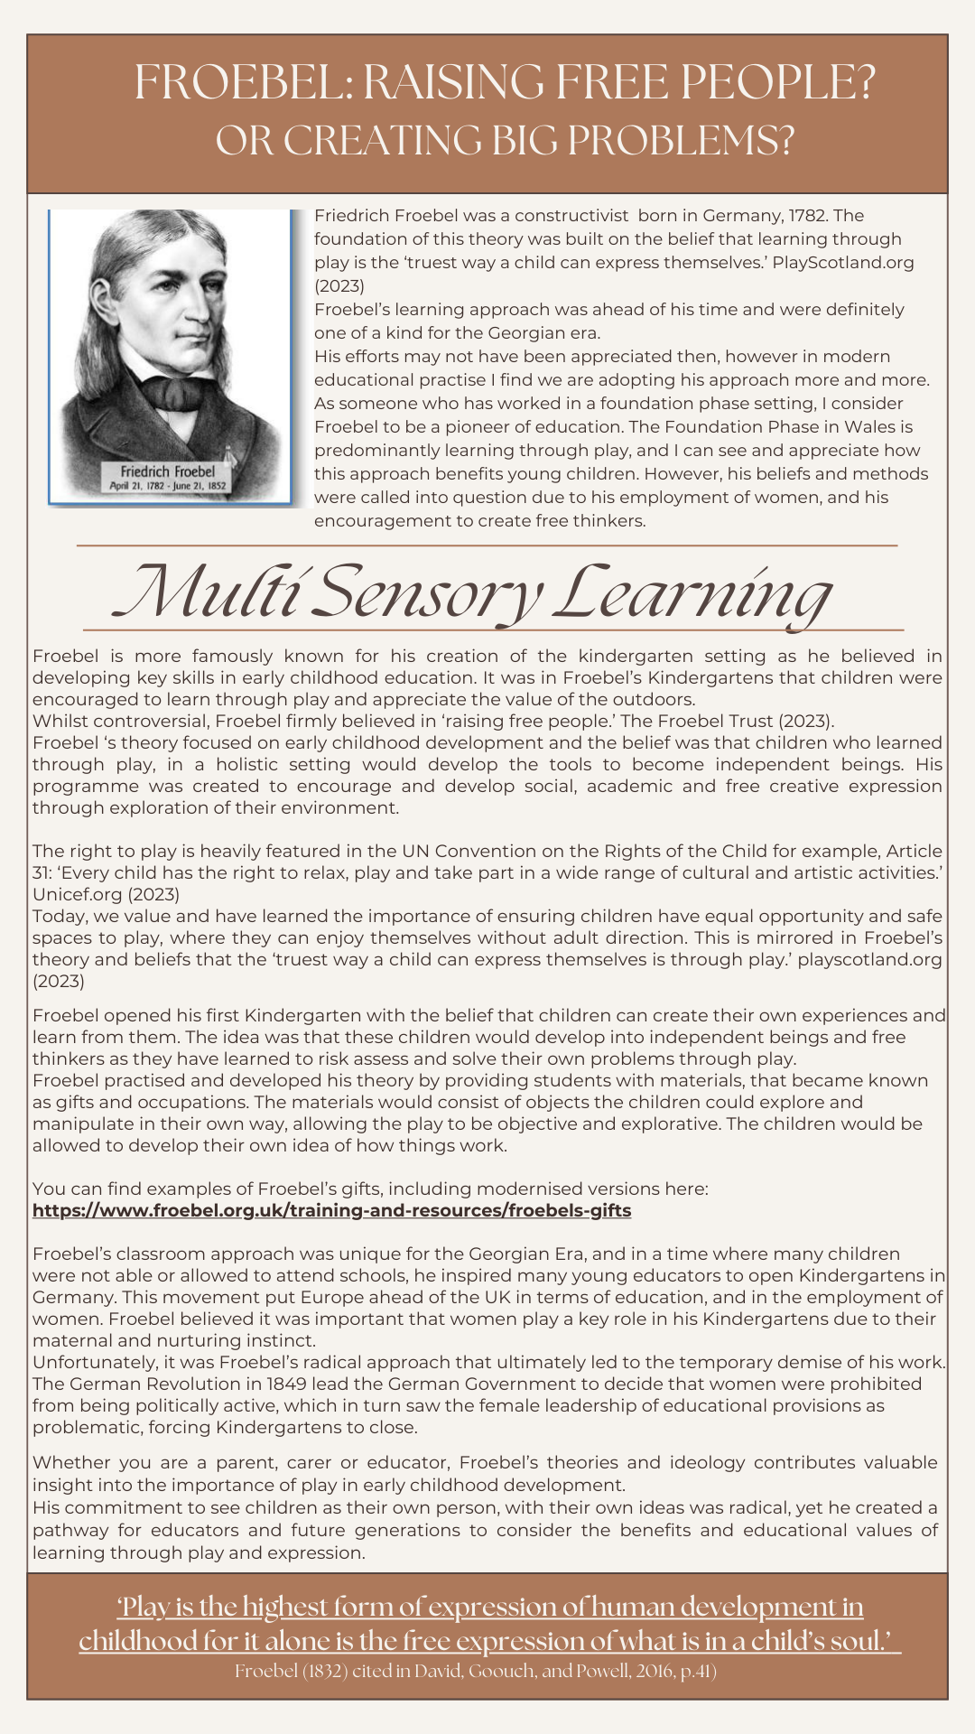Blog 1: Reference list

Cave, S. (2020). The Froebel Trust: ‘Coaching the Froebelian way’. Available at: https://www.froebel.org.uk/news/coaching-the-froebelian-way [Accessed on: 30/11/2024].
David, T., Goouch, K. and Powell, S. (2016). The Routledge International Handbook of Philosophies and Theories of Early Childhood Education and Care. London: Routledge.
Image 1: Froebel. Available at: https://ncn.ie/froebel/ [Accessed on: 27/11/2024].
Image 2: Froebel’s gifts and Operations. Available at: https://illustrationnwsad.wordpress.com/2009/03/20/froebels-gifts/ [Accessed on: 27/11/2024].
Unicef.org (2023) UNCRC: Article 31. Available at: https://www.unicef.org.uk/wp-content/uploads/2019/10/UNCRC_summary-1_1.pdf [Accessed on: 01/12/2024].

Blog 2
Demonstrate your understanding of a theory of learning from the following list:
Bruner, Skinner, Piaget, Vygotsky, Froebel. The theory must be different to Blog 1.

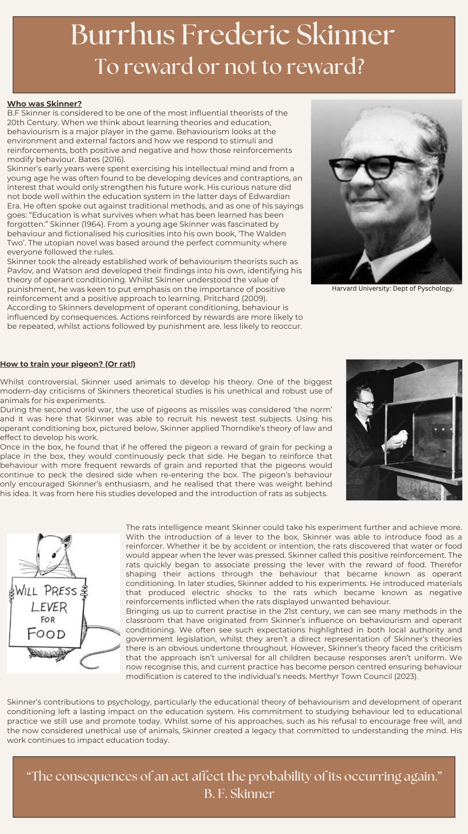
Blog 2: Reference list

Image 1: B.F Skinner. Available at: https://psychology.fas.harvard.edu/people/b-f-skinner [Accessed on: 15/12/2024].
Image 2: Rat with sign. Available at: https://medium.com/swizec-s-nightowls/the-long-term-effects-of-multitasking-3b22443e9b9a [Accessed on: 16/12/2040].
Image 3: Rat in Skinners Box. Available at: https://www.sciencephoto.com/media/95709/view/skinner-box-reseach [Accessed on: 16/12/2024].
Achology: 30 Thought-Provoking B. F. Skinner Quotes to Elevate your Perspective. Available at: https://achology.com/psychology/burrhus-frederic-skinner-quotes/ [Accessed on: 20/12/2024].
Bates. B. (2016) Learning theories simplified and how to apply them to teaching. London: SAGE.
Blakemore S-J. and Frith U. (2005). The Learning Brain. Oxford. Blackwell.
Merthyr Town Council: Positive Behaviour Management Policy. Available at: https://www.merthyr.gov.uk/media/6452/positive-behaviour-management-guidance.pdf [Accessed on: 19/12/2024].
Pritchard. A. (2009) Ways of Learning: Learning theories and learning styles in the classroom, 2nd edition. New York: Routledge.
Skinner. B.F. (1964) Oxford Essential Quotations (4th Edition) 2016. London: Oxford University Press.

Blog 3
Identify, discuss, and evaluate the theoretical approaches to learning linked to your theories from Blogs 1 and 2.

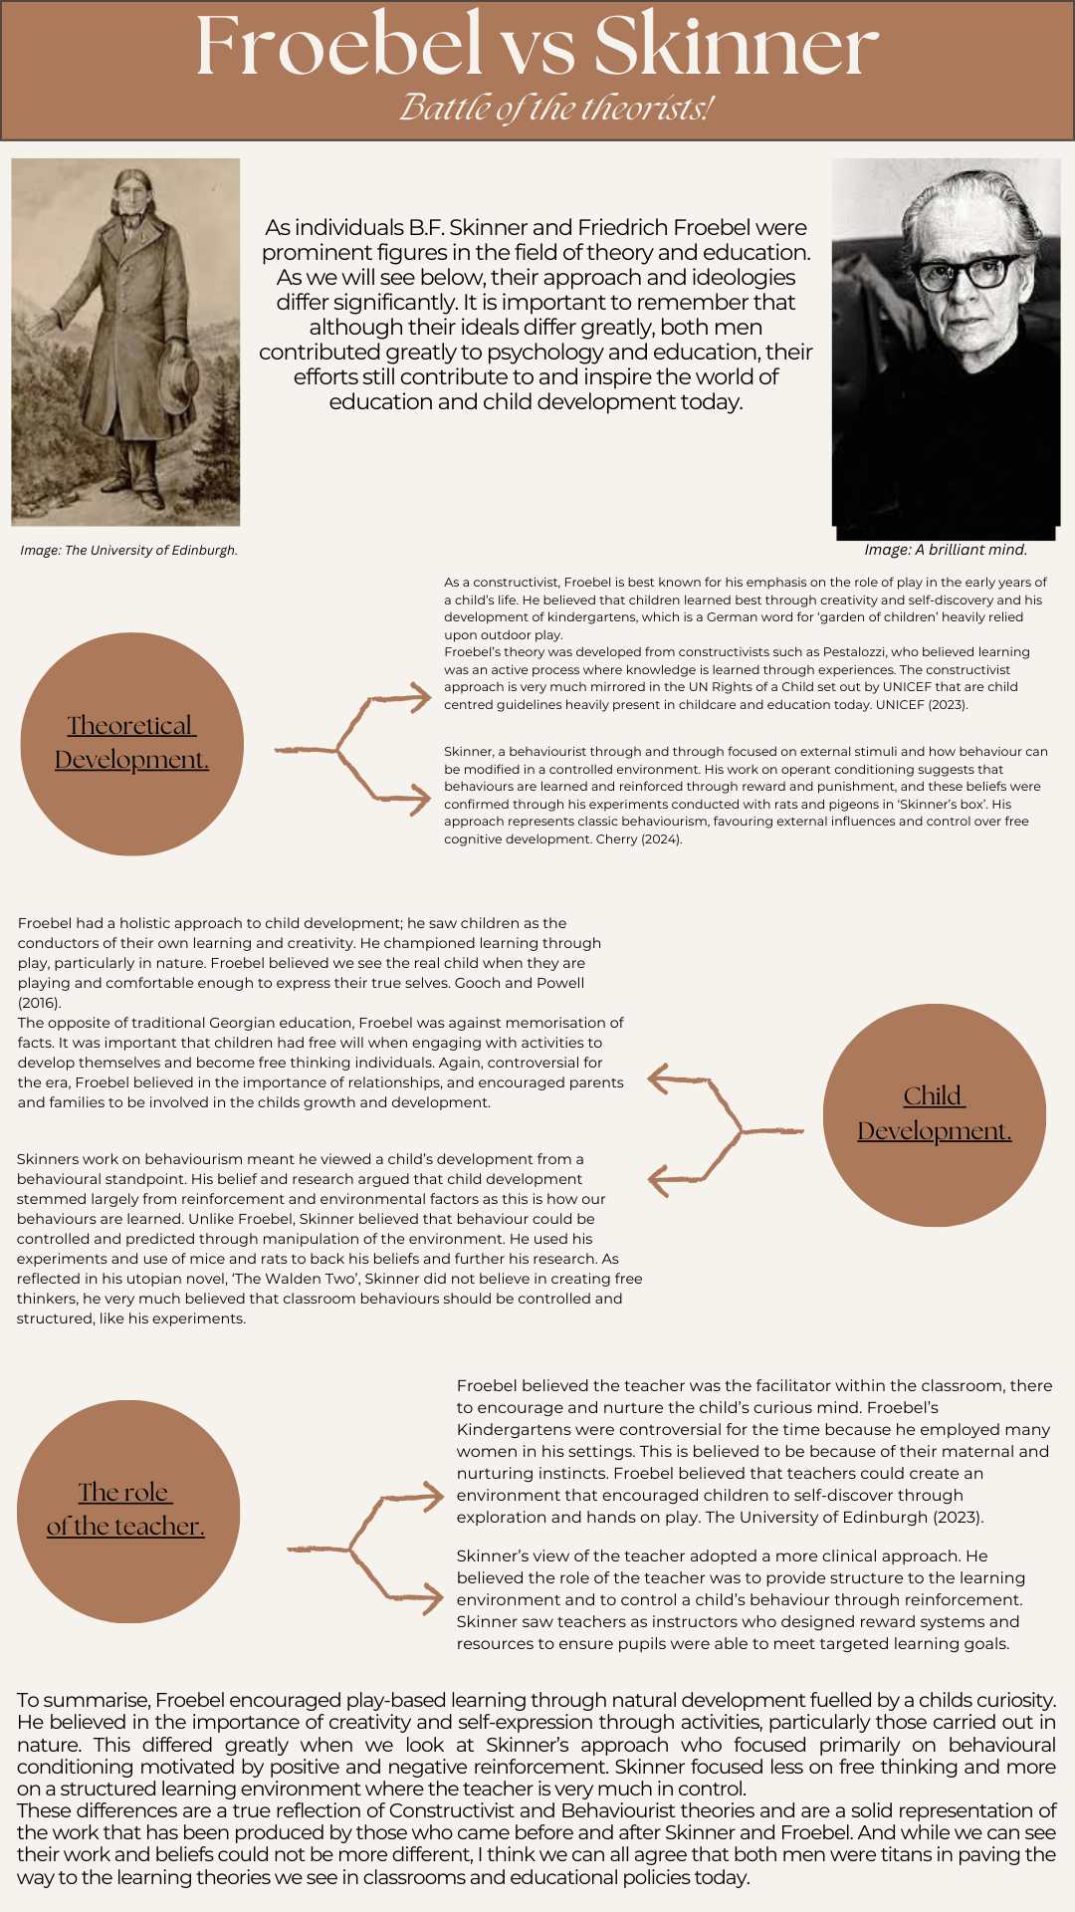Blog 3: Reference list

Cherry. K. (2024) Very well mind: ‘B.F. Skinner’s life, theories and influence on psychology’. Available at: https://www.verywellmind.com/b-f-skinner-biography-1904-1990-2795543#:~:text=Skinner's%20theory%20of%20learning%20says,ABCs%20of%20behaviorism%20were%20developed. [Accessed on: 29/12/2024].
David, T., Goouch, K. and Powell, S. (2016). The Routledge International Handbook of Philosophies and Theories of Early Childhood Education and Care. London: Routledge.
Image 1: University of Edinburgh. Available at: https://www.froebel.ed.ac.uk/froebel-an-introduction/ [Accessed on: 28/12/2024].
Image 2: Google Images (2024). Available at: https://www.google.com/imgres?imgurl=https://abrilliantmind.blog/wp-content/uploads/2024/04/Skinnerphoto2.jpg&tbnid=CRUReIzxH2KK_M&vet=1&imgrefurl=https://abrilliantmind.blog/daily-rituals-of-scientists-the-meticulous-routine-of-b-f-skinner/&docid=MIvpB0_pFZuC_M&w=463&h=599&source=sh/x/im/m1/1&kgs=63fbac6852822f0f [Accessed on: 28/12/2024].
The University of Edinburgh: Froebel an introduction (2023). Available at: https://www.froebel.ed.ac.uk/froebel-an-introduction/ [Accessed on: 29/12/2024].
UNICEF: UN rights of a child (2024). Available at: https://www.unicef.org.uk/child-friendly-cities/crba/#:~:text=This%20practical%20tool%20is%20made,interdependence%20and%20indivisibility%3B%20and%20transparency [Accessed on: 29/12/2024].

Blog 4
Draw on experiences from your own setting to identify resources and strategies used to support effective teaching and learning, linking back to your chosen theories in Blogs 1 & 2

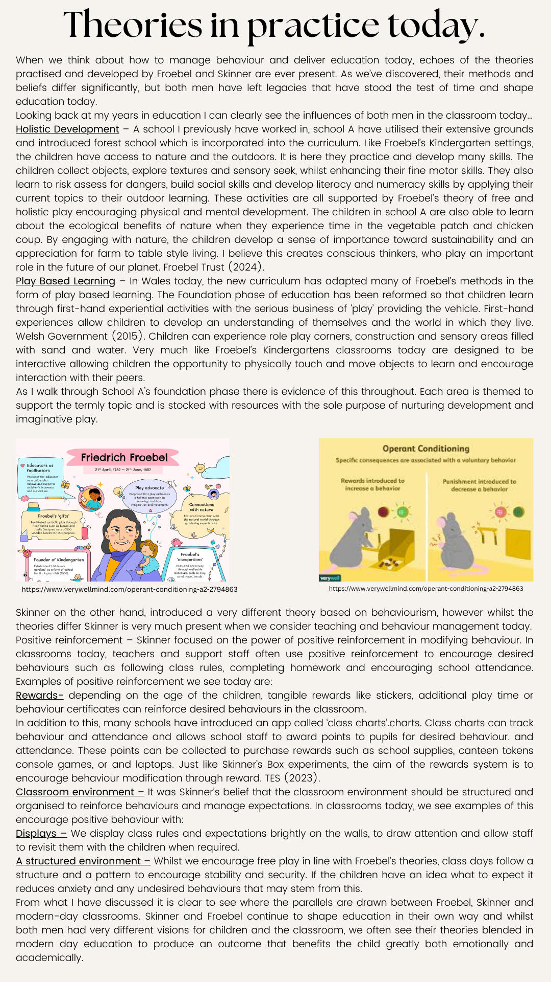
Blog 4: Reference list

Image 1: Skinner’s box. Available at: https://www.verywellmind.com/operant-conditioning-a2-2794863 Accessed on: 01/01/2025
Image 2: Friedrich Froebel. Available at: https://www.verywellmind.com/operant-conditioning-a2-2794863 Accessed on: 01/01/2025
Froebel Trust (2024). ‘Froebelian Principles.’ Available at: https://www.froebel.org.uk/about-us/froebelian-principles Accessed on: 01/01/2025
TES Class Charts. ‘Behaviour Management’. Available at: https://www.froebel.org.uk/about-us/froebelian-principles Accessed on: 01/01/2025
Welsh Government (2015). ‘Revised framework for Wales.’ Available at: https://hwb.gov.wales/storage/d5d8e39c-b534-40cb-a3f5-7e2e126d8077/foundation-phase-framework.pdf Accessed on: 01/01/2025

