Understanding and Engaging Stakeholders
Student Number: 2325979
Student Name: Corason Barbu
Module Code: LCLM5001
Module Leader: Eric Osei

Understanding the Importance of Stakeholder Engagement in Successful Project Implementation: The Case of StaySmart+ at Hilton

TABLE OF CONTENTS

- Executive Summary
- Introduction
- Company Overview and Project Description
- Situational Analysis
4.1 SWOT Analysis
4.2 PESTLE Analysis
4.3 SMART Objectives
- Stakeholder Identification and Classification
- Roles, Responsibilities, Benefits and Challenges
- Stakeholder Engagement Frameworks
- Stakeholder Engagement Process (4C Model)
- Impact on Business Performance
- Recommendations
- Conclusion
- References

List of Figures
Figure 1: SWOT Analysis of Hilton StaySmart+
Figure 2: PESTLE Analysis of Hilton StaySmart+
Figure 3: SMART Objectives for StaySmart+
Figure 4: Stakeholder Power-Interest Matrix
Figure 5: RACI Matrix for StaySmart+ Project
Figure 6: Communication Plan for Stakeholders

1. EXECUTIVE SUMMARY
This report examines the importance of stakeholder engagement in the successful implementation of the StaySmart+ service within Hilton Hotels & Resorts. The service aims to integrate artificial intelligence, personalised guest experiences, and sustainability initiatives to enhance both customer satisfaction and operational efficiency.
The report identifies and categorises key internal and external stakeholders, analysing their roles, influence, and level of interest in the project. It applies relevant frameworks such as the stakeholder matrix, RACI matrix, and communication plan to support effective stakeholder management.
A critical evaluation is conducted using the 4C model (communication, collaboration, consultation, and commitment), highlighting its importance in managing stakeholder relationships and reducing potential conflicts.
The findings demonstrate that effective stakeholder engagement contributes to improved decision-making, stronger relationships, and enhanced business performance. The report concludes with recommendations aimed at improving stakeholder communication, increasing employee readiness, and ensuring long-term project success.

2. INTRODUCTION
Hilton Worldwide Holdings is a leading global hospitality organisation operating in over 120 countries. The company is known for innovation, customer experience, and sustainability.
StaySmart+ is a new service integrating AI-driven tools, personalised travel planning, and sustainable features. The aim is to enhance customer satisfaction and operational efficiency.
Stakeholders play a crucial role in project success, as they influence and are affected by organisational activities (Freeman, 1984). Effective engagement is essential in global projects.
Additionally, effective stakeholder engagement is essential for ensuring that organisational objectives are aligned with stakeholder expectations. In large-scale international projects, such as StaySmart+, engagement strategies help reduce risks, improve decision-making, and enhance overall project success. Therefore, understanding how to manage and engage stakeholders effectively is a key factor in achieving sustainable business performance.
In addition, stakeholder engagement plays a critical role in reducing uncertainty and improving organisational decision-making. In global projects such as StaySmart+, the involvement of multiple stakeholder groups requires clear communication and alignment of objectives. Effective engagement strategies allow organisations to anticipate risks, respond to stakeholder concerns, and ensure smoother implementation. This highlights that stakeholder management is not only a supporting activity but a core component of successful project delivery.

3. COMPANY OVERVIEW AND PROJECT
Hilton operates thousands of hotels worldwide and has strong digital capabilities. StaySmart+ is designed to enhance guest experience through automation and sustainability.
The project includes:
- AI guest interaction
- personalised services
- eco-friendly technologies
In a highly competitive hospitality market, Hilton faces increasing pressure from other global hotel brands that are also investing in digital transformation and customer experience innovation. Therefore, the implementation of StaySmart+ is not only a strategic initiative but also a necessary step to maintain competitive advantage and respond to changing customer expectations.
Furthermore, the adoption of digital technologies in the hospitality industry has significantly transformed customer expectations. Guests increasingly expect seamless, personalised, and technology-enabled services. As a result, organisations such as Hilton must continuously innovate to remain competitive. The StaySmart+ initiative reflects this shift, aiming to integrate advanced technologies into service delivery while maintaining high standards of customer experience. This also requires strong coordination between departments and stakeholders to ensure consistency across international locations.

4. SITUATIONAL ANALYSIS
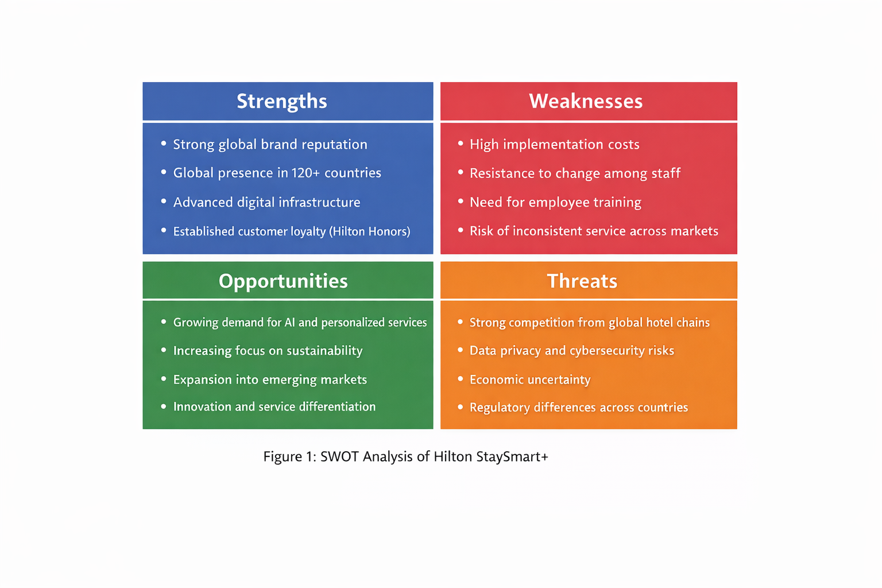
4.1 SWOT ANALYSIS

Figure 1: SWOT Analysis of Hilton StaySmart+
The SWOT analysis highlights Hilton’s strong internal capabilities, including its global brand reputation, advanced digital infrastructure, and established customer loyalty programme, which support the successful implementation of StaySmart+. However, internal challenges such as high implementation costs and potential resistance to technological change may affect the rollout process.
Externally, the analysis identifies significant opportunities driven by the growing demand for personalised, AI-driven, and sustainable hospitality services. At the same time, threats such as increasing competition, data privacy concerns, and economic uncertainty must be carefully managed to ensure long-term success.
Overall, the SWOT analysis demonstrates that while Hilton is well-positioned to implement StaySmart+, strategic planning and effective stakeholder engagement are essential to mitigate risks and maximise opportunities.
The SWOT analysis also highlights the importance of aligning internal capabilities with external conditions. For example, Hilton’s strong brand reputation and digital infrastructure provide a solid foundation for implementing StaySmart+, but these strengths must be effectively utilised to respond to external threats such as increasing competition and technological risks. This means that strategic decision-making should focus on leveraging strengths to maximise opportunities while minimising weaknesses and threats.
Furthermore, the analysis suggests that stakeholder engagement plays a key role in addressing identified weaknesses. For instance, employee resistance to change can be reduced through effective communication and training, while collaboration with technology partners can help overcome technical challenges. Therefore, the SWOT analysis not only identifies factors affecting the project but also supports the development of appropriate management strategies.
In addition, the SWOT analysis highlights the need for continuous strategic evaluation, as both internal and external factors may change over time. Organisations must regularly review their strengths and weaknesses to ensure they remain competitive in a dynamic market environment. For Hilton, maintaining its technological capabilities and brand reputation requires ongoing investment and innovation.
Moreover, the integration of stakeholder perspectives within the SWOT analysis allows organisations to develop more effective strategies. By understanding stakeholder expectations, Hilton can better align its internal capabilities with market demands, ultimately improving project outcomes and organisational performance (Freeman, 1984).

4.2 PESTLE ANALYSIS

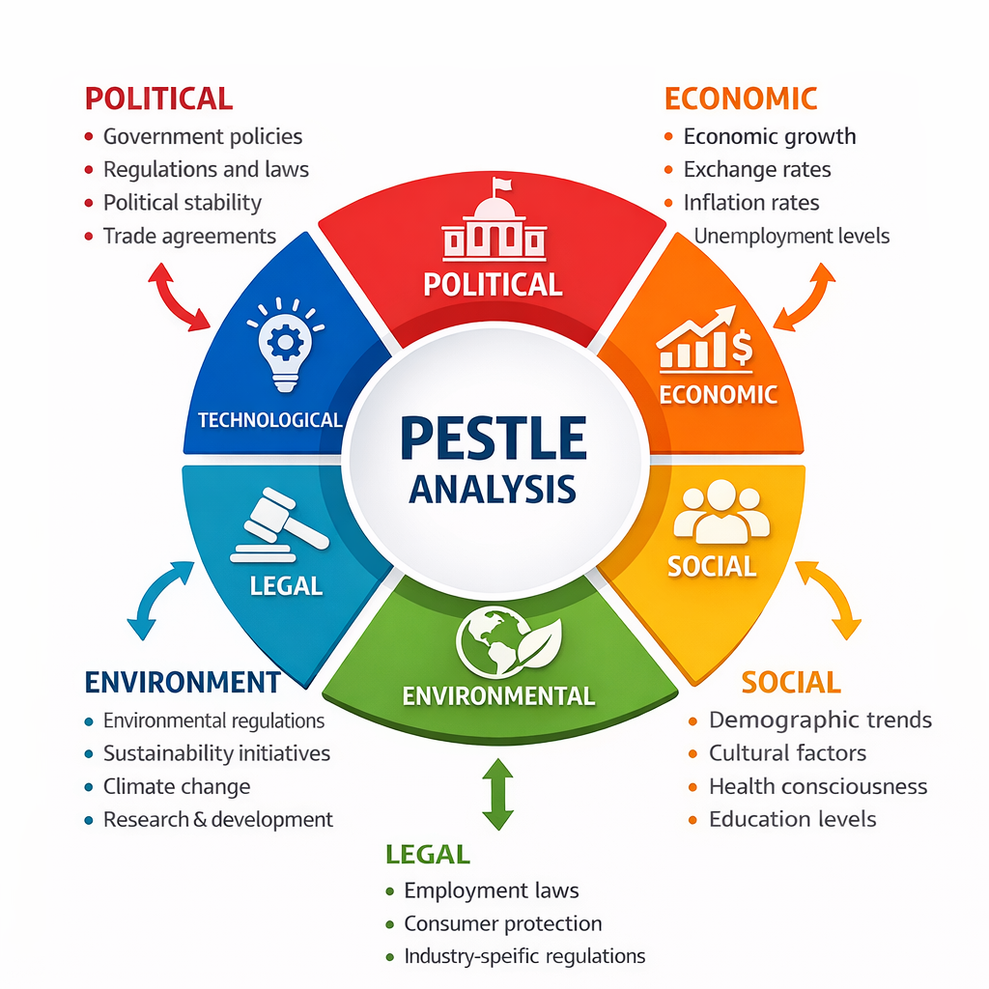
Figure 2: PESTLE Analysis of Hilton StaySmart+
The PESTLE analysis provides valuable insights into the external environment in which the StaySmart+ project operates. By understanding these factors, Hilton can better anticipate risks and identify opportunities for strategic growth. For example, legal and technological factors play a significant role in shaping how AI-based services are implemented, particularly in relation to data protection and system security.
Additionally, the analysis supports strategic decision-making by enabling organisations to adapt to changing market conditions and stakeholder expectations. This highlights the importance of continuously monitoring external factors to ensure long-term success (Ivanov and Webster, 2019).

The PESTLE analysis identifies key external factors influencing the implementation of StaySmart+. Political and legal factors, such as data protection regulations, affect how AI services are developed. Economic conditions influence customer spending, while social trends highlight increasing demand for personalised and sustainable experiences.
Technological advancements support innovation but also introduce cybersecurity risks. Environmental factors emphasise the importance of sustainability in modern hospitality.
Overall, the analysis shows that Hilton must adapt its strategy to external changes to ensure successful implementation.
External environmental factors are critical in shaping strategic decisions, particularly in global industries such as hospitality (Bryson, 2004). For example, legal and political regulations related to data protection require organisations to ensure compliance when implementing AI-based services. Failure to meet these requirements may result in reputational damage and financial penalties.
Technological advancements have significantly transformed service delivery in the hospitality sector, enabling automation and personalisation; however, they also introduce operational risks and require continuous investment (Ivanov and Webster, 2019). This demonstrates that organisations must balance innovation with risk management to ensure sustainable implementation.
Furthermore, the PESTLE framework supports organisations in identifying potential risks before they occur, allowing for proactive decision-making. For example, anticipating regulatory changes or economic shifts enables Hilton to adjust its strategies accordingly and reduce uncertainty. This demonstrates the importance of environmental scanning as part of strategic management in global organisations (Bryson, 2004).

4.3 SMART OBJECTIVES

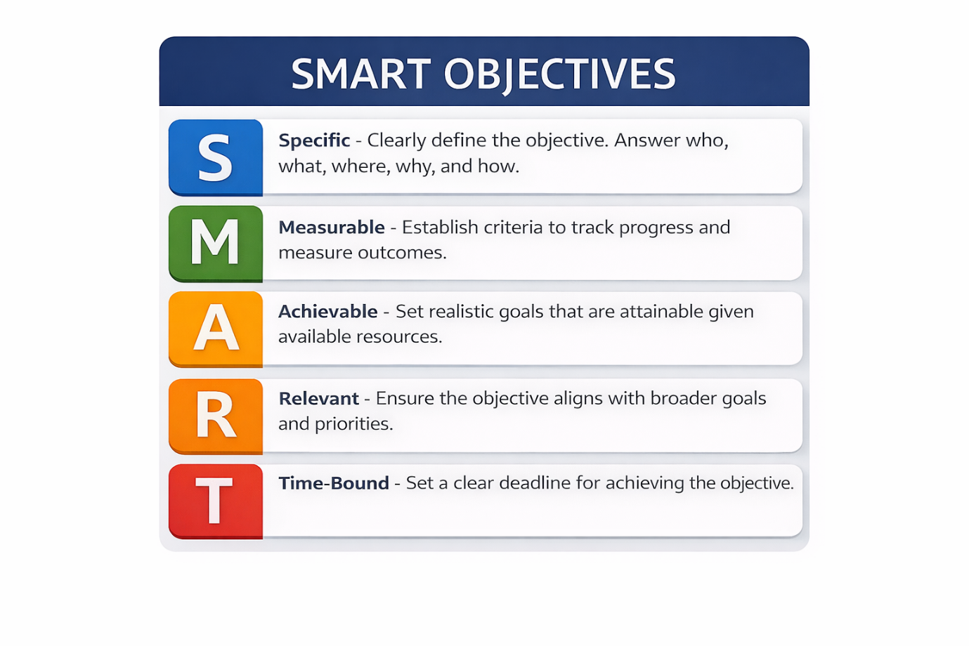
Figure 3: SMART Objectives for StaySmart+
The SMART framework ensures that project objectives are clearly defined and achievable. The StaySmart+ initiative is designed to be specific in its goal of launching an AI-driven service, measurable through improvements in customer satisfaction, achievable using Hilton’s existing infrastructure, relevant to the organisation’s strategy, and time-bound within a six-month rollout period.
The use of SMART objectives ensures that project goals are clearly defined and measurable, allowing for better planning and performance evaluation. By setting specific and time-bound targets, organisations can monitor progress effectively and identify potential issues at an early stage. This approach also supports stakeholder alignment, as clearly defined objectives help stakeholders understand project expectations and outcomes.
Furthermore, SMART objectives contribute to improved decision-making by providing a structured framework for evaluating project success and ensuring that resources are used efficiently (Bryson, 2004).
In addition, SMART objectives provide a clear framework for evaluating project performance and ensuring accountability among stakeholders. By defining measurable outcomes, organisations can track progress and identify deviations from planned targets. This allows project managers to implement corrective actions in a timely manner and maintain control over project delivery.
Moreover, clearly defined objectives improve stakeholder understanding and engagement, as they provide a shared vision of project goals and expected outcomes. This reduces uncertainty and ensures that all stakeholders are working towards the same objectives, which is essential for successful project implementation (Bryson, 2004).
5. STAKEHOLDER IDENTIFICATION
Internal stakeholders include management, project managers, IT teams, marketing, and operations staff. External stakeholders include customers, suppliers, regulators, and local communities.
Stakeholders influence organisational success and must be effectively managed (Bryson, 2004).
Internal stakeholders are directly involved in the execution of the project and have a significant influence on its success. In contrast, external stakeholders, such as customers and regulators, impact how the service is perceived and accepted in the market. For example, customers influence brand reputation through feedback and satisfaction levels, while regulators ensure compliance with legal requirements. This highlights the importance of balancing stakeholder needs and expectations.
Stakeholder identification is a crucial step in project management, as it allows organisations to understand the level of influence and interest each stakeholder has. Internal stakeholders, such as management and employees, directly impact project execution and performance. Their engagement is essential for ensuring that operational processes run efficiently. External stakeholders, including customers, suppliers, and regulators, influence the external environment in which the organisation operates.
For example, customers play a key role in determining the success of StaySmart+, as their satisfaction and feedback directly affect brand reputation and future demand. Similarly, regulatory bodies ensure that the organisation complies with legal requirements, particularly in relation to data protection and AI usage. Suppliers and technology partners also contribute to the reliability and functionality of the service. Therefore, understanding stakeholder expectations is essential for developing effective engagement strategies.
This approach reflects stakeholder theory, which emphasises that organisations must consider the interests of all stakeholders to achieve long-term success (Freeman, 1984). In this context, effective stakeholder identification allows project managers to prioritise engagement strategies and allocate resources efficiently.

6. ROLES, RESPONSIBILITIES, BENEFITS AND CHALLENGES
Senior management provides direction and resources. Project managers coordinate activities. IT teams develop systems, while marketing promotes services.
Challenges include resistance to change, high costs, and coordination issues. External stakeholders influence adoption and compliance (Mitchell et al., 1997).
Conflicts may arise between stakeholders due to differing priorities and expectations. For instance, management may focus on cost efficiency, while IT teams prioritise system quality and security. Similarly, customers may demand personalised services, which may increase operational complexity. Therefore, effective stakeholder management is essential to balance these interests and minimise potential conflicts.
In addition, different stakeholders may have conflicting interests, which can create challenges during the project lifecycle. For example, while management may prioritise cost efficiency and return on investment, IT teams may focus on system quality, security, and innovation. Marketing teams may aim to promote advanced features, while operations staff may be concerned with the practicality of implementation. These differences highlight the importance of effective communication and coordination between stakeholders.
Moreover, training and development play a key role in ensuring that employees are prepared to use new technologies. Without adequate training, staff may resist change, leading to reduced efficiency and potential service disruptions. Therefore, organisations must invest in employee development to support successful project implementation.
These challenges highlight the complexity of stakeholder management, as different stakeholders may have varying levels of power, interest, and influence. According to Mitchell et al. (1997), stakeholders should be prioritised based on their salience, which includes power, legitimacy, and urgency. This supports the need for structured stakeholder engagement frameworks within the StaySmart+ project.

7. STAKEHOLDER ENGAGEMENT FRAMEWORKS
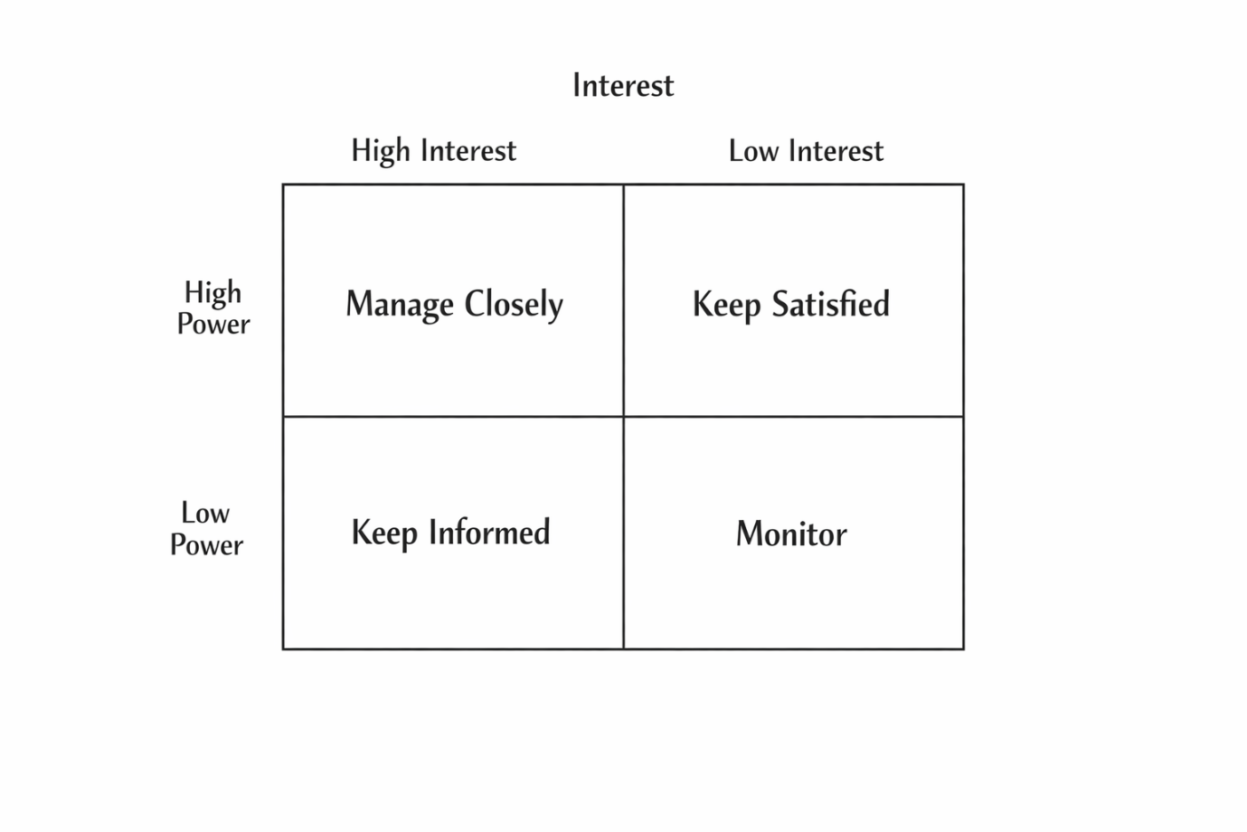
Figure 4: Stakeholder Power-Interest Matrix
The stakeholder matrix categorises stakeholders based on their level of power and interest in the project. Stakeholders with high power and high interest should be managed closely, as they have significant influence over project outcomes. Those with high power but low interest should be kept satisfied, while stakeholders with low power but high interest should be kept informed.
Stakeholders with low power and low interest require minimal monitoring. This approach helps prioritise engagement strategies and ensures effective stakeholder management throughout the project lifecycle.

RACI MATRIX
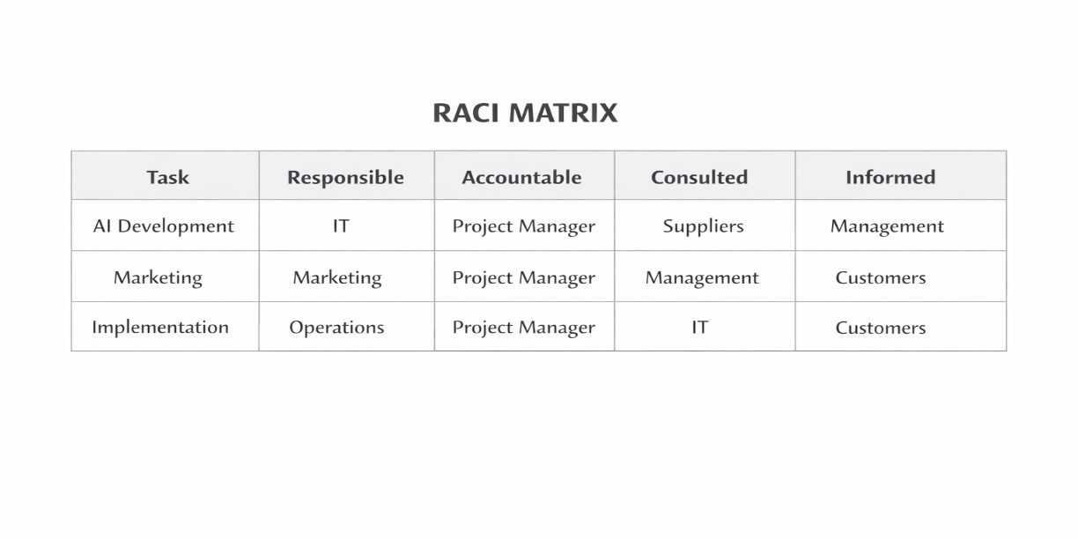
Figure 5: RACI Matrix for StaySmart+ Project
The RACI matrix defines the roles and responsibilities of stakeholders involved in the project. It clarifies who is responsible for completing tasks, who is accountable for final decisions, who should be consulted during the process, and who needs to be informed.
This structure improves coordination, reduces confusion, and ensures effective project management.
In addition, the RACI matrix supports effective stakeholder coordination by clearly defining roles and responsibilities within the project. This reduces ambiguity, improves accountability, and ensures that tasks are completed efficiently. By assigning clear responsibilities, the project manager can enhance communication and minimise the risk of misunderstandings between stakeholders. This structured approach is essential in complex projects involving multiple stakeholder groups (Bryson, 2004).

Communication Plan
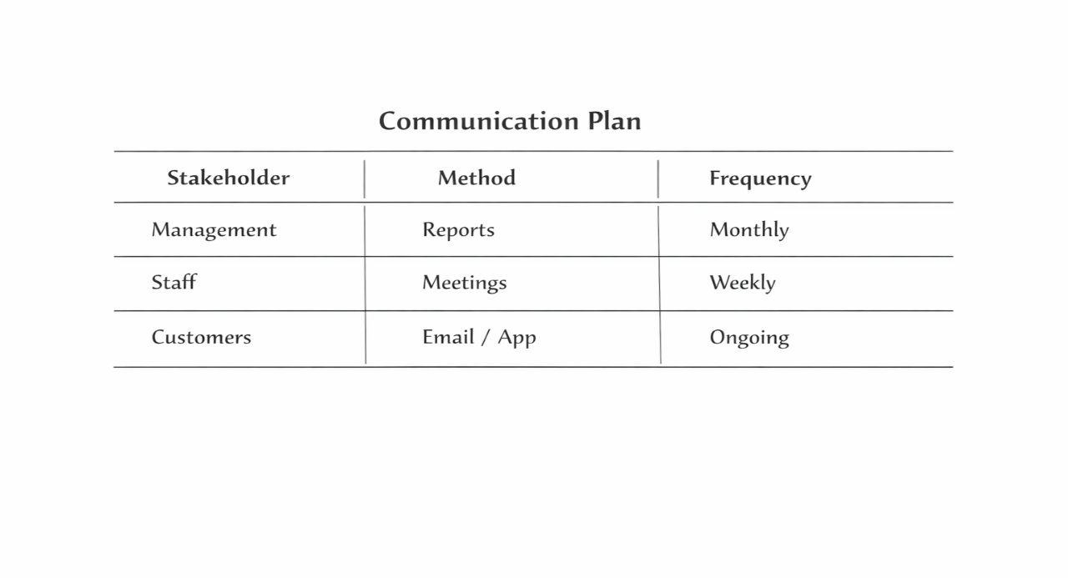
Figure 6: Communication Plan for Stakeholders
The communication plan outlines how information is shared with different stakeholders throughout the project. It identifies the appropriate communication methods and frequency for each group, ensuring that all stakeholders remain informed and engaged.
This approach supports transparency, improves collaboration, and reduces the risk of misunderstandings.
Effective communication planning is essential for ensuring that all stakeholders receive accurate and timely information. Different stakeholder groups require different communication approaches, and failure to address these differences may result in misunderstandings or reduced engagement. For example, employees may require regular updates and training sessions, while customers may prefer digital communication channels.
Therefore, a structured communication plan enhances transparency, improves coordination, and supports the overall success of the project. It also helps to build trust between stakeholders, which is a key factor in effective stakeholder management (Cornelissen, 2020).

8. STAKEHOLDER ENGAGEMENT PROCESS (4C MODEL)
Communication ensures transparency and trust (Cornelissen, 2020).
Collaboration improves engagement and decision-making.
Consultation ensures stakeholder input.
Commitment builds long-term support.
Conflict management is essential to address differences between stakeholders.
The application of the 4C model provides a structured approach to stakeholder engagement. Effective communication ensures that all stakeholders are informed and aligned with project objectives, reducing uncertainty and resistance to change. Collaboration encourages active involvement, allowing stakeholders to contribute their expertise and improve decision-making processes. Consultation ensures that stakeholder feedback is considered, which is particularly important in a global context where cultural differences may influence expectations. Commitment reflects the level of stakeholder support, which is essential for the successful implementation of the project.
However, the 4C model also presents certain challenges. For example, excessive consultation may delay decision-making, while collaboration may lead to conflicts due to differing perspectives. Therefore, the project manager must balance these elements to ensure effective stakeholder engagement while maintaining project efficiency.
The importance of the 4C model becomes more evident when applied in a real organisational context. For example, in Hilton’s StaySmart+ project, communication ensures that employees understand how the new system operates and how it benefits both staff and customers. Without clear communication, employees may feel uncertain or resistant to change.
Collaboration allows different departments to work together, ensuring that technological, operational, and marketing aspects of the project are aligned. This improves efficiency and reduces the likelihood of errors. Consultation is particularly important in global operations, as it allows organisations to consider cultural differences and adapt services to local markets. Commitment ensures that stakeholders remain engaged throughout the project, increasing the likelihood of long-term success.
However, managing these elements requires strong leadership skills. The project manager must balance stakeholder expectations, resolve conflicts, and ensure that project objectives are achieved within the given timeframe. This demonstrates that stakeholder engagement is a continuous process that requires careful planning and monitoring.
Effective communication is essential in stakeholder engagement, as it improves transparency, builds trust, and reduces uncertainty (Cornelissen, 2020). In the
context of StaySmart+, clear communication ensures that all stakeholders understand their roles and responsibilities.
Furthermore, relationship management plays a key role in sustaining stakeholder engagement. Long-term stakeholder relationships are built through trust, commitment, and consistent interaction, which are essential for project success (Ashcroft, 2017). This demonstrates that stakeholder engagement is not only a short-term activity but a continuous process that supports organisational performance.
In addition, the effectiveness of the 4C model depends on how well it is implemented throughout the project lifecycle. For example, continuous communication ensures that stakeholders remain informed about project progress, while collaboration encourages shared responsibility and active participation. Consultation allows organisations to gather feedback and adapt strategies accordingly, particularly in diverse international markets. Commitment, on the other hand, ensures that stakeholders remain engaged and supportive, which is essential for long-term success.
These elements demonstrate that stakeholder engagement is a dynamic process that requires constant monitoring and adjustment. By applying the 4C model effectively, organisations can reduce resistance to change, improve stakeholder satisfaction, and increase the likelihood of successful project delivery (Cornelissen, 2020).

9. IMPACT ON BUSINESS PERFORMANCE
Effective stakeholder engagement improves project success, innovation, and customer satisfaction. Poor engagement may lead to delays and increased costs.
Furthermore, effective stakeholder engagement contributes to long-term organisational success by strengthening relationships and improving trust. In the hospitality industry, customer trust and satisfaction are directly linked to brand loyalty and repeat business. Therefore, stakeholder engagement plays a critical role in enhancing both short-term project outcomes and long-term business performance.
Additionally, effective stakeholder engagement contributes to innovation by encouraging the exchange of ideas and knowledge between stakeholders. This is particularly important in technology-driven projects, where collaboration between different departments is essential. Engaged stakeholders are more likely to support project initiatives, leading to improved outcomes and higher levels of satisfaction.
On the other hand, poor stakeholder management can result in misunderstandings, delays, and increased costs. This highlights the importance of implementing structured engagement strategies to ensure that all stakeholders are aligned with project objectives.
This aligns with stakeholder theory, which suggests that organisations that effectively engage stakeholders are more likely to achieve improved performance and long-term sustainability (Freeman, 1984).
Moreover, effective stakeholder engagement can provide organisations with a competitive advantage by enhancing innovation and improving service quality. When stakeholders are actively involved, they contribute valuable insights and ideas that support better decision-making. This is particularly important in the hospitality industry, where customer expectations are constantly evolving.
In contrast, a lack of stakeholder engagement may result in misalignment between organisational objectives and stakeholder expectations, leading to reduced performance and potential project failure. Therefore, organisations must adopt structured and proactive stakeholder management strategies to ensure long-term success (Freeman, 1984).

10. RECOMMENDATIONS
- Improve communication
- Train employees
- Enhance cybersecurity
- Adapt to cultural differences
- Monitor feedback
Furthermore, organisations should implement regular monitoring and evaluation processes to assess the effectiveness of stakeholder engagement strategies. This allows for continuous improvement and ensures that stakeholder needs are consistently addressed. Investing in digital tools and communication platforms can also enhance stakeholder interaction and improve overall project performance.
Additionally, organisations should ensure that stakeholder engagement strategies are integrated into overall business planning. This includes aligning stakeholder management with organisational goals and continuously evaluating the effectiveness of engagement activities. By doing so, Hilton can ensure that stakeholder needs are consistently met while maintaining a strong competitive position in the market (Ashcroft, 2017).

11. CONCLUSION
Stakeholder engagement is essential for the success of StaySmart+. Applying structured frameworks improves collaboration and business performance.
These recommendations aim to support continuous improvement and ensure the long-term success of stakeholder engagement strategies.
In addition, organisations that prioritise stakeholder engagement are more likely to achieve sustainable success, as they are better equipped to respond to changing market conditions and stakeholder expectations. This highlights the long-term value of effective stakeholder management in achieving organisational goals.

12. References
- Freeman, R.E. (1984) Strategic Management: A Stakeholder Approach. Boston: Pitman.
- Bryson, J.M. (2004) ‘What to do when stakeholders matter: Stakeholder identification and analysis techniques’, Public Management Review, 6(1), pp. 21–53.
- Mitchell, R.K., Agle, B.R. and Wood, D.J. (1997) ‘Toward a theory of stakeholder identification and salience’, Academy of Management Review, 22(4), pp. 853–886.
- Ivanov, S. and Webster, C. (2019) Robots, Artificial Intelligence and Service Automation in Travel, Tourism and Hospitality. Bingley: Emerald Publishing.
- Buhalis, D. and Leung, R. (2018) ‘Smart hospitality: Interconnectivity and interoperability towards an ecosystem’, International Journal of Tourism Cities, 4(3), pp. 269–292.
- Cornelissen, J. (2020) Corporate Communication: A Guide to Theory and Practice. London: Sage.
- Ashcroft, J. (2017) The Relational Lens: Understanding, Managing and Measuring Stakeholder Relationships. Cambridge: Cambridge University Press.

