December 2012
Peer to Peer I
Distributed Enterprise Applications
Tim Bashford

There five exchange patterns supported by WCF; One-Way, Request-Response, Half Duplex, Full Duplex and Peer to Peer. Appropriate selection of these exchange patterns is very important for ensuring logical network traffic flow and data transfer. Remember that you can select one exchange pattern per method, but may mix these between different methods in the same WCF program.

Peer to peer applications
A peer to peer (P2P) application is one in which clients may connect directly to one another for the purposes of communication or transmission of data. This does not necessarily imply that a P2P application does not feature some form of centralisation, just that that centralisation is not inherent to at least one operation between clients. In Microsoft nomenclature, a P2P application without any form of centralisation is termed “pure” and one with a centralised server but P2P methods is termed “hybrid”.
In this example, we will develop a pure P2P chat application; one without any host, built exclusively from clients (which in of themselves perform the duties of a host).

Application
Create a user interface with the following controls:
- 1 ListBox
- 1 TextBox
- 1 Button
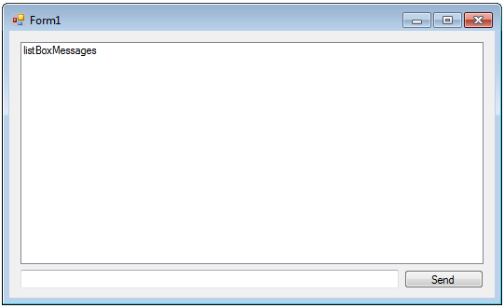

Add a class named “Chat”. This application uses the namespace SimpleChat.
Implement the following contract:
[ServiceContract(CallbackContract = typeof(IChat))]
public interface IChat
{
[OperationContract(IsOneWay = true)]
void SendMessage(string user, string message);
}

Note that this is a callback method. Refer to the previous tutorials if you are unsure of the implications of callback.
Implement this interface:
[ServiceBehavior(InstanceContextMode=InstanceContextMode.Single)]
public class Chat : IChat
{
FormChat mfp;

public Chat(FormChat mf)
{
mfp = mf;
}

public void SendMessage(string user, string message)
{
mfp.AddMessage(user + ": " + message);
}
}

In the main form, add a delegate and the corresponding method to update the listBox (refer back to the threading tutorials if you do not remember how or why this is done):
public delegate void UpdateListboxDelegate(string msg);

public void AddMessage(string msg)
{
if (listBoxMessages.InvokeRequired)
listBoxMessages.Invoke(new UpdateListboxDelegate(AddMessage), msg);
else
listBoxMessages.Items.Add(msg);
}

Now declare an IChat instance which will serve as a channel and a string which will temporarily hold the username.
private IChat channel;
private string userName;

Modify the constructor to create the channel. This application will self-host, i.e. there will be no host application; all clients are the same and to some degree mutually host the service.
InitializeComponent();

userName = Guid.NewGuid().ToString();

Chat ci = new Chat(this);

DuplexChannelFactory<IChat> cf = new DuplexChannelFactory<IChat>(new InstanceContext(ci), "SimpleChatEP");
channel = cf.CreateChannel();

((ICommunicationObject)channel).Open();

Modify the button’s click event:
channel.SendMessage(userName, textBoxSend.Text);
textBoxSend.Clear();

And finally, create an app.config file. Remember that there is no host, so endpoints will be created utilising the <client></client> tags.
<?xml version="1.0" encoding="utf-8" ?>
<configuration>
<system.serviceModel>
<client>
<endpoint name="SimpleChatEP"
address="net.p2p://localhost:8000/SimpleChat"
binding="netPeerTcpBinding"
bindingConfiguration="simpleChatBinding"
contract="SimpleChat.IChat" />
</client>

<bindings>
<netPeerTcpBinding>
<binding name="simpleChatBinding">
<security mode="None" />
</binding>
</netPeerTcpBinding>
</bindings>
</system.serviceModel>
</configuration>

Note the use of the address formed starting “net.p2p://” and the binding “netPeerTcpBinding”. netPeerTcpBinding requires a security mode be set.
Start multiple instances of this client and test the code:

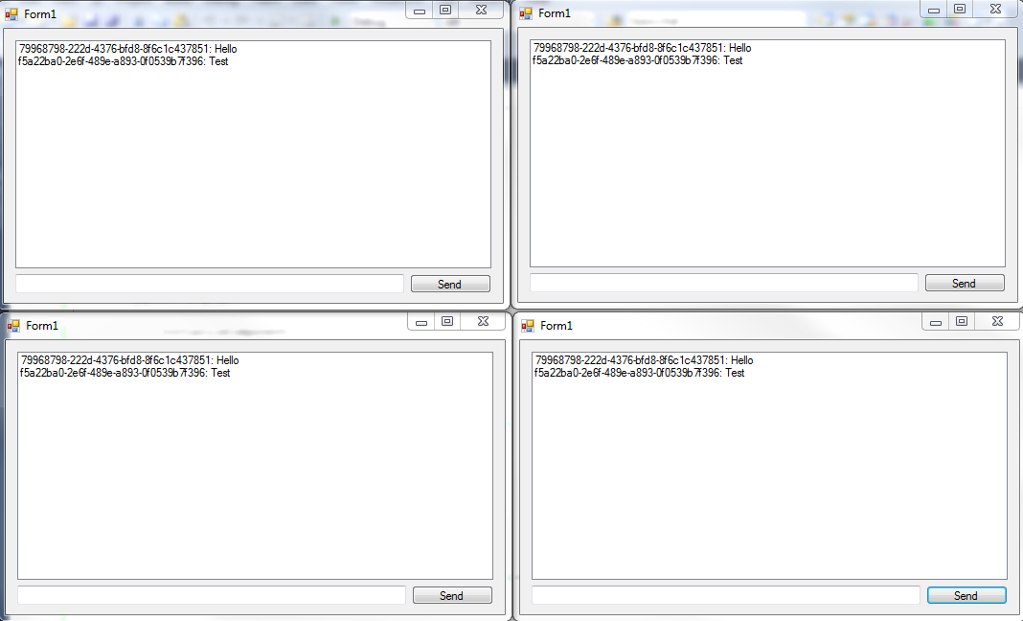

Exercise
Add some form of user management to the application, including:
- A way for users to change their username from the default
- A list of connected users – this is more complex than it may initially appear. You will have to:
  - Catch users as they connect and add them to a list
  - Remove users from the list as they disconnect
  - Consider how to handle an unclean disconnect
Creating a list of connected users is a relatively complex problem which we will ultimately solve next week – don’t worry unduly if you’re finding it challenging to remove users from the list.

