Site Specific report:

What issues can arise from site specific work and how can they be avoided?
  - Mia Kirby: 2501685

In the world of art, site specific work is very important in creating politically moving pieces. However, this has to be delt with in a delicate fashion due to ethical matters. This can be due to the message that the art creates or how the art and location work with each other. Sometimes the issues can be smaller, and perhaps in the end, are good for allowing people to be motivated into acting on issues raised in the art.
Site specific art is where artworks are created to exist in a certain place, meaning, the artist will take the location into account while planning and creating the art. There are 11 categories of different types of site-specific art. The category that I will be focusing on today, which relates to my artworks and the question the most is Activism. This is all about the purpose of the work, thinking about how this will impact people, but also about taking responsibility for any issues that may be created, whilst also making sure to present work in a sensitive manor. The artist examples I will discuss below, are great examples of how site-specific art can cause multiple issues, politically and ethically.

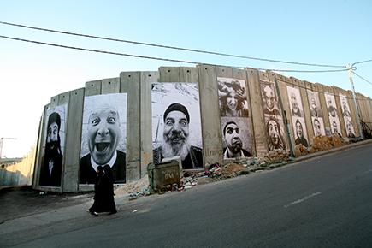

The artwork called “Face 2 Face”, 2007 by JR has been and is a very controversial piece, politically and socially. The project was based off of portraits of Palestinian and Israeli people taken by the American photographer, JR, which were placed on opposite sides of the wall separating the two countries. They are black and white, large, high detail portraits. They are also high contrast images, making them appear bold and in your face, which fits well with the context of the project.

JR was interested in the conflict between Palestine and Israel that has been going on for many years. He was almost curious into why the conflict was still going on and thinking about what he could do to potentially stop it, which in my opinion is very oblivious, ignorant thinking. According to (JR, 2007) we can determine that JR and a colleague investigated these cities, looking at potential places the work would fit. The source (JR, 2007) states that JR described visiting these places by stating “where you can see mountains, sea deserts and lakes, love and hate, hope and despair embedded each other”. They investigated for a week roughly and stated as what they would call their final conclusion “like twin brothers raised in different families”. He then goes on to state “They must put them face to face. They will realise”. The portraits were of people who did similar jobs, in JR’s view, lived similar lives, which were then pasted on opposite sides of the wall. This means that the people of Israel saw the people from Palestine and Vise versa. With this work, JRs aim was to make everyone laugh at the portraits, as the faces that the people are pulling are intended to be funny faces, with the intention of JR’s perspective being that people from each side would laugh, but also realise perhaps that they related to them, and that in his opinion would somehow stop the war.

Not a lot of evidence was recorded into how people reacted, however objectively looking at the project, I can see that it is deeply flawed. The fact that JR is just assuming that he alone will be able to help solve the war is very oblivious of him and frankly ignorant to say. By simply putting the circumstances into one sentence, is hugely underestimating how big of a deal this war is to each country and to the world. In no way is he thinking about the issues that can arise from this otherwise he either wouldn’t’ve done it or he would’ve delt with this more sensitively. This can be perceived as the artist making a joke about the situation, which I am sure the people of both countries didn’t appreciate.
What I also don’t understand about this artwork, is that if his ambitions were to stop the war, or head towards a solution to the conflict, why wouldn’t he put the pictures of the locals in front of people who could actually make a difference to the war, for example, politicians etc. By putting the pictures in front of the local people, it almost seems pointless to the point that he is trying to make. Yes, the people might relate to the people on the walls at a stretch, but the reality is that it would’ve made people more upset and angrier that someone has come along, blatantly vandalised the wall and tried to get involved in a situation that he knows a significantly little amount about, almost making what looks like a mockery of the people that have to live every day in this war. It just shows his lack of knowledge on the situation.

To avoid the issues created, I think the general conclusion would be to not make this work at all and avoid any controversy. Another way would be, to maybe talk to the locals and get their opinions on the matter and create a more sensitive piece of work, which could possibly allow local people to relate to this work, reminding them that they are not alone. But this would not be placed on opposite sides of the wall.
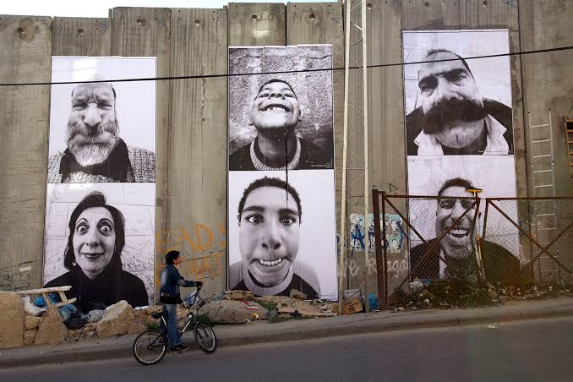

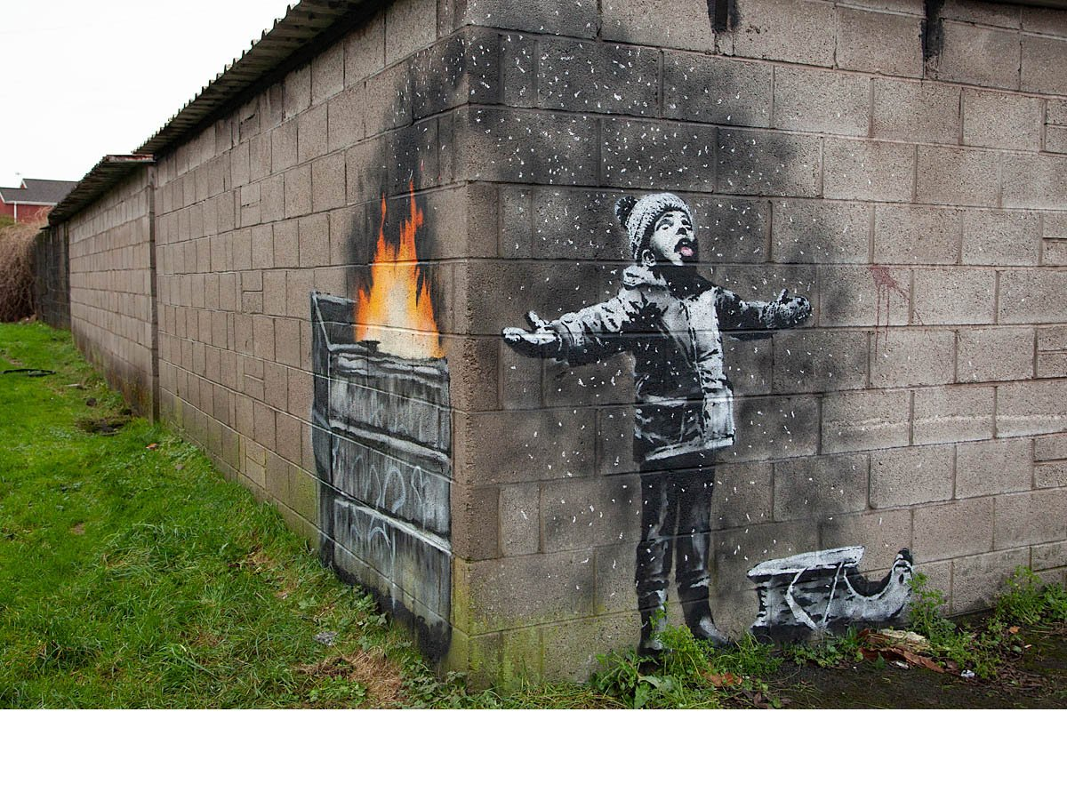

Based on a similar theme of activism in site specify, the artwork “Seasons Greetings”, 2018 by Banksy has great political value, being the more positive impactful piece. The project is based on the pollution created by the atmosphere in Port Talbot where this art was created.

If you look at the first bit of the wall, on the right, the art appears to be a child playing in the snow, with his sledge next to him. However, as you walk round the corner, the illusion is revealed and the snow turns out to be ash from a bin fire, so the child is playing in the pollution coming from the bin, symbolizing what pollution and climate change is doing to the planet. The graffiti is black and white with the flame, bright orange becoming the secondary focal point to the piece after walking round the corner of the wall. The composition of the fire on one side and the boy on the other was in order to make an illusion to make people think the opposite of what it actualy is. Banksy wanted to create emotion when making this, and wanted a reaction, hence the illusion, to shock people into action.

The artwork was created on the side of a man’s garage, in the town of Port Talbot in Wales, infamous for its plant and pollution issues. According to (Banksy Explained, 2021) we can determine that, the artwork is inspired by the people of Port Talbot reporting “black dust” coming from the plant, being found across cars, streets and homes. This work being made in Port Talbot, means this is very site specific, as the pollution-based artwork is based in the town where people actually complained about the issues, making this personal to both the location and the locals. This also means that they can relate to this on a personal level, making this piece even more powerful.

The art was bodyguarded after found by the people of Port Talbot. The art was then cut out of the man’s garage and placed as an exhibited piece of work in the centre of Port Talbot. This later on was sold and transferred to a gallery in England. The fact the artwork was moved is a shame as this took away the site-specific quality in it, as the new location wasn’t as relevant to the art. By it being removed from the place it intended, which added emphasis to the art itself, it took away a lot of reasons why this was so impactful and personal to the community.

This work was intended for a reaction, for people to act on this issue. The work drew a lot of attention towards it, creating lots of debate about the conditions of the locals in the town. This could’ve created lots of issues for the council of Port Talbot, with the possibility of riots and petitions starting about the living standards in the town. However, with climate change being a general issue on its own, this piece is in my opinion is a positive act of activism, allowing the locals to look at this and become motivated to put a step forward and make changes for not just themselves, but the locals living with them.

I think sometimes artists create slightly controversial work, in order to get a reaction, to change things for the better, which I think is a positive thing to be doing as long as it is delt with in the right way.

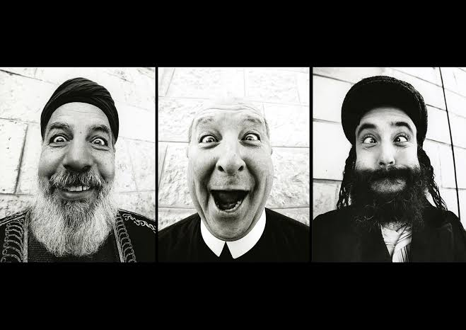
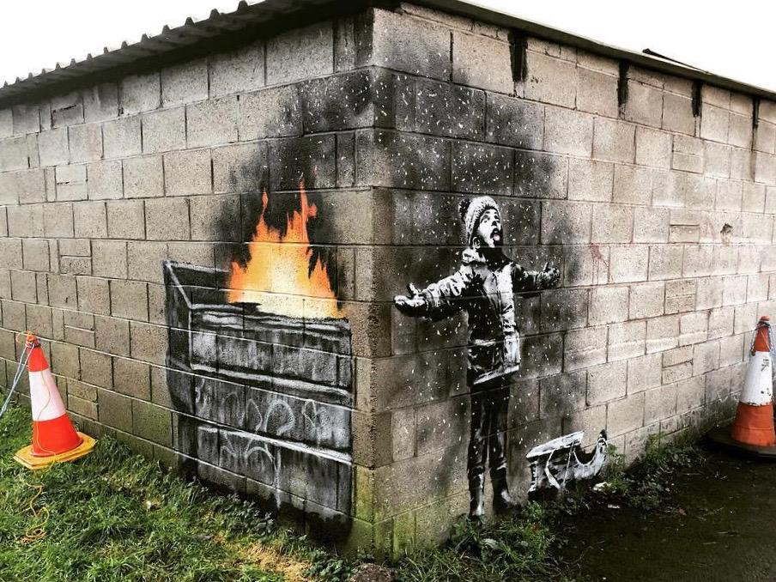
These works are similar and different in many ways. The one similarity is that they are both works, based on the theme of activism. Face 2 Face is trying to actively make work to send a message to make steps into trying to stop the conflict between two countries. Season’s greetings is trying to similarly send a message, but about acting on a different issue. JR has gone about his work in a more controversial way, using unethical methods to communicate his opinions. His ignorance comes through his work as he thinks that to make people laugh, this is going to stop conflict, which is wrong and unethical. However, Banksy has researched the location, considered how the placing of the art will affect the people around it and what it will do for the community.

To sum up, the issues that can arise from site specific work, are very much dependant on the artist, and what they plan for the work. Issues that can arise include political and social issues to do with the location and the people who inhabit that area. If the artist is willing to research into a location properly, making sure that the project intertwines with the location well and ethically, they should be able to avoid any issues that may arise from their work. Banksy is an example of an artist that did this well on this occasion, but JR is not. The locals are also heavily important in creating site specific work, which should be considered when creating a piece of site-specific work.

References:

Banksy (2021). Seasons greetings. [online] Banksy Explained. Available at: https://banksyexplained.com/seasons-greetings-december-2018 [Accessed 17 Oct. 2026].

JR (2007). JR – artist. [online] JR – Artist. Available at: https://www.jr-art.net/projects/istael-palestine [Accessed 17 Oct. 2026].

