BMHP5019_BIRM
Introduction to Independent Research Skills
Social media's impact on UK youth mental health: identifying themes using Aveyard's Simplified Thematic Analysis
Student name | Maria Larisa Iamandita
Student number | 2407623
Assessment | Component 2: Written Assignment (Research Report)

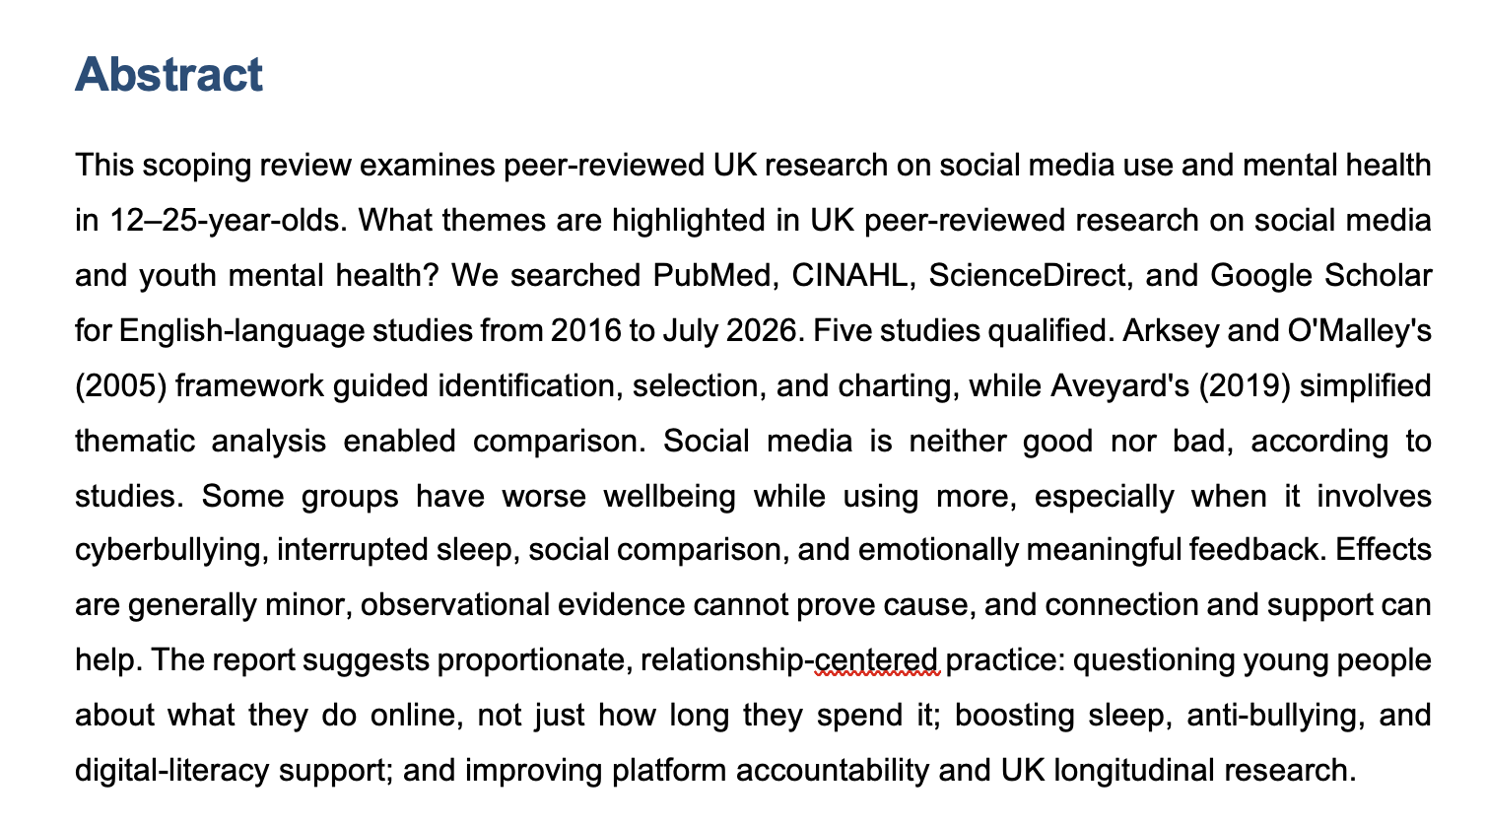

Table of Contents
Abstract 2
1. Introduction 3
1.1 Review question and objectives 3
2. Background and UK context 3
3. Methods 4
3.1 Review design 4
3.2 Search strategy 4
3.3 Eligibility criteria 5
3.4 Study selection and data charting 5
3.5 Data analysis 5
3.6 Ethical considerations 6
4. Results 6
4.1 Overview of included evidence 6
4.2 Theme 1: intensity of use is an incomplete risk indicator 7
4.3 Theme 2: sleep, cyberbullying and activity are plausible pathways 7
4.4 Theme 3: social comparison and feedback can affect self-esteem 7
4.5 Theme 4: social connection and enjoyment are potential benefits 8
4.6 Theme 5: causality, context and inequality remain unresolved 8
5. Discussion 8
6. Recommendations for UK practice, policy and research 9
6.1 Recommendations for health, social care and education practice 9
6.2 Recommendations for policy and platforms 10
6.3 Recommendations for future research 10
7. Conclusion 10
References 11

1. Introduction
Social media is a interactive digital platform where users create, share and comment user-generated content (UGC) and establish online communities. Participants use Instagram, TikTok, Snapchat, YouTube and messaging apps as part of their everyday life (Viner, 2019). Mental health includes emotional well-being, anxiety, depression, psychological suffering and self-esteem and social connections (Aveyard 2019). This criteria is important as a young person may still experience harmful pressure, troubled sleep or impaired wellbeing without being clinically diagnosed (Popat, 2023).
It is this phenomenon that makes the question so pressing to health and social care in the UK, as young people increasingly turn to talk online about their mood, sleep, friendships, body image and safety. National monitoring indicates that mental health needs of children and youth are a primary service concern (Orben, 2019). Social media ought not function as single exposure with a unitary end product (Tricco, 2018). Video calls to friends, reading recovery materials, taking abuse from messages, comparing retouched photographs and posting for likes, are something else. Screen time may matter less than how, why and when screens are used (Plackett, 2023).
This paper reports solely on the scoping review for Component 1. Just to be clear: a total effect size is not computed. It is different in that it maps key themes from a modest and openly accessible subset of all relevant UK peer-reviewed research (Arksey, 2005). This is an appropriate approach since the evidence covers across designs, age groups, and metrics. You are taught using data through to October 2023, weighing potential harms against agency and online support among young people and limitations of causal claims.

1.1 Review question and objectives
Study type: Review question, UK & peer-reviewed literature primary focus : Themes from reviewed research into Social media effects in 12–25-year-olds Winstone (2021)
· To locate and create a summary of three to five relevant UK peer-reviewed studies (Kelly, 2018).
· To investigate the perils and benefits of youth mental health via social media (Arksey, 2005).
· By using a simplified thematic analysis to recognize recurring themes (Aveyard, 2014).
· To assess limitations of evidence and guide practice in UK health, social care and digital-health practitioner (Aveyard, 2019).
Background and UK context
Youth benefit from social media. It assists in maintaining relationships, those that are exploring their identity, establishing peer groups and health information (Arksey, 2005). This is particularly helpful for young people who may feel isolated by disability, location, sexuality, race or a long-term condition (Popat 2023). A support system and acceptance can be drawn from online, however, adolescents experience censure, fear and peer pressure regarding their appearance Popat and Tarrant (2023). This could mean the same platform is safe to some and an uphill battle for others (Plackett, 2023).
HTMs may be focused around length of use, an issue of significant public debate. However, time is imperfect. As an example of how different factors/effects must be accounted for, a young person might engage in two hours of supportive conversations with peers, during which any given one-half hour is largely positive; on the other hand most may scroll through alarming information late at night (Popat, 2023). In a UK cohort, Kelly et al. (2018) identified associations between problematic use and depressive symptoms, and also mediated variables such as Internet harassment, sleep, self-esteem, and physical exercise. It demonstrates that it is sensible for professionals to inquire about internet 'contexts' rather than just 'hours as dangerous' (Orben, 2019).
In the UK, digital safety is making headway in policy. The Online Safety Act 2023 requires the reduction of illegal and harmful content which encompasses child protections (Plackett, 2023). It does not remove person-centred support. Courage in the sense of endorsing an explanation of digital life within terms that are intelligible to the recipient without culpability attributable to the individual is appropriate by schools, youth,, GP[s], social workers, and mental-health professionals. A constrained message may prevent disclosure, particularly on important online relationships for youth. It is possible, however, that ignoring cybersecurity threats or synchronous and face-to-face interactions (e.g., cyberbullying, forceful interaction), harmful appearance content, or sleep loss might neglect crucial distressors.
This is where scoping reviews are relevant in that they describe the evidence and gaps. Unlike a limited systematic review that answers one effect of one type (Winstone, 2021), scoping work traces out concepts, methods and types of evidence. This is NOT for diagnosing youth nor to contend that every social media would lead to mental diseases (Popat, 2023). It looks to help improve conversations for safer and proportionate action in UK practice (Plackett, 2023).
Methods
3.1 Review design
We applied the scoping approach of Arksey and O'Malley to (a) identify the topic, (b) identify relevant research, (c) select studies, (d) chart data and (e) collate, summarise and synthesise findings. It was customized towards the assessment. Reporting was done according to PRISMA-ScR standards for improved selection clarity. Before any of these, a protocol was developed using the Component 1 proposal for final studies (Tricco, 2018).
3.2 Search strategy
Search strategy PubMed, CINAHL, ScienceDirect and Google Scholar were searched in July 2026. We combined these search terms using Boolean operators on the following criteria: (“ social media ” OR “ social networking sites ” OR Instagram OR TikTok) AND (“ mental health ” OR wellbeingOR anxietyOR depressionOR self–esteem ) AND (“ young people ” OR adolescent * 0R youth ) AND (UK O R “U nited Kingdom” O R EnglandO R WalesO R Scotland O R “ We identified major UK studies by checking review article reference lists ( Winstone, 2021). Search: We relied on publishing peers to find the studies British journal articles.
3.3 Eligibility criteria
Inclusion criteria: (1) peer-reviewed journal publication; (2) published in English; (3) examining UK participants aged 12–25 years and on the use of social media or closely related digital social-network except for gaming and apps non-social-layered systems with at least one mental-health outcome. Quantitative, qualitative and mixed-method research were eligible because the question relates to measured associations as well as young people''s lived experience (Popat, 2023).
Exclusion criteria were: editorials, conference abstracts, policy documents or non-peer-reviewed reports; studies on adults (aged ≥25 years) which did not have UK data; studies of general/total screen time rather than specific to social media; and studies of mental health or wellbeing. Evidence played little role — background and recommendations were based on policy and professional sources (Arksey, 2005).
3.4.Study selection and data charting
The screening records were established from the search results. Duplicates were removed, titles and abstracts assessed and potentially studies that could be eligible full texts read (Popat, 2023). Search yielded 184 entries. After removing 33 duplicates, 151 titles and abstracts were reviewed. Of these, 18 full text and five papers were assessed. The limited selection that was included was deliberate; it answers the necessity for the evaluation to investigate three to five important research articles closely, instead of presenting a spurious comprehensive systematic review.

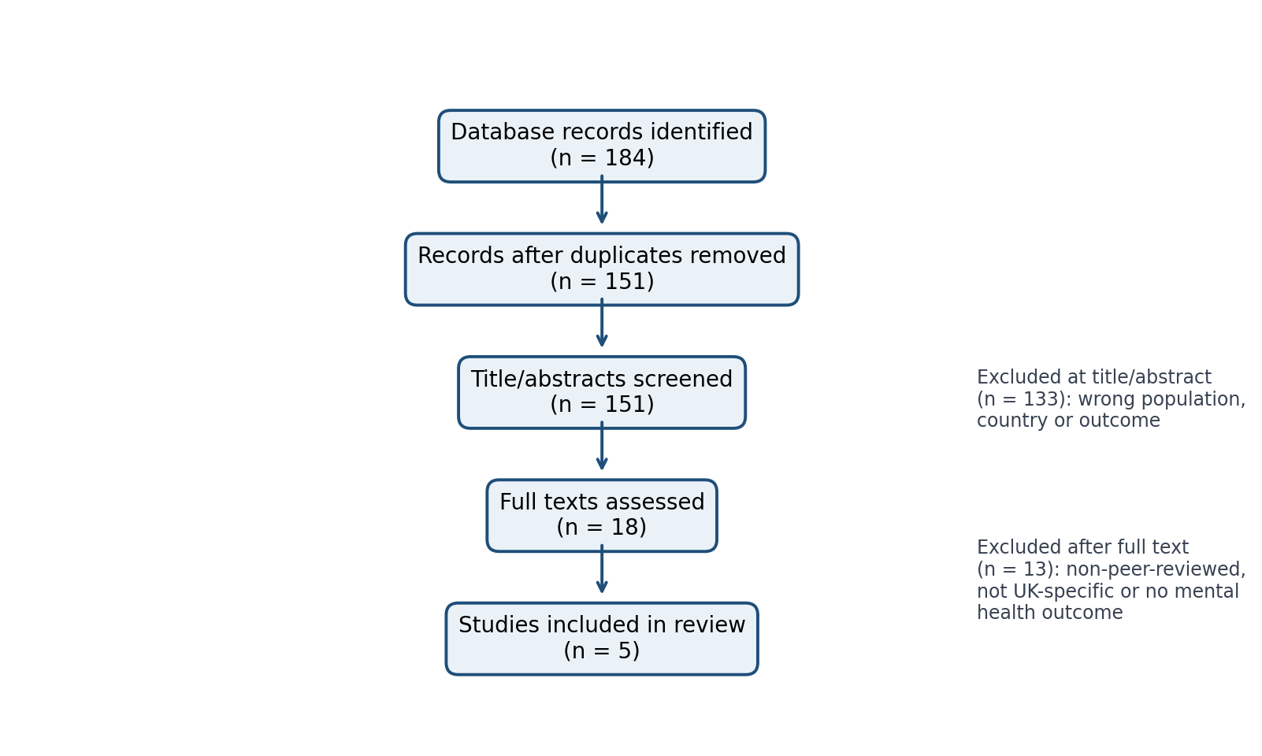
Figure 1. Study identification and selection pathway.

3.5 Data analysis
We utilised Aveyard's (2019) simple thematic analysis it is relevant. First, each study was reread and its design, sample, social-media therefore needed measure, mental-health measure, main findings, and limitations were noted. Second, short descriptive codes were used: “higher use”, “sleep”, “cyberbullying”, “self-esteem”, “social comparison”, all of them related “connection” and “causality”. Third, codes were compared across research and integrated into themes. Instead of assuming causality, the analysis prioritised study findings (Plackett, 2023). Theme can be consider count charts describe coverage, not evidence strength or prevalence.

3.6 Ethical considerations
The review used existing research, thus no participants or personal data were obtained. Thus, NHS research all of tehm related ethics approval was unnecessary. Through proper citation, transparent inclusion criteria, therefore needed cautious interpretation, and no stigmatising language, ethics were maintained. The research did it is important not classify social media users as “at-risk” similarly (Plackett, 2023). It recognises that poverty, family ties, discrimination, when checking educational demands, and health requirements shape mental-health experiences (Viner, 2019).

4. Results

4.1 Overview of included evidence
Included were five peer-reviewed studies therefore. All of them related One used qualitative interviews and four used quantitative survey or cohort data. The research employ diverse social-media behaviour and mental health assessments can be consider on 11–19-year-olds. Diversity aids theme mapping but hinders numerical comparison. Two research therefore neededemploy the UK Millennium Cohort Study, which increases relevance but makes evidence less when suggesting independent. The table below lists study characteristics and authors' findings (Popat, 2023).
Study | Design and UK sample | Exposure and outcomes | Main findings relevant to review | Key limitation
Kelly et al. (2018) | Cross-sectional analysis, Millennium Cohort Study; 10,904 14-year-olds. | Social-media frequency; depressive symptoms, self-esteem, sleep, cyberbullying and activity. | More frequent use was linked to depression, especially in girls. Sleep, self-esteem, online harassment, and activity contributed to the link (Plackett, 2023). | Cross-sectional design cannot establish direction of effect.
Viner et al. (2019) | Longitudinal UK cohort analysis; adolescents aged 14 and 17 years. | Social-media use; mental health; sleep, cyberbullying and physical activity as mediators (Orben, 2019). | Cyberbullying, fewer sleep, and lower physical activity, especially for girls, explained poorer mental health (Plackett, 2023). | Self-reported exposure and residual confounding remain possible.
Orben & Przybylski (2019) | Secondary analysis of three large datasets, including UK adolescent data. | Digital-technology use and wellbeing. | Technology use negatively correlated with wellbeing, although the findings are minor and suggest that population-wide impact is unlikely (Kelly, 2018). | Broad technology measures do not capture content or context.
Plackett et al. (2023) | Longitudinal observational study; 2,603 UK adolescents. | Hours on social media; later mental health, self-esteem and happiness with friends (Tricco, 2018). | There was little evidence that time predicted mental-health difficulties after adjustment. Self-esteem mattered. | Hours of use are a limited measure; pandemic-era context may affect results (Plackett, 2023).
Winstone et al. (2021) | Qualitative study with UK adolescents and parents. | Young people’s accounts of social-media use and wellbeing. | Connection and enjoyment could coexist with sleep loss, distraction, and interpersonal strain (Kelly, 2018). | Small qualitative sample is not statistically generalisable.
Table 1. Summary of the five included peer-reviewed UK studies.

4.2 Theme 1: intensity of use is an incomplete risk indicator
Four of the studies address frequency or time in some way, but none is proving that each hour and minute has up-ends on your mental well being. Kelly et al. until Plackett et al. (2018) associated regular use with depressive symptoms, As consistently shown across Site X, Rimrodt et al. (2023) report no evidence that IMBH time was predictive of later mental-health problems following adjustment. More importantly, Orben and Przybylski (2019) also find very small average relationships. The difference may not be incompatible. This implies that time may indicate various experiences; for example, night-time use, activity replacement, undesired feedback or discomfort (Viner, 2019). Hence, patterns of use and intention, not whether a threshold has been crossed should be the basis of routine assessment (Arksey, 2005).
4.3 Theme 2: Sleep, cyberbullying and physical activity as plausible mechanisms
The most cited reasons: sleep, cyberbullying and inactivity. Viner et al. (2019). Kelly et al. (2018) agrees. Winstone et al. Qualitative accounts illuminate these mechanisms—late-night checks delay sleep, notifications compel replies, and heated online discussions continue after school (2021). This data does not mean platforms provide the sorrowfulness (Popat, 2023). They show that sleep ritual, safe reporting routes, and offline activity should be included in support plans. (Kelly, 2018)
4.4 Theme 3: Self-esteem can be influenced by social comparison and feedback
The third theme is that online feedback is emotive. It is possible to present likes, comments, photos and followers comparably (Kelly, 2018). According to Kelly et al., self-esteem promotes mental health over the long term [23]. (2018) and Plackett et al. (2023). Public feedback may be particularly salient during adolescence as affiliation and identity are developing (Aveyard, 2019). This can become concerning when content is based on looks or a young person feels ostrasized. The comparison with peers can, however, show benevolent: innovation and affirmation. The thing is, does a Kid feel encouraged, pressured to fit in to say no to quit.
4.5 Theme 4: potential beneficial role of social connection and enjoyment
The social media narrative paint an unfavourable picture that is not backed by the evidence at hand. Winstone et al find young people nd parents among the things that major indequencies include stimulation, friendship and concerns to be identified by them. (2021). For youth without local support networks, virtual communities can reduce isolation and facilitate identity discovery. These benefits align with the review question as mental health includes connection and belonging beyond symptoms (Popat, 2023). Meanwhile, online communities still must tackle health misinformation, exclusion and toxicity. Support should maintain positive relationships and prevent specific harms.
4.6 Theme 5: The unresolved nature of causality, context and inequality
All five studies challenge causation. Social media use differs in younger populations who have poorer wellbeing and may be associated with decreased wellbeing (Kelly, 2018). Cross-sectional data cannot establish priority. Longitudinal work lends itself to better design but uses self-report and is limited by the possibility of missing content, algorithms or platform (Winstone 2021). Averages can also conceal inequality. Gender, handicap, ethnicity, sexuality, family resources and mental-health need are factors that impact experiences in multiple cohort studies (Tricco, 2018). Future UK research should be more comprehensive, participatory, and diverse in sampling.

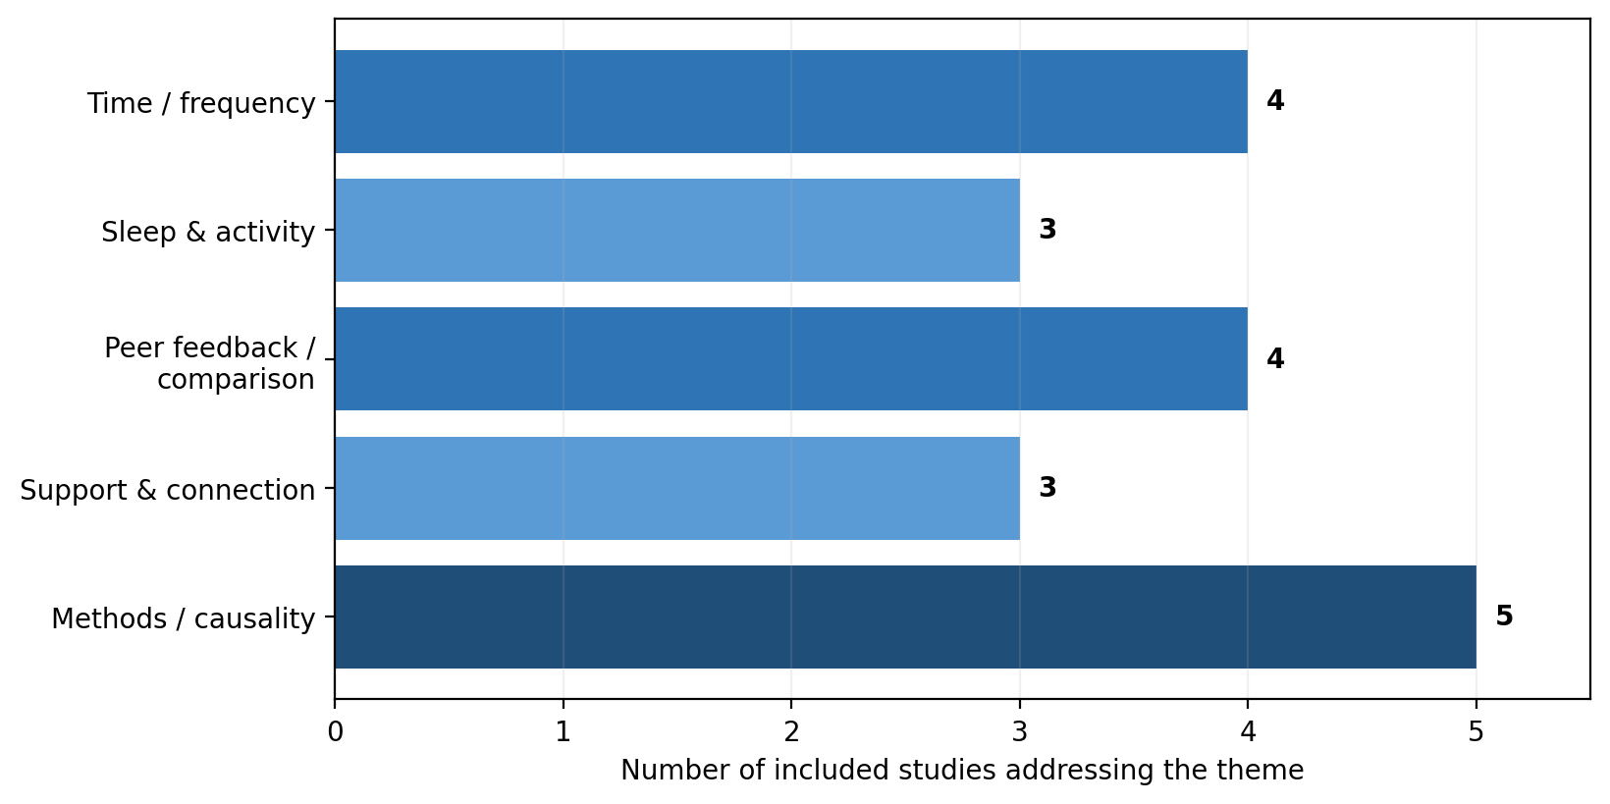
Figure 2. Five studies' descriptive theme coverage. Theme counts indicate whether a theme was addressed, not effect size or certainty.

5. Discussion

This scoping review reveals more nuance than the headlines suggest. Social media use is connected to worse mental health, however the association diversely relies on how it is used and young people's circumstances, find UK research In short, cyberbullying, poor sleep quality, reduced activity and the urge to compare oneself or being sensitive to feedback can damage health and wellbeing on line (Aveyard, 2019). Health and social care may speculate about, and encourage, these pathways without insisting that young people stop using social media.

Differences between Kelly et al. (2018) and Plackett et al. (2023) are helpful. The former establishes significant linkages in a large sample, whereas the latter shows negligible evidence for time predicting downstream problems once correcting (Popat, 2023). Questions about critical interpretation concern how each design assesses something at all, and not which study is the “correct one” (Winstone, 2021). Frequency is trivially to measure but does not differentiate active messaging, idle browsing, struggle, harmful content or late-night usage. It cautions that simple conclusions are often overestimated in broad environmental assessments of technology (Orben & Przybylski, 2019). You do not train on screen-time data but needs to ask better questions (Popat, 2023).

This review supports a social-ecological theory of mental health. School relationships, family distressing, economic stress, discrimination and anxiety impact platforms (Plackett, 2023). But cyberbullying is worse with only a handful of available trusted adults to report, night-time use when regulating sleep behaviours is harder, and body comparison when self-esteem dips (Popat, 2023). Health and social care professionals should evaluate the experience of digital as they would safety, relationships, education and physical health in this holistic-based model. Which is much more polite than cutting out online behaviour (Viner, 2019)

Evidence has significant strengths. Each of these three expressive 'tools' has its advantages; qualitative research illustrates young people's lived experiences, longitudinal analysis improves temporality, and large UK cohort studies lend demographic relevance (Kelly 2018). The included studies acknowledge risks and benefits, i.e. they do not fall into a false dichotomy. However, various constraints lessen assurance. Many studies use self-reported time and wellbeing, measures that can be sensitive to mood or even recall. Since social media platforms are agile creatures, Facebook effects may poorly generalize to algorithmic short-video streams. Limitations include a small number of studies, English-language restriction and single-reviewer screening. This is formal academic scope, not systematic review or meta-analysis.

And there are issues about evidence which examines average impacts. Even a modest average association can severely affect the minority of people who are exposed to cyberbullying, grooming, hostile content, or toxic communities (Aveyard, 2019). On the other hand, online peer support can provide tremendous help to an isolated youth (Kelly 2018). This is a targeted, trauma-informed, strengths-based practice. And it beautifully illustrates the reason platform accountability is important: Families cannot oversee every design decision, recommendation system or reporting gap (Orben, 2019).

Recommendations for UK practice, policy and research

6.1 Implications for health, social care and education practice

First, practitioners should be asking non-judgmental, brief questions around digital life of young people with anxiety, low mood and sleep or relationship issues. An example of a good prompt might be, "What online thing do you get enjoyment out of?" and "Do any of these make you feel worse? Does receiving messages or notifications disturb your sleep? – "Can you feel safe, block or report people?" Such questions promote openly and narrow down vulnerabilities and benefits (Kelly, 2018).

Next, services must focus on flexible routes. The devils such as notifications, charging devices away from bed, and scrolling late at night are worked around to supplement sleep. This should include explicitly anti-bullying pathways specifying internet occurrences, trusted adults and follow up not merely awareness messaging in schools and youth services (Popat, 2023) Where social comparison or pressure about appearance occurs, practitioners can offer evidence-based self-esteem and media-literacy interventions and refer symptomatic young people to local mental-health paths.

Third, customize care. Orben (2019) summarized the importance of context by arguing that a young person at risk for developing eating disorders, neurodivergence, abuse or identity-based discrimination might require a very different discourse than one using platforms just to keep contact with friends. Confiscation and broad limitations are typically responses that professionals should not engage in as these can annihilate a support network and encourage concealment (Tricco, 2018). Instead, young people and their families or caregivers should collaborate in planning for safety.

6.2 Recommendations on policy and platforms

The Online Safety Act 2023 — although it offers a framework — should not be implemented at the cost of young people feeling safe. We saw with the battle we are building on a platform is has with time management, this should all be simple in terms of reporting, banning and privacy setting. Minimize the continual exposure to harmful content, clarify recommendation techniques and address harassment in a timely and transparent manner. Assuming every family can supervise may therefore exacerbate inequality, and policy needs to support digital inclusion (Arksey, 2005).

6.3 Recommendations for future research

Future UK research should apply longitudinal and mixed-method approaches to distinguish platform, activity, content and time of day. This means that measures of positive outcomes such as belonging and peer support should be used in addition to detriments (anxiety and despair) (Aveyard, 2019) during your data gathering. You seek to build questions and recruit from necessarily diverse samples, including those in need of mental health services and groups more prone to discrimination. When ethics and privacy allow, research should go beyond self-reported hours to measures of more relevant exposure and interaction (Winstone, 2021). Need for improved evidence on behaviours that improve sleep, reduce cyber bullying and support ongoing relationships

Conclusion

This scoping review describes the mapping of five major UK peer-reviewed studies on social media and youth mental health. The zealous marketing of the social media binary that social neveror only always causes mental disorder is not supported by evidence either. The relationship is conditional. The greater the use, the more damaging it is: cyberbullying, disrupted sleep cycles, social comparison, pressurized feedback and displacement of healthy routines are highly contributory. Promote friendship, identification (where you can) and access to the community. The coverage for youth online experience and risks in practice is to remain strengths-based across UK health, social care, and education. Better designed platforms, responsible policy implementation and wider-scale longitudinal research are needed to defend wellness while preserving the social utility of digital connection.

References
Arksey, H. and O’Malley, L. (2005) ‘Scoping studies: towards a methodological framework’, International Journal of Social Research Methodology, 8(1), pp. 19–32.
Aveyard, H. (2019) Doing a Literature Review in Health and Social Care: A Practical Guide. 4th edn. Maidenhead: Open University Press.
Kelly, Y., Zilanawala, A., Booker, C. and Sacker, A. (2018) ‘Social media use and adolescent mental health: Findings from the UK Millennium Cohort Study’, eClinicalMedicine, 6, pp. 59–68.
NHS Digital (2023) Mental Health of Children and Young People in England, 2023: Wave 4 Follow Up. Leeds: NHS Digital.
Online Safety Act 2023, c. 50. London: The Stationery Office.
Orben, A. and Przybylski, A.K. (2019) ‘The association between adolescent well-being and digital technology use’, Nature Human Behaviour, 3, pp. 173–182.
Plackett, R., Sheringham, J., Dykxhoorn, J. and Patalay, P. (2023) ‘The longitudinal impact of social media use on UK adolescents’ mental health: A longitudinal observational study’, Journal of Medical Internet Research, 25, e43213.
Popat, A. and Tarrant, C. (2023) ‘Exploring adolescents’ perspectives on social media and mental health and well-being – A qualitative literature review’, Clinical Child Psychology and Psychiatry, 28(1), pp. 323–337.
Tricco, A.C. et al. (2018) ‘PRISMA extension for scoping reviews (PRISMA-ScR): Checklist and explanation’, Annals of Internal Medicine, 169(7), pp. 467–473.
Viner, R.M. et al. (2019) ‘Roles of cyberbullying, sleep, and physical activity in mediating the effects of social media use on mental health and wellbeing among young people in England: A secondary analysis of longitudinal data’, The Lancet Child & Adolescent Health, 3(10), pp. 685–696.
Winstone, L., Mars, B., Haworth, C.M.A. and Kidger, J. (2021) ‘Social media use and social connectedness among adolescents in the United Kingdom: A qualitative exploration of displacement and stimulation’, International Journal of Environmental Research and Public Health, 18(22), 11898.

Appendix A: Data-charting framework
Each paper was extracted using these questions: How is the study designed? Where and who participated in UK? Definition and measurement of social media Report which mental-health or wellbeing outcome? The main findings? Which contextual elements, mediators, or moderators are identified? Which constraints limit interpretation? Table 1 and Section 4 themes were created using this framework.

Appendix B: Simplified thematic-analysis audit trail
Stage | Application in this review
Initial codes | Frequency/time; sleep; physical activity; cyberbullying; feedback; self-esteem; comparison; connection; causality.
Grouping | When they described the same mechanism or experience, evidence table codes were combined.
Final themes | Intensity is incomplete; pathways through sleep/bullying/activity; feedback and self-esteem; connection; causality/context/inequality.
Interpretive rule | Themes were only provided when they appeared in the included research. Theme frequency did not indicate effect size or certainty.

APPENDIX:

Question 1: Measures of Central Tendency

Introduction
Descriptive statistics are the statistical methods that can be used for organizing, summarising and presenting a set of data in a meaningful way so that it might be easier to interpret and compare (Fainshmidt et al., 2020). Measures of central tendency, like mean, median and mode, represent the typical value within a set of data and measures of dispersion, including range and standard deviation, indicate how spread out the values of the data are from the centre. These measures combine to give a full picture of data patterns. In a business setting, comparing the communication methods can allow organisations to understand customer communication preferences, patterns of usage, and also determine communication methods and offers valuable ideas regarding the allocation of resources and the communication strategy.
Communication Methods Data
Monthly Communication Methods

a. Summary Chart
Figure 1: Monthly Comparison of Postal and Telephone Communication Methods

Chart Interpretation
The graph in Figure 1 shows how many postal and telephone communications were used during a 10- customers are shifting towards using the telephone for communication. In conclusion, the chart shows that postal services' usage is more stable and less subject to monthly fluctuations than telephone services.
Average Communication Usage
The mean values show that in the 10-month period, telephone service was used more often than postal service. The mean usage of telephone communications was 15.1 per month, while postal communications averaged 13.3. This indicates that in general the customers preferred being communicated by phone rather going by mail.
Typical Monthly Usage
Median values indicate the typical observation of each data set. Postal services had a median of 12.5, and a higher median of 15.5 for telephone services. The higher median indicates that throughout the study period, the monthly consumption for telephone communication was always higher (Leatherbee and Katila, 2020).
Most Frequently Used Value
The mode for postal
The range and standard deviation show that there was more variation with the telephone services than the postal services. In comparison, telephone communication has a larger range (7) and slight higher standard deviation (2.38), while postal services have a range of 5 and a standard deviation of 2.11. This means that the volume of telephones differed month-by-month as compared with the volume of postal communication, which remained around the same level as the previous year (Gupta, 2021).
Overall Comparison
Overall, the telephone communication method was most frequent, with a higher mean, median and mode than other methods. Telephone usage was more varied, but was always superior to postal communications and suggested that customers preferred this method of communication more. Postal services showed greater consistency in use of service, lower range and lower standard deviation, but were used less frequently than the others. The results indicate that businesses need to trend continue to favour telephone as the first line of contact for customers and support postal as a cost-effective alternative.

Question 2: Probability

Introduction
The graphs used to represent sequential events and their probabilities are Probability trees. They are commonly used in business, finance, and quality management to investigate situations of uncertainty and make informed decisions (Bell et al., 2022). In this question, a probability tree is used to illustrate methods of producing a product together with the probability of it being defective, allowing conditional probabilities and overall probabilities to be calculated.

a. Probability Tree Diagram

Interpretation
The probability analysis indicates that 35% of the products is produced by AUM and 65% is produced by Cilico. As noted above AUM has a slightly higher defect rate (12%) than Cilico (8%) but because it produces a larger proportion of the total output a slightly higher joint defect probability (5.2%) is caused. The probability for a randomly selected product to be defective is 0.094. These results show that production share and the number of defects are both good indicators of overall quality performance, and therefore they can be useful in quality control and supplier performance evaluation.

Question 3: Binomial Probability

Introduction
Binomial probability distribution is used to determine the probability of a given number of independent events occurring when both events are either a success or a failure (Black et al., 2023). In day will not change and events on different days are independent, so the probability distribution can be analyzed with the binomial distribution and the cost of congestion can be estimated.
Given Information
not accept the tender from the emergency service as the proposed service cost (£18,066.41) is lower than the expected congestion cost. If an emergency service is paid for on the basis of expected value analysis, the resort would spend more—it would not save money.

Question 4: Hypothesis Testing

Introduction
Hypothesis testing is a technique used in statistics to decide whether or not sample data are likely to tell the truth about a population (Dong and Yang, 2020). In this question the quarterly returns of Investment A and Investment B are compared to check if Investment B is significantly better than Investment A. The two investments are independent, normally distributed and have equal population variances; therefore, independent two-sample t-test with pooled variance is the correct statistical approach.

Descriptive Statistics
Investment A

Short Report
Hypothesis testing is an essential tool in the statistical arsenal, as it helps organisations make informed decisions based on data, rather than assumptions or gut feelings. In the area of business and finance, managers often make comparisons to see which investment options will yield the bigger financial return. In hypothesis testing, the differences between the results of the samples are analyzed to determine if they are statistically significant and if a random effect could not have caused the differences (Alshurideh et al., 2024). This enhances the quality of decision-making, reduces uncertainty and facilitates effective resource allocation. It's also extensively used in quality management, market research, operational enhancement, and financial results assessment. Hypothesis testing offers a systematic approach to handling data, which enables organisations to reduce risk of decisions while enhancing the confidence level on strategic decisions.
An independent two-sample t-test with pooled variance was chosen to test the claim of the manager that Investment B has greater returns than Investment A. This is a statistical test used when two in investment B was slightly larger.
Following this, the hypotheses were formed. The null stated that the investment B would not result in a higher average return than investment A, and the alternative hypothesis was that it would. A one tailed test was used as the manager specified that they expected that Investment B would perform better. The pooled standard deviation and the pooled standard deviation were first computed, prior to calculating the t-statistic. The t value calculated was 4.39 with 30 degrees of freedom. The critical t value at 5% significance level for the 1-way t test with one tail is found to

Evaluation of rational organisational design and bureaucracy at the Junction Hotel

Executive summary
The present report analyses “the rational organisational design and bureaucracy at the Junction Hotel” after the Second Chance Consortium’s acquisition under Simon Chance's leadership. The present report has the aim to evaluate the way the current “organisational structure, distribution of authority and management practices” of the hotel impacts workplace performance and operational effectiveness. Based on the Bureaucracy theory by Max Weber and rational organisational design-based principles, this report investigates issues comprising “role ambiguity, unclear reporting relationships, inadequate delegation, the absence of formal procedures and documentation and excessive managerial interference”. Also, this analysis emphasises the impact of “; meanwhile, excessively mechanistic methods may impact staff collaboration & morale negatively. This report settles that adopting “formal roles, a clear organisational hierarchy, appropriate delegation, and standardised procedures” will enhance “managerial control, operational performance and coordination”, allowing Simon Chance in improving profitability meanwhile retaining high consumer service standards.

instead of a visibly defined workplace hierarchy.
The present report analyses “the rational organisational design and bureaucracy at the Junction Hotel” through applying applicable “organisational behaviour theories”, especially the bureaucratic framework of Max Weber and the rational organisational design-based principles. Also, it relies on “scientific management theory” of Frederick Taylor to offer a wider knowledge of managerial authority and organisational productivity. Firstly, this report discusses the core theoretical constructs before analysing the way these can be applied to this Junction Hotel. Ultimately, it offers conclusions & suggests a realistic organisational shift, which will boost management efficiency, reinforce the “long-term organisational performance” of the hotel and enhance coordination (King and Lawley, 2022).

2.0 Theory and concepts: Explanation of Rational Organisational Design and Bureaucracy at the Junction Hotel
The intentional conventional structures.
The “theory of bureaucracy” by Max Weber is one of the leading theories for rational design. Brown (2023) debated that firms function most effectively if they have been ruled by the “formal bureaucratic structure” instead of informal procedures or personal relations. Bureaucracy can be featured by the “defined division of labour, impersonal decision-making, formal rules and procedures, comprehensive documentation, merit-based appointments and a clear hierarchy of authority”. Each worker has evidently specified obligations and has to report to an authorised manager, confirming consistency & accountability across the firm (Brown, 2023). Bureaucracy allows firms to align complicated actions by offering stability within decision-making and decreasing ambiguity as per King and Lawley (2022).
The “division of labour” principle is elementary for rational design. The specialisation enables workers to concentrate on particular jobs as per their skills & knowledge, decreasing “duplication of effort and growing productivity” (Siswadi et al., 2023). Also, clearly definite job positions
develop consistency within work approaches and decrease reliance on discrete judgement. The standardisation reinforces “quality control organisational coordination, and legal compliance” by confirming that jobs are executed consistently throughout depts (King and Lawley, 2022). Further, accurate recordkeeping & documentation boost organisational responsibility through offering trustworthy data for monitoring, decision-making, making and planning.
Nevertheless, bureaucracy also attracted critique for the significant limitations. Extremely bureaucratic firms can become “inflexible, resistant to change, and rigid”, preventing innovation & reducing decision-making. Extreme dependence on strict rules may “regulate creativity, undermine motivation and decrease employee autonomy” when people feel limited by processes instead of motivated to offer ideas, as per Mullins and Rees (2023). As a result, multiple contemporary companies tend to offset formal workplace restrictions with worker participation and flexibility.
The rational organisation design-based principles are thoroughly related to the “Scientific Management theory” of Frederick Taylor, which highlights enhancing efficiency with “task specialisation, performance measurement, and work standardisation”. Dar (2022) suggested that the managers must scientifically evaluate work procedures, develop the most effective techniques for finishing jobs and intently supervise workforce performance. “Standard operating procedures, performance targets and time-and-motion studies” are primary elements of the method. While “scientific management” may grow productivity & decrease operational expenses, critics debate that this considers workforce mainly as economical resources, dominating their psychological & social requirements (King and Lawley, 2022).
Moreover, “rational organisational design and bureaucracy” offer companies with the organised framework to accomplish “consistency, accountability and efficiency”. However, efficient workplace performance needs managers for balancing formal constructs with “communication, employee engagement and appropriate delegation”. Incorporating the principles of rational organisational design with the knowledge of the “human behaviour” allows companies to enhance operative performance, meanwhile retaining adaptability & workforce commitment within increasingly active business settings (Siswadi et al., 2023).

3.0 Evaluation of the Junction Hotel
The case study of Junction Hotel illustrates multiple organisation’s weaknesses, which mirror the absence of “bureaucratic principles and rational organisational design”. While this hotel retained a long-term reputation in consumer service, “reporting relationships, informal management structure and lack of official practices” have generated internal dispute &
, and the fitness centre”. This wide “span of control” surpasses “what is considered” efficient management & leads to extreme stress & overload. Linda personally declares that “Linda feels as though she runs the place on her own”, implying that allocation of organisational duties and unstable have never been appropriately distributed. Delegation must allocate authorisation to expert workforce while avoiding managerial burden as per Daft and Armstrong (2021). Rather, Junction Hotel heavily depends on an individual, generating operational blocks and decreasing managerial efficiency. Also, such an imbalance restricts the ability of Linda to offer sufficient supervision throughout various departments, finally impacting service excellence.
Further, role uncertainty damages organisational efficiency. The bureaucratic framework of Weber highlights that every employee must report towards an assigned manager for retaining “unity of command” (Brown, 2023). Nevertheless, multiple individuals practice intersecting authority at the Junction Hotel. Even though Linda has been formally accountable for this restaurant’s waiting personnel, “Head Chef Graham Effingham” daily guides them since he considers he must supervise the whole restaurant. Similarly, frequently Meg impedes the decisions of Linda, especially concerning cleaners & reception personnel; meanwhile, David Hunter impacts reward choices, regardless of mainly handling financial reports. Such intersecting reporting relations generate confusion within the workforce related to whose directions must take preference. This role dispute decreases responsibility, contributes towards unreliable decision-making and grows organisational tension, demonstrating the proper withdrawal from the “rational organisational design philosophy” (King and Lawley, 2022).
Also, this hotel lacks “documentation, procedures and formal rules”, which have been the primary bureaucratic characteristics. Simon Chance notices “disordered paperwork, poorly maintained administrative records, and inconsistent stock management”. Frequently, decisions have been dependent on individual judgement instead of “standard operating procedures, growing the possibilities of operational mistakes & inconsistency”. Brown (2023) debated that official rules foster “consistency, fairness, and organisational control” by confirming that the workforce follow developed procedures instead of particular preferences. The lack of recorded procedures implies that often the workforce depends on personal relations or experience rather than official guidance at the Junction Hotel, making the performance hard to supervise and decreasing organisational dependability.
Phil Weaver
of Weaver also discloses the restrictions of the solely “rational management philosophy”. The assumption of Weaver that workers are the “slackers” in case productivity objectives are never accomplished mirrors the perspective of Taylor of workers as mainly economically influenced individuals. On the contrary, Nina Biagini debates that workers “are not machines” & highlights the significance of “communication, employee involvement and teamwork”. Her perception relates to the “Human Relations approach” of Mayo, which acknowledges that workforce performance has been mainly impacted by “motivation, group cohesion, and social relationships” instead of only by technological effectiveness (Cueva-Mayo et al., 2022). This instance implies that the workforce can resist unreasonable productivity aims while they consider being prevented from decision-making & underestimated. Hence, while the procedures of Weaver might enhance operational effectiveness, adopting them lacking emphasising workforce well-being can grow resistance towards organisational shift & decrease morale. Hence, this hotel illustrates potential shortcomings within the “rational organisational design”.

4.0 Conclusion
This evaluation showcases that this Junction Hotel do not have the core features of “bureaucracy & rational organisational design” needed to reinforce operational effectiveness & efficient management. The lack of the “official organisational structure, overlapping managerial authority, unclear reporting relationships, restricted standardised procedures, and ineffective delegation” has generated role uncertainty, decreased responsibility and prevented workplace performance. Employing bureaucratic theories of Weber emphasises the significance of developing “defined responsibilities, clear hierarchies, and official systems” for enhancing decision-making & coordination. Additionally, this evaluation demonstrates that although “scientific management” of Taylor can improve efficiency with “performance measurement and standardisation”, it must be complemented with an emphasis on collaboration & workforce wellbeing. Moreover, implementing the more organised organisation design reinforced by efficient communication & suitable delegation is going to allow Simon Chance in boosting “managerial control, accomplishing the long-term profitability goals of the hotel and enhancing service quality”.

5.0 Recommendation
Simran Chance is suggested to adopt the official organisational arrangement dependent on the must be developed to engage workers within organisational shifts & resolve operational worries, reinforcing both workforce commitment & efficiency (King and Lawley, 2022). Such a balanced method incorporates the rational organisational design-based strengths with efficient people administration, allowing this hotel for enhancing “decision-making, service quality and coordination” while decreasing disputes and reinforcing the goal of Simon Chance of developing a well-managed, sustainable and profitable organisation (Siswadi et al., 2023).

Executive Summary
The aim of the report was to highlight the concept and theories related to employee motivation and assess contemporary performances of Junction Hotel. The report has helped to analyse the concept approach that are significant for Simon Chance, the general manager of Junction Hotel, to expand employee development and relations. Focusing on the strategy of McClelland’s

1.0 Introduction
In contemporary times, organisational behaviour has been assessed as a significant procedure to promote employee relations and incorporate motivation (Varma, 2017). In comparison to conventional business practices which prioritised technical management and control, contemporary organisations focus more on exemplifying workplace performances by understanding people relations (Bilderback and Miller, 2023). Through the report, a detailed understanding of employee motivation challenges and important concepts will be explored.
The report will explain Junction Hotel’s contemporary employee motivation challenges and implement recommendations for improving employee performances and restaurant services. Through distinctive

of employee motivation
Employee motivation is recognised as one of the critical determinants of organisational development, success and employee well-being. The concept of employee motivation is connected to organisational psychology and organisational behaviour factor (Syailendra, 2023). Prioritising employee motivation is effective for the growth of organisational commitment, creativity and amplifying productivity. Moreover, King and Lawley (2016) explained that effective employee motivation strategies are conducive to fostering productivity, expanding job satisfaction and working
are conducive to enhancing employee performances, positive organisational behaviour and addressing distinctive employee requirements to promote productivity (Baxi and Atre, 2024). At the same time, motivation within workplace environments can be connected to different sources such as individual’s personal interest in the workplace, presence of recognition and rewards, implementation of financial incentives, promoting a sense of belonging and incorporating growth and development factors.
However, in one of the studies, Bilderback and Miller (2023) argued that employee motivation is versatile and does not address the requirements of every employee. Different individuals are known to be motivated by distinctive factors (including personal along with professional requirements). Therefore, expansion of employee motivation endeavours in the workplace through strategic development procedures are constructive for organisational growth.

2.1 Concept of Human Relations Theory
In contemporary times, employee motivation has become one of the significant concepts to ensure that organisational behaviour, employee development and workplace satisfaction outcomes are present (Dhone, 2022). In analysing conventional management theories through Weber’s bureaucratic management or Taylorism, there was an absence of belonging factor or social engagement. Although the management theories helped to promote professional development factors, recognition of intrinsic motivation were not present (Maclean et al., 2022).
Human Relations Theory
Employee Satisfaction
Communication and Teamwork
Informal Groups and Social Dynamics
Fig 1: Human Relations Theory
Source: (Self)
Human relations theory was one of the significant determinants which focused on the psychological elements of employee motivation and workplace growth objectives. This has also been developed from Hawthorne studies in which the organisational management transformed from technical development objectives to human relations determinants (Bransby et al., 2023).
At the same time, the concept of human relations is also effective because it focuses on the social requirements of employees, primarily through belonging, expanding emotional satisfaction and promoting internal engagement factors (Omolawal, 2021). There is no doubt that rational organisational approaches are conventional and focus on technical development. For contemporary organisations, recognition of employee development and contribution through social engagement are undeniably substantial for promoting motivation.
Important theories of employee motivation are:

2.2 Theory of Motivation: McClelland’s Three Needs Theory
One of the most recognised motivation theories is attributed to The Three Needs Theory by David McClelland (King and Lawley, 2016). The theory helps to define the versatility of employee motivation strategies by recognising three determinants: Power, Achievement and Affiliation. An important factor which is connected to McClelland’s Three Needs Theory is the domination of one motivation determinant.
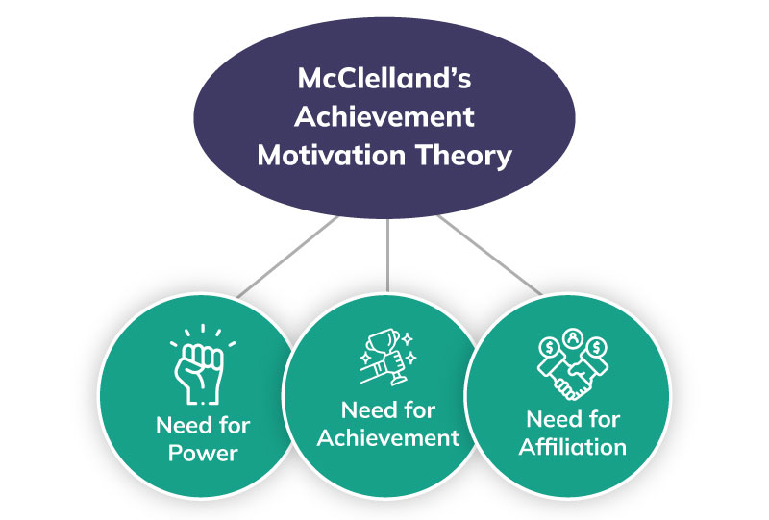
Fig 2: McClelland’s Three Needs Motivation
Source: (Miller, 2022)
This is also mentioned by Siok et al. (2023) in which employees are able to expand their productivity when their power requirements, achievement requirements or affiliation preferences are achieved. However, Guo and Ayoun (2023) argued that contemporary organisational
of Needs in which belongingness helps to exemplify social coordination in the workplace and also prioritise collaborative performances (King and Lawley, 2016).
In understanding McClelland’s Three Needs theory, it can be assessed that the motivation theory identifies the personality of individuals and does not focus on organisational requirements. Although the motivation strategy is important for the development of professional growth factors, application of the determinants can be complicated because personal employee requirements can be inconsistent.

2.3 Theory of Motivation: Herzberg’s Two Factor Theory
One of the excellent motivation strategies which are connected to the human relations approach of Mayo is the two-factor theory of Herzberg. As per the motivation theory, employees are motivated and also exemplify their productivity when there are two significant determinants of motivation: Hygiene factors and Motivators (Bhatt et al., 2022).
For example, motivators are important intrinsic motivation attributes which help individuals to demonstrate higher satisfaction. Presence of recognition, acknowledgement or achievement are important motivator determinants that help to prioritise employee growth and professional development objectives (Ibrahim et al., 2023). At the same time, important hygiene factors such as salary, workplace environment, security and working conditions are important determinants which help to exemplify employee motivation.
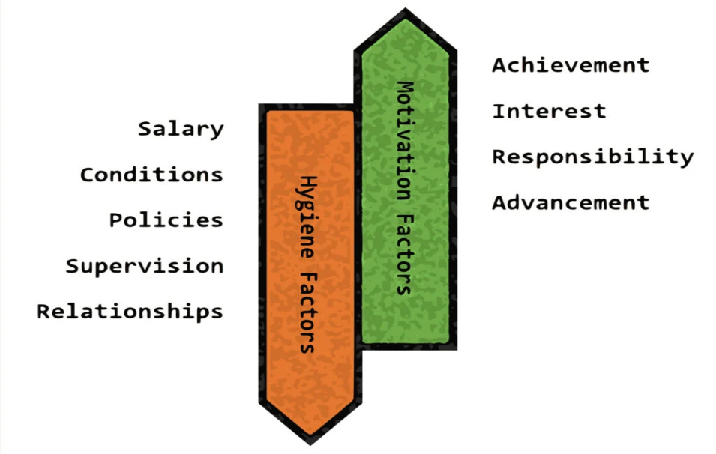
Fig 3: Herzberg’s Two-Factor Theory of Motivation
Source: (Nickerson, 2025)
The theory of Herzberg helps to ensure that two motivation determinants are interrelated and help to prioritise productivity (Siok et al., 2023). The motivation theory argues the conventional job satisfaction approach, primarily where workplace satisfaction and dissatisfaction were connected to external motivation attributes like salary, workplace conditions and supervision (Bhatt et al., 2022).
The theory is imperative because hygiene factors will help an organisation to minimise workplace dissatisfaction and absenteeism. Moreover, motivation factors will be effective in developing engagement, employee retention and fulfilment.

3.0 Evaluation of the Junction Hotel
Junction Hotels’
for customers in 80 minutes is one of the significant targets for employees in Junction Hotel. Important responsibilities such as cutlery formation, decoration of restaurant tables with wine glasses, correct cutlery and napkins are implemented within the requirement. By analysing the operations performances and hospitality functionalities in the organisation, it can be argued that contemporary management practices of Junction Hotel are connected to authoritarian leadership practices and focus extensively on scientific practices. Formation of unrealistic productivity guidelines and individual targets are known to question the presence of leadership practices implemented by Simon Chance and Phil Weaver.
At the same time, there are significant organisational development practices implemented in the Junction Hotel. However, the objectives related to leadership contributions and management endeavours focus on individualising workplace processes. These mechanical factors can be effective for expanding Junction Hotel’s performances but does not implement a human relations approach which will be beneficial for employee growth.
The rational organisational contribution helped Simon Chance to manage restructuring objectives and ensure that authority and excellent governance is formulated. However, implementation of motivation strategies through belongingness, inclusion of employees in decision-making or fostering social motivation strategies have not been prioritised (Refer to Case Study). These are important for Junction Hotel to ensure that informal organisational behaviour, presence of social engagement, and affiliation is fostered.
Besides these strategies, Junction Hotel’s contemporary organisational practices focus on strengthening productivity through delegation. This strategy can be beneficial for developing business growth outcomes but can minimise the internal satisfaction objectives. In contemporary times, the approach of Simon Chance along with Phil Weaver for expanding workforce development is attributable to rational organisation approach. These factors will minimise employee growth objective because there will be an absence of loyalty formation or recognition of intrinsic motivation requirements.
By integration of a human relations approach, Simon Chance can focus on implementing a participative leadership approach that will help the leader of Junction Hotel to recognise the requirements of employees (Siok et al., 2023). This approach will be beneficial for Simon to promote excellent employee relations objectives through open communication, recognising employees’ difficulties and implementing feedback from employees to recognise their contribution.
Expansion of professional growth determinants through incentivisation as well as wellbeing practices through wage policies, social development, and flexible workplace arrangements will be beneficial to promote employee satisfaction and develop collective collaborative practices.
For Simon Chance, developing motivators and hygiene factors through incentivisation, workplace safety, belongingness and feedback are not only people-oriented but are social motivators to promote affiliation. These can become important for the growth of employee development objectives and expand productivity strategies in Junction Hotel (Bransby et al., 2023). Accomplishing loyalty from employees by recognising their challenges are also conducive to excellent participative leadership determinants that can be helpful for Simon Chance to expand Junction Hotel’s performances.

4.0 Conclusion
The report explained important employee motivation strategies of Junction Hotel. The report focused on understanding the contemporary challenges demonstrated by Simon Chance in the company. The report has highlighted employee growth endeavours and also focused on the development objectives. By understanding human relations theory, and important concepts of employee motivation strategies and theories, a detailed understanding of Junction Hotel’s growth determinants and implementation of a human relations approach will be assessed.

5.0 Recommendation
In contemporary organisational practices, social engagement has become one of the significant strategies to expand workplace development. Employee motivation helps organisations to develop their culture, minimise absenteeism and ensure that employee relations factors are present.
To recognise employee development and growth objectives, there is a requirement for comprehensive human relations approach. The addition of employee’s contribution in decision-making and inclusion will be important for Simon Chance to expand productivity. Moreover, the company will also ensure that flexible workplace practices are recognised that will help to improve professional growth outcomes and strengthen team-building objectives.
For Junction Hotel, development of recognition, productivity and reward policies through promotion and incentivisation are undoubtedly efficient for the expansion of Junction Hotel’s performances. However, one

Question 1: Central Tendency Measurement

a) Data Summary
A grouped bar chart is the appropriate way to summarise the communication data since it will allow making a comparison between Postal Services and Telephone Services over the 10-month period. Trends, differences, and fluctuations are easier to identify using graphical presentation than using raw numerical information. Visual summaries are employed in business statistics to assist the interpretation of data by the business before numerical analysis (Sublime, 2022).

Figure 1: Communication Methods Usage Comparison
(Source: Self-created)
Based on the chart, it is possible to make the following observations:
- Most months saw Telephone Services registering a higher level of utilization compared to Postal Services.
- The Postal Services showed rather steady communication rates with minimal changes every month.
- Telephone Services were more fluctuating and it means there is change in the behaviour of communication among the customers.
- There was a slight rise in communication activity towards the later months in Telephone Services.
The graphical summary gives the preliminary information of the communication pattern followed by computation of descriptive statistics.

b) Measures of Central Tendency and Dispersion
Measures of central tendency establish the representative figure of a dataset whereas measures of dispersion establish the separations of the data about the representative figure. All these steps combined offer a full statistical description of the business data, helping managers equip themselves with the same variability and regularity of trends (Choudhry et al., 2024).
Step 1: Arranging Data in Ascending Order
Postal Services
Standard Deviation | 2.00 | 2.47

c) Description and Comparison
The descriptive statistics describe that during the study period; Telephone Services experienced more communication activity compared to Postal Services. This is mirrored in the greater mean (15.1), median (15.5), and mode (17), where the means, median and mode showed that telephone communication was preferred.
Dispersion measurements indicate that Telephone Services had higher dispersion. Range (7) and standard deviation (2.47) are larger than the Postal Services (5 and 2.00), meaning that monthly usage has more variability. The Postal Services was stable indicating that there is a regular pattern of communication. Sampaio et al., (2024) argued that because averages are an incomplete measure of data sets in business, using central tendency measures alongside measures of dispersion would give a comprehensive view of the data.
Telephone Services were more utilised with more variability but less with Postal Services that were more consistent. The results offer valuable statistical data regarding the behaviour of communication and assist managers in making decisions using quantitative analyses (Goudanavar and Sharma, 2024).

Question 2 - Probability
Probability analysis is involved to assess the uncertainty and estimate the probability of business events. A probability tree diagram is used to simplify the sequential events as a probability tree diagram depicts all the possible events and their probability making it simpler to compute joint and conditional probabilities (Sirohi et al., 2026).

Calculations on probabilities show that there was a likelihood of 9.4% of defects. Though AUM defects on an individual basis, Cilico has a proportion of high number of defective products since AUM produces the bulk of it. Probability analysis is of practical help to evaluate the quality of manufacturing and making business decisions in the case of uncertainty (Arroyo Barrigüete et al., 2025).

Question 3 - Binomial Probability
Binomial probability is used in cases where there are two possible outcomes that arise when one or more trials are fixed and the number of such trials is fixed. In this case, a 4-day weekend can either be an accident-free day or occurrence of an accident. Since the probability of an accident (0.25) is a constant and the outcome of each given day is independent, the binomial distribution is suitable in estimating the probability and the financial losses of accidents (Bhaduri, 2025).
Given Information

Question 4 - Hypothesis Testing

Introduction
A
and enhance the quality of decisions.
Statistical methods are getting critical in business analytics to help assess the financial performance and aid strategic planning (Goudanavar and Sharma, 2024). Descriptive statistics are used to summarise data and hypothesis testing is used to ascertain whether differences observed are statistically-significant (Lušjancic et al., 2024).

Process of getting Results
Step 1: State the Hypotheses
Null Hypothesis:

