Blog

From the top of the mountain

Tyrone Hudson
Lecturer: Philip Organ
3D Film Making
L5 - Animation

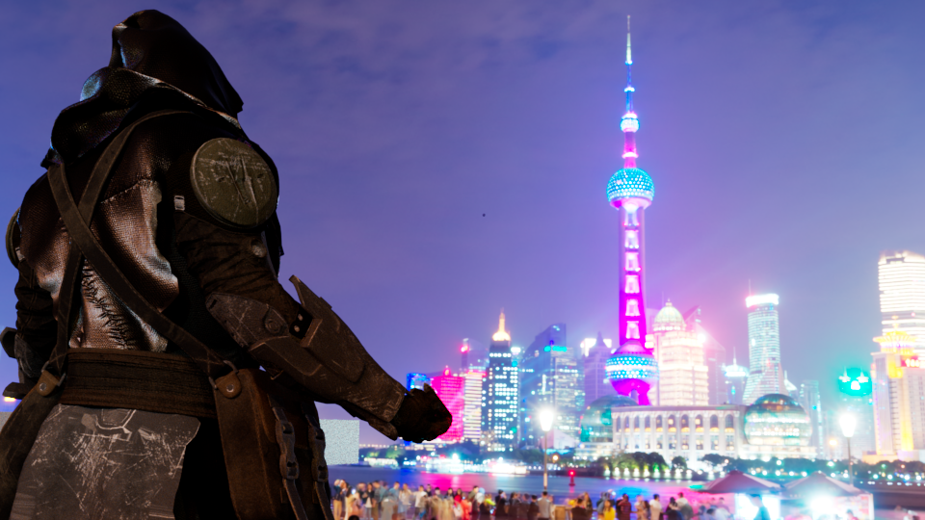

Process
My first step was to create some test poses to see if it would fit in the scene and the 3D environment I am going to be using, in order to do this I took a mannequin and proceeded to do fighting and exaggerated poses to see how far I could stretch realism.

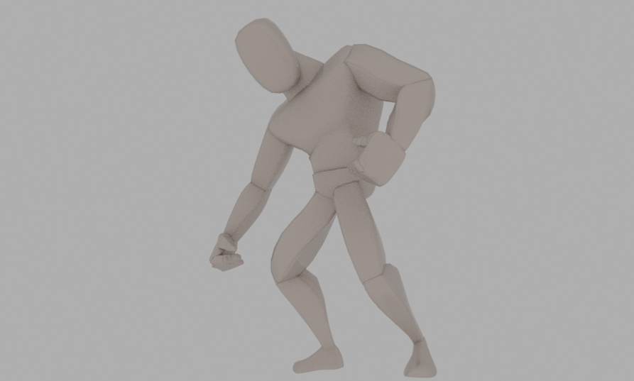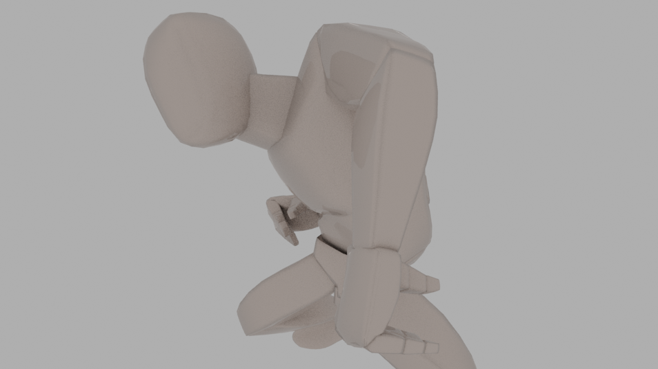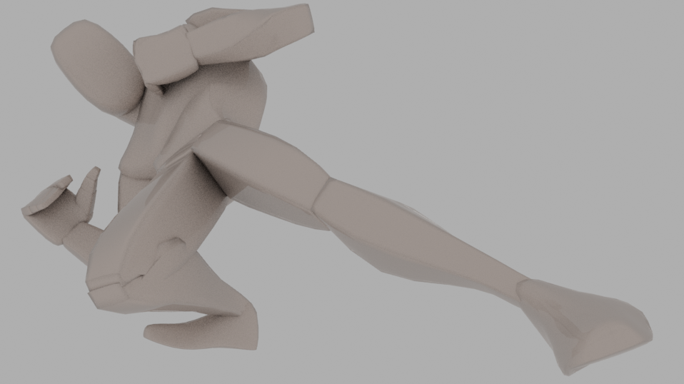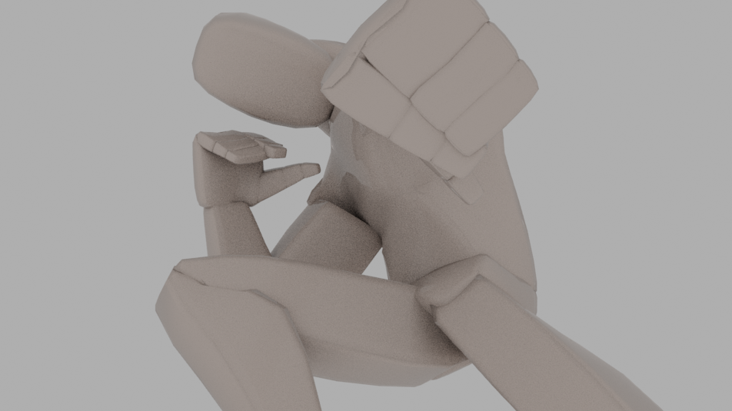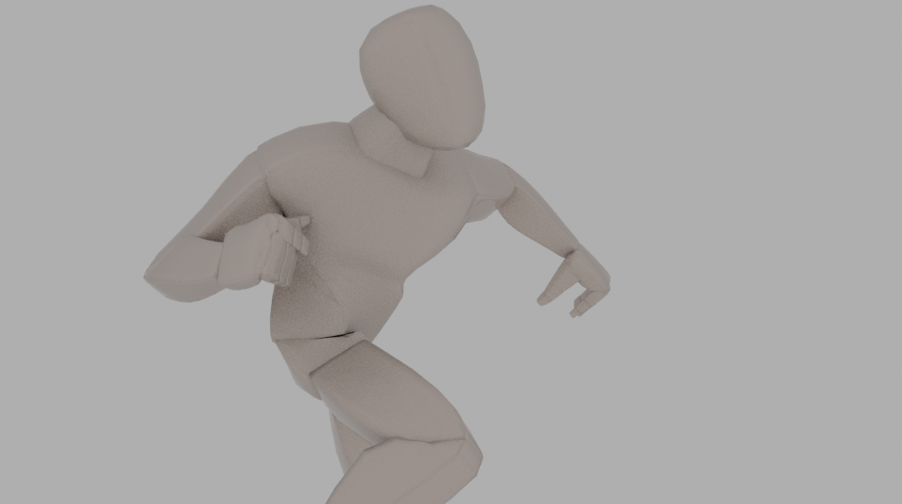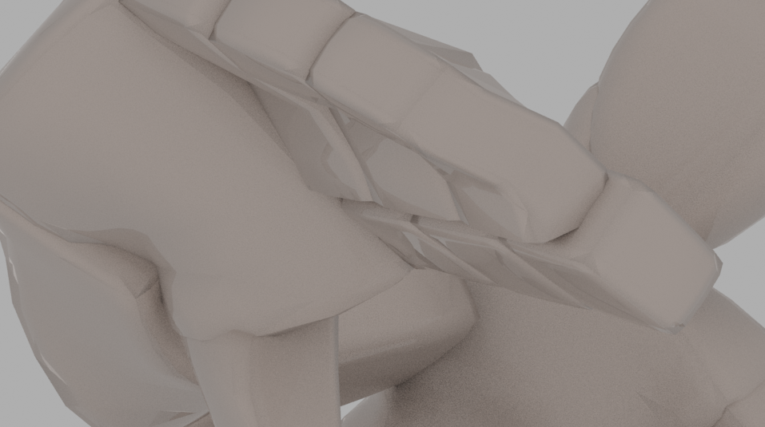

I found that these turned out fairly well in terms of pushing poses and seeing what I can get away with, this was important as I would be doing a lot of different action sequences in my film.

Secondly I put together the TV Show Bible so I can get a better idea of what I wanted to portray in the 3D scene.

For this I made a 10 page Bible showcasing main character plots, synopsis, logline, pilot, episode concepts, future seasons, tone and more.
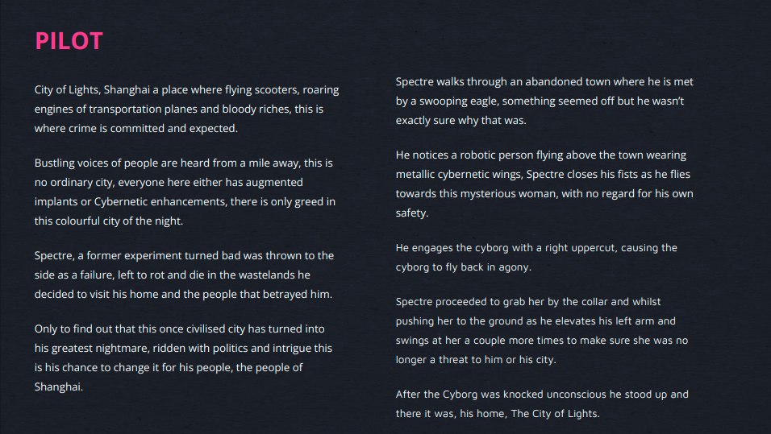
Thirdly I was doing a lot of research into the Neon Dystopia aesthetics, seen in such films as Bladerunner, the research consisted of getting reference imagery of Cyberpunk and Bladerunner.
Example:
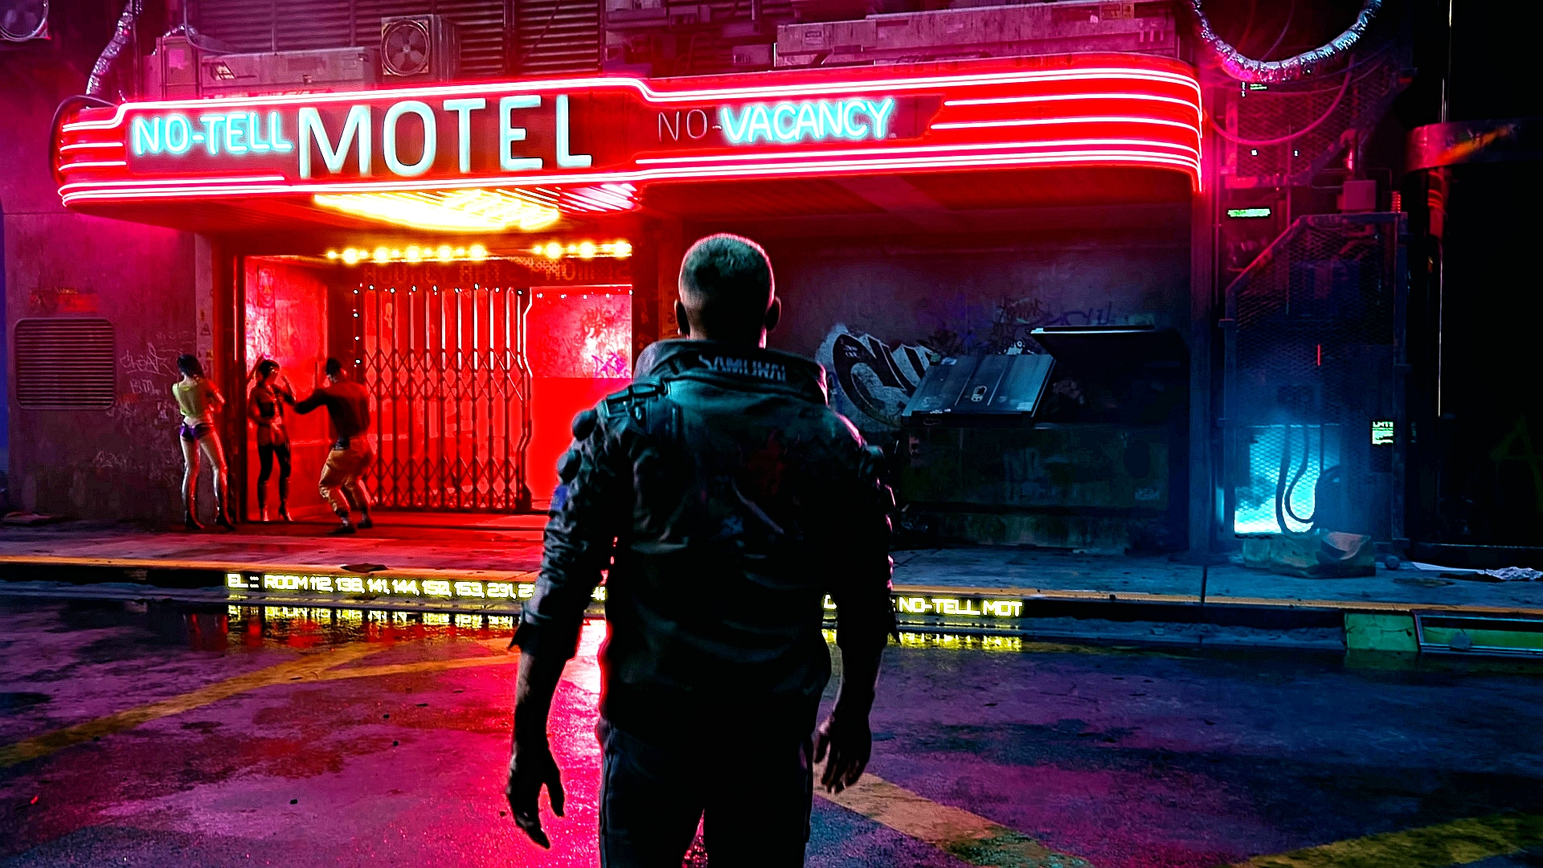

After the reference material was done, I did research into human anatomy and was learning about the different muscles such as glutes, biceps, quadriceps and more, once I learnt human anatomy I started to create a basic human model in Zbrush and rigging it in Maya.
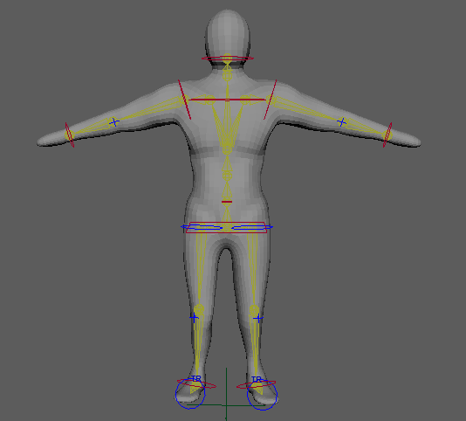
Afterwards I tried my hand at a more complicated model which turned out ok but wasn’t ready for production in a 3D scene, although I did learn a lot from using different tools such as the rake to create effects.
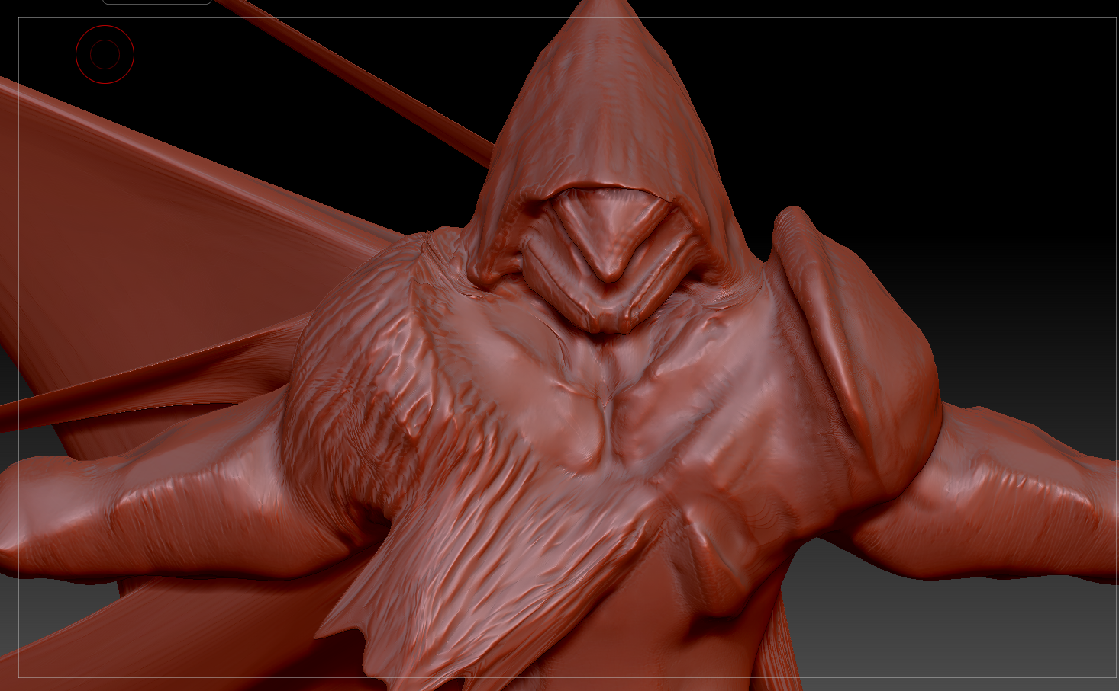

As I wasn’t pleased with the basic Zbrush model I produced, I decided to purchase a pack of characters from CGTrader to use in the 3D Film scene.
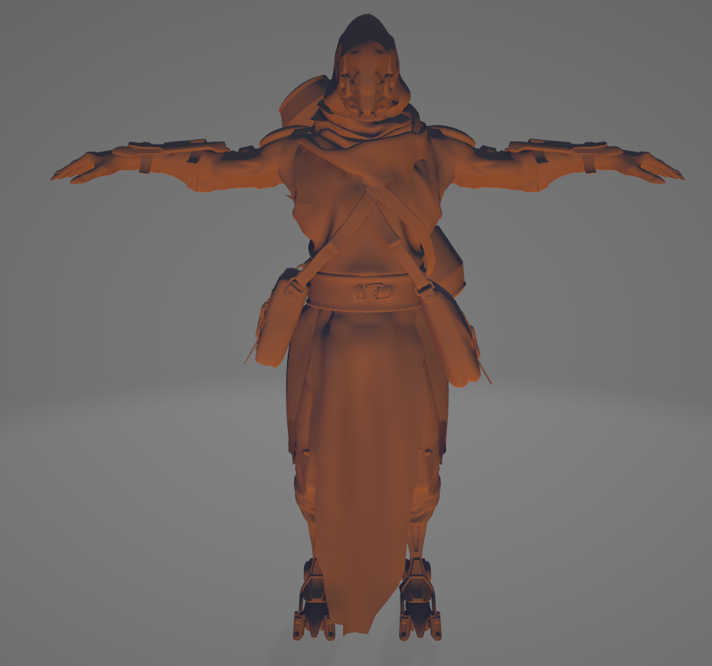
After I had the characters and the environment ready I started to work on the 3D Film scene in Maya, the first step I did was to import the environmental scene that the characters would be acting inside.

Once everything was imported I had to create different light sources such as AiPhysicalSky and use a HDRI Image to replicate the environment where the film is taking place, so it needed to be a bright neon city with tons of lights.

After the HDRI image was set, I then proceeded to manipulate other light sources such as the spotlights and directional lighting, changing the exposure rate, colour, intensity, cone angle and sample rate.
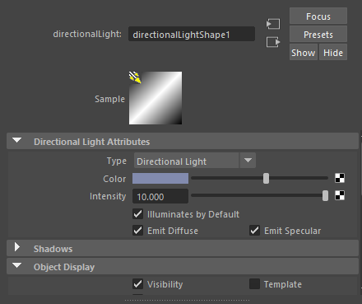
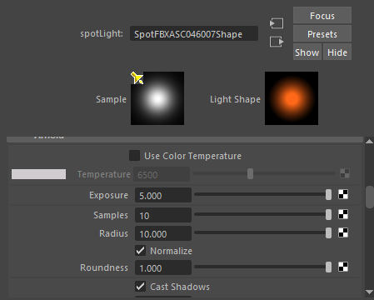
After all the lights was set correctly, I moved on to texture all of the environment and characters using the UV editor making sure the textures were placed properly.

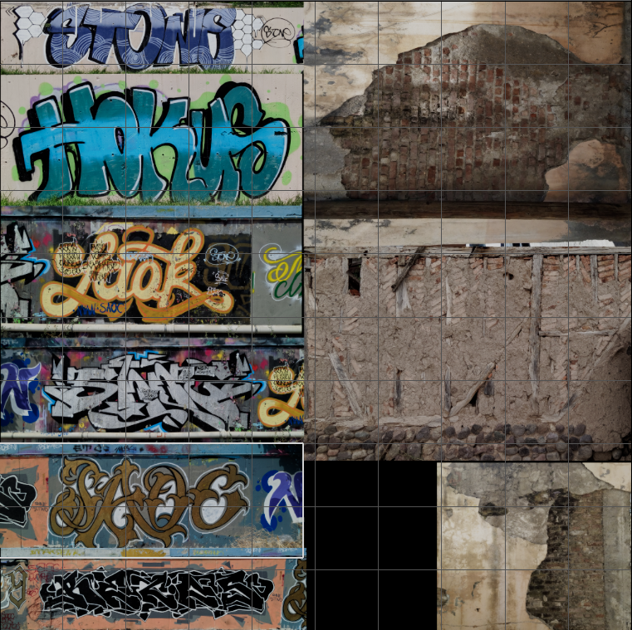

After the texturing process, I changed the reflectivity and spectacular lighting on the textures so it would appear more realistic and constant with the lighting in the scene, this was important because there was a lot of action in the scene so I had to make sure the levels and colour balance was correct so the audience could see what is happening in the film.

I then moved on to readjust any objects in the scene so everything was level and didn’t appear floating or disjointed.
Before:
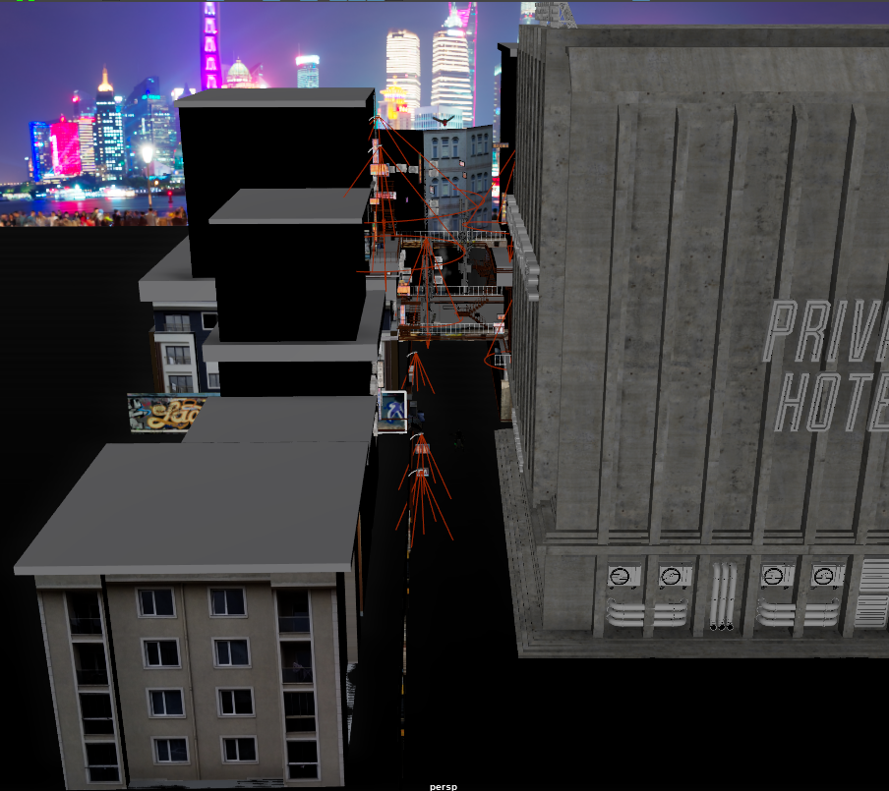
After:
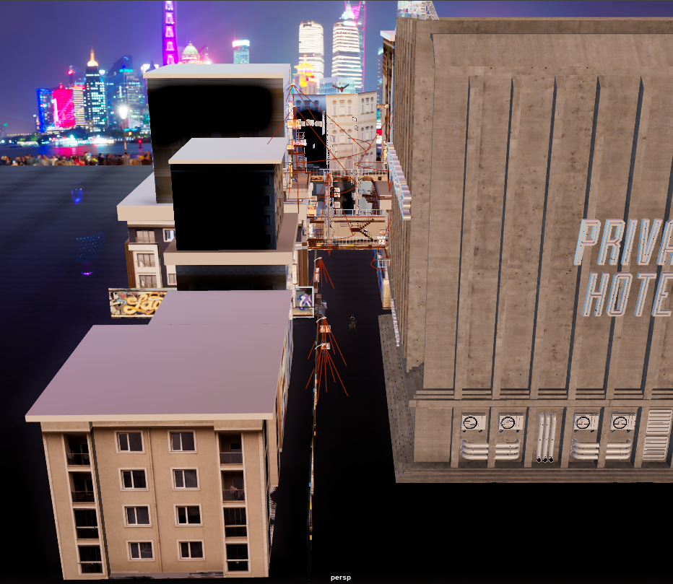
Once all the basic foundation was set in place I then proceeded to start animating both of the main characters that would play a role in the scene, Sceptre and Valkyrie.

I had a hard time animating the movements so I had to refer to a reference sheet of anatomy so the movements were believable to some extent.

I had to rearrange thousands of keys in order to get the exact poses I was looking for in the camera shots and as I was using two different cameras I had to make sure the animations & poses looked good in both cameras.

Example:

The scene did deviate from the original animatic, I had to do this in order to fit the 3D scene and had to compromise with the character rigs so there wasn’t any flapping of long capes.

During the animation I did end up breaking the rig a few times trying to re-align the skeleton but luckily I had multiple back-up saves.

I had to google a fair amount to problem solve the rigs and IK behaviour, this caused an immense slow down in my workflow.

When it came to the animations I wanted to show action and energy in the scene so I chose to do fast keying in order to get that impact from the punches and flight movement.

However while working on the flight movement I had to have pin-point accuracy in the axis so it looked believable, this had me rotating and moving the characters often.

When it came to the camera movements I had to re-align the keys all the time because if one key was off slightly it would cause distortion in the movement and cause nausea, this was very difficult to balance.

Camera timeline:

During the animations I had to make the interactions between both characters feel impactful and meaningful, this required both characters to have a responsive action that could help tell a narrative in the scene.

This was especially important when character two: Valkyrie was using magic to conjure a ball and then beam, this required me to animate the ball simultaneously while she was moving, this animation had a lot of accuracy involved with each keyframe being in the right spot at the exact time as the character was moving.

During the animation when the character shoots a beam of purple void, I had to line it up at the exact moment that character one: Spectre was going to fly into the beam.

In the second half of the scene, I had to make sure the falling scene didn’t look like static character falling, so during this part of the scene I had to keep both character moving in the multiple axis.

This was done by using the first character to push on the body of the female Cyborg to cause gravity and create an on-going animation during the full duration of the falling scene,

This was exaggerated and helped by the movements of character one: Sceptre by having him move both in the X and Y axis with his hands and body motions.

After the landing I wanted the character Sceptre to pan up and look at his city so it could be a leading point for the audience for what is to come.

During the beam scene I moved objects to create a sense of destruction and atmospheric disturbance from the magic.

After all the scenes were complete I hid all of the rigs and created two playblasts from Camera one and Camera two that both had 520 frames each from different perspectives.

I did want to have the whole scene rendered out from both cameras for the quality that I was hoping for, but it would have taken me roughly a week to complete the render.

Once all the frames from the playblasts were done I then moved to Premiere pro to cut the shots and place them in the parts I felt was the best part to do a perspective change in the film, for more dynamic shots.

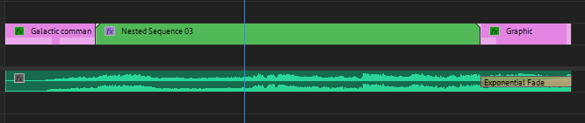

I then added a Fuji film filter to add highlights, contrast, saturation and a vignette around the film to make it appear more as a cinematic.

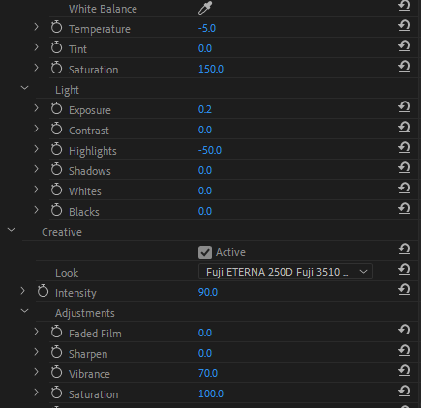

Once all the editing was done I added a title & credits screen with some editorial music to make it appear more professional looking.

After I was happy with the overall outcome I then did a HDR.260 4k export.

The overall design I was trying to achieve with this film is a violent, crime driven dystopian future, similar in sense to Blade Runner 2049, this was one of my big inspirations for creating a 3D film with this style of aesthetic

Another big inspiration for the film concept is from Cyberpunk 2077 taking the overly bright, colour neon theme and robotic, cybernetic and synthetic concepts and applying them to my work.

I felt like I did a good job in conveying those feelings throughout my work and film, although I did deviate from the original animatic source material, I felt like I kept the essence of what made it energetic and action packed.

The key difference between my animatic and the 3D film was the objects and environment which I felt made the film even more dynamic than what it would originally look like in the animatic as It didn't have much going on in the background.

With the huge fire explosion from the animatic I didn’t feel like it was right for a neon dystopia world so instead I went for void magic that acts as a gravity beam to convey more futuristic elements.

Another element of the animatic that I removed was Sceptre falling to the ground with his cloak acting as a glider, instead I replaced it with the two characters falling.

I felt like this was a good change that was coherent with the narrative and was somewhat necessary with having two characters interact in a film.

Another change that happened was with the eagle, instead of going directly past the character into a close-up shot of the eye and transitioning I changed it so the bird was sweeping through the environment and around the character.

I felt like it made the eagle more dynamic in the movement and helped establish identification in the environment that the eagle is moving through.

My over-all animation was fairly solid albeit a little loose at times, my production workflow was fairly straight forward and was easy for me to maintain and keep track of everything, although I did end up losing the reference model I used in the scene.

My animations could definitely do with improving and being a bit more precise in the specific actions and poses but I felt like the animations were understandable.

Looking at the whole work process behind what was involved and what made me change my mind about a few things I felt that it improved the overall 3D film.

A change that I would have made is to make the actions more pronounced so the animations are a little bit easier to read for the audience.

The second change that I would have implemented if I had time was to apply vfx to the beam and environment to make the film come to life a lot more, this would help with the overall world building aspect.

The last change that I would have liked to do is being able to completely finish fully detailed models and render them out at the highest quality possible so the trailer and process involved in the 3D film would look more professional.

Overall I am happy with how everything turned out and I believe that I made the right decisions in changing some aspects from the animatic because I think it benefitted the 3D film as a whole.

I feel like my animation and film production skills have increased a lot from this assignment, my workflow is a lot smoother and the confidence in my abilities to produce a cinematic scene has gone up a considerable amount.

Bibliography

StudioBinder, How to make a TV Show Bible, September 17th 2018, https://www.youtube.com/watch?v=Z56nxVKmwR8&t=251s

Film Courage, 9 Questions Television Writers Must Answer When Developing A Television Show, August, 7th, 2018, https://www.youtube.com/watch?v=X_1JEz24kPA

Little Mountain Animation, New Film Making Tools for Unity, June 29th 2021, https://www.youtube.com/watch?v=7R7_xJGdY8k

MovieMotion, How 3D Animation Is Made for Movies, August 5th 2019, https://www.youtube.com/watch?v=bV-GXz_noJI

CGMeetup, CGI Dreamworks Animation Studio Pipeline, January 4th 2016, https://www.youtube.com/watch?v=ru0tQRJ4qKs

Sir, Wade Neistadt, The 7 Workflows of Professional Animators, February 17th 2021, https://www.youtube.com/watch?v=GMTet6nd_iM

Sir Wade Neistadt, Why I use Maya over other 3D Software, November 25th 2020, https://www.youtube.com/watch?v=qFQFds14i5Y

