MSc Dissertation in Lean and Agile Operations

Charging alternatives for electric battery trucks



Adrian- Gigi Ciacareanu
Student ID: 1710292
October 2022

University of Wales Trinity Saint David

Acknowledgements

Researching and writing this MSc dissertation has been more than a learning journey, and I am appreciative to the many people who contributed to my success.

First and foremost, I want to express my gratitude to my supervisor, Lecturer Andrew Thorn, whose direction and insightful feedback helped me develop my critical thinking skills and improve the quality of my work.

Additionally, I owe a great debt of gratitude to Dr. Kerry Tudor, whose advice greatly aided me in narrowing down the focus of my master's thesis research.

Without the people who took the time to fill out my survey, I would not have been able to collect the information necessary to write this dissertation.

Finally, I'd like to express my gratitude to my family, who has always been there for me emotionally, and to my girlfriend, who has been there to support me and cheer me on at every turn.

Abstract

Freight transport and logistics in urban cities are recognized to contribute to a set of specific urban area problems (e.g. air, visual and noise pollution), and directly affecting the public health. With the increase in environmental concerns along with the aim of improving efficiency of processes, many of the supply chain experts are considering to use electric-powered trucks so that the emission of CO2 can be reduced and efficiency in performance can also be achieved. A literature study, with academic and commercial sources, are used to evaluate the BET. Utilising academic and commercial sources, a literature review is conducted to evaluate the BET. It demonstrates that the BET is divisible into the truck types of Single Unit (N2), Specialise (N2), and Single Trailer (N3). The present BET fleet consists primarily of N2 diesel vehicles that have been converted into BET. Currently, truck manufacturers are developing N2 and N3 BET trucks, however these vehicles are still in the pilot and testing phase. The evaluation of charging methods is also performed using a literature study. It looked at the main charging methods for electric HGV’s which are plug-in, battery swap, catenary, third rail, and wireless charging. Plug-in is most likely to be implemented due to its popularity with electric passenger cars. It charges a truck when they are at a standstill, called stationary charging. The most promising dynamic charging method (charging on the move) is third rail. It has a high probability of being commercially available before 2025 and possesses favourable technological properties, including moderate spatial integration, minimal optical disturbance, and low physical interference.
Therefore, this research is aimed at exploring if charging alternatives for battery powered heavy goods vehicles can sustain an efficient supply chain. Charging infrastructure is defined as a network of charging stations that use a charging method to supply electricity to HGV. For this reason, the researcher has used quantitative methodology and conducted surveys among truck drivers. The result of the study shows that charging alternatives have their own strengths and limitations due to the reason that all the discussed alternatives of charging electric vehicles are in their novel phases and require maturity, modifications, and advancement to flourish. However, as the technology is evolving, days are not far when all of these alternatives will be implemented and highly adopted throughout the supply chain process.
The purpose of this dissertation is to further our understanding of prospective charging solutions for battery-powered HGVs. Due to a lack of specific information, assumptions were developed to clarify the scenario under investigation. When more information about battery-powered HGVs and charging alternatives becomes accessible, additional research is required. In order to establish a carbon-free environment, the supply chain industry and governments around the world should use the conclusions of this study as a guidance.

Table of Contents
Acknowledgements..........................................................................................................iv
Abstract vi
Chapter 1. Introduction 2
1.1 Background of the Study 3
1.2 Problem Statement 5
1.3 Research Questions 6
1.4 Research Aim and Objectives 6
1.5 Significance of the Study 6
1.6 Structure of the Dissertation 7
Chapter 2. Literature review...............................................................................................8
2.1 A Truck Industry Approach 8
2.2 Charging Alternatives 11
2.2.1 Plug-in charging 12
2.2.2 Electric road system 15
2.2.3 Wireless Charging 19
2.2.4 Battery swapping station 20
2.2.5 Third-rail system in Sweden 22
2.3 Financial Suggestions 26
Chapter 3. Methodology 28
3.1 Research Approach 28
3.2 Methodological Choices 29
3.3 Ethical Considerations 29
Chapter 4. Results & Discussion 31
Chapter 5. Conclusion and Recommendations 42
5.1 Conclusion 42
5.2 Recommendations 45
Reference list 47

Chapter 1. Introduction

Energy consumption for heavy-duty vehicles (HGVs) was estimated to be 6 Mtoe (70 TWh) in 2019. Liquid fuels for transportation are the primary transport energy vector in the United Kingdom (UK). The government of the United Kingdom has accelerated the transition away from internal combustion engines (ICE), becoming one of the first countries to ban ICE sales by 2030, beginning with automobiles and light vans. This plan aligns with their greenhouse gas (GHG) emission reduction goals as outlined by the Paris Agreement. To meet these decarbonisation objectives, the government of the United Kingdom has devised a Whole Systems Policy that intends to integrate and aggregate decarbonisation actions across essential industries and energy infrastructure. Without a unified plan that offers clarity on energy network capacity, adaptive capacity, technology readiness, and energy demand predictions for transportation, infrastructure developments run the risk of being inadequate, incompatible, or underutilised. Therefore, it is necessary to establish a viable plan for achieving intermediate carbon targets (de Saxe et al., 2022).
In today’s fast-paced life, vehicles are greatly in demand (Arif et al., 2021). The rise in e-commerce industry has automatically given rise in logistics operation requiring a greater number of large trucks to be functional (Sanguesa et al., 2021). However, as the number of vehicles is growing, it is giving rise to a series of grim and lethal environmental issues. It is mainly because majority of the vehicles have been driven by the non-renewable power sources, i.e., dependent on fossil fuels that make them unsustainable. When transporting goods across borders, large trucks are the most energy-intensive approach due to the need for diesel fuel for powering entire fleet – a major contributor of greenhouse gas emission. At the global level, CO2 emission from trucks accounts for almost 16 per cent of all the emissions associated with transportation. This inferred towards the need for developing alternative for future public transportations with an efficient vehicle management approaches. In this regard, the study of Çabukoglu et al. (2018) has shown that electrification of vehicles tends to have the potential to change current dynamics and solve environmental problems associated with greenhouse gas emission from transportation. As a result, the recent years have witnessed a significant increase in interest towards electric vehicle (Dericioglu et al., 2018).
Consequently, automotive industry is seeking realistic and practical approaches to increase the capacity of battery and develop viable options of recharging. Moreover, the advancement and alternatives in charging options are also needed to be explored since the options available are bound by certain limitation; including, but not limited to, the implementation of effective systems for calculating and predicting energy consumption, effective deployment of charging stations, assessing the potential of deployed systems for predicting and calculating energy consumption on existing electric grids, and requiring new legislative measures for expediting electric vehicles assimilation into transportation structures (Mourad et al., 2021). Several research and reports anticipate that the market for medium- and heavy-duty vehicles will soon be ready for electric vehicles. Future fuel costs were assigned by Löfstrand et al. (2013) to determine the timeline for electric truck adoption on the European market.
With the aim of addressing climate change, it is the need of an hour that complete electrification of the transportation industry must be achieved. The market is witnessing great acceptance and penetration of electric vehicle in the consumer segment of personal vehicles, trucks carrying heavy goods are still relying mainly and largely relying on fossil fuels (Mohammed and Jung, 2021). For a number of electric vehicle users, the main concern is changing interval. The industry has developed two major types of charging alternatives, i.e., conductive and inductive charging. In studies, it has been acknowledged that conductive charging involves physical contact between the charging station and the electric vehicle, while inductive changing alternatives involves wireless infrastructure of charging enabling transfer of charge between car and station without necessitating a physical connection (Karakitsios, Karfopoulos and Hatziargyriou, 2016).

Background of the Study

In the United Kingdom, 90 per cent of the CO2 emission comes from road transportation accounting for more than one-third of the total greenhouse gas emission of the country. According to the investigation conducted by Nicolaides, Cebon and Miles (2018a), approximately 17 per cent of road transport pollution resulting from light-duty freight vehicles, while more than 22 per cent of the transport pollution is resulted from heavy-goods vehicles. Large companies and more than 200 countries have taken the pledge for reducing CO2 emission and thus signed the “Paris Climate Change” agreement. To meet the goals of this document, there is need for significant advances in science and technologies in the area of electric vehicle (Erickson and Brase, 2019a; Erickson and Brase, 2019b).
As the global warming, carbon emission, and oil crises are at their peak all over the world, shifting from internal combustion engine-based vehicles to electric vehicles in the field of automobiles is deemed as a revolutionary change (Mohammed and Jung, 2021). Electric vehicles are considered best alternative because internal combustion engine-based vehicles work primarily oil as its fuel which is one of the crucial reasons for global environmental crisis. The advantages of electronic vehicles are not limited to being an eco-friendly option, it also offers the benefits of high-power density, less moving parts, good efficiency, high starting torque, etc. by replacing ICE from electronic motors like switched reluctance motor (SRM), brushless DC (BLDC) motor, induction motors, DC series motor, or permanent magnet synchronous motor (West, 1994). Electrical batteries are the main source of power in these afore-mentioned motors; thus become energy efficient and eco-friendly.
A charging station plays a crucial role in charging the batteries of these electric vehicles in the shortest amount of time. According to the level of charging, there are different charging stations (Habib et al., 2018). A number of standards coders offer guidelines and voltage level to charge the vehicle as per its rated capacity, such as International Organisation for Standardisation, Society for Automobile Engineers (SAE), International Electromechanical Commission (IEC), Institute of Electrical and Electronic Engineering (IEEE), and International Energy Agency (IEA). However, deploying charging stations for electric vehicle is a challenging in the wake of the fact that there is daily increase in the number of electric cars being functional on the road and accommodating enough electrical power stations is deemed crucial for sustaining this idea. Consequently, there is a constant pressure on the grid for supplying more electrical power that may lead to overloading (Zhang and Gu, 2012) that can further cause issues like voltage fluctuation, decline in reliability and system efficiency, increase in thermal loading, and improper load forecasting despite the fact that forecasting load accurately is very important in the system of electrical distribution so as to determine the amount of power needed to be generated. As we continue to increase the charging stations for electric vehicles, calculating accurate load forecast will tend to become challenging. This signifies towards the need for developing different alternative for changing the electric vehicles in order to overcome the issue of overloading leading other subsequent issues. In the following section, the problem this research is going to be addressing is discussed

Problem Statement

Battery Electric Trucks, in recent years, have become viable, zero tailpipe emission alternatives to trucks that used diesel as fuel. Thereby, several models of electric trucks have been announced and some of them are even launched with different technical specifications. In the wake of the differences in prices, air drag coefficient and range, different alternatives for changing have been put forward. Because of different charging methods for truck powered by electric batteries, there is need for drawing a comparison between different alternatives available for changing electric vehicles; specifically trucks, that are energy efficient and cost efficient. Different manufacturers and specifications of batteries and electric charging systems are used by electric vehicles. Electric automobiles use a variety of charging techniques, including conventional charging and wireless charging. The car must be stationary for this to be possible, and it will take some time for the battery to fully charge. The car can go a specific distance after a full charge in a fully charged state. The vehicle must be recharged in a stationary setting where it can recharge in order to run longer. It can take a lot of time, which will impede movement, and it can be challenging to locate a charging station for every car brand. Although this technology has now developed to include fast charging possibilities, it is still not a complete and hopeful answer to the challenges associated with IC engine vehicles.
Additionally, with the aid of Siemens technology, businesses like Scania produced electric roadways for vehicles like trucks. By touching the pantograph to the overhead cables, this can charge the vehicle. The main flaw is that it can only be used for trucks and not for other compact vehicles. Later, Sweden installed rail lines in the road, accessible to all vehicles by a mobile arm attached to the bottom of the vehicle. The disadvantage of this is that only a certain number of vehicles can be charged simultaneously by this technology, and when the vehicle is stopped, the power source is cut off. One of the recent research studies have indicated that the literature has necessity of research to address the problem linked with charging infrastructure on highways for meeting the demand of electric mobility (Danese et al., 2021). Therefore, the gap in the research is also found in addressing network structure and network design for trucks. Hence, this research work is proposed for helping to overcome these challenges put forward a suggestion for efficient and effective method of charging trucks.

Research Questions

The research questions that this study attempts to answer are as follows:
- Do we have enough charging alternatives available for battery powered HGVs to be used in supply chain process?
- What are the technological requirements for a charging infrastructure, pondering the various charging approaches?
- What charging technique do battery-powered electric trucks need?

Research Aim and Objectives

The aim of this research is linked with exploring if battery powered large goods vehicles can be used in supply chain process or not to achieve efficiency. For this reason, following are the objectives of the research:
- To explore electric road, dynamic wireless charging, battery swapping station, and third rail system in Sweden as the available charging alternatives
- To assess the cost, existing infrastructure, range, and charging time of different methods of charging available for battery operated trucks
- To conduct a survey among HGVs drivers for analysing the acceptability and challenges of adopting electric powered trucks

Significance of the Study

With the advancement in technologies, all businesses and related fields are attempting to improve the performances and achieve efficiency in system. Internet and connectivity have expended the boundaries of trade which implies towards the increased demand of efficient supply chain processes so as to smoothen out the entire operations of trade. In this regard, there are number of options that can be adopted for improving the efficiency, however, this research is specifically focusing on advancement in transportation. With the results of this study, not only the acceptability of battery-operated trucks will be unfolded among truck drivers, but the research is also helpful in revealing the challenges and different alternatives available for overcoming the common challenge. The significance of this study lies in the fact that literature has scarce studies where different changing methods of electric-powered vehicles have been compared and contrast in order to assess the efficient way of conducting supply chain processes.

Structure of the Dissertation

This dissertation is divided into five distinct chapters that are interlinked with each other. The first chapter of this study has explored preliminary information associated with the topic. From exploring background information to significance of the research, this chapter has delivered foundational information to its readers involving aim, objectives, and research questions. In the second chapter, titled Literature Review, previous research studies are explored in order to develop the understanding of charging alternatives available and their infrastructures. From the lens of literature, the first objective of the study has been achieved along with providing the foundation for supporting or rejecting the primary findings. In the third chapter, the methodology of the study has been explored along with exploring critical decision regarding methods of the study. The fourth chapter of the study has presented primary results along with discussion to answer the research question. Lastly, the fifth chapter consists of conclusion of the overall study followed by providing a set of recommendation for a particular method of charging on the basis of its effectiveness in cost, infrastructure, range, and charging time for trucks involved in supply chain.

Chapter 2. Literature Review

As their costs have decreased, demand for electric vehicles has soared. In order to meet the increase in electric vehicles that will be smoothly integrated into future power networks, many new charging stations have been constructed (Wang Tang, and Pan, 2019). In order to reduce emissions from road transportation in the UK by 2050, low-carbon energy sources must be deployed, power networks must be strengthened, alternative heating systems must be installed, and electric vehicle charging stations must be built (Vaughan, 2019). Due to the fact that electric vehicles enable zero emission of greenhouse gases in the environment during the travel, it is very attractive in metropolitan areas. While electrifying goods transportation is a viable option for some near-term solutions, decarbonizing the transportation sector is a long-term goal. Electric freight vehicles minimise the release of toxic pollutants by not producing any emissions at all from their tailpipes. Electric freight vehicles are an appealing option for urban operations due to this characteristic, low operating noise, and straightforward regenerative braking implementation, especially when the required operating range is constrained and predictable (Chaudry et al., 2022). With ranges of more than 200 kilometres on a single charge, electric trucks get better and more efficient with each new generation. Since autonomous trucks are already transporting freight and the industry is anticipated to grow quickly as regulations catch up, autonomy will truly change the game (Monios and Bergqvist, 2019). Hence, following sections are looking at different alternatives available for charging electric vehicles from the lens of past studies.

A Truck Industry Approach

Light-duty electric truck, medium-duty electric truck, and heavy-duty electric truck are the primary categories of electric trucks. Trucks with gross vehicle weights of up to 8,500 pounds or 3,855 kilogrammes and payload capabilities of up to 4,000 pounds or 1,815 kilogrammes are considered light-duty electric trucks. Electric trucks are propelled by battery electric vehicles, hybrid electric vehicles, plug-in hybrid electric vehicles, and fuel cell electric vehicles with a range of up to 150 miles, 151-300 miles, and over 300 miles, respectively. There are numerous applications for electric trucks, including last-mile delivery, long-distance transportation, garbage collection, field services, and distribution.
The global electric truck market is projected to increase at a compound annual growth rate (CAGR) of 45.06% from $1.26 billion in 2021 to $1.83 billion in 2022. In the medium term, the Russia-Ukraine war diminished the likelihood of a worldwide economic recovery from the COVID-19 epidemic. The battle between these two nations has resulted in economic sanctions against other nations, a spike in commodity prices, and supply chain disruptions, which have impacted numerous global markets (Vantage Market Research, 2022).
Government programmes and incentives are anticipated to propel the expansion of the electric truck market. Governments across the globe are introducing new regulations and incentive programmes to boost the adoption of all categories of electric vehicles (bikes, autos, cars and commercial vehicles).

One of the biggest electric trucks manufacturers is Volvo Trucks, a Swedish company that is working relentlessly to develop long-range electric trucks and committed to electrifying half of all trucks sold by 2030. The business is now offering an improved version of the Volvo VNR Electric in North America, with up to an 85 percent improvement in mileage and rapid charging. Roger Alm, President of Volvo Trucks, declared:

“We are determined to lead the transformation of the transport industry. In only eight years’ time, our goal is that half of our global truck sales are electric. The interest among customers is high, and it’s quickly becoming a competitive advantage for transporters to be able to offer electric, sustainable transports. That is very encouraging.” (Salisbury, 2022)

The German truck industry has also shown enthusiasm in the subject, and in the automotive industry, Daimler AG aspires to be a leader in the electrification of short-radius distribution. In addition to its Mercedes-Benz passenger vehicles, Daimler operates a substantial fleet of commercial vehicles. Across its commercial brands, the company manufactures a range of electrified vehicles, from vans to class 8 electric trucks.
Daimler produces the eActros, an electric version of its successful Actros heavy duty vehicle, for the European market. This vehicle has been field-tested by twenty different companies and is available in 18- and 25-tonne capacities. Daimler aims to release the eActros by the end of 2021, once initial testing with customers is complete. Freightliner already manufactures the eCascadia electric heavy-duty vehicle with a range of up to 250 miles and the eM2 electric medium-duty truck with a range of up to 230 miles in the United States. It also manufactures the medium-duty Mitsubishi Fuso eCanter truck for European and Asian markets, which is said to save EUR1,000 in gasoline for every 10,000 kilometres driven (Just-auto, 2021).
In the second quarter of 2018, the recently accessible van for orders in “Mercedes-Benz eVito” will be accessible to acquire. An enormous eSprinter is predicted to release in 2019. The world’s first all-electric truck, eCanter, goes into series production. It is one of the lightweight vehicles and is already accessible to buy. On Mercedes-Benz Citaro all-electric urban bus, a demonstration was made on the latest development status this year. On a large scale, a variety of commercial vehicles are designed by Daimler for utilisation in urban contexts due to the launch of the new eActros in a minimal period (Zeilinger and Wohlfarth, 2018).

In the United Kingdom, Leyland Trucks are leading the transition from conventional fuels to electric propulsion for heavy goods vehicles and the hard work developed the DAF LF Electric, a 19-tonne battery powered truck. During a recent visit at the production facility, Transport minister Trudy Harrison was very pleased about the future plans of the company and also declared that:

“I had the pleasure of test driving their impressive new LF electric truck and seeing first-hand this forward-thinking business lead the way as we commit to making all new HGVs zero emission by 2040.” (Roberts, 2021)

The DAF LF Electric is equipped with an e-motor that produces 335bhp (250kW) of nominal power (496bhp peak) and 1,200 Nm of nominal torque (3,700Nm peak). The battery pack is made of lithium iron phosphate (LFP) and has a gross energy capacity of 282kWh (254kWh effective). This provides the LF Electric with a range of at least 174 miles (280km).
The onboard batteries are composed of lithium ferrophosphate cells. They are made without cobalt or magnesium for environmental reasons and come with a six-year warranty. A unique feature is the integrated charging system. This enables the vehicle to be charged via the grid as well as take a rapid charge. Slow charging (400V AC, 22kW, 3-phase) can charge the battery pack from 20% to 80% in 6.5 hours. A complete charge (from 0% to 100%) takes up to 12 hours. If specialised facilities are available, fast charging the cells (650V DC, 150 kW) takes just 60 minutes to charge from 20% to 80% or two hours to charge completely (Transport Engineer, 2021).

Charging Alternatives

At this point in the project, the literature review demonstrated that there is a major interest in the development of battery electric trucks amongst key players within the heavy goods vehicle industry. The existing interest for electric lorries generates the need for charging alternatives to power the long-haul freight and ensure continuous performance in the supply chain sector. Further on, this paper will examine the types of charging alternatives required to power electric trucks.
When businesses use battery-electric trucks, they eventually have to replace their battery pack because of their heavy use. Because of this, when BET's power supply becomes low, it must be recharged. This dissertation discusses five of the many possible approaches to charging that are currently in use. Depending on the nature of the motion and the means by which the energy is transferred, several charging techniques can be categorised (Fisher et al., 2014).

The charging options are divided into two major technologies: static and dynamic. Dynamic charging is the most helpful technology, allowing cell charging while the vehicle is on the move. According to Omar et al. (2014) dynamic charging reduces the size of the battery needed, decreases range anxiety, and allows the vehicle to continue moving without stopping to recharge. In comparison to constant charging, the lithium battery's lifespan can be extended by using this method. During static charging the vehicle must come to a complete stop so it can be to the charging station via the plug-in cable. All of the charging techniques that will be presented are grid-connected, requiring the batteries to be powered by the grid. The electric grid generates 230 volts of Alternating Current (AC). Notably, a battery can only be (re)charged by direct current (DC), necessitating the use of a converter (Chung, 2020).
The main components of the EV charging infrastructure are charging devices and charging facilities. The two types of charging stations are for use at home and in public. The opportunity charging stations, fast charging stations, and battery swapping stations are additional names for the public charging facilities. In the meantime, there are three types of charging apparatuses: conductive chargers, inductive chargers, and wireless chargers. Below are some of the commonly employed charging systems for electric vehicles that can be divided into the categories of being inductive, wireless, or conductive at public places.
The majority of previous research on electric vehicle charging has been concentrated on static charging stations, swappable batteries, eco-routing of vehicles, or dynamic charging based on static sources. The study conducted by Kosmanas et al. (2018) revealed that dynamic wireless charging of trucks has the potential to eliminate the need for night-time charging of electric vehicles by utilising dynamic chargers that may be positioned on the road to keep the vehicle's batteries charged continually, hence increasing the appeal of electric vehicles. The usage of constant wireless charging may extend an electric vehicle's range and lower the size of its battery pack.

Plug-in charging

The most commonly used charging technique, for both passenger electric vehicles and battery powered truck is embodied by the plug-in system. It is a simple stationary and conductive charging structure which requires a cable connected to the grid that is attached through a connector into the charging socket of the electric vehicle. Daimler, the German truck manufacturer, has built a charging park with an output of 1 Megawatt. The fast-charging stations with a combined capacity of 300 kW for trucks and three more charging stations with a combined capacity of 150 kW for vans (Lambert, 2021).
Interest in powering medium and large vehicles with plug-in methods is growing. These vehicles feature more efficient power transfer systems and emit no exhaust fumes. However, the travel range is reduced and charging time is increased. Recent advancements in battery technology have enabled such vehicles to have a cruise range of 300–500 miles and a charging time of 30 minutes, making them a viable alternative (Osieczko et al., 2021).
This charging option can be used for overnight charging in depots, but it may also be unsafe for trucks when parking in reverse.
Figure 2.1 Plug-in charging system (Kane, 2020)

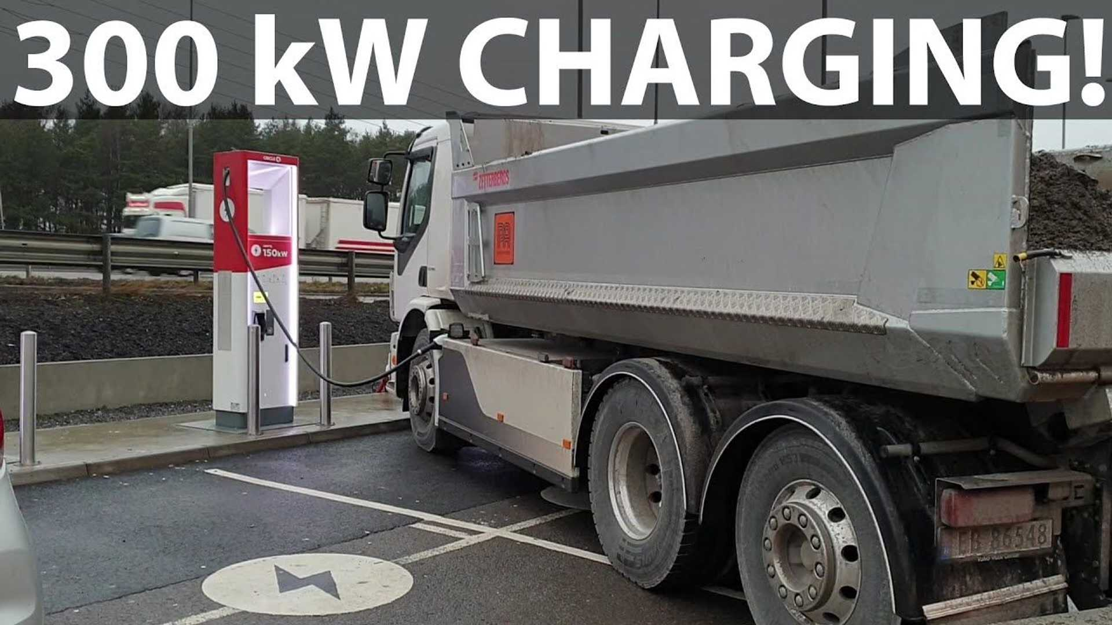

Electricity from the grid is fed into the charging station, which in turn powers the BET. A variety of power levels are available, including slow, public, rapid, highway, and ultra-fast charge for homes. Super-fast chargers are the most powerful plug-in chargers on the market at the moment and can be seen frequently along major highways. Soon, extremely rapid charging at 350–500 kW is expected to become commonplace (Haugen et al, 2022).
To charge the batteries, the AC power from the power grid is changed to DC through a converter. It's up to the user whether they want the converter installed on board or not. When a BET is said to be "on-board," it means that the BET is equipped with its own charger and converter, and that the charging process takes place within the BET itself. This approach is best for low-output charging infrastructure. For rapid recharging, the BET can be charged off-board using an external charger, analogous to a gas station (Bi, Kleine and Keoleian, 2017).

Table 2.1 System features of Plug-in charging
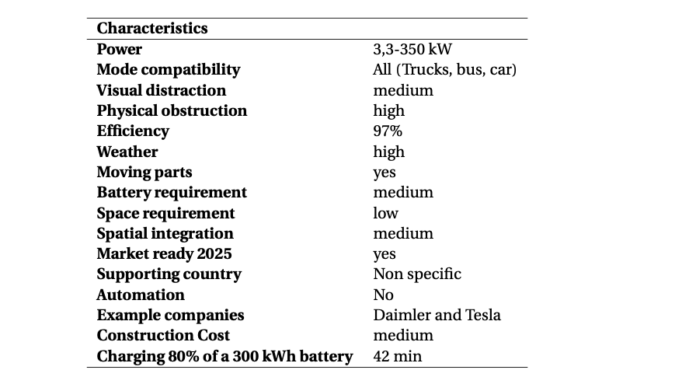

There are three major parts to the plug-in system: a cable with a connector, a charging station, and a converter. The system's design allows for potential application in overnight charging and opportunity charging in the workplace. It is compatible with any transport method. A depot's use of such a system is not without its drawbacks, though. In addition to not being automatic, the free cables can cause accidents. Also, the charging station can be an inconvenience while parking backwards at a station. The research conducted by Chung (2020) revealed that the highest charging power is only 350 kW, therefore it's not terribly fast. Assuming a linear charging profile, it would take 42 minutes to charge an empty 300 kWh to 80%.

Table 2.2 Plug-in system pros and cons
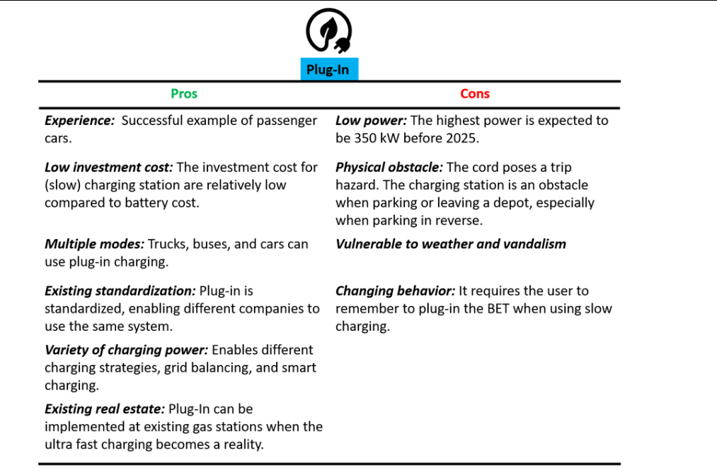

Electric road system

In recent years the United Kingdom has made serious efforts to decarbonise HGVs fleet and become more environmentally aware. The Government has allocated £19.3 billion to build the Electric Road System, an overhead catenary charging mode, which will contribute to a better quality of air and the reduction of gas emissions. It is similar to the system used in the railroad sector, using cables and a pantograph that acts like an electric collector located on the roof of the HGV, through which the battery is recharged. The lorry can easily disconnect from the Electric Road System in order to overtake or complete its route using a separate on-board battery, ensuring that it always emits zero tailpipe emissions (Ainalis, Thorne and Cebon, 2020).
Electrical road systems using conductive methods are more equipped and prepared to handle the power demands of big cargo vehicles, whereas magnetic ERS are often more suited to low-power cars and cannot achieve the same efficiency as conductive systems. Risk assessments were conducted on each technology, with the conclusion that the majority of hazards are low to extremely low'. Conductive rail technologies were intrinsically riskier than conventional rail solutions due to the existence of an open live conductor on high-speed roadways and their impact on road maintenance operations. Concerns emerge regarding the longevity, future maintenance, and safety of any form of device embedded into the pavement structure (Bateman et al., 2018).

Figure 2.2 Electric road system (Gowans, 2021).
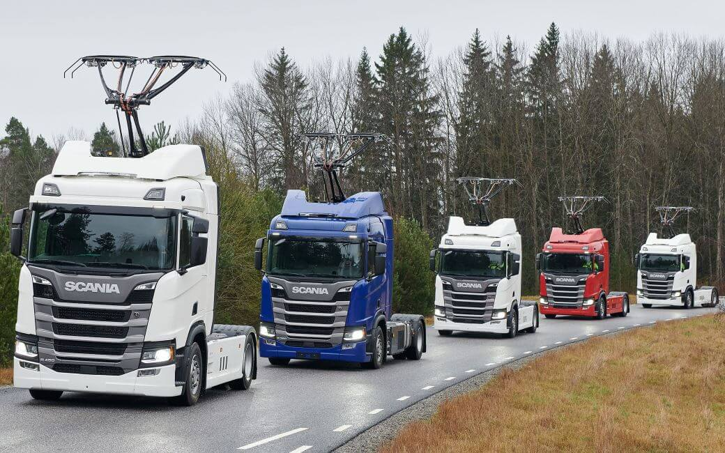

According to Sanguesa et al. (2021) electric vehicles will soon be able to recharge their batteries while in motion. The main objective of the most recent advancement in electrification is to create roads that can charge EV batteries while they are moving or stopped. Reducing the size of EV batteries, making them lighter and more efficient, and reducing the environmental impact of battery manufacturing are some of the objectives of implementing the new electric roads. There are research studies in the literature that highlight certain aspects of effectiveness of electric road system, such as Arif et al., (2021) discussed increase in operational hours and cost effectiveness while Dericioglu et al., (2018) also mentioned that Wireless Electric Road Systems are helpful in accelerating the adoption of electric vehicles along with reducing pollution and congestion on roads. This may include the transfer of power to moving electric vehicles via wireless technology deployed on roads, overhead lines, or rails designed for electric vehicles.
A similar charging method to the existing Electric Road System is in development and it can be done using inductive chargers. This approach is based on a coil embedded in the road surface, and a pick-up coil mounted beneath the vehicle's floor functions as a high-frequency converter. A high frequency transformer supplies power to the roadside coil. The vast distance between the coils (> 10 cm) results in a significant leakage flux, which is mostly compensated for by resonant capacitors. Numerous manufacturers are nearing market introduction, the most significant of which being OLEV (Korea) and Bombardier, which are doing ongoing tests with buses and trams. OLEV operates at a frequency of 20 kHz and claims to be capable of transmitting 60 kW at an efficiency of 80% (Alatalo, 2013).

Coventry City Council in partnership with environmental specialists Ricardo and electricity distributor Western Power Distribution are developing a dynamic wireless charging system in the United Kingdom, for the decarbonisation of heavy-duty vehicles. Denis Naberezhnykh, technical director at Ricardo also stated: “This technology allows electric vehicles to charge their batteries or be powered directly while being driven and would allow vehicles with demanding duty cycles to switch from petrol or diesel to being electric.” (Professional Engineering, 2021)

Governments, authorities, and businesses place a high and strategic value on the electrification of transportation. Researchers and professionals in the field have a number of cutting-edge skills that are pertinent to electrified and environmentally friendly transportation. There is a lot of potential for various electrical road technologies to reduce reliance on fossil fuels, greenhouse gas emissions, air pollution, and noise in urban areas (Mohammed and Jung, 2021). A car that travels on a network of electric roads in the future will have a large driving range, a smaller battery requirement, which means lower costs, and a smaller need to stop and recharge, which increases flexibility (Dericioglu et al., 2018). In a nutshell, an electric road system (ERS), also known as an e-road, e-Highway, or electric road, is a system that enables transfer of power between a moving vehicle and the road on which it is covering distance. Depending on how they are charged, electric roads are divided into three categories: conductive power transfer from roads, overhead conductive power transfer, and inductive power transfer from road.
The overhead conductive technology allows continuous transfer of power via overhead lines to the vehicles by means of pantograph. The research of Sanguesa et al., (2021) has further elaborated that the trucks and buses that can be raised enough to reach the power lines are the best candidates for overhead conductive charging. Additionally, it works better with vehicles that follow a predetermined path so they can maintain a constant connection to the power lines. On the other hand, there is conductive power transfer from the road, which is similar to previously discussed technology with a difference that power is transferred by means of rails to vehicles instead of pantograph which is embedded on or in the road surface. Power is supplied via an on-board mechanical arm. Lastly, in the inductive power transfer from the road, there is no use of wires. Thus power is transferred between coils in the vehicle and coils embedded in the road. High frequency AC power from the grid is transformed to produce a magnetic field, which is then captured by coils under the vehicle to produce voltage.
Batteries are required to be powered by the grid in all charging methods. The electric grid produces an alternating current of 230 volts, and mainly, direct current can only be used to charge or recharge the batteries. Based on the static sources, most of the previous articles on electric automobile charging have been focused on fixed charging stops, excoriating vehicles, and swappable batteries. Dynamic wireless charging of trucks can remove the necessity for the night-time charging of electric automobiles through dynamic chargers (Chlebis et al., 2014). The electric vehicle’s capacity is extended by constant wireless charging and reduces the proportions of its battery pack.
The following battery charging method is classified as dynamic conductive charging, also called the third-rail system. Techniques may also be used for stationary charging, but there are no pilots of it. A conductor rail called a power line is a kind of catenary that is the same as a catenary, but the point of contact is on the road surface in the shape of a rail rather than a conductive wire. In 2010 in South Korea, this concept was introduced for the first time, and other countries like Sweden, China, and Germany quickly embraced this idea. Elonroad and Lund University made the earlier types of dynamic charging systems in Sweden, which required a 56kW battery and 100kW onboard charger to get maximum expertise. The laund truck works at a voltage of 600 DC, having the highest power output of 250kW per car. This truck will be placed on a public road (Arif et al., 2021). The electrified road is the world’s first road launched by Sweden. It recharges the car’s cells and trucks that drive on it. The unique feature of this road is that it recharges the batteries of trucks and vehicles that operate on it. On a public road near Stockholm, approximately 1.2 miles of electric rail have been placed. However, the Swedish Road Agency has previously drawn up a federal map for future growth. By 2030, from the transportation district, 70% of Sweden’s aim of getting fossil fuel independence necessitates reducing emissions. For 20,000 kilometres of road, the fulfilment of this project will cost 7.3 billion euros (Boffey, 2018).

Wireless Charging

Hearing the word “charging” develops the perception of traditional contact-type chargers that requires special plug-in cables for charging the cars in a parking lot. However, there are now different kinds of charging options present, involving wireless charging enabling the batteries to be charged without cables, and swappable batteries that involve replacing fully charged batteries. In dynamic wireless power transfer, devices are used that are embedded in roads, highways, and at city intersections, for charging the cars during driving or parking.
The wireless charging (WC) system is a stationary and dynamic inductive charging technology. Similar to a transformer, WC technology operates on the basis of magnetic inductance and magnetic resonance. A magnetic field is produced by passing an electric current through a main coil (the source), thereby acquiring magnetic inductance. When another coil (the receiver) is exposed to this magnetic field, an electric current is induced in this secondary coil, allowing for wireless power transfer (Maglaras et al., 2015). Magnetic resonance is essential to boost the efficiency at a great distance between the source and the receiver. The magnetic resonance tunes the source coil and the receiving coil to magnetically resonate at the same frequency, hence enhancing the wireless power transfer efficiency.
The Oak Ridge National Laboratory from the United States provided a method for transferring energy wirelessly between two coils that are actually parted by a medium-range gap. Unfortunately, systems based on inductive charging between the network and a moving car might result in power undulations in the vehicle's battery and grid supply. This can result in a decrease in the battery life of electric vehicles and a decrease in the grid's power quality (Lin and Liu, 2021).

Figure 2.3 Dynamic Wireless Charging (Salisbury, 2021)
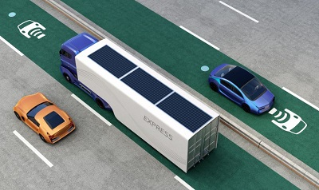

This kind of system reduces the inconvenience to plug in the charger cables and eliminates people from anxiety when their batteries are out of charge. Likewise, as batteries are normally heavy and expensive, some individuals think that large vehicles, involving large buses and trucks, are not appropriate for BEV technology as they need long cruising ranges. However, if this system of dynamic wireless power system is considered, large vehicles that need an increased amount of energy to drive will no longer require to have large capacity batteries and this will help to move more people and things in the future days. Dynamic wireless electric vehicle charging is a promising opportunity as it could be a preferred process that enables power exchange between the grid and the vehicle while it is moving. In this context, mobile energy disseminators (MED) are an emerging concept that can facilitate and extend the range of EVs in an urban condition (Miller et al., 2014).

Battery swapping station

Several scholars have identified the battery swap system as a feasible alternative for battery charging methods. It is a stationary and conductive alternative where the flat battery is replaced by a charged one in the battery swap system. The swap station, which includes the underground device, charging station, supply of extra batteries, and cooling system, is the most important component of a battery swap system. Other components include the battery swap system itself. The BET vehicle's battery is situated underneath the vehicle's chassis. The subterranean switching mechanism is responsible for removing the empty batteries from a BET and replacing it with a fully charged one. The empty battery is stored in a battery stock and charged by the charging system while it is not in use. The cooling system maintains a constant temperature in the battery stock in order to prevent the battery from degrading further (Mullen, 2021).

Rather than charging the batteries rapidly, there is another procedure for refuelling the energy source of EVs. A battery swapping station enables the users to mechanically swap the discharged batteries with fully charged batteries. In this case, all these batteries are owned by the battery company or service station while the EV user is considered to be a battery borrower. The discharged batteries will either be centrally collected or then charged or they are charged at the service station. Mechanical replacement, as well as battery recharging, are involved during the battery swapping procedure, hence it is also called mechanical recharging or refuelling. The qualities of both slow charging and fast charging are combined by these battery swapping stations, namely slow recharging EV batteries during the off-peak period and quick refuelling EVs in a short time. Through the utilisation of robotic machinery, the entire process of battery swapping can be conducted in a few minutes in comparison to the present refuelling procedure of conventional vehicles (Ahmad et al., 2020).
Despite its advantages, many obstacles are present while implementing the battery swapping process practically. Initially, the cost required to set up the system of battery swapping is very high that includes high-quality robotic machinery for swapping the batteries as well as the availability of large numbers of costly batter for required operations. Moreover, Mahoor et al. (2017) claims a necessary space is required to store both fully charged and discharged batteries at the same time and this space must be larger than that of the conventional charging station Furthermore, the EV batteries should be standardised in relation to electrical parameters and physical examination prior to the automatic implementation of battery swapping.
Companies have tried this system before without success. Companies in China have recently demonstrated the system's success with government support. As a result of its design, the system offers significant benefits in terms of both charging speed and initial capital expenditure. Vehicle costs can be reduced thanks to the higher charging speed and the option to lease or purchase batteries separately. Cost of replacement batteries is prohibitive, and users who choose not to lease batteries have no guarantee of a set lifespan for their devices.
Figure 2.4 Battery swapping station. (Allan, 2021)

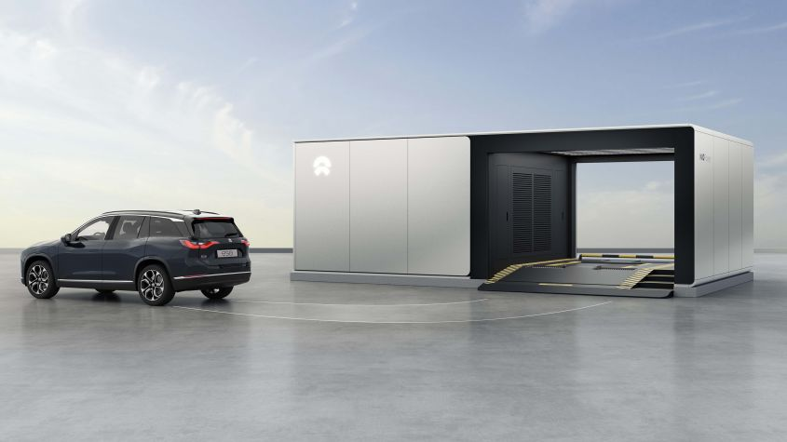

Third-rail system in Sweden

The following battery charging system is also known as the third-rail system and is classified as dynamic conductive charging. It is believed that the method might also be used for stationary charging; however, no pilots or instances of this have been discovered. The power line, also known conductor rail, is a type of catenary that is similar to catenary except that the contact point is on the road surface in the form of a rail rather than an overhead conductive wire. Despite the fact that this concept was introduced for the first time in South Korea in 2010, it was quickly adopted by other countries, including Germany, Sweden, and China, among others. Early versions of the dynamic charging system, developed in Sweden by Elonroad and Lund University, needed a 100kW onboard charger and a 56kW battery in order to achieve maximum efficiency. The Lund track, which will be installed on a public road, will operate at a voltage of 600V DC with a maximum power output of 250kW per car (Wynn-Jones, 2019).
Sweden has launched the world's first electrified road, which replenishes the cells of cars and trucks that drive on it. The road is the world's first electrified road to recharge the batteries of automobiles and trucks that drive on it. Near Stockholm, approximately 1.2 miles of electric rail has been inserted in a public road; nevertheless, the Swedish government's road agency has already drawn up a national map for future growth. Sweden's goal of reaching fossil-fuel independence by 2030 necessitates a decrease in emissions from the transportation sector of 70 percent. According to Boffey (2018) the completion of this ambitious project will stretch over a period of ten years and it will cost 7,3 billion euros for 20,000 kilometres of road.

Table 2.3 Structure features of Third-rail system
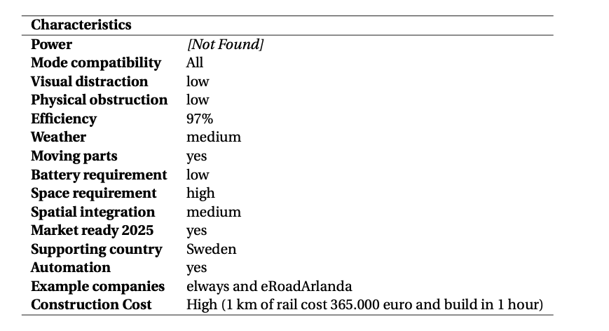

Figure 2.5 Third-rail system in Sweden. (Britton, 2018)
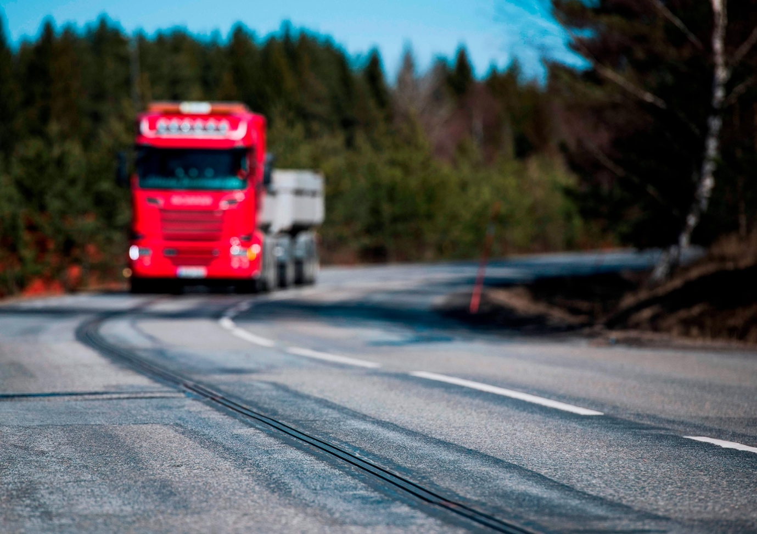

As defined by Moazzami et al. (2018) a third rail system is recognised as a process through which electric power is provided to an electric train via a semi-continuous rigid conductor located between or alongside the running rails of a railway track. In the third rail structure, an additional rail is used, known as the conductor rail, to supply electrical power to the train. In most traction systems, the conductor rail is found near the sleep ends external to running rails; however, in some situations, a central conductor is utilised. Ceramic insulators or insulated brackets support the conductor rail, particularly at every interval of three meters. Following are the advantages of the third rail system over the overhead system:
- The third rail traction system is found to be cost-effective. The overall cost of the third rail is much lesser than that of the overhead conductor. This is due to the reason that no additional structures are needed to carry the overhead contact wires in the third trail system.
- It is less affected by natural disasters.
- The installation of a third rail system is more appropriate in tunnels having smaller clearance as compared to overhead wire systems.
- In the third rail system, the maintenance workload is reduced. This is because the subway third rail does not require to be erected under tension and thus, it is not susceptible to accidents or breakage. Even in failure situations, the reliability is higher while the scope is lesser.
- In the third rail traction system, protective measures can easily be implemented for electromagnetic pollution.
The following points are presenting the disadvantages of the third rail traction system:
- An electrified rail is present in the third rail traction system, making it dangerous for an individual to fall into.
- In the third rail system, there is the risk of pedestrians walking onto the tracks during crossings.
- A practical limitation is presented by the end ramps of the conductor rails on speed because of the mechanical effect on the shoe. Practically, the upper limit in the third rail system is found to be 160 kmph.
- Snow and ice can be accumulated at the top contacts of the third rail systems, leading to interruption of operations.
- Due to the presence of gaps in the conductor rails at junctions and crossing levels, it is the possibility that a train can stop in a position where all its shoes are in gaps so that traction power is not available. During this position, the train is found to be gapped. The following train is required behind the train for pushing it onto the conductor trail or a jumper cable is needed for supplying sufficient power to the train so that one of its contact shoes gets back on the third rail. This provides the minimum length of different units on a line.

Financial Suggestions

Like any other project within a company or the local authorities, the charging stations for electric vehicles and heavy-goods vehicles must be considered as a long-term investment. In contrast to short-term investments, long-term investments cost more, generate more profit for the parties involved within the project, but the profit is generated over a longer period of time. Same financial principles are applied also in the case of the charging stations for electric vehicles.
It is up to the City Council and the companies involved to come up with thorough planning before installing the charging points. The first expenditure associated with the installation charging points is in close relation with the land acquisition cost. A study conducted in 2021 (Kavianipour et al.) in the state of Michigan, United States, has shown that the cost of charging stations is directly linked by the levels of power it generates to charge the battery. Charging stations generating 50kW cost around $92,000 dollars and those generating 150kW are priced at more than $150,000 dollars.
Among the initial costs associated with each charging option will be charger hardware and fitting, any storage or allocated generation equipment, one-time site building and grid connection charges, and one-time software development fees, among others. Maintenance, electricity, demand charges, and labour will all be included in the ongoing operational costs. Compared to DCFC chargers, which range in power from 50 kilowatts to 100 kilowatts and cost anywhere between $15,000 and more than $40,000, level 2 chargers are significantly cheaper, with prices ranging from $2,500 to $5,000 (Furnari et al., 2020).

According to the assumptions, the infrastructure for the initial stage facility, which is expected to hold a maximum of two BETs, will cost almost twice the price of the trucks themselves. According to the assumptions for established sites, the price per charger or installed kW of electricity should be lower in the future. A fleet of 12 BETs fitted with 100 kW chargers would require an infrastructure investment of close to €1.5 million, or around 60% of the truck's purchase price, to be fully operational and profitable. The depreciation term for infrastructure, on the other hand, would be significantly longer than the depreciation period for vehicles (Earl et al., 2018).
The charging stops for heavy goods automobiles and electric automobiles must be treated as a long-term investment by the local authorities or a company (Chlebis et al., 2014). A long-term investment is more costly than a short-term investment, while a long-term investment produces more profit for the parties and is produced over a more significant period. For electric automobiles, similar financial principles can be considered in the case of charging stations.

Chapter 3. Methodology

This section exposes the investigate approach and the methods used in the completion of this dissertation. The methodology consisted in three distinct stages. The initial paragraphs within the literature review considered the contribution of electric HGVs in the reduction of gas emissions. The data gathered from peer reviewed journals acts as a testimony of the active involvement of major truck producing companies in their efforts to develop battery propelled trucks with long-range capabilities.
The research then continued with the evaluation of the charging alternatives, proving the urgent necessity of the proper infrastructure. The data presented in this subchapter was focused on presenting several charging solutions, from the most conventional, such as plug-in charging stations, to the most ground-breaking represented by the dynamic charging of the third-rail system.
As demonstrated in the research of Doyle, Brady, and Byrne, (2016) methodology directly contributes to providing an appropriate response to the research question. Therefore, choosing the appropriate approaches and methods is essential in determining whether or not the research question's response is sufficiently effective. The purpose of this chapter is to introduce the research methodology elements that have been adopted and used by researchers in the pursuit of our goals. First, the research philosophy has been discussed in relation to other philosophies, and then the research strategy, including the research methodologies used, has been elaborated.

3.1 Research Approach

The study's methodologies, according to Teherani et al. (2015), provide a process or plan for particular ways of gathering, analysing, and interpreting data using steps based on general hypotheses. In this sense, the type of research problem that the study is attempting to solve largely determines the research approach that is used. Depending on the aim and purpose of the investigation, deductive or inductive research methodologies are categorically used in research studies (Cavaye, 1996). Using a bottom-up approach, the inductive method progresses from the particular to the overall aspect of the material. According to the study by Doyle, Brady, and Byrne, survey questionnaires are the most common research tool used by scientists who conduct studies using a deductive approach (2016). This study uses a deductive methodology, by recalling the study's goals, which include polling HGV drivers to assess the acceptability and difficulties of switching to electric trucks.

3.2 Methodological Choices

The research's methodological choice is crucial in determining the approach it should take to systematically solve the research topic (Wilson, 2016). Choosing it tends to have a significant role in the research's entire process, given its importance. For researchers, there are generally two options for methodologies: qualitative research methodology or quantitative research methodology. It is advised to employ a qualitative methodological approach when the purpose for the research is only related to narrative, that is, a thorough and full description of the occurrences. On the other hand, it is advised to utilise a quantitative methodological approach if statistical investigation of the phenomena is required. In this wake, the objective of the study is indicating towards quantitative approach to be selected. Therefore, the study has used quantitative methodological choice. In this choice, survey has been conducted among truck drivers which aimed at analysing the acceptance of electric trucks among them along with understanding the challenges they encounter.

3.3 Ethical Considerations

To ensure that any research is valid and authentic for its readers, certain ethical considerations must be kept in mind while conducting the study. Additionally, research studies that do not consider ethical issues while conducting the study are unable to significantly advance the literature. Regarding ethical considerations for quantitative research, the research study has considered to restrain from moulding the survey results and ensured that answers given by the participants are used without any alternation to support the research desire.

Chapter 4. Results & Discussion

The aim of this chapter is to analyse the pieces of evidence used in the research. Therefore in this chapter the results will be described according to the analysis that has been conducted in relation with literature review and the information gathered through the questionnaire- based survey. Furthermore, in the analysis section there will be examinations regarding the anomalies, gaps, identified in the findings of this research.
The methodology chosen for the study is a mix method qualitative research, therefore the systematic literature review mentioned above will be analysed against the survey conducted in the research. The sample size of the survey was medium, since the questionnaire was handed over to 80 individuals in which only 70 responded. The chosen audience as a respondent for the survey were only “driver” as the perspective of drivers on the financial costs, charging times and infrastructure of the batteries and truck delivered insights to the surveyor.
Ethical approach was used while conducting the research, all the names of the participants in the research are kept confidential, and therefore the drivers submitted their survey while maintaining the anonymity. Code of ethics in research is a collection of guidelines and value that organisations and authors use in their research to discern the facts and data. These guidelines provide a basic logical understanding of the results while complying with the ethical standards. The code of ethics involves professional skills, direction, objectivity, integrity and professional conduct. Following mentioned is the information regarding the results that were acquired in the survey.
Following mentioned is the sample size and information regarding it:
Table 1: Sample Size
Employment | Drivers (100%)
Gender | Male (100%)
Age | 20 – 50
Occupation | Driver (100%)

The above information indicates that the participants in the survey were 100 percent drivers in which all of them were employed. However, it is observed that the age range was from 20 – 50, indicating that the range of the age was not particularly targeted, instead it was random. However the sample size indicates that the information or the results gathered from survey could be based on a certain sample size or a certain group of people.
As the survey was a complex mixture of both, open ended questions and close needed questions therefore the answers of the participants in certain area varied, following mentioned is the illustration of the survey through diagrams and charts.

The first question of the survey was projected to discover the respondents’ opinion regarding the future of e-trucks.

Table 2: Future of Transportation

22 out of 70 stated yes, which means that there are expectations from a driver’s perspective to decarbonise the environment and the supply chain fleet.
However, 48 out of 70 respondents suggested that these trucks will not be used for moving heavy good vehicles in the future, indicating that participants experience difficulty with the existing version of the technology. However as mentioned in the research that light duty trucks take for an average 90,000 miles and 20 percent people take more than the 75000 miles averaged in cars indicating that the time consumption is more with the current version of trucks (Overboe, 1987).

In the survey, participants were asked regarding the ‘environment friendly’ impact of the electric trucks, as the drivers were asked whether these trucks are better for the environment or not.

Table 3: Impact on Environment

Above mentioned response indicates that 52 marked ‘No’ as their answer, meaning that the respondents believe that electric trucks are not better for the environment. Only 18 people stated that electric trucks are better for the environment.
Despite the pessimistic answers of the respondents, studies have shown that battery electric trucks solution is the lowest total carbon- emitting option in many regions (Mojtaba, Axsen and Crawford, 2019). Studies undertaken in the United Kingdom have shown that battery electric trucks are the best economical solution to achieve a complete decarbonisation of the supply chain by 2050 (Mulholland et al., 2018).

Table 4: Point and infrastructure, Challenges

Another question pointed to the respondents was regarding the challenges of infrastructure. However the question was a close end one, as the survey aimed at only analysing the impact on the charging station or impact on charging limited alternatives, therefore the result marked that only 50 people out of 70 stated that there are not enough charging stations indicating that the drivers mostly experience issues finding the charging stations to charge the trucks. From a different perspective, 20 drivers stated that the charging alternatives for the trucks are also limited indicating an issue in their specific demographic area due to a reduced number of charging stations.
The adoption and building of a successful BET and charging infrastructure necessitates change, such as journey profile, charging/fuelling moment, and vehicle category. Change has a significant effect on society and the larger environment. Numerous parties can influence or are influenced by the implementation's outcome.
Truck manufacturers must work together with other stakeholders, government representatives and charging point operators, as well as with the so-called e-mobility service providers, so they can all ensure a smooth adoption of various charging methods.
The drivers play an important role in this environmental change, as they are classed as backers because zero emission promise is a must, and they cannot stay behind.
In order to keep businesses up and running, drivers and leadership must put in place an action plan regarding charging times of the battery-powered trucks.
The best alternative to charge a battery powered truck is considered to be overnight charging. It is the cheapest charging alternative and it is usually achieved outside working hours.
In contrast to overnight charging, opportunity charging is usually executed during work hours, when trucks are rapidly charged as much as possible is a short amount of time.

Table 5: HGV fleet replacement

Within the survey, the respondents were also asked regarding the plans of their company for decarbonising the HGV fleet in order to analyse whether it will be replaced with diesel in the future or not. The respondents were given closed ended answer options such as ‘Yes’, ‘No’, or ‘Do not know’. The respondents mostly stated that they are not aware of any plans of the company to decarbonise the HGV fleet, suggesting that the organisations are not working on informing employees regarding the practices and decisions made by the leadership. It also indicates that organisations are focusing on replacing diesel trucks with electric trucks. The responses suggests that 10 responders only stated that their company was not working in this particular project. Lastly only 5 people said that their company was working in replacing the diesel trucks with the electric trucks. The drivers had good reason to be unconvinced about their companies’ plans to decarbonise the HGV fleet and replace it with battery electric trucks, mainly due to the lack on infrastructure around depots and motorways.
To create a culture of change the majority of BET's private charging stations will be placed at depots or at the request of customers. Their ownership, construction, operation, and maintenance will mostly be handled by the carriers themselves. Without a long-term focus, carriers aspire for huge profit margins and can only be enticed to engage in private charge infrastructure and BET through grants from local governments.

Table 6: Preference while purchasing

Question number five of the survey asked the drivers about personal preferences while purchasing an electric truck. The subjects were given three picks to choose from, option number one was “range on a signal charge of the trucks”, the second targeted ‘charging time”, and lastly the ‘price’ of the trucks. However, surprisingly the respondents were more focused on the range on a single charge of the trucks, indicating that the drivers were willing to spend on the trucks. 51 individuals stated that they were concerned about the range on a single charge of the trucks as compared to the prices of the trucks. 12 people stated that they prefer analysing the charging time of the truck which is linked to the ‘range of charging’. Lastly, only 7 people stated that they are troubled regarding the price of the battery powered trucks while purchasing them.

Table 7: Charging points to sustain supply chain

In the above question, the respondents were asked regarding the availability of the charging alternatives in order to sustain the supply chain. Unfortunately, 0 drivers suggested that the charging points were enough indicating that all of the drivers were unsatisfied with the charging infrastructure. As 65 of the respondents stated that there are not enough charging outlets, 5 people on the other hand stated that they do not know if the existing charging points are enough or not. According to study the three major levels of the EV charging points Level 1, Level 2 and Level 3 however the Level 3 is broken into DC fast super charging procedure. Experts suggest that a higher level of charging alternatives leads to faster procedure which leads to more power of the battery that is delivered to the vehicle (Santos, et al, 2022). Although as mentioned above, as well as in the literature review, the current growth rate that only a quarter of the total number of expected public charging stations will be realised by year 2032, which is due to a global shortage of essential raw materials, such as lithium, and other precious metals.

Table 8: Requirement of chagrining points

The next question of the survey aimed to understand the requirement of the necessary number of charging points within depots, warehouses and other facilities engaged in the supply chain. This question was open ended as the participants were given the choice to write down the number on charging points based on their view and knowledge gained through years of experience as HGV drivers. As a results group one of the participants suggested that they need at least 50 charging points in the depot; however the miles, radius or area was not analysed neither revealed as it was considered a ‘rough estimation.’ Similarly, group 2 indicated that the essential number of charging points within facilities must be over 55. However, some of the drivers stated that that they are not aware of the quantity therefore they selected the “Don’t know” option instead of writing a range or number of charging stations. Although it is not clear how many charging stations are required on a city, research showed that London has more than 8600 public charging points installed all over the city.

Table 9: Challenges for driving an electric truck

The last question was focused on the challenges that the drivers are facing when utilising the charging points. In the survey the respondents were given two options to choose from, one of which was infrastructure and the second option was the charging time. The respondents stated that they experience difficulty with the infrastructure more as compared to the charging time. As 55 respondents stated that infrastructure of the electric truck is more challenging due to insufficient number of charging stations serving depots and warehouses, as well as the limited number of charging alternatives, whether static or dynamic. According to experts an efficient supply chain requires the access to adequate charging stations and multiple charging alternatives which is also known as the EVSE (electric vehicle supply equipment). Most of the drivers argue that this initiative with charging the fleet at factories or at the stations, it is considered challenging as not everyone has access to an ESVE (Crawford, 2021). On the contrary according to a research the supporting infrastructure which exists today requires major changes, as it necessitates vast upgrades to be ready for the massive changeover. An environmentally friendly supply chain is far from being a feasible alternative to the existing conventional fossil fuel due to the inadequate charging infrastructure for battery powered trucks, the risk of overloaded grids, the financial considerations and also due to shortages of critical minerals needed to produce the batteries.
In the first question of the survey the participants were mostly inclined to answer that the electric trucks are not the future of transportation due to the issues experienced by the lack of infrastructure in terms of charging alternatives and the cost of production regarding the electric trucks. Although, as suggested in the literature review the change from fossil fuel powered trucks to battery electric trucks will reduce the costs associated with maintenance of trucks. In other words the soaring cost of diesel fuel will be eliminated and also the maintenance cost when repairing the diesel engine of a conventional truck. In most cases electricity is considered significantly cheaper as compared to the estimation of the diesel fuel. Therefore focusing in the four themes such as the financial costs of the electric truck, cost of its infrastructure, industry and charging times. The results indicate that the electric trucks are more cost effective in contrast to the diesel trucks. As the drivers stated that electrical trucks are not better for the environment, some the participants agreed to the facts that it is better, however most of the participants stated that the electrical trucks are not better for the environment, the research indicates that the raw materials that are used in the research could be problematic for the environment. For instance, there are many batteries and material used in the electrical car such as the rare earth metals, the lithium ion cells, and various other elements these have been associated with grave environmental negative impacts and hazards on the earth and is considered against the human rights as well. Some scholar’s specifically criticises the use of cobalt in the infrastructure of the batteries (Elavarasanet al, 2022). However this is not the prime cause of drivers does not see it as the future of truck industry. Therefore, the drivers stated that electrical truck is not safe for the environment, side from being cost effective the electrical trucks are not as eco-friendly as they are claimed by the experts (Sandeep Kumar, 2022). In the survey question, the respondents stated that the major issue with the electrical car is not the financial costs, or infrastructure but the issue which is costly and commonly experienced by the drivers is ‘not enough charging station.’ The reason of less charging stations is due to the global shortage of the charging points, the market industry has an interdependence between the market of EVs along with the investment of charging infrastructure. However the driving alternatives are known to affect the life of the truck batteries, aside from it there are various other significant factors which can have an impact on the truck charging methods. Furthermore most of the employees were not aware of the fact that whether their companies are focusing on moving towards the electrical trucks instead of the diesels ones. However only some of the employees stated that their companies are moving towards the electrical truck approach indicating that the companies are also analysing the costs and benefits of the truck. Although one question confirmed that the drivers are not concerned of the prices of the trucks as well, on the contrary they are more concerned of the charging range in a single charge is supposedly less as compared to the needs of the driver. Therefore the issue drivers experience is mainly based on the usability, and the charging range of the electric trucks.

Chapter 5. Conclusion and Recommendations

5.1 Conclusion

In this master project, the author reiterated the vital interest in the advancement of battery electric trucks. For electric lorries, the existing awareness gives rise to a variety of charging alternatives to power the large-haul freight and assure consistent performance in the supply chain sector. Furthermore, this dissertation will review the different charging alternatives needed to power the electric trucks. As discussed in the literature review chapter there are two leading technologies of charging options, i.e., static charging and dynamic charging. In static charging, the machine must come to a full stop so that it can be at the charging point using the plug-in cable, while dynamic charging offers a unique feature that permits the cell to be charged during the movement of vehicles. It is one of the most convenient technology.
Any of these technologies can be present on a road that a car or truck is travelling on, and the energy may either be used to power the propulsion system directly or to recharge the on-board batteries. The vehicle may switch to an electric, hybrid, or internal combustion engine once it is on a normal road, though. Although there are some pilot projects being conducted in partnership with automakers, research institutions, governments, and energy companies, the use of electric roads is currently quite limited. Insofar as they offer a cleaner alternative to combustion engines, electric roads are advantageous—especially if the energy used is obtained from a renewable source like wind or solar. Electric roads are also quite effective for conductive charging. But the benefits of using electric road systems pretty much stop there. Almost all diesel substitutes have a long way to go before becoming widely used, but many have advanced much further than ERS. With the exception of the pantograph, which is an old technology (100 years), there is currently a lack of real-world data to support its dependability, and all other charging types are new, developing technologies.
Based on the results, stationary catenary appears to be the most effective way for charging at a standstill (when a BET is at a complete stop). Using overhead cables and pantographs, it supplies the most power of any charging technique to a halted BET. When a BET is in motion, third-rail charging offers the most promise as a dynamic charging approach. To power a moving BET, this system uses a rail laid along the roads. All of the dynamic charging techniques have been tried out by the Swedish government, but third-rail has gotten the most attention. The widespread adoption of plug-in charging technology for passenger vehicles has made it the most visible and widely used charging method. While plug-in technology may not hold the most promise for BET, it will be widely adopted in early charging infrastructures and so serves as a useful reference point.
As mentioned above the requirement of the results indicated that the participants are experiencing difficulty with the electrical trucks due to the limitation of the charging points and the cringing range of the trucks, however the less explored area in the research was the difficulty experienced by the infrastructure which requires further investigation for future implications. In terms of costs the truck powered batteries could be feasible however the charging range and limitation of charging points affects the usability of the trucks. The previously suggested conductive or inductive charging techniques may not be acceptable for heavy-duty EVs running on tight schedules. These cars require their batteries to be charged quickly, hence very high charging levels are necessary. Inductive charging technologies have not yet evolved to handle such high-power requirements. Despite the fact that conductive charging can sustain very high charging power levels with DC fast charging, batteries get overstressed, resulting in performance deterioration and a loss in cycle life. Another advantage of battery swapping is the ability to use the batteries at swapping stations as grid support units, supplying electricity to the grid during peak hours and charging during off-peak periods. Currently, there are various obstacles to adopting battery switching, such as infrastructure, interchangeability, practicality, and battery ownership.
Currently, there are various obstacles to adopting battery switching, such as infrastructure, interchangeability, practicality, and battery ownership. When opposed to conductive or inductive charging, swapping stations need a far more complicated and extensive infrastructure. Each charging station necessitates a substantial amount of storage space, which may be difficult to come across in some regions. Furthermore, battery swapping stations place a significant strain on the grid and may necessitate the installation of new distribution equipment, such as transformers. Different manufacturers have their own battery system designs, which may cause interoperability and practicality concerns when replacing batteries. Another issue that may become an extra burden to the substituting station is the ownership of the battery under the exchanging arrangement. Nonetheless, new business models are being created to bypass these constraints and promote battery switching.
However, it is also explored in this study that e-Highways are highly priced. Setting up the infrastructure for charging requires a considerable investment in planning the layout of the roads, setting up the electricity lines, and maintaining them. Additionally, they have the potential to significantly disrupt current traffic flow while infrastructure is being updated. A conductive overhead system might take 1 month to install 10 kilometres, while a dynamic inductive system would take 3 weeks to install every 100 metres. If ERS construction took place at the same time as scheduled maintenance, disruption could be reduced, but the speed at which the technology could be implemented would be severely constrained. The complexity of ERS also means that many actors including governments, municipalities, power suppliers and freight companies would have to work together. It would also require some cross-border cooperation in places like the EU where trucks traveling across the region would need to be adapted with the same technology to make use of the roads.

The earlier mentioned conductive or inductive charging techniques might not be appropriate for heavy-duty EVs operating on tight schedules. These vehicles need to charge their batteries quickly, necessitating the use of very high charging levels. Technologies for inductive charging have not yet developed to handle such high-power levels. Even though DC fast charging is capable of handling very high charging power levels with conductive charging, overstressed batteries experience performance loss and cycle life reduction. Battery swapping, which involves replacing a depleted battery with a charged battery, is a promising solution for these applications. Robotic arms have been built into battery swapping stations to automate the process and cut the time needed for swapping to a few minutes. The ability to use the batteries at swapping stations as grid support units, where they could power the grid during peak hours and charge during off-peak hours, is another benefit of battery swapping. Implementing battery swapping currently faces obstacles related to infrastructure, interchangeability, feasibility, and battery ownership. However, a number of business models are currently being created to get around these restrictions and encourage battery swapping.

5.2 Recommendations

In order to provide a sustainable and long-term solution for the charging alternatives for battery powered HGV’s, this study suggests a series of recommendations based on cost effectiveness, charging times of the battery and infrastructure related costs:
- For the increased cost and the financial implications calcium ions can be used as an alternative solution to lithium, as it is less expensive. (Durmus, et al, 2020).
- Charging times is a global issue, as the current studies show there are no effective immediate solutions to the problem, however keeping the batteries warm could reduce the side effects. Furthermore the experts suggests that rapid charging affects the EV battery therefore avoiding these actions also increases the battery life.
- Lastly, the grid managements and charging infrastructure is the issue often experienced by the people, therefore different manufacturers have their own battery system design, which may cause interoperability and practicality concerns when replacing batteries. Another issue that may become an extra burden to the switching station is the ownership of the battery under the exchanging arrangement. Nonetheless, new business models are being created to bypass these constraints and promote battery switching. Improve battery recycling so that the costly metals used in electric car batteries may be reused, making them more environmentally friendly. Ceramic or other solid electrolytes are used in solid-state batteries to improve energy density and charging speed.
If zero-emissions vehicles are to be widely adopted after 2025, then further study is needed to determine what kind of charging infrastructure is practical. Alternate choices may emerge as a result of the lightning-fast pace of technological development. Future research needs to contemplate the many applications for charging infrastructure. There is a possibility that businesses will prefer overnight charging to opportunity charging.
The demand curve can be smoothed out over time and a large demand peak can be avoided with the use of smart charging, an adaptive method that economically regulates the charging of BET. This reduces the cost of fortifying the power grid and the likelihood of power outages.

Reference list

- Ahmad, F., Saad Alam, M., Saad Alsaidan, I. and Shariff, S.M., (2020). Battery swapping station for electric vehicles: opportunities and challenges. IET Smart Grid, 3(3), pp.280-286.
- Ainalis, D.T., Thorne, C. and Cebon, D. (2020). Decarbonising the UK’s Long-Haul Road Freight at Minimum Economic Cost. [online] The Centre For Sustainable Road Freight. Available at: https://www.csrf.ac.uk/wp-content/uploads/2020/11/SRF-WP-UKEMS-v2.pdf [Accessed 5 Mar. 2022].
- Alatalo, M. (2013). Pre-study of Charging Connections- Convenient charging while parked. [online] Gothenburg: CHALMERS UNIVERSITY OF TECHNOLOGY, pp.11–19. Available at: https://publications.lib.chalmers.se/records/fulltext/181794/181794.pdf [Accessed 6 Mar. 2022].
- Allan, L. (2021). NIO and Shell sign agreement for battery swap stations. [online] Auto Express. Available at: https://www.autoexpress.co.uk/nio/356687/nio-and-shell-sign-agreement-battery-swap-stations [Accessed 6 Mar. 2022].
- Arif, S.M., Lie, T.T., Seet, B.C., Ayyadi, S. and Jensen, K., (2021). Review of electric vehicle technologies, charging methods, standards and optimization techniques. Electronics, 10(16), p.1910.
- Bateman, D., Leal, D., Reeves, S., Emre, M., Stark, L., Ognissanto, F., Myers, R. and Lamb, M. (2018). Detail of a publication | Virtual Library of PIARC | Electric road systems: a solution for the future? [online] piarc.org. Available at: https://www.piarc.org/en/order-library/29690-en-Electric%20road%20systems:%20a%20solution%20for%20the%20future.htm?catalog&catalog-size= [Accessed 5 Mar. 2022].
- Bi, Z., Kleine, R. and Keoleian, G.A. (2017) ‘Integrated Life Cycle Assessment and Life Cycle Cost Model for Comparing Plug‐in versus Wireless Charging for an Electric Bus System’, Journal of industrial ecology, 21(2), pp. 344–355. Available at: https://onlinelibrary-wiley-com.ezproxy.uwtsd.ac.uk/doi/full/10.1111/jiec.12419 [Accessed 12 Aug. 2022]
- Boffey, D. (2018). World’s first electrified road for charging vehicles opens in Sweden. [online] The Guardian. Available at: https://www.theguardian.com/environment/2018/apr/12/worlds-first-electrified-road-for-charging-vehicles-opens-in-sweden [Accessed 6 Mar. 2022].
- Britton, B. (2018). This eRoadArlanda is an example of a sustainable and cost-effective solution to enable the electrification of existing commercial roads. [online] CNN. Available at: https://edition.cnn.com/2018/04/26/motorsport/sweden-electrified-road-intl-spt/index.html [Accessed 6 Mar. 2022].
- Çabukoglu, E., Georges, G., Küng, L., Pareschi, G. and Boulouchos, K., 2018. Battery electric propulsion: An option for heavy-duty vehicles? Results from a Swiss case-study. Transportation Research Part C: Emerging Technologies, 88, pp.107-123.
- Cavaye, A.L., 1996. Case study research: a multi‐faceted research approach for IS. Information systems journal, 6(3), pp.227-242.
- Chaudry, M., Jayasuriya, L., Blainey, S., Lovric, M., Hall, J.W., Russell, T., Jenkins, N. and Wu, J. (2022). The implications of ambitious decarbonisation of heat and road transport for Britain’s net zero carbon energy systems. Applied Energy, [online] 305, p.117905. Available at: https://www.sciencedirect.com/science/article/pii/S0306261921012186 [Accessed 5 Mar. 2022].
- Chlebis, P., Tvrdon, M., Havel, A. and Baresova, K., 2014. Comparison of standard and fast charging methods for electric vehicles. Advances in Electrical and Electronic Engineering, 12(2), pp.111-116.
- Chung, E. (2020). Feasible charging infrastructure for battery electric trucks in Amsterdam. [Master Thesis] pp.11–28. Available at: http://resolver.tudelft.nl/uuid:581b063f-d892-4899-b72c-e7215470ef39 [Accessed 5 Mar. 2022].
- Crawford, K., 2021. The atlas of AI: Power, politics, and the planetary costs of artificial intelligence. Yale University Press
- Danese, A., Garau, M., Sumper, A. and Torsæter, B.N. (2021). Electrical Infrastructure Design Methodology of Dynamic and Static Charging for Heavy and Light Duty Electric Vehicles. Energies, [online] 14(12), p.3362. Available at: https://www.proquest.com/docview/2544975740?accountid=130472&parentSessionId=q%2BnM9B0bKsrZvb%2BbGfhFih2xFa48KV4vrcr9pOqNie4%3D&pq-origsite=primo [Accessed 7 Mar. 2022].
- Danese, A., Torsæter, B.N., Sumper, A. and Garau, M., (2022). Planning of High-Power Charging Stations for Electric Vehicles: A Review. Applied Sciences, 12(7), p.3214.
- de Saxe, C., Ainalis, D., Miles, J., Greening, P., Gripton, A., Thorne, C. and Cebon, D. (2022). An Electric Road System or Big Batteries: Implications for UK Road Freight. SSRN Electronic Journal. doi:10.2139/ssrn.4194379. Available at: https://papers.ssrn.com/sol3/papers.cfm?abstract_id=4194379 [Accessed 21 Sep. 2022]
- Dericioglu, C., YiriK, E., Unal, E., Cuma, M.U., Onur, B. and Tumay, M., 2018. A review of charging technologies for commercial electric vehicles. International Journal of Advances on Automotive and Technology, 2(1), pp.61-70.
- Doyle, L., Brady, A.M. and Byrne, G., (2016). An overview of mixed methods research–revisited. Journal of research in nursing, 21(8), pp.623-635.
- Durmus, Y.E., Zhang, H., Baakes, F., Desmaizieres, G., Hayun, H., Yang, L., Kolek, M., Küpers, V., Janek, J., Mandler, D. and Passerini, S., (2020). Side by side battery technologies with lithium‐ion based batteries. Advanced energy materials, 10(24), p.2000089
- Earl, T., Mathieu, L., Cornelis, S., Kenny, S., Calvo Ambel, C. and Nix, J. (2018). Analysis of long-haul battery electric trucks in EU Marketplace and technology, economic, environmental, and policy perspectives. In: European Federation for Transport and Environment (T&E). 8th Commercial Vehicle Workshop.
- Elavarasan, R.M., Pugazhendhi, R., Irfan, M., Mihet-Popa, L., Khan, I.A. and Campana, P.E., (2022). State-of-the-art sustainable approaches for deeper decarbonization in Europe–An endowment to climate neutral vision. Renewable and Sustainable Energy Reviews, 159, p.112204
- Erickson, L.E. and Brase, G. (2019a). Reducing greenhouse gas emissions and improving air quality: two interrelated global challenges. 1st ed. [online] Boca Raton, Fl: Crc Press, Taylor & Francis Group. Available at: https://www.taylorfrancis.com/books/oa-edit/10.1201/9781351116589/reducing-greenhouse-gas-emissions-improving-air-quality-larry-erickson-gary-brase [Accessed 4 Mar. 2022].
- Erickson, L.E. and Brase, G., (2019b). Paris Agreement on Climate Change. In Reducing Greenhouse Gas Emissions and Improving Air Quality (pp. 11-22). CRC Press.
- Fisher, T. M., Farley, K. B., Gao, Y., Bai, H., & Tse, Z. T. H. (2014). Electric vehicle wireless charging technology: a state-of-the-art review of magnetic coupling systems. Wireless Power Transfer, 1(2), 87–96. [online] ProQuest. Available at: https://www.proquest.com/docview/1680832096?accountid=130472&parentSessionId=sMglwbdiwD9eEGiVr6zPpWIrqZM63qOMI12yk6pcNcw%3D&pq-origsite=primo [Accessed 21 Jul. 2022]
- Furnari, E., Johnnes, L., Pfeiffer, A. and Sahdev, S. (2020). Why most electric trucks will choose overnight charging | McKinsey. [online] McKinsey. Available at: https://www.mckinsey.com/industries/automotive-and-assembly/our-insights/why-most-etrucks-will-choose-overnight-charging [Accessed 6 Mar. 2022].
- Gowans, G. (2021). UK Government to fund “Electric Road System” trial on M180 near Scunthorpe. [online] Trans.INFO. Available at: https://trans.info/en/uk-government-to-fund-electric-road-system-trial-on-m180-near-scunthorpe-248190 [Accessed 6 Mar. 2022].
- Global electric and hybrid light vehicles market - forecasts to 2035: 2021 Q4 Edition: 6 Electric trucks and commercial vehicles. (2021). In just - auto (pp. 40–45). Aroq Limited.
- Haugen, M.J., Flynn, D., Greening, P., Tichler, J., Blythe, P. and Boies, A.M. (2022). Electrification versus hydrogen for UK road freight: Conclusions from a systems analysis of transport energy transitions. Energy for Sustainable Development, 68, pp.203–210. doi: 10.1016/j.esd.2022.03.011.
- ‌Habib, S., Khan, M.M., Abbas, F., Sang, L., Shahid, M.U. and Tang, H., (2018). A comprehensive study of implemented international standards, technical challenges, impacts and prospects for electric vehicles. IEEE Access, 6, pp.13866-13890
- Kane, M. (2020). Volvo FE Electric Truck Seen In The Wild At A DC Fast Charging Station. [online] InsideEVs. Available at: https://insideevs.com/news/462665/volvo-fe-electric-dc-fast-charging-station/ [Accessed 24 Jul. 2022].
- Karakitsios, I., Karfopoulos, E. and Hatziargyriou, N. (2016). Impact of dynamic and static fast inductive charging of electric vehicles on the distribution network. Electric Power Systems Research, [online] 140, pp.107–115. Available at: https://www-sciencedirect-com.ezproxy.uwtsd.ac.uk/science/article/pii/S0378779616302425?via%3Dihub [Accessed 4 Mar. 2022].
- Karvelis, D., (2018). Administration and activities of Kėdainiai Evangelical Reformed Church in the 17th century. History, 111(3), pp.4-35.
- Kavianipour, M., Fakhrmoosavi, F., Singh, H., Ghamami, M., Zockaie, A., Ouyang, Y. and Jackson, R. (2021). Electric vehicle fast charging infrastructure planning in urban networks considering daily travel and charging behavior. Transportation Research Part D: Transport and Environment, [online] 93, p.102769. Available at: https://www.sciencedirect.com/science/article/pii/S1361920921000730?casa_token=L3rOBqRA7pYAAAAA:SZ4oT0QOfcA5nsZ2JqdtD8Jx2aYPBeDfTmwIW7kGcNJ-OVL9cSGmV4JAQ1bk-gbFgPOeNubE5lyK [Accessed 6 Mar. 2021].
- Lambert, F. (2021). Daimler unveils new “first of its kind” electric truck charging station. [online] Electrek. Available at: https://electrek.co/2021/04/21/daimler-electric-truck-charging-station/ [Accessed 5 Mar. 2022].
- Löfstrand, S., Hellgren, J., Thulin, N., Engdahl, H., Pettersson, S., Williamsson, J. and Sandoff, A. (2013). Feasibility of Electrifying Urban Goods Distribution Trucks. SAE International Journal of Commercial Vehicles, 6(1), pp.24–33. doi:10.4271/2013-01-0504.
- Lin, Z. and Liu, J. (2021). Analysis on Coupling Structure of Dynamic Wireless Charging in Electric Vehicle. IOP Conference Series: Earth and Environmental Science, [online] 680(1), p.012030. Available at: https://www.proquest.com/docview/2512940680?accountid=130472&parentSessionId=2%2BrWbFd8RZudaYvPMp0%2Bm6L0rfopq7BBkLE5NXEARG8%3D&pq-origsite=primo [Accessed 5 Mar. 2022].
- Maglaras, A., L., Jiang, J., Maglaras, A., V., F. and Moschoyiannis, S. (2015). Dynamic wireless charging of electric vehicles on the move with Mobile Energy Disseminators. International Journal of Advanced Computer Science and Applications, 6(6). Available at:
https://www.proquest.com/docview/2656516556?accountid=130472&parentSessionId=LrRZzbOcpCvYMAHKAbG%2BB6Tz9T2LO9AoBoktResRoTQ%3D&pq-origsite=primo [Accessed 13 Sep. 2022]
- Mahoor, M., Hosseini, Z.S., Khodaei, A. and Kushner, D., 2017. Electric vehicle battery swapping station. arXiv preprint arXiv:1710.06895.
- Miller, J.M., Onar, O.C., White, C., Campbell, S., Coomer, C., Seiber, L., Sepe, R. and Steyerl, A., (2014). Demonstrating dynamic wireless charging of an electric vehicle: The benefit of electrochemical capacitor smoothing. IEEE Power Electronics Magazine, 1(1), pp.12-24.
- Moazzami, M., Moradi, J., Shahinzadeh, H., Gharehpetian, G.B. and Mogoei, H., (2018). Optimal economic operation of microgrids integrating wind farms and advanced rail energy storage system. International Journal of Renewable Energy Research (IJRER), 8(2), pp.1155-1164.
- Mohammed, S.A.Q. and Jung, J.W., (2021). A comprehensive state-of-the-art review of wired/wireless charging technologies for battery electric vehicles: Classification/common topologies/future research issues. IEEE Access, 9, pp.19572-19585.
- Monios, J. and Bergqvist, R. (2019). The transport geography of electric and autonomous vehicles in road freight networks. Journal of Transport Geography, [online] 80, p.102500. Available at: https://www.sciencedirect.com/science/article/pii/S0966692319303692?casa_token=yqm1Je8J7RcAAAAA:_8Y5CB16tlHXqZ_66e9wImPMRG8YpKvc86m_GogriMxWmoGswPsT62fJoJ9q2WBS6dspqHAm6APX [Accessed 16 Feb. 2022].
- Mourad, A., Hennebel, M., Amrani, A. and Ben Hamida, A. (2021). Analyzing the Fast-Charging Potential for Electric Vehicles with Local Photovoltaic Power Production in French Suburban Highway Network. ProQuest, [online] 14(9), p.2428. Available at: https://www.proquest.com/docview/2528257584?accountid=130472&parentSessionId=ZQOvYCwhkshyhtDFtX00Jm0ZZQFprBnmuLacHXzi3KU%3D&pq-origsite=primo [Accessed 5 Mar. 2022].
- Mulholland, E., Teter, J., Cazzola, P., McDonald, Z. and Ó Gallachóir, B.P. (2018). The long haul towards decarbonising road freight – A global assessment to 2050. Applied Energy, [online] 216, pp.678–693. Available at: https://www-sciencedirect-com.ezproxy.uwtsd.ac.uk/science/article/pii/S0306261918300746 [Accessed 21 Sep. 2022]
- Mullen, D. (2021). Is battery swapping for electric cars a good idea? [online] Driving. Available at: https://www.driving.co.uk/news/technology/is-battery-swapping-for-electric-cars-a-good-idea/ [Accessed 6 Mar. 2022].
- Nicolaides, D., Cebon, D. and Miles, J. (2018a). Prospects for Electrification of Road Freight. IEEE Systems Journal, [online] 12(2), pp.1838–1849. Available at: https://ieeexplore.ieee.org/abstract/document/7904618?casa_token=lleOP_3UUMEAAAAA:BoK8JVHPpBrw7Mj0EMw2RuVTcegobBDDES8Pbjz5tJnjpM97UvFXjHoI1chMRDH71Ivxxiqklw5frw [Accessed 4 Mar. 2022].
- Nicolaides, D., Cebon, D. and Miles, J., (2018b). An urban charging infrastructure for electric road freight operations: A case study for Cambridge UK. IEEE Systems Journal, 13(2), pp.2057-2068.
- Omar, N. et al. (2014) ‘Lithium iron phosphate based battery – Assessment of the aging parameters and development of cycle life model’, Applied energy, 113, pp. 1575–1585. Available at: https://doi.org/10.1016/j.apenergy.2013.09.003. [Accessed 8 Sep. 2022]
- Osieczko, K., Zimon, D., Płaczek, E. and Prokopiuk, I. (2021). Factors that influence the expansion of electric delivery vehicles and trucks in EU countries. Journal of Environmental Management, [online] 296, p.113177. Available at: https://www.sciencedirect.com/science/article/pii/S0301479721012391?casa_token=m0lu0pjrPAwAAAAA:nXnvnazHJfDPihfs-wiFPoSmjLtsW28uonuathsTppqW5r7xeJCDutp2QsvNFXvxvYMChP646jFq [Accessed 5 Mar. 2022].
- Overboe, P.D., (1987). Optimizing log truck payload through improved weight control (Doctoral dissertation, Virginia Tech)
- Pluzhnikova, N.N., (2021), September. Digital education and social competences of a modern engineer. In AIP Conference Proceedings (Vol. 2389, No. 1, p. 100004). AIP Publishing LLC.
- Professional Engineering (2021). “This could be a game-changer”: Coventry project to explore wireless lorry charging. [online] imeche.org. Available at: https://www.imeche.org/news/news-article/this-could-be-a-game-changer-coventry-project-to-explore-wireless-lorry-charging [Accessed 7 Mar. 2022].
Roberts, G. (2021). Transport minister test drives DAF LF Electric. [online] Commercial Fleet. Available at: https://www.commercialfleet.org/news/truck-news/2021/11/25/transport-minister-test-drives-daf-lf-electric [Accessed 5 Mar. 2022].
- Salisbury, M. (2021). Wireless charging project for long haul electric trucks. [online] FleetPoint. Available at: https://www.fleetpoint.org/electric-vehicles-2/electric-trucks/wireless-charging-project-for-long-haul-electric-trucks/ [Accessed 7 Mar. 2022].
- Salisbury, M. (2022). Volvo Trucks launches electric truck with longer range. [online] FleetPoint. Available at: https://www.fleetpoint.org/electric-vehicles-2/electric-trucks/volvo-trucks-launches-electric-truck-with-longer-range/ [Accessed 5 Mar. 2022].
- Sandeep Kumar, S., (2022). Study on Customer Perception Towards Ola Electric Vehicles (EV) in Bangalore
- Sanguesa, J.A., Torres-Sanz, V., Garrido, P., Martinez, F.J. and Marquez-Barja, J.M., (2021). A review on electric vehicles: Technologies and challenges. Smart Cities, 4(1), pp.372-404.
- Santos, L., Steininger, K., Cordeiro, M.C. and Vogel, J., (2022). Current Status and Future Perspectives of Carbon Pricing Research in Austria. Sustainability, 14(15), p.9684
- Teherani, A., Martimianakis, T., Stenfors-Hayes, T., Wadhwa, A. and Varpio, L., (2015). Choosing a qualitative research approach. Journal of graduate medical education, 7(4), pp.669-670.
- Tiger Trailer. (2021). Electric & Hybrid Trucks. [online] Available at: https://tigertrailers.co.uk/road-transport-hub/technology-electric-hybrid-trucks/ [Accessed 5 Mar. 2022].
- Transport Engineer (2021). DAF to launch UK-made full-electric distribution rigid. [online] Transport Engineer. Available at: http://www.transportengineer.org.uk/transport-engineer-news/daf-to-launch-uk-made-full-electric-distribution-rigid/234061/ [Accessed 5 Mar. 2022].
- Vaughan, A. (2019). UK raises climate goal to net zero carbon by 2050. New Scientist, [online] 242(3235), p.10. Available at: https://web-s-ebscohost-com.ezproxy.uwtsd.ac.uk/ehost/detail/detail?vid=0&sid=6aa2b58d-3b91-4895-86db-bf0c8571e435%40redis&bdata=JnNpdGU9ZWhvc3QtbGl2ZQ%3d%3d#AN=137099533&db=aph.
- Vaughan, A. (2019b). The looming electric car battery waste mountain. New Scientist, 244(3256), p.12. doi:10.1016/s0262-4079(19)32142-6.
- Vantage Market Research (2022). $1686.6 Million Global Electric Truck Market to Grow at a CAGR 26.1% 2022-2028 | Lower Battery Costs and Rising Government measures to Promote E-vehicle Driving the Market | Industry Size, Share, Trends | Vantage Market Research. [online] GlobeNewswire Newsroom. Available at: https://www.globenewswire.com/en/news-release/2022/06/07/2457599/0/en/1686-6-Million-Global-Electric-Truck-Market-to-Grow-at-a-CAGR-26-1-2022-2028-Lower-Battery-Costs-and-Rising-Government-measures-to-Promote-E-vehicle-Driving-the-Market-Industry-Siz.html [Accessed 16 Jul. 2022].
- Wang, B., Dehghanian, P., Wang, S. and Mitolo, M. (2019). Electrical Safety Considerations in Large-Scale Electric Vehicle Charging Stations. IEEE Transactions on Industry Applications, [online] 55(6), pp.6603–6612. Available at: https://ieeexplore.ieee.org/abstract/document/8809284?casa_token=ONvoTXkd7x0AAAAA:hDwQd38edPWwoVs4gkJCZJH_yoaZm6GfqqsSorO65SUy9bMgb4VEKCHvz6qel6UntiURkfGv0kpp1A [Accessed 15 Feb. 2022].
- Wang, N., Tang, L. and Pan, H., (2019). A global comparison and assessment of incentive policy on electric vehicle promotion. Sustainable Cities and Society, 44, pp.597-603.
- West, J.G., (1994). DC, induction, reluctance and PM motors for electric vehicles. Power Engineering Journal, 8(2), pp.77-88.
- Wilson, V., (2016). Research methods: Action research.
- Wynn-Jones, W., Koehlmoos, T.P., Tompkins, C., Navathe, A., Lipsitz, S., Kwon, N.K., Learn, P.A., Madsen, C., Schoenfeld, A. and Weissman, J.S., (2019). Variation in expenditure for common, high cost surgical procedures in a working age population: implications for reimbursement reform. BMC health services research, 19(1), pp.1-7.
- Wynne-Jones, T. (2019b). ELECTRIC DRIVETRAINS. [online] Transport Engineer, pp.12–14. Available at: http://www.transportengineer.org.uk/article-images/219896/Third_rail.pdf [Accessed 6 Mar. 2022].
- Zeilinger, M. and Wohlfarth, E. (2018). Locally Emission-free and Quiet Freight Transportation with the Mercedes-Benz eActros. MTZ worldwide, [online] 79(6), pp.30–35. Available at: https://link.springer.com/article/10.1007/s38313-018-0036-2 [Accessed 5 Mar. 2022]
- Zhang, Z. and Gu, D., (2012). September. Impacts of charging plug-in hybrid electric vehicles on the electric grid and its charging strategies. In 2012 Power Engineering and Automation Conference (pp. 1-4). IEEE.

