

STRATEGIC MANAGEMENT LCMB7003

AKAMAI STRATEGIC ANALYSIS


Student name: DENISE LUCCHESE
Student Number: 1915973
Lecturer: GLADIUS KULOTHUNGAN
Submission Date: 10 January 2020
Wordcount: Word

Table of Contents
INTRODUCTION. 3
AKAMAI BACKGROUND. 3
AKAMAI BUSINESS MODEL. 4
AKAMAI STRATEGIC ANALYSIS. 6
Strategy and customer value preposition. 6
Content Delivery Network and Additional Capabilities. 6
PORTER FORCES. 7
AKAMAI COMPETITIVE ADVANTAGE. 8
SWOT ANALYSIS. 9
MARKET SHARE, COMPETITORS. 10
MARKETING MIX IN AKAMAI. 11
Functional Organization Structure 12
Alternative Solutions and methods. 12
Alternatives Evaluation. 13
Globalization vs Localization. 14
Final Recommendation. 14
Implementation Plan. 14
CONCLUSION. 16
BIBLIOGRAPHY 17

INTRODUCTION.
This is a case study that will conduct a strategic analysis of how the company has addressed the core issues and strategic management theories, models and strategies taught in the module and showing how these have been implemented in the new strategies. in addition, it will be shown how the company gains a competitive advantage from its strategic management choice.

AKAMAI BACKGROUND.
Akamai is one of the world's leading Content Delivery Network (CDN) providers. Akamai offers multiple products to assist in generating performance, availability, security, and insights across its platform.
Akamai operates a worldwide network of approximately 240,000 edge servers. These are placed at the "edge" of the Web, as close as possible to the edge of the end users. To realize this, many edge servers are even located directly in ISPs or mobile data towers, to further reduce the latency between connecting to a user's ISP before joining the Akamai network. (lessard & reavis, 2017)

AKAMAI BUSINESS MODEL.
Gary Hamel compares a business model to a "way of doing business". In short, a business model determines the flows of products, services, and information and therefore the role of the participating parties, forming part of a structure. (johnson, scholes, & whittington, 2008)
Akamai moved from the functional structure to a business unit or product organizational model. The functional organization structure does not allocate all specialists needed for all areas and therefore the communication channels for every business unit is longer because the workers are function oriented. (World's Best Digital Experiences | Akamai, s.d.)
Behind Akamai's business model, a basic but revolutionary concept has been structured. Although, in its beginnings, once the concept takes shape, it will gradually disrupt more industries and companies including the SD-WAN market, Viptela, CloudGenix, Aryaka, Symantec, Palo Alto, Zscaler and others. Everything is based on a quite simple concept, all you need is an online connection to be able to connect, either from a foreign office or remotely. No hardware, software or VPN client required. Just have a connection and you can have the service available.
A remote worker will only need a mobile device to connect to Salesforce, CNN, and Oracle Financials through a single connection. After the request arrives at the Akamai cloud, everything is checked: authorization, authentication, security, DLP, firewall, etc. is the way this database works - offering secure cloud-based access on a CDN - which leads Akamai to outperform the competition, except Cisco, for 6 months, one year.
(New Akamai Business Model. CDN and SD-WAN and Cloud-based Secure Access - Bizety, 2020)
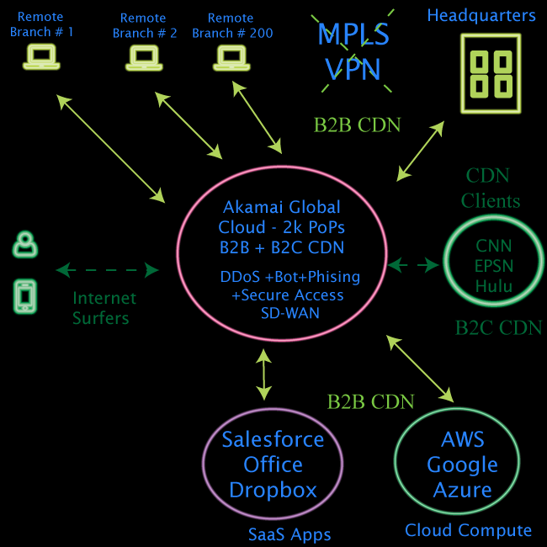
Akamai has become a major growth point in the edge computing industry due to its technical reach and strength. He bases his work on the reliability of his network and the growing risks to his security, he always takes them into consideration. Security has become one of the added values to Akamai's product portfolio.
In addition, the platform belonging to the company helps it reach far more than 130 countries. Akamai's access to the flow of online traffic helped her gain valuable information, which she then used to develop her security business.
Akamai owns the Media and Carrier divisions, which are two operating divisions, and its earnings come from media and carrier customers. Earnings growth has reached nearly 100 million, which will still grow driven by OTT traffic. In fact, CDNs have become of interest above all for those who require distribution coverage, such as gaming companies or others. We can see that, in the Web section, the earnings come from customers who carry out online based businesses. Like those who choose to have cyber protection, they bring the earnings from web security. Revenues have increased by nearly 300 million, which will increase year by year thanks to the revenue in cloud security.
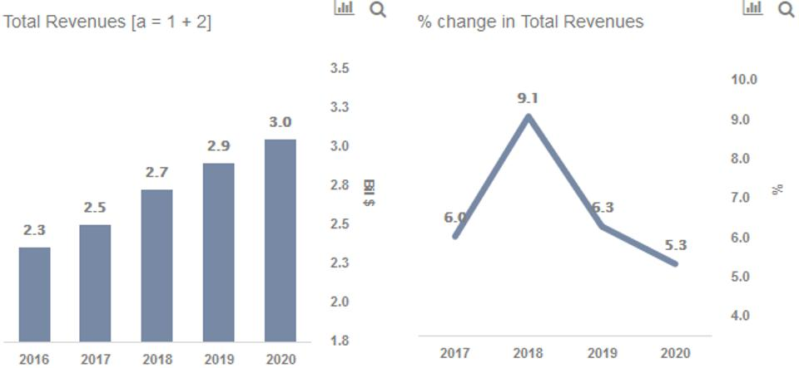
(team, s.d.)

AKAMAI STRATEGIC ANALYSIS.

Strategy and customer value preposition.
The strategy defines where and where the company will go in the future, making a profit thanks to a constantly changing environment by using its resources to fulfil the demands of stakeholders. (johnson, scholes, & whittington, 2008)
The customer's value proposition can give a company the opportunity to create the value retained by its customers from the product / service. All this can be estimated by calculating the outcome of the supplier benefits suggested to customers. (Customer value proposition, s.d.)
Akamai Strategies collaborates with revolutionary companies to help review strategic questions, this involves generating clear, yet customized documents that contain information data that empowers clients to make critical decisions about direction and business strategy, and product development. Combining a detailed business acumen with a scientifically strong background, Akamai Strategies fills the void that is created between understanding the facets of technology with understanding the various steps that go into making a possible product. (Akamai Strategies, s.d.)
Since its founding in 1999, Akamai has defined itself as an “architecture of network servers,” thereby differentiating itself from other Content Delivery Networks (CDN‟s). Such architecture means they need a decentralized setup in their servers which allows them to be as close as possible to its users. This decentralization was made possible by promptly negotiating with Internet service providers (ISPs) to locate servers in strategic locations, giving Akamai the ability to serve a more functional direction from user to server, creating faster ration and less error rates. The decentralized configuration, referred to as "The Edge", has given the company the ability to enter as one of the few CDNs, focusing advertising on user-oriented explanation to help understand the differentiation from other networks, which are more traditional and centre, i.e., less close to the user. While not the first, Akamai was the main promoter to come up with a decentralized setup for their servers, compared to competitors twice as fast. In the last period, the company has had to implement a price decrease, to extend its sale. The following table summarizes Akamai's profit margin from 2007 to 2011. Year 2007 2008 2009 2010 2011 Margin 73.7% 71.9% 70.9% 70.4% 67.7% Akamai was one of the first to facing threats suffered by competitors, so much so that a dispute was initiated with Limelight in 2007, which ended in Akamai's favour with compensation of $ 45 million in lost profits. It was also known that Limelight wants to appeal, therefore the sentence must be overturned. This story aims to show that Akamai uses a truly effective differentiation strategy, where the competition often tries to maximize its properties.
Content Delivery Network and Additional Capabilities.
Akamai has recently been focusing on developing more modern features, in step with the times, while also trying to expand into the dynamic content delivery and application accelerator sector where competition is weak. He is also working in the field of Enterprise and E-Commerce, attracting new customers. With the advancement of streaming in the past, Akamai has seized opportunities on the fly to expand its innovative services. Instead of focusing on video only, they specialize in cloud computing, security, and mobile content to offer many different services. By structuring its network in a decentralized way, Akamai was able to finance data more quickly, create a more compressed and therefore more useful storage, faster creation of new products and services, provide superior internet analytics, compared to competitors.

PORTER FORCES.
Porter's five forces structure represent a particular sector, analysing:
the threat of new entrants, the bargaining power of suppliers, the bargaining power of buyers, the threat of substitute products and the intensity of competitive rivalry. This analysis is used to determine the profitability of a particular sector and give a company the opportunity to take a favourable position compared to the competition. (augier, 2020)
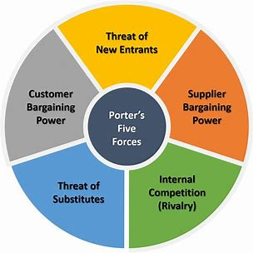
Examining the Content Delivery Network (CDN) industry has shown that we can identify a sixth force: web service providers. Threats to entry, are presented with MODERATE value, capital is high intensity, given by the creation of software, which is expensive. To survive, and grow over time, the company must have large sums, secure funds. However, venture capital is always a threat to new entrants, also due to the explosion in the online video market.
Buyer bargaining power is HIGH, segmented along with 50 other CDN players. The company also provides a low cost on the passage of various suppliers, thus customers are more likely to create their own internal network, to decrease the price of outsourcing.
The threat of substitutes is LOW, as the CDN is integrated into the internet value chain, without the existence of likely substitutes.
The bargaining power of suppliers is LOW, given that among suppliers, there is the inclusion of fragmented server manufacturers and network suppliers, leading to server costs to always be decreasing.
The rivalry is HIGH, given by strong competition, because the players produce competitive prices. The reluctant integration by CDN customers and the rapid expansion in technologies and market trends are evolving more and more.

AKAMAI COMPETITIVE ADVANTAGE.
Competition is the central reason for business success or failure. Competition defines the adequacy that a firm's activities can contribute to its performance, such as innovations, a compact culture and implementation. The competitive strategy is based on a competitive position in a particular sector, the basic place where competition occurs. The competitive strategy leads to the development of a profitable and sustainable degree against the forces that determine competition in the sector.
The competitive advantage grows above all outside the company
and creates a business position for its buyers to form that exceeds the cost. Value is what buyers are willing to pay, and usually the offer is higher than competitors who offer lower prices for equivalent benefits or provide unique advantages that compensate for a far better price.
There are two basic types of competitive advantage: cost leadership and differentiation. (Porter, 2004)

Akamai's decentralized network of distributed servers has given them a significant advantage, providing them with faster response times and greatly reduced error rates, which are critical to core CDN operations. It was critical to choose to locate their servers within the ISP's premises for Akamai's success. This has led the company to significant growth outside its core and to produce new differentiated products, including:
-Analysis of Internet usage
- Consulting services
-Online storage
-Distribution of customizable content
Akamai's billing model is based on recurring customer agreements, a one-time integration fee for new customers, use of resellers and the direct sales division.
This showed that compared to the industry average of 15%, Akamai's revenues from its resellers, using non-refundable minimum purchase contracts, were slightly above 27% (year 2018, page 23 of 10-K). The CAGR (compound annual growth rate) of its revenues was 25% for the five-year period 2014-2019. The years 2014 2015 2016 2017 2018 2019, had a growth in revenues of 59.4% 56.4% 42.3% 31.7% 19.1% 13.2%

SWOT ANALYSIS.
SWOT analysis gives individuals or organizations the opportunity to understand the daily difficulties, and to move from classic strategies to emerging perspectives, examining the strengths and weaknesses of a company, and the opportunities and threats that present themselves to it. Finding more advantageous markets is the most important challenge facing the company.
The SWOT Analysis framework can be a particularly important and useful gizmo to use.
A clear understanding of SWOT is required for majors.
(Uj.edu.sa, s.d.)
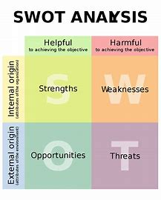
AKAMAI's SWOT analysis examines the brand and the company, as well as, obviously, its strengths, weaknesses, opportunities, and threats. In AKAMAI's SWOT analysis, opportunities and threats are presented as external factors, while strengths and weaknesses are presented as internal.
SWOT analysis is a proven management model, which allows the AKAMAI brand to compare its business and performance with the competition in the industry. As of 2020, AKAMAI Technologies is one of the leading brands in the IT and technology industry.
the strengths of the SWOT analysis of AKAMAI technologies.
Akamai is STRONG in value, as it has consistent customers and revenues, with a diversified product portfolio that allows it to operate in multiple markets. It has a significant competitive advantage due to robust networking capabilities. It has ongoing research and development thanks to solid financial data. It has over 5,000 employees, and their customers include Facebook, Apple, Bing, and Twitter.
the weaknesses in AKAMAI Technologies' SWOT analysis are the primary reliance on the US market for revenues and short-term liquidity concerns.
the opportunities in the SWOT analysis of AKAMAI Technologies, are the growth of demand on bandwidth, and therefore requires the use of cloud computing, advancement of growth thanks to mergers and acquisitions and the area of cyber security is increasingly growing.
The threats in AKAMAI Technologies' SWOT analysis are intense competition from new and existing players in the industry, various data privacy regulations, and constantly and rapidly growing technological advances.

MARKET SHARE, COMPETITORS.
For primary players, the key to surviving is market share, because it acts as a tool used against buyers, also creating a competitive advantage in terms of cost.
Organizations, with years of accumulated experience, serving specific areas in a so-called market section, should not only have minimal expenses but have built intrinsic and difficult to unravel networks of relationships. What can be a strength, which gives good light to customers, create variety in a market proportion, building advantages that will become your strengths. (johnson, scholes and whittington, 2008)
Akamai could not do all the work "alone", overwhelm everyone, so it maintained 10% of the market share in countries such as India, Korea and China, CD acquired 70, while GS Neotech 20. In China, ChinaCache acquired 90% of the market, but Akamai only retained 8% of the market. In India, BitGravity acquired 60% of the market share while Akamai's market share was only 30%. Global customers. Unfortunately, Akamai cannot even have "supremacy” because it can create the possibility that a customer would have to use the platform in countries that may not be present, and therefore will find themselves using something different. This makes it difficult to define the owner of the problems. They can be defined as Sales Goals. Some markets have certain product demands that are different from those offered by Akamai, which would remain unsolicited. merchandise teams set sales targets, ignoring the influence that could lead to the feedback of the sales team.
Akamai's main competitors are three:
Limelight
mirror image
level 3 communications

the difference between the networks of Akamai and Limelight, is mainly in the market shares, that of akamai was much higher, 66% and 10% Limelight.
Also, in terms of services, they offer the same but also different ones, Akamai Technologies distributes Internet content and application delivery services. The key services and products offered by the company include digital asset solutions: Akamai media delivery, Akamai stream OS, Electronic software delivery, Dynamic Site Solutions: Dynamic Site Accelerator, Dynamic Site Accelerator Enterprise, and Application Performance Solutions: Accelerator Web Application, IP Application Accelerator. In addition to more professional services: corporate services, standard services Customized solutions: other solutions: Site Intelligence offers
Limelight Networks provides Content Delivery Network (CDN) services in the United States, Europe and then Asia Pacific. The company's key products and services include audio, video, and gaming content. (Gartner, s.d.)

MARKETING MIX IN AKAMAI.
Akamai's earnings have grown year-on-year in part due to the dense network it has managed to build, and while there has been a decline in market share within local competitors, Akamai has continued to grow.
The Marketing Mix is ​​the set of 4 decisions that must be analysed before launching a specific product / service on the market. Companies choose which approach to adopt which must aim at these four different elements, which are Product, Price and Place and promotion.
Also called variables, they help the company make strategic decisions that can be useful in creating competitive advantage. the main objective of this analysis, and the importance of explaining the relationship that is created between the various components of the sales mix, creating a competitive advantage as a result. The Marketing Mix also includes the product and repair. In general, the merchandise marketing mix consists of product, price, location, and promotion and is typically used for the tangible assets of the marketing mix. Furthermore, the variables that make up the marketing of services are different, and they are 3, people, processes, and physical tests. The term marketing mix knew its popularity, thanks to the publication in the 64th article "The concept of selling mix" by N.Borden. One of the main steps is to create a marketing plan for the product, dividing it into three sections, namely the main product, the augmented product and then the tertiary product. But the decisions to be made are not just about the products but also about the
prices, if they will be applied uniformly, or different, by product based on the market in which it operates. Place is the third variable, which defines which choices to make about how and where to sell.
In addition, promotional decisions depend on increasing sales. The marketing manager must therefore point out what impact the different factors that are marked in the 4 P's can have to decide the marketing mix for a product / service.
The price is part of one of the variables, the 4 Ps of sale (product, price, place, promotion). However, in many B2B companies, marketers don't always occupy a position in pricing strategy. Your pricing must match the value you are offering versus the competition, gaining success with revenue and market share goals, maximizing your profits.
(Iosrjournals.org, s.d.)

When you offer an incredibly unique product or service with little direct competition, it is often challenging to determine your price. Put together a robust strategy and competitive analysis so you will see:
- What your prospects might buy other solutions to their problems.
- Where your price should fall about theirs.
-When your price, value proposition and competitive position are aligned, you are within the best situation to maximise revenue and profits. for instance, here are three scenarios that show the relationship between these elements. (Mooradian, 2013)
Pricing Strategy. The international pricing factors were not considered. The pricing strategy may change from country to country and not standardized. Where, the factors that play a crucial role in determining of international pricing strategy standardization are the extent of similarity between home and host countries in terms of customer characteristics, legal environment, economic conditions, and stage of the merchandise lifecycle ( Factors Influencing the Degree of International Pricing Strategy Standardization of Multinational Corporations - Marios Theodosiou, Constantine S. Katsikeas, 2001, s.d.)
In the beginning, the merchandise was new the planet then the industry conditions changed. therefore, the pricing strategy must support its new competitors and the product life cycle by changing course, which is also a method of determining costs. New competitors may be able to decrease costs, through labour wages or using differently determined costs. In this way, Akamai has to enter fixed costs to differentiate itself and obtain competitive prices.
New arrivals. The changing conditions in the industry had an impact on the company's market share. In general, new entrants have more opportunities than larger, proven companies because they have less chance of overhead and penetration. A conscious culture has played a role against Akamai, in the interest of local competitors who know more about customer culture and their needs. This provides a better product and greater fidelity. Even in the United States, Akamai lost market share as many of its customers started building internal CDNs like Amazon and Microsoft. Success in the global market begins at the domestic level, as described in the diamond model, which in order to be successful in the international field one must follow four factors: the demand conditions of one's country of origin, the conditions of the factors of the country of origin, the industries related and supportive within the home country and the strategy, structure and rivalry between domestic competitors. (My.uopeople.edu, s.d.)
Functional Organization Structure.
The functional organization was the rationale for the lack of handling the various markets during a highly responsive way. the choice centralization and standardization were not the right technique to be utilized in the worldwide markets where each market has different conditions. The transformation was a compulsory solution. Unawareness of every Market Individually. Akamai was not conscious of each market conditions and requirements. This caused serving inappropriate products. The external factors of each market should always be studied to create the right product and appropriate sales objectives. In addition, market conditions and demand must be provided in each market to create a suitable mix of products and targets. value, and change should go hand in hand within demand leading to a relationship called price elasticity. (Winer, 2014)

Alternative Solutions and methods.
Based on the matter analysis and therefore the root causes diagnosis, the choice solutions to the matter are often as follows: Agile Pricing Strategy. The competition within the price is suffering from the currency and therefore the costs which end in profits or losses. the worldwide companies got to adopt a special pricing strategy to beat competitors like the agile pricing strategy (Bozadzhieva, 2016). Controlling the value is not a simple task. It is reported that several companies set up a manufacturing factory where wages and costs are reduced. The most effective solution Akamai can adopt is Agile pricing strategy, as it operates at an enterprise level, and has different needs. Furthermore, it must include pricing strategies that can change with the market, aligned with the value provided and the spending possibilities of customers on available products.The pricing strategy works on pricing so that it is prepared for customer changes, new entrants and competition.
Company Reorganization. The reorganization is vital to extend the efficiency by eliminating the ineffective communication channels. Moreover, the new markets may require adding new staff or departments which may affect cultural diversity, and this might not work smoothly during a functional organization. Therefore, Akamai should work to simplify the regional offices' structure the maximum amount as possible to match the business size and complexity in each market. this may enable simpler decision-making system which may affect the market challenges during a dynamic and proactive way.
Forming the worldwide Marketing Strategy. The marketing strategy forming needs knowledge of selling management and world affairs to unravel global marketing strategy problems like defining the marketing mix which inserts each market (Kotabe, 2016)
Akamai should raise its awareness of every market conditions to define the factors that change from market to plug to line appropriate goals and objectives. The marketing mix should also vary. The pricing is discussed above. Nevertheless, the merchandise mix should be suitable for the market also because the targeted segments, communication, and distribution channels. The components of the external environment might be analysed consistent with the PESTEL tool which organizes six areas to spot how these factors influence industries and firms. These factors are political, economic, social, technological, environmental, and legal.

Alternatives Evaluation.
The above-mentioned alternatives should cause a final recommendation. This needs analysis and evaluation of every alternative to try to so.
Pricing Strategy. The agile pricing strategy can combine the available approaches with the pliability to vary and achieve profits. It can consider the worth elasticity and the way it acts towards the demand in low-margin and high-margin settings to balance revenues, expenses, and profits (Dolan, 2009). this will be considered as an excellent competitive advantage in pricing.
Marketing Positioning. Forming a correct company strategy especially in marketing are often ready to make the corporate grow among the five forces and taking the advantage of them (Porter, 1979). Hence, the purchasers can see Akamai during a unique position to evoke their purchasing decisions towards acquiring the worth of its products. Company Structure. The organization should find the foremost effective structure to reply to the changes within the market and environment with the acceptable decisions. (Scirp.org, s.d.) The complicated structures are not a plus within the current dynamic markets. The flat and straightforward organizations can perform more effectively and overcome the risks during a timely manner. Otherwise, the long communication channels would make the team not on the brink of the issues. they are going to miss the knowledge and awareness. it is going to subsequently hinder and stop the corporate from taking the proper response at the proper time.
Product Mix. Tracking the customer behaviour makes the organization ready to provide the proper product types and quantities where it fits the customer needs. Global Marketing. the notice of the market elements may be a key point of the case. The decision-making relies on behavioural, cultural, and environmental aspects. (Scirp.org, s.d.) Having a unified marketing strategy is not the proper solution for global companies then. the range in markets requires diversity within the marketing strategies reciprocally.
Analysing the environmental factors of every market is important to understand the way to set the proper marketing strategy and marketing mix. Finally, the sales, market share, and customer satisfaction are the foremost relevant indicators to live the corporate performance.
Sales and Customer Satisfaction. Deeper to gauge the development and achieving success, (Winer, 2014) stated that to live brand equity there are two approaches which are behavioural or attitudinal measures. The attitudinal is predicated on feelings and emotions, where the behavioural are often measured by sales increase and market share.

Globalization vs Localization.
The globalization was the initial approach of Akamai. This approach was not maintaining the simplest when new local competitors entered the market. A good strategic advantage is the transition from standardization to localization. Furthermore, personalization can motivate local experimentation and can create a long competitive advantage for resellers and manufacturers of similar products. (Localization: The Revolution in Consumer Markets, s.d.)

Final Recommendation.
Akamai is a global company that influences with diversity the ability to benefit from each market as a separate unit. All of this is often implemented to some or all components of business strategies such as marketing, human resources, and differentiation. most of the elements that require quick fixes are pricing strategy, value positioning, business structure, sales goals and marketing mix. The agile pricing strategy is often used to influence market changes. Leads to define value, customer, competition, demand and lifecycle stage in each market
(Ferrell, 2011)
Marketing positioning has the task of analysing the objectives of competitors, and what advantage the company can use in each market, be it quality, perception, or price, to differentiate and distinguish its products. a simple organizational structure is important, to ensure high efficiency and effectiveness. Each regional office must determine sales objectives with the support of the factors that the market allows. There needs to be a diverse marketing mix that satisfies the diversity of customers, including the product offered, the price, the promotion and the location.

Implementation Plan.
For effective implementation, it is critical to identify capabilities as resources, and build upon the less recognized aspects of the marketing organization. An effective strategy is based on techniques of planning actions, budgets and resource allocation, but also on administrative systems projects, it is also based on beliefs and attitudes that the participants of the organization may have and, above all, on the interests of dominant management and culture within the organization. (Baker, n.d) The action decides to implement the proposed recommendation are often applied by taking the subsequent steps:
1- Reorganization and assigning the acceptable staff to every regional office who are aware of the market culture and conditions.
2- Analysing the external factors and competition of every market using PESTEL tool and five forces analysis.
3- Defining the objectives and targets for every market.
4- Identifying the differentiation strategy which fit each market conditions.
5- Developing the acceptable marketing mix for every market including product, price, place, and promotion.
6- Applying the agile pricing strategy to reply to the market changes considering the most pricing factors.
7- The performance is often measured against the sales, market share, and customer satisfaction to regulate the implementation and act accordingly.

CONCLUSION.
Akamai may be a CDN company which was the only provider in 1998. After the industry and market changes, the corporate has encountered a challenge of competing the new local providers.
Moreover, there have been problems of setting the sales targets in each country and handling global customers. the explanations behind these problems are investigated supported by different perspectives of analysis. the causes of these problems are a poorly functional organizational structure, a lack of knowledge of the market in which one operates, such as the use of inadequate pricing strategies, and competition from new market entrants.
Based on the analysis of the subject, the chosen solutions are proposed. Effective solutions, to make a company perform at its best and make it a leader in the sector must be the agility of approach in pricing strategies, valid and adequate market positioning, creating effective corporate reorganizations, always creating innovative marketing strategies, which follow the market trends. These alternatives are evaluated, then the final recommendation is defined with implementation steps, including design and control indicators that use sales and customer satisfaction.

BIBLIOGRAPHY
(s.d.). Tratto da Scirp.org: https://www.scirp.org/reference/referencespapers.aspx?referenceid=2787231
Factors Influencing the Degree of International Pricing Strategy Standardization of Multinational Corporations - Marios Theodosiou, Constantine S. Katsikeas, 2001. (s.d.). Tratto da SAGE Journals: https://journals.sagepub.com/doi/10.1509/jimk.9.3.1.19928
Akamai Strategies. (s.d.). Tratto da Akamai strategies: https://www.akamai.bio/
augier, m. (2020). The Palgrave Encyclopedia of Strategic Management. London: Palgrave Macmillan UK.
Baker, M. J. (n.d). the marketing book.
Bozadzhieva, M. (2016). Multinationals Doubling down.
Customer value proposition. (s.d.). Tratto da mycustomer: https://www.mycustomer.com/hr-glossary/customer-value-proposition
Dolan, R. J. (2009). Principles of pricing. Boston, Mass: Harvard Business School Pub.
Ferrell, O. C. (2011). Marketing management strategies. Mason, Ohio: South-Western Cengage Learning.
Gartner, I. (s.d.). Top Akamai CDN Competitors and Alternatives - Gartner 2020. Tratto da Gartner: https://www.gartner.com/reviews/market/global-cdn/vendor/akamai/product/akamai-web-performance-services/alternatives
Iosrjournals.org. (s.d.). Tratto da http://iosrjournals.org/iosr-jbm/papers/vol3-issue6/G0364045.pdf?id=5454
johnson, g., scholes, k., & whittington, r. (2008). exploring corporate strategy (8 ed.). harlow: prentice hall.
Kotabe, M. (. (2016). Global Marketing Management. Somerset: Wiley.
lessard, d., & reavis, c. (2017). Akamai's Localization Challenge.
Localization: The Revolution in Consumer Markets. (s.d.). Tratto da Harvard Business Review: https://hbr.org/2006/04/localization-the-revolution-in-consumer-markets
Mooradian, T. (2013). strategic marketing. Harlow, United Kingdom: Pearson Education, Limited.
My.uopeople.edu. (s.d.). Tratto da https://my.uopeople.edu/pluginfile.php/57436/mod_book/chapter/122442/BUS5117.Ketchen.Short.Strategic.Mgmt.pdf
New Akamai Business Model. CDN and SD-WAN and Cloud-based Secure Access - Bizety. (2020, 12 19). Tratto da Bizety.com: https://www.bizety.com/2017/04/06/new-akamai-business-model-cdn-sd-wan-and-clientless-cloud-secure-access/
Porter, M. (2004). competitve advantage. new york: free.
Scirp.org. (s.d.). Tratto da https://www.scirp.org/reference/referencespapers.aspx?referenceid=2787231
team, t. (s.d.). What Has Been Driving Akamai Technologies’ Performance? Tratto da Forbes: https://www.forbes.com/sites/greatspeculations/2019/11/01/what-has-been-driving-akamai-technologies-performance/?sh=4b9a5fcde1a3
Uj.edu.sa. (s.d.). Tratto da https://www.uj.edu.sa/Files/1001210/Subjects/Chapter%2011%20SWOT%20ANALY
Winer, R. S. (2014). Marketing management. Harlow: Pearson.
World's Best Digital Experiences | Akamai. (s.d.). Tratto da Akamai.com: https://www.akamai.com/uk/en/what-we-do/world-class-digital-experiences.jsp?utm_id=PS02020&utm_campaign=UK_Brand&ef_id=EAIaIQobChMI9-iH4o7i7QIVkO3tCh0xUw7hEAAYASAAEgJXQvD_BwE:G:s&utm_source=google&utm_medium=cpc&gclid=EAIaIQobChMI9-iH4o7i7QIVkO3tCh0xUw7hE

