Student Number:2215573
Student Name:Andreea Catalina Mecic
Name of the Lecturer: Tristan Hawkins
Word Count: 2000
Assignment 1:Business Report- Comparison of Corinthia Hotels and Ibis Hotels
Table of Contents
1 Introduction 3
2 Overview of Hotels 3
3 Comparison of Hotels 5
3.1 Total Revenue 5
3.2 Market Position 7
3.3 Growth Potential 9
3.4 Financial Commitment to CSR 10
4 Recommendations 10
5 Conclusion 11
6 References 12

Introduction
The report mainly discuss the financial management of the two selected hotels “Corinthia Hotels and Ibis Hotels”. The primary purpose of the report is to evaluate and compare the critical areas that have a considerable impact on the sustainability and financial performance of the two hotels. In particular, the report will focus on the comparison of total revenue, market position, growth potential, and financial commitment of both hotels to CSR. Also, the report will propose well-reasoned recommendations to the hotels related to the specific area that are important for the improvement of financial performance and sustainability.

Overview of Hotels
The headquarter of Corinthia Hotels Ltd. is in London, UK. The company works in the hotel business and has between 2,000 and 5,000 workers. Corinthia Hotels Limited (CHL) builds and runs Corinthia hotels in Europe, Africa, and the Middle East. CHL is fully owned by the International Hotel Investments (IHI), which has headquarter in Malta (Corinthia Hotels, 2024). In the heart of London, Corinthia Hotel is located where Northumberland Avenue and Whitehall Place intersect. The hotel overlooks the Thames River and it is also near Trafalgar Square Theatreland. Many celebrities have been staying at the Corinthia Hotel London like Johnny Depp, George Clooney, Beyoncé Knowles and also Oprah Winfrey among others (Corinthia Hotels, 2024). Currently, the Corinthia Group has ten hotels on its list of assets; it purchased shares worth 50% in three other ones. This includes the Radisson Blu Resort & Spa Golden Sands, The Corinthia Grand Hotel Astoria in Brussels and also The Corinthia Hotel&Residences located in London.

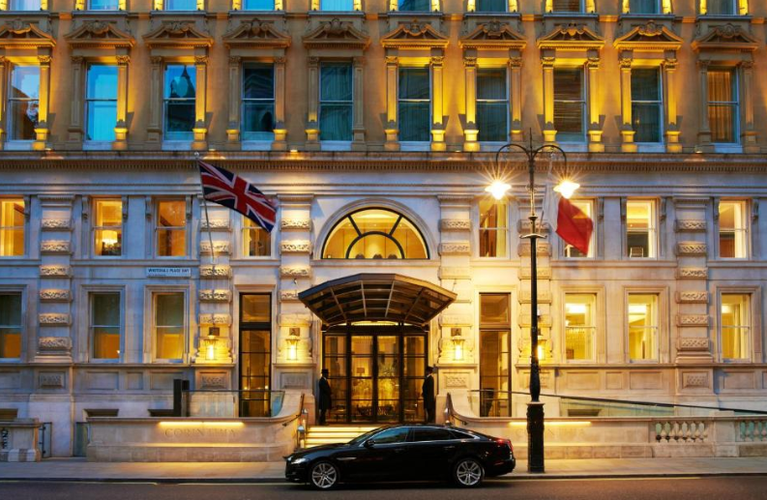
Figure 1: Corinthia Hotel
Source: Corinthia Hotel (2024)
Ibis is one of the Accor group names and also a budget hotel company in France. The brand has been established since 1974 and currently boasts of more than a thousand two hundred eleven hotels in sixty seven countries (Ibis Hotels, 2024). It is a common knowledge that the Ibis provides decent services at an affordable price. The rooms of Ibis Hotels are very comfortable and homely with all the necessary things facilities such as desks and free Wi-Fi. A few of these places also have pubs and restaurants. The Ibis Styles name, which is part of Ibis, is known for stylish stays. The 1980s were the start of Ibis Styles, which used to be called All Seasons. When Accor bought the company in 1999, it got a new name in 2011. As of April 2023, there are 642 Ibis Styles hotels in 51 different countries (Ibis Hotels, 2024). Ibis is a leading hotel chain around the world, with many rooms in many countries. These hotels are great for both business and pleasure travellers because they are in great spots in cities and suburbs.
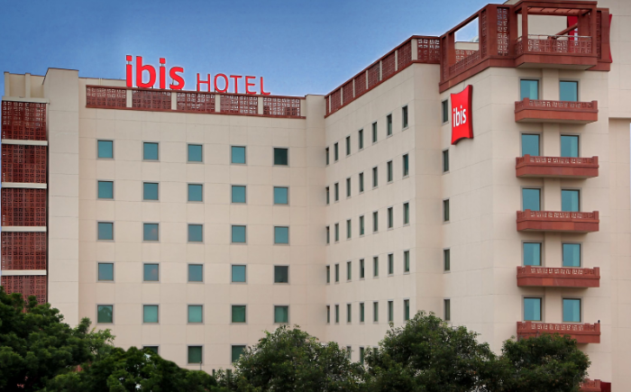
Figure 2: Ibis Hotel
Source: Ibis Hotel (2024)

Comparison of Hotels

Total Revenue
It is reported that Corinthia Hotels made a total of €238,207,000 in 2022, a big jump from the €129,266,000 they made the previous year (Annual Report, 2024). From the big rise in income, it looks like the hotel business is doing really well. When discussing the income sources, it is important to keep in mind the main things that have caused this growth. The hotel likely makes most of its money from booking rooms, holding events, and providing other catering services.
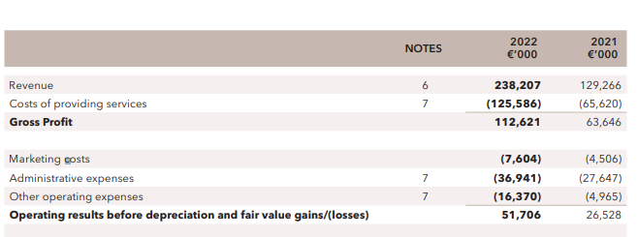
Figure 3: Revenue of Corinthia Hotels
Source: Annual Report (2024)
Over the past year, there has been a big increase in income, which points to a positive direction. One possible reason for this growth is that the global travel and hotel business is recovering from losses caused by pandemics. If the marketing had been more effective, it can brought in more customers. The gross profit of €112,621 shows that there is a good mix between getting money and spending less, which helps to explain the rise in sales (Annual Report, 2024a). More tourists, more people looking for high-end housing, and a well-thought-out price and service approach could all be what drives income growth. However, problems like economic downturns, global unrest, or disasters that were not expected could have a big impact on income (Annual Report, 2024a). The strong sales performance of the company in 2022 should be due to a recovering hotel market, smart moves that make more people want to use the services, and good business management of Corinthia Hotels.
The total income of Ibis Hotels went from €1.725 million in the first half of 2022 to €2.402 million in the first half of 2023. A lot of different factors have led to this huge rise of €677 million in the hotel business. There are many ways for Ibis Hotels to make money, such as through room booking, food and drinks, meeting rooms, and even partnerships with travel companies. The rise in earnings could mean that more people are looking for places to stay (Sakovska et al., 2021). This could be because of successful advertising efforts that brought in more customers, or it could mean that foreign travel has become easier since the pandemic.
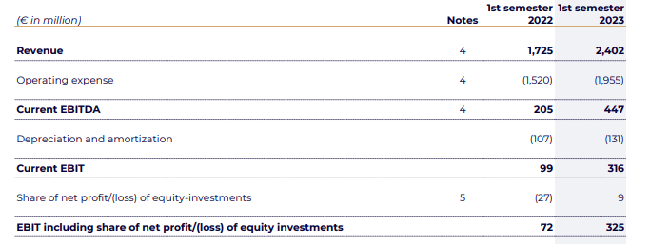
Figure 4: Revenue of Ibis Hotels
Source: Annual Report (2024a)
Based on how much money they make, Ibis Hotels seems to have had a good business plan by taking advantage of market opportunities. This growth could be due to smart pricing, higher rental rates, better customer experiences, or the addition of brand-new services. But running costs must also be taken into account, as they went up from €1.520 million to €1.955 million.

Market Position
Corinthia Hotels presents itself as an expensive name because it has high-end rooms and services. The main goal of the brand is to give picky visitors a polished and luxurious experience. Corinthia Hotels usually caters to wealthy people who value privacy, personalised service, and top-notch facilities (Kulgachev et al., 2020). Their hotels are located in some of the most famous spots of the world. To stand out in the market, Corinthia Hotels offer luxury, gourmet food, spa services, and a focus on making guests' stays memorable. People who want a fancy and rich experience, like business visitors, wealthy guests, and people celebrating important events, are drawn to this location.
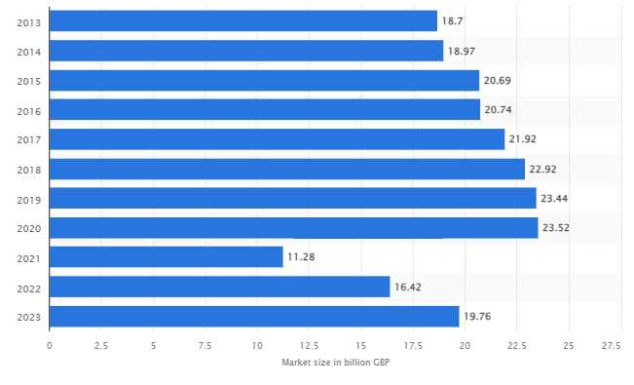
Figure 5: Market size of the hotel industry in the United Kingdom from 2013 to 2022, with a forecast for 2023
Source: Satista (2024)
On the other hand, Ibis Hotels really shines in the economy sector. Ibis is known for having cheap but nice hotels that are aimed at tourists on a budget. The principle behind the brand is to offer basic comforts at a fair price (Damnjanović et al., 2020). These include tourists on a budget, families on a budget, and people looking for cheap and useful places to stay. This option is great for people who care about price and ease of use because it is simple, useful, and simple to get.
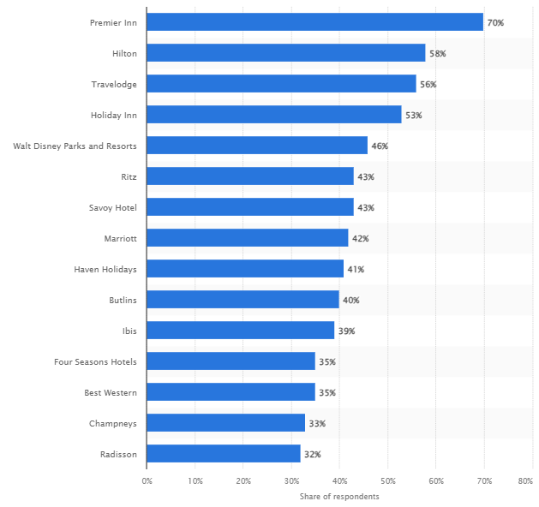
Figure 6: Most popular hotel brands in the United Kingdom (UK) as of the third quarter of 2023
Source: Statista (2024a)
The people that Corinthia Hotels and Ibis Hotels want to attract have an effect on their market shares. Corinthia has a smaller part of the upscale hotel market total, even though it fights with other high-end hotel groups. Ibis probably has a bigger part of the market, though, because it focuses on price and a wider range of people (Kumar, 2021). While Ibis Hotels cater to a bigger range of customers, from low-income students and families to wealthy tourists, Corinthia Hotels tend to attract wealthy individuals. How people think about these hotels' names has a big impact on where they stand in the market. A lot of people think of high-end, exclusive hotels when they hear the name Corinthia. A good and polished image is helped by the commitment of the brand to make a mark and give great service. Ibis Hotels, on the other hand, make people think of value, speed, and low cost. The name is a reliable choice for people who want to stay somewhere cheap and simple.

Growth Potential
Rich tourists looking for something really unique could be potential customers for Corinthia Hotels. A good way to grow could be to form partnerships for private vacation projects that are aimed at high-end customers (Fang and Fang, 2020). But because Ibis Hotels is aimed at budget-conscious visitors, the company experiences fast growth in places that are either developing quickly or have a lot of tourists. Technologies that are getting better can be a big part of how both companies grow. Hotels can get more attention in the market by adding cutting-edge booking systems, smartphone apps, and personalised experiences for each customer (Çevik, 2022). But problems could happen because of worries about hacking and the cost of adding new technologies. Businesses can be able to grow by adapting to changing customer tastes if they work to be more sustainable.

Financial Commitment to CSR
The famous Corinthia Hotels care a great deal about the sustainable practices and their attention to CSR confirms this. As a part of their endeavors to save the planet, the company ensured that all its buildings were equipped with many energy efficient technologies and also durable construction materials. Besides, Corinthia provides aid to the community and also donates money among other items towards social and environmental causes. It is normal for hotels to make donations to good causes like healthcare, education, and preserving culture (Yasir et al., 2021). Ibis Hotels, which is in the cheap class, agrees that CSR is important. Ibis continues to use environmentally friendly methods in its business while focusing on keeping prices low. Some goals that could be set are to reduce trash, use more sustainable sources, and save energy. Ibis often works with and connects with local groups to offer jobs and work together (Franco et al., 2020). As part of its financial commitment to CSR efforts, the brand focuses on providing value to travellers on a budget who are looking for a mix between doing the right thing and saving money.

Recommendations
From the evaluation of the report, it has been recommended that Corinthia Hotels could make its dedication to green even more of a business asset. Getting environmental certifications, moving to clean energy, and putting in state-of-the-art trash management systems are all steps that can be taken in this direction. This shows that Corinthia is committed to responsible and sustainable luxury, and it also helps the company stand out to people around the world who care more and more about the environment. Trends and market studies in the high-end hotel industry show that customers are looking for eco-friendly choices more and more, which supports this idea.
The idea focuses on making it easier for Ibis Hotels to get involved in the community while staying within a budget. Ibis should work with local groups to build relationships if it really wants to spend in things like community development, education, and health care. Ibis is committed to doing business in an honest way, and building better relationships with local communities help tourists who care about social problems have a positive view of the brand.

Conclusion
In conclusion, Corinthia Hotels and Ibis Hotels are in different places in the market and have different cash situations. The upscale focus of Corinthia is marked by strong income growth and a strong dedication to corporate social responsibility. One idea for Corinthia is to invest more money in new tools. Ibis is a company that is good for the budget and has shown a commitment to corporate social responsibility while also making a lot of money. Ibis is given ideas for how to get involved in the community. All things considered, these ideas are in line with what people want and how the market is moving right now. This means that any hotel should be able to improve its social impact, bottom line, and impact on the environment. The fast-paced nature of the hotel industry makes it clear how important it is to adapt to changing customer needs and global trends.

References
Annual Report, 2024. Corinthia Group. [Online] Available at < https://www.corinthiagroup.com/wp-content/uploads/2022/05/Corinthia-Annual-Report-2021.pdf> [Accessed on 24th Jan 2024].
Annual Report, 2024a. Ibis Group. [Online] Available at < https://group.accor.com/en/finance/results-and-publications/financial-result> [Accessed on 24th Jan 2024].
Çevik, S., 2022. Literary hotels: A new type of literary tourism or just a product?. Dos Algarves: A Multidisciplinary e-Journal, (42).
Corinthia Hotels, 2024. About us. [Online] Available at < https://www.corinthia.com/en-gb/london/?> [Accessed on 24th Jan 2024].
Damnjanović, V., Lončarić, D. and Dlačić, J., 2020. Digital marketing strategy of Accor Hotels: shaping the future of hospitality. Tourism and Hospitality Management, 26(1), pp.233-244.
Fang, W.T. and Fang, W.T., 2020. Future tourism. Tourism in Emerging Economies: The Way We Green, Sustainable, and Healthy, pp.267-295.
Franco, S., Caroli, M.G., Cappa, F. and Del Chiappa, G., 2020. Are you good enough? CSR, quality management and corporate financial performance in the hospitality industry. International Journal of Hospitality Management, 88, p.102395.
Ibis Hotels, 2024. About us. [Online] Available at < https://all.accor.com/brands/ibis.en.shtml> [Accessed on 24th Jan 2024].
Kulgachev, I.P., Kosolapov, A.B., Savinkina, L.A., Dracheva, E.L. and Babakhanova, I.B., 2020. Russian hotel chains: formation and development trends. Journal of Environmental Management & Tourism, 11(2 (42)), pp.290-298.
Kumar, P., 2021. Digital marketing in hospitality and tourism. University of South Florida M3 Center Publishing, 17(9781732127593), p.3.
Sakovska, O., Kozhukhivska, R., Kustrich, L., Gomeniuk, M. and Podzihun, S., 2021. Improvement of the Marketing Management System of Tourism and Hospitality Industry Enterprises on the Basis of Innovations. In International Conference on Business and Technology (pp. 881-895).
Statista, 2024. Market size of the hotel industry in the United Kingdom from 2013 to 2022, with a forecast for 2023. [Online] Available at < https://www.statista.com/statistics/1364712/hotel-industry-market-size-uk/#:~:text=In%202022%2C%20the%20market%20size,reach%2019.76%20billion%20British%20pounds. [Accessed on 24th Jan 2024].
Statista, 2024a. Most popular hotel brands in the United Kingdom (UK) as of the third quarter of 2023. [Online] Available at < https://www.statista.com/statistics/951262/most-popular-hotel-brands-uk/> [Accessed on 24th Jan 2024].
Yasir, M., Majid, A., Yasir, M., Qudratullah, H., Ullah, R. and Khattak, A., 2021. Participation of hotel managers in CSR activities in developing countries: A defining role of CSR orientation, CSR competencies, and CSR commitment. Corporate social responsibility and Environmental Management, 28(1), pp.239-250.

