The Impact of Virtual Learning Environment - VLE

Moodle Name: DIGITAL SKILLS AND RESEARCH METHODS
BMSW4003
University Name: Wales Trinity Saint David
Lecturer Name: PAUL WALLIN

Student Name: Lavio Nobre Espirito Santo
Student ID: 1816717

Date: 06/01/2020

Table of Contents
Overview 3
Statement of Problem ………………………………………………………………………..…3-4
Rationale…………………..………………………………………………………………………………………………………………………4-5
Methodology 5
Data Analysis…………………………………………………………………………………...5-6
Primary and Secondary Data Analysis ………………………………………………………………………………..…………6-7
Conclusion……………………………………………………………………………………………………………..…………………………..8
Recommendations 8
References 9
Appendices 10-16

Overview
Procedures to learn formally are associated with the environments of virtual learning and with the relationships between students, teachers, and school.
There is a growing interest in internet-supported virtual learning environments among educational institutions, students and teachers. Virtual learning environments by using Moodle are making continuous progress with the increasing advancements in digital innovations, for which they are considered as the dynamic notion. Its potential concept and features have made significant changes in the process of learning (Mogus et al., 2012).
Over the earlier decade, the development of computer advancement and the web get to has conveyed critical changes to language learning mode.
In the occasion that learning mode, by and large, relies upon the traditional eye to eye teaching in the examination corridor, virtual learning mode has added to the way where establishments offer their courses today.
Using the Moodle virtual settings for teaching purposes is more customary relative to the communication between the learner and the instructor. The advent of ICT helps teachers or educators to create a virtual learning environment (VLE) and encourage students to study beyond the walls of the classroom.

Statement of Problem
Using digital platforms and technology that are associated with the environment of learning are intermediaries to integrate the process of learning.
This is because of the way that in a consistent correspondence process they encourage collaboration and interrelation, in this way improving the development and reproduction of information and implications just as the arrangement of propensities and dispositions inside a structure that is normal to every one of those engaged with the procedures of education and learning (Falakmasir and Habibi, 2010).
The environment plays an important part in motivating and developing skills in the students to learn.
Students face different issues to be engaged in the learning process, like the most observed issue is they do take part in the class or in the process of learning.
There should be the solution to these problems in relation to the Moodle virtual environment learning that allows the students to speak and take part in the classroom, integration of the activities that help them in sharing their ideas and self-assess the issues to propose the solutions.
Showing exercises for understudies in numerous subjects, especially, has gotten troublesome. Due to the absence of learning apparatuses (aside from customary study hall instructing), science, social examinations, and innovation (Zhang et al., 2006).
This prompts understudy withdrawal and discontent which brings about incessant non-appearance in schools.
The problems that the study focuses in relation to the above problem statement includes:
Determination of the impacts and benefits which the Moodle virtual learning environment has on the language to learn. These impacts are negative or positive? This environment can enhance the motivation level of the student or not, determining the constraints of learning in virtual settings. To what extent and level of access to Moodle do this lead to the autonomy of learning for students?

Rationale
The main purpose of the subjected matter is to determine the use of the virtually leaning tools and methods and how they are effective at the universities.
In regard to this topic, it generates an unanswered question regarding whether the expanded utilization of software has drastically changed the manner in which understudies pick up, heading towards the thought of being a self-ruling student, or whether it is basically an instance of understudies composing up their expositions of digital devices and presenting their assignments through computerized gadgets to educators, or of teachers sending arrangements of talks to understudies (Barker and Gossman, 2013).
It is still not been determined, at which level the learners use this framework for developing their skills, increasing their level of motivation, knowledge, and autonomy to learn.

Methodology
The research study analyses the data with the help of quantitative and qualitative methods. The qualitative analysis is done through the review from the literature relative to the topic and quantitative data was collected from the questionnaire face-to-face. The questionnaire included 10 questions in an open-ended manner with a sampling size of 30. The individuals are randomly selected in the Universities. (Appendices 1 and 2)
Data Analysis
Data is an information, particularly actualities or numbers collected to be inspected and considered and utilized to assist choice making or data in an electronic shape that can be put away and utilized by a computer. Facts, figures, or data that is put away in or utilized by a computer. Crude truths and figures without meaning until they are handled and turned into something valuable. (https://dictionary.cambridge.org/dictionary/english/data)
It is characterized as a handle of cleaning, changing, and modeling information to find valuable data for the decision-making. The reason of Information Investigation is to extricate valuable data from information and taking the choice based upon the information analysis. Whenever we take any choice in our day-to-day life is by considering almost what happened a final time or what will happen by choosing that specific choice. This can be nothing but analyzing our past or future and making choices based on it. For that, we accumulate recollections of our past or dreams of our future. (https://www.guru99.com/what-is-data-analysis.html#4)
Data can be quantitative and qualitative; both can be profitable for diverse purposes. Quantitative data is about all approximate numbers. It is employments scientific examination and information to shed light on critical measurements almost your trade and advertise. This sort of information, found by means of tactics such as multiple-choice surveys, can assist you gage intrigued in your company and its offerings. Most imperatively, since quantitative research is numerically based, it is statistically valid. This implies you will be able to utilize its discoveries to create expectations around where your commerce is headed.
Qualitative data is not so much almost numbers because it is almost individuals – and their suppositions around your trade. Regularly conducted by inquiring questions either one-on-one or to bunches of people, qualitative investigate can assist you to characterize issues and learn almost customers' suppositions, values, and convictions. Since subjective investigate for the most part includes littler test sizes than quantitative investigate, it is not implied to be utilized to foresee future execution; or maybe, it gives you a recounted see into your business. Whereas quantitative inquire about inquires short-answer questions that start with “to what extent,” “how much” and “how many,” subjective investigate inquires long-answer questions that start with “how” and “why.” It is especially valuable in the event that you are creating an unused product, service, site or advertisement campaign and need to induce a few inputs sometime recently you commit an expansive budget to it.

Primary and Secondary Data Analysis
For gathering data we can use a primary source, when you go out and get the information yourself, by asking people or observing or use a secondary source, when you use data already collected by someone else for another purpose. In this module, I learn about data, and now I know what mean data, the importance of data, how to collect data, how to make a survey, research question, questionnaire visual representation of data, etc. Then I made a survey about the Virtual Learning Environment and I use Excel to make the visual representation about the result. (Appendices 3)
The study focuses to get students opinions about the Virtual Learning Environment in higher school, learning patterns and its impacts on the learners at university. The objectives this survey is for example: determining the level of access of the students to VLE in the UK universities, effectiveness and impacts on the learning ability of the students, assessment of the degree of association between the number of VLE accesses and the performance-related variables of the students.
In this case study I used Primary data because I got information directly from university students. Primary data is inquiring about you conduct yourself, it includes going specifically to a source – as a rule, client, and planned clients in your target showcase – to inquire questions and assemble information. Primary investigate ordinarily costs more and regularly takes longer to conduct than auxiliary investigates, but it gives conclusive results. Primary sources are not fair reports and composed records. There are numerous diverse sorts of essential sources,
including first-person accounts, reports, physical artefacts logical information that has been collected but not interpreted. Primary data have advantages for example: you control the plan and the questions, so you precisely get the data you want sometimes the data you would like cannot be gotten in any other way. There is some disadvantage like time expending and can be expensive If the information is available elsewhere, essential information collection may be a destitute utilize of resources.
Secondary data are information that have been collected by other analysts. Of course, the inquire about may well be a person, a gather, or a body working on sake of an organization (Maund A., Schriek M., Tinkler P., 2017). Also is very important and I looking something that what another people writing about VLE. (Appendices 4)
This is about that has as of now been compiled, accumulated, organized, and distributed by others. It incorporates reports and ponders by government organizations, exchange affiliations or other businesses in your industry. For little businesses with constrained budgets, most investigate is ordinarily auxiliary since it can be gotten speedier and more affordably than essential research. A part of secondary inquire about is accessible right on the Internet, essentially by entering keywords and expressions for the sort of data you are trying to find. You will too get secondary research by perusing articles in magazines, exchange diaries, and industry distributions, by going by a reference library, and by reaching industry affiliations or exchange organizations. (Note: After you find the inquire about you need, check its distribution date to be beyond any doubt the information is new and not outdated.) One great source of auxiliary inquire about information is government offices; this information is often accessible free of charge. (https://www.thehartford.com/business-playbook/in-depth/business-primary-second-research)

Conclusion
The virtual environments provide learners with solutions to the problems and meet the requirements to attend the fulltime lectures.
Virtual learning through Moodle gives beneficial outcomes for the understudies. Though only a few of them who are successfully connected with virtual talk, the vast majority of the understudies feel that learning works out, for instance, posting notes and sharing materials have caused and added to learning (McGill and Hobbs, 2008). Activities similarly have benefitted the understudies in their language capacities since they are required to grant in English, and they must know the language and endeavour to make well.
Electronic or virtual learning with Moodle defines the range of technologies and digital platforms used in schools and corporations for training and education. Different research studies are so far isolated understudies and are not yet into the inclination for controlling their one of a kind pace of learning.
As the number of colleges, schools and organizations is increasing, they are utilizing web-based instructive frameworks not exclusively to coordinate web innovation into their classes, yet in addition to enhancing their regular up close and personal courses. Such frameworks gather a lot of information that helps survey the nature of the course and the utilization of the members.

Recommendations
This study derives some recommendation for utilizing the Virtual Learning Environment through Moodle by analysis through statistics that indicates the post-positivistic concept of the study.
- Integrating the use and development of VLE by students and teachers.
- Taking the necessary steps for ensuring that every student and teacher has access to VLE Moodle at home so that they can interact with each other.
- Ruminate the minimum requirements for the targeted use of the VLE by the learner
- Integration of the strategies to stimulate the non-composed usage of a VLE.
- Give openings and flexibility to empower understudies to be answerable for their getting the hang of using a VLE.

References
Barker, J. and Gossman, P., 2013. The learning impact of a virtual learning environment: students’ views. Teacher Education Advancement Network Journal (TEAN), 5(2), pp.19-38.
Falakmasir, M.H. and Habibi, J., 2010, June. Using educational data mining methods to study the impact of virtual classroom in e-learning. In Educational Data Mining 2010.
Maund, A. Schriek, M. and Tinkler, P. (2017). Certificate in Higher Education: Skills for the Workplace Student Yearbook. Sage Publications
McGill, T.J. and Hobbs, V.J., 2008. How students and instructors using a virtual learning environment perceive the fit between technology and task. Journal of Computer Assisted Learning, 24(3), pp.191-202.
Mogus, A.M., Djurdjevic, I. and Suvak, N., 2012. The impact of student activity in a virtual learning environment on their final mark. Active Learning in Higher Education, 13(3), pp.177-189.
Zhang, D., Zhou, L., Briggs, R.O. and Nunamaker Jr, J.F., 2006. Instructional video in e-learning: Assessing the impact of interactive video on learning effectiveness. Information & management, 43(1), pp.15-27.
Available at:https://dictionary.cambridge.org/dictionary/english/data (Accessed: 5th January 2020)
Available at:https://fireflylearning.com/what-is-a-virtual-learning-environment-vle (Accessed: 5th January 2020)
Available at:https://www.guru99.com/what-is-data-analysis.html#4 (Accessed: 5th January 2020)
Available at:https://www.insight.cumbria.ac.uk/id/eprint/1455/ (Accessed: 5th January 2020)
Available at: https://www.thehartford.com/business-playbook/in-depth/business-primary-second-research (Accessed: 5th January 2020)

Appendices

Appendix 1: ln-Class exercise 1: Questionnaire Design
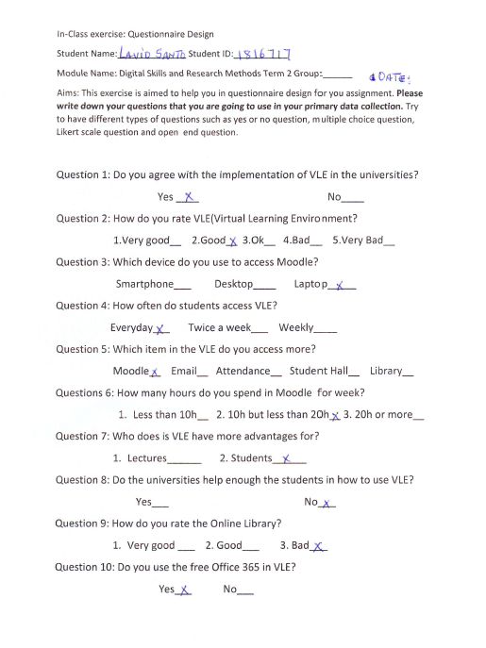
Appendix 2: In class exercise 2
Appendix 3/1: Primary data
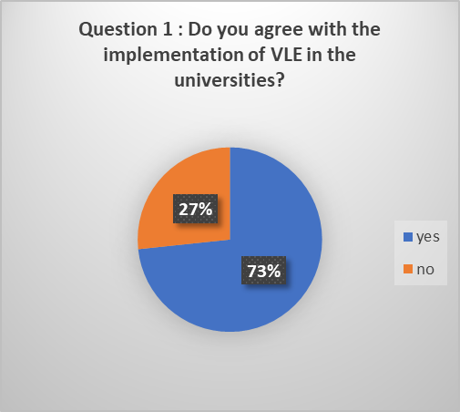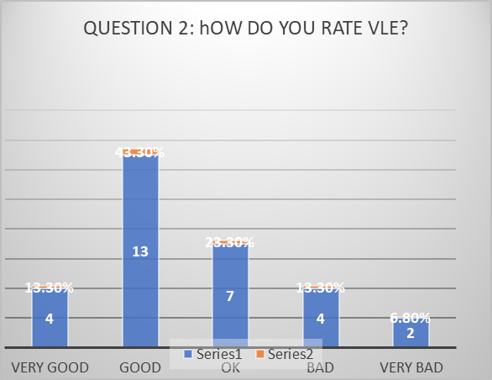

Appendix 3/2: Primary data
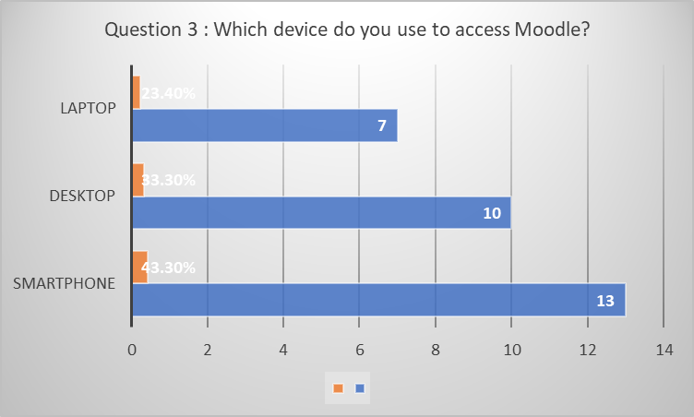
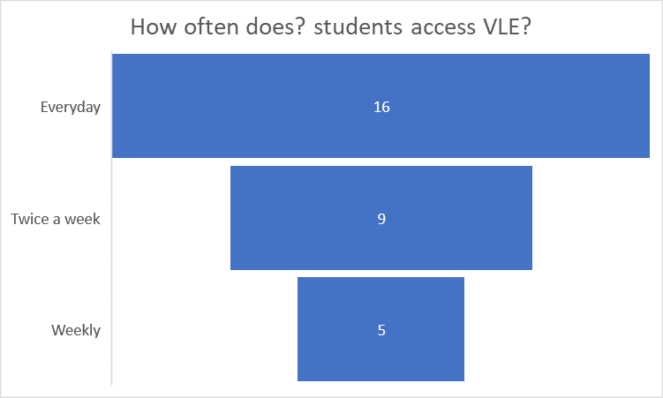

Appendix 3/3: Primary data
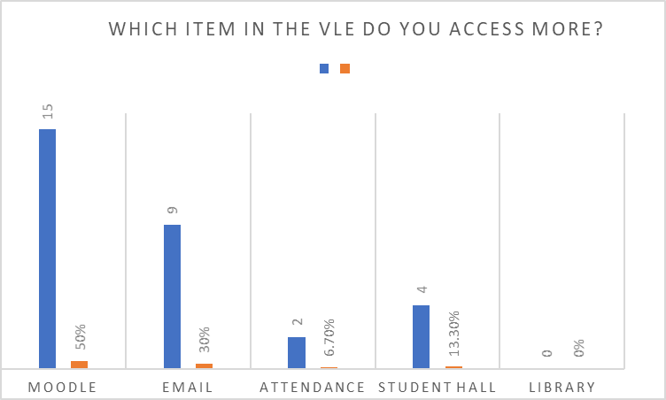

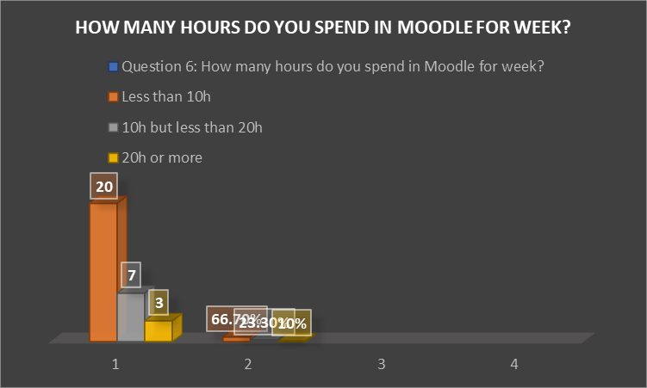

Appendix 4/1: Secondary data
Appendix4/2: Secondary data

