
APPENDIX GA36d



Strategic Market Expansion

of

Beyond Meat to China

By: Lee, Tak Man Anna Lisa

Date: 18th April, 2022

Executive Summary

Beyond Meat is one of the American pioneers in meat-alternatives processing industry, it has been playing an active role in green finance to transform plant proteins into meat-substitutes resembling the taste, texture and fragrance of real meat. It has objectives to improve human health, reduce impact of climate change and care for animal welfare, and with the mission to create food for the future. Beyond Meat’s successful IPO listing had drawn worldwide attention to join the man-made meat market, severe competition had limited Beyond Meat’s growth, thus this is the appropriate time for Beyond Meat to look for overseas expansion.
As a strategic management consultant, the researcher will assist Beyond Meat in generating the best strategies for future development. The process will include internal and external audits of the company and environment by using different analytical tools. When strategies are generated, a selection matrix will be constructed to help Beyond Meat making the right choice. Barriers at the new territory will be identified, and solving solutions will be provided. Further recommendations will also be suggested to ensure Beyond Meat’s success in the new domain.

1. Introduction
Man-made meat is introduced by the West as the ‘Food of the Future’, it is labelled as the remedy for saving the world from environmental impact of greenhouse gas emission and global warming, lengthening meat-eaters’ lifespan by reducing obesity and chronic diseases, promoting animal welfare, and rescuing mankind from food shortage in the future (Sexton, A. E., Garnett, T. and Lorimer, J., 2019). There is an increasing demand of plant-based meat both in the West and Asia.

1.1 Overview of the Plant-based Meat Industry and Beyond Meat
Alternative meat can basically be classified into three distinct categories – plant-based proteins from peas, mung beans and soy, lab-grown meat cultured from animal stem cells, and from edible insects (Sexton, Garnett and Lorimer, 2019). All categories mimic the texture and taste of real meat, some manufacturers produce meat-like byproducts, such as patties and sausages, while some concentrate in emulating steaks. For Beyond Meat, its products emulate beef patties, sausages, meatballs and ground meat.
Beyond Meat is an American food processor of plant-based meat founded in 2009 by Ethan Brown. The company has over 27,000 distribution points within U.S. and is rolling out its products to more than 80 international markets. When started-up, it had received investment funds from investors such as Bill Gates and Tyson Foods. It filed a $100 million initial public offering in 2019, and was listed in May as first publicly-traded company focused solely in producing meat-alternatives. Its stock price surged 163% on the first day of IPO, reflecting investors’ confidence in the man-made meat market. However, the success of listing and soring of stock price invited severe competition, especially from the well-established food leaders with renowned brand recognition. Beyond Meat’s once-supportive investor Tyson Foods sold all its 5% Beyond Meat’s shares before the company was listed, as the food giant intended to produce man-made meat on its own.
Beyond Meat is aggressive in expanding its market share by collaborating with leading food-service companies. It partners with Tesco in U.K., teams up with A & W and Tim Hortons in Canada, allies with McDonald’s to sell McPlant burgers and pizzas with plant-based toppings, and joins with Burger King to sell Beyond Burgers. In 2021, it started to cooperate with Pepsi to develop beverages and snacks made of plant-based proteins. Besides these, Beyond Meat also collaborates with Costco, Subway, Dunkin’, KFC and Starbucks (Leggate, 2020). In 2021, it teamed up with Panda Express to create gourmets in Chinese flavor for debuting the Chinese market.
According to Statista (2021), the ‘global plant-based meat market is expected to reach U.S.$77.8 billion in 2025, and by 2030 the amount will be doubled’, comparing to the current US$44.2 billion, the growth rate is significant. According to Ho (2020), the demand of plant-based meat in Asia hit US$15.8 billion in 2020. Currently, Beyond Meat had opened two manufacturing facilities in Jiaxing, China and Netherlands.

As a first mover of the meat-substitute market, Beyond Meat has a lot of privileges and strengths; but the competition is fierce enough to destroy a company if it is not in a readily position to turn around with feasible growth strategies to sustain revenue and profits. Beyond Meat is currently facing a shrinkage of market share, this is the time that a strategic consultant should step in to help Beyond Meat making the best decision of where its best resources should be allocated for breaking through the dilemma.

1.2 Objectives of Research
As a strategic consultant, the researcher will go through the procedures of collecting and analyzing large amounts of data at different levels, identifying problems of weaknesses and threats, and then suggesting methods for maximizing strengths and opportunities to overcome the deficiencies of Beyond Meat. Followed by a stage of strategies selection, advices will be given for choosing the best strategy, together with warnings of barriers and suggestions of overcoming methods.

1.3 Research Methodology
The following diagram shows the research methodological steps for deriving the Change Strategy of Beyond Meat.
Diagram 1 Fundamental Steps of Research Methodologies for Beyond Meat. The diagram is constructed by the researcher.

2. Mission-Objectives Matrix of Beyond Meat
The Mission-Objectives Matrix is an innovative tool for use at the initial stage of strategic planning for clarifying the company’s situated environment, objectives and strategies currently used. Mission statements serve as guidelines to show directions, and they are the prerequisites of strategy-formulations.

Missions of Beyond Meat

There are two mission statements found on Beyond Meat’s 2022 website but without vision statement. The missions are as follows:
- “We believe there’s a better way to feed our future. By shifting from animal to plant-based meat, we can positively affect the planet, the environment, the climate and even ourselves. After all, the positive choices we make every day, no matter how small, can have a great impact on our world”
- “Feed a better future – to create delicious, nutritious, sustainable protein so that you can Eat What You Love”
These statements clearly show Beyond Meat’s objectives to feed a better future by shifting from animal meat to create delicious and nutritious plant-based meat. By making the right choice, subordinates and customers can positively affect the climate and environment. “Eat What You Love” creates the purchase motives.

Table 1 The Beyond Meat’s Mission-Objectives Matrix was constructed by the researcher.

3. Strategic Internal Audit of Beyond Meat
Before generating strategies for Beyond Meat, it is necessary to conduct an internal audit for the company to evaluate its business performance and ability to manage risks, then will determine whether Beyond Meat is ready to go for change.

3.1 Beyond Meat’s Business Model and Business Strategies
Beyond Meat’s business model and business strategies reveal the methods of how it generates profit in the industry.

3.1.1 Business Model
Beyond Meat’s business model divides into 6 areas:
- Products
- Distributors
- Suppliers of ingredients
- Manufacturing processes and manufacturers
- Distribution logistics
- Sales of products

Products
Beyond Meat’s products are basically categorized in the U.S. as:
a. Ready-to-cook “Fresh”
Produced across three platforms of chicken, beef and pork. Namely, Beyond Burger,
Beyond Beef, Beyond Sausage, Beyond Breakfast Sausage, Beyond Chicken and
Cookout Classic.
b. Ready-to-heat “Frozen”
Beef Crumble is currently the only item.

Distributors

Beyond Meat sells through two distribution channels in both U.S. and international markets:
a. supermarkets and food retail outlets
b. fast-food service and dining restaurants

Suppliers of Ingredients
The products’ main ingredient is pea protein. Beyond Meat signed multi-year supply agreements with suppliers to secure constant supplies of raw materials. Another key ingredient is plant-based flavors, formulas were developed in its own lab, and sourced out to third-party manufacturers to produce the substance.

Manufacturing Processes and Manufacturers
Beyond Meat’s products involve seven basic manufacturing processes, and the tasks are divided between Beyond Meat’s own manufacturing facilities and co-manufacturers’.
Beyond Meat is responsible for dry blend, extrusion, protein-woven, cutting and freezing of woven protein; whereas co-manufacturers are responsible for processing, product finishing and packaging.
Beyond Meat has co-manufacturing facilities in Columbia, Missouri and Pennsylvania in the U.S., and own factories at Netherland in Europe and at Jiaxing in China.

Distribution and Logistics
Finished products will be shipped out directly from the plants. Some of them will be transferred and stored at Beyond Meat’s appointed cold-storage facilities, and some will be shipped directly to distributors and customers.

Sales of Products
Beyond Meat has sales teams at two levels:
a. a sales team with four divisions – retail, foodservice, international and strategic
partnership. The sales team works in alliance with a network of food distributors and
brokers in North America and around the world.
b. a team of field marketing representatives working at stores and events to present
Beyond Meat’s products to customers for sample tasting, they also work along with
food trucks.
Beyond Meat also sell on e-commerce platforms around the world.

3.1.2 Business Strategies
The following strategies are used by Beyond Meat for achieving its goals and objectives:

Focus Strategy
Beyond Meat uses a Focus Strategy to ‘focus on creating meat that is not actually meat, but tastes just like the real thing to replace meat in people’s diet’. Consumers used to relate meat as the best source of protein, Beyond Meat focused on redefining the source of protein as ‘protein is protein, no matter where it comes from’ (McKinnon, 2021).

Branding Strategy
Beyond Meat kicked off its branding strategy by redesigning the original meat package from a masculine image to a softened outlook, rebranding the company’s visual identity.
The second approach is to persuade restaurants to put the Beyond Meat logo on the menu when they are featuring its products, or to tag a little flag on the burger with the logo. This strategy is of low-cost and effective in brand recognition.
Beyond Meat also collaborated with a network of “brand ambassadors” to represent and advertise the brand on social media via channels such as personal websites and blogs.

Marketing Strategy
- Segmentation and Position
Beyond Meat targeted its market not only to vegans and vegetarians,
but to meat-eaters and flexitarians as well, there is no specific segmentation.
Beyond Meat positioned its products to be “as similar to meat as they could”,
closely resembled to real meat in taste and texture, so the products were the
first to be displayed in the meat sections of supermarkets and grocery stores.
positioned its products to be “as similar to meat as they could”, they are so

- Speed-to-market
When a novel product is ready to launch, it will be rushed to the market for
capturing first mover advantage.

- Digital and Social Media Marketing
Beyond Meat used social media platforms, such as LinkedIn, Twitter, Facebook
and Instagram for promotion.

- Athlete and Celebrity Endorsement
Meat-eating is often being perceived as masculine, associated with strength and muscles. Celebrity baseball player David Wright endorsed Beyond Meat’s
first campaign “The Future of Protein”, aiming to twist around consumers’
beliefs about vegetarian food (Besserve, 2020).

3.2 Beyond Meat’s Internal Financial Analyses
By using the numerical values taken from Beyond Meat’s Balance Sheet, Income Statements and Cash-flow Statements of 2021, the researcher is able to assess the company’s financial performance and its position in the industry. Detailed calculations of ratios and indexes are displayed in Appendix 1. All values used in calculations are in USD millions.

3.2.1 Analyses of Financial Ratios and Indexes
a. Liquidity Ratios
Liquidity ratios are for measuring a company’s ability to pay off short-term liabilities.

Beyond Meat had a Current Ratio of 11.148 by the fiscal year end of 2021, which was the company’s record-high. Beyond Meat is healthy with high liquidity, it can easily repay their debts and has sufficient working capital to afford operations.

Beyond Meat’s Quick Ratio had to be measured against the Food Processing Industry’s ratio, which is 0.24, a figure less than 1; that means most counterparts in the industry are not in positions to pay off their current liabilities. With a high 8.58 ratio, Beyond Meat is in a healthy financial position of having $8.58 of liquid assets to pay off every $1 of its current liabilities.

Beyond Meat had a Cash Ratio of 7.79 which was highly greater than 1, that means it had more cash or cash equivalents than liabilities. It is financially healthy.

b. Leverage Ratios
Leverage ratios shows a company’s ability to meet financial obligations when they are due, and shows the extent of capital that are borrowed from debts.

Beyond Meat had a Debt-to-Total Assets Ratio of 0.84, which was less than 1, indicating that its purchase of assets was totally funded by equity.

Beyond Meat had a very high Debt-to-Equity Ratio of 8.92, its long-term debt shot high in 2021 to over 1.15 billion. The surging is due to two reasons: 1) the company had issued $1 billion debt in 2021, consisting of ‘0% convertible senior notes’ due in 2027; 2) before 2020, the company’s operating leases were not shown in the balance sheet according to accounting rules, after accounted the operating leases, the debt rate rose to a high level. However, we can see a negative net debt amount in Beyond Meat’s books, that means it has a great amount of cash on hand. A Long-term Debt-to-Equity Ratio of 8.85 is highly above 1, but if Beyond Meat is able to use the debt wisely to generate a rate of return higher than the interest paid for loans, then this long-term debt is profitable to the company.

Times-Interest-Earned Ratio shows the number of times that a company can cover its interest charges with its earnings before interest and tax paid. Beyond Meat’s negative times of interest coverage means it is not able to pay off interests by current income at the time being.

c. Activity Ratios
Activity ratios shows the efficiency of a company in utilizing its assets to generate revenues and profits, demonstrating the company’s fiscal strength.
Inventory Turnover Ratio tells how fast a company can sell its products within a specific period of time. Beyond Meat had a ratio of 1.92 by 2021 year-end with a comparative year-on-year decline from 2.34. Comparing to the industry’s ratio of 6.55, Beyond Meat’s plant-made products were selling slowly. Normally, supermarkets and food retailers have large ratio numbers with high turnovers. By dividing 1.92 into 365 days, Beyond Meat takes 190 days to finish selling products on hand. Partial reason may be due to the closing of restaurants under pandemic.

Fixed Assets Turnover Ratio is an index showing how efficient a company uses its existing fixed assets to generate net sales, a higher ratio reflects management’s stronger ability. For every dollar of fixed assets invested by Beyond Meat, $2.05 of sales were generated, its fixed assets were not fully-utilized.

Total Assets Turnover indicates how a company is using its totals assets to generate sales. Every dollar Beyond Meat invested in total assets, only $0.337 was generated. Sometimes a low ratio is not at all bad, since Beyond Meat had opened two facilities in Netherlands and China in 2020, it turned out to have a lower asset base than its industrial counterparts.

The industry is having a 1.67 ratio of Accounts Receivable Turnover, and Beyond Meat is having a ratio of 10.61 with Average Collection Period of 34.5 days, slightly better than 36.5 days of the industry. Beyond Meat was efficient in collecting accounts receivables, showing that its customers were creditworthy and of quality.

d. Profitability Ratios
Profitability Ratios are for measuring a company’s performance at the end of a fiscal year, it shows how well a company generate profits from its business operations.

Beyond Meat’s Gross Profit Margin steadily climbed over years. Its 25.2% margin is better than the industry’s 20.17% at the year-end of 2021. Beyond Meat generates a higher gross profit margin, as it had opened its own manufacturing plants, the products were produced at a reduced cost of goods sold, giving it competitive edge in the market.

Operating Profit Margin was calculated before interest and taxes are deducted. Beyond Meat’s operating costs included R&D expenditure, restructuring costs, and general administrative expenses. Having a -34.2% operating profit margin, indicating that Beyond Meat had loads of fixed operating expenses for the start-up of manufacturing plants. After some time, when the plants run in full scale and start generating profits, the condition will improve; therefore, it is unfair to compare Beyond Meat’s margin with that of the industry’s, which is 8.06%.

Beyond Meat’s Net Profit Margin showed negative of -39%, that means its revenue earned was inadequate to cover the cost of goods sold. The negative number might be viewed as poor business performance when compared to the industry’s margin of 7.04%; but as Beyond Meat is in a stage of expansion, it needs capital investments to get started, its expenses will exceed revenues for a period of time.

Beyond Meat had a Return on Total Assets of -13.2%, and the industry had a return of 5.8%. ROA is a measure for testing asset efficiency. It is difficult at this moment to compare Beyond Meat’s ROA with that of the industry, since it is in the expansion stage.
Beyond Meat had a -84.30% of Return on Stockholder’s Equity, that means it had incurred a loss. But a negative percentage is not always bad, especially when Beyond Meat is going global. When net income showed bad, free cash flow will be looked at for revealing the company’s real financial situation. Beyond Meat had a positive net cash flow of USD1,022 billion, and having USD733 billion as cash and cash equivalents, its financial strength was in good position. This is common when a business started to roll out into international markets, they might suffer losses for a few years.

Beyond Meat’s Earnings per Share shows -2.88, and the Price-Earnings Ratio also showed -22.625. It is obvious that it had spent an enormous amount on production facilities which could not be paid off by net income, but this could be a temporary one-time effect during the investment phase.

e. Growth Ratios

Growth ratios indicate how fast a business is growing over a specific period of time. Negative growth ratio shows reduction in sales and revenues.

Beyond Meat got a 15.22% year-on-year Growth Rate in Sales, which is less than 22.95% of the industry. But the rate has to be compared with those of major competitors, such as Tyson Food, Kellogg, Nestlé and Conagra; however, these competitors are not pure plant-based meat producers like Beyond Meat, so the comparison is not on an orange-to-orange basis.
Beyond Meat’s negative Growth Rate in Profits and Growth Rate in Earnings can be misleading. If the starting figure at the beginning of the year is a negative figure, the growth rates will end up be negatives, calculations were off. In conclusion, Beyond Meat had made improvements in growth of sales.

f. Bankruptcy Index Z-Score Analysis
Table 2 The Bankruptcy Index Z-score Analysis table was constructed by the researcher.
The Altman’s Z-score is for predicting a company’s possibility of going bankrupt. The formula was designed for publicly listed manufacturers with values over USD1 million. With a score lower than 1.8, the company has a high chance of going out of business. With a score above 3, the company is safe from bankruptcy. Beyond Meat lied in the “grey area” or “caution zone” of having a 2.3441 Z-score, it has to pay attention to the financial health of balance sheet. Table 2 shows how the Z-score was calculated and Beyond Meat’s financial performance was compared for three years.

3.2.2 Summary of Internal Financial Analyses
Beyond Meat has sufficient working capital to repay debts and keep the business running in a healthy position, since it has more cash than liabilities. It is capable to buy assets with equity instead of from borrowing. After issuing the “0% convertible senior notes”, it has a great amount of cash on hand. However, Beyond Meat should be aware that its plant-based products were selling slowly and the company was not able to pay off interests by current income. Beyond Meat had a lower asset base than its industrial counterparts due to the investments of facilities in Netherlands and China, but its gross profit margin is better than that of the industry. Although its other margins, ROA and ROE all shows negative, this phenomenon should be periodic as it was at the expanding stage. In conclusion, Beyond Meat’s financial strength is in good position, as it had recorded a free cash flow of USD1,022 billion by the fiscal year end of 2021, and had on hand USD733 billion in cash and cash equivalents. The company is capable to finance itself in global market expansion.

4. External Audit of Plant-based Meat Industry
Various analyses will be used for doing external audit, important information of the business environment will be gathered for the evaluation of competition and threats within industry.

4.1 Porter’s Five Forces Analysis
The Porter’s Five Forces Model is a competitive analysis tool for assessing Beyond Meat’s external competitiveness in dimensions of the following 5 factors.

Rivalry among existing competitors
All competitors entering the plant-based meat market emphasized their care about environment. The industry is booming but product differentiation among rivalries is low. According to Reinicke (2019), ‘as there are more food leaders entering the plant-based meat market, Beyond Meat will encounter extra pressure in order to compete for brand recognition and competitive edge’. Existing competitors are mostly leading companies with established distribution networks and had investments from renowned investors. As a result, rivalry among existing competitors is extremely high.

Threat of substitutes
Plant-based meat is classified as low-implication food, thus switching costs between different plant-based products is rather low. Consumers have large varieties of alternatives to choose, and new products emerge consistently, thus brand loyalty is low. To the industry, threat of substitutes is high.

Bargaining power of buyers
Plant-made meat buyers are having strong bargaining power since the meat-substitutes do not differentiate much among competitors and switching costs are low. High consumer power lowers the industry’s profitability. Existing rivalries have to make strategic changes to stand out from the competing crowd.

Threat of new entrants
The successful listing of Beyond Meat had attracted a lot of new entrants to enter the meat-alternatives market, and most of them are existing food leaders with solid financial background. As a result, the threat of new entrants is high.

Bargaining power of suppliers
Beyond Meat has been in business with Roquette for over 10 years for supply of ingredients (Roquette, 2020). Roquette is a global leading supplier in plant-based proteins, but it is not Beyond Meat’s sole supplier of ingredients, Puris is another one. Besides, Beyond Meat has more supply chains of proteins from mung bean, brown rice and sunflower seed (Watrous, 2019); therefore, Beyond Meat’s suppliers has low bargaining power.
The following table shows the summary of plant-based meat industry’s Five Forces Analysis:

4.2 PESTEL Analysis

A PESTEL Analysis is used for analyzing the political, environmental, social, technological, economical and legal factors that have impacts on the plant-based meat industry.
Political
So far there is no official announcement from any government that animal-farming plays a responsible role in climate change, greenhouse gas emission and deforestation, but environmentalists keep urging governments to financially support farmers to transit from high-carbonated farming system to low-emissions food system. They even suggested governments to introduce “meat taxes” (Montague, 2018).
On contrary, governments and politicians around the world had received pressures from meat producers to lay down legislative measures for restricting the market growth of meat alternatives. They also requested government to clearly define what the term “meat” is, and man-made meat alternatives should not be labelled as “meat” and should not be displayed at the meat section of grocery stores and supermarkets.
According to Montague (2018), the meat industry is tied-up to politics. Meat producers donated generously to support political campaigns and they even found their ways to have reporters attacking scientific studies that recommended fewer meat consumption.

Environmental
Environmentalists emphasized that the crisis of water-shortage is imminent. One-third of the world’s drinking water has gone to animal agriculture; and meat producers had irresponsibly dump toxic pollutants into waterways, causing pollution, creating water dead zones, and leading to extinction of ocean-living species (Loria, 2018). Overuse of land in animal agriculture is also a causal factor of desertification. Environmentalists argued that the world should have sufficient food, but they are not for people, but rather for feeding animals to generate meat. Moreover, livestock agriculture was proved to release more carbon than transportation (Montague, 2018), causing global warming.

Social
The growth in vegans and vegetarians, particularly in the younger generation, is perceived as a social trend. The concept of Green Monday, or Meat Free Monday, is highly proposed around the world, encouraging people to take the Monday off from eating meat, eggs and dairy products. In some areas, schools play an active role in encouraging students to eat less meat. Van Loo, Caputo and Lusk (2020) had conducted a study and discovered that over 70% of interviewees socially against the labelling of “meat” or “beef” for plant-based food.

Technological
Innovation of meat-alternatives is viewed by environmentalists as ground-breaking food technology. However, these meat-replicating technologies can be very costly and were unaffordable to common investors; thus a few producers, especially in the lab-grown meat segment, might monopolize the man-made meat market (Newton and Blaustein-Rejto, 2021).

Economical
Davis (2016) stated that if meat-eating continues, the “social damage cost of carbon emissions” will cost U.S. government over $200 billion per year, and the amount will accumulate to $1.6 trillion by 2050. But there are contradictive views. Newton and Blaustein-Rejto (2021) showed that decrease in meat demand will affect the income and livelihoods of ranchers and farmers. Governments should subsidize the meat-agriculture industries to transit to alternative-meat manufacturing. However, it is also arguable that no one can foresee accurately the moving trend of man-made meat that it will take up a large portion of consumption. If real-meat farmers made investments to transit and ended up to be under expectation, they will suffer from capital loss and fall between two stools. Up to recent, there are no official economic analyses to aid animal-agriculture participants to help considering transitions.

Legal
The regulatory framework for novel food safety was laid down in the food standards around the world, especially in production standards and labelling. Descriptions on man-made meat labels are having higher legal requirements than those on real meat (Martin, 2021). China is also exerting strict rules in plant-based food regulatory system. Foreign imported foods once landed in China, they are examined right on the spot.

5. Strategy Generation
After the internal and external audits were completed and situations were analyzed, new strategies can be generated for Beyond Meat’s future growth. Firstly, a SWOT Analysis is needed for discovering Beyond Meat’s strengths, weaknesses, opportunities and threats. After that, a TOWS Strategic Alternatives Matrix will be developed for generating strategies.

5.1 SWOT Analysis of Beyond Meat
A SWOT Analysis is required for identifying the core competencies of Beyond Meat, discovering the company’s major strengths of competitive advantage, covering weaknesses that prevent it from accomplishing its mission, recognizing external opportunities, and realizing environmental threats that jeopardize the company’s profitability.

Strengths
Beyond Meat entered the U.S. market early in 2009, with the privilege of gaining a large market share in plant-made meat. It was one of the pioneers in industry and was focused to produce a food substitute to simulate real meat, this focus is a major strength. It was publicly listed in 2019, made the company easier to finance for expansion. Its 2021 financial statements showed an adequate amount of cash-flow.

Its successful marketing strategies of double distribution channels exposed it to high brand recognition in the U.S., and it has strong and experienced selling teams.

It had opened two production facilities in Netherland and China. In respect of quality and quantity, the products are under consistent and better control.

Beyond Meat had made tremendous investment in research and development, its R&D Spending to Revenue Ratio moved up from 6% in 2020 to 14% in 2021 (Beyond Meat, 2021), and the company is commented by the public as innovative.

Beyond Meat’s products have a major advantage of not using genetically modified organism ingredients, China publicly shows opposition to GMO foods.

Weaknesses

Beyond Meat’s major weakness is that its price is two to three times higher than that of actual meat, causing it to sell slow. When a new product is released, people might buy it for a trial and boost up sales, but repeated buying is a must for product survival. Price-parity to close the price gap is Beyond Meat’s urgent priority for increasing revenue growth. With its own manufacturing plants opened, hoping that the price of plant-based meat will be driven down as fixed costs leveraged. However, Beyond Meat’s pea-protein suppliers had just announced a rise of price in ingredients.

Beyond Meat’s net earnings was below market’s expectation, therefore most financial analysts gave negative purchase comments to investors, and they evaluated Beyond Meat’s high stock price as unrealistic in face of slow revenue growth. These negative comments are destructive to Beyond Meat’s capital-raising ability. This is another weakness. Furthermore, previous research by Humane Research Council, with huge sample size of 11,399 adults, showed that 84% of vegetarians or vegans return to eating meat after a year (Wiseman, 2016). Beyond Meat has to overcome this weakness by changing meat-eaters’ perception of eating vegan foods.

Opportunities
COVID-19 had changed Chinese people’s perception towards protein, as they view it as a booster of the immune system (Zhang, 2021), thus China’s demand of protein is rising. This is an obvious opportunity. Gain better understanding of Chinese cultures and tastes of different regions will be beneficial to expand in China.
Beyond Meat’s China plant can serve multi purposes than solely use as a production facility. Beyond Meat is currently cooperating with Panda Express in experimenting two new dishes of Mapo Tofu with Beyond Beef in spicy Sichuan sauce and Stir-fired Vegetable-forward String Beans with Beyond Beef (Starostinetskaya, 2022). Partnering with well-established food leaders will create opportunities. Beyond Meat has also been working with PepsiCo in joint venture to create pea-protein beverage and a vegan beef jerky called PLANeT (Beyond Meat, 2021). Innovation and creativeness are the best ways to outpace competitors in the market.
Increased awareness and support from government bodies on plant-based products will also create opportunities for the industry.

Threats

While Beyond Meat is working on traditional Chinese dishes, Impossible Foods is testing on Meatless Orange Chicken with Lo Mien (Starostinetskaya, 2022). Tyson Foods also debuted plant-based food in Asia, and Nestlé had also opened a plant-based meat production factory in Tianjin, China. China market is crowded with competitors and the threats can be hindrances to Beyond Meat’s business growth.
The barriers of entry are very low in the global plant-based meat market, especially for those food leaders with solid financial backgrounds and well-established brand recognition. They are selling large varieties of food items, which they can easily takes the rough with the smooth to outperform Beyond Meat who is concentrating in competing with one single item. Sooner or later, Beyond Meat will not be the only plant-based meat company in the listing market, its privilege of easy fund-raising via IPO will short be diluted (Ghate, 2020). The outbreak of COVID-19 had also threatened Beyond Meat’s revenue growth, as restaurants were closed. There are also threats from meat producers and opposite parties, as they criticized plant-based food is highly processed food with little nutrition (Barot, 2019).

5.2 IFE and EFE Matrices of Beyond Meat
After the SWOT analysis is done, the Internal Factor Evaluation (IFE) Matrix and External Factor Evaluation (EFE) Matrix will also be constructed. The evaluating factors will be more precise than those from SWOT Analysis, PESTEL Analysis and Porter’s Five Forces Analysis. Each factor will be assigned a weight from 0.0 to 1.00, indicating its level of importance to Beyond Meat, all weights will be summed up to 1.00. A rating from 4 to 1 will also be given for EFE Matrix. 4 indicates the highest level of response that Beyond Meat gave to opportunities and threats, whereas 1 showed poor response. For IFE Matrix, strengths receive 4 for major and 3 for minor, and 2 for major weakness and 1 for minor weakness. By multiplying the weight with the rating, a weighted score would be obtained and all weighted scores will be summed up to a total weighted score. The average weighted score is 2.5, any score higher than 2.5 means the situation is well-responded to, while a score below 2.5 means the company’s current strategies are not well-structured to overcome problems.
Table 3 EFE Matrix of Beyond Meat. The matrix was constructed by the researcher.

Table 4 The IFE Matrix of Beyond Meat. The table was constructed by the researcher.
The matrices clearly showed that Beyond Meat had made fast action to deal with its strengths, opportunities and threats, but showed slow response to its weaknesses, as it received a score of 1.9, below 2.5.

5.3 TOWS Strategic Alternatives Matrix and Strategies Generation

TOWS Matrix is dissimilar to SWOT Matrix by the ways that TOWS helps a company to identify its strategic options that they can be used for controlling and overcoming weaknesses and threats, and management is able to grasp opportunities with the best of its strengths. The following is a TOWS Matrix of Beyond Meat, clearly demonstrates the strategic options that the company can adopt by using the evaluation generated from the IFE and EFE Matrices.
Table 5 TOWS Matrix of Beyond Meat, the table was constructed by the researcher.
After developing the TOWS Strategic Alternatives Matrix, four strategies catering to the needs of Beyond Meat were generated:

a. SO Strategies (Strategy 1)
To maximize strength and opportunities, Beyond Meat is advised to adopt “Conglomerate Diversification Strategy” by using “Expansion through Internationalization” and “Expansion through Penetration” to gain larger market shares in China, enlarge economies of scale, earn higher profits and increase brand recognition in Asia.

b. ST Strategies (Strategy 2)
Use “Expansion through Concentration Strategy” to invest in new product line extensions for meeting consumers’ needs in the targeted markets, compete with existing rivalries by using innovative technologies.

c. WO Strategies (Strategy 3)
To overcome weaknesses and pursue opportunities, use “Expansion through Cooperation Strategy” by collaborating with reputable B2C business platforms, such as Tmall and JD.com to activate the brand for mass distribution in China.

d. WT Strategies (Strategy 4)
To lessen the degree of weaknesses and threats, use “relationship marketing” to concentrate in developing customer relationships. Build a platform to share cooking ideas and information of plant-based meat. Hold plant-based meat cooking contests, get consumers to recognize Beyond Meat. Observe competitors closely, copy their strategies and do better than them.

6. Selection of Strategies
The TOWS matrix had generated 4 types of strategic options for development planning. The Quantitative Strategic Planning Matrix will be used for selecting the best strategy for Beyond Meat’s growth.
6.1 Quantitative Strategic Planning Matrix (QSPM)

Attractive scores (AS) ranging from 1 as least attractive to 4 as highly attractive, are assigned to key factors in each set of alternative strategies. Total Sum of Attractiveness Score was calculated and the result clearly showed that Strategy 1, which is the maxi-maxi strategy to maximize strengths and opportunities in the TOWS Matrix, received the highest score of 6.15.
With adequate cash-flow on hand, Beyond Meat is advised to expand to Asia and penetrate deeper into China by using a mix of Conglomerate Diversification Strategies and Branding Strategies.
7. China Food Market
China had a GDP of 8.1% in 2021, which was the fastest growth in the world. It is the largest exporter of consumer goods with strong external demand, and its robust domestic household consumption also supported the growth and it placed second in global economy. Booming of digital-commerce and online financial services also gave momentum to China’s growth.

China is the world’s leading consumer of meat and poultry; but meanwhile, due to coronavirus pandemic, flooding, intrusion of insects and swine disease, China is facing with food shortages in grains and pork, and Chairman Xi Jinping had officially called on the country not to waste food. China’s food security is threatened by the disruption of food supply chains. Demand of meat-alternatives is on the rise in China, thus many man-made merchants rushed to China to compete in this new-developed battleground, a place contested by strategists.

7.1 Overview of Plant-based Meat and Beyond Meat in China
Beyond Meat is one of the plant-based meat start-ups in China. It had earned an early-mover advantage of having a production plant readily established and is running in full-scale. However, it still has a long way to go in terms of brand recognition and exposure on distribution channels. Competition in China is even much severe, threats do not come only from world famous man-made meat brands who want to get a piece of the pie, but also from domestic Chinese brands. Chinese has a long history of eating vegan foods and artificial-meat, but Chinese vegan foods are much cheaper in price and Chinese merchants are super aggressive to compete in the Red Ocean of price war.
To Beyond Meat, one of the most astounding competitors is the homegrown start-up Hero Protein. Its founders are previous R&D senior executives of Beyond Meat and Impossible Foods, supported by a pre-seed fund to start the business in China, and use innovative “high-moisture extrusion technology” to formulate oriental flavours in plant-based meat. Hero Protein had already landed in Shanghai and used similar distribution channels as Beyond Meat, and is a competitor who knows Beyond Meat well from in and out. To confront with competition, Beyond Meat immediately set up a R&D Centre in Shanghai with much advanced lab facilities, and will be opened in 2022.
Besides Hero Protein, Chart 1 shows other major competitors of Beyond Meat in China. Those who were first-to-market, such as the American brand Alpha, had already gained extensive exposure and their brands were recognized by respondents of the research. Among these companies, many of them are from Asia, they have the privilege of understanding more about oriental flavours that Asians like.
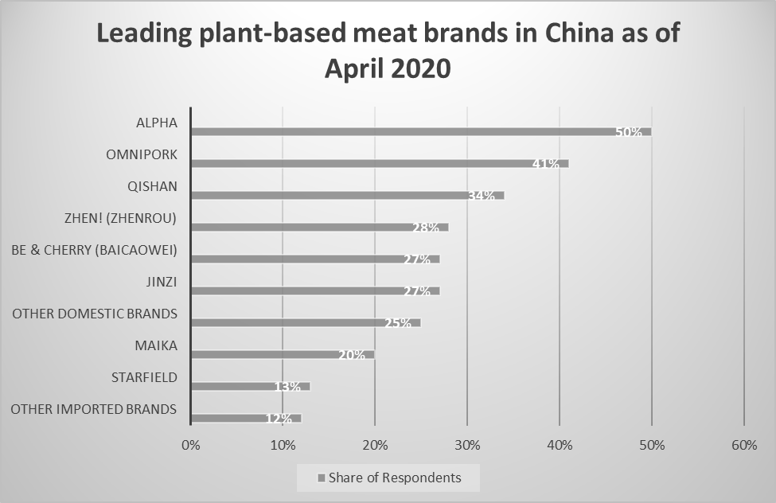
Chart 1 Leading plant-based meat brands in China as of April 2020. Source of information is from Ma (2021). The graphical chart was constructed by the researcher.

7.2 Major Market Barriers
In order to gain success in the immense China market with a population of 1.41 billion, Beyond Meat needs to identify what the major market barriers are before it can generate strategies to compete in a place with totally different business culture and sales infrastructure.

a. Cultural Misunderstanding
A positive statement made by a Westerner may be misconceived by Chinese as offensive, or vice versa. This is cultural misunderstanding. Another misunderstanding is the divergence of hierarchy. Westerners are much care-free and believe in equality. At a meeting, if a Chinese senior executive is arranged to sit beside a Western junior staff, the Chinese will feel humiliated, and the deal may be blown. Westerners entering the Chinese market must have strong localized knowledge of “dos and don’ts”.

b. Language Barrier
This is a great challenge to Westerners who cannot speak Putonghua. Many Chinese still cannot master English well, therefore to hire a good and competent translator is a must for Westerners to do business in China. A good translator does not only translate from words to words, but able to convey the right idea without misunderstandings. Effective communication is extremely important to business success.

c. Government Policies and Regulations
China’s government policies and regulations are the “must-know-well” before a Western company enters the market, especially in the registration of patents, trademarks and copyrights of products, which are highly different from those of the West. Labour Law is another area that must be cautious with. Furthermore, Chinese government have strict regulations about doing business in China and control capital in and out.

d. Hiring Talents
A joint-study by LinkedIn and Bain & Company (Globalization Partners, 2021) showed that China’s business leaders under age 35 quit working for multinational companies and move to work for local national companies at an extremely fast rate, as they see these local companies are having higher potential for long-term growth. Multinational companies are having difficulties in retaining talents.

e. Business Relationship
Relationship or “guanxi” with Chinese business counterparts takes time to establish, and will not start until trust has been built up. Most Chinese do not trust people, but they respect leaders with strong personalities and perseverance. Do not fall into a misperception that business relationship is governed by contracts; in China, it is driven by personal relationship, and very often, deals are closed at dining tables.

f. Consumers’ Distrust in Unknown Brands
Most Chinese are not early adopters of new products. Chinese consumers are paranoid with unknown brands as they used to live in a distrust environment overwhelmed with counterfeits in the past. Chinese even show doubt and disbelief in official reports on the press, but they believe in the comments of actual buyers who had used the products. Branding is everything in China, without a renowned brand name, new products cannot even find distributors or resellers. Distributors also check on e-platforms, forums and social networks to view how others commented on the new product before cooperation begins. Furthermore, if the brand does not sell well, distributors will quit right away to go for something more profitable.

g. Emergence of “He-Commerce”
Male consumers become the driving force of e-commerce in China, the old belief of “men hate shopping” was long-gone. New entrants to the China market must remove their mindset barriers and reconstruct promotion strategies to target this arisen group of pragmatic and rational male shoppers.

h. Fast Action
Chinese think fast, act fast and move fast, Westerners must adapt fast to these differentiations. There is no perfect business strategy for use in China, Westerners must make rapid decisions and then learn from mistakes, since Chinese has a culture of not afraid of failures. Westerners must break their psychological barriers to sustain in China.

7.3 Strategies for Overcoming Barriers
Barriers are obstacles to success. Overcoming barriers involves assessment of the market situation, consulting business experts, considering alternatives and to implement without hesitation. The following strategies are recommended for overcoming barriers in China.

a. Use a Holistic Approach to Understand China
Look at the China market as a whole interconnected entity, must understand the country’s full picture in history, economy, politics, international threats and its future visions. Not only to think of it out of the box, but to remove the box completely.

b. Find a Right Local Partner
Working with a local partner can eliminate most of the barriers in language, culture and geographic dispersion. But finding the right one is challenging and needs a lot of research.

c. Hire Local
China has lots of returnees studying overseas with high proficiency in English, and China has abundance of talents graduated from universities and colleges. In 2019, there were 7.6 million graduates from undergraduate programs, and over 640 thousand students graduated with post-graduate degrees.

d. Thorough Due Diligence
Carry out due diligence before signing any contracts in China, whether it is a lease, a supplier contract, a co-partnering agreement or an employment contract with senior staff. Protect the business from reputational risks and fraudulence.

8. Recommendations and Conclusion
As a brand, it is very important to be famous, big and stylish in China. Chinese people emphasize “face”, which is a status signified by using certain kinds of products or living in certain lifestyles that makes them look “rich”. International brands are highly appreciated by Chinese people and products from the West were perceived as luxurious, of high quality and reflecting a superior style of living; but these Western brand names have to be frequently shown on social digital media, implanted into the mindset of Chinese consumers, then they will be trusted.
Beyond Meat entered China shortly, and it is still exploring ways to survive and sustain. Currently, it adopts the same strategies as other plant-based meat business players are using in China. Co-partnering with famous food brands to sell products at their restaurants, liaising with supermarkets to sell uncooked plant-based meat, using digital platforms to promote and selling directly via Tmall and JD.com. It follows closely its competitors’ footprints; however, these strategies do not make Beyond Meat stand out from the crowd. It does not earn reputation fast enough to fight against new entrants like Hero Protein, who had recently won the TechNode Global’s 2020 ORIGIN Innovation Award.
As a strategic management consultant, the researcher would like to recommend Beyond Meat to use a mix of the following brand exposure strategies for protruding from the crowd in China.

Recommendations
a. Branding Strategy
China consumers rely heavily on digital information to make decisions of purchase. They research extensively on internet, reading comments on discussion forums, and trust only what their community said about a product. A new Western product entering China with fame does not mean it can thrive, a new brand with no branding means no business. Do not intend to target all Chinese in selling plant-based meat, research had shown that young, educated male with a decent job is the target group, they are willing to pay more for meat-substitutes which they perceive as contemporary and trendy. Build the brand around this group, post advertisements on platforms that they frequently visit and sell physical products to them in their neighbourhood. Show Beyond Meat on billboards and signages, anywhere that caught their eye-sight. Invite influencers or key opinion leaders to be spokespersons and talk about the products daily on TikTok, WeChat, Xiaohongshu, and Douyin, and place advertisements on Weibo, Youku and Baidu. A well-balanced mix of branding and advertisement will get customers to know the name of Beyond Meat.

b. Retail Brand Strategy
Open a Beyond Meat plant-based flagship restaurant in Shanghai - the city with highest population and grow fast as a world financial centre. Open a fancy and stylish vegetarian restaurant in famous shopping areas, such as Nanjing Road or Huaihai Road, the busiest streets in Shanghai. Surrounded the restaurant by a circle of fashionable branded merchandise. Use only Beyond “meat” as the main ingredient, brand-position the restaurant to create fusion dishes to suit the young and wealthy Millennial Generation Z. Hang an eye-catching Beyond Meat signboard outside the restaurant, connecting the brand to consumers and creating an image of luxury.

c. Brand Expansion
Expand the brand’s reputation and recognition by opening a new consumer touch point at Beyond Meet’s Jiaxing production plant, hold factory tours to promote the name of Beyond Meat. Jiaxing is about 85km away from Shanghai, travelling time on highway will be less than an hour. At the plant, setup a separate production line purposefully for the tour, surrounded by glass walls for safety. A good tour guide is necessary to explain in details about the flow of plant-based meat manufacturing processes, starting from receiving raw materials, all the way to packaging; and most importantly, to educate visitors the benefits of consuming meat-alternatives. At the end of the tour, treat visitors a Beyond Burger or Beyond Sausage, and visitors can purchase the plant-based products at its self-contained supermarket. Next to the showroom, build a nicely-decorated restaurant featuring Beyond Meat’s Chinese-flavoured gourmets, serve with protein drinks. This joyful experience will spread out as word-of-mouth, and form a cost-effective marketing strategy.

d. Left Long-term Strategies Behind
China is fast-changing, any products or business practices have to be re-evaluated in shorter cycles. Be fast to turn around with better and brighter ideas, and always bear in mind of the Product Life Cycle. When one product reaches the peak of growing stage, start innovating another product before the previous one goes mature. Remember that Chinese merchants copy fast, be ready to act fast in “China speed” and always be prepared for adversities.

Conclusion
Beyond Meat had made the right move to expand into China, but better to concentrate in Shanghai and Jiaxing to start with, and then later to Hong Kong, Shenzhen and Guangzhou. Once relationship is built, Chinese people are easy to work with. Put aside political prejudice, concentrate in business, no company can resist the attempt to make great profits in a fast-growing country.

Appendix

Calculations of Ratios and Indexes:

Liquidity Ratios:
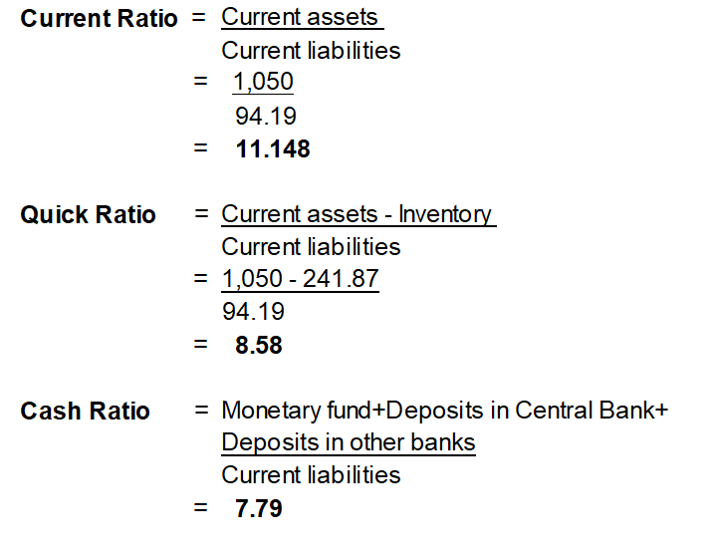

Leverage Ratios:
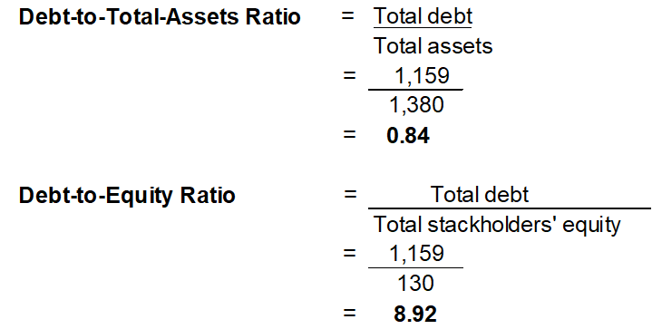

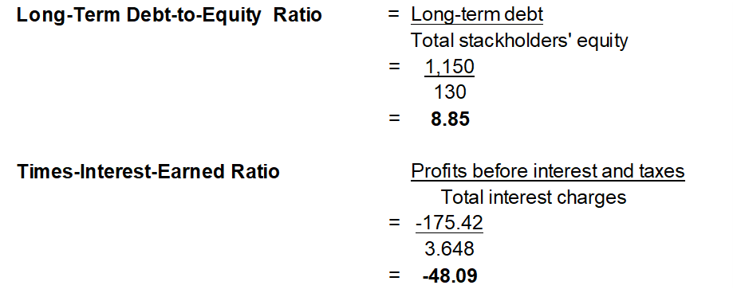

Activity Ratios:

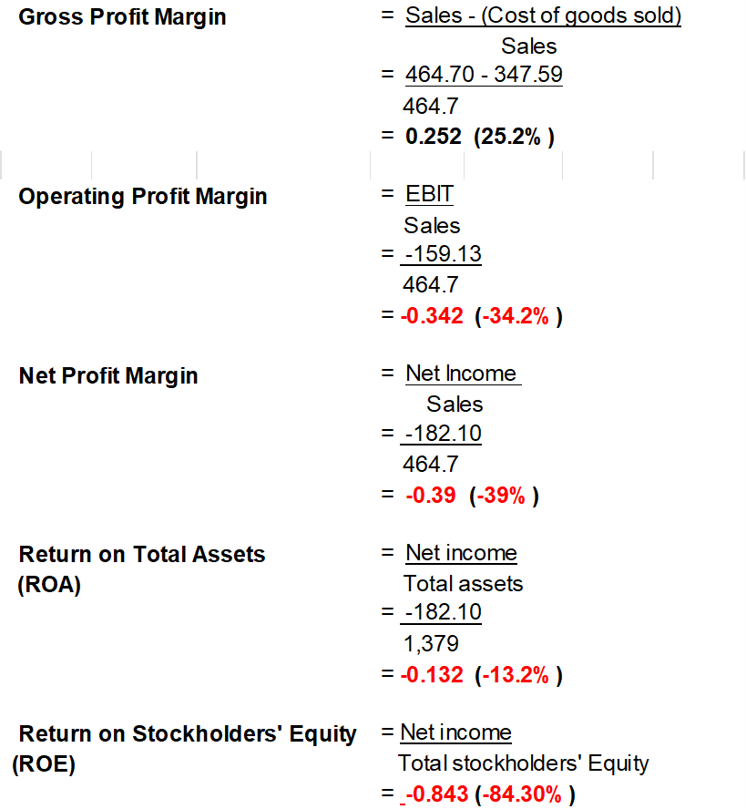
Profitability Ratios:

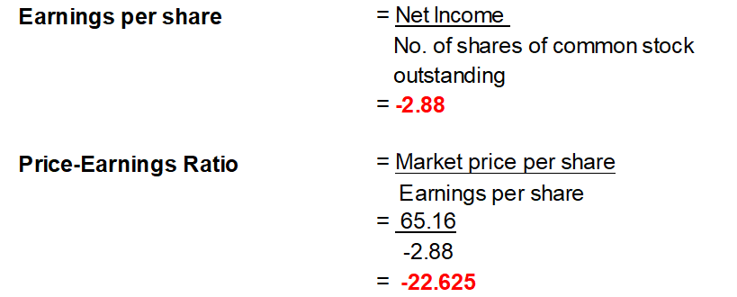

Growth Ratios:

The Growth Ratios were retrieved online.

References

Agnihotri, A. and Bhattacharya, S. (2020) ‘Beyond Meat: On the Route to Profitability?’ Ivey Business School Foundation, Version: 2020-04-29. Online. Available: Beyond Meat Case - Case study - 9B20M BEYOND MEAT: ON THE ROUTE TO PROFITABILITY? 1 Arpita Agnihotri - StuDocu [Accessed: 12th March, 2022]

Aguerrevere, A. (2019) ‘How Beyond Meat Uses Its Social Media To Attract Customers’. Wegacha Blog. Online. Available: How Beyond Meat Uses Its Social Media To Attract Customers | Wegacha [Accessed: 14th March, 2022]

Batini, N. (2019) ‘Transforming Agri-Food Sectors to Mitigate Climate Change: The Role of Green Finance’. Vierteljahrshefte zur Wirtschaftsforschung, ISSN 1861-1559, Duhcker & Humblot, Berlin, Vol. 88, Iss.3, pp. 7-42. Online< Available: Transforming Agri-Food Sectors to Mitigate Climate Change: The Role of Green Finance (econstor.eu) [Accessed: 9th March, 2022]

Barot, M. (2019) ‘Our Beef with the Beyond Burger’. KetoConnect. Online. Available: Our Beef With The Beyond Burger - KetoConnect [Accessed: 23rd March, 2022]

Besserve, E. (2020) ‘Beyond Meat: Analysis of a Successful Marketing Strategy’. Quinoa Marketing. Online. Available: Beyond Meat: Analysis of a Successful Marketing Strategy (quinoamarketing.com) [Accessed: 11th March, 2022]

Beyond Meat (2022) ‘Annual Reports’. Beyond Meat. Online. Available: Annual Reports | Beyond Meat, Inc. [Accessed: 13th March, 2022]

Brasier, Z. (2015) ’10 Negative Effects The Meat Industry Has On the World’. Our World. Online. Available: 10 Negative Effects The Meat Industry Has On The World - Listverse [Accessed: 13th March, 2022]

Bush, T. (2019) ‘Internal and External Analysis in Strategic Management (SWOT and PESTLE)’. PESTLE Analysis. Online. Available: Internal and External Analysis in Strategic Management (SWOT and PESTLE) (pestleanalysis.com) [Accessed: 10th March, 2022]

Choudhary, A. (2020) ‘Sustaining a First Mover Advantage in a Fast-Growing Meat Substitute Market’. Rutgers Business Review, Vol. 5, No.3, pp. 405-415. Online. Available: Microsoft Word - RBR 050311 set (rutgers.edu) [Accessed: 9th March, 2022]
CSIMarket (2021) ‘Food Processing Industry Financial Strength Information’. CSIMarket. Online. Food Processing Industry financial strength, leverage, interest, debt coverage and quick ratios (csimarket.com) [Accessed: 17th March, 2022]

CSIMarket (2022) ‘Food Processing Industry Profitability’. CSIMarket. Online. Available: Food Processing Industry Profitability, Gross Margin, Net Margin, Cash Flow Margin, ROE (csimarket.com) [Accessed: 17th March, 2022]

CSIMarket (2022) ‘Beyond Meat Inc. Management Effectiveness Comparisons’. CSIMarket. Online. Available: Beyond Meat Inc (BYND) Management Effectiveness Comparisons to Industry Sector and S&P (csimarket.com) [Accessed: 17th March, 2022]

FAS China Staff (2021) ‘Market Overview of Plant-Based Meat Alternative Products in China’. USDA Foreign Agricultural Service. Online. Available: DownloadReportByFileName (usda.gov) Accessed: [16th March, 2022]

Finkle, C. (2019) ‘Beyond Meat brand profile’. BMB. Online. Available: Beyond Meat: No more mystery for the plant-meat brand - BMB (brandmarketingblog.com) [Accessed: 12th March, 2022]

Food & Drink International (2021) ‘Tyson Foods debuts plant-based products in Asia’. Food & Drink International. Online. Available: Tyson Foods debuts plant-based products in Asia - FDI magazine (fdiforum.net) [Accessed: 10th March, 2022]

Furhmann, R. (2021) ‘Understanding Negative Return on Equity (ROE): Is It Always Bad?’. Investopedia. Online. Available: Understanding Negative Return on Equity (ROE): Is It Always Bad? (investopedia.com) Accessed: [17th March, 2022]

Ghate, A. (2020) ‘Beyond Meat: No Longer The Only Plant-Based Food Pure Play’. Seeking Alpha. Online. Available: Beyond Meat: No Longer The Only Plant-Based Food Pure Play (NASDAQ:BYND) | Seeking Alpha [Accessed: 9th March, 2022]

Globalization Partners (2021) ‘Doing Business in China: What to Know Before You Hire a Team’. Globalization Partners. Online. Available: Doing Business in China: What to Know Before You Hire a Team (globalization-partners.com) [Accessed: 1st April, 2022]

Hadi, J. and Brightwell, G. (2021) ‘Safety of Alternative Proteins: Technological, Environmental and Regulatory. Aspects of Cultured Meat, Plant-Based Meat, Insect Protein and Single-Cell Protein’. Foods, National Library of Medicine 2021 Jun; 10(6): 1226. Online. Available: Cited by ... - PMC (nih.gov) [Accessed: 22nd March, 2022]

Healy, W. (2020) ‘4 Challenges That Could Hurt Beyond Meat Stock’. The Motley Fool. Online. Available: 4 Challenges That Could Hurt Beyond Meat Stock | The Motley Fool [Accessed: 15th March, 2022]

Heller, M. C. and Keoleian (2018) ‘Beyond Meat’s Beyond Burger Life Cycle Assessment: A detailed comparison between a plant-based and an animal-based protein source’. Centre for Sustainable Systems – University of Michigan, Report No. CSS18-10. Online. Available: Beyond Burger LCA report v3.1 FINAL (umich.edu) [Accessed: 12th March, 2022]

Hirsch, L. (2018) ‘Beyond Meat vegan food company taps investment banks for IPO’. CNBC. Online. Available: Beyond Meat vegan food company taps investment banks for IPO (cnbc.com) [Accessed: 7th March, 2022]

Hu, F. B., Otis, B. O. and McCarthy, G. (2019) ‘Can Plant-Based Meat Alternatives Be Part of a Healthy and Sustainable Diet?’. 2019 American Medical Association. Online. Available: Can Plant-Based Meat Alternatives Be Part of a Healthy and Sustainable Diet? (hagstromreport.com) [Accessed: 12th March, 2022]

Issa, T., Chang, V. and Issa, T. (2010), ‘Sustainable Business Strategies and PESTEL Framework’. GSTF International Journal on Computing, Vol. 1, No. 1, August 2010. Online. Available: 2263 (globalstf.org) [Accessed: 11th March, 2022]

Jha, M. (n.d.) ‘What is the Altman Z Score?’. WallStreetMojo. Online. Available: (Altman Z Score (Meaning, Formula) | How it Predicts Bankruptcy? (wallstreetmojo.com) [Accessed: 20th March, 2022]

John, L. and Kirkinin, A. (2019) ‘The rise of plant-based “meats” and emerging legal issues’. Allens Linklaters 200. Online. Available: The rise of plant-based 'meats' and emerging legal issues (allens.com.au) [Accessed: 17th March, 2022]

Kaplan Financial Knowledge Bank (2020) ‘Strategic Choice’. Kaplan Financial Knowledge Bank. Online. Available: Strategic choice (kaplan.co.uk) [Accessed: 10th March, 2022]

Ketabchi, N. (2019) ‘Plant Power: A Look at Beyond Meat and Its Competitors’. Finance. Online. Available: Beyond Meat and the Competitive Landscape | Toptal [Accessed: 10th March, 2022]

Law, Ikigai (2021) ‘Labelling of Plant-Based Meats: Regulatory Landscape’. Ikigai Law.Online. Available: Labelling of Plant-Based Meats: Regulatory Landscape | Ikigai Law [Accessed: 15th March, 2022]

Leggate, J. (2020) ‘Beyond Meat doubles R&D spending, driving sales through partnerships’. FOX Business. Online. Available: Beyond Meat doubles R&D spending, driving sales through partnerships | Fox Business [Accessed: 15th March, 2022]

Liao, R. (2021) ‘Beyond Meat opens its first production plant in China’. TechCrunch. Online. Available: Beyond Meat opens its first production plant in China | TechCrunch [Accessed: 8th March, 2022]

Lockwood, A. (2021) ‘Vegan Meat Price Parity: Why Cost Not Kindness Will End Animal Agriculture'. Plant Based News. Online. Available: Vegan Meat Price Parity: Why Driving Down Cost Will End Animal Agriculture - Plant Based News [Accessed: 12th March, 2022]

Loria, J. (2018) ‘Animal Agriculture Wastes One-Third of Drinking Water (and eight Other Facts for World Water Day)’. Mercy for Animals. Online. Available: Animal Agriculture Wastes One-Third of Drinkable Water (and 8 Other Facts for World Water Day) - Mercy For Animals [Accessed: 21st March, 2022]
Ma, Y. (2021) ‘Most popular plant-based meat brands in China 2020’. Statista. Online. Available: • China: most popular plant-based meat brands 2020 | Statista [Accessed: 30th March, 2022]

Martin, P. (2021) ‘Plant-based food labelling: what the law says’. Food Manufacture. Online. Available: Vegan food labelling: what the law says (foodmanufacture.co.uk) [Accessed: 21st March, 2022]

McKinnon, T. (2021) ‘How Beyond Meat’s Marketing Strategy Set it Apart’. Indigo Digital. Online. Available: How Beyond Meat’s Marketing Strategy Set it Apart (indigo9digital.com) [Accessed: 16th March, 2022]

Mcinnis, T. (2020) ‘Beyond Meat is Wasting Its Advertising’. Better Marketing. Online. Available: Beyond Meat is Wasting Its Advertising | by Toby Mcinnis | Better Marketing [Accessed: 18th March, 2022]

Meticulous Research (2022) ‘Top 10 Companies in Plant Based Food Market’. Meticulous Research. Online. Available: TOP 10 COMPANIES IN PLANT BASED FOOD MARKET (meticulousblog.org) [Accessed: 7th March, 2022]

Mirzakhani, M., Parsaamal, E., and Golzar, A. (2014) ‘Strategy Formulation with SWOT Matrix: A Case Study of an Iranian Company’. Global Business and Management Research: An International Journal. Vol.6, No. 2 (2014). Online. Available: Vol. 4 No. 3 (gbmrjournal.com) [Accessed: 22nd March, 2022]

Montague, S. (1999) ‘Beyond Balanced Scorecards’. Performance Management Network Inc. Online. Available: Beyond-Balanced-Scorecards.pdf (pmn.net) [Accessed: 14th march, 2022]

Montague, B. (2018) ‘Governments must tackle meat over-consumption’. Ecologist. Online. Available: Governments must tackle meat over-consumption (theecologist.org) [Accessed: 15th March, 2022]

Moran, C. (2021) ‘How Does Beyond Meat Make Money?’. MyWallSt. Online. Available: How Does Beyond Meat Make Money? | MyWallSt (dypao.com) [Accessed: 23rd, March, 2022]

Negulescu, O. (2014) ‘Using a Decision-making Process Model in Strategic Management’. Review of General Management, Volume 19, Issue 1, Year 2014 [1]. Online. Available: Microsoft Word - Revista nr. 1 2014-pag.doc (managementgeneral.ro) [Accessed: 9th March, 2022]

Neo, P. (2021) ‘Plant-based innovation in Asia: Localisation, health, taste and affordability top drivers of industry growth and evolution – Growth Asia panel’. FOOD navigator-asia.com. Online. Available: Plant-based innovation in Asia: Localisation, health, taste and affordability top drivers of industry growth and evolution – Growth Asia panel (foodnavigator-asia.com) [Accessed: 11th March, 2022]

Nestle, M. (2021) ‘Keeping up with the plant-based food product industry’. Food Politics. Online. Available: Food Politics by Marion Nestle - Page 9 of 507 – [Accessed: 11th March, 2022]

Newton, P. and Blaustein-Rejto, D. (2021) ‘Social and Economic Opportunities and Challenges of Plant-Based and Cultured Meat for Rural Producers in the US’. Frontiers in Sustainable Food Systems. Online. Available: Frontiers | Social and Economic Opportunities and Challenges of Plant-Based and Cultured Meat for Rural Producers in the US | Sustainable Food Systems (frontiersin.org) [Accessed: 16th March, 2022]

Ng, A. (2020) ‘The plant-based meat industry has grown into a $20 billion business – but challenges remain’. CNBC. Online. Available: The plant-based meat industry is on the rise, but challenges remain (cnbc.com) [Accessed: 15th March, 2022]

Papalexandris, A. et al. (2005) ‘An integrated Methodology for Putting the Balanced Scorecard into Action. European Management Journal. 23.2 (2005): 214-227. Online. Available: (1) (PDF) An Integrated Methodology for Putting the Balanced Scorecard into Action | Gregory Prastacos, George Ioannou, and Alexandros Papalexandris - Academia.edu [Accessed: 15th March, 2022]

Pevreall, K. (2019) ‘93% of People Buying the Beyond Burger are Meat Eaters’. Livekindly. Online. Available: 93% of People Buying the Beyond Burger are Meat Eaters (livekindly.co) [Accessed: 14th March, 2022]

Popa, V. and Topolică M. (n.d.) ‘Supply Chain Performance and Collaborative Management by Balanced Scorecard’. Valahia University of Tărgovişte. Online. Available: Supply Chain Performance and Collaborative Management by Balanced Scorecard Proceeding 2009.pdf [Accessed: 15th arch, 2022]

PWC (2015) ’Internal audit strategic planning – Making internal audit’s vision a reality during a period of rapid transformation’. PwC 2015 State of the Internal Audit Profession Study. Online. Available: NY-13-0427_SOTP_v2 (pwc.com) [Accessed: 9th March, 2022]

Quast, J. (2020) ‘Beyond Meat’s Price Approaches that of Real Beef’. The Motley Fool. Online. Available: Beyond Meat's Price Approaches That of Real Beef | The Motley Fool [Accessed: 12th March, 2022]
Quast, J. (2021) ‘3 Differences Between Beyond Meat and Impossible Foods’. The Motley Fool. Online. Available: 3 Differences Between Beyond Meat and Impossible Foods | The Motley Fool [Accessed: 10th March, 2022]

Reinicke, C. (2019) ‘Beyond Meat costs more than traditional meat, but data show consumers are willing to pay the premium price – for now’. Markets Insider. Online. Available: Beyond Meat Sales Are High, but so Is Price Compared to Competitors (businessinsider.com) [Accessed: 11th March, 2022]

Reinicke, C. (2019) ‘Experts say watch these 5 companies clamoring to join the plant-based “meat” market dominated by Beyond Meat’. Markets Insider. Online. Available: Beyond Meat Competitors: 5 Other Plant-Based Meat Market Players (businessinsider.com) [Accessed: 12th March, 2022]

Roquette (2020) ‘Beyond Meat and Roquette announce multi-year pea protein supply agreement’. Roquette. Online. Available: Beyond Meat® and Roquette announce multi-year pea protein supply agreement - Corporate | Roquette [Accessed: 14th March, 2022]

Sarath (2020) ‘Company Valuation: Financial Ratios by Industry’. EQVISTA. Online. Available: Company Valuation: Financial Ratios By Industry | Eqvistra (eqvista.com) [Accessed: 17th March, 2022]

Schönberger, D. (2022) ‘Beyond Meat: Still No Investment’. Seeking Alpha. Online. Available: Beyond Meat Stock _ Still No Investment (NASDAQ _ BYND) _ Seeking Alpha [Accessed: 14th march, 2022]

Sexton, A. E., Garnett, T. and Lorimer, J. (2019) ‘Framing the future of food: The contested promises of alternative proteins'. Nature and Space, 2019, Vol.2(1) 47-72. Online. Available: Framing the future of food: The contested promises of alternative proteins (sagepub.com) [Accessed: 11th March, 2022]

Smith, K. (2022) ‘Can Food Giants and Vegan Brands Really Be Friends?’. Livekindly. Online. Available: Can Food Giants and Vegan Brands Really Be Friends? (livekindly.co) [Accessed: 12th March, 2022]

Smith, K. (2022) ‘Beyond Meat Is Opening a Major Production Facility in China’. Livekindly. Online. Available: Beyond Meat Is Opening a Major Production Facility in China (livekindly.co) [Accessed: 12th March, 2022]

Starostinetskaya, A. (2022) ‘Panda Express is testing new vegan dishes made with Beyond Beef, extending its partnership with Beyond Meat beyond vegan orange chicken’. VegNews. Online. Available: Panda Express Expands Beyond Meat Partnership with Two New “Beefy” Dishes. Here’s Where to Find Them. | VegNews [Accessed: 21st March, 2022]

Szejda, K. and Parry, J. (2020) ‘Strategies to Accelerate Consumer Adoption of Plant-Based Meat’. The Good Food Institute. Online. Available: FINAL-Consumer-Adoption-Strategic-Recommendations-Report.pdf (gfi.org) [Accessed: 27th March, 2022]

Terazono, E. (2022) ‘Beyond Meat takes a beating as plant-based sector reports slowing sales’. Financial Times. Online. Available: Beyond Meat takes a beating as plant-based sector reports slowing sales | Financial Times (ft.com) [Accessed: 20th March, 2022]

Trading View (2022) ‘Beyond Meat, Inc’. Trading View. Online. Available: BYND Stock Price and Chart — NASDAQ:BYND — TradingView [Accessed: 13th March, 2022]

Trainer, D. (2020) ‘Competition Will Eat Beyond Meat Alive’. Forbes. Online. Available: Competition Will Eat Beyond Meat Alive (forbes.com) [Accessed: 12th March, 2022]

Van Loo, E. J., Caputo, V. and Lusk, J. L. (2020) ‘Consumer preferences for farm-raised meat, lab-grown meat, and plant-based meat alternatives: Does information or brand matter?’. Food Policy 95 (2020) 101931. Online. Available: Consumer preferences for farm-raised meat, lab-grown meat, and plant-based meat alternatives_ Does information or brand matter? (sciencedirectassets.com) [Accessed: 10th March, 2022]

Watrous, M. (2019) ‘Beyond Meat C.E.O. sees “endless” sources of plant protein’. Food Business News. Online. Available: Beyond Meat c.e.o. sees ‘endless’ sources of plant protein | 2019-07-31 | Food Business News [Accessed: 14th March, 2022]

Wiseman, A. (2016) ‘84% of Vegetarians/Vegans Return to Eating Meat. Why?’. LinkedIn. Online. Available: 84% of Vegetarians/Vegans Return to Eating Meat. Why? (linkedin.com) [Accessed: 20th March, 2022]
WSJ Markets (2022) ‘Beyond Meat Inc. (BYND)’. WSJ Markets. Online. Available: BYND | Beyond Meat Inc. Annual Income Statement - WSJ [Accessed: 13th March, 2022]

Yahoo! Finance (2022) ‘Beyond Meat, Inc. (BYND)’. Yahoo! Finance. Online. Available: Beyond Meat, Inc. (BYND) Stock Price, News, Quote & History - Yahoo Finance [Accessed: 13th March]

Yau, E. (2019) ‘China’s plant-based alternatives to take on Beyond Meat, Impossible Foods – and the world’. South China Morning Post. Online. Available: China’s plant-based alternatives to take on Beyond Meat, Impossible Foods – and the world | South China Morning Post (scmp.com) [Accessed: 12th March, 2022]

Zhang, M. (2020) ‘The rise of plant-based meat in China’. SupChina. Online. Available: The rise of plant-based meat in China – SupChina [Accessed: 29th March, 2022]

Zhang, P. (2021) ‘Beyond Meat Expanded into China’. Marketing Right Now. Online. Available: Beyond Meat Expanded into China. The major obstacle facing Beyond Meat… | by Panxinyue Zhang | Marketing Right Now | Medium [Accessed: 21st March, 2022]

Zhang, S. et al. (2021) ‘A Systematical Method to Evaluate Omnipork’s Market Competitiveness Ability’. Advances in Economics, business and Management Research, volume 190. Online. Available: 125961038.pdf [Accessed: 11th March, 2022]

Available online @ • Plant-based food market value worldwide 2030 | Statista
Available online @ Food Companies Compete For US$16 Billion Asian Plant-Based Meat Market (greenqueen.com.hk)
Plant-based meat competitors include Tyson Foods, Nestlé, Danone SA, Amy’s Kitchen Inc., Impossible Foods, Axiom Foods Inc., Hain Celestial Group, Inc. and Garden Protein International Inc. and so forth.
Some well-known investors, such as Bill Gates, had invested in Beyond Meat, Impossible Foods and Memphis Meats – a cultured meat company. The Asian investor Li Ka Shing had also invested in Impossible Foods, and became major investors together with Bill Gates. Tyson Foods once owned 5% of Beyond Meat’s share, but sold them all before Beyond Meat was listed, with the desire to produce its own made-made meat.

