DISSERTATION PROPOSAL

An investigation into the role of Police, Fire and Ambulance responding to major incidents

Introduction – Research Background
Over recent years, the general public of the United Kingdom have been victim to a phenomenal increase in major incidents. Due to this, the UK’s emergency services have sustained a dramatic increase in joint emergency service attendance at major incidents.
The UK is heavily dependent on their emergency service personnel and up until recent years, joint attendance of all services has been intermittent. The UK has one of the world’s leading emergency services, and research indicates that there has been an increase in 999 calls for all services over the past few years. “New figures released to mark Emergency Services Day show that the volume of calls has increased from around 25 million a year in 2000, to 33 million today” (techradar.pro).
Due to the increase in major incidents, such as terrorist attacks, it became apparent that a programme would need to be set up in order to improve the way police, fire and ambulance respond to major incidents together. This programme was named, The Joint Services Interoperability Programme (JESIP) and was set up in 2012. It provides a joint working strategy to major incidents, known as the JESIP principles for joint working. JESIP was set up due to the fact that emergency services were under huge scrutiny due the way they dealt with major incidents. One example of this would be the London 7/7 bombings. Having researched into this, it appears that the main issues were lack of communication and understanding between the three services.
Below is a joint working model set out by JESIP to help with communication and knowledge between the three services at major incidents (figure 1).
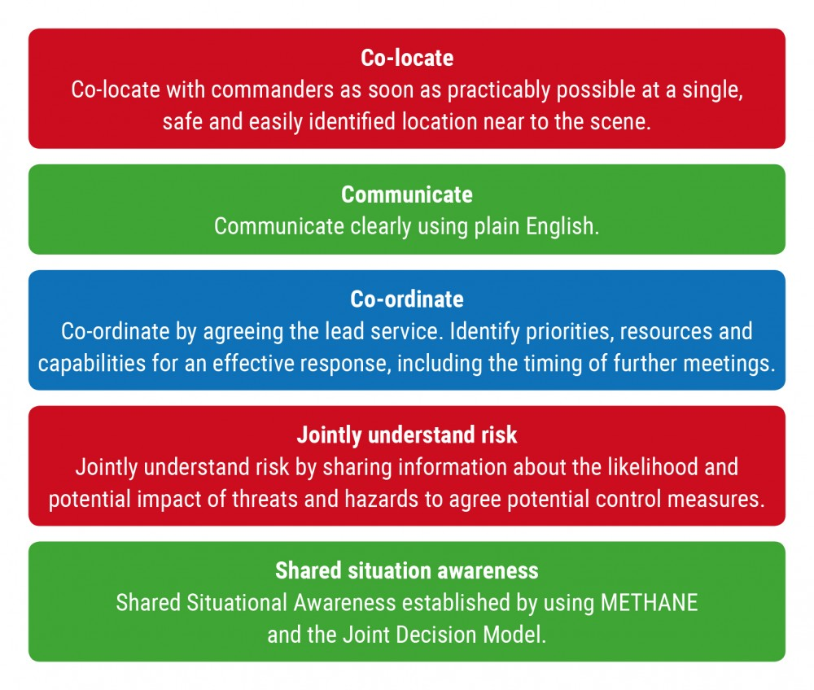
Figure 1 – Joint Working Model
(Source: JESIP)

Research Rationale

The objective of this research is to investigate the knowledge and understanding of the Fire, Police and Ambulance service and to improve communication skills between them when attending major incidents. Each emergency service is unique in the sense that they have their own priorities at emergency calls and therefore, have their own models to follow when attending these incidents. These models provide the relevant pointers for the police officer, fire fighter and ambulance crew to follow in order to provide the best possible outcome at a call. As well as these individual models, JESIP have made a joint model which include the 5 principles stated above.
Organised groups who plan crimes such as terrorist attacks are becoming ever more sophisticated, enabling them to execute more precise and damaging attacks, for example, the Manchester bombing. Therefore, this research will also consider the increase in attacks such as the 7/7 bombings in London and more recently the Manchester bombings and the correlation of demand on the emergency services attending these calls. The purpose of this research is to attempt to answer the following question:
- An investigation into the role of Police, Fire and Ambulance responding to major incidents.
The justification for this research is to investigate previous joint attendance at major incidents with Fire, Police and Ambulance and establish what issues arose such as lack of communication and understanding of each services role, what could have been done better and what went well as well as considering the possibility of joint training. Therefore, research will include speaking with members of each service to establish what percentage of staff feel joint training days simulating a major incident and how services communicate will be beneficial.

Research Methodology
The Cambridge dictionary defines research as “a detailed study of a subject, especially in order to discover (new) information or reach a (new) understanding”. (Cambridge dictionary). “There are a variety of approaches to research in any field of investigation, irrespective of whether it is applied research or basic research. Each particular research study will be unique in some ways because of the particular time, setting, environment and place in which it is being undertaken” (iEduNote).
“Survey Any Place” defines a questionnaire as “an instrument for collecting data, which almost always involves asking a given subject to respond to a set of oral or written questions” (Survey Anyplace). Questionnaires would be one of the best research methods for this study because they will be inexpensive, anonymous and can be produced online and emailed out to the target audience for quick responses.
Although there are many positives to questionnaires, this style of research can have some downsides. For example, participants may misread or misunderstand the questions being asked due to lack of human contact when answering. Along with this, some participants may not have access to computers, therefore questionnaires may have to be posted, leading to costs and lengthy time delays.
Overall, I feel the positives out way the negatives and the information gained by this type of research would be hugely beneficial and reliable.
Another form of research to take into consideration would be interviews. Business research methodology defined interviews in research terms as “Interviews can be defined as a qualitative research technique which involves “conducting intensive individual interviews with a small number of respondents to explore their perspectives on a particular idea, program on situation” (Business Research Methodology). There are a number of varying types of interviews; Unstructured interviews, Semi-structured Interviews and Structured Interviews.
I have used unstructured interviews to conduct some research which has enabled me to establish a focus area, such as communication and JESIP. I won’t be using this style of interview going into my dissertation as the results will be too unreliable. Although semi-structured interviews can be less reliable than structured interviews, they may be beneficial as one to one interviews with relevant personnel from Police, Fire and Ambulance as it may lead to some unplanned conversations, resulting in some useful information being extracted. Structured interviews will best suit my research method as I can compare the results easier between the three service areas. This would be the most effective use of interview as specific and precise questions can be asked, as well as this I can monitor the amount of questions asked to prevent lack of interest.
When conducting any interview, it is important to create a friendly, non-threatening atmosphere whilst stressing the importance of the participants. There is a risk of interviewee bias during the primary data collection process which could compromise validity. However, this can be avoided by not overreacting to responses.

Reliability and Validity

A number of research methods will be used when conducting this proposal and final dissertation. The research methods will help me produce a balanced and unbiased view throughout the study. With the study that I am considering, it is important to understand and consider that qualitative research such as interviews are vital in gaining an in-depth understanding. However, these type of research methods can be bias due to personal opinion on the matter. Therefore it will be crucial to ensure that the questions asked will not be leading in anyway and that there will be a wide range of interviewees selected.
Attending emergency services meetings, such as police, fire and ambulance briefings and or debriefings on major incidents if possible would be extremely beneficial. This would provide useful research involving problem solving techniques between services. This will enable me to analyse possible issues of communication and knowledge between services. However, this could also lead to bias from each services as they believe their duties were performed to a high standard were others are looking for a service to blame.
Questionnaires are useful in gathering quantitative data and general understanding. The questions will be targeted towards the understanding of each services role and their priorities, as well as whether they are aware of the others roles and priorities at a major incident. As well as this, questions will be asked around the benefit of joint training and if they deem it useful. It is hoped that this will enable a core understanding of the current and future knowledge and understanding of emergency services jointly attending major incidents. However, consideration must be taken as questionnaires can often be a result of how someone is feeling at the time of completion.
Resources and Time Management

As time is limited due to work, family and training commitments, it is vital to establish an approximate timeframe to carry out all the relevant research and analysis I need in order to produce this study. Therefore, I have made a table in order to help me stay on track with the amount of work I need to complete and how I am going to complete it. Along with time frames and outcomes I anticipate to get from the study. Please see Figure 2.

Project name | Components | Timeframe | Expected cost | Outcome
Dissertation |  | Submission: 29/11/2021 | Travel cost to interviews &printing cost of questionnaires | Meeting with dissertation mentor.
Proposal |  | Completed by 17/05/2021 | Travel cost to initial meetings | Produce aims, objectives & methodology
Literature review | Carry out initial research into JESIP & service communication.  Compile interview questions &  Construct questionnaires | Submission:  26/07/2021 | Printing cost | Establish that the area is sufficient to research.  Relevant interview and questionnaires.
Analysis of results | Analyse interview/ questionnaire results | Submission: 04/10/2021 | Travel to interviews | Reliable results from both questionnaire and interviews
Findings and conclusion | Produce conclusion of results obtained | Submission:  01/11/2021 |  | Completed by submission date

Figure 2 – Time Management Table

As well as using the above table, it is essential that I form a bond with my mentor which will enable me to access all the support needed. This will be in addition to the continued access of the UWTSD online resources and the internet. An in-depth research into to history of joint emergency service attendance and communication at major incidents will be essential as well recent incidents. Therefore, it is vital to allow time for this research to be gathered and cost elements of travel to conduct interviews and deliver questionnaires. Survey Monkey will be used however, if issues arise with email contacts, the questionnaires may need to be posted which will require more time and additional costs.

(1650)

References
Techradar.pro, BT marks emergency services day with new data on 999 calls. By Steve McCaaskill. Available at: https://www.techradar.com/uk/news/bt-received-105000-emergency-999-calls-a-day-during-lockdown - Accessed 08/05/2021

JESIP, Joint Working Model, The Five Principles. Available at: https://www.jesip.org.uk/five-principles - Accessed 08/05/2021

Cambridge Dictionary, research, B1. Available at: https://dictionary.cambridge.org/dictionary/english/research - Accessed 10/05/2021

iEduNote, Reseacrh Process: 8 Steps in Research Process. Available at: https://www.iedunote.com/research-process - Accessed 11/05/2021

Survey Anyplace, 10 Advantages and disadvantages of questionnaires, what is a questionnaire. Available at: https://surveyanyplace.com/blog/questionnaire-pros-and-cons/ - Accessed 11/05/2021

Business Research Methodology, Interviews. Available at: https://research-methodology.net/research-methods/qualitative-research/interviews/ - Accessed 13/05/2021

