vascular dementia

There are very small blood vessels in our brain which carry blood to the subcortical area of the brain when narrowing occurs in the mentioned tiny vessels causing vascular dementia. NHS (2020)

  - Mental Disorders



Assessment 1

Supporting Paper

Student name: Erkan Paca
Student ID: 2010132
Module name: Mental Disorders and Psychopathology
Module code: BMHP6006
Lecturer name: Bianca Sanfilippo
Date: 10/12/2022

Table of Contents
INTRODUCTION 1-3
Data and causes of vascular dementia 3-7
Symptoms, signs, with historical perspective and current treatment……………………………………………………………………………………………7-9
Principles when working with people with Vascular dementia……………………………………………………………………………………………...9
Recommendation & Conclusions…………………………………………………………………………………………9
References…………………………………………………………………………………………...9
Appendix…………………………………………………………………………………………….10

Introduction

What is mental health disorder? General Definition of mental health disorder and a brief overview of the UK context?

- Mental Disorders;
‘A mental disorder is characterised by clinically significant disturbances in an individual’s cognition, emotional regulation, or behaviour. It is usually associated with distress or impairment in important areas of functioning.’ (WHO, 2022).
On the other hand, the Mental Health Act defined mental disorder as ‘any disorder or disability of the mind’. (NHS, 2022).
In the UK, the 1983 Mental Health Act was designed to have the prospective aim for the right of a person in a legal aspect defined as their admission, detention and treatment can be decided without their consent. In time the act was rectified in 2007 in a clear and structured way to support patients in their therapy. And the Mental Capacity Act 2005 was created to guard and empower individuals who may lack cognitive abilities to make decisions and for therapy purposes aged individuals who are 16 years and over. (NHS, 2022).
Not only in the UK but globally the effect of mental health issues growing rapidly. Ethnically the level of mental health sufferers differs between African men who have a dark complexion and Caucasian counterparts where African men have more psychotic disorders and are predicted four times more to be restrained than white ethnicity. On the other hand, it is predicted that south Asian females are more threat to commit to ending their life. People seeking asylum have shown high-level of depression, anxiety and PTSD.
Furthermore, less self-harm or suicide among Asian and Chinese than compare to Caucasians. Societal inequalities can have an impact on mental health issues, particularly within Black, Asian and Minor Ethnic cohorts. In some cultures, mental health stigmas are often displayed widely due to embarrassment or rather shame. Therefore, recognising the issues such as language obstacles or community-based support is important to overcome the challenges. In that respect locally Mind charities have been set up to assist people in due course. (Mental Health Foundation, 2021).

Vascular dementia within the ICD-10 Manual Chapter V:

‘It belongs to the group of Organic, including symptomatic, mental disorders (F00-F09).
Classification: F01, Vascular Dementia’. (ICD-10 Version, WHO, 2019).
‘Vascular dementia is caused by an obstruction of the circulation to the brain as a result of vascular disease that includes cerebrovascular and hypertensive ailments. Obstructions are usually minor but progressive in their impact’. (ICD-10 Version, WHO, 2019).

Vascular dementia;
Vascular dementia is a form of dementia induced by decreased blood circulation to the brain. (NHS, (2020).
Also defines as, the interruption to blood vessels by many conditions impacting the blood flow to the brain where a person loses cognitive abilities in general. (National Institute on Aging, 2021).

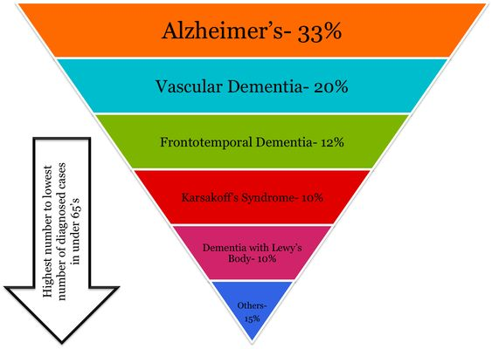(Microsoft Bing, Image 1).

Vascular dementia statistic in the UK
The second highest dementia type affects every 100 individuals who suffer from dementia, and, 20 of these will be affected by vascular dementia. (Alzheimer’s Research UK, 2021). The UK figure states that 150.000 people are affected by the ailment. (NHS,2020). Nationally the country will face challenges with almost 1 million individuals clinically diagnosed with dementia prospectively. Nearly most of us will have someone we know to experience this ailment in future. (Dementia, 2021).
It is only several decades ago Alzheimer’s disease was recognised as causing element of dementia but currently despite being in the 1900s the prime cause of dementia was perceived to be related to vascular impairments and there are many forms of dementia recently. (Jelinger, 2006).
Vascular dementia is diversified as a cohort of brain disorders in which cognitive damage is accountable for cerebrovascular diseases as well as other additional factors that cause the ailment such as Alzheimer’s and other neurodegenerative ailments. (Gorelick et al. 2011).

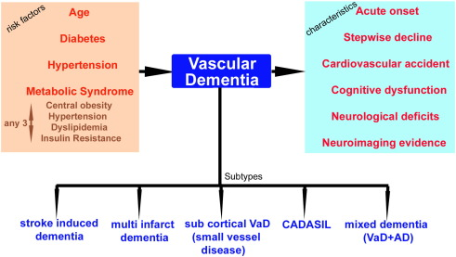
Fig. 1. (Venkat et al, 2015) Summarizes the risk factors, subtypes and characteristic features of VaD.

Causes:

Many risk elements are associated with Vascular dementia below the ailments that can trigger the ailment.

Diabetes
Diabetes has been proven to be a significant threat component for VaD (Vascular dementia), (Xu W, et al, 2009) and more or less can double the threat of dementia. (Ott A, et al.1999). Even people at risk of diabetes can have a risk of mid-cognitive decline resulting in dementia. (Xu W, et al. 2010) particularly within the age range of <65 years, and the progressive threat is higher than Alzheimer’s disease at 76,8 years. ((Xu W, et al, 2009) and consequently maximises the threat of stroke. (Idris et al, 2006). Moreover, it damages the arterial connection in the cerebral region as the white matter supplies to subcortical areas of the brain. (You R et al. 1995) where a significant deterioration can be seen particularly after a stroke. (Weir CJ, et al. 1997).
Additionally, ischemic or haemorrhage bleeding in the brain results in strokes and is described as ‘TIA’s, (Transient Ischemic Attacks), which contribute to an impairment in the brain cells. As a result of this unanticipated occurrence in the cerebral area, the individual’s recovery is either very minor or non- whatsoever and is described as the plateaued effect. As the gradual changes are now inevitable and impacting impairments in the brain restricting an individual’s abilities anatomically and cognitively in a prospective manner. (Dementia, 2021).
Hypertension:
As we get older the threat becomes inevitable, especially the threat of hypertension. (Anderson GH, et al.1999) which then consecutively be a threat component for vascular dementia. (Kennelly et al. 2009). Middle-aged individuals who are <54 and with hypertension if not appropriately treated they carry the threat of getting the early sign of Alzheimer’s disease, particularly after 25-30 years of duration. (Yamada M et al. 2003). Therefore, treating hypertension is fundamental to preventing VaD accordingly. (Tzourio C, et al. 2003).
Metabolic Syndrome (Mets):
This can be defined as multimorbidity where people who suffer from multiple conditions such as cardiovascular threat elements that include obesity, high blood pressure, and cholesterol (HDL) if not properly treated in a timely manner can cause significant damage to a person cognitively for dementia and condition deepening. (Solfrizzi et al. 2011).
Evaluation of Cognitive dysfunction:
Figure 2 (Venkat et al, 2015) below outlines the numerous elements impacting cognitive decline in vascular dementia patients.

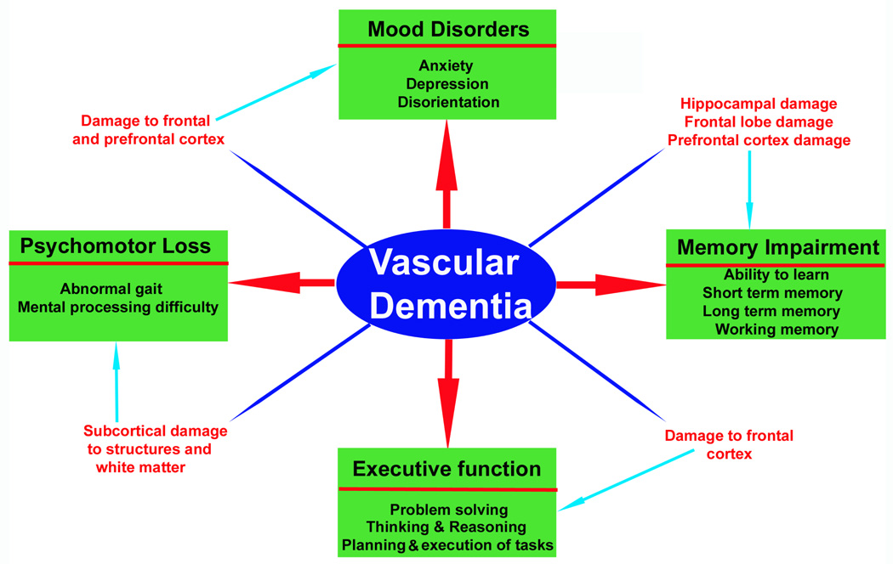
And elaborated as ICD-10 (10th revision of the international classification of diseases) along with DSM-IV (Diagnostics & Statistical manual of mental disorders, 4th EDT.) with ADDTC (Alzheimer’s Disease Diagnostics & Treatment Centre). (Lee AY, 2011). and (Wetterling et al, 1996).

Symptoms/signs:
These can be a confused state of mind, communication obstacles, memory issues, lack of speech, problems with mobility and balance, mood swings, personality disorders and cognitive decline. (Being Patient,2022).
Alongside, the commencement can either be sudden or gradual in progression. It gets worse over time but a certain approach to treatment can slow the ailment.
Initial signs can be concluded as:
- Slower thought process
- Unable to make any commitment of planning
- Lack of understanding
- Concentration issues
- Obstacles with memory and speech.
Initially, these issues hardly are perceptible or misguided for another condition as depression. Indications point out that some damage already occurred and that therapy will be needed.
Later on, in time the progression becomes severe either occurring gradually or unexpectedly, This, purely relies on the part of the brain that is impacted on. These signs are;
- Sluggish thinking process
- Confused or disorientation of the mind
- Lack of memory span or concentration
- Unable to find the right vocabulary
- Insufficient willingness and depression
- Falls, inability to walk or balance
- Being incontinence
- Unable to do daily tasks. (NHS, 2020).

Diagnosis;
Multiple tests for vascular dementia include; Complete medical histories such as strokes & high blood pressure and high cholesterol alongside evaluation of mental capabilities.
Brain scans such as MRI & CT will enable to detection of changes in the brain. NHS (2020).
Blood & urine samples eliminate the symptoms of thyroid, infection or other hormonal imbalances. (Stroke Association 2022).

Historical view and treatments for:

The cases were detected in 1672 and emphasised by Thomas Willis. In this, the first episode of VaD presented with his book called stroke emphasises and separates mental retardation from dementia. And he discovers different cases of dementia which is caused by head injury, alcoholism, utilising drugs and prolonged levels of epilepsy. (Roman, 2003).
In the 18th & 19th centuries, it is diagnosed as “brain congestion” due to high blood pressure caused by the condition when left untreated.
Bloodletting was the treatment method utilized widely. In 1894 Otto Binswanger & Alois Alzheimer first divided vascular dementia from venereal diseases. (STD).
In 1960, ground-breaking studies began at New Castle school in England leading to the new modern age of vascular dementia. (Roman,2003).

Current treatments:
Unfortunately, there is no cure for this medical condition or a path to alter the destruction already caused to the brain. (NICE,2022).
Before the therapy begins the current and future health and social care involvements need to be evaluated. Support of independent living, empowerment and personalised care of assistance whether the care at home or in care homes alongside financial supportive assistance. (NHS, 2020).
Preventing further impairment of the brain in individuals with vascular dementia may stabilise its progression. (NHS,2020).
Therefore, lifestyle changes will support individuals medically to have more outcome-focused quality of life along with healthy nutrition and low salt intake to stabilise high blood pressure will be fundamental.
Weight control, smoking cessation, reducing alcohol consumption, and being more active would make people benefit from a healthy lifestyle holistically.
Supported therapies such as Occupational therapy to find pragmatic solutions to getting dressed or undressed, altering necessary changes at home installing rails, bars, and holders to ensure that the environment is safe and free from hazards (Well-lit)., speech & language therapy to assist patients to communicate, physiotherapy with mobility issues, and psychological therapies can enhance cognitive abilities by improving memory span, problems solving skills and language. Involve them socially so that they will not suffer from loneliness. (NHS,2020).
Utilising Medication;
Slowing down the condition with medication such as treating high blood pressure, and high cholesterol with statin even low-dose of aspirin or clopidogrel can reduce the threat of blood clots or further damage such as stroke. There are several other medications that can be utilised if patients suffer from Alzheimer’s too depending on their mental stability. (NHS,2020).

Principles when working with people in Vascular dementia:
Suitable communication style and patience & calmness are essential.
Adjust the tone and level of your voice when necessary. Creating respective distance by lowering your level with patients can make them feel secure. Active listening, and eye contact, allow no room for disruption or distractions. Human touch can provide self-efficacy. Active listening, and eye contact endeavour not to disrupt and reduce the level of distraction as much as possible. (NHS,2020).
Recommendations for the improvement of the symptoms:
The person-Centre Care approach is essential when Involving dementia people in decisions making and should be aligned with their personalised care.
Provide dignity, choice, and shared decision-making.
Mental Capacity Act 2005, this act supports individuals 16 years and over who may be lacking mental capabilities.
Equality Act 2010 enables their legal rights in a holistic way by protecting them from any type of discrimination.
The Care Act 2014 enables local government departments to safeguard adults as a responsibility.
The Human Rights Act of 1998 supports people in participating in decision-making.
Interventions to promote cognition, independence and well-being.
Also, offer group cognitive stimulation for mild-moderate dementia along with cognitive rehabilitation programs, particularly ones with mobility issues.
Utilise group reminiscence therapy for individuals with dementia at a mild-moderate level. (NICE,2018).

Conclusion:
Vascular health seems to be fundamental in preventing both vascular and neurodegenerative elements of the ailment and is probably the feasible course of action at the present and prospectively. (Wang et al. 2012).
Research carried out included neurological images, which seem to be a significant device when utilised for the clinical identification of dementia, and when they try to utilise some animals such as (mice and rats). It is called animal models and animals are exploited for this reason but are yet to be fully evaluated in order to reduce the outcome of dementia, more research is needed prospectively. (Venkat et al, 2015).
Pharmaceutical strategical plans that impact the connection between the brain and all immune responses are indicated as prospective unique therapies for stroke. (An C et al, 2014) and may also assist with Vascular dementia.

Appendix:

References
An C, et al. (2014) Molecular dialogues between the ischemic brain and the peripheral immune system: dualistic roles in injury and repair. Prog Neurobiol. 2014;115:6–24.
Anderson GH. et al (1999) Effect of age on hypertension: analysis of over 4,800 referred hypertensive patients. Saudi J Kidney Dis Transpl. 1999;10(3):286–297
Alzheimer’s Research UK, (2021) What is vascular dementia: Available at: https://alzheimersresearchuk.org/dementia-information/types-of-dementia/vascular-dementia. (Accessed: 09/12/2022).
Being Patient (2022) Alzheimer’s Disease vs. Vascular Dementia: What’s the Difference? Available at: https://www.beingpatient.com/alzheimers-disease-vs-vascular-dementia-whats-the-difference/ (Accessed:09/12/2022).
Dementia UK, (2021) What is dementia: Available at: https://www.dementiauk.org/about-demntia/dementia-information/what-is-dementia/#vascular. (Accessed: 09/12/2022).
Gorelick, P.B., Scuteri, A., Black, S.E., et al. (2011) American Heart
Association Stroke Council, Council on Epidemiology and Prevention, Council
on Cardiovascular Nursing, Council on Cardiovascular Radiology and
Intervention, and Council on Cardiovascular Surgery and Anesthesia:
Vascular contributions to cognitive impairment and dementia: a statement
for healthcare professionals from the American heart association/American
stroke association. Stroke 42, 2672–2713.
Idris I, Thomson GA, Sharma JC. et al. (2006) Diabetes mellitus and stroke. Int J Clin Pract. 2006;60(1):48–56
Jellinger, K.A. (2006). Alzheimer 100—highlights in the history of Alzheimer’s
research. J. Neural Transm. 113, 1603–1623.
Kennelly SP, Lawlor BA, Kenny RA. (2009) Blood pressure and dementia - a comprehensive review. Ther Adv Neurol Disord. 2009;2(4):241–260.
Lee AY. (2011) Vascular dementia: Chonnam Med J. 2011;47(2):66–71.
Mental Health Foundation (2021) Black, Asian and minority ethnic (BAME) communities: Available at: https://www.mentalhealth.org.uk/explore-mental-healh/a-ztopics/black-asian-and-minority-ethnic-bame-communities/ (Accessed: 12/12/2022).
National Institute on Aging (2021) Vascular Dementia: Causes, Symptoms, and Treatments. Available at: https://www.nia.nih.gov/health/vascular-dementia. (Accessed: 10/12/2022).
NHS (2022) Mental Health Act: South West Yorkshire Partnership NHS Foundation Trust. Available at: https://www.southwestyorkshire.nhs.uk/service-users-and-carers/your-rights/mental-health-act/. (Accessed: 10/12/2022).
NHS (2020) “Vascular Dementia: NHS, (Online), Available at https://nhs.uk/conditions/vascular-dementia/ (Accessed: 10/12/2022).
Ott A, et al. (1999) Diabetes mellitus and the risk of dementia: The Rotterdam Study. Neurology. 1999;53(9):1937–1942
Roman, G. (2003) “Vascular Dementia: A Historical Background” International Psychogeriatrics. Cambridge University Press, 15(S1), pp.11-13. Available at: doi:10.1017/S1041610203008901. (Accessed: 08/12/2022).
Solfrizzi V, et al. (2011) Metabolic syndrome, mild cognitive impairment, and progression to dementia. The Italian Longitudinal Study on Aging. Neurobiol Aging. 2011;32(11):1932–1941.
Stroke Association (2022) What is vascular dementia: Available at: https://www.stroke.org.uk/nz6. (Accessed:10/12/2022).

Tzourio C, et al. (2003) Effects of blood pressure lowering with perindopril and indapamide therapy on dementia and cognitive decline in patients with cerebrovascular disease. Arch Intern Med. 2003;163(9):1069–1075
Venkat, P., Chopp, M., & Chen, J. (2015). Models and Mechanisms of Vascular Dementia. Experimental neurology, 272, 97. https://doi.org/10.1016/j.expneurol.2015.05.006
Weir CJ, et al. (1997) Is hyperglycaemia an independent predictor of poor outcome after acute stroke? Results of a long-term follow-up study. BMJ. 1997;314(7090):1303.
Wetterling T, Kanitz RD, Borgis KJ. (1996) Comparison of different diagnostic criteria for vascular dementia (ADDTC, DSM-IV, ICD-10, NINDS-AIREN) Stroke. 1996;27(1):30–36.
WHO - World Health Organisation (2010) ICD-10 - International Statistical Classification of Diseases and Related Health Problems 10th Revision. Available at: https://icd.who.int/browse10/2010/en#/V (Accessed: 10/12/ 2022).
WHO (2022) Mental Disorders: Key facts: Available at: https://www.who.int/news-room/fact-sheets/detail/mental-disorders. (Accessed: 10/12/2022).
WHO (2019) ICD-10 Version:2019: Available at: https://icd.who.int/browser10/2019/en#/F00-F09. (Accessed: 10/12/2022).
Wang, B.W., Lu, E., Mackenzie, I.R.A., (2012). Multiple pathologies are common in
Alzheimer patients in clinical trials: Can. J. Neurol. Sci. 39, 592–599.
Xu W, et al. (2009) Mid- and late-life diabetes in relation to the risk of dementia: a population-based twin study. Diabetes. 2009;58(1):71–77
Xu W, et al. (2010) Accelerated progression from mild cognitive impairment to dementia in people with diabetes. Diabetes. 2010;59(11):2928–2935.
Yamada M, et al. (2003) Association between dementia and midlife risk factors: The Radiation Effects Research Foundation Adult Health Study. J Am Geriatr Soc. 2003;51(3):410–414.
You R, et al. (1995) Risk factors for lacunar infarction syndromes. Neurology. 1995;45(8):1483–1487.

Appendix: Power Point Presentation

