

Due date: 25/04/23
Student Name: Cross, Adam
Student Number: 2106959
Lecturer: Steve Mosey
Module Code: ACDA6004

Power Electronics & Drives
Assignment 1
Contents
List of Tables and Figures 1
Abstract 3
Introduction 3
Task 1 3
Background Information 3
Types of Motor Starters 3
DC Bus 5
VFD Communications 5
Dynamic and Regenerative Braking 6
Factory Motor Drive Systems – Solutions 6
Conclusion 9
Task 2 10
Background Information 10
What are Harmonics? 10
Effect of harmonics on power and power factor (pf) 10
Discussion 12
Diode Rectification 12
Thyristor Rectification (Silicon Controlled Rectifier - SCR) 13
Insulated Gate Bipolar Transistor Rectification (IGBTs) 13
How can harmonic noise be minimised? 14
Conclusion 15
References 16

List of Tables and Figures
Table 1 - Motor A 6
Table 2 - Motor B 7
Table 3 - Motor C 8
Table 4 - Motor D 8
Table 5 - Motor E 9

Figure 1 - Direct Online Motor Circuit [2] 3
Figure 2 - Star-Delta Motor Circuit [4] 4
Figure 3 - Soft Starter Motor Circuit [5] 4
Figure 4 - Variable Frequency Drive Motor Circuit [7] 5
Figure 5 - Smoothing of Rectified Waveform [9] 5
Figure 6 - Voltage Distortion due to Harmonics [44] 10
Figure 7 - "Skin Effect" caused by Harmonics [44] 11
Figure 8 – 6 Pulse Diode Rectifier 12
Figure 9 - 6 pulse rectifier output with no smoothing capacitor 12
Figure 10 - 6 Pulse Rectifier with Smoothing Capacitor 12
Figure 11 - Fourier Analysis 6 Pulse Rectifier 13
Figure 12 - 6 Pulse Thyristor Rectifier [49] 13
Figure 13 - 6 Pulse IGBT Rectifier [50] 13
Figure 14 - AC Line Reactor to Reduce Harmonic Noise [51] 14
Figure 15 - DC Line Reactor to Reduce Harmonic Noise [51] 14
Figure 16 - 12 Pulse Rectifier [53] 14
Figure 17 - 12 Pulse Rectifier Simulation 15
Figure 18 - 12 Pulse Rectifier Simulation Fourier Analysis 15

Abstract
This report studies the fundamentals of motor drive starters, specifically variable frequency drives (VFDs) and the vast array of types and sizes available on the market and thus the most suitable for each given scenario. Whereby a factory is to refit its motor drive systems for induction motors ranging from 500kW to 1kW. This paper also delves into the use of diodes, thyristors, and insulated gate bipolar transistors for rectification of the incoming mains to a VFD and examines harmonics and how it affects power and power factor.
It was determined that Schneider Electric VFDs would be best suited for the selection of motors due to offering an extensive selection of drives to cover all applications and would therefore allow the factory to standardise their equipment. It was also determined that an IGBT rectifier provides the best efficiency and variable voltage control to the DC bus, creating the least amount of low order harmonics.

Introduction
There are several variations of motor drives used in industry today, for example:
- Direct online starters
- Star-delta starters
- Soft starters
- Variable frequency drives
These motor drives are used in industry across the world to control equipment such as fans, pumps, compressors and much more. By varying the frequency and voltage supply to motors, the drive can control its speed, overall enhancing process control and reducing energy usage. Each starter has its associated advantages and disadvantages that this report highlights and discusses.

Task 1

Background Information

Types of Motor Starters

Direct Online Starter (DOL)
A DOL starter is the simplest and cheapest form of motor starting circuit which connects the motor to the line voltages directly [1]. It consists of fuses/circuit breakers, an electromagnetic contactor and overload relay. The fuses protect the cabling and components while the overload relay protects the motor against overloads and phase failure. Due to connecting directly, this method has an extremely high inrush current for a small period during start up which must be considered when selecting a suitable motor drive.
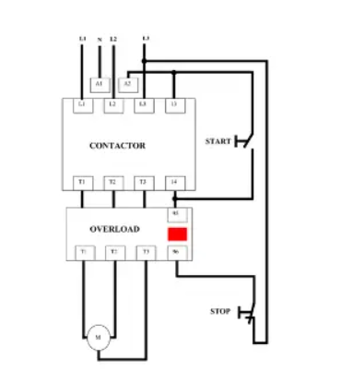
Figure 1 - Direct Online Motor Circuit [2]

Star-Delta Starter
A start-delta starter configuration can be used for larger motors to reduce voltage and thus limit starting current. The connections from each phase group are made in the motor terminal box as shown in Figure 2, this allows the motor to initially start in star configuration and then reconnect in delta configuration once up to speed. [3] The system consists of supply fuses, three contactors, a timing module, and a thermal overload. During startup and in star configuration the voltage through the windings is reduced by a factor of 1/√3 of the line voltage which also has the effect of reducing the starting current and torque by approximately 2/3.
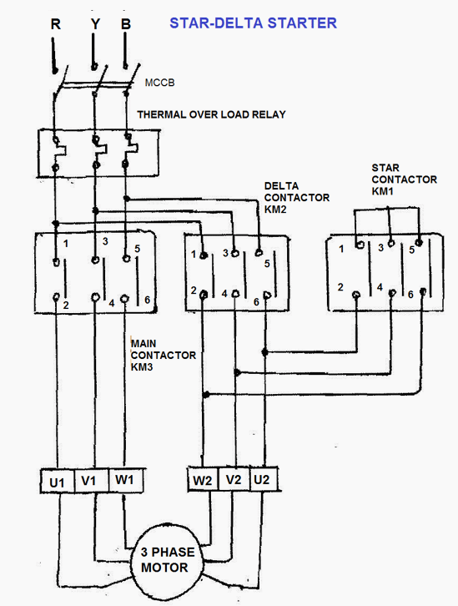
Figure 2 - Star-Delta Motor Circuit [4]

Soft Starter
A soft starter also uses a voltage reduction technique to reduce inrush current during the start-up of a motor, although these devices use semiconductor switches such as silicone-controlled rectifiers (SCRs) for better efficiency. The firing angle of the SCRs is controlled to slowly ramp up the supplied voltage to the motor allowing a current limit of 175% to 500% of full load current. [3] A soft starter circuit consists of fuses, a contactor and bypass contactor, overload and thyristor firing circuit. The bypass contactor kicks in when the maximum speed of the motor has been reached.
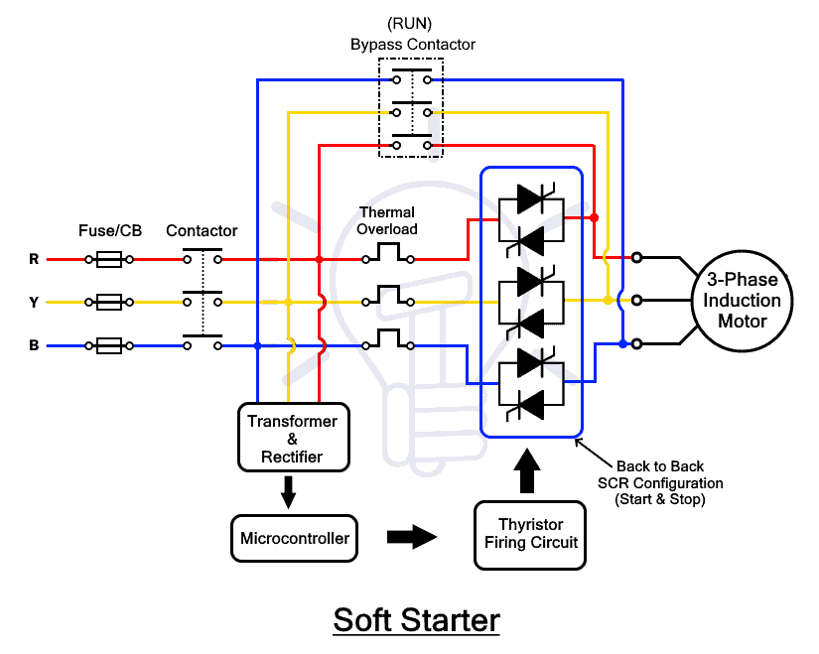
Figure 3 - Soft Starter Motor Circuit [5]

Variable Frequency Drive (VFD)
A variable frequency drive (VFD) is a type of motor controller that is used to control the speed of a motor by changing the voltage and frequency supplying the motor at a relatively constant ratio of voltage to frequency, this in turn produces adequate torque across a large speed range. A VFD consists of rectifier and inverter units that convert AC into DC and DC to AC voltage respectively [6] [7]. The rectifier unit consists of diodes, SCRs or IGBTs connected in a full wave bridge configuration that converts AC to DC, this is fed along the DC bus and filter section where the harmonics generated during the conversion are filtered out. The inverter section utilises six insulated gate bipolar transistors (IGBT) and pulse width modulation (PWM) to control the time period that the output voltage is turned on and off at a high frequency to output an approximate sinusoidal waveform to the motor. [8]
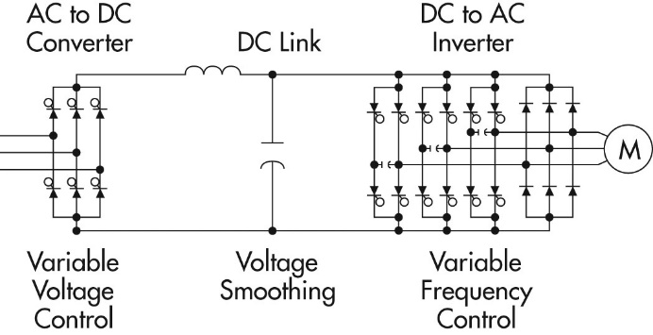
Figure 4 - Variable Frequency Drive Motor Circuit [7]

DC Bus
The DC bus section follows the primary rectifier unit containing an inductor and smoothing capacitor (LC choke filter) shown in Figure 4. The inductor minimises harmonics caused by the rectification as it blocks the high frequency signals, while the capacitor stores and releases power to minimise the DC ripple. The output waveform is shown in Figure 5 below.
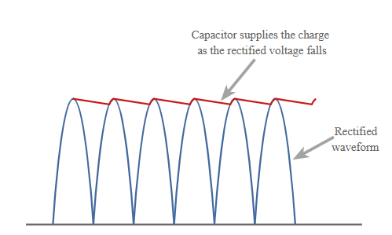
Figure 5 - Smoothing of Rectified Waveform [9]

VFD Communications
There are several types of communication protocol used in VFDs, examples include:
- EtherNet/IP
- DeviceNet
- Profibus
- Profinet
- Modbus RTU
- Modus TCP/IP
Fieldbus communication is a serial network that uses RS-485 or Ethernet, information is sent between a single master device and the slave devices, such as a PLC and multiple VFDs. [10]

Dynamic and Regenerative Braking
When the supply power to the motor is removed or reduced to decelerate, the motor continues to spin. When this happens the rotor frequency becomes greater than the stator (winding) frequency, this sustains a magnetic field that turns the motor into a generator. In this instance, a VFD can use regenerative braking, dynamic braking or increase the deceleration time to prevent overvoltage of the DC bus. Without braking, the voltage generated would continue to build up within the DC bus capacitor until an overvoltage failure occurs. Dynamic braking deals with this excess energy by dissipating it through braking resistors as heat or by turning off the inverter output when the DC bus voltage sensing circuit detects a high voltage, allowing the motor to coast to a stop. Whereas regenerative braking allows the voltage fed from the motor back to the DC bus to either be used by other VFDs, where multiple VFDs are connected to a common DC bus or the rectifier diodes (which are uni-directional) are replaced with IGBTs which provide the opportunity to be bi-directional, allowing the power generated by the motor to flow back to the grid, making the application more efficient. [11][12]

Factory Motor Drive Systems – Solutions

Motor A – 500kW AC 400V
 | Starter 1 | Starter 2 | Starter 3
Brand/Technology | Schneider Electric – ATV980 | Allen Bradley PowerFlex 750 Series | Mitsubishi – FR-F842-560K-2
Power | 560kW | 560kW | 560kW
Rated Supply Voltage | 380 to 415V AC | 380 to 400V AC | 380 to 480V AC
Is it reversable? | Yes | Yes | Yes
Variable speed | Yes | Yes | Yes
DC Common Bus | Yes | Yes | Not specified
Protection | Overload, over voltage and short circuit protection with semi-conductor fuse built in | Overload, over voltage and short circuit protection with semi-conductor fuse built in | Overload protection built in; other protection methods not specified
Energy Recovery | Regenerative | Regenerative | Regenerative
Communication Networks | Ethernet/IP, Modbus serial, Modbus TCP  3 – RJ45 ports  1 – RS-485 port | Modbus/TCP, Profibus, Ethernet/IP, RS-485 | Modbus RTU, RS-485
Cost | N/A | N/A | Est. £72,000+
Links Used | [13] | [14] | [15], [16]
Table 1 - Motor A
Table 1 shows a selection of VFDs for the 500kW motors, these drives are best suited to this application due to requiring variable speed. This application will also greatly benefit from regenerative braking and a common DC bus, when slowing down the rolling mill or when stopping the motors to change the steel coils, the power generated can be fed into the running motors for better efficiency.

Motor B – 80kW AC 400V
 | Starter 1 | Starter 2 | Starter 3 | Starter 4
Brand/Technology | Schneider Electric – ATV980 | ABB – ACS880-11-169A-3 | Siemens – G120C-6SL3210-1KE31-7AF1 | Mitsubishi – FR-A840-02660-2-60
Power | 90kW | 90kW | 90kW | 90kW
Rated Supply Voltage | 380V to 415V AC | 380 to 415V AC | 380 to 480V AC | 380 to 500V AC
Is it reversable? | Yes | Yes | Yes | Yes
Variable speed | Yes | Yes | Yes | Yes
DC Common Bus | Yes | Yes | No | No
Protection | Overload, over voltage and short circuit protection with semi-conductor fuse built in | Type of protection not listed in datasheet | Overload and phase loss protection | Overload and phase loss protection
Energy Recovery | Regenerative | Regenerative | No | No
Communications Networks | Ethernet/IP, Modbus serial, Modbus TCP  3 – RJ45 ports  1 – RS-485 port | Ethernet/IP, Modbus, Profibus  6 – Other ports  1 – RS-485 port | PROFINET, EtherNet/IP | CC-Link IE Field Network, Modbus/TCP
Cost | N/A | N/A | £7323.98 | £6691
Links Used | [17], [18] | [19], [20] | [21], [22] | [23], [24]
Table 2 - Motor B
Table 2 shows a selection of VFDs suited to this application. Due to the size and quantity required and the need for variable speed, it was determined that the most suitable motor drive system for motor B is a variable frequency drive. An important aspect of the specification for this application includes the need for a common DC bus to allow for regenerative braking between the 10 gantry crane drives to increase efficiency. The choice is therefore between starter 1 and 2 due to the vast array of communication networks and added features such as regenerative braking via a common DC bus. The final choice could depend on the manufacturer chosen for the other applications across site.

Motor C – 10kW AC 400V
 | Starter 1 | Starter 2 | Starter 3 | Starter 4
Brand/Technology | Schneider Electric – ATV930 | ABB – ACS880-11-032A-3 | Siemens – G120C-6SL3225-0BE31-1AA1 | Mitsubishi – FR-A840-00380-E2-60CRN
Power | 15kW | 15kW | 15kW | 15kW
Rated Supply Voltage | 380V to 480V AC | 380 to 415V AC | 380 to 480V AC | 380 to 500V AC
Variable speed | Yes | Yes | Yes | Yes
DC Common Bus | No | Yes | No | No
Protection | Motor overload and phase loss protection | Motor overload protection built in | Motor overload protection built in | N/A
Energy Recovery | No – Dynamic Braking | Regenerative | No | No
Communications Networks | Ethernet/IP, Modbus serial, Modbus TCP  3 – RJ45 ports  1 – RS-485 port | Ethernet/IP, Modbus, Profibus  6 – Other ports  1 – RS-485 port  1 - USB | PROFINET, EtherNet/IP | CC-Link IE Field Network, Modbus/TCP
Cost | £2666.87 | £3101.40 | £2438.79 | N/A
Links Used | [25] | [26], [27] | [28], [29] | [30]
Table 3 - Motor C
Table 3 shows a selection of VFDs suitable for this application due to the need for speed control, the drives are slightly over specified at 15kW due to predicted heavy use of the conveyor application. The only drive that comes fitted with regenerative braking out of the 4, with an integrated low harmonic line filter and common DC bus functionality is the ABB ACS880 and with conveyors potentially stopping and starting frequently, this application would very much benefit from regenerative braking.

Motor D – 5kW AC 400V
 | Starter 1 | Starter 2 | Starter 3 | Starter 4
Brand/Technology | Schneider Electric – ATS48 Soft Starter | ABB – PSE 5.5kW Soft Starter | Siemens – 3R252131AC15 Soft Starter | Allen Bradley – 150-F25NBD SMC Flex Soft Starter
Power | 5.5kW | 5.5kW | 5.5kW | 5.5kW
Rated Supply Voltage | 230V to 415V AC | 208 to 600V AC | 200 to 600V AC | 200 to 480V AC
Is it reversible? | Yes | Yes | Yes | Yes
Protection | Built in thermal protection for motor and starter | Built in electronic motor overload protection | Built in electronic motor overload protection | Built in electronic motor overload protection
Communications Networks | Modbus TCP  1 – RJ45 port | Optional fieldbus communication using Modbus, Profibus or DeviceNet | Communication module supported but not included | Network communications are an optional feature on this drive
Cost | £770.88 | £494.71 | £594.75 | £1339.24
Links Used | [31], [32] | [33], [34] | [35], [36] | [37], [38]
Table 4 - Motor D
Table 4 shows a selection of soft starter drives, variable speed is not required, thus a soft starter is better suited to this application for efficiency when starting the motors. All drives have similar functionality, ABB being the cheapest of the 4.
Motor E – 1kW Single Phase 230V AC
 | Starter 1 | Starter 2 | Starter 3 | Starter 4
Brand/Technology | Schneider Electric – TeSys LE Direct Online Starter | Crompton –3DL1CKS10 Direct Online Starter | WEG – DLWM Direct Online Starter | RS PRO Direct Online Starter
Power | 1.1kW | 1.1kW | 1.1-1.5kW | 1.5kW
Rated Supply Voltage | 220V to 230V AC | 230V AC | 230V AC | 230V AC
Protection | Thermal overload relay | Thermal overload relay | Thermal overload relay | Thermal overload relay
Cost | £120.64 | £110.50 | £33.36 | £80.15
Links Used | [39] | [40] | [41] | [42]
Table 5 - Motor E
For this application, as the motors are single phase and don’t require variable speed, a DOL starter with motor overload protection is best suited due to cost effectiveness and ease of installation. The 24V control circuit can be configured through an operating system to remotely start/stop each direct online starter in the field. DOL starters don’t provide information via communication ports or regenerative braking like VFDs but are a far more cost-effective solution in this instance.

Conclusion
Overall, the best suited manufacturer for each scenario, based on the research conducted is Schneider Electric, as unlike any other manufacturer, they offer a solution to each application and would therefore allow the factory to standardise their equipment across their site. All drives use several communication protocols that will allow a single HMI to operate multiple drives and allow for extensive information gathering. Standardising would also improve maintenance and set up costs and thus help workers to understand each application far better due working with and operating the same manufacturer equipment throughout. There are some drawbacks to using one manufacturer though, for example, when referring to Table 3, the best suited drive for this application is the ABB-ACS880 due to its regenerative braking functionality, Schneider do not seem to offer regenerative braking at this kilowatt range, thus the company would have to way up the pros and cons and decide if they would like to use ABB rather than Schneider Electric for this particular application.

Task 2

Background Information

What are Harmonics?
VFDs contain rectifiers that use semiconductor devices, the non-sinusoidal switching behaviour of these devices generates harmonics. Harmonics are defined as an unwanted higher frequency component that is an integer multiple of the fundamental frequency, thus creating a distorted fundamental waveform.
The fundamental frequency of a 3 phase supply is 50Hz, and when passed through a standard 6-pule rectifier to convert to DC, the waveforms are cut and chopped in a way that is non-linear (as diodes for example only permit one half of the sinusoidal current flow), meaning they draw current that is not ordinarily sinusoidal, creating current harmonics that react with system impedances to create voltage harmonics. [43]
Distortions in the supply due to higher frequency harmonics combine with the supply frequency to cause voltage fluctuations as shown in Figure 6 below. The fundamental waveform is shown in black with 3rd and 5th harmonics in red and blue, respectively.
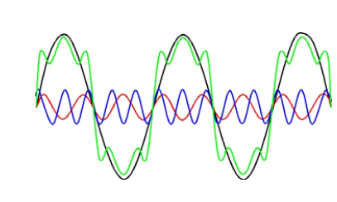
Figure 6 - Voltage Distortion due to Harmonics [44]

Effect of harmonics on power and power factor (pf)
Power factor is very much affected by harmonics, as true pf is a combination of displacement pf (phase shift) which depends on the linear loads in the circuit and the distortion power factor caused by harmonics. As you can see from the below expression containing displacement pf and total harmonic distortion, when harmonics increase, distortion pf decreases which will therefore affect the overall power factor of the system. A low pf means increased energy losses which therefore means that more current is required to deliver the same amount of active power to the system. [45], [46]
$$True pf= \frac{cosΦ (displacment power factor)}{\sqrt{1+THD^{2}} (distorion power factor)}$$

One effect that harmonics can have on power and pf is conductor losses. The resistance of copper increases as the frequency passing through it increases due to a phenomenon known as the “skin effect.” High frequency harmonics cause the current to concentrate around the outer surfaces of the conductor creating a non-uniform current density. The density/frequency relationship is shown in Figure 7 below. At the fundamental frequency the skin effect is negligible, but as harmonic frequencies rise, the less “skin depth” the conductor has. For example, the 3rd harmonic at 150Hz causes the “skin depth” of copper to be 9mm, making it less efficient at carrying current, increasing resistance which generates heat. [44]
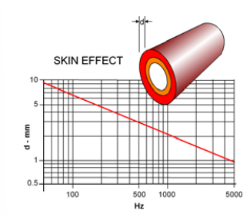
Figure 7 - "Skin Effect" caused by Harmonics [44]
Harmonic currents cause eddy currents to form within a transformer, causing an increase in “iron” and “copper” losses due to the Joule effect, which generates resistive losses reducing the efficiency of the transformer. The “skin effect” plays a part in the “copper” losses, explained previously, decreasing the cross-sectional area to the current flow, which generates heat within the transformer.
As harmonics cause an increase in apparent power, this means that components within a harmonic system must be rated for larger currents than they need to be to prevent overload, this comes with a corresponding increase in the cost of installation. [44]
Harmonics also cause damage to capacitors, these capacitors are used to improve pf, but they can also introduce problems in systems with harmonic frequencies. A pf correction capacitor and power system arrangement have a resonant frequency, if the harmonic frequencies generated coincide with the resonant frequency, this can result in total or partial resonance, amplifying voltage distortions and increasing current, which will result in overheating and degradation of the capacitor and other system components. [44], [47]

Discussion

Diode Rectification
Most standard rectifiers contain a 6-pulse rectifier configuration, containing 6 diodes as shown in Figure 8 below. It is referred to as a 6-pulse rectifier as it draws current from the AC source in six pulses, each set of diodes per phase allow current to pass through when the voltage is negative and the other allows current to flow when the voltage is positive, chopping the output waveform to create a DC output with some ripple. This design is cheaper and easier to build but comes with some disadvantages, such as worse harmonic content when compared to IGBT or SCR rectification as well as being unidirectional which means it won’t allow energy to flow back from the motor to the grid. Furthermore, diode bridge rectifiers are uncontrolled, meaning the average output voltage is a fixed value relative of the input AC voltage, unlike SCRs and IGBTs that can be controlled to vary the DC bus voltage.
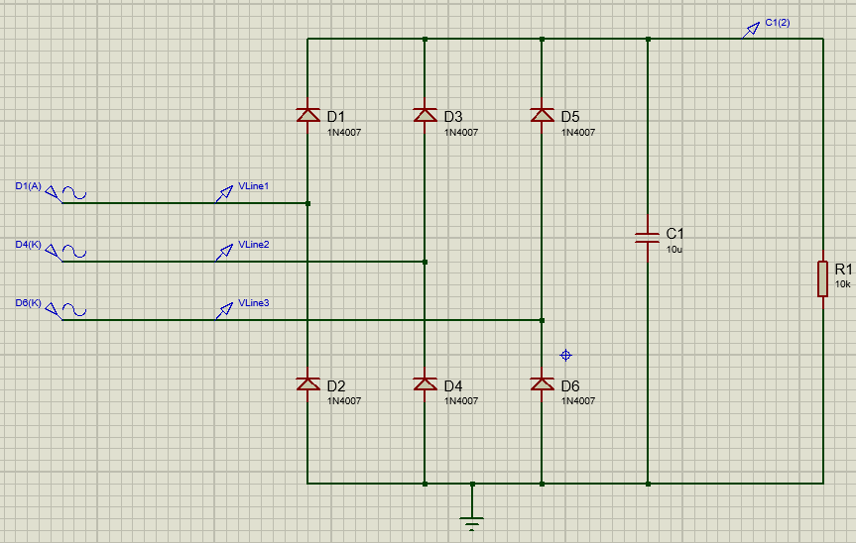
Figure 8 – 6 Pulse Diode Rectifier
As shown in Figure 9 below, without the smoothing capacitor shown in Figure 8, the output waveform (yellow) contains a lot of DC ripple.
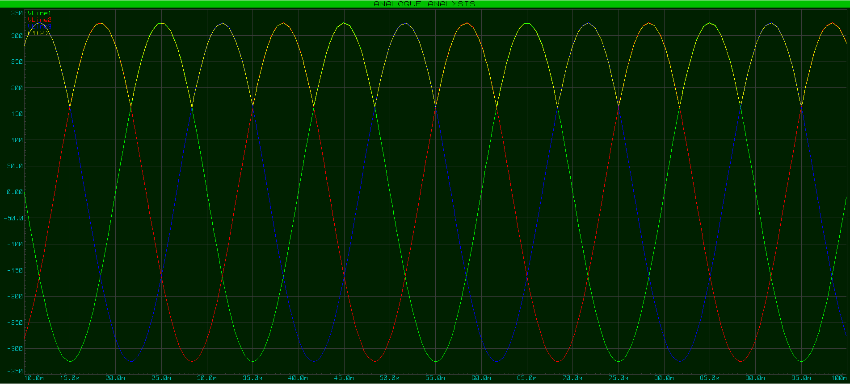
Figure 9 – 6 pulse rectifier output with no smoothing capacitor
Figure 10 shows a far smoother DC output when a smoothing capacitor is added to the output.
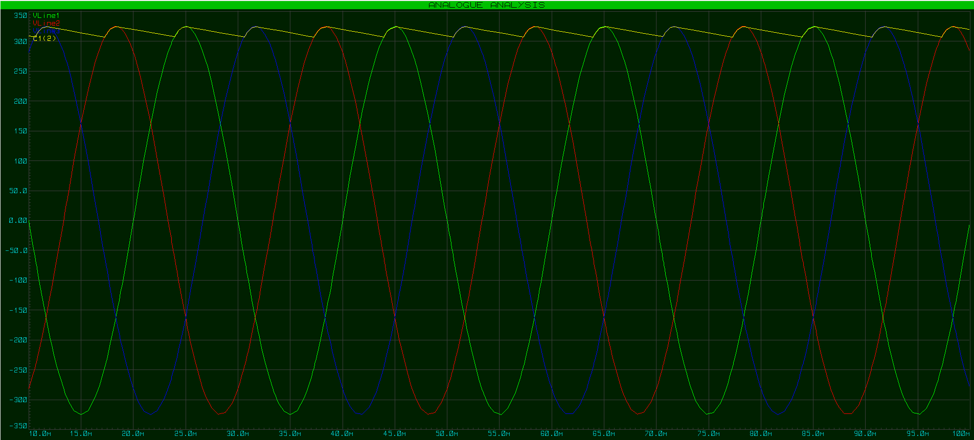
Figure 10 - 6 Pulse Rectifier with Smoothing Capacitor

The simulation results using a Fourier analysis with a decibel scale show 3rd, 6^{th,} and 9th order harmonics in the output waveform, see Figure 11 below.
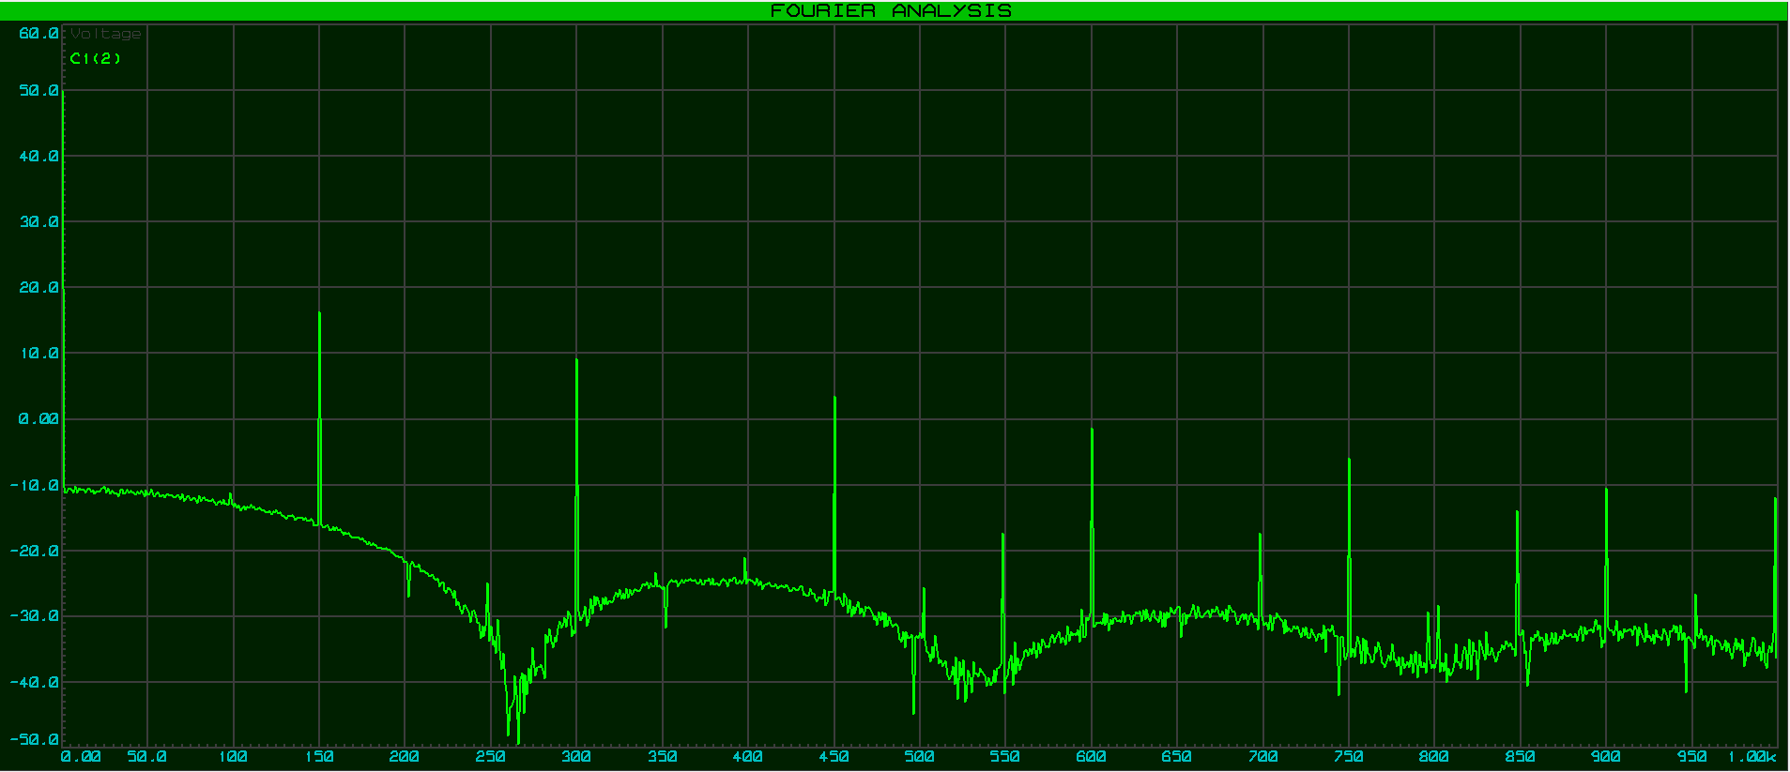
Figure 11 - Fourier Analysis 6 Pulse Rectifier

Thyristor Rectification (Silicon Controlled Rectifier - SCR)
SCRs work in a similar way to a diode but provide a means of controlling the value of the rectified DC voltage by applying a voltage trigger to the gate terminal to allow it to conduct and pass current through it, the conduction angle can be adjusted using a RC circuit to phase shift the gate trigger, a longer period of conduction results in a larger average value of DC output voltage. In close loop VFDs, the DC current/voltage is measured and compared to the desired values, if the DC bus current is too low, the firing angle of the SCR can be decreased to increase the current flowing through it. SCRs have the advantage of being easy to control and inexpensive but can create high harmonic distortions, increasing total harmonic distortion (THD) in the input current waveform which will lower the power factor due to drawing reactive current. This can shorten the lifespan of system components such as capacitors and transformers due to heat and stress caused by harmonics. [48]
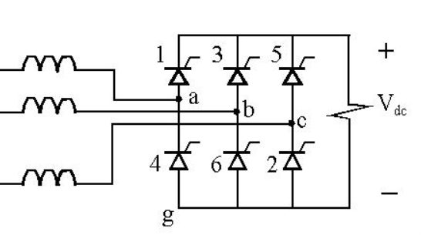
Figure 12 - 6 Pulse Thyristor Rectifier [49]

Insulated Gate Bipolar Transistor Rectification (IGBTs)
Used in high voltage, fast switching applications, an IGBT contains three terminals, gate, collector, and emitter, essentially made up of a MOSFET gate connected to NPN and PNP transistors, operating as a switch via PWM. When voltage is applied to the gate, it turns on creating a path for voltage to flow between the anode and cathode, when the gate voltage is removed the flow of current is turned off, the width of each pulse determining the amount of power converted into DC by the rectifier. Unlike SCRs, they don’t have to be turned on or off at the zero-crossing point and they do not change the input power factor. [48]
IGBTs also significantly reduce lower order harmonics and can conduct in both directions, which means regeneration of power produced by the motor can be fed back into the grid for efficiency, however they do introduce higher order harmonics, so a dedicated filter is required, making this rectifier more costly than other rectifier types.
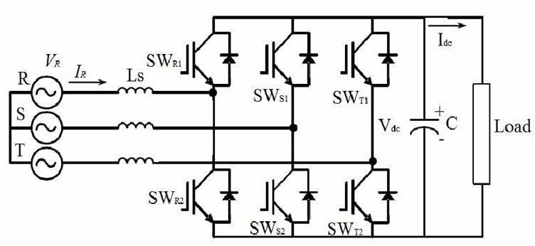
Figure 13 - 6 Pulse IGBT Rectifier [50]

How can harmonic noise be minimised?
There are several methods used in VFDs to minimise harmonics, two of these are an AC line reactor and DC link reactor. An AC line reactor is placed in series with the input phases and works by increasing the impedance of the line, which in turn limits the rise of current, reducing harmonic content. There are some drawbacks to this method as it does create a voltage drop due to the impedance which has to be factored in, they are quite expensive and have a large footprint. [51]
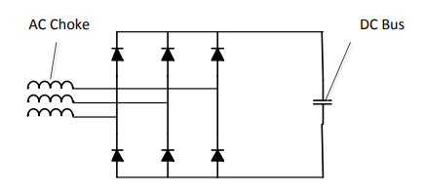
Figure 14 - AC Line Reactor to Reduce Harmonic Noise [51]
A DC link reactor works in the same way as an AC reactor but is usually smaller in size and provides some more advantages over an AC line reactor. Firstly, it acts to reduce DC ripple voltage on the bus and is usually less costly, provides a smaller voltage drop as the frequency is zero, therefore the impedance to the DC current is zero and it attenuates 5th and 7th order harmonics better than AC line reactors, which are the largest contributors of harmonic noise. [51]
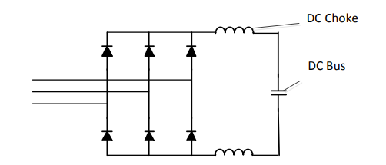
Figure 15 - DC Line Reactor to Reduce Harmonic Noise [51]

Another method used to limit harmonic distortion is a 12 or 24-pulse rectifier design, a 12 pulse design contains two sets of 6 pulse rectifiers in parallel, shown in Figure 16 below, a transformer with one primary winding and two secondary windings are used to create a 30-degree phase shift between the two output current waveforms and thus a phase shift between the harmonic components which then cancel each other out. This configuration reduces THD in the circuit, while mitigating lower order, high amplitude harmonic currents such as those found in the 5th and 7th order. [52]
Disadvantages of this method include high upfront cost of transformer and its large physical footprint. Furthermore, the input phases need to be very well balanced.
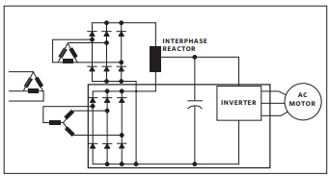
Figure 16 - 12 Pulse Rectifier [53]

Figure 17 and Figure 18 below illustrate vastly reduced low order harmonic content in the output waveform when compared to a 6-pulse design shown in Figure 11. There are only small amplitude 6th and 12th order harmonics, with vastly reduced 3rd and 6th order harmonics when compared to a 6-pulse design.
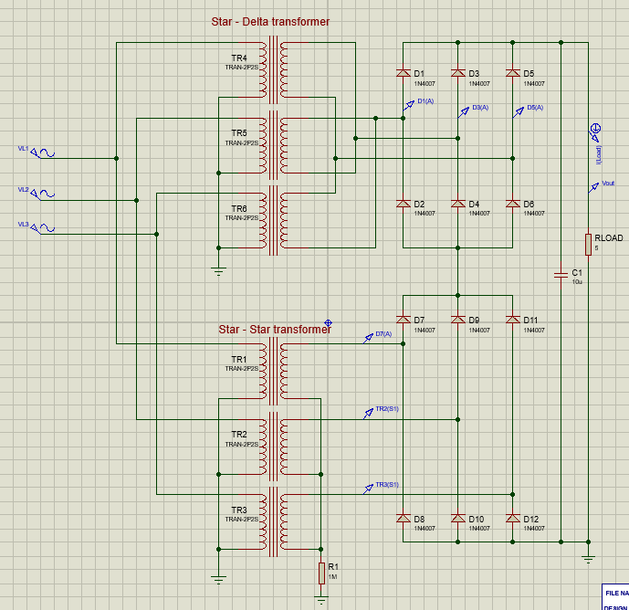
Figure 17 - 12 Pulse Rectifier Simulation
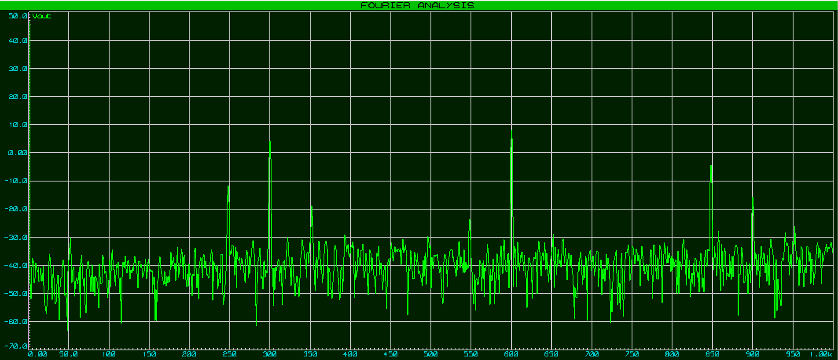
Figure 18 - 12 Pulse Rectifier Simulation Fourier Analysis

Conclusion
To summarise, it is evident that all types of VFD rectifier units have some effect upon the efficiency of the total system, creating some harmonic distortion on the output and line currents. There are steps that can be taken to minimise harmonic distortion such as increasing the number of diodes to 12 or 24 pulse, switching out diodes and SCRs for IGBTs or through the use of AC and DC line reactors to increase system impedance to reduce high frequency harmonics. It was determined that 6-pulse diode and SCR rectifier designs create more low order harmonic distortion due to the chopping of the sinusoidal input waveform but in the case of a diode design, it is by far the cheapest and most simple form of rectifier. An IGBT rectifier has a higher upfront cost but provides the best efficiency, with the least DC ripple and low order harmonics which will reduce operating costs and the negative effects that harmonic distortion has on system components. IGBTs also provide the added functionality of bidirectional switching for regenerative efficiency back to the grid.

References
[1] “DOL Starter - Working, Circuit, Advantages, Disadvantages, Applications.” https://instrumentationtools.com/dol-starter-working-circuit-advantages-disadvantages-applications/ (accessed Apr. 01, 2023).
[2] “DOL Starter (Direct Online Starter): Wiring Diagram & Working Principle | Electrical4U.” https://www.electrical4u.com/direct-online-starter-or-dol-starter/ (accessed Apr. 01, 2023).
[3] J. Larabee, B. Pellegrino, and B. Flick, “Induction motor starting methods and issues,” in Record of Conference Papers - Annual Petroleum and Chemical Industry Conference, 2005, pp. 217–222. doi: 10.1109/pcicon.2005.1524557.
[4] “Star-delta motor starter explained in details | EEP.” https://electrical-engineering-portal.com/star-delta-motor-starter (accessed Apr. 01, 2023).
[5] “What is Soft Starter? Its Working, Diagram and Applications.” https://www.electricaltechnology.org/2020/08/soft-starter.html (accessed Apr. 01, 2023).
[6] T. Aditya, “Research to study Variable Frequency Drive and its Energy Savings,” International Journal of Science and Research, vol. 2, pp. 2319–7064, 2013, Accessed: Apr. 01, 2023. [Online]. Available: www.ijsr.net
[7] “Principles of Operation - AC VFD Drives.” https://natural-resources.canada.ca/energy-efficiency/energy-star-canada/about/energy-star-announcements/publications/variable-frequency-drives/principles-operation-ac-vfd-drives/15433 (accessed Apr. 01, 2023).
[8] T. Aditya, “Research to study Variable Frequency Drive and its Energy Savings,” 2013. [Online]. Available: www.ijsr.net
[9] “Capacitor Smoothing Circuits & Calculations » Electronics Notes.” https://www.electronics-notes.com/articles/analogue_circuits/power-supply-electronics/capacitor-smoothing-circuits.php (accessed Apr. 02, 2023).
[10] “VFDs from the inside out | Control Engineering.” https://www.controleng.com/articles/vfds-from-the-inside-out/ (accessed Apr. 02, 2023).
[11] “VFD Regeneration Explained | eMotors Direct.” https://www.emotorsdirect.ca/knowledge-center/article/vfd-regeneration-explained (accessed Apr. 02, 2023).
[12] Rīgas Tehniskā universitāte, IEEE Industry Applications Society, Institute of Electrical and Electronics Engineers. Latvia Section. IAS-IES-PELS Joint Chapter, Institute of Electrical and Electronics Engineers. Latvia Section, and Institute of Electrical and Electronics Engineers, RTUCON : 58th Annual International Scientific Conference on Power and Electrical Engineering : October 12, 13, 2017 : Riga Technical University : conference proceedings.
[13] “ATV980C56Q4X1 - Variable speed drive, Altivar Process ATV900, Regenerative System ATV980 -560/450 kW, 400 V with CE, IP23 | Schneider Electric Global.” https://www.se.com/ww/en/product/ATV980C56Q4X1/variable-speed-drive-altivar-process-atv900-regenerative-system-atv980-560-450-kw-400-v-with-ce-ip23/ (accessed Apr. 04, 2023).
[14] R. Automation, “PowerFlex 750-Series AC Drives Technical Data”.
[15] “FR-F842-560K-2 by MITSUBISHI - Buy or Repair at Radwell - Radwell.co.uk.” https://www.radwell.co.uk/Buy/MITSUBISHI/MITSUBISHI/FR-F842-560K-2?redirect=true (accessed Apr. 04, 2023).
[16] “INVERTER INVERTER FR-F800 INSTRUCTION MANUAL (DETAILED)”.
[17] “ATV980C11Q4X1 - Variable speed drive, Altivar Process ATV900, Regenerative System ATV980 -110/90 kW, 400 V with CE, IP23 | Schneider Electric Global.” https://www.se.com/ww/en/product/ATV980C11Q4X1/variable-speed-drive-altivar-process-atv900-regenerative-system-atv980-110-90-kw-400-v-with-ce-ip23/ (accessed Apr. 04, 2023).
[18] “ATV900 DC Bus Sharing This document describes how to design applications using ATV900 series drives on a common DC bus,” 2020.
[19] “ACS880-11-169A-3 | ABB.” https://new.abb.com/products/3AXD50000042307/acs880-11-169a-3 (accessed Apr. 04, 2023).
[20] “ABB industrial drives Application guide ACS880-01 drives and ACS880-04 drive modules Common DC systems”.
[21] “Siemens Sinamics 400v 90kW G120C - 6SL3210-1KE31-7AF1 Variable Frequency Drive - Drives and Automation.” https://www.drivesandautomation.com/product/ac-drives/siemens-sinamics-g120c-ac-drives/siemens-sinamics-400v-90kw-g120c-6sl3210-1ke31-7af1-variable-frequency-drive/ (accessed Apr. 04, 2023).
[22] “Data sheet for SINAMICS G120C.”
[23] “Mitsubishi FR-F840 series inverter - FR-A840-02600-2-60 - ACD&D Limited.” https://www.acpd.co.uk/mitsubishi-fr-a840-series-inverter-type-fr-a840-02600-2-60 (accessed Apr. 04, 2023).
[24] “Mitsubishi VFDs Inverter 90kW FR-A840-02660-2-60 - United Automation.” https://www.plc-sensors.com/product-item/mitsubishi-vfds-inverter-90kw-fr-a840-02660-2-60/ (accessed Apr. 04, 2023).
[25] “ATV930D15N4 - variable speed drive, ATV930, 15kW, 400/480V, with braking unit, IP21 | Schneider Electric UK.” https://www.se.com/uk/en/product/ATV930D15N4/variable-speed-drive-atv930-15kw-400-480v-with-braking-unit-ip21/ (accessed Apr. 04, 2023).
[26] “ABB ACS880 IP21 11kW/15kW 400V 3ph AC Inverter Drive, DBr, STO, C3 EMC - AC Inverter Drives (400V).” https://inverterdrive.com/group/AC-Inverter-Drives-400V/ABB-ACS880-01-032A-3-E200/ (accessed Apr. 04, 2023).
[27] “ACS880-11-032A-3 | ABB.” https://new.abb.com/products/3AXD50000047494/acs880-11-032a-3 (accessed Apr. 04, 2023).
[28] “6SL3225-0BE31-1AA1 | Siemens Power Module, 11 kW, 3 Phase, 380 → 480 V ac, 26 A, SINAMICS G120 Series | RS.” https://uk.rs-online.com/web/p/inverter-drives/1895345 (accessed Apr. 04, 2023).
[29] “Data sheet for SINAMICS Power module PM250.”
[30] “FR-A840-00380-E2-60CRN - Mitsubishi Electric Factory Automation - United Kingdom.” https://gb.mitsubishielectric.com/fa/products/drv/inv/fr_a800_plus/fra800crn/fr-a840-00380-e2-60crn.html (accessed Apr. 04, 2023).
[31] “ATS48D17Q - soft starter for asynchronous motor - ATS48 - 14.8 A - 230..415 V - 3..15 KW | Schneider Electric UK.” https://www.se.com/uk/en/product/ATS48D17Q/soft-starter-for-asynchronous-motor-ats48-14-8-a-230-415-v-3-15-kw/ (accessed Apr. 04, 2023).
[32] “Product datasheet Specifications soft starter for asynchronous motor-Local distributor code: 386179464 ATS48D17Q Protection type Product certifications UL CCC GOST DNV CSA NOM 117 SEPRO TCF C-Tick Minimum switching current,” 2023.
[33] “1SFA897101R7000 | ABB 5.5 kW Soft Starter, 600 V ac, 3 Phase, IP00, IP20 | RS.” https://uk.rs-online.com/web/p/motor-starters/7328336 (accessed Apr. 04, 2023).
[34] “PSE-The efficient range Description”, Accessed: Apr. 03, 2023. [Online]. Available: www.abb.com/lowvoltage
[35] “3RW52 soft starter - (5.5kW at 400V), 200-600 V 13 A, 110-250 V AC Screw terminals Analog output - 3RW52131AC15.” https://www.parmley-graham.co.uk/lv-controlgear/siemens/softstarter/general-3rw52-200-600v/3RW5213-1AC15 (accessed Apr. 04, 2023).
[36] “Data sheet 3RW5213-1AC15 Subject to change without notice © Copyright Siemens.”
[37] “150-F25NBD | Routeco.” https://www.routeco.com/en-gb/shop/control-gear-switchgear/soft-starters/150-f25nbd (accessed Apr. 04, 2023).
[38] “SMC Flex Low Voltage Soft Starters | Allen-Bradley.” https://www.rockwellautomation.com/en-gb/products/hardware/allen-bradley/motor-control/soft-starters--low-voltage/smc-flex-smart-motor-controllers.html (accessed Apr. 04, 2023).
[39] “Product datasheet Specifications TeSys LE-enclosed DOL starter-3.7...5.5 A-24 V AC coil Local distributor code: 398264985 LE1M35B712.”
[40] “Crompton 1.1kW 230V DOL Starter with 7-10A Overload (3DL1CKS10) | CEF.” https://www.cef.co.uk/catalogue/products/1778197-1-1kw-230v-direct-on-line-starter-with-overload-fitted (accessed Apr. 04, 2023).
[41] “WEG DLWM DOL Starter with Overload for 230V Single Phase Motor 1.1kW to 1.5kW, IP65 - DOL Starters (Single Phase).” https://inverterdrive.com/group/DOL-Starters-Single-Phase/WEG-DLWM-150-Direct-On-Line-Starter/ (accessed Apr. 04, 2023).
[42] “RS PRO 1.5 kW DOL Starter, 240 V ac, 1 Phase, IP55 | RS.” https://uk.rs-online.com/web/p/motor-starters/9094098?cm_mmc=UK-PLA-DS3A-_-google-_-CSS_UK_EN_Automation_%26_Control_Gear_Whoop-_-Motor+Starters_Whoop-_-9094098&matchtype=&pla-342072366642&cq_src=google_ads&cq_cmp=9771206608&cq_term=&cq_plac=&cq_net=g&cq_plt=gp&gclid=Cj0KCQjwla-hBhD7ARIsAM9tQKs3nHLwhOaDOGp5ZDO9I_yE6pEfJtmAiphxfjOhVEKcXKdpDCQv3OYaAoJUEALw_wcB&gclsrc=aw.ds (accessed Apr. 04, 2023).
[43] M. Grady, “Understanding Power System Harmonics”.
[44] “Power Factor Correction and Harmonics (Passive Inductance Solutions).”
[45] A. Hoevenaars and P. Eng President, “HOW HARMONICS HAVE CONTRIBUTED TO MANY POWER FACTOR MISCONCEPTIONS,” 2014, Accessed: Apr. 08, 2023. [Online]. Available: www.mirusinternational.com
[46] “Effect of Harmonics on Power Factor.” https://www.electricalvolt.com/2022/12/effect-of-harmonics-on-power-factor/ (accessed Apr. 08, 2023).
[47] “Risk of resonance due to power-system harmonics - Electrical Installation Guide.” https://www.electrical-installation.org/enwiki/Risk_of_resonance_due_to_power-system_harmonics (accessed Apr. 08, 2023).
[48] R. Engelhardt, “SSFC rectifier power stages A brief summary of the advantages and disadvantages of using igbt’s and scr ’s in rectifier power stages.”
[49] “SIX PULSE BRIDGE RECTIFIER.” https://www.ewh.ieee.org/soc/es/Nov1998/08/CONVERTR.HTM (accessed Apr. 10, 2023).
[50] “IGBT Rectifier - IGBT rectifier vs 12 pulse rectifier. Which one is better?” https://www.sinepower.com/en/sinepower-highlights-igbt-rectifier-12-pulse-rectifier/ (accessed Apr. 10, 2023).
[51] “Harmonic Mitigation Comparison: AC Line Reactors vs DC Link Chokes AP040109EN”, Accessed: Apr. 09, 2023. [Online]. Available: www.eaton.com
[52] Nidec, “Harmonic Distortion and Variable Frequency Drives.”
[53] Armstrong Fluid Technology, “Harmonic Effect Reduction”.

